

Date: 11 December 2019

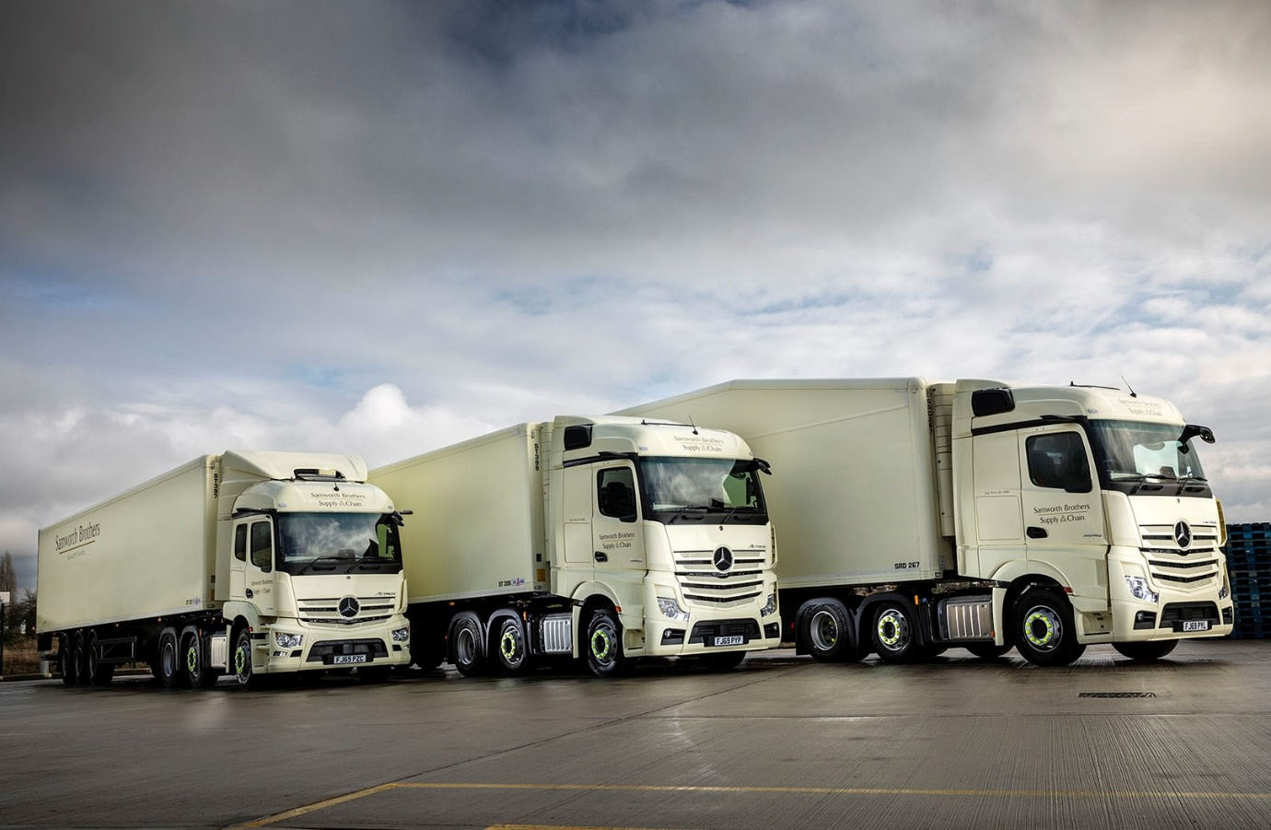

It’s ‘horses for courses’ as Samworth Brothers returns with new order for 48 Mercedes-Benz Actros

So delighted has Samworth Brothers been with the fuel-efficiency and uptime of the Mercedes-Benz Actros tractor units it acquired a year ago, that it has just taken delivery of a further 48.

The latest additions to the Leicester-based temperature-controlled distribution specialist’s fleet are all from the new-generation Actros range and arrived, like their predecessors, via East Midlands Dealer Mertrux Truck & Van.

Most are Actros 2545 models with flat-floored StreamSpace cabs and 12.8-litre in-line six-cylinder engines which produce 330 kW (450 hp). Ten, however, are Actros 2546 variants with 340 kW (460 hp) 10.7-litre ‘straight sixes’. They have 2.3m StreamSpace cabs, the narrower of the two widths available, and the 320mm engine tunnels which have earned this model a 3-star Direct Vision rating from Transport for London.

All feature the ground-breaking technology which saw new Actros win the International Truck of the Year 2020 crown in November. Highlights include MirrorCam, which replaces conventional mirrors and represents a major safety advance, while also offering improvements in economy due to the compact, streamlined profile of the camera housings; the state-of-the-art Multimedia Cockpit, which brings connectivity and intuitive operation to the fore; and enhanced versions of the Active Brake Assist emergency braking and fuel-saving Predictive Powertrain Control systems.

The new trucks have lined-up alongside the 18 Actros 2545 StreamSpace units which have so impressed since they entered service with Samworth Brothers in December 2018, thanks, in no small part, to the timely, customer-focused back-up provided by Mertrux.

Samworth Brothers Operations Director Paul Marrow confirmed: “We’ve forged excellent relationships with the Dealer’s Fleet Truck Sales Manager Bob Holt and his colleagues, and with the manufacturer’s Strategic Account Manager Matt Lee, which are based on transparency and integrity. Mertrux are very supportive, while we’ve felt from the outset that Mercedes-Benz really wanted our business and had a fantastic vehicle which could meet our high expectations. So it’s proved.”

The operator maintains its trucks in-house but relies on Mertrux for technical assistance and management of an imprest parts stock. “The feedback I get from my vehicle maintenance and transport managers is really positive,” continued Mr Marrow. “In the 12 months we’ve been running them our first clutch of Actros have proved totally reliable, and haven’t spent anything like as much time in the workshop as other vehicles we run. The Dealer’s response times, meanwhile, irrespective of whether the query relates to service or parts, are always very good.

“We spend a lot on fuel, so economy has obviously been a huge factor in our decision-making process. We’re getting a better mpg performance from our first Actros than we do from other, comparable vehicles, and I’m very excited about the additional benefits in terms of further reductions in diesel consumption which the new models offer.”

Samworth Brothers operates more than 120 of its own trucks, as well as approximately 230 semi-trailers of various configurations – it also supplements the fleet with rental vehicles. The bigger, flat-floored units are on nationwide distribution work, much of which entails pulling double-deck trailers. The smaller models are assigned to more local duties.

Mr Marrow explained: “We make a lot of collections from production facilities in and Leicestershire. The fact that the 10.7-litre Actros are so much more compact, and offer better low-down visibility, makes life easier for drivers. These trucks are interchangeable between shunting and distribution activity, though, which means we have the flexibility we need within the fleet.”

Mercedes-Benz Trucks’ leadership in the field of safety was instrumental in convincing Samworth Brothers to place its first multiple order for Actros – the operator’s only previous unit was withdrawn from front-line duties last year after clocking up one million km, refurbished by Mertrux, and is now used by its acclaimed Supply Chain Academy.

Paul Marrow added: “Fantastic Mercedes-Benz technology such as MirrorCam and Active Brake Assist 5, combined with the third-party camera systems we fit on all our trucks, and our industry-leading commitment to driver training, mean that our new Actros are right up there with the safest trucks on the road.”

www.samworthbrothers.co.uk

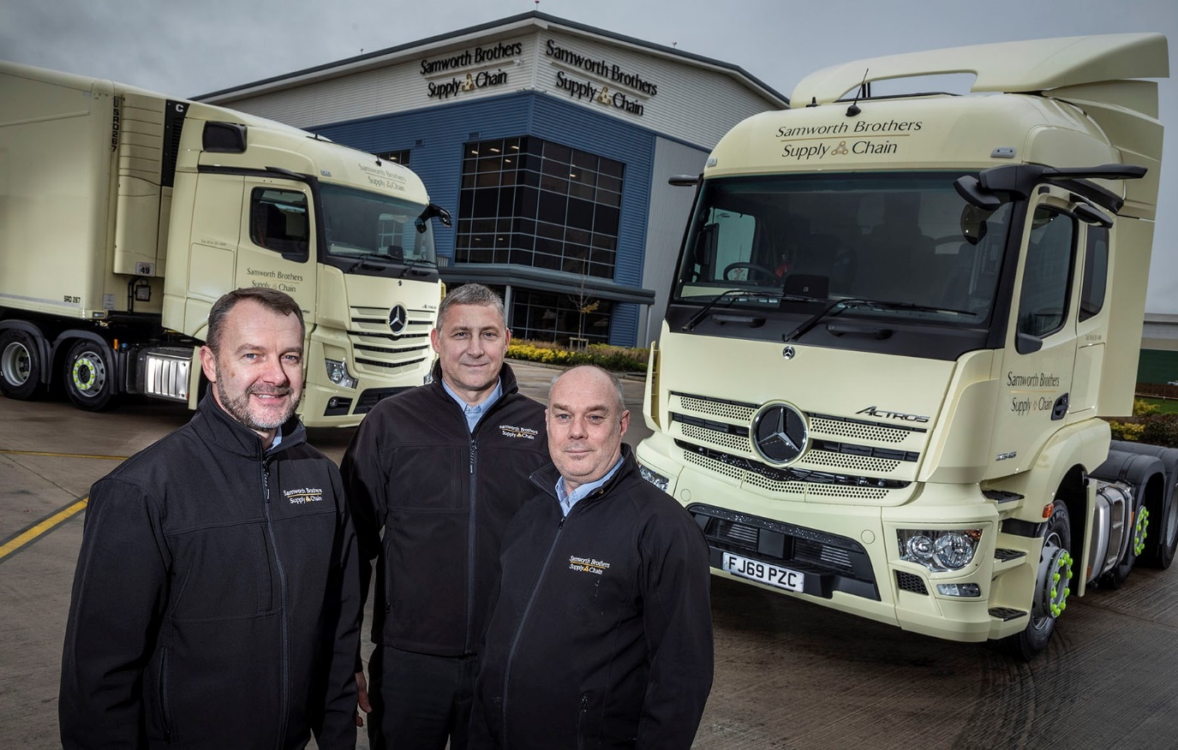

Back for more from Mercedes-Benz: Samworth Brothers Paul Marrow, left, is pictured with colleagues Transport Manager Dave Alexander, centre, and Fleet Manager Ian Cooper

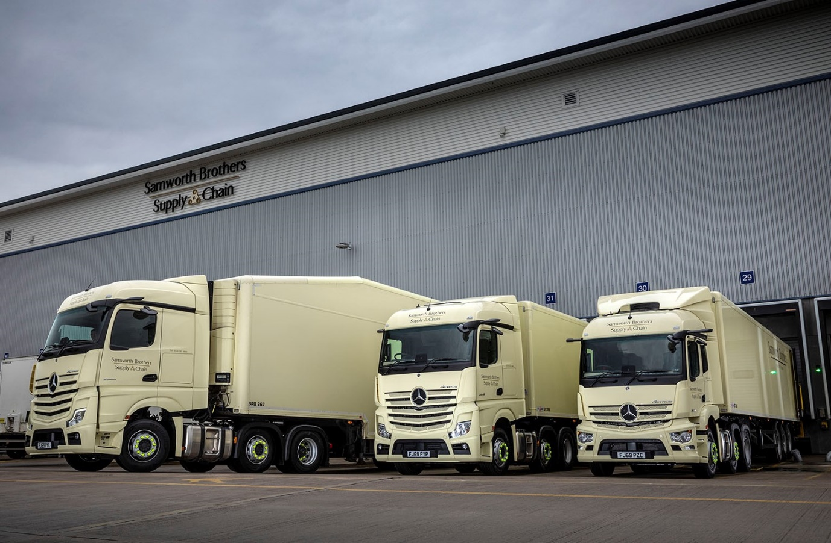

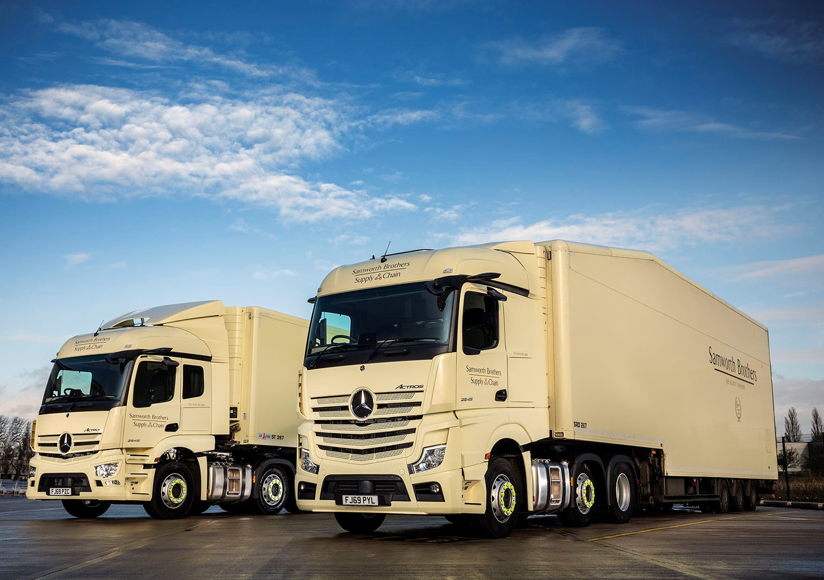

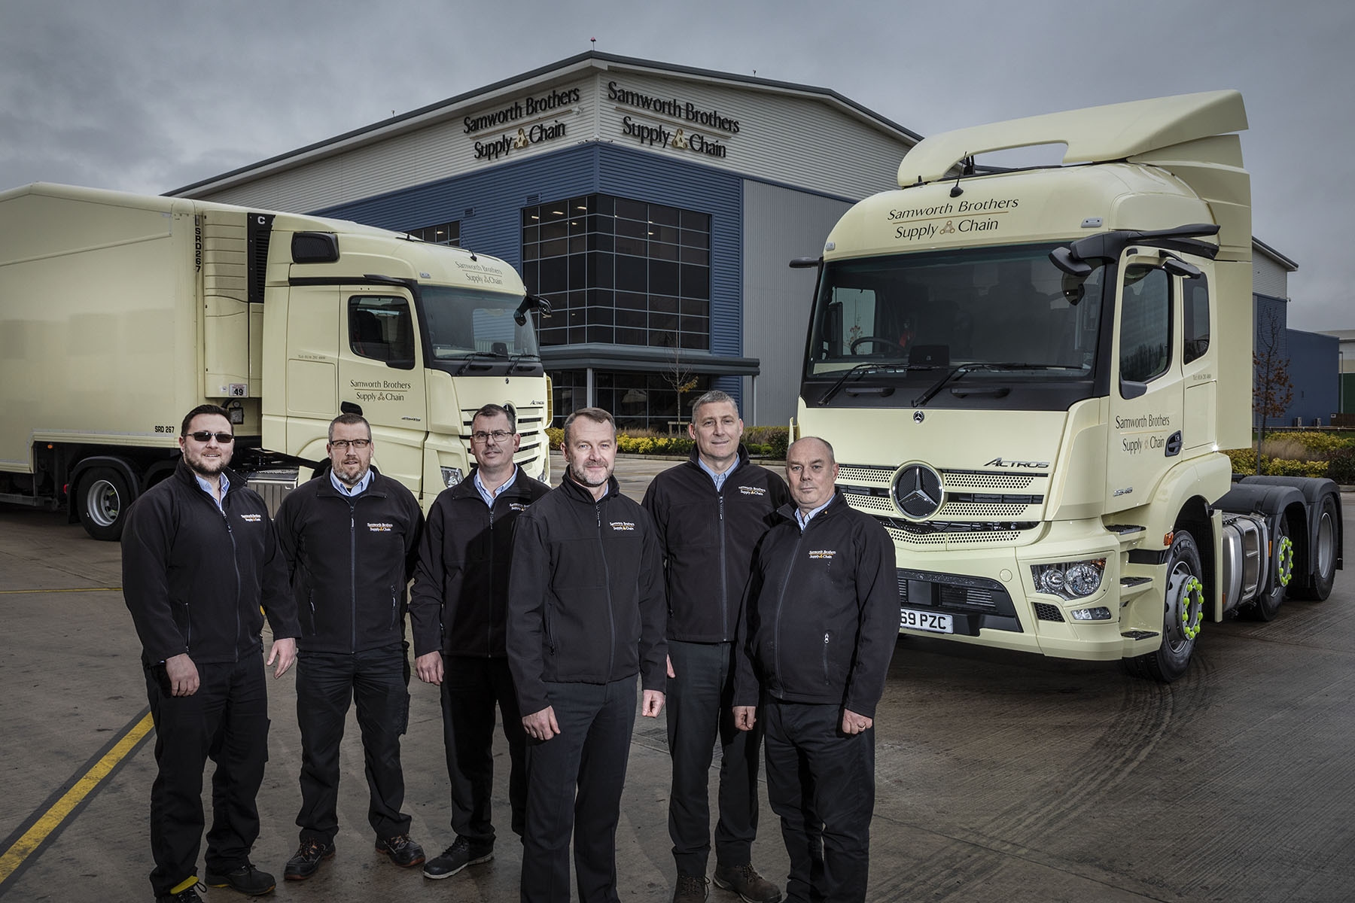

Front-runners: Pictured from left, are Samworth Brothers Driver-trainers Paul Golding, Richard Straw, and Matt Pickering, Operations Director Paul Marrow, Transport Manager Dave Alexander, and Fleet Manager Ian Cooper

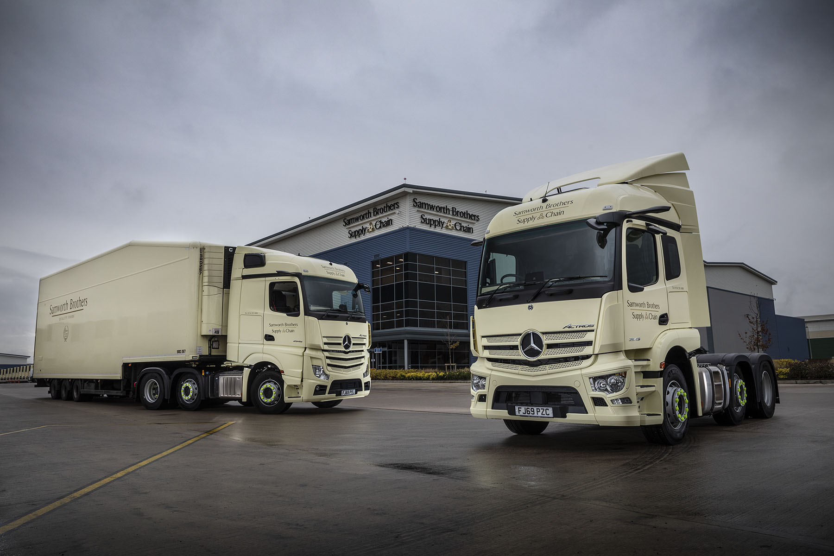

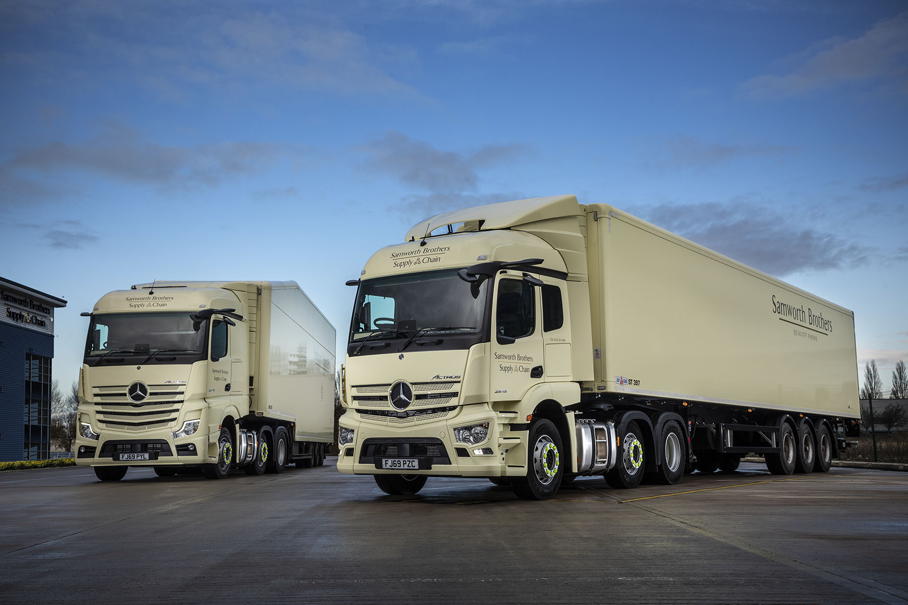

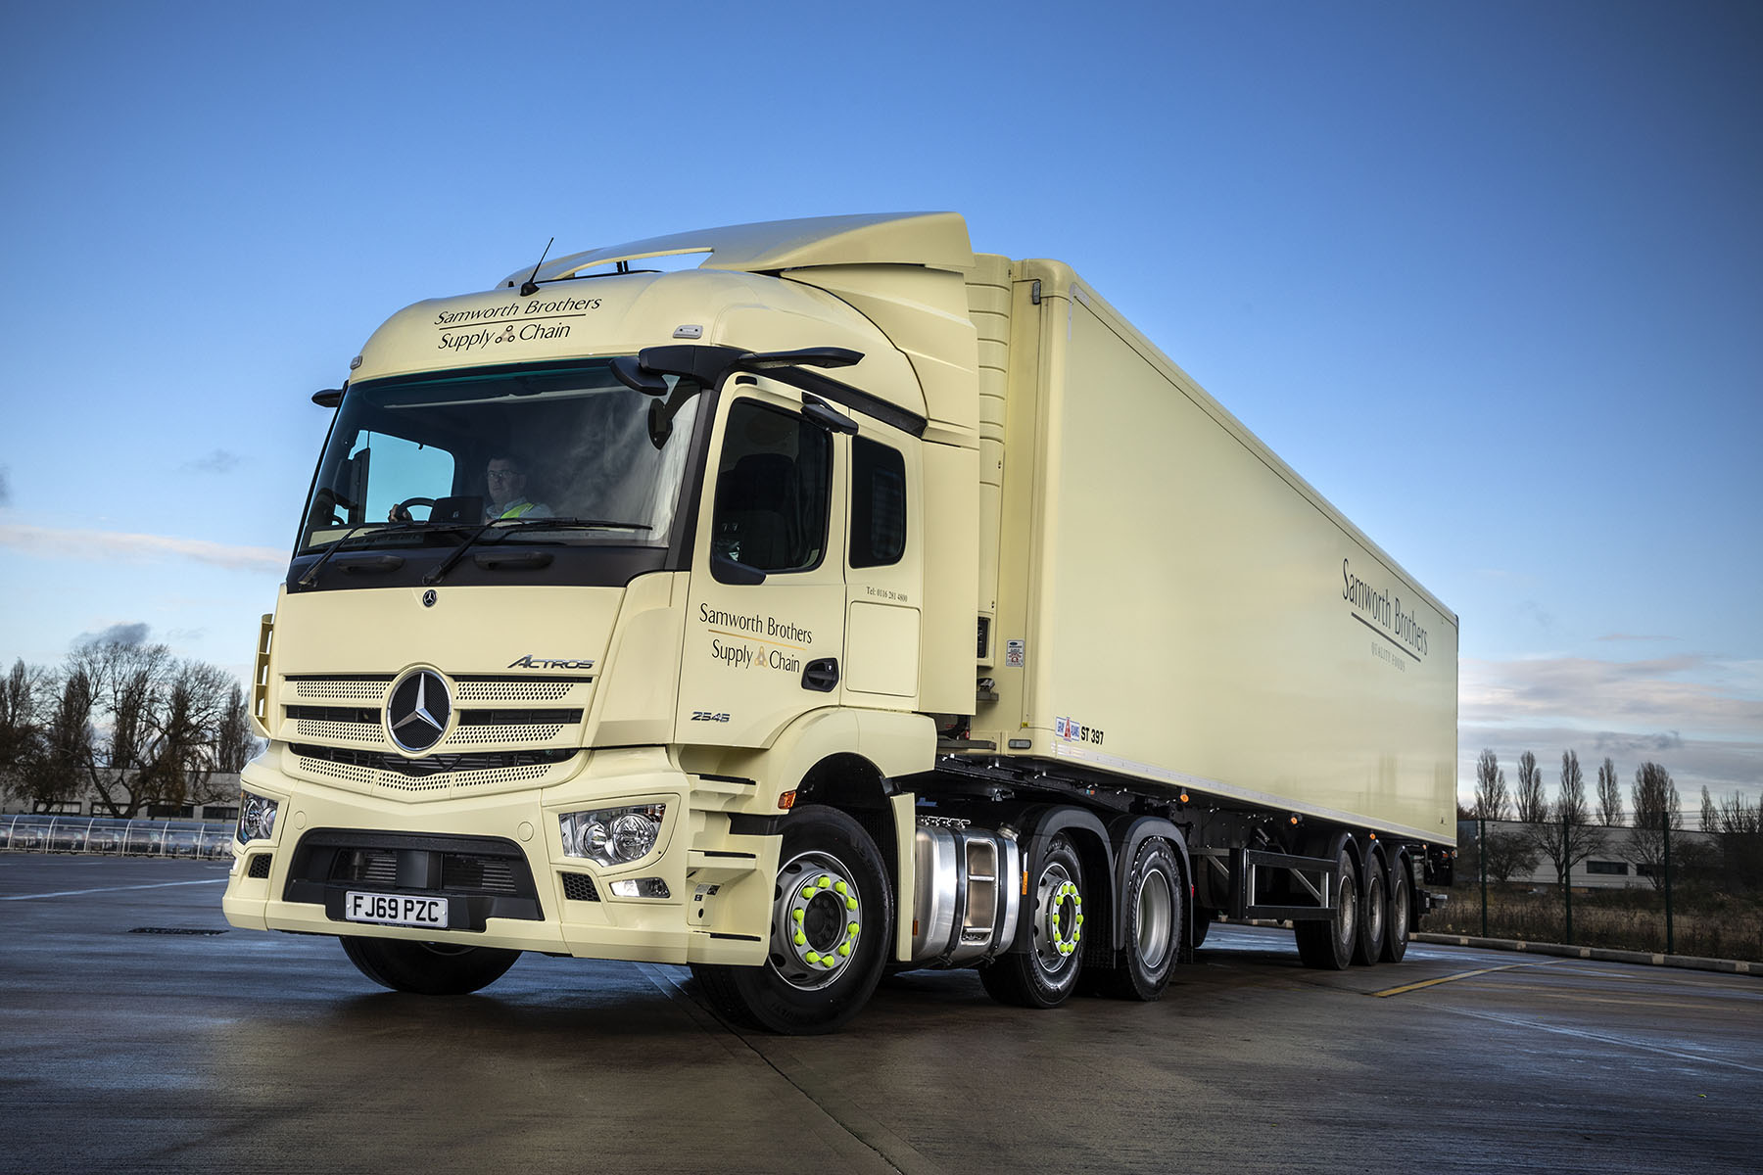

ends

For hi-res image files, please visit:
media.mbtrucks.co.uk

For further information, please contact:

Jamie Fretwell, PR & Internal Communications
Mercedes-Benz Trucks
07712 519230, Jamie.Fretwell@daimler.com

or

Steve Warren or John Ripley
Impact Communications, 01926 842126
Steve: 07770 470251, steve@impactcom.co.uk
John: 07771 484595, john@impactcom.co.uk

About Mercedes-Benz Trucks UK Ltd

Mercedes-Benz Trucks UK Ltd is the sales and marketing organisation responsible for all Mercedes-Benz truck products in the UK, including FUSO Canter.

In 2018, the company registered 8,061 new trucks. After growth in 2017, Mercedes-Benz registrations levelled off to 7,223 trucks in 2018, ensuring it retained its title as the second-biggest truck brand in the UK. Meanwhile, FUSO made great strides to reach 838 registrations – including 675 new trucks over 6.0-tonnes.

For more than 125 years, Mercedes-Benz has stood for innovative vehicles that meet exceptionally high standards of quality. Our claim to perfection, sustainability and avant-garde design is now embodied in the next generation of trucks: Actros, Arocs, Atego, Econic and Unimog.

www.mbtrucks.co.uk

