

Date: 7 December 2018

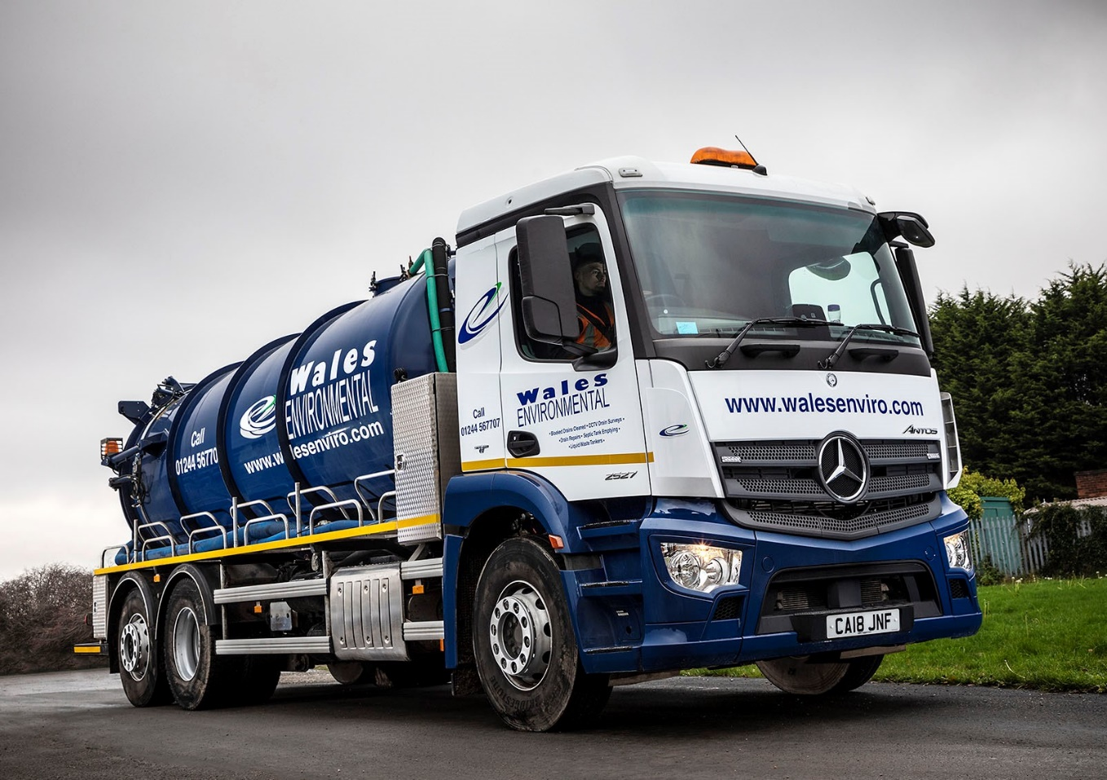

Cost savings flow after Wales Environmental switches to new Mercedes-Benz trucks

Wales Environmental Ltd’s new truck acquisition policy has marked the start of a partnership with Mercedes-Benz which is now delivering valuable fuel savings and slashing downtime.

The liquid waste management and drainage specialist was established in 1980 and, until recently, purchased only pre-owned trucks of various marques. Since it embarked on a strategy of buying new vehicles, however, every addition to the fleet has been a
Mercedes-Benz.

After delivering three Actros 2446 tractor units earlier this year, South Wales Dealer Euro Commercials has now supplied a 26-tonne Antos 2527 tanker. This vehicle is working from Wales Environmental’s depot in Bagillt, Flintshire, on the Dee estuary, in North Wales, and is assigned to a contract with Dŵr Cymru Welsh Water, which entails emptying waste water treatment plants at various sites across the region.

Powered by a 7.7-litre straight-six engine with 200 kW (272 hp) output, the rigid has a ClassicSpace M-cab and a body by Fuller Tankers, of Chepstow, with 3,000-gallon waste tank. A second tank carries up to 250 gallons of clean water for washing down and replenishing welfare units

Wales Environmental’s fleet of 70 vehicles also includes a 66-registered Mercedes-Benz Atego 13-tonner with jet-vac body, which is used to maintain drains. The company changed its acquisition policy in the hope that the price premium payable for new rather than used vehicles would be more than offset by savings from their increased fuel-efficiency, enhanced reliability, and reduced maintenance and repair costs. This has proved a wise decision.

Transport Manager John Jones revealed: “These are still early days, of course, but in terms of reliability our Mercedes-Benz trucks haven’t missed a beat. They are also highly economical. Each Actros is using £30-£40 worth of diesel less per day than our previous tractor units – a reduction in fuel consumption of this magnitude is worth a small fortune over the course of a year.”

The Actros have ClassicSpace L- sleeper cabs, 335 kW (455 hp) 10.7-litre engines and small-wheeled (17.5 in) mid-lift axles. Working with bulk tank trailers they also support the operator’s MoD contract, as well as undertaking other duties such as collecting whey – a by-product of the cheese-making process – from creameries, then delivering it to farms for injection onto the land as a fertiliser.

All four of Wales Environmental’s new Mercedes-Benz trucks are now being inspected and maintained under Complete Service Contracts. Two of the tractor units are based in the southern half of the country and the work is carried out at Euro Commercials’ Cardiff and Swansea branches.

“We’re very impressed with the Dealer’s customer-focused back-up,” confirmed John Jones. “One of our Actros operates from a depot at Templeton, Pembrokeshire, which is 50 miles from Swansea. When the vehicle is due in the workshop, as long as it’s back by 4pm, Euro provide a collection and delivery service.

“And if the driver gets delayed, he’ll take his Actros into Swansea, go home in one of the Dealer’s vans, then return first thing next morning to collect the truck. Either way, the work gets done overnight, so the vehicle is always available when we need it. It’s a first-class service.”

Mr Jones added: “Our strategy of buying new Mercedes-Benz trucks is working very well. These vehicles are popular with their drivers and look very smart. Image is important to us, and Mercedes-Benz is a brand we’re proud to be associated with.

“Given its reputation for quality, running vehicles with three-pointed stars on the front can only reinforce our own standing as a sector leader, committed to understanding each customer’s individual waste management requirements and providing efficient services, within budget, to meet those needs.”

www.walesenviro.com

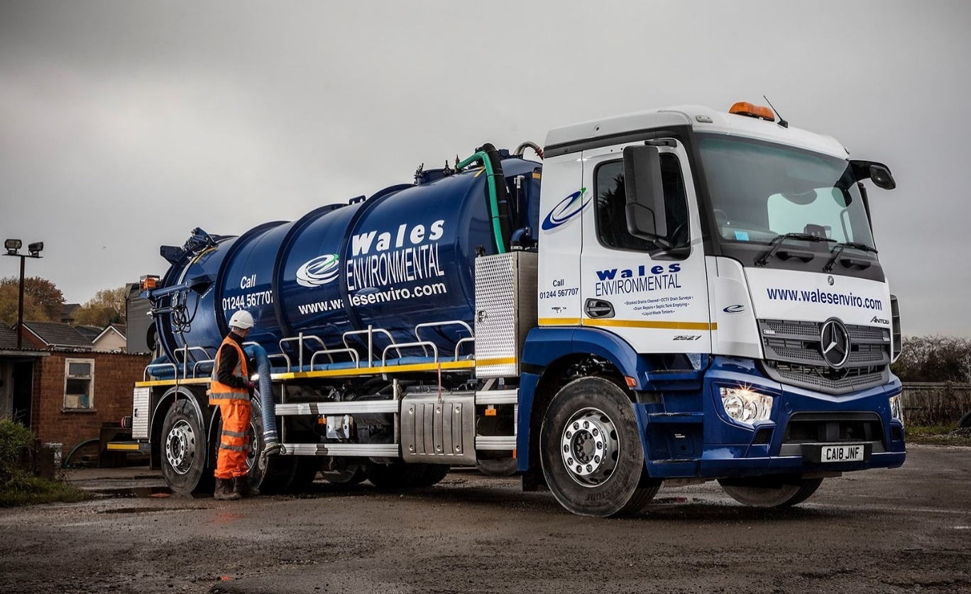

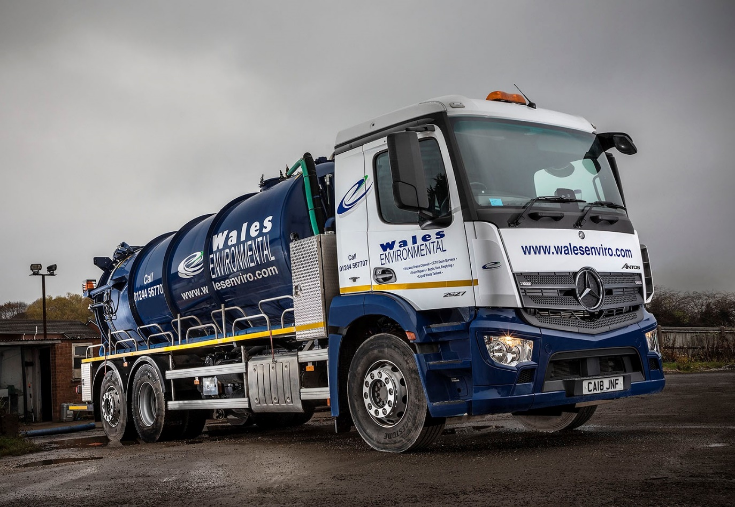

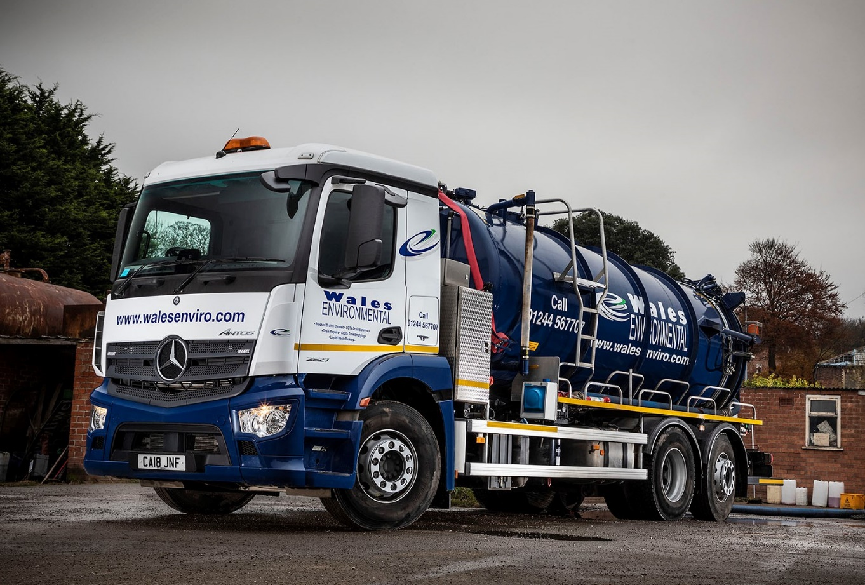

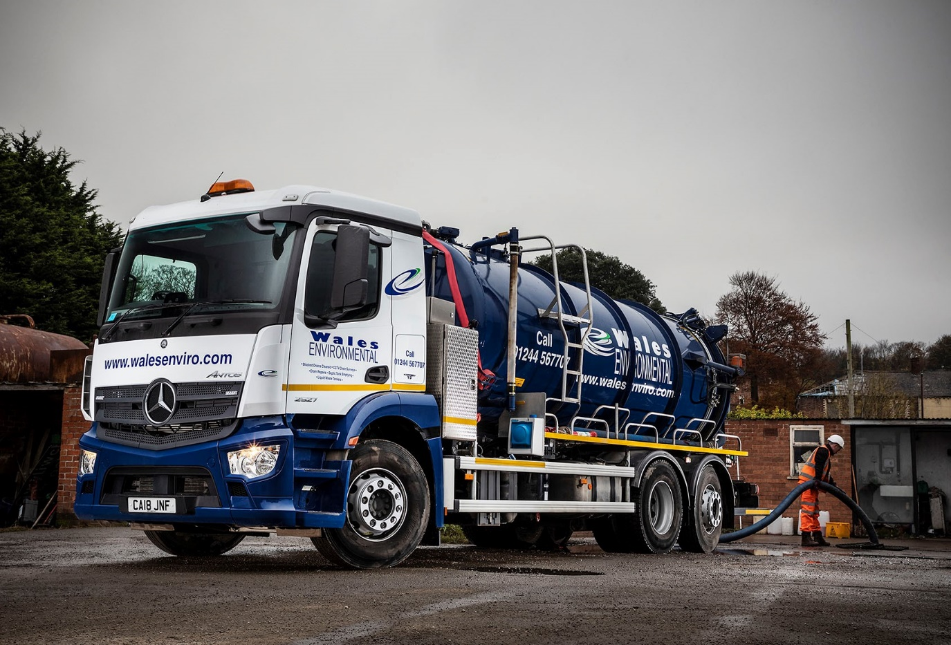

ends

For more information, or to request bigger versions of image files, please contact:
Steve Warren or John Ripley
Impact Communications
01926 842126
John: 07771 484595, john@impactcom.co.uk
Steve: 07770 470251, steve@impactcom.co.uk

