

Date: 15 July 2020

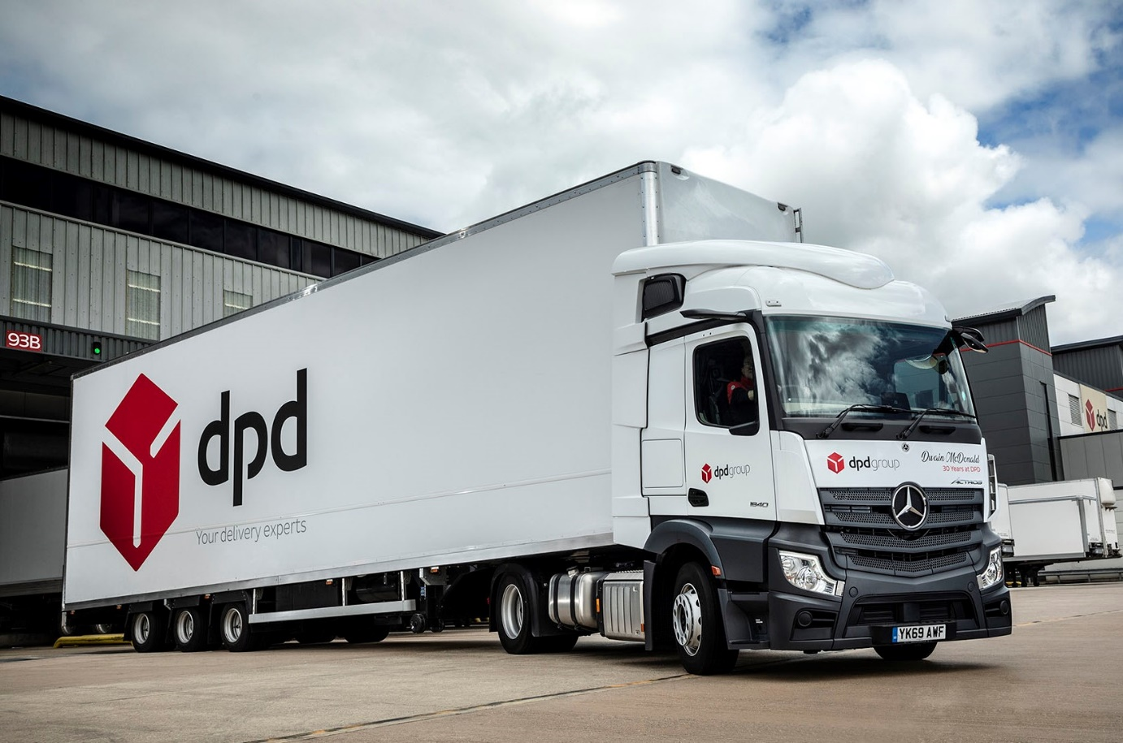

A winner on all fronts: With innovative technology such as the level 2 autonomous Active Drive Assist and MirrorCam contributing to increased safety, reduced operating costs and enhanced driver appeal, the new-generation Mercedes-Benz Actros adds up to the perfect package for DPD

DPD trebles its 2020 Mercedes-Benz Actros order to 150 units as online delivery demand continues to soar

So busy has DPD UK been since the start of the Covid-19 pandemic that shortly after confirming its 2020 requirement for 50 new Mercedes-Benz Actros tractor units the parcels delivery leader returned with an order for 100 more.

All will be 4x2 variants with ground-breaking Active Drive Assist technology. A committed innovator, DPD has been running 25 new-generation Actros featuring the first level 2 autonomous driving system to enter series production, since late last year.

Even before lockdown restrictions were announced in March, the public’s increasing reliance on internet shopping had resulted in soaring demand for DPD’s seven day a week, nationwide next-day delivery service. This trend shows no sign of slowing, as established online retail customers experience a sales boom, and new customers develop their own online propositions.

DPD has responded to the ‘new normal’ by announcing its intention to invest £200 million this year on expanding its next-day parcel capacity. Half of this sum is going towards new vehicles, with £60 million being spent on 15 new regional depots – 10 more than originally planned – and the remainder on technology. DPD is also creating 6,000 new jobs, 3,500 of them for HGV and delivery drivers.

Since DPD cannot easily rent the low-height tractor units it needs, over recent years it has kept trucks in storage then pressed them into service ahead of its peak period, the eight-week run-up to Christmas. That was not possible this year, though, as the surge in demand has meant every asset is working flat out.

DPD operates a ‘line haul’ fleet of approximately 1,150 tractor units, which pull double- and single-deck semi-trailers between four hubs in the West Midlands – a fifth is scheduled to open in Hinckley before the end of the year – as well as its network of depots and customer locations. All but a handful of these trucks are by Mercedes-Benz.

Half of the 50 Actros units commissioned by DPD towards the end of 2019 were from the new-generation range crowned International Truck of the Year 2020. In addition to Active Drive Assist they feature a host of other innovations such as MirrorCam cameras instead of conventional mirrors, the latest Active Brake Assist 5 emergency braking system, enhanced Predictive Powertrain Control technology for increased fuel efficiency, and the optionally upgraded Multimedia Cockpit, interactive version of Mercedes-Benz Trucks’ radical new dashboard, which replaces switchgear with two stylish and intuitive screens.

Following the introduction of a new staff recognition policy, these vehicles were also among the first to bear the names of DPD colleagues who have served the business for 25 years or more. CEO Dwain McDonald, whose own name appears on the front of one of the trucks, has achieved the 30-year milestone.

DPD’s original 2020 order was for 80 trucks – as well as the 50 Actros, it is also adding another 30 Atego 816 7.5-tonners with curtainside bodies by Bevan Group to its network fleet. All of these vehicles, plus the 100 Actros it then added, are scheduled for delivery by Dealer Northside Truck & Van in September and October.

Like those supplied last year, the tractors will all be low-frame height Actros 1840 LS nR models with 2.3m StreamSpace cabs (the narrower of the two widths available) and 10.7-litre in-line six-cylinder engines producing 290 kW (394 hp). Plated for operation at 38 tonnes GCW, they will also be fitted with dual-height fifth wheels.

Commenting on the introduction of its first new-generation Actros, Head of Transport Dave Winchcombe said: “DPD is a very innovative company, and well known for its commitment to new technology. We therefore welcomed the opportunity at this very early stage, to introduce level 2 autonomy to our fleet.

“We talk to our drivers all the time, and they’re very enthusiastic about the new features on these vehicles. MirrorCam gets a particularly big ‘thumbs up’ for the much-improved rear-facing visibility it provides – they love the fact that you can set the camera to the back of the trailer – and because by replacing mirrors it’s eliminated some major blind spots.

“They also think the Actros looks fantastic. With aids like Active Drive Assist and new Predictive Powertrain Control, it’s a very simple truck to drive nowadays. From the company’s point of view, meanwhile, being able to offer a state-of-the-art vehicle like this helps us to attract new drivers to our business. That’s a very big plus, given the scale of the recruitment campaign in which we’re now engaged.”

Currently available as an option on 4x2 and 6x2 tag axle Actros tractor and rigid models, Active Drive Assist manages the vehicle’s speed to keep it a safe distance from traffic ahead, and steers it to keep its position in the centre of the lane. The driver always retains overall control, though, and must keep hands on the steering wheel at all times – if sensors in the steering column or seat detect a lack of human interaction, an audible alert will sound, and the system will disengage after a minute of inactivity.

Active Drive Assist encourages a more relaxed and fuel-efficient driving style, thereby increasing safety. A study by Mercedes-Benz Trucks parent Daimler Trucks concluded that highly automated driving technologies such as Active Drive Assist can reduce sleepiness in drivers by as much as 25%.

The growth in e-commerce has helped DPD to become one of the fastest growing major companies in the UK over the last 10 years, but its association with Mercedes-Benz goes back more than a quarter of a century.

“We have a very good, long-standing and professional relationship with Mercedes-Benz Trucks,” confirmed Dave Winchcombe. “Key Account Manager James Venables provides excellent support on a day-to-day basis, while we also speak regularly to Managing Director Mike Belk and Sales Director Sam Whittaker.”

He continued: “As well as being popular with our drivers and leading the field in terms of innovation – we were also one of the first customers for the Safety Pack introduced by Mercedes-Benz a few years ago – the Actros is highly reliable and fuel-efficient.

“We also benefit from first class aftersales back-up. On the line haul fleet, this is restricted to warranty work, parts deliveries and emergency breakdown support, as our factory-trained technicians maintain the tractors in our own workshops. Most of the Atego delivery vehicles that work from our depots, however, are also serviced by members of the manufacturer’s Dealer network.”

Added Mr Winchcombe: “Ultimately, there’s no one single factor that explains why we continue to invest so heavily in the Mercedes-Benz Actros. Instead, the truck’s many attributes, coupled with industry-leading support, combine to make it a great all-round package.”
www.dpd.co.uk

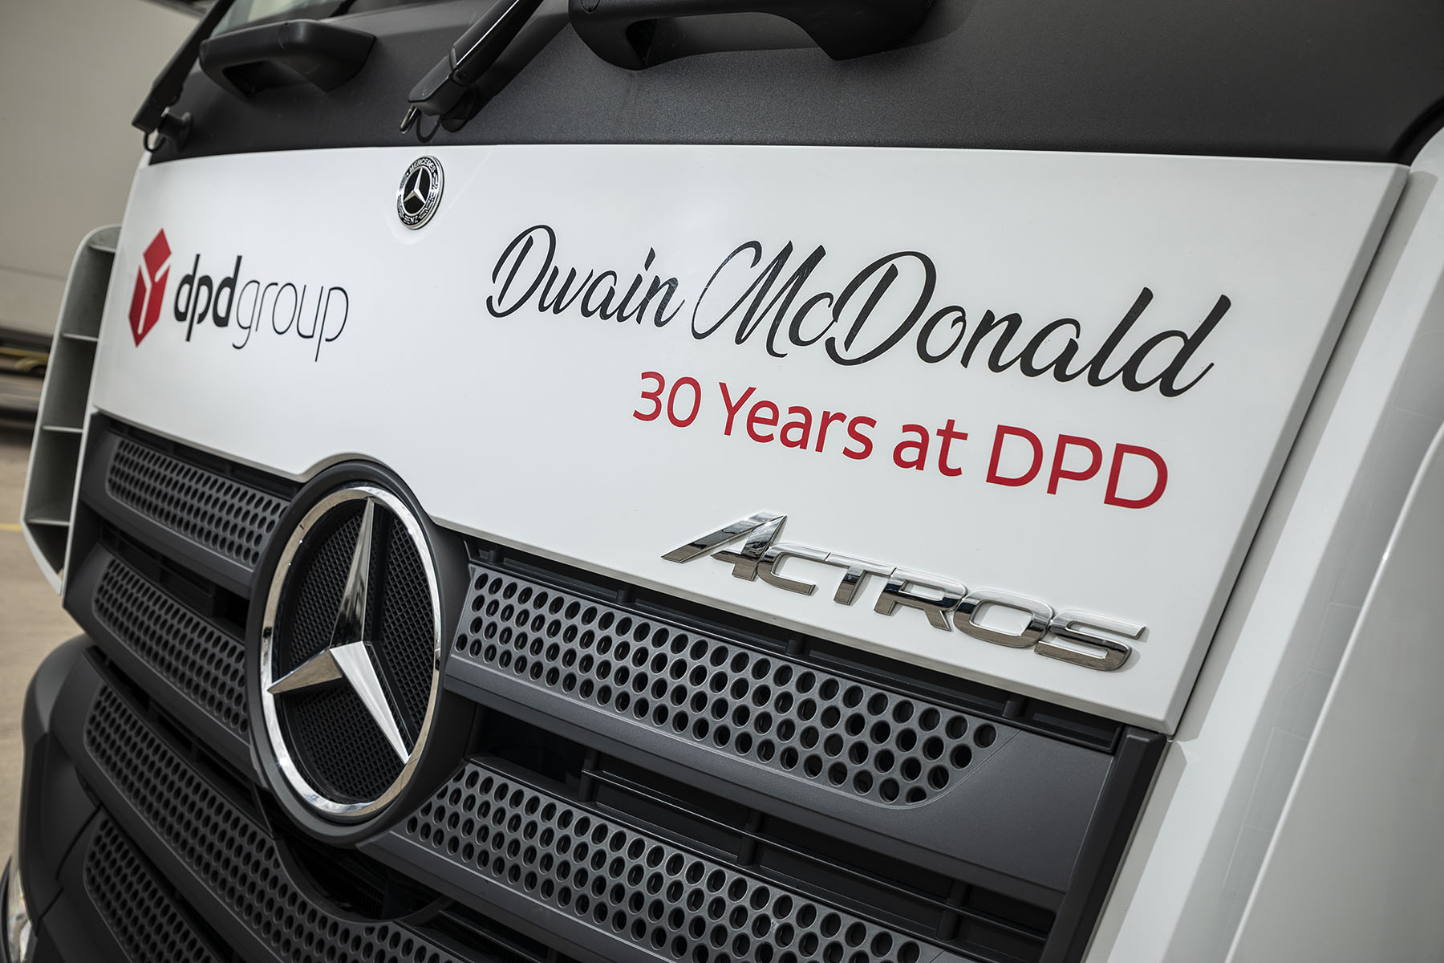

Loyalty bonus: In line with DPD’s new policy of recognising long servers on its trucks, one of the company’s latest Actros bears the name of CEO Dwain McDonald

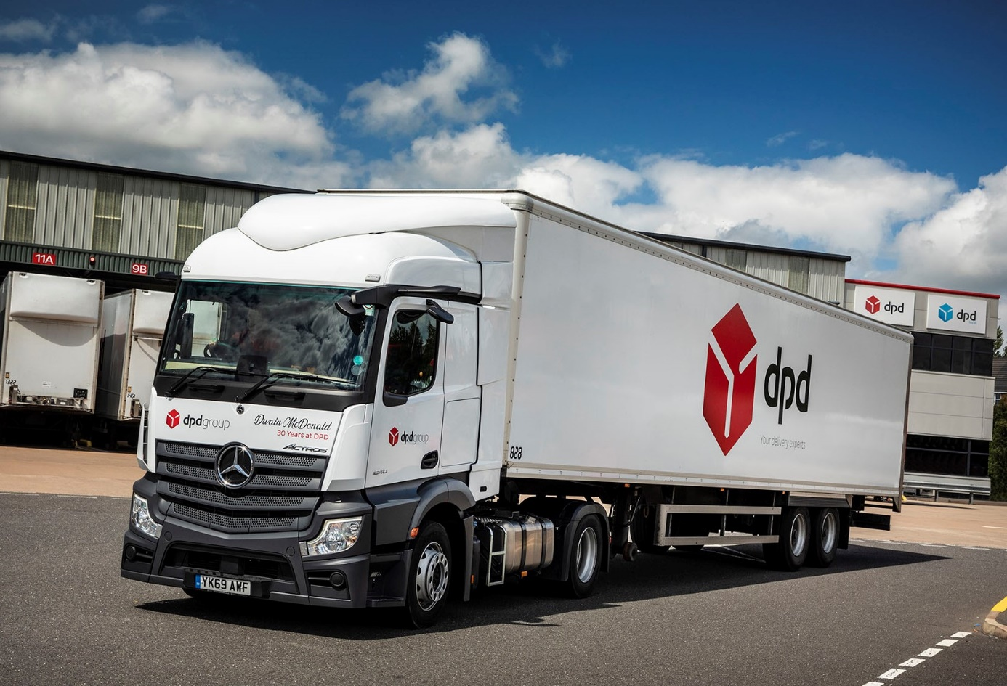

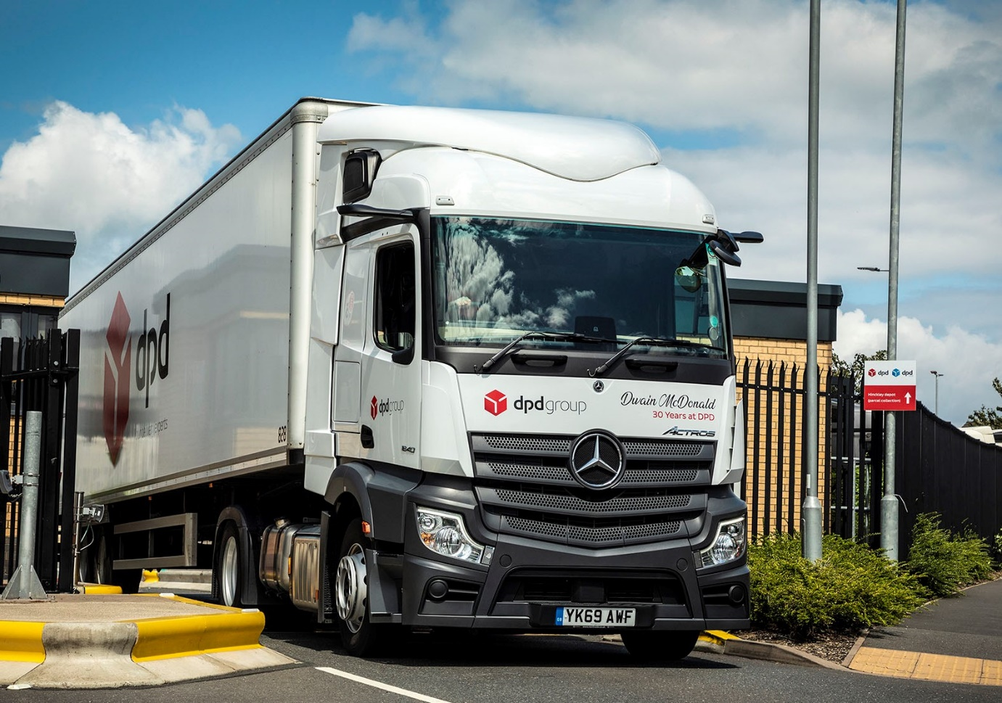

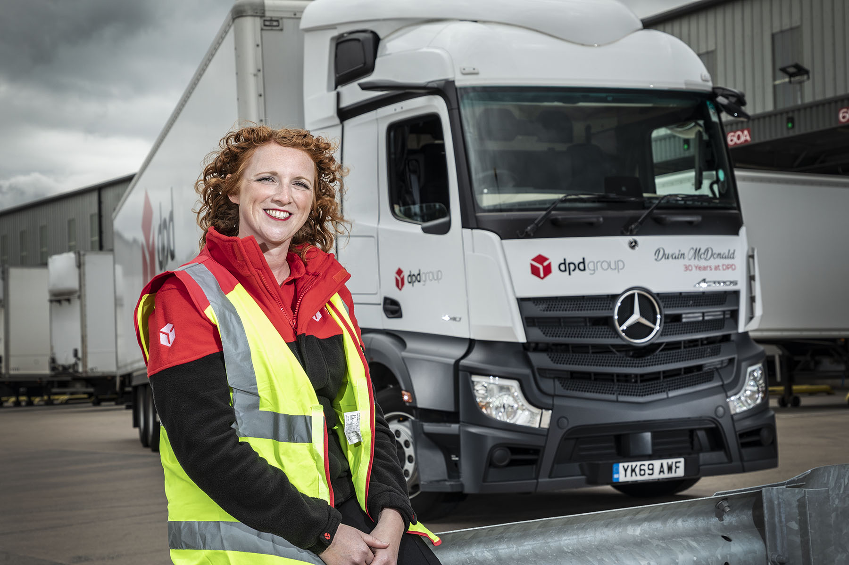

Prioritising safety: Road Safety & Partnership Manager Ashlee Clark is pictured at DPD UK’s Hinckley hub – the company will open a second in the same town later this year

ends

For more information, or to request higher-res image files, please contact:

Jamie Fretwell at Mercedes-Benz Trucks UK Ltd
07712 519230, jamie.fretwell@daimler.com

or

Steve Warren or John Ripley
Impact Communications, 01926 842126
Steve: 07770 470251, steve@impactcom.co.uk
John: 07771 484595, john@impactcom.co.uk

About Mercedes-Benz Trucks UK Ltd
Mercedes-Benz Trucks UK Ltd is the sales and marketing organisation responsible for all Daimler truck products in the UK, including FUSO Canter. In 2019, the company registered 6,963 new trucks.

Mercedes-Benz accounted for 6,188 new trucks registered in 2019, making it the third-biggest truck brand in the UK. Meanwhile, FUSO registrations hit 775 – including 580 new trucks over 6.0-tonnes.

The flagship new Mercedes-Benz Actros which won the 2020 International Truck of the Year award, features seven core innovations including MirrorCam, Multimedia Cockpit and Active Brake Assist 5.

Our premium range of innovative trucks – Actros, Arocs, Atego, Econic and Unimog – draw upon more than 125 years of exceptionally high standards of quality, backed up by our promise of Trucks You Can Trust.

www.mbtrucks.co.uk

