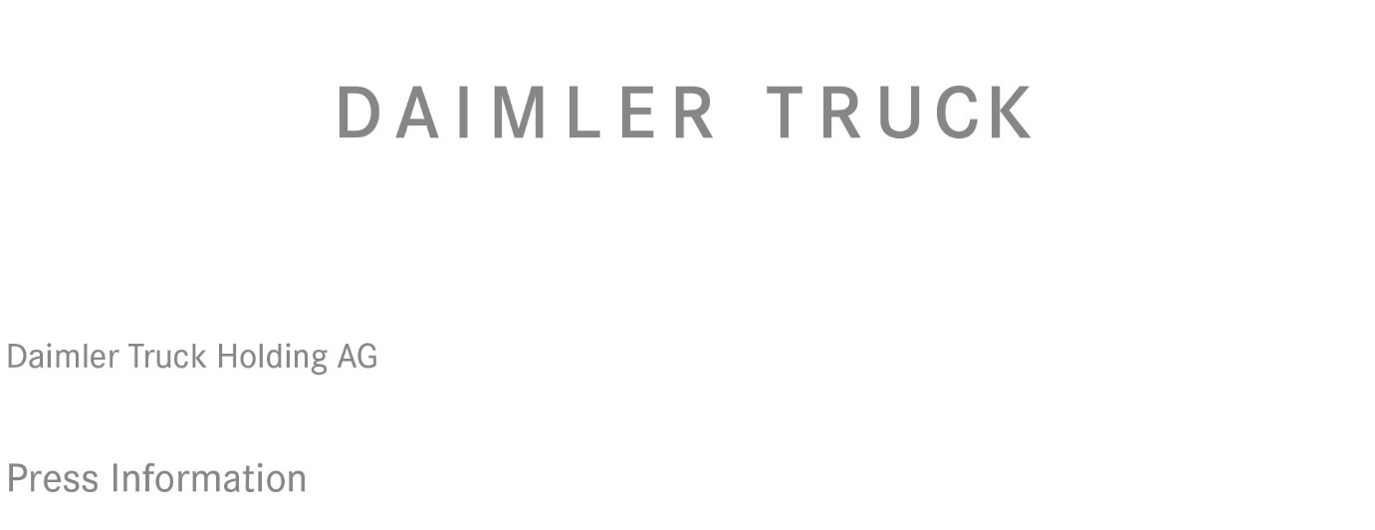

Date: 10 December 2021

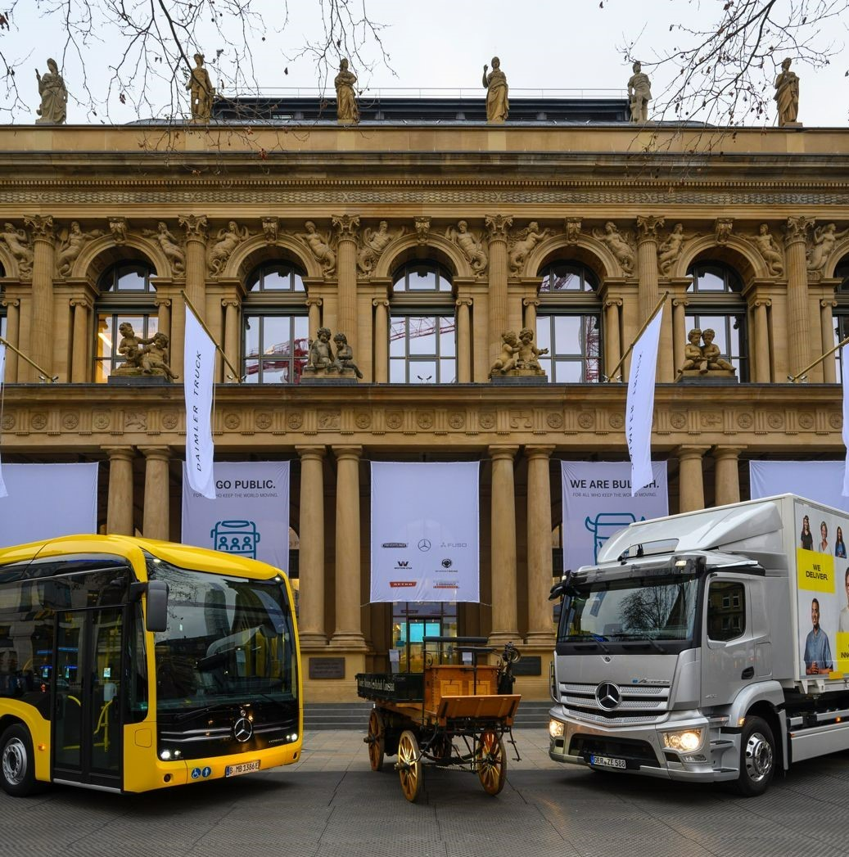

A glorious past and a future of endless possibilities: A replica of the world’s first truck, which was unveiled by Gottlieb Daimler 125 years ago, was presented alongside fully electric eActros and eCitaro models outside the Frankfurt Stock Exchange, to mark Daimler Truck’s first day of trading

Daimler Truck launched on stock exchange as an independent company

- First trading day for Daimler Truck Holding AG (‘Daimler Truck’) on the Frankfurt Stock Exchange, stock exchange symbol DTG, WKN number DTR0CK

- Daimler Truck takes the path of unrestricted entrepreneurial independence

- Investors can now invest in one of the world’s largest commercial vehicle manufacturers

- Daimler Truck’s ambition is to increase the performance and profitability of its business segments and to master the transformation towards CO2-neutral transport

- DAX qualification expected for Q1 2022

Stuttgart/Frankfurt – Today’s first day of trading on the Frankfurt Stock Exchange marks the start of a new era for Daimler Truck. Following the spin-off from Daimler AG, today’s first day of listing symbolises Daimler Truck’s embarkment into unrestricted entrepreneurial independence. This is probably the most important milestone in the company’s history. In future, investors will have the opportunity to invest directly in the shares of one of the world’s largest commercial vehicle manufacturers. Daimler Truck considers itself well positioned for the new era of independence. In preparation for the spin-off, the company has specified its financial ambitions to increase the performance and profitability of the segments. Daimler Truck is consistently and continuously focusing on improving profitability in order to lead the industry on the road to CO₂-neutral transport. Based on its proven cash generation and strong balance sheet, Daimler Truck has received solid investment grade credit ratings. Daimler Truck expects its shares to be listed in the Regulated Market of the Frankfurt Stock Exchange in the DAX index, which has been expanded to 40 members, at the next possible date – probably in the first quarter of 2022.

“Today is a historic one for Daimler Truck,” said Martin Daum, Chairman of the Board of Management of Daimler Truck Holding AG in the stock exchange hall in Frankfurt. “For 125 years, our truck and bus business was part of the Daimler Group – now we are becoming an independent, listed company. Making this possible organizationally was a tour de force. My thanks therefore go to our entire team for their unparalleled commitment over the past weeks and months. So in this respect, today is a finish line for us. We have worked hard to get there. However, this 10th of December 2021 is above all the exact opposite, namely a starting line. Because now things are really getting started for Daimler Truck. Now we are looking ahead with courage and confidence. Now we look forward to using creative opportunities as an independent company with our great global team, for even more entrepreneurial success in the future. Everyone should benefit from this: our workforce, our customers and, of course, our shareholders.”

Ola Källenius, Chairman of the Board of Management of Daimler AG and Mercedes-Benz AG, said: “Today marks the beginning of a new era for us. We are fully focused on building the world’s most desirable cars and leading the way in electromobility and vehicle software. At the same time, the listing of Daimler Truck turns one success story into two. The historic reorganisation to two ‘pure-play’ companies is intended to unleash the full potential of both and create decisive added value for all sides. We wish Daimler Truck a successful future and look forward to the beginning of a new era with confidence.”

Jochen Goetz, CFO of Daimler Truck Holding AG, said: “Daimler Truck is also financially in a very good starting position for our entrepreneurial independence. Our balance sheet is rock solid and we have already proven in the past how reliably we can generate an attractive cash flow. We are now putting all our energy into fully exploiting our earnings potential and driving forward the transformation to emission-free transport in a focused manner. We want to create sustainable value for our investors as well.”

Leading company in the transport industry – for 125 years

The founders of Daimler Truck started the modern transportation industry with their trucks and buses 125 years ago. Today, the company is one of the largest commercial vehicle manufacturers with a global reach, with over 40 production facilities worldwide and more than 100,000 employees. Daimler Truck unites seven brands under its umbrella: BharatBenz, Freightliner, FUSO, Mercedes-Benz, Setra, Thomas Built Buses and Western Star. The company aims to make sustainable transport a success, with strong technological expertise and a view to the needs of its customers.

To this end, Daimler Truck aims to achieve a double-digit return on sales in its industrial business by 2025, assuming strong market conditions. Daimler Truck’s business activities are structured into five reporting segments for which the company has formulated concrete return targets for strong market conditions. For example, Daimler Truck is specifically targeting an adjusted return on sales of 12% for the Trucks North America (TN) segment in the event of strong market conditions. For the Mercedes-Benz (MB) segment, the target is 10% adjusted return on sales, for the Trucks Asia (TA) segment 9% and for the Daimler Buses (DB) segment 7.5%. With the new Financial Services business of Daimler Truck (DTFS) as a fifth segment, the company is targeting an adjusted return on equity of 14%.

As Daimler Truck announced at its Capital Markets Day in November, the focus on increasing profitability is having an incremental effect already. In line with this, the company expects an adjusted return on sales (RoS) in the industrial business of between 6% and 8% for 2021 – despite semiconductor shortages and rising raw material prices. Based on the progress already made, Daimler Truck expects to achieve the 15% reduction in fixed costs in its industrial business (compared to 2019) as early as 2023, two years earlier than announced at the Strategy Day in May 2021. For 2022, the company expects an adjusted return on sales of the industrial business between 7% and 9%. The investment grade ratings of the rating agencies in October were correspondingly positive. S&P Global Ratings awarded a first issuer rating of BBB+ (outlook stable), Moody’s a first issuer rating of A3 (outlook stable).

Leading the industry in sustainable transport development

As a listed company, Daimler Truck intends to lead the way to zero-emission transportation by being even more focused and agile in the future. The development of battery and fuel-cell vehicles is to be accelerated – under its own steam and with strategically sensible partnerships. For example, battery and fuel cell vehicles are to account for up to 60% of Daimler Truck sales by 2030. From 2039, the company wants to offer only vehicles in the Triad that are CO₂-neutral in driving operation. For Daimler Truck, both technologies are compatible and necessary. Purely battery-powered trucks are used in light and heavy distribution transport, for example when it comes to delivering goods in cities. The hydrogen-based fuel cell drive will be indispensable in the CO₂-neutral long-distance truck transport of the future.

Daimler Truck shares are traded on the Regulated Market (Prime Standard) of the Frankfurt Stock Exchange under the stock symbol DTG. The International Securities Identification Number (ISIN) is DE000DTR0CK8, the German Securities Identification Number (WKN) DTR0CK.

ends

For more information, please contact:

Jamie Fretwell at Mercedes-Benz Trucks UK Ltd
07712 519230, jamie.fretwell@daimler.com

or

Uta Leitner, +49 160 863 46 68, uta.leitner@daimler.com
Florian Laudan, +49 176 309 308 78, florian.laudan@daimler.com
Maximilian Splittgerber, +49 160 860 71 24, maximilian.splittgerber@daimler.com

Further information on Daimler Truck is available at:
www.media.daimlertruck.com and www.daimlertruck.com

Advertisement
This communication is an advertisement for the purposes of the prospectus regulation EU 2017/1129 (“Prospectus Regulation”) and underlying legislation. It is not a prospectus. The admission of the shares of Daimler Truck Holding AG to trading on the regulated market (Regulierter Markt) of the Frankfurt Stock Exchange (Frankfurter Wertpapierbörse) is subject to the publication of a prospectus. The prospectus is expected to be approved by the German Federal Financial Supervisory Authority (Bundesanstalt für Finanzdienstleistungsaufsicht – “BaFin”) in accordance with the Prospectus Regulation regime. However, the approval of the prospectus by BaFin should not be understood as an endorsement of the shares of Daimler Truck Holding AG. Investors should purchase shares solely on the basis of the prospectus relating to the shares and should read the prospectus before making an investment decision in order to fully understand the potential risks and rewards associated with the decision to invest in the shares. The prospectus will, following approval of BaFin, be available on Daimler Truck Holding AG’s website (www.daimler-truck.com).

Forward-looking statements:
This document contains forward-looking statements that reflect our current views about future events. The words “anticipate,” “assume,” “believe,” “estimate,” “expect,” “intend,” “may,” ”can,” “could,” “plan,” “project,” “should” and similar expressions are used to identify forward-looking statements. These statements are subject to many risks and uncertainties, including an adverse development of global economic conditions, in particular a decline of demand in our most important markets; a deterioration of our refinancing possibilities on the credit and financial markets; events of force majeure including natural disasters, pandemics, acts of terrorism, political unrest, armed conflicts, industrial accidents and their effects on our sales, purchasing, production or financial services activities; changes in currency exchange rates, customs and foreign trade provisions; a shift in consumer preferences towards smaller, lower-margin vehicles; a possible lack of acceptance of our products or services which limits our ability to achieve prices and adequately utilize our production capacities; price increases for fuel or raw materials; disruption of production due to shortages of materials, labor strikes or supplier insolvencies; a decline in resale prices of used vehicles; the effective implementation of cost-reduction and efficiency-optimization measures; the business outlook for companies in which we hold a significant equity interest; the successful implementation of strategic cooperations and joint ventures; changes in laws, regulations and government policies, particularly those relating to vehicle emissions, fuel economy and safety; the resolution of pending government investigations or of investigations requested by governments and the conclusion of pending or threatened future legal proceedings; and other risks and uncertainties, some of which are described under the heading “Risk and Opportunity Report” in this Annual Report. If any of these risks and uncertainties materializes or if the assumptions underlying any of our forward-looking statements prove to be incorrect, the actual results may be materially different from those we express or imply by such statements. We do not intend or assume any obligation to update these forward-looking statements since they are based solely on the circumstances at the date of publication.

Daimler Truck at a glance
Daimler Truck Holding AG ("Daimler Truck") is one of the world's largest commercial vehicle manufacturers, with over 40 main locations and more than 100,000 employees around the globe. The founders of Daimler Truck have invented the modern transportation industry with their trucks and buses a good 125 years ago. Unchanged to this day, the company's aspirations are dedicated to one purpose: Daimler Truck works for all who keep the world moving. Its customers enable people to be mobile and get goods to their destinations reliably, on time, and safely. Daimler Truck provides the technologies, products, and services for them to do so. This also applies to the transformation to CO2-neutral driving. The company is striving to make sustainable transport a success, with profound technological knowledge and a clear view of its customers' needs. Daimler Truck's business activities are structured in five reporting segments: Trucks North America (TN) with the truck brands Freightliner and Western Star and the school bus brand Thomas Built Buses. Trucks Asia (TA) with the FUSO and BharatBenz commercial vehicle brands. Mercedes-Benz (MB) with the truck brand of the same name. Daimler Buses (DB) with the Mercedes-Benz and Setra bus brands. Daimler Truck's new Financial Services business (DTFS) constitutes the fifth segment, the product range in the truck segments includes light, medium and heavy trucks for long-distance, distribution and construction traffic and special-purpose vehicles used mainly in the municipal and vocational sector. The product range of the bus segment includes city buses, school buses and intercity buses, coaches and bus chassis. In addition to the sale of new and used commercial vehicles, the company also offers aftersales services and connectivity solutions. In 2020, approximately 378,500 trucks and buses were delivered.

