

Date: 20 December 2018

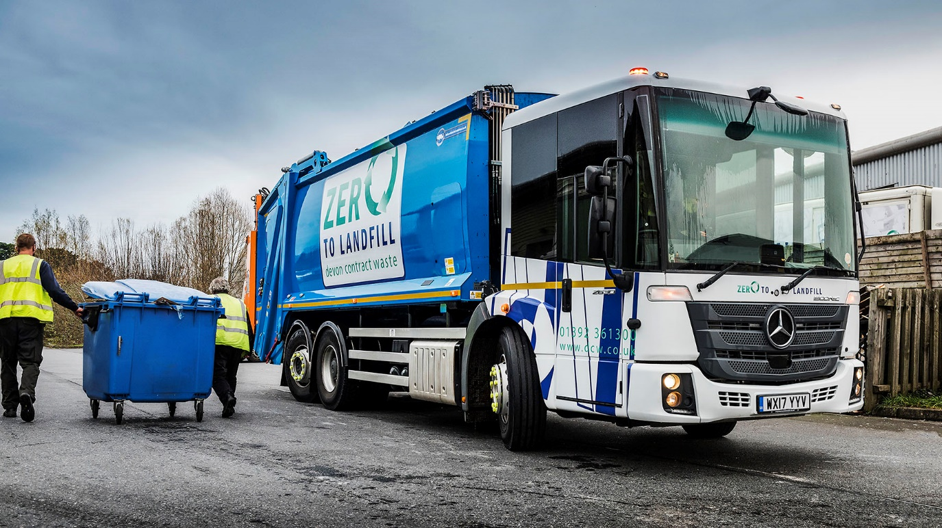

Devon Contract Waste goes for growth with RVS-supplied Mercedes-Benz Econic from City West Commercials

Devon Contract Waste has turned once again to Refuse Vehicle Solutions and City West Commercials for the new Mercedes-Benz Econic that will support another major expansion of its business.

Having already achieved significant growth over the past three years, the Exeter-based operator is preparing to launch its commercial waste collection services to customers across Cornwall, while continuing to serve those in its home county.

Like its first low-entry Econic, which has been in service since 2017, the truck that Devon Contract Waste now has on order will be a 6x2 2630L model with rear-steer axle, 220 kW (299 hp) engine, and fully automatic, six-speed Allison transmission.

Devon Contract Waste, which also runs five 26-tonne Mercedes-Benz Antos with compactor and hook-loader bodies, this year celebrated its 30th anniversary. Fully focused on recycling –it is proud of its ‘Zero to Landfill’ policy – the company offers a range of flexible collection services covering all sorts of refuse, from paper, glass and plastic, to confidential, clinical and hazardous waste.

As with the operator’s other Mercedes-Benz Econic, the new truck will be supplied by specialist provider Refuse Vehicle Solutions. RVS purchases chassis from City West Commercials, then fits them with bodywork and ancillaries, including on-board weighing equipment and all-round cameras, before delivering the finished vehicles to its customer.

Every Mercedes-Benz Econic comes with a comprehensive three-year warranty as standard. Devon Contract Waste’s latest truck will be inspected and maintained by City West Commercials under a seven-year Mercedes-Benz Complete Service Contract. The Dealer, which represents the three-pointed star in the South West, recently opened a purpose-built workshop in Exeter, Devon, and also has a branch in Roche, Cornwall.

“This arrangement makes perfect sense for us,” said Managing Director Simon Almond. “The rates are competitive, and the standards of workmanship and customer service we receive from City West Commercials are of the highest order.

“Most importantly, though, the fact that we know exactly what our maintenance costs are going to be in the future means we can plan ahead with confidence. This has certainly helped us to expand our business, as it’s given us the peace of mind which comes from knowing there are no nasty surprises around the corner.”

Mr Almond continued: “We’re looking forward to launching our push into Cornwall and are already planning ahead for further fleet acquisitions as demand for our services grows.”

RVS operates from a production facility at Cam & Dursley, near Stroud. Although the trucks supplied to Devon Contract Waste were new, its business also entails purchasing, refurbishing and in some cases modifying, then retailing pre-owned refuse vehicles – all are subjected to rigorous quality checks and services, and supplied with 12-month MoTs.

Managing Director Spencer Law commented: “We’ve been buying Mercedes-Benz chassis since 2005, and have developed an excellent relationship with City West Commercials, whose team provide regular assistance from an engineering perspective.”

dcw.co.uk
refusevehiclesolutions.co.uk

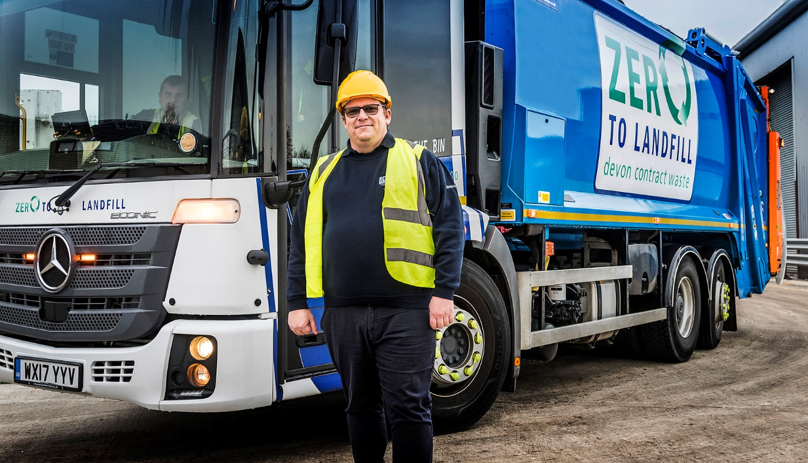

Going for growth: Transport Manager Richard Smith, with Devon Contract Waste’s first Mercedes-Benz Econic

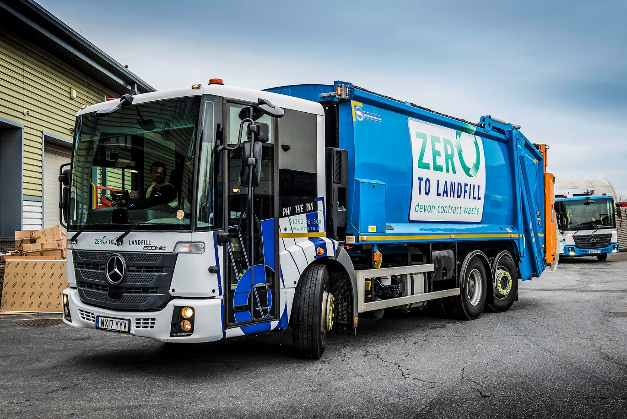

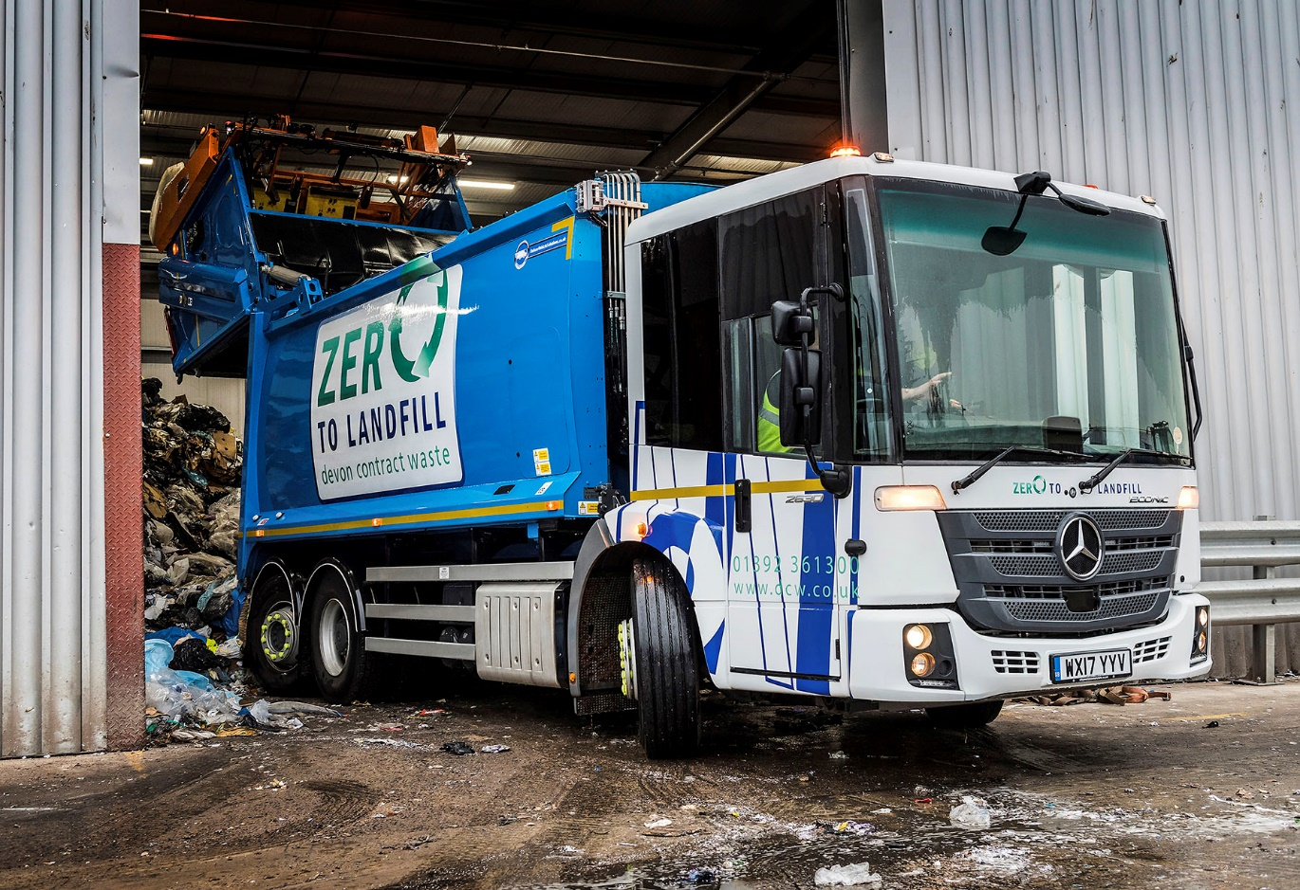

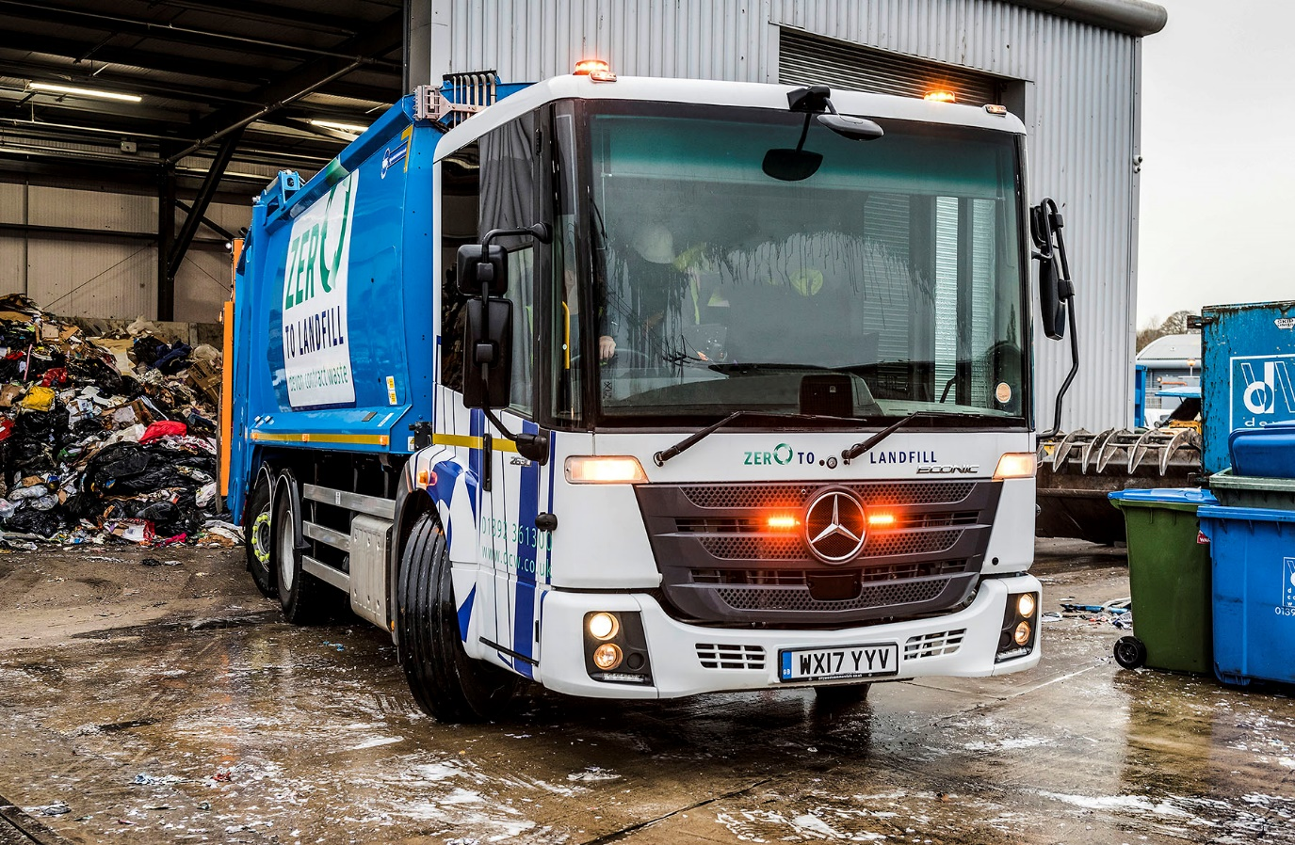

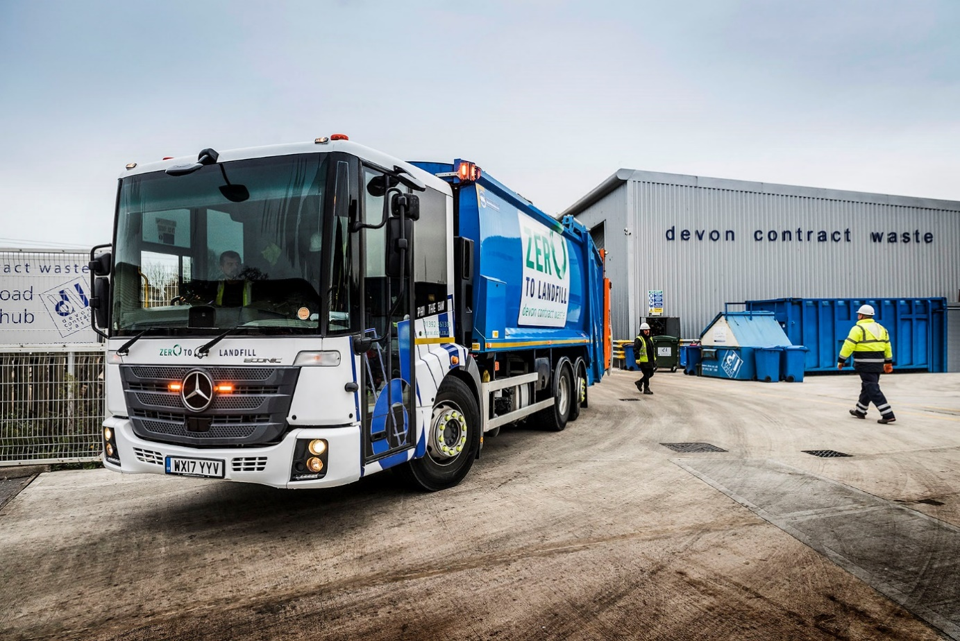

ends

For more information, or to request bigger/higher-res image files, please contact:
John Ripley or Steve Warren
Impact Communications, 01926 842126
John: 07771 484595, john@impactcom.co.uk
Steve: 07770 470251, steve@impactcom.co.uk

