

Date: 26 July 2021

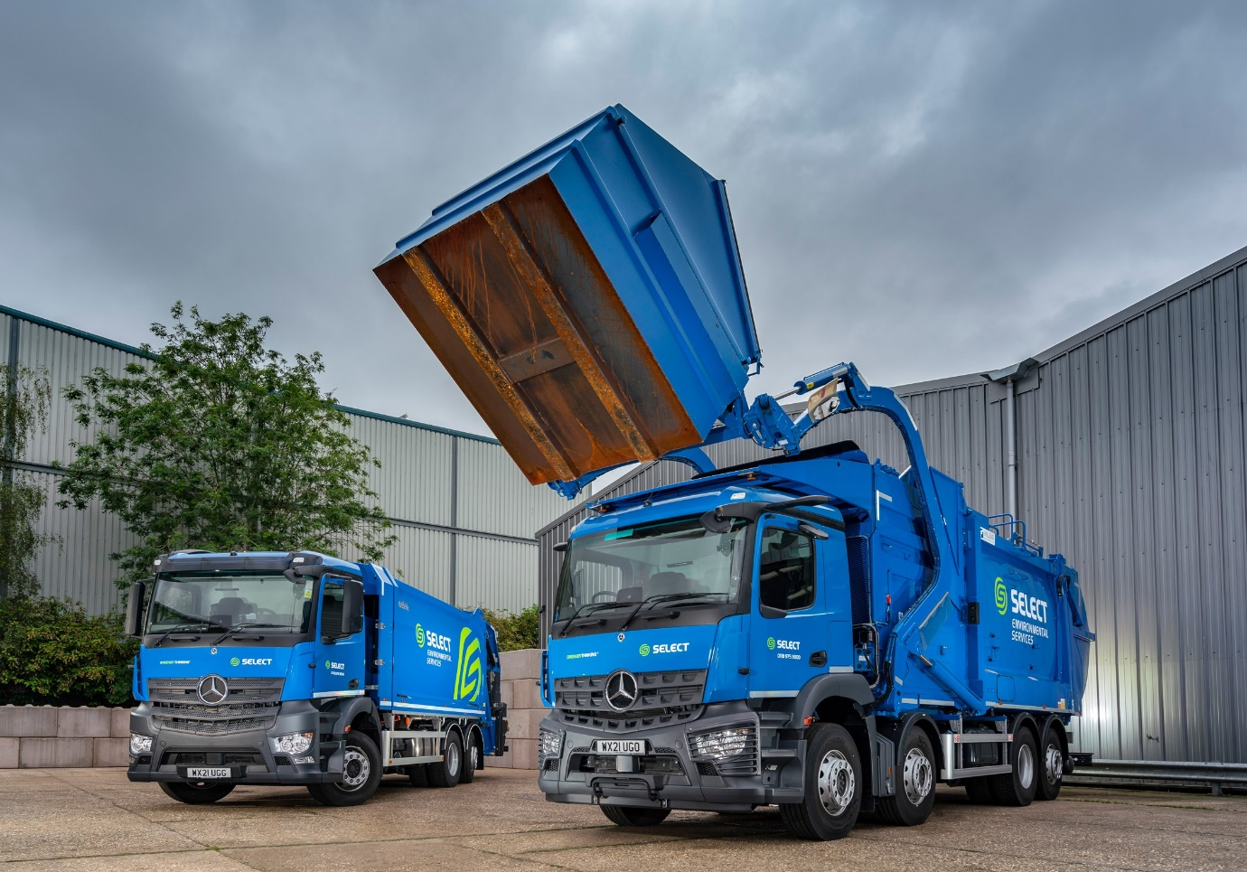

Top universities’ recycling and waste management supplier lands a ‘double first’ with 8x2 Arocs from Mercedes-Benz Dealer City West Commercials

Technology-led independent waste management specialist Select Environmental Services has added the first front-end loader to a fleet dominated by Mercedes-Benz. The 32-tonne Arocs is also its first truck to be fitted with the manufacturer’s ground-breaking MirrorCam system.

The muscular eight-wheeler arrived, together with a 6x2 Actros that has a lithium-powered compaction body, via City West Commercials, an established supplier to the Reading-based operator.

Family-owned Select provides bespoke recycling, waste management and confidential shredding services across the Thames Valley to the commercial and healthcare sectors, and educational establishments including the Universities of Oxford and Reading.

The company recently invested £3 million in a new Materials Recovery Facility and purchased the front-end loader to extend its recycling collection capabilities. The Arocs has joined a fleet of 30 trucks, the majority of which wear three-pointed stars, and five vans.

Over the last five years dedicated Mercedes-Benz Truck Dealer City West Commercials has also supplied Select with four 18-tonne Arocs skip-loaders and a pair of 26-tonne Antos refuse compaction vehicles.

Select’s Managing Director, Philip Stone, explained: “We have an excellent rapport with the team at City West Commercials. Their pricing is always competitive, but more importantly it’s their experience and expertise of the recycling and waste management sector that really matters.
“Putting together a refuse compaction vehicle is a great deal more complex than your average 18-tonne box truck or curtainsider. There’s the chassis supplier, the bodybuilder, occasionally a third-party bin lifter and then all the container weighing and RFID technology to contend with. Every component has to work simultaneously from day one.

“It is essential, therefore, that the chassis supplier is fully engaged with all parties to ensure 100% compatibility before we place our order. In the past we’ve had issues with another manufacturer whose chassis hadn’t been specified properly and had to be reordered, delaying delivery by over nine months.

“That’s never happened with a vehicle purchased from City West Commercials. They’ve always gone that extra mile to tick every box; hence we continue to source our new trucks from them.”

The new 8x2 Arocs is a 3240 ENA variant with single-tyred rear axle and 10.7-litre, in-line six-cylinder engine producing 290 kW (394 hp). Its robust and efficient Farid Hillend Engineering front-loading Euro Half Pack bodywork can handle containers weighing up to 3,630 kg, giving it the best lifting capacity in its category.

The eight-wheeler’s ClassicSpace M-cab is 2.3 m wide – the narrower of the two widths available – and has a 320 mm engine tunnel, which means the driver sits relatively low. This, coupled with the fact that by replacing conventional mirrors the MirrorCam cameras have eliminated forward-facing blind spots, contributes to the truck’s three-star Transport for London Direct Vision rating. The Arocs is also fitted with a five-way Brigade camera system that enables Select’s operative to view the container emptying process.

The 6x2 Actros has a ClassicSpace S-Cab and, as a 2530 model, employs a 220 kW (300 hp) 7.7-litre ‘straight-six’. Its Geesinknorba lithium-powered N4 LLP refuse body is equipped with a trade lift for emptying standard size 240-1,100-litre Euro bins.

Both trucks also feature c-trace dynamic container weighing and RFID technology, which transfers collection data including individual bin weights to an on-board order management system in real time.

Philip Stone continued: “We choose Mercedes-Benz trucks for their build quality and reliability. The latest Arocs has replaced an eight-wheeled Actros rear-end loader that we bought new in 2007 and has been indestructible. It was the best truck we’ve ever had.

“Mercedes-Benz is invariably right up to date and ahead of the competition when it comes to technology and design features. We’re a premium quality waste management business, Mercedes-Benz is a brand that reflects our values.”

“Our drivers like their Mercedes-Benz trucks too. We were keen to try MirrorCam and it’s been well received, so I’m sure that moving forward we’ll be specifying this technology wherever we can.”

In line with its Greener Thinking ethos, virtually all of Select’s trucks now meet Euro VI emissions regulations, and the company looks forward to switching to an all-electric truck fleet at the first opportunity.

“We’ve just bought a battery-powered Mercedes-Benz eVito van and currently have a larger eSprinter on demo,” said Mr Stone. “We are also very interested in the eActros launched last month. We trialled a vehicle last year, that was based on a Mercedes-Benz Econic chassis but fitted with an aftermarket electric drivetrain. When the vehicle developed a fault, we had an issue identifying who was responsible for fixing it.

“At that point we realised that it would be better to wait for the genuine, factory-built version, not least because when you’re spending upwards of half a million pounds on a single refuse vehicle you need to know you can rely on the warranty and back-up to support the product over its whole lifetime. With Mercedes-Benz we have complete confidence.”

selectenviro.co.uk

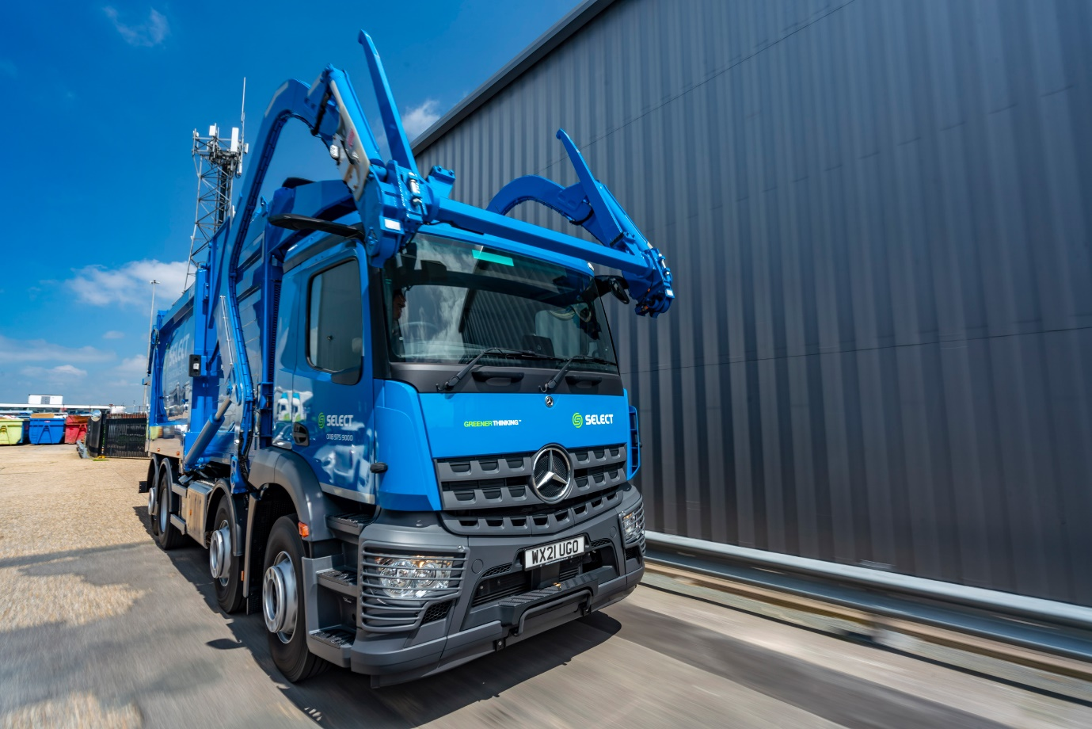

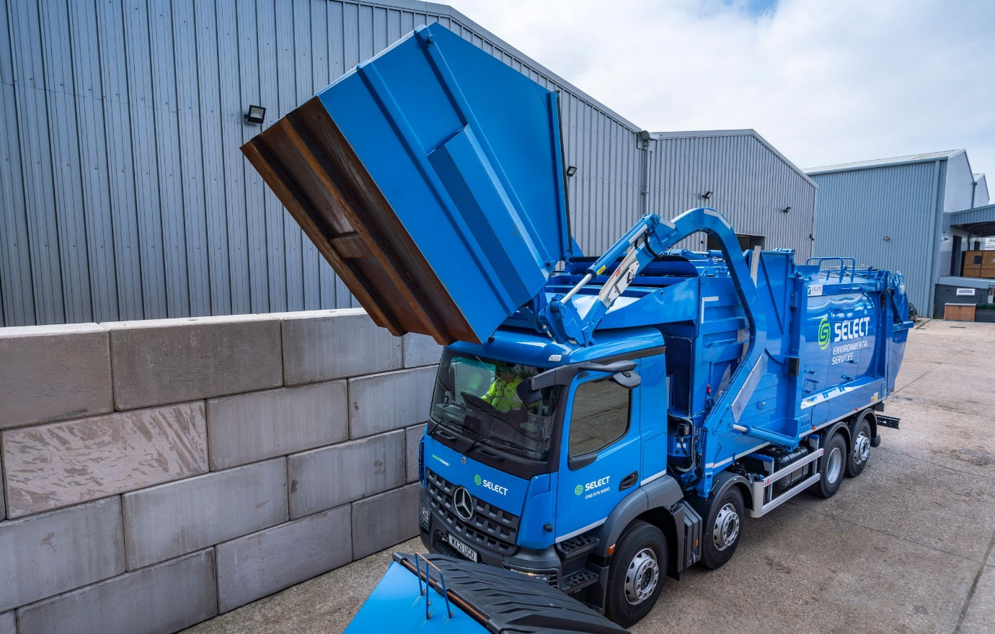

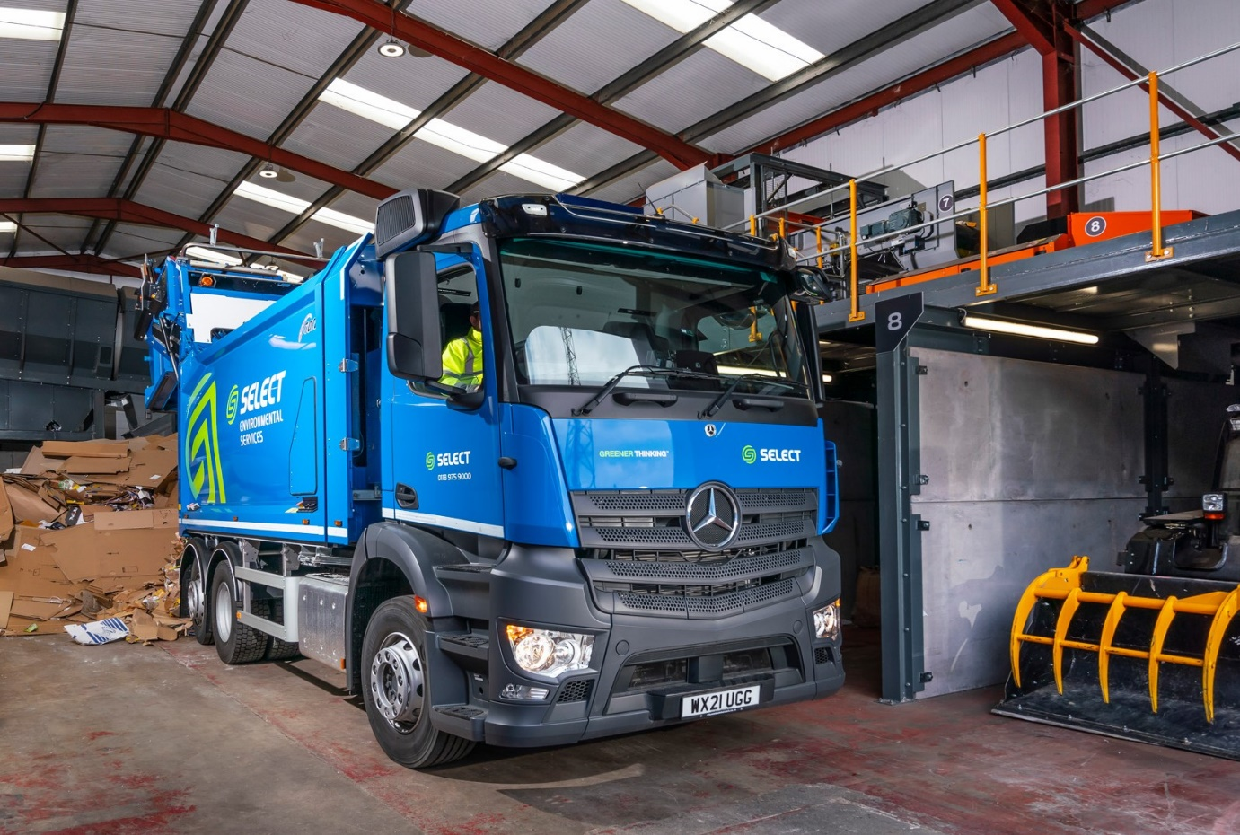

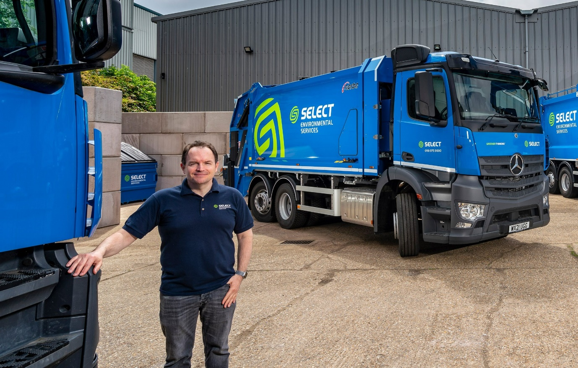

Leading from the front: Managing Director Philip Stone relies on the winning combination of Mercedes-Benz product quality and City West Commercials’ expert knowledge of the recycling and waste management sector

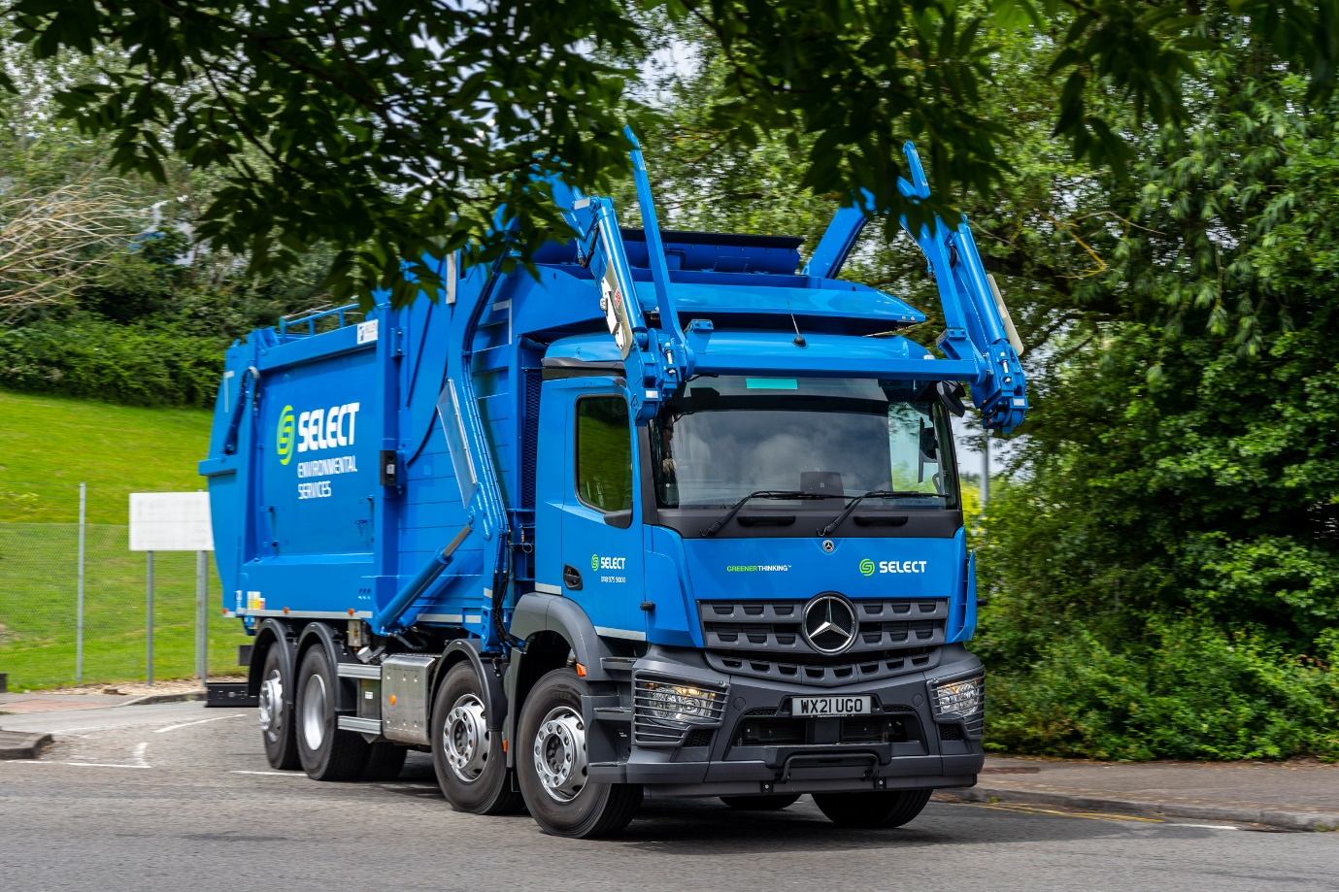

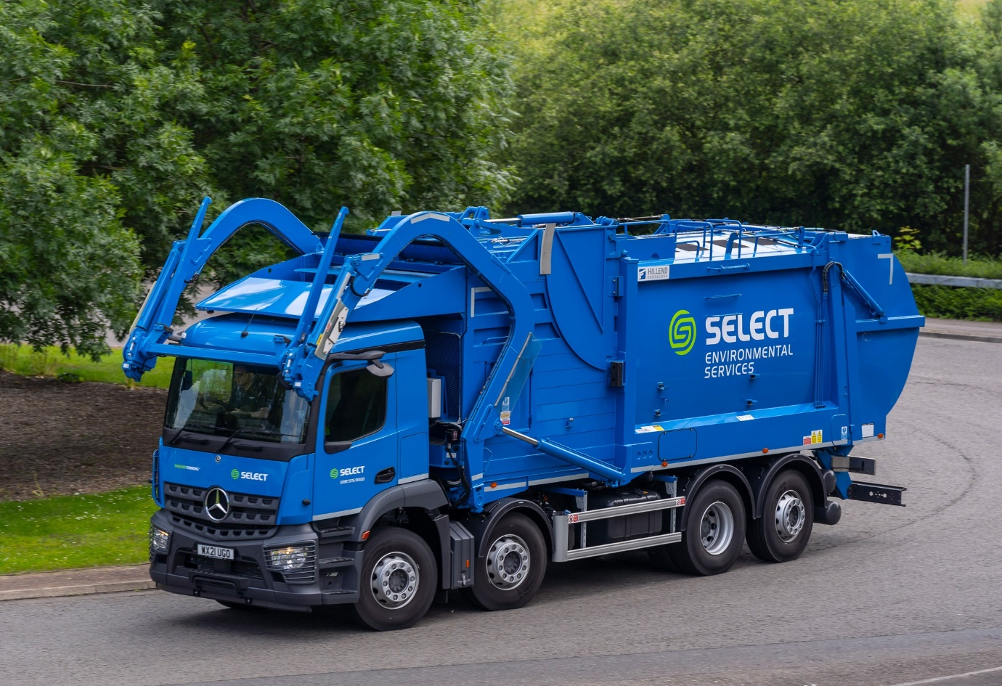

ends

For more information, or to request bigger/higher-res image files, please contact:
Steve Warren or John Ripley
Impact Communications, 01926 842126
Steve: 07770 470251, steve@impactcom.co.uk
John: 07771 484595, john@impactcom.co.uk

