

Date: 16 November 2022

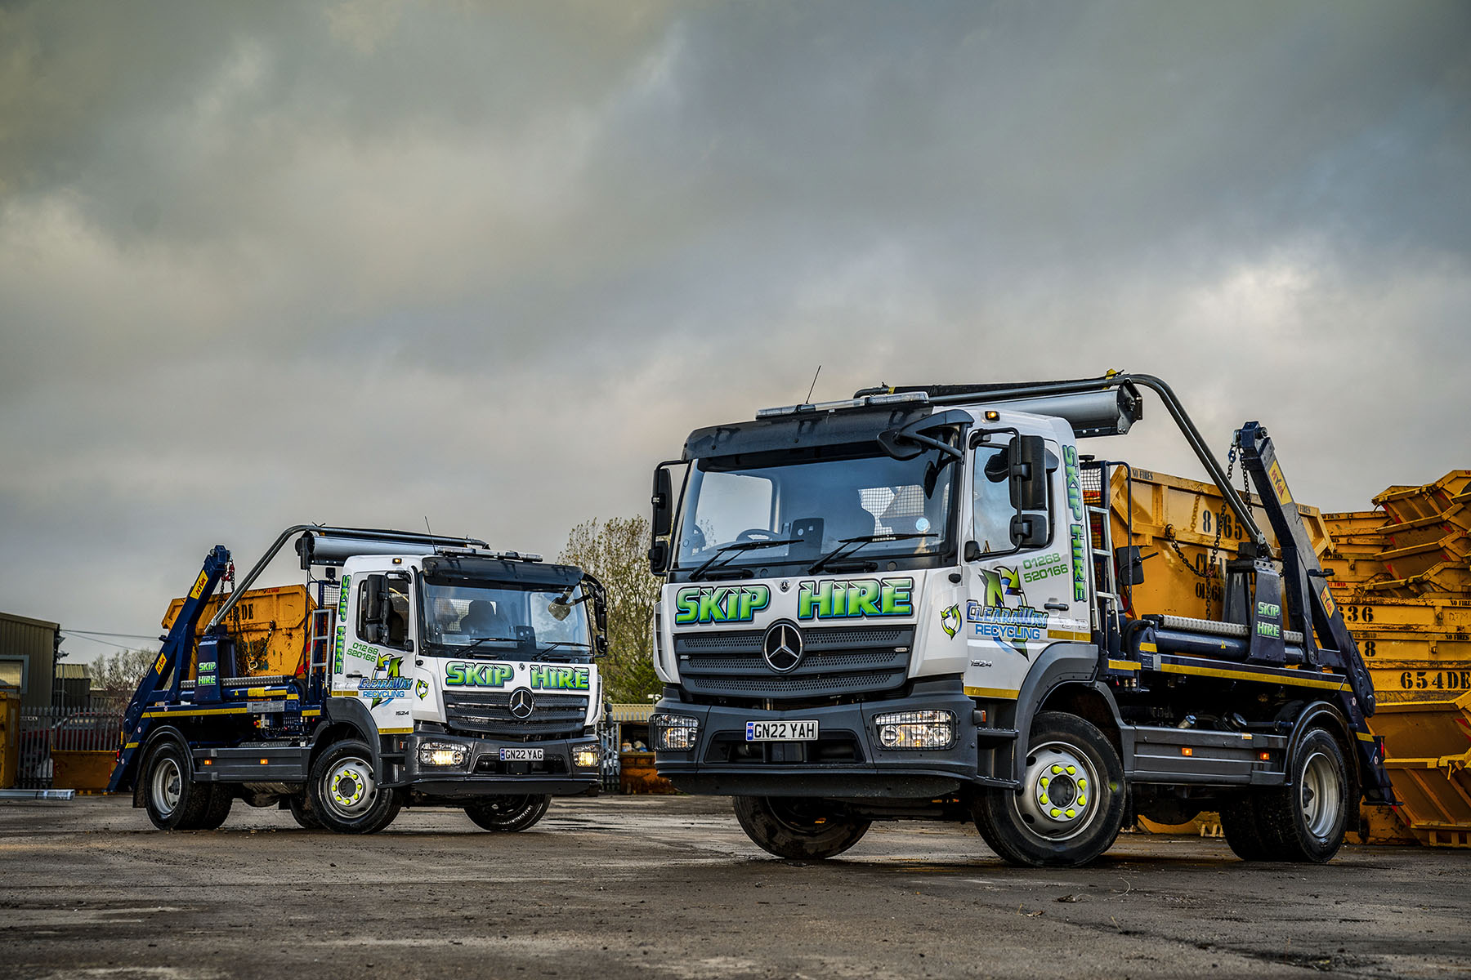

Atego ‘at the double’: Clearaway’s two new Mercedes-Benz 16-tonners

Mercedes-Benz Atego measures up as Clearaway’s light- and medium-duty waste line of choice

High productivity from a compact chassis – that’s what its first 16-tonne Mercedes-Benz Atego skiploaders are delivering for waste management specialist Clearaway.

The latest additions to its Mercedes-Benz-dominated fleet arrived via trusted supplier Sparshatt Truck & Van. Both construction-specification 1524 K variants with short, ClassicSpace S-cabs and Hyva lifting equipment, they offer payload capacities of almost 7.5-tonnes.

Clearaway took advantage of competitive funding support from Daimler Truck Financial Services UK to acquire its new trucks. Both employ economical, high-torque 7.7-litre in-line, six-cylinder engines that produce 175 kW (238 hp) and drive through six-speed Mercedes PowerShift automated manual transmissions.

Established in 2010 by Ian and Paul Whitehair, Clearaway serves private and commercial customers located within a 50-mile radius of its base on the Burnt Mills Industrial Estate in Basildon, Essex. The company is committed to recycling as much as possible of the waste it collects – any that cannot be recycled goes to an ‘energy-from-waste’ facility, where it is used to generate electricity.

All but three of Clearaway’s 15 trucks wear Mercedes-Benz three-pointed stars. In addition to the new arrivals, the line-up includes four more vehicles from the Atego light- and medium-duty range – two 13.5-tonne skip-loaders and a pair of 7.5-tonners, to which Sparshatt will shortly be adding a third.

The company’s remaining Mercedes-Benz trucks are all muscular Arocs models – six 18-tonne skiploaders, two of which were delivered by the Dealer earlier this year, and a couple of 32-tonne eight-wheelers, one a hook-loader, the other a tipper.

The Whitehair brothers also own and operate sister company Wasteaway from the same site. It runs a fleet of 40 Mercedes-Benz tractor units that pull walking floor trailers and collect commercial and domestic waste from transfer stations throughout Essex and Kent. Most is then taken to recycling centres but there are still times when landfill has to be used, which explains why most of Wasteaway’s trucks are double-drive variants.

Commenting on Clearaway’s new trucks, Paul Whitehair said: “We’re really pleased with our first 16-tonners. They’re no bigger than the 13.5-tonne Atego, but each offers a very useful increase of approximately 2,400kg in body and payload allowance.”

He continued: “Our Mercedes-Benz trucks have proved over the last 10 years to be exceptionally strong and reliable, which is crucial given the nature of our operations. Skip-loaders will always get knocked about a bit, yet we still have a couple that are on 15-plates – I was going to let them go a little while back but haven’t done so yet because they’re still good, solid trucks that continue to stand the test of time.”

No less important, though, is the customer-focused support the two companies receive from Sparshatt Truck & Van. “As good as our Mercedes-Benz vehicles are, it’s difficult to buy a bad truck these days,” said Paul Whitehair.

“This means that when we’re deciding where to place our business, the service we receive from the Dealer is an even bigger factor than it might otherwise have been. Head of Sales Martin Kemsley is first-class, while from an aftersales perspective Sparshatt looks after us really well.”

As with previous vehicles, Clearaway’s new Atego skiploaders are now being inspected and maintained under Mercedes-Benz Complete Service Contracts, by the workshop team at Sparshatt Truck & Van’s Dartford branch.

“We have a great relationship and it all runs very smoothy,” confirmed Mr Whitehair. “The Dealer’s mobile technicians come to us to carry out the six-weekly checks and routine services in our own, three-bay workshop, which is obviously very convenient. For any major work, though, the vehicle goes over to them.”

clearawaywastemanagement.co.uk

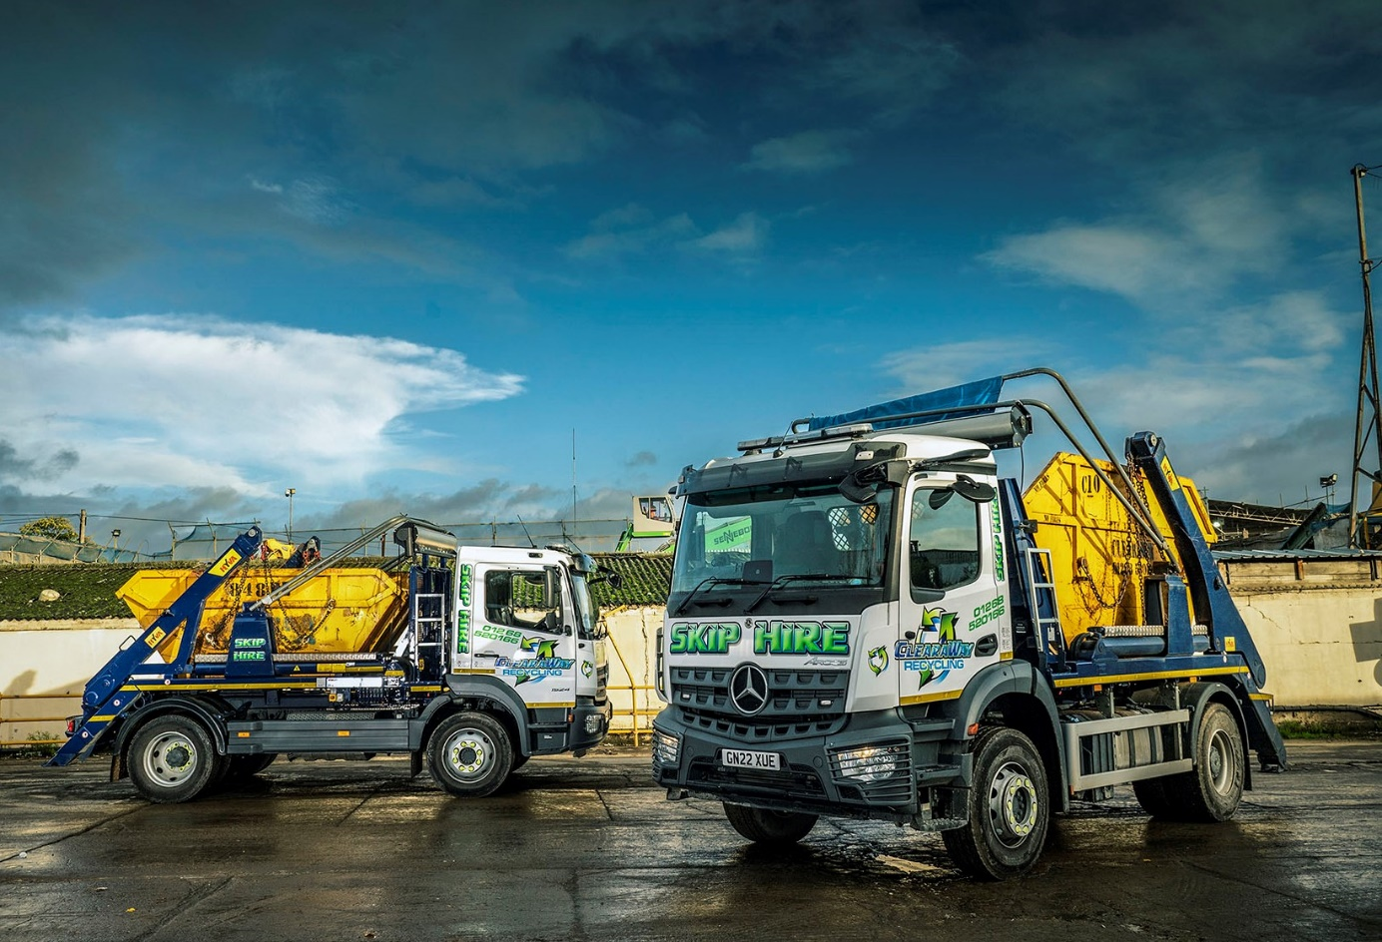

Brand of brothers: Ian and Paul Whitehair swear by their Mercedes-Benz Atego, left, and Arocs trucks

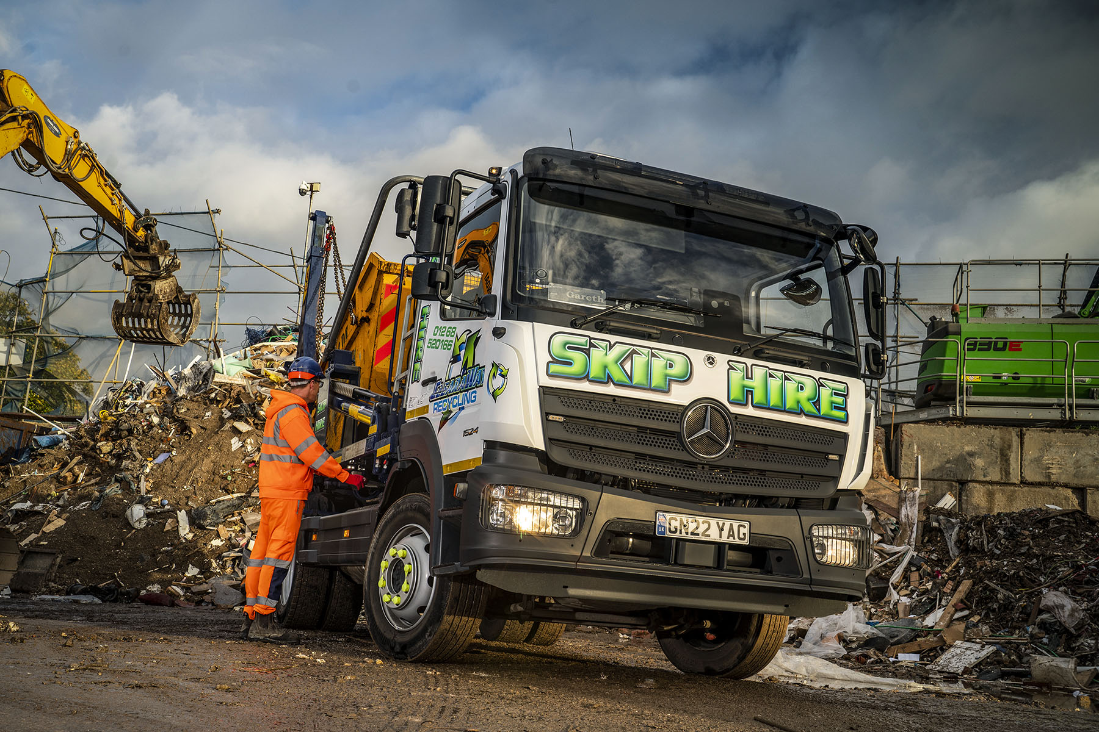

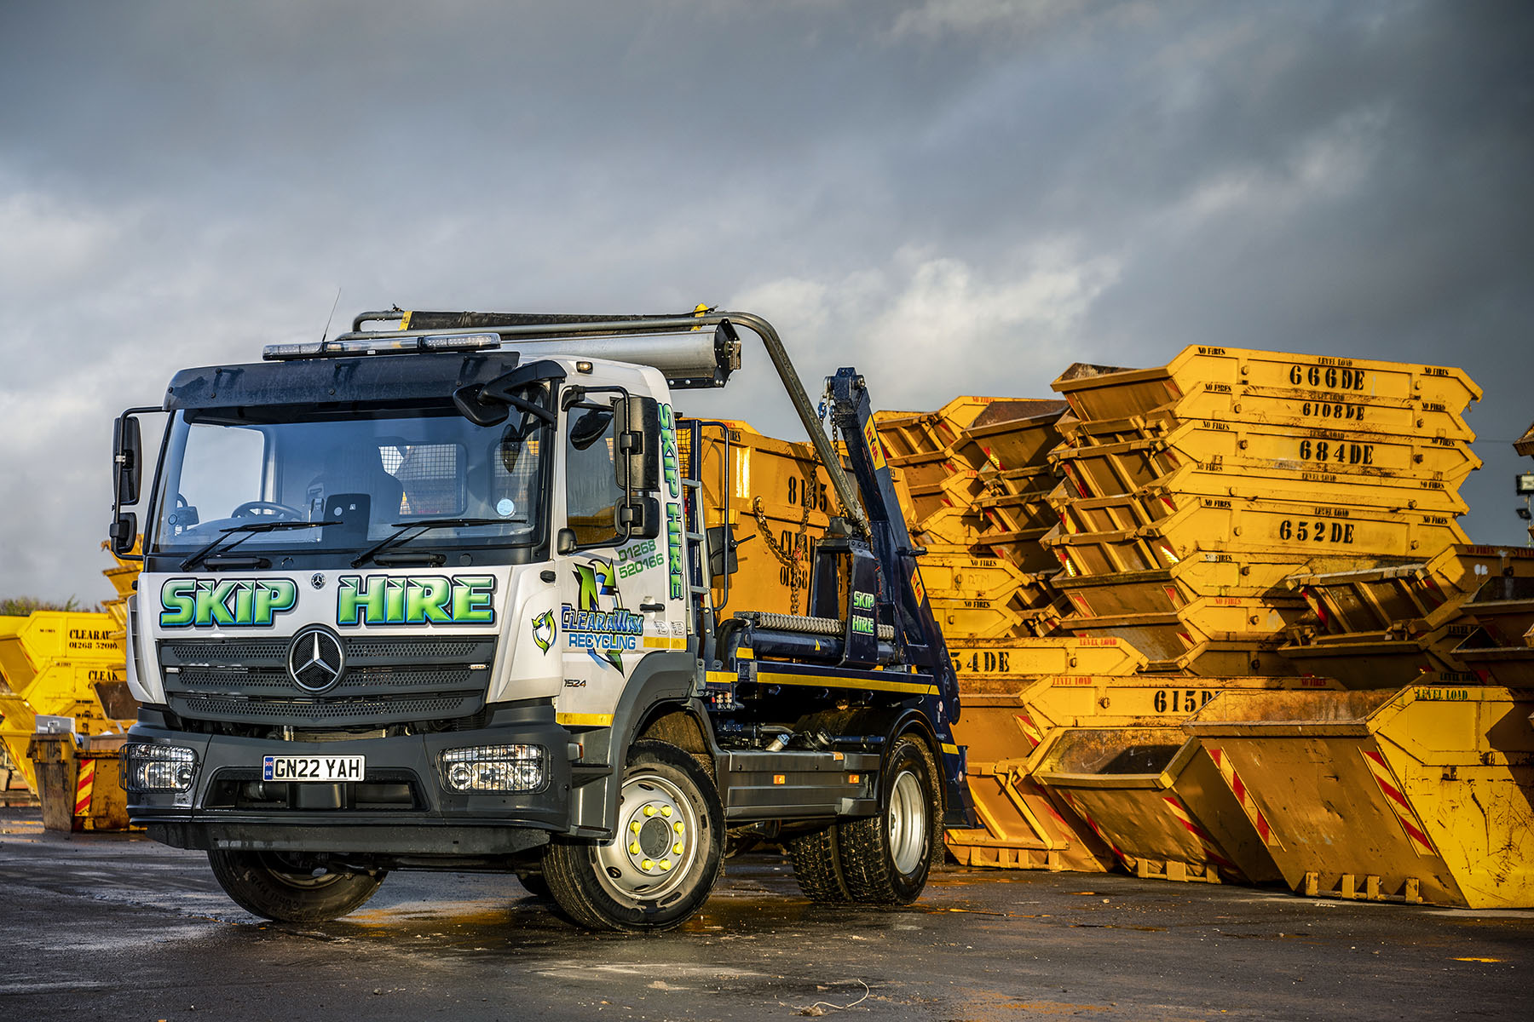

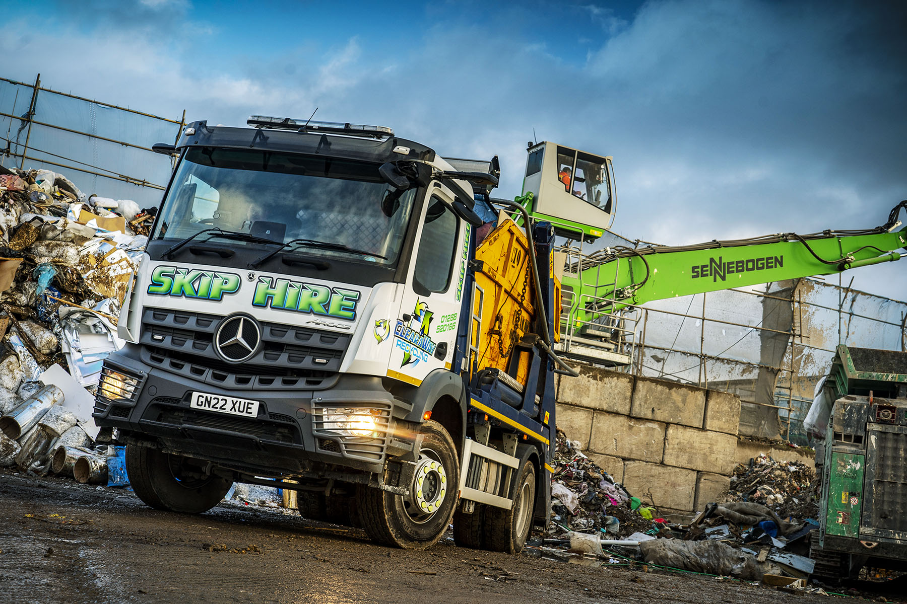

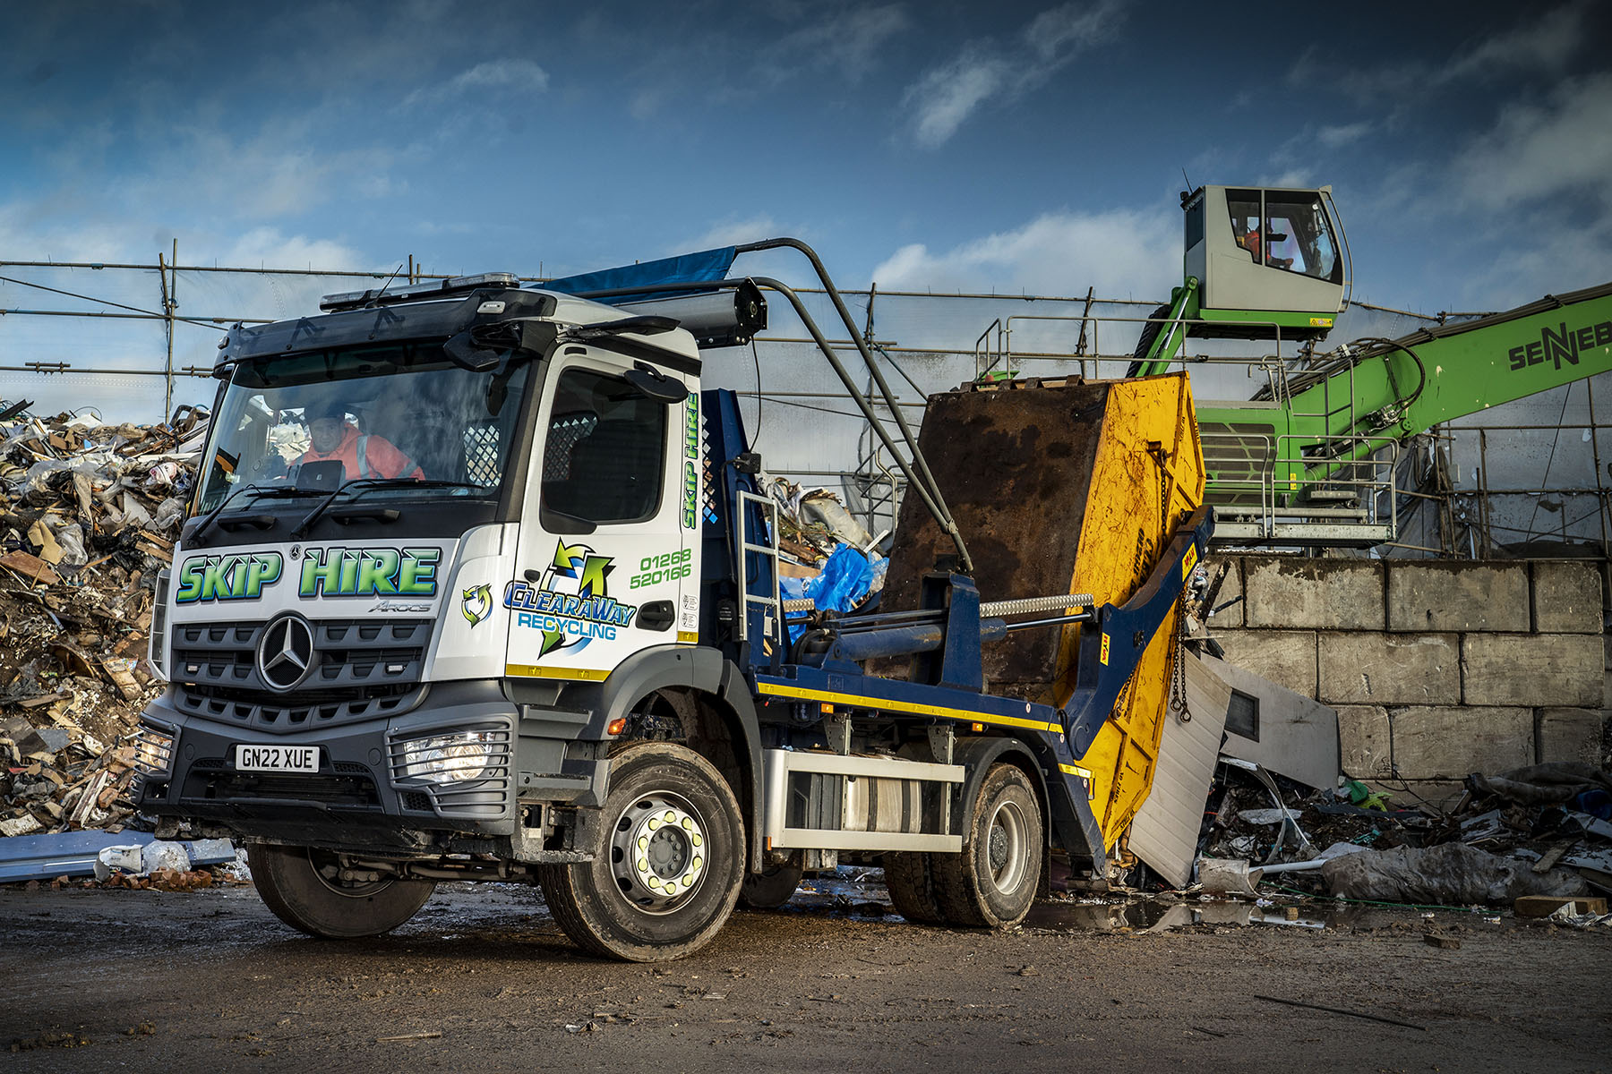

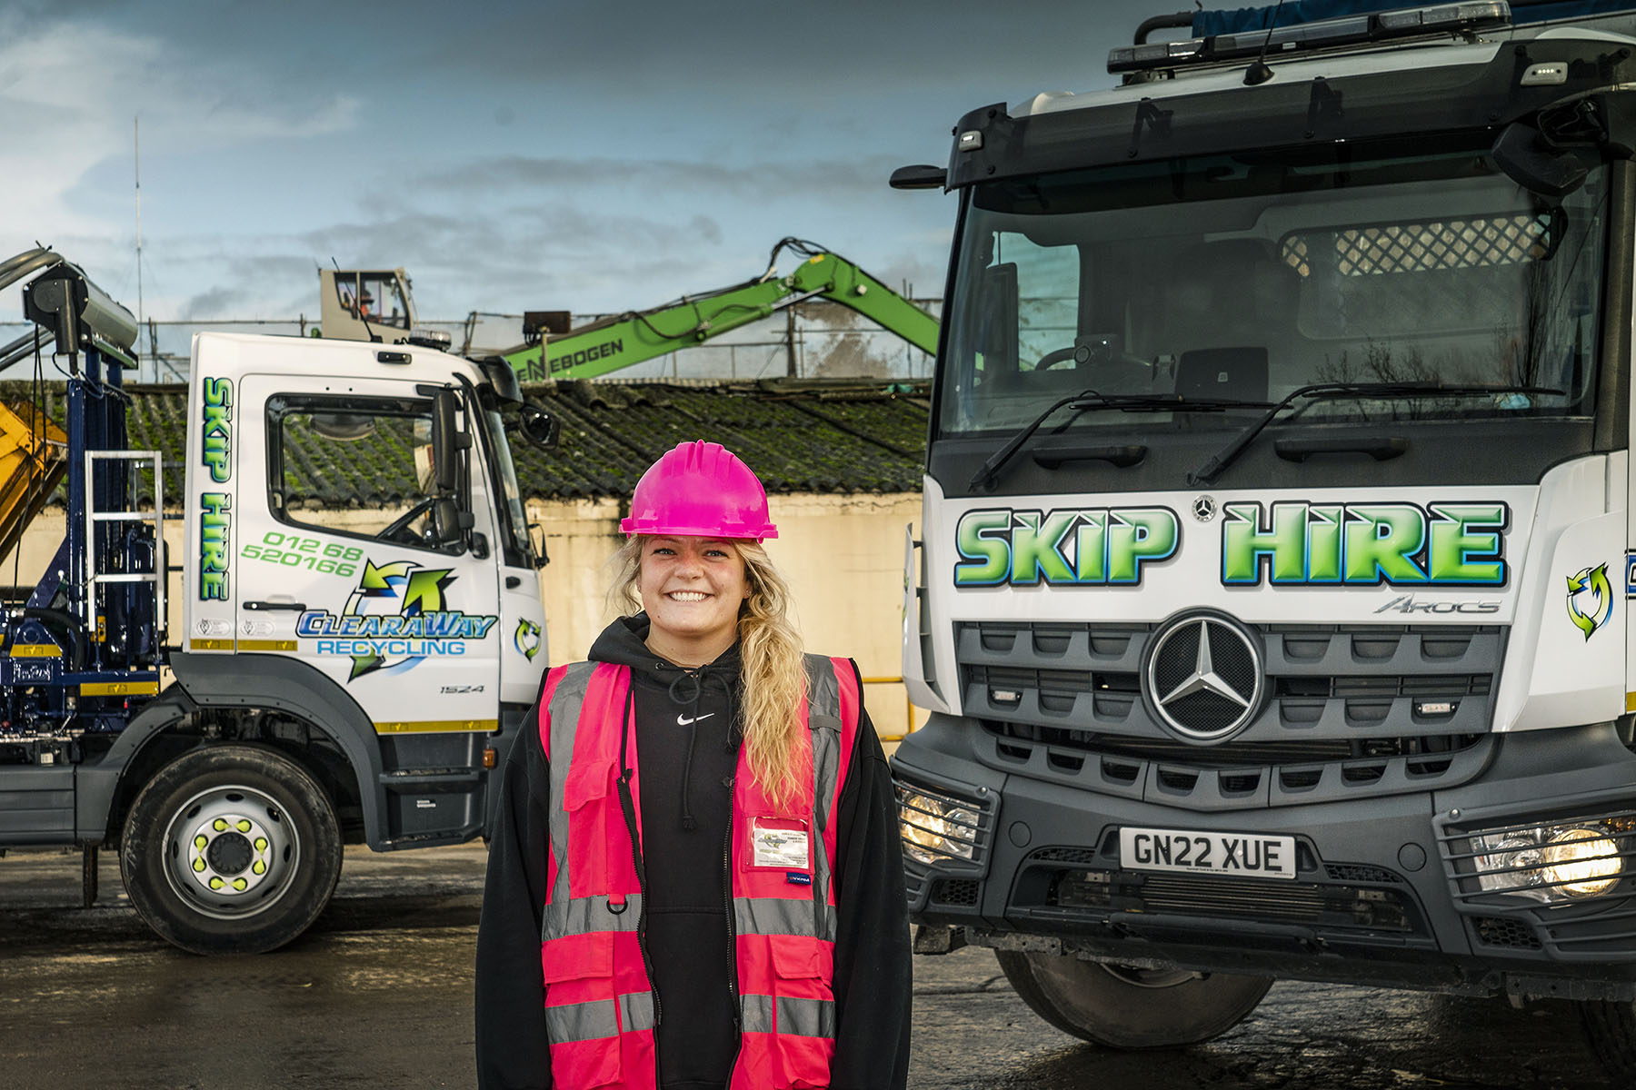

Next generation: Paul Whitehair’s daughter Abbie is a Project Manager and works for the family’s businesses with her sisters Jordan and Jody. So, too, do Ian Whitehair’s daughters Charlie, Levi, Cabana and Bow

ends

For more information, or to request bigger/higher-res image files, please contact:
Steve Warren or John Ripley
Impact Communications
Steve: 07770 470251, steve@impactcom.co.uk
John: 07771 484595, john@impactcom.co.uk

