

Date: 24 March 2021

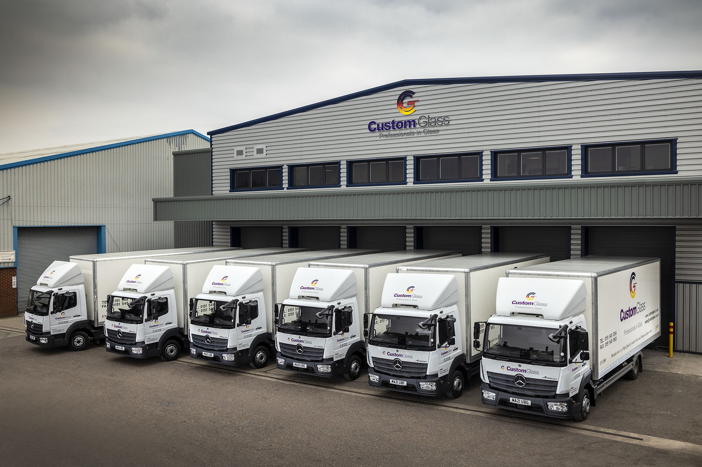

Custom Glass adds six new Mercedes-Benz rigids after boss’s powerful ‘pitch’ for eStar Truck & Van back-up

A reassuring personal visit from Chairman Sid Sadique convinced Custom Glass that it was in safe hands when placing one of the first orders to be secured by eStar Truck & Van, the newest member of the Mercedes-Benz Trucks Dealer Network.

Having placed his order in September, the Liverpool-based operator’s Managing Director Jeff Hooson has just taken delivery of its latest six Atego 7.5-tonners. All box-bodied 816 models with ClassicSpace S-Cabs, they are powered by 5.1-litre engines producing 115 kW (156 hp).

Custom Glass is a loyal customer of Mercedes-Benz Trucks, but as Mr Hooson said: “eStar is a new venture and I didn’t know anything about its owners, or their plans for the long term.

“Sid came to see me with Sales Executive Richie Rainford, who I’ve worked with for many years. Once we’d sat down face-to-face and Sid had told me about his plans to develop the business, and his commitment to supporting operators like ourselves, I had no hesitation in committing to the order.”

A high-profile figure in the commercial vehicle industry, Sid Sadique formed eStar Truck & Van after acquiring most of the assets of the brand’s previous representative, including a dealership on Rathbone Road in the Wavertree district of Liverpool, and other facilities in Deeside, Stoke-on-Trent, Trafford Park and Warrington.

Since then, the Dealer has strengthened its ‘top team’ by making two more high-profile appointments – Steve Bridge, the former Managing Director of Mercedes-Benz Vans UK, has taken up the same position at eStar Truck & Van, while Chris Taylor, who has 20 years’ aftersales experience within the Mercedes-Benz Truck Dealer network, is its new Operations Director.

Simultaneously, Custom Glass was building back up towards full capacity at new production facilities after its premises at Knowsley Industrial Park were badly damaged by fire. Now fully up and running, the development represents an investment of more £2 million and is home to a Glaston FC500 6000 x 2800mm toughening plant; Hegla Optimax cutting table with laser marking system; and Lisec KSR/KSV arrissing machine, for removing the sharp edges of glass prior to toughening, with a maximum pane or unit size of 3210 x 2500 mm.

Mr Hooson ordered the latest trucks to deliver the increased volumes of glass that are now being produced at Custom Glass’s new facility. Their box bodies, which feature fixed internal glass-carrying frails, were designed and manufactured to the operator’s own specification by Truckcraft Bodies, of Stalybridge, Greater Manchester.

Four have replaced older 7.5-tonne Atego glass-carriers that have been stood down – one with more than 600,000 km on the clock – while the other two represent extensions to the fleet. Their arrivals mean Custom Glass now runs 16 vehicles from the well-proven Atego range, as well as a 44-tonne Actros tractor unit and Mercedes-Benz Sprinter vans.

Established in 1982, Custom Glass produces 2,500 double-glazed units every day and turns over £12 million annually. The firm supplies window fabricators and installers, builders and home improvers throughout the North and Midlands. It also offers toughened and decorative glass, high-performance roof glass and ‘Low E’ thermal panels, painted glass splashbacks and ancillaries such as silicone sealant and integral blinds.

Mr Hooson continued: “The fact that our trucks have bespoke bodies means that if one breaks down it’s very difficult to hire or buy a replacement at short notice. That’s why we’ve come to depend on the Atego, which leads the field in terms of reliability and longevity.

“eStar’s Richie Rainford also understands our business well and has always delivered our vehicles on time and in perfect condition. Meanwhile, I’ve received the assurances I needed that the Dealer’s Service team will do their very best to get our trucks into the workshop for routine maintenance through the night or at weekends, so downtime should never be an issue.”

The Atego range from 7.5-16 tonnes GVW is purpose-designed for light- and medium-duty distribution applications. It offers outstanding dynamics, comfort and manoeuvrability, as well as the durability necessary for intensive, multi-drop delivery work.

www.customglass.co.uk

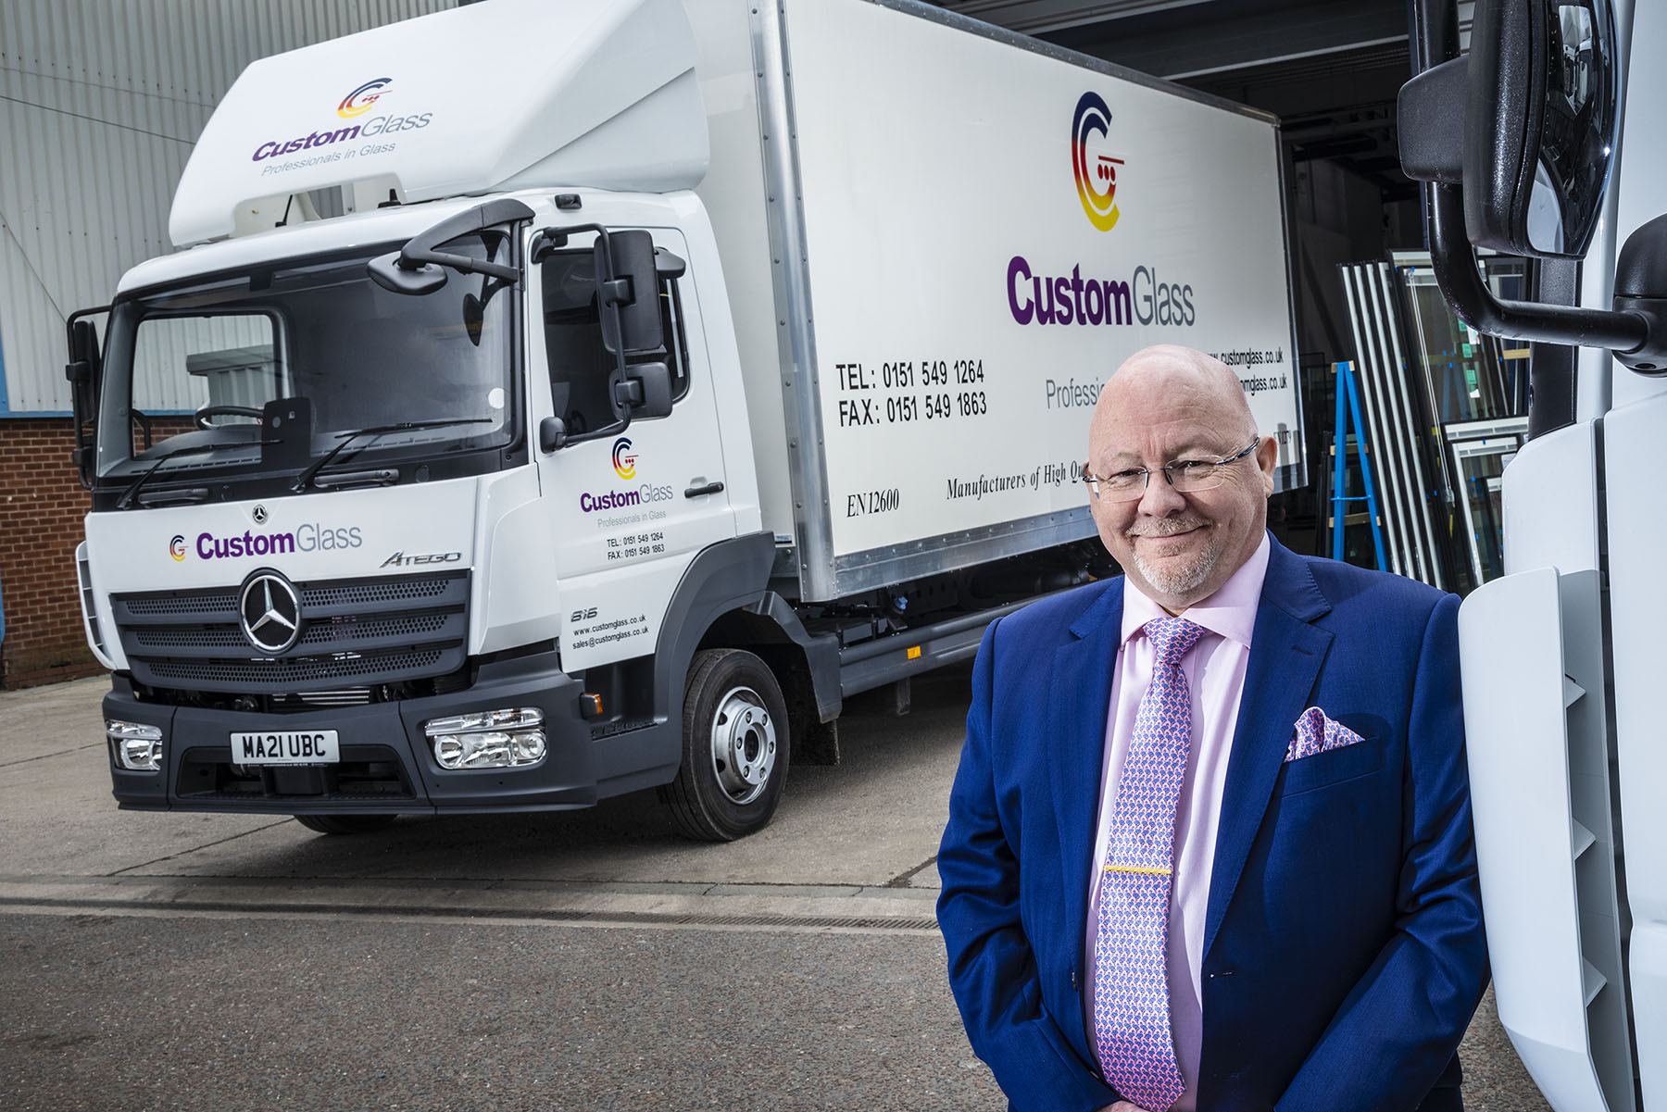

Quality assured: The Chairman’s promise of first-class back-up from eStar Truck & Van meant Custom Glass Managing Director Jeff Hooson had no qualms about placing his first order with the new Dealer

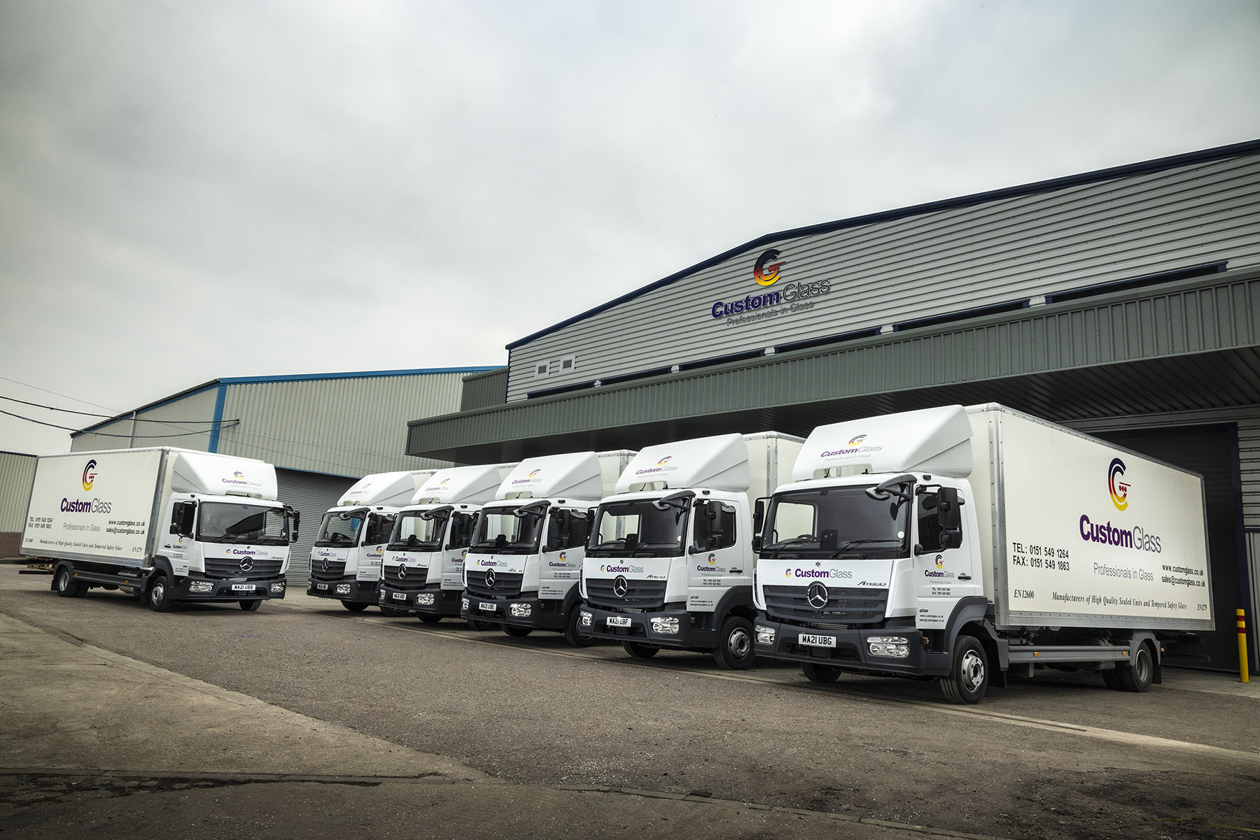

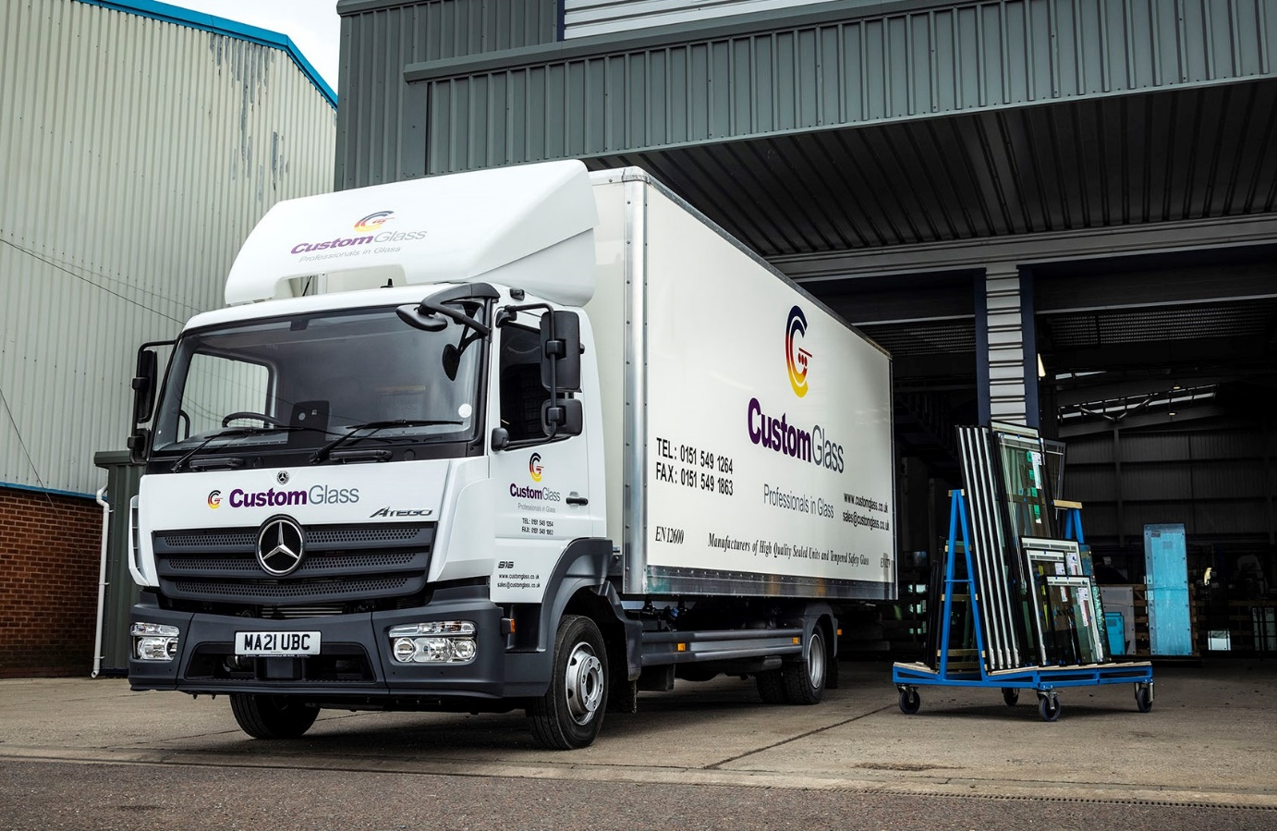

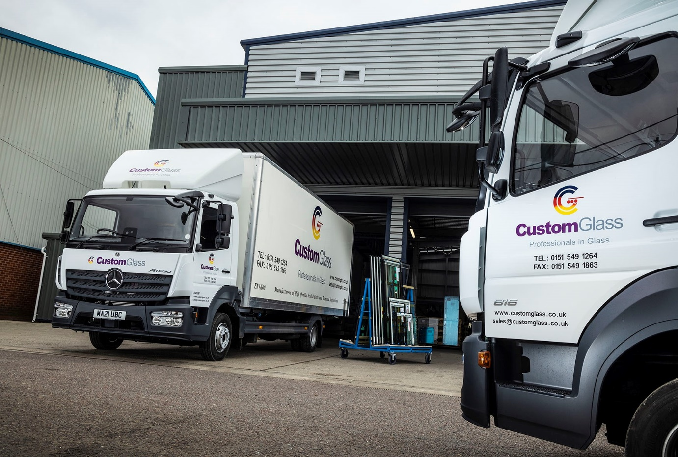

ends

For more information, or to request higher-resolution image files, please contact:
John Ripley or Steve Warren
Impact Communications, 01926 842126
John: 07771 484595, john@impactcom.co.uk
Steve: 07770 470251, steve@impactcom.co.uk

