

Date: 1 October 2021

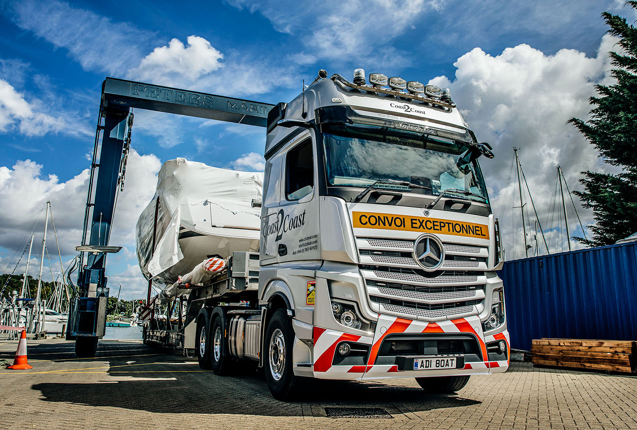

Coast2Coast Marine Transport slips into ‘cruise control’ with Mercedes-Benz Actros heavy haulers

It’s been plain sailing all the way for Coast2Coast Marine Transport since the Portsmouth-based firm commissioned its first Mercedes-Benz trucks, a pair of eye-catching double-drive tractor units plated for operation at gross combination weights of 80 tonnes.

Supplied by local Dealer Marshall Truck & Van both are Actros 3358 variants with top-of-the-range GigaSpace cabs and 15.6-litre ‘straight six’ engines producing 425 kW (580 hp).

The trucks are smartly finished in metallic silver with roof-mounted light bars, alloy wheels and personalised registration plates. They earn their keep by transporting yachts and motor cruisers throughout Europe. These vessels can weigh anything up to 35 tonnes and given that most exceed the standard permissible width the work is invariably governed by ‘convoi exceptionnel’ regulations

Coast2Coast Marine Transport was launched in 2004 by Russell Mitchell, who had just left the Army after 25 years’ service with the Royal Engineers. As a Warrant Officer Russell ran a fleet of 300 trucks; he was also a diving instructor and directly involved in the raising of the Mary Rose.

The new venture was quick to establish a positive reputation within the boat-owning fraternity and grew rapidly, its location in Portchester providing easy access to the ferry terminal and south coast marinas. Coast2Coast Marine Transport is now the UK’s biggest boat movement specialist, with a fleet of six tractor units, eight trailers and a number of escort vehicles.

Russell remains at the helm, supported by Operations & Finance Manager Sarah Bee, who has been with the company from the outset. Also sharing responsibility for its day-to-day management is Russell’s son James, who was welcomed aboard in 2012. James initially drove pilot vehicles before passing his HGV Class 1 test and spending several years on the road delivering boats. ‘Truckers’ at heart – their company is a proud member of the Road Haulage Association – father and son still seize every opportunity to get behind the wheel.

Russell had been steadfastly loyal to the same manufacturer from the outset but finally resolved to look elsewhere for his company’s new trucks after becoming disillusioned with the service he was receiving from its local representative.

“It didn’t take us long to settle on Mercedes-Benz,” he confirmed. “The Actros looks great and thanks to its advanced technology leads the field in terms of safety, reliability and cost-efficiency. With the help of Marshall’s Sales Executive John Sunderland we were able to specify the trucks perfectly.”

Coast2Coast took advantage of competitive funding support from Mercedes-Benz Finance to acquire its 6x4 units. Russell continued: “We’re an international operation and run regularly to France, Portugal and Spain, so our drivers are often away from home for more than three weeks at a time. The roomy and comfortable GigaSpace cab is therefore a massive ‘plus’ – we’ve kitted ours out with TVs, microwaves and fridges, and the lads love them.”

The trucks are being inspected and maintained under five-year Mercedes-Benz Complete Service Contracts at Marshall Truck & Van’s Fareham workshop. “Aftersales support was also crucial,” said Russell. “Mercedes-Benz provides unrivalled coverage on the Continent while we’ve already seen enough of the Dealer’s back-up to be reassured that we’re in safe hands.

“Coast2Coast is successful because we make the complex process of boat transport as simple as possible for our customers. We’re friendly and approachable, and we’re very good at what we do. The same is true of Marshall Truck & Van’s fantastic team.”

Standard equipment on the fifth-generation Actros includes Active Brake Assist 5 emergency braking technology with enhanced pedestrian recognition capability, and enhanced Predictive Powertrain Control, which manages gear changes to make maximum use of the Mercedes PowerShift 3 transmission’s Eco-Roll mode and thereby optimise economy.

Coast2Coast’s Actros are also equipped with the upgraded interactive version of
Mercedes-Benz Trucks’ radical, twin-screen Multimedia Cockpit, which boast a larger, 12in instrument panel and comes with extra functionality, including satellite navigation.

It is, however, another standard feature in the shape of MirrorCam, the ground-breaking camera-based replacement for conventional mirrors, that has most impressed Adrian Dennis, another long-serving member of the team who has been driving for Coast2Coast Marine Transport since the very beginning.

“First and foremost, I no longer have to contend with the forward-facing blind spot caused by the mirror housing, which was enormous in my last truck,” he explained. “That’s particularly helpful in France, where we’re not allowed on the motorway network so have to stick to smaller roads with roundabouts, where it can be difficult to see vehicles hidden by the mirror.

“I’ve also noticed that the absence of mirrors means my side windows don’t get as grubby, while rear visibility is much improved too, not least because the camera pans to ensure you never lose sight of the back of the trailer when reversing.”
Adrian added: “Fuel-efficiency is noticeably better than my previous vehicle, and I’m really pleased with the way the Actros handles. Even when it’s wet and slippery this truck is beautifully balanced and a real pleasure to drive.”

c2cboat.com

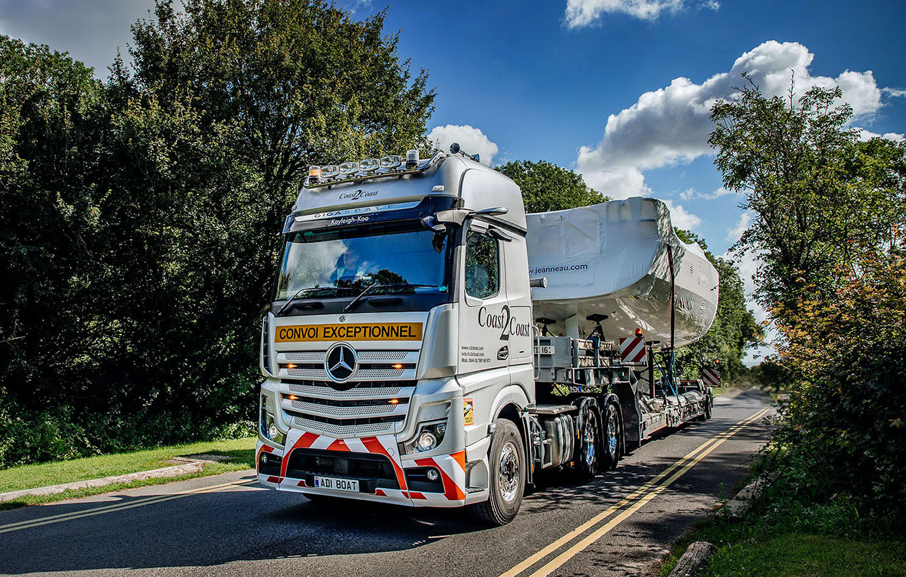

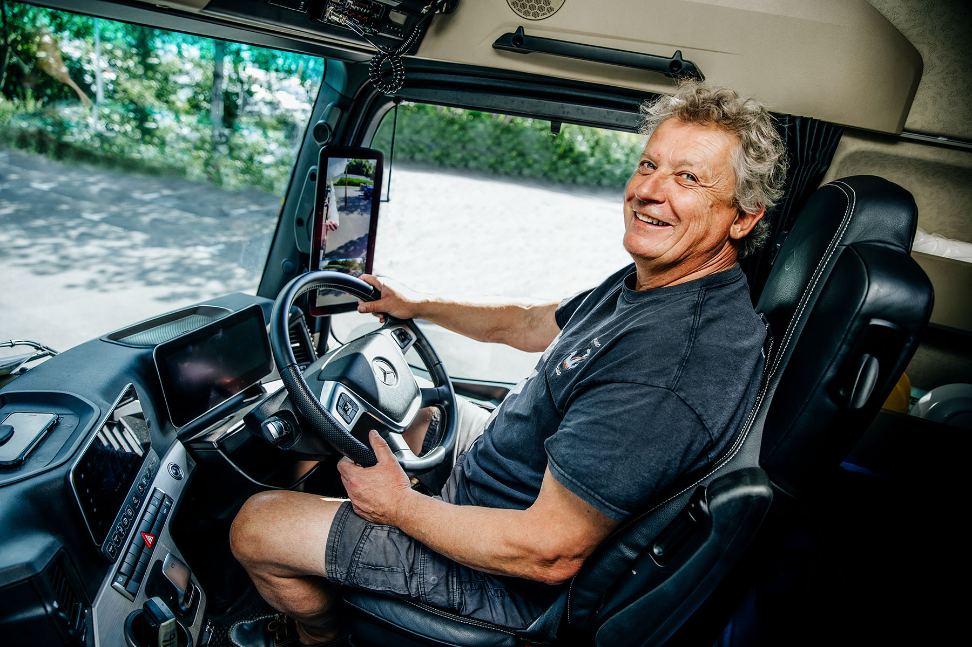

Wheel appeal: Having driven a succession of trucks by another brand over the last 17 years, Adrian Dennis is delighted to be piloting one of Coast2Coast Marine Transport’s new Actros

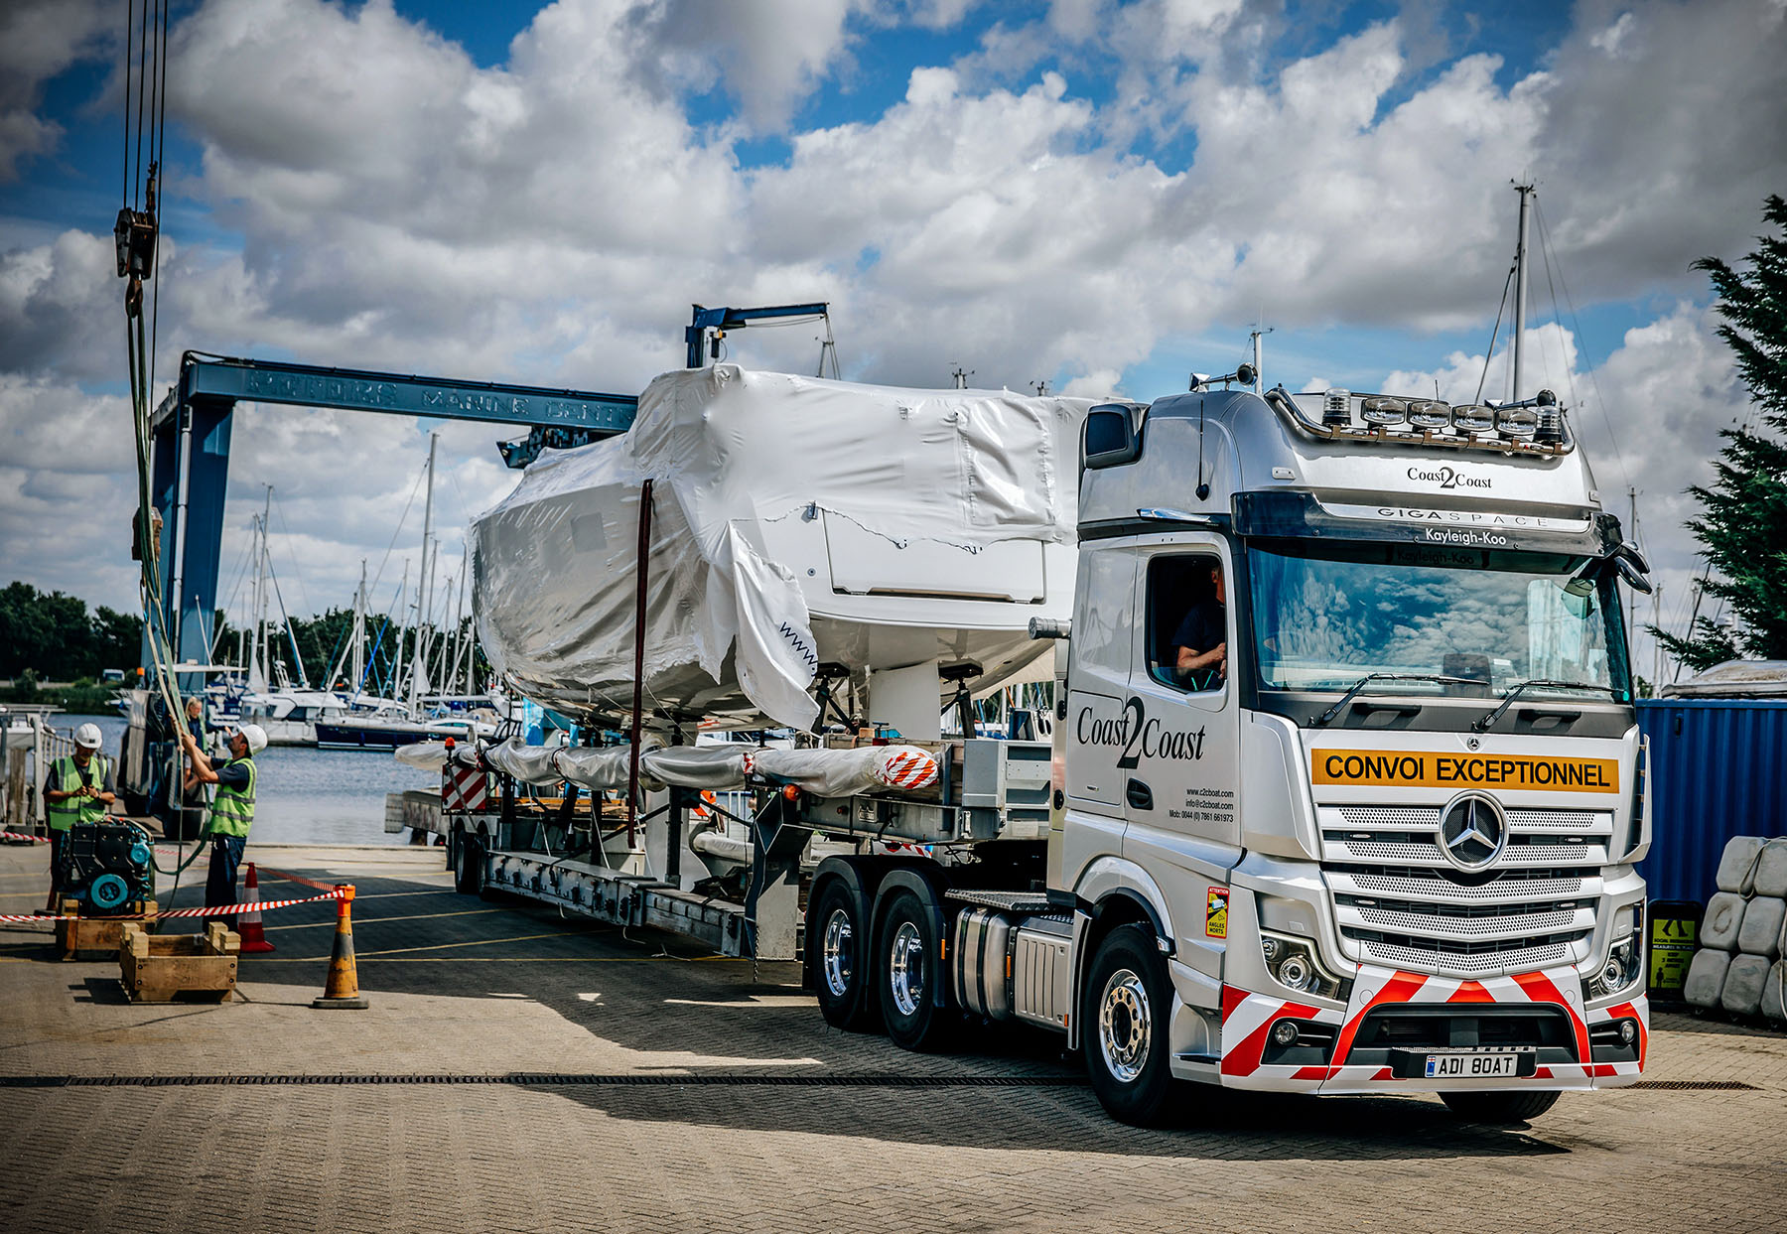

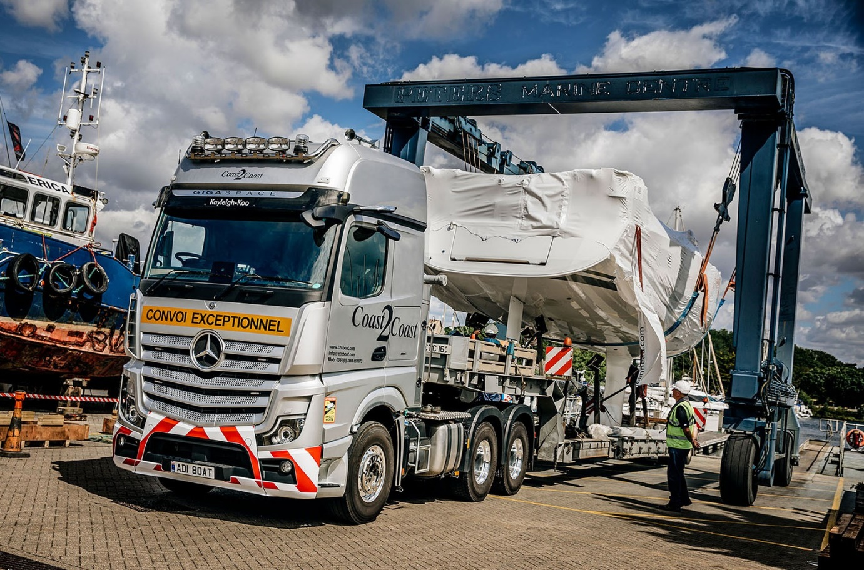

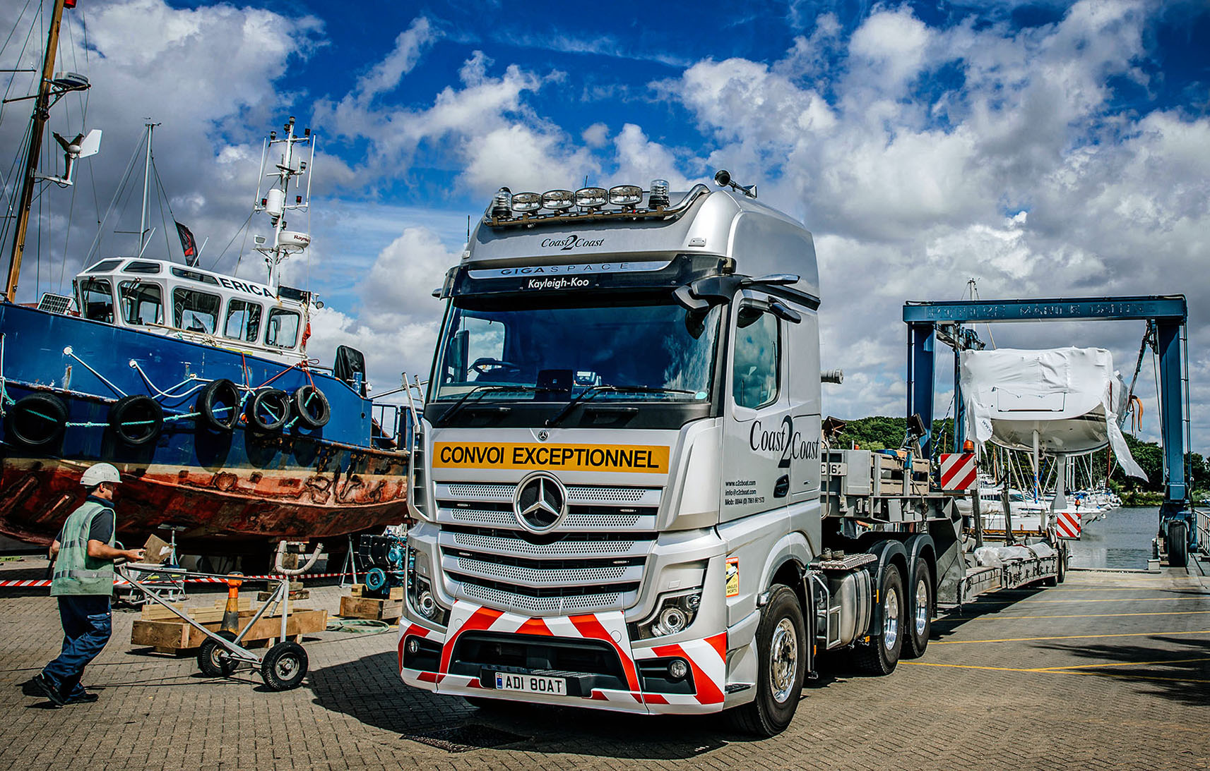

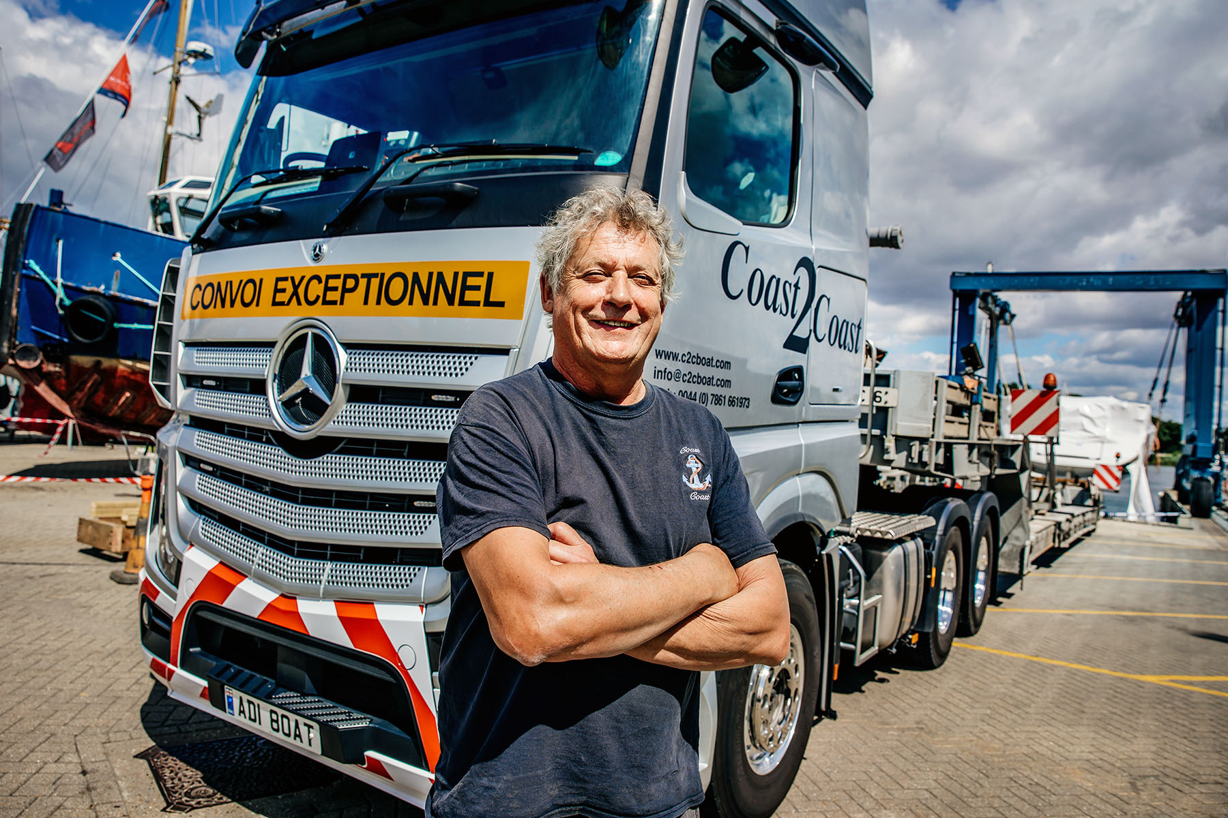

Happy in his work: Coast2Coast Marine Transport driver Adrian Dennis, with his new Mercedes-Benz Actros

ends

For more information, or to request bigger/higher-res image files, please contact:
Steve Warren or John Ripley
Impact Communications, 01926 842126
Steve: 07770 470251, steve@impactcom.co.uk
John: 07771 484595, john@impactcom.co.uk

