

Date: 19 June 2023

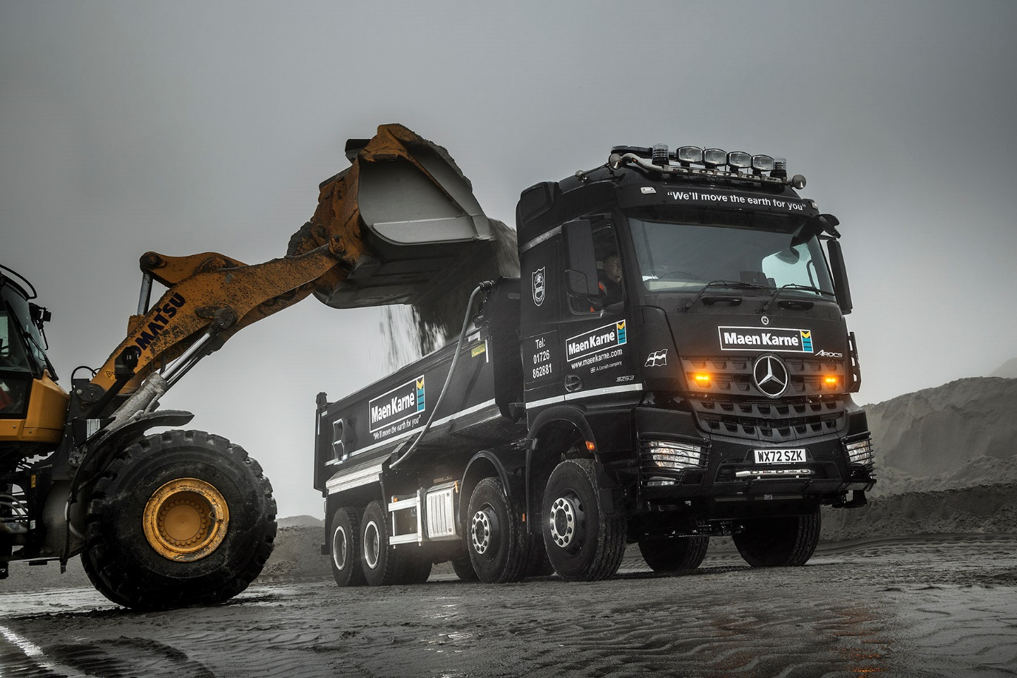

Dark energy: Maen Karne’s Arocs tipper works in all weathers

Maen Karne moves the earth with another reliable Mercedes-Benz Arocs from City West Commercials

The latest truck to join the fleet of Cornish operator Maen Karne is its first 8x4 tipper from Mercedes-Benz – but the truck was chosen for its proven reliability, supported by trustworthy back-up from Dealer City West Commercials.

That’s because the aggregates, concrete and bulk haulage specialist has already been deeply impressed by the performance of its 13 Mercedes-Benz mixer chassis, and by the high-quality support from City West that keeps them working and earning.

“We have Mercedes-Benz trucks in the fleet dating back as far as 2008, and they continue to provide reliable, cost-effective service,” said National Fleet Manager Darren Squire. “That’s testament to the engineering quality of the vehicles, but also to the ongoing of the Dealer’s team to keep improving the service they provide.

“Sales Executive Richard Smith has worked hard to become a trusted supplier to our business, but the same is true of his aftersales colleagues, who look after us very well. That’s why we were happy to hand this latest order, for our first Mercedes-Benz with a tipper body, to City West Commercials.”

The new truck is an Arocs 3253K, powered by a muscular 390 kW (530 hp), 12.8-litre in-line six-cylinder engine. It has an aerodynamic StreamSpace sleeper cab, finished in gleaming black and fitted with Kelsa lightbars and beacons, and is equipped with a Charlton steel tipping body with Hyva front-end ram.

Working from a depot at Nanpean, near St Austell, it makes deliveries of sand and aggregates to customers across Devon and Cornwall, as well as undertaking muckaway duties. The truck will be maintained in City West Commercials’ workshop at Roche, less than five miles away, under the terms of a Mercedes-Benz Service Contract.

“Having a depot so close, and being to get any servicing done outside our own working hours, will help keep downtime to an absolute minimum,” said Mr Squire.

“The Arocs is ideal for its role,” he continued. “The spacious, comfortable cab is great for the long runs it sometimes has to make, and the big 530 hp engine just eats the hills, even when the truck is fully loaded. Like our other Mercedes-Benz vehicles I’ve every reason to believe it will be a dependable performer, well up to the job and highly efficient in terms of both fuel consumption and maintenance costs.”

The keys to the truck have been handed to 22-year-old driver Morgan Carveth, who joined the company two years ago. He is understandably delighted.

“The Arocs is great, I love the modern dash layout with its twin screens and the engine is much more powerful than my last truck,” he said. “That really comes in handy, with some of the terrain we have to negotiate in Cornwall.”

Maen Karne operates from five depots in the South-West and proudly claims to be the region’s premier independent supplier of bagged and loose aggregate, concrete blocks, ready-mixed concrete and flowing screed.

Since 2016 the company has been part of leading UK-wide construction materials supplier GRS Group – as Fleet Manager for the whole operation Mr Squire has responsibility for a roster of more than 300 trucks.

“Mercedes-Benz trucks from City West Commercials still make up a minority of the fleet but if they continue to perform as well as we expect, there’s every opportunity for that to increase as our business continues to grow,” said Mr Squire.

www.maenkarne.com

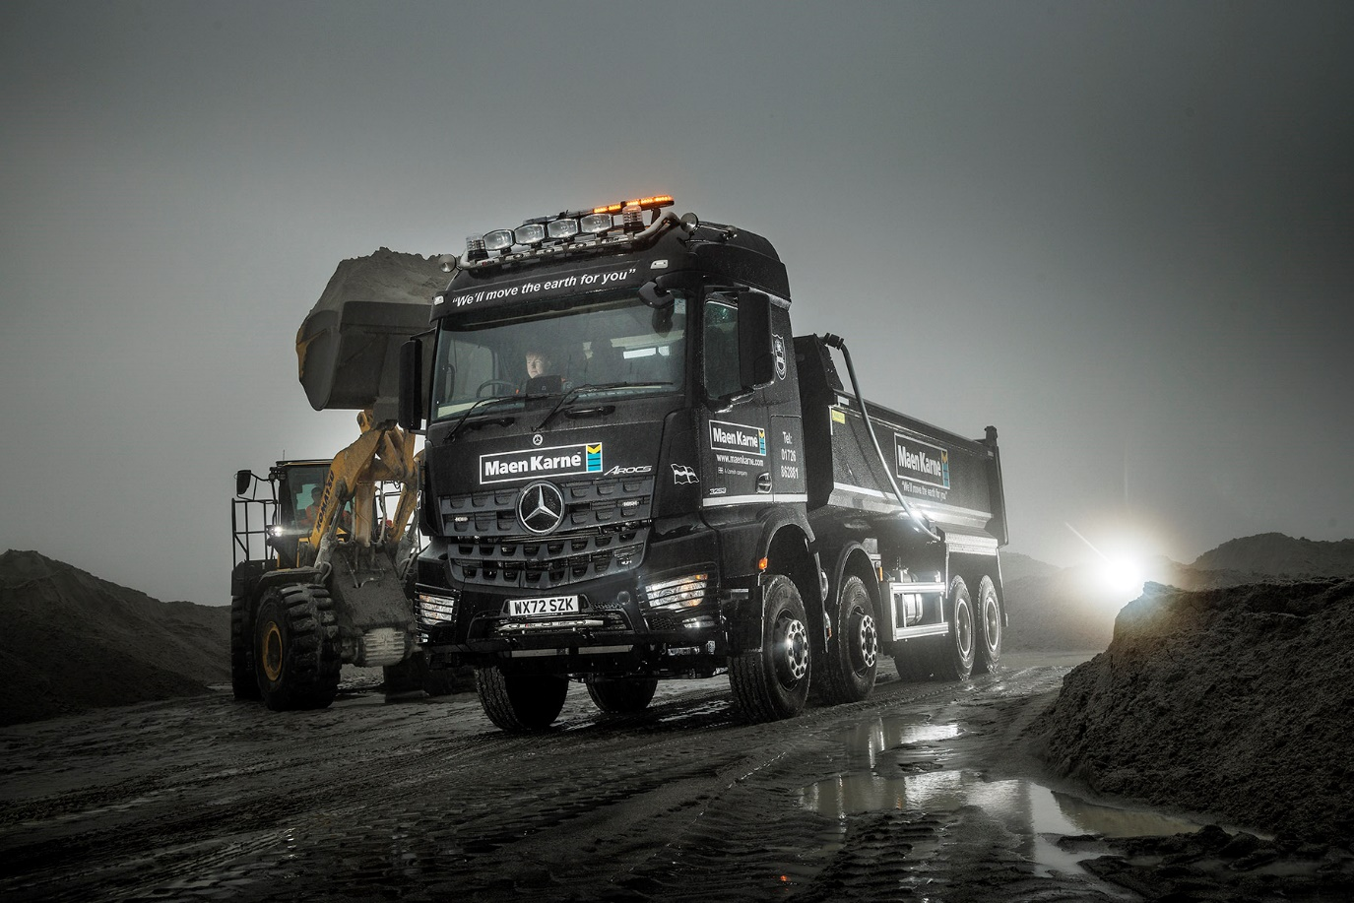

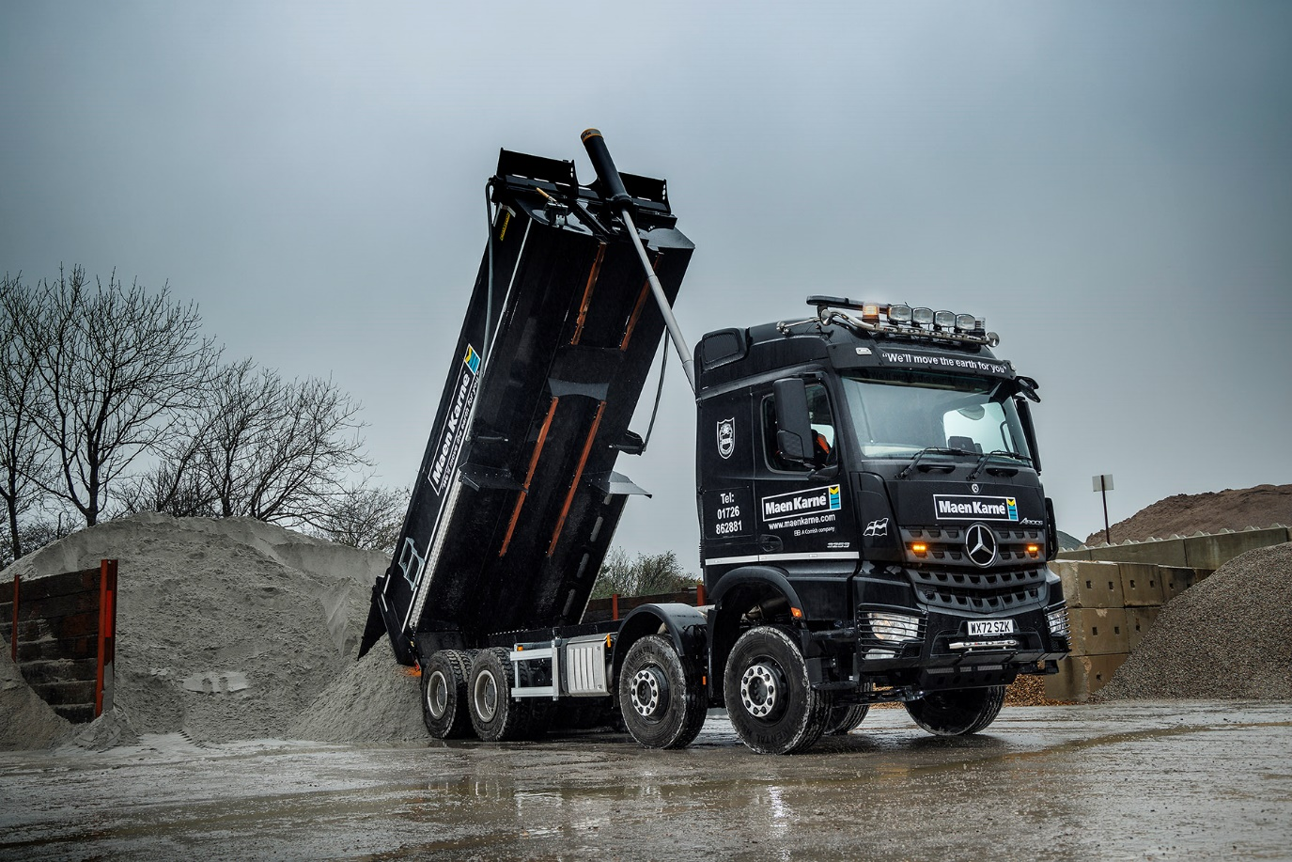

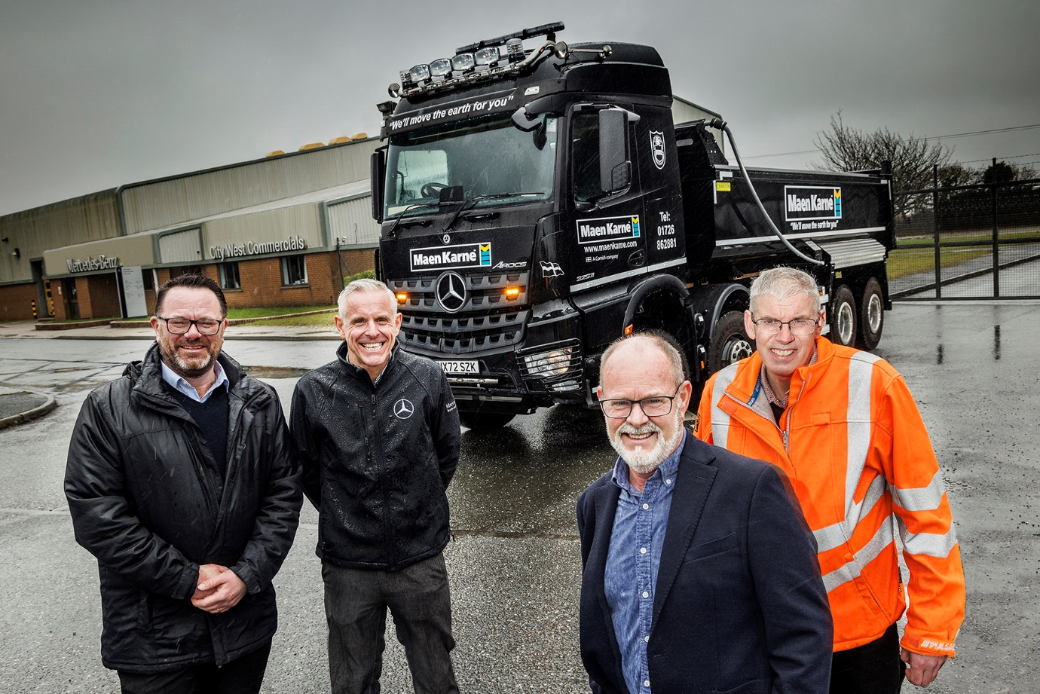

Productive partnership: From left, City West Commercials Sales Director Paul Ridout and Sales Executive Richard Smith, with Maen Karne Sales Director Martyn Lyme and Fleet Manager Darren Squire

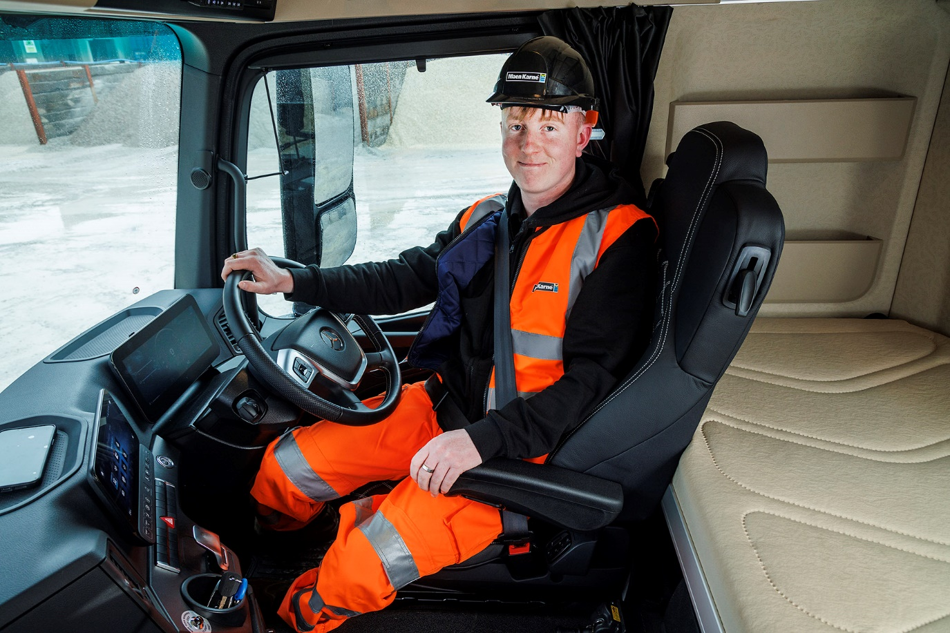

Power up: Maen Karne driver Morgan Carveth is impressed with the effortless performance and high-tech cab of his new Mercedes-Benz Arocs

ends

For more information, or to request bigger/higher-res image files, please contact:
John Ripley: 07771 484595, john.ripley@loopagency.co.uk

