

Date: 16 October 2019

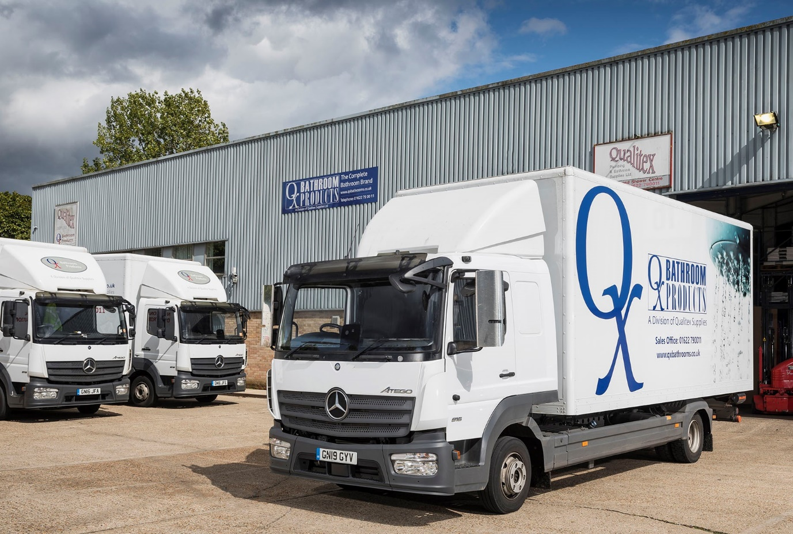

Thirty years later, bathroom distributor is still tapping into Mercedes-Benz Atego reliability

When your 7.5-tonners are covering upwards of 120,000 km a year, you need to know they will last the pace. For Qualitex Supplies, only the Mercedes-Benz Atego can be trusted to go the distance.

The three-pointed star has been an ever-present feature of its operation since 1990, when Managing Director Duncan Andrews established the family business in Aylesford, Kent.

The latest arrivals from local Dealer Sparshatt Truck & Van are a pair of Atego 816 models with fuel-efficient 5.1-litre in-line six-cylinder engines producing 156 kW (115 hp), and ClassicSpace L-cab sleepers. The subject of Mercedes-Benz Finance contract hire agreements, the new trucks are fitted with box bodies by C&D Fabrications, of Faversham, Kent.

They have joined a fleet of 14 other Atego 7.5-tonners. Half are based at Aylesford, while the other half work from Qualitex Supplies’ distribution centre in Mansfield. Another Atego, with uprated 9.0-tonne gross weight, ferries stock between the two locations, while the company runs five Mercedes-Benz Sprinter vans also supplied by Sparshatt.

Qualitex offers a next-day nationwide delivery service covering sanitaryware, baths, showers, mirrors, furniture and more, from the exclusive QX Range which it introduced in 1998. QX Bathroom Products are sold by most reputable showrooms, as well as building and plumbing merchants, throughout the UK.

Operations Manager Kevin Slevin has worked for Qualitex since 2001. “We choose Mercedes-Benz Atego trucks because they’re so robust and reliable,” he said. “Our vehicles can clock-up some pretty high mileages, yet breakdowns are few and far between.”

Qualitex is relatively unusual in specifying its 7.5-tonners with sleeper cabs. It does so because for areas such as the south-west, Wales and Scotland, the trucks are often assigned to multi-drop routes that keep them out on the road for a couple of days.

“Our drivers are perfectly happy to spend nights away in their Atego,” Mr Slevin confirmed. “There’s plenty of storage space for their stuff, and the bunk is nice and comfortable.”

He continued: “We’ve been working with the Dealer for three decades, and Sparshatt’s service is very good. Of course, issues will crop up from time to time but when they do so we work through them together in a spirit of partnership.”
Contract hire has long been Qualitex Supplies’ favoured method of acquisition. “It allows us to keep our fleet smart, up-to-date and fully compliant, and means we can budget with confidence knowing there are no nasty surprises around the corner,” said Mr Slevin.

Commenting on the manufacturer’s Service 24h emergency roadside assistance programme, he reported: “On the rare occasions that we’ve had to call for help the experience has invariably been positive.

“Staff at the Mercedes-Benz Customer Assistance Centre are calm and professional, and they’ve been able to get a technician out to the vehicle promptly. In most cases the problem has been rectified at the roadside but when that hasn’t been possible, they’ve arranged recovery to the nearest Dealer workshop.”

Despite the length of its association with Mercedes-Benz and Sparshatt, Qualitex Supplies tests the market from time to time to reassure itself that it is getting ‘best value’ for its fleet investments.

“We undertook a cost comparison exercise last year, and invited the representatives of three other truck brands to submit quotes,” recalled Mr Slevin. “We were pleased when this confirmed that our current arrangements are competitive; for our specification of vehicle, we’re certainly within the right price range.”

www.qualitex.co.uk

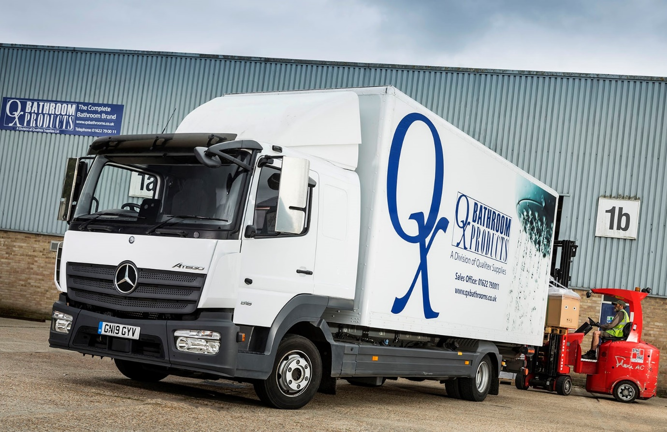

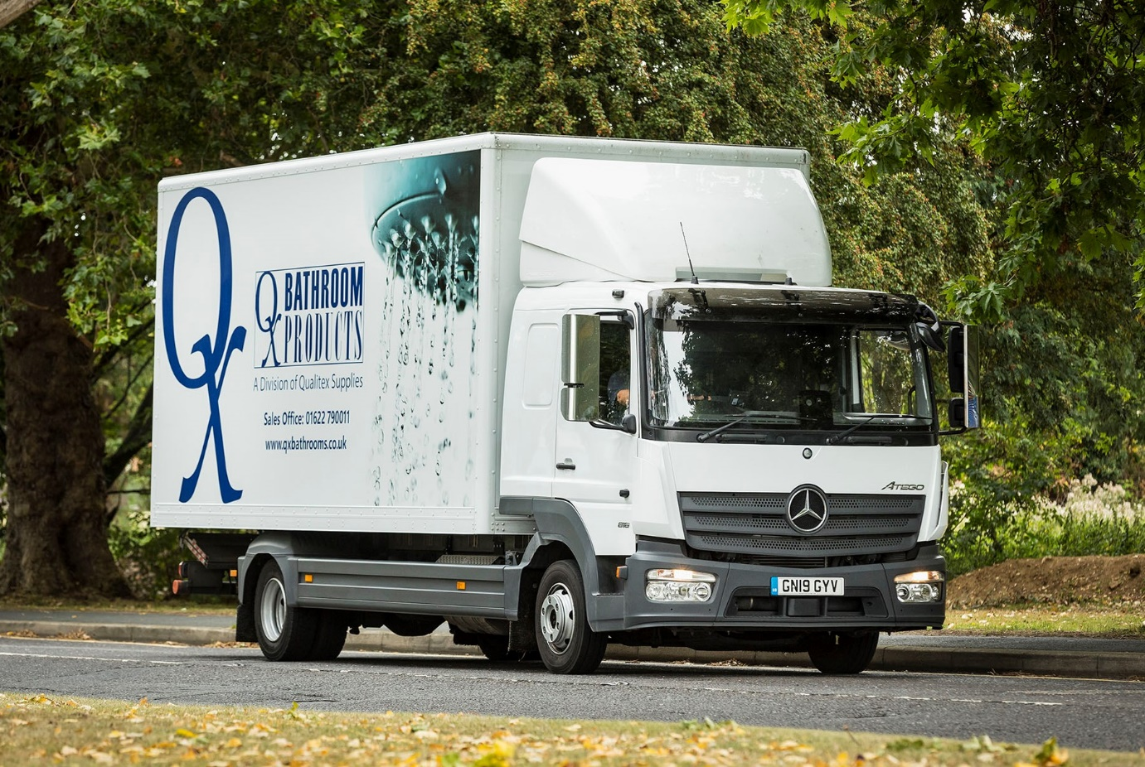

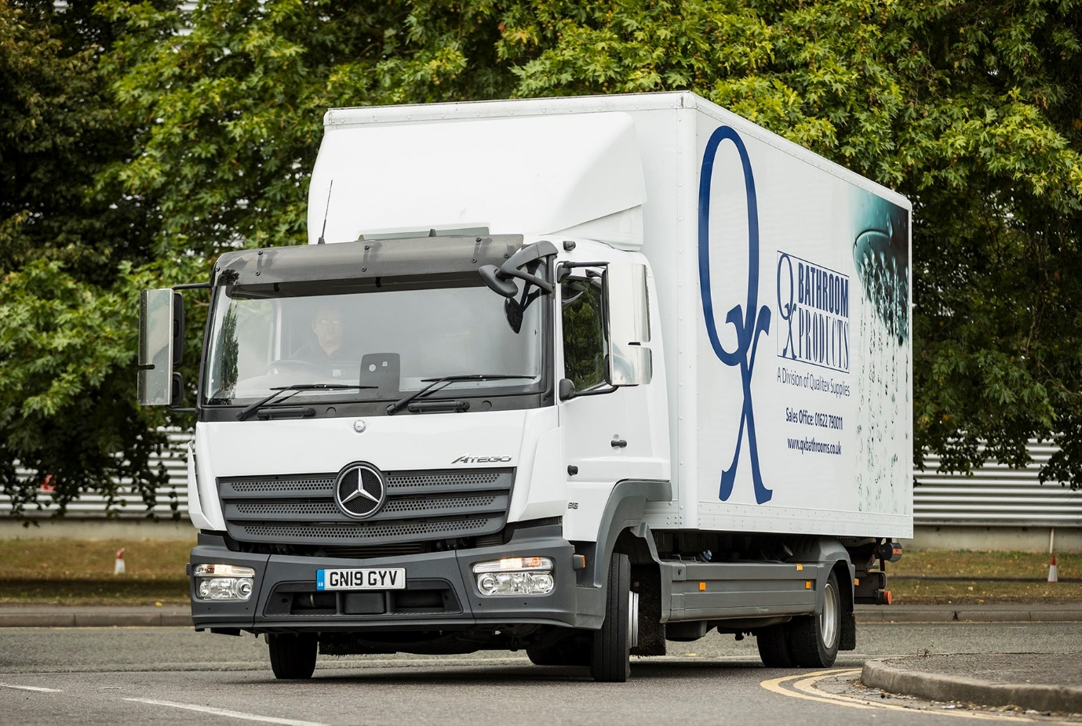

ends

For more information, or to request bigger/higher-res image files, please contact:
Steve Warren or John Ripley
Impact Communications, 01926 842126
Steve: 07770 470251, steve@impactcom.co.uk
John: 07771 484595, john@impactcom.co.uk

