

Date: 22 July 2020

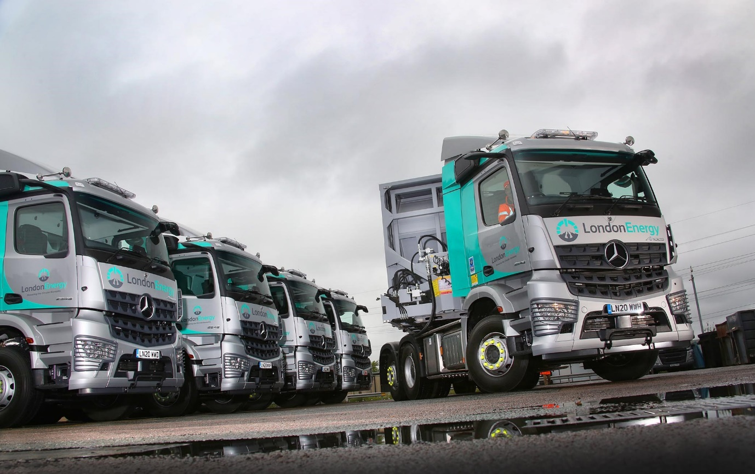

Five new-generation Mercedes-Benz Arocs with MirrorCam sharpen LondonEnergy’s safety focus

Waste management service specialist LondonEnergy has underscored its safety ethos by commissioning some of the first Mercedes-Benz Arocs tractor units in the UK to be equipped with ground-breaking MirrorCam technology.

The five trucks and their bespoke Legras (France) bulk trailers – four ejectors and a single walking floor – represent a total investment by the North London-based company of some £1.5 million.

The muscular Arocs will spend most of their time working between the flagship waste-to-energy plant on LondonEnergy’s 40-acre EcoPark head office site in Edmonton, and a household reuse and recycling centre in Islington. The two facilities are only six miles apart but the roads are heavily congested, so each unit typically makes the journey five times a day. The trucks will also service the company’s five other recycling centres, and transport wood and green waste to be recycled by third parties located nationwide.

MirrorCam’s compact cameras provide much improved visibility to the rear. By replacing the conventional mirrors responsible for major blind spots, they also ensure that drivers can see a lot more of what matters in front of them. The result is enhanced safety for cyclists and pedestrians, and less stress for the individual at the wheel.

Supplied by Dealer S & B Commercials, LondonEnergy’s new Arocs are the subject of a contract hire agreement with Hitachi Capital Vehicle Solutions. All 2548 models with ClassicSpace M-Cabs, they have 12.8-litre in-line six-cylinder engines that produce 350 kW (476 hp), and lifting tag axles for enhanced manoeuvrability. They also left the factory with uprated 8.0-tonne front axles, as well as optional, reverse warning alarms and red seat belts.

Mercedes-Benz Safety Packs incorporate the latest Active Brake Assist 5 emergency braking technology and Proximity Control Assist. Whereas the previous version relied solely on radar, Active Brake Assist 5 employs cameras as well, to provide dramatically improved responses at speeds of up to 50 kph. The system can apply full braking – as opposed to the 50% achieved previously – if it detects a pedestrian crossing the truck’s path.

To provide further protection for vulnerable road users Wisbech-based SB Components installed an extra window in each nearside door, while the tractors and their trailers are fitted with a full complement of safety cameras and scanners that comply with FORS (Fleet Operator Recognition Scheme) requirements.

MirrorCam’s compact, roof mounted cameras relay images to twin screens mounted inside the cab, on the A-pillars. London Energy’s Arocs also feature the radical new Multimedia Cockpit, which is standard equipment on the construction range’s Actros stablemate. Attractive and intuitive to operate, the new dashboard employs tablet-style twin screens instead of traditional switchgear.

LondonEnergy is owned by the North London Waste Authority (NLWA) and contracted to provide waste management services to seven of the capital’s boroughs. Last year it recycled more than 70% of all waste brought in by the general public. Rather than being sent to landfill the remaining 700,000 tonnes was processed and used to generate enough electricity to power more than 80,000 homes, thereby delivering a CO₂ saving of nearly 300,000 tonnes.

The company operates a fleet of 28 trucks. With the exceptions of nine 32-tonne hook-loaders, all are Mercedes-Benz tractor units sourced from S & B Commercials. Smartly finished in a new silver and high-visibility green scheme, the latest five are also fitted with roof-mounted light bars and air horns, and protective grilles over the headlights.

Transport & Logistics Manager Katie Blowes said the new trucks underlined LondonEnergy’s commitment to safety leadership within the resource management sector. “We’ve been running Mercedes-Benz vehicles since 2015, and they’ve always been reliable and cost-effective to operate,” she explained. “Our number one priority, however, is safety, so the introduction of MirrorCam was also key to our decision to acquire the new Arocs.”

Katie and a representative from Hitachi visited Mercedes-Benz Trucks’ Customer Experience Centre at Wentworth Park, near Barnsley, where they put the new system to the test. “We were hugely impressed,” she recalled.

“I really like the way the cameras adapt so that, for example, you never lose sight of the back of the trailer as you negotiate a roundabout. As MirrorCam also does away with the blind spots which can be a nightmare in London, it was the proverbial ‘no brainer’.”

The company’s drivers are equally enthusiastic. “They all love the system; even those who had initial reservations were very quickly won over,” reported Katie. “MirrorCam definitely helps to reduce fatigue, which is really important – the general public don’t realise how hard truck drivers work, and how tiring the job can be.”

LondonEnergy’s Mercedes-Benz trucks are inspected and maintained at S & B Commercials’ headquarters in Welham Green, Hatfield. “The Service team are brilliant,” she continued. “They keep us updated on progress, and are always honest – if there’s going to be a delay, for whatever reason, they don’t beat around the bush, or fob me off with what they think I want to hear. Instead, they tell it like it is, which is all I’ve ever asked.

“The Dealer also provides a collection and delivery service, which is great for us. On the rare occasion they’ve been stuck for a driver, we’ve done the drop-off or picked-up the vehicle ourselves. That’s the way we work – S & B help us, and we help them. It’s just a really good relationship.”

Peter Sharpe, LondonEnergy’s Managing Director, added: “We are extremely conscious of our responsibility to manage North London’s waste safely and effectively, and to minimise our impact on local communities. These vehicles combine state-of-the-art safety features with high efficiency, so reducing our fuel usage and emissions even further. New messaging on the trailers also provides a terrific opportunity to raise awareness of what is happening with waste generated locally.”

www.londonenergyltd.com

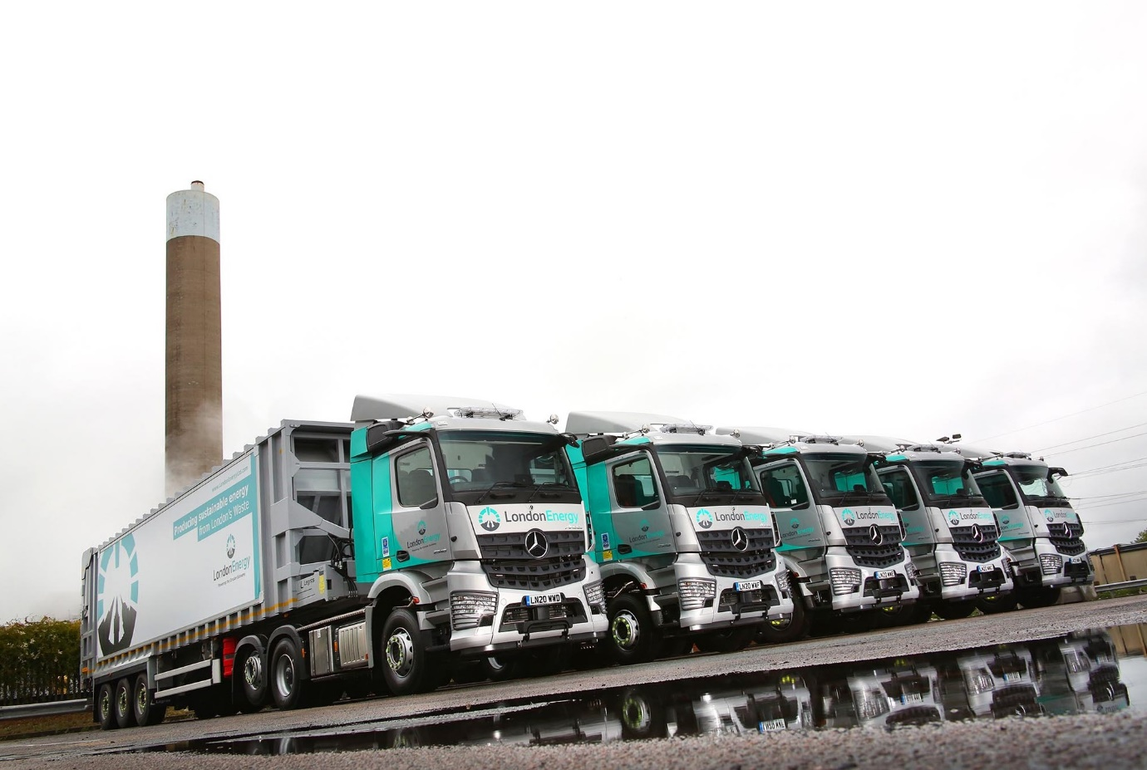

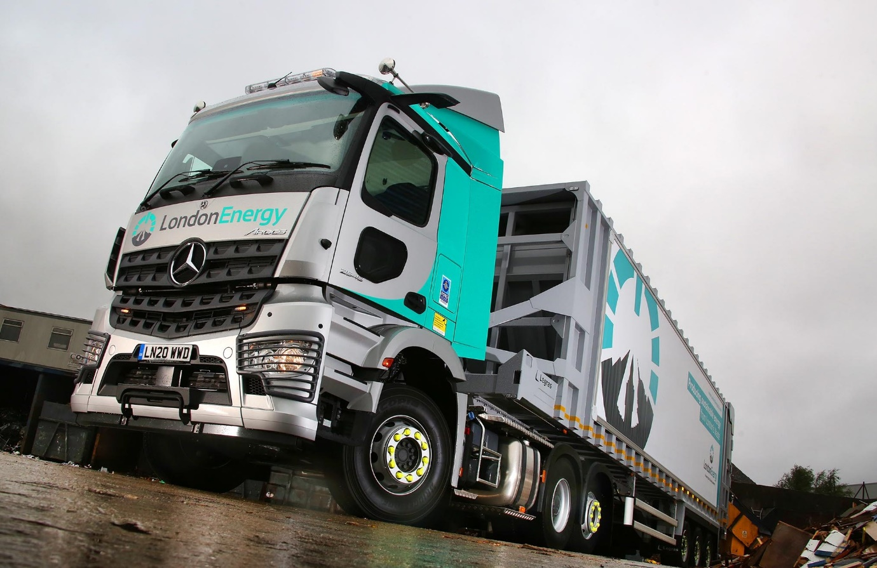

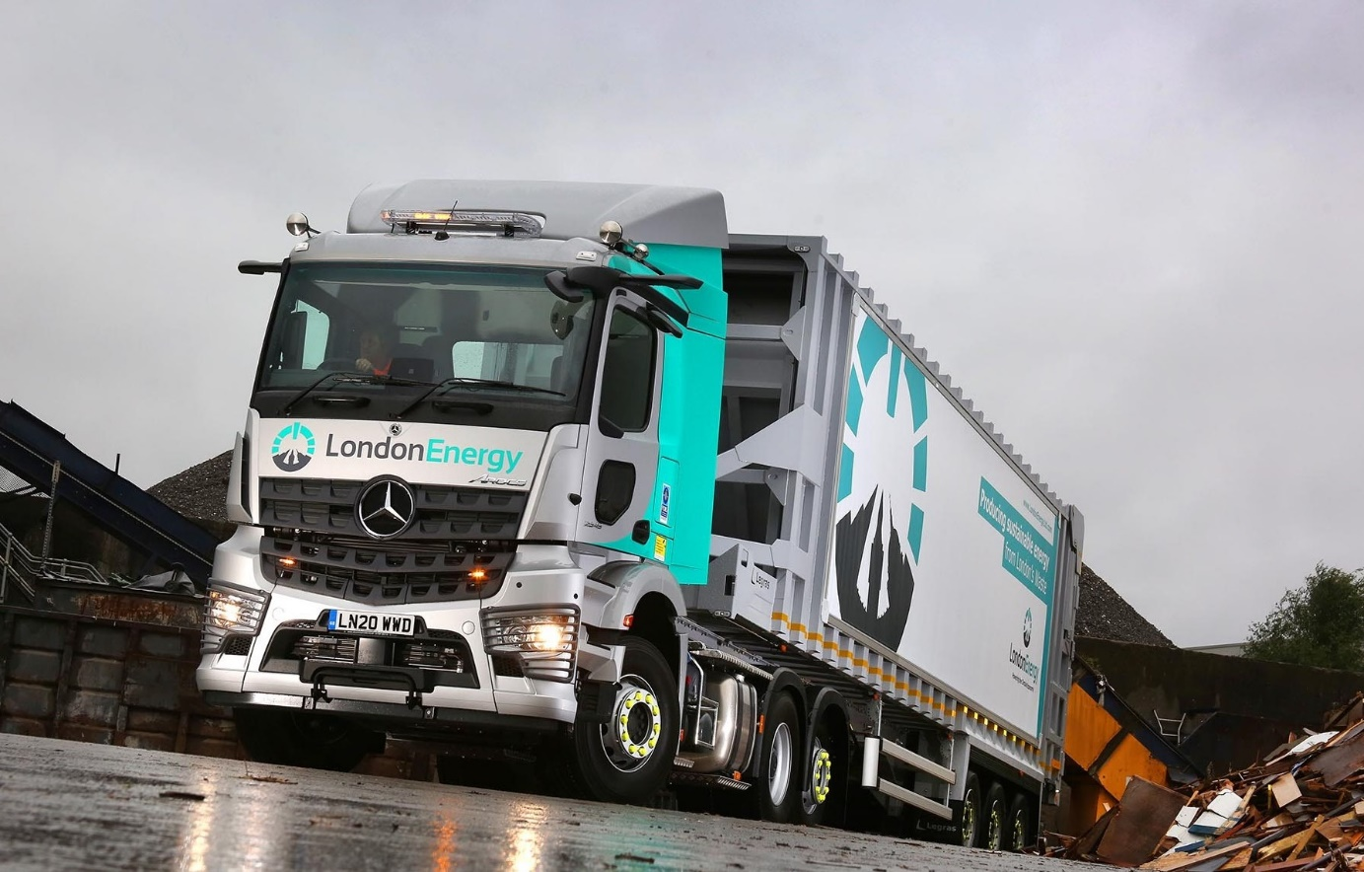

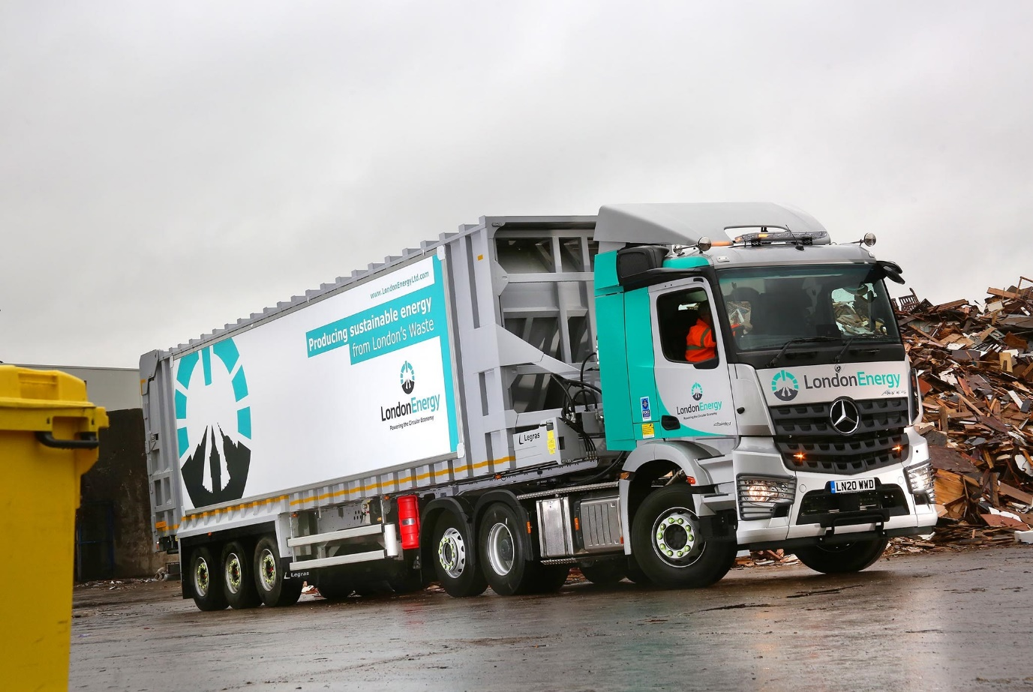

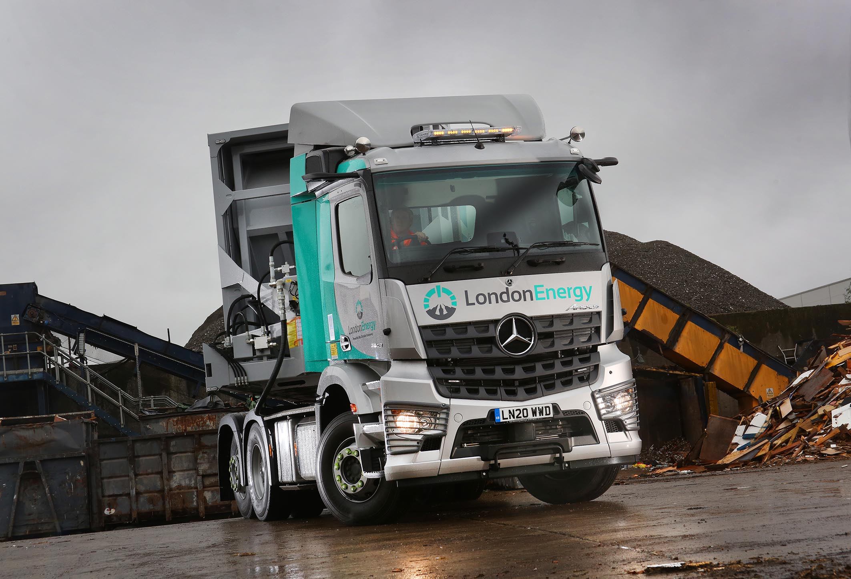

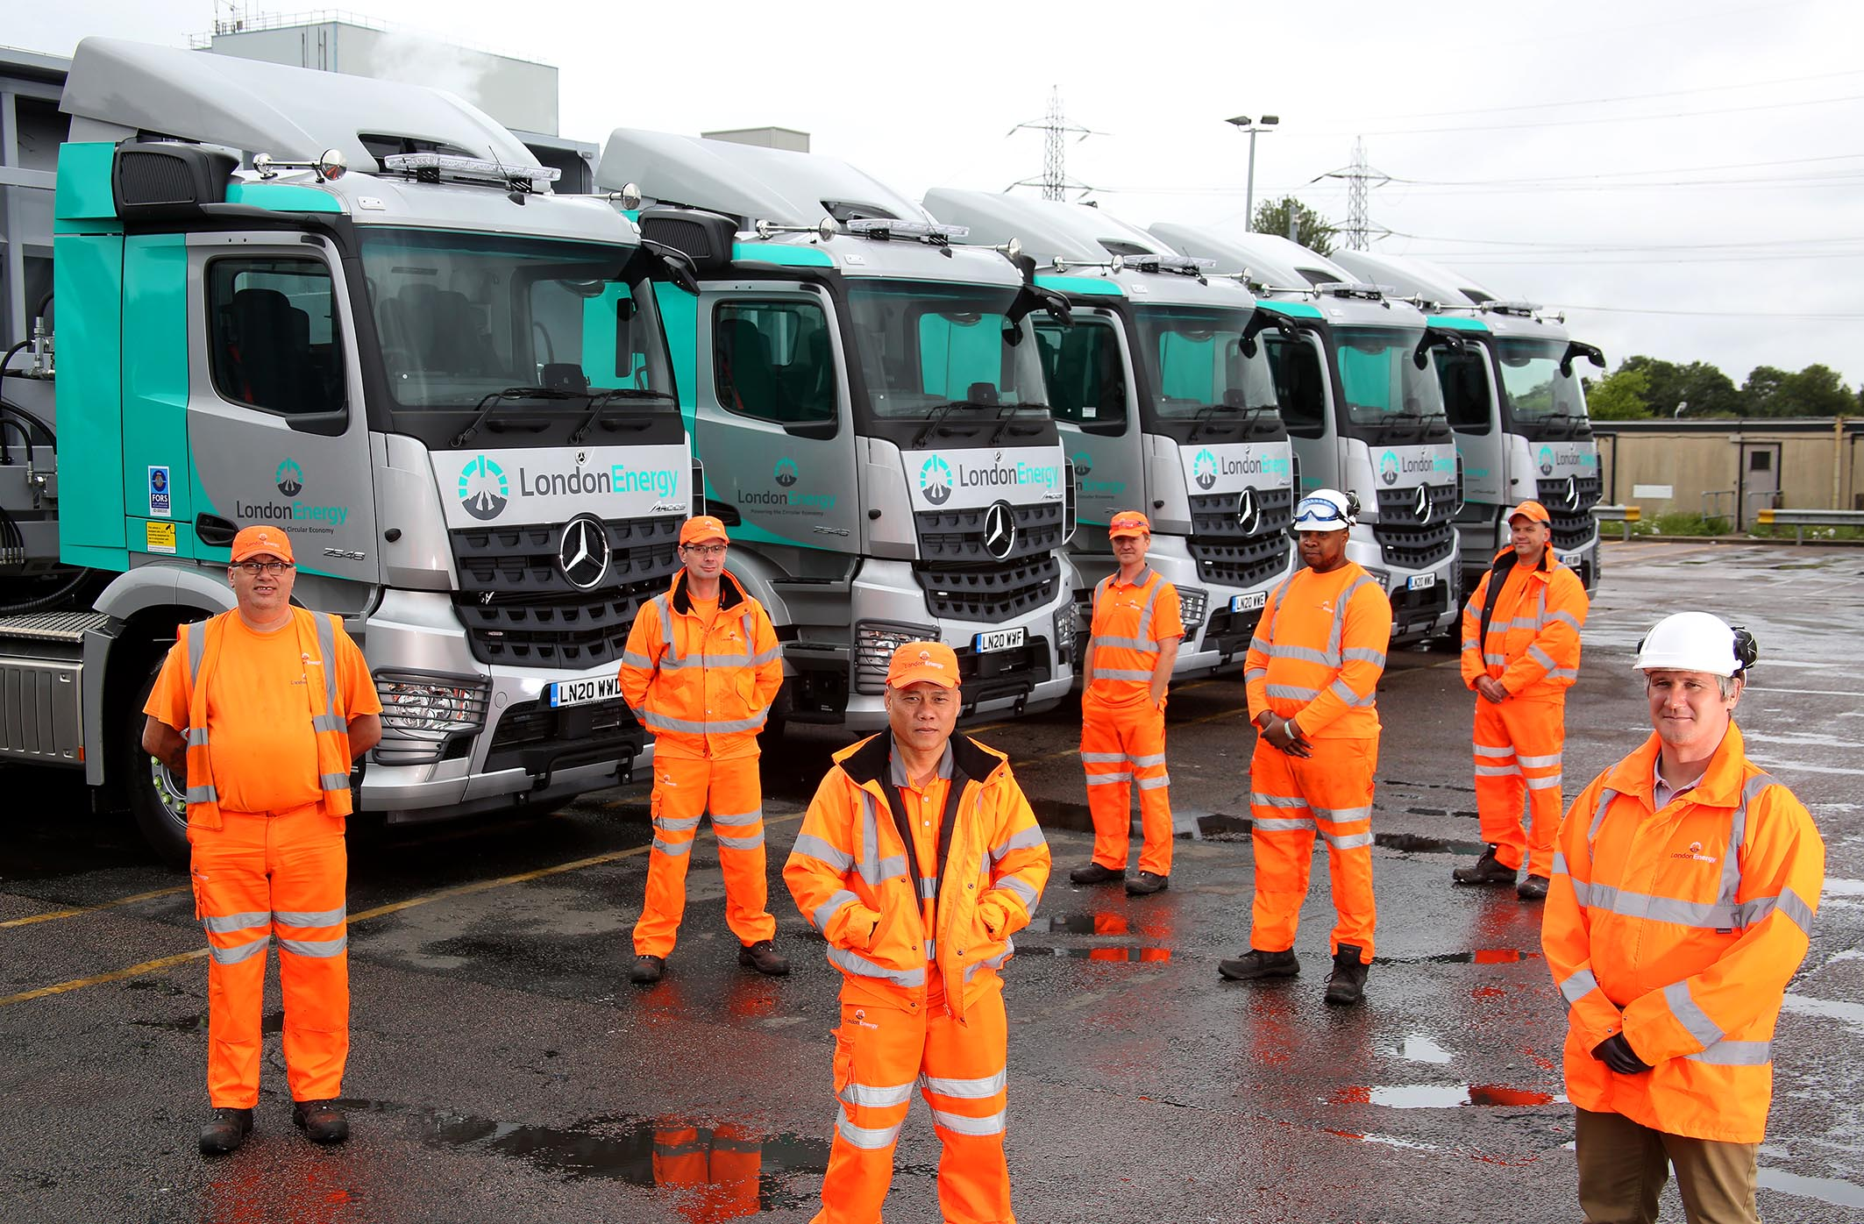

Clear-sighted: LondonEnergy drivers and colleagues with their new, MirrorCam-equipped Mercedes-Benz Arocs (NB The area was made safe for the photoshoot)

ends

For more information, or to request higher-res image files, please contact:

Jamie Fretwell at Mercedes-Benz Trucks UK Ltd
07712 519230, jamie.fretwell@daimler.com

or

Steve Warren or John Ripley
Impact Communications, 01926 842126
Steve: 07770 470251, steve@impactcom.co.uk
John: 07771 484595, john@impactcom.co.uk

About Mercedes-Benz Trucks UK Ltd
Mercedes-Benz Trucks UK Ltd is the sales and marketing organisation responsible for all Daimler truck products in the UK, including FUSO Canter. In 2019, the company registered 6,963 new trucks.

Mercedes-Benz accounted for 6,188 new trucks registered in 2019, making it the third-biggest truck brand in the UK. Meanwhile, FUSO registrations hit 775 – including 580 new trucks over 6.0-tonnes.

The flagship new Mercedes-Benz Actros which won the 2020 International Truck of the Year award, features seven core innovations including MirrorCam, Multimedia Cockpit and Active Brake Assist 5.

Our premium range of innovative trucks – Actros, Arocs, Atego, Econic and Unimog – draw upon more than 125 years of exceptionally high standards of quality, backed up by our promise of Trucks You Can Trust.

www.mbtrucks.co.uk

