

Date: 18 February 2020

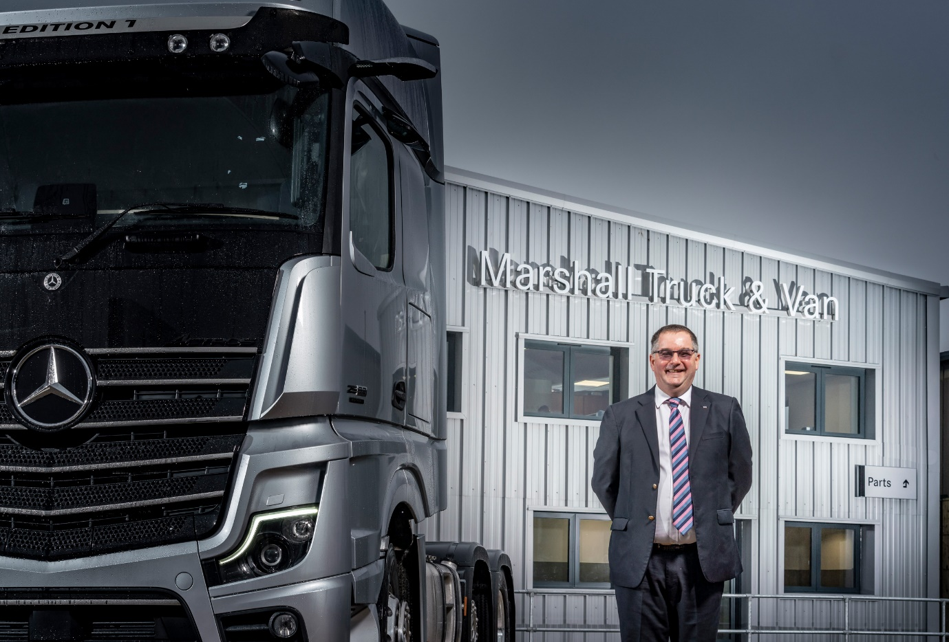

Committed to customers: New Head of Business Wayne Edwards says there is huge potential for growth at Marshall Truck & Van

Wayne’s world of opportunity knocks at
Mercedes-Benz Dealer Marshall Truck & Van

More than 40 years after he began his career as an apprentice truck technician, Wayne Edwards is gaining his first experience of working with the Mercedes-Benz brand.

The new Head of Business at Marshall Truck & Van could not have joined the manufacturer’s representative for Hampshire and Dorset at a more exciting time, following the recent opening of its purpose-built Dealership in Southampton.

Developed at a cost of some £4 million, and smartly fitted out to the latest Mercedes-Benz corporate standards, the facility on the Nursling Industrial Estate is immediately opposite the Dealer’s former premises, which it had outgrown.

The comprehensively equipped, much larger workshop remains open from 6am on Mondays until 1pm Saturdays, while the two-storey Parts department holds wider and deeper stocks than was previously possible.

Crucially, the two-acre site provides plenty of room for customers, including drivers of tractor unit and trailer combinations, to manoeuvre and park. It also serves as a base for a pair of dedicated Service 24h vans, which are allocated to elite technicians who provide operators of Mercedes-Benz trucks, FUSO light trucks, and Mercedes-Benz vans with round-the-clock emergency roadside assistance, 365 days a year.

“With its solar panels and rainwater capture system this state-of-the-art facility is the most efficient I’ve had the pleasure of working with,” enthused Wayne. “The very substantial investment it has made here in Southampton underlines the commitment of our parent company Marshall Motor Holdings plc to truck and van customers.

“Indeed, the drive and determination of MMH Chief Executive Daksh Gupta to provide commercial vehicle operators with the industry’s finest levels of service and back-up was instrumental in attracting me to this new role.”

Originally from Manchester, Wayne moved with his family to North Yorkshire 32 years ago. By then he had left the workshop and was selling trucks. He went on to hold a succession of senior management positions and shareholdings with various dealerships, including one of the biggest multi-franchise groups in the country.

French and Dutch truck manufacturers feature most prominently on Wayne’s CV, although he has represented other vehicle marques as well. “I have had some exposure to the van sector, but in truth I’m a truck man through and through,” he acknowledged.

“That means I understand the legislative regimes within which truck customers have to operate, and I appreciate the fundamental importance of restricting downtime to an absolute minimum. Unless a vehicle is on the road and earning, it’s costing its owner money.”

He continued: “This an opportunity I’m relishing. Until now Mercedes-Benz has been a competitor, and a formidable one at that. It’s an aspirational brand with which I’m very proud, finally, to be associated.”

In addition to its new Southampton Dealership, Marshall Truck & Van has headquarters in Fareham and other branches in Poole and Andover. The Dealer’s dedicated van site in Croydon was extensively refurbished last year, and it recently began retailing and servicing vans from the Mercedes-Benz passenger car outlet which the MMH Group also owns, on Portsmouth Motor Park.

He continued: “There is huge potential to grow this business. The Mercedes-Benz and FUSO ranges include some of the most technically advanced commercial vehicles on the road, while recent investments at Nursling and elsewhere within our branch network mean we currently have workshop capacity which is rare within the sector.

“I’ve also inherited a very talented and motivated team, with a nice blend of youth and experience. All they need now is leadership and support. Given my track record in this business, I don’t have anything to prove to myself or anyone else for that matter. Much of my job satisfaction, therefore, will come from developing our people, helping them to grow and fulfil their potential. This accords very much with our parent company’s ethos.”

Marshall Motor Holdings acquired the Mercedes-Benz Trucks and Mercedes-Benz Vans franchises for Hampshire and Dorset in 2016, when it purchased the previous Dealer’s parent company. The £107-million deal was the biggest in the automotive sector for 10 years.

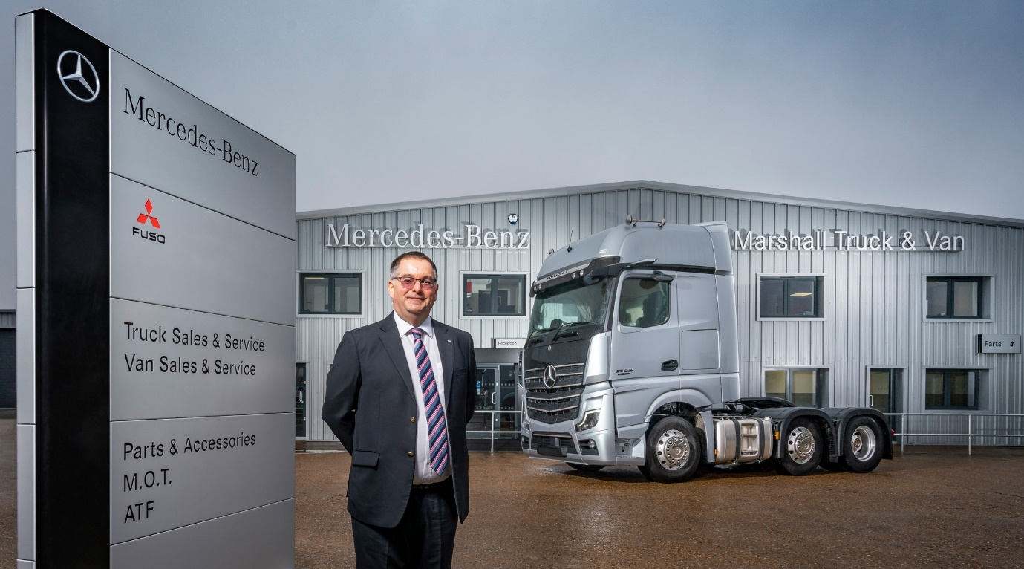

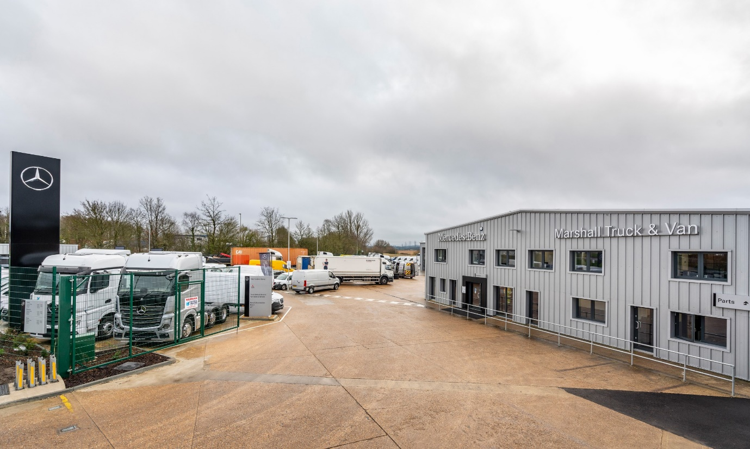

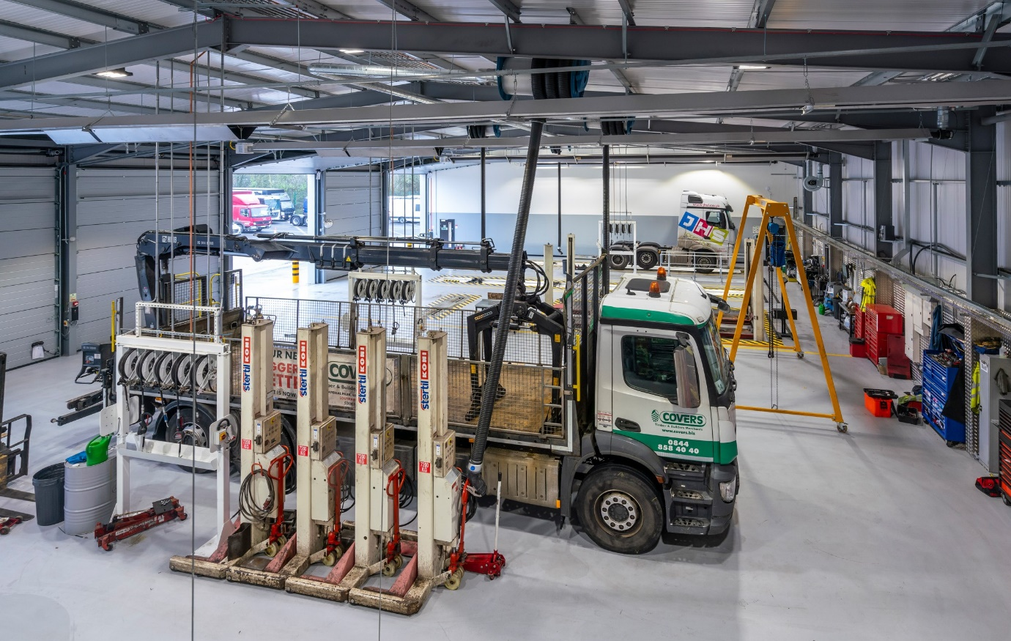

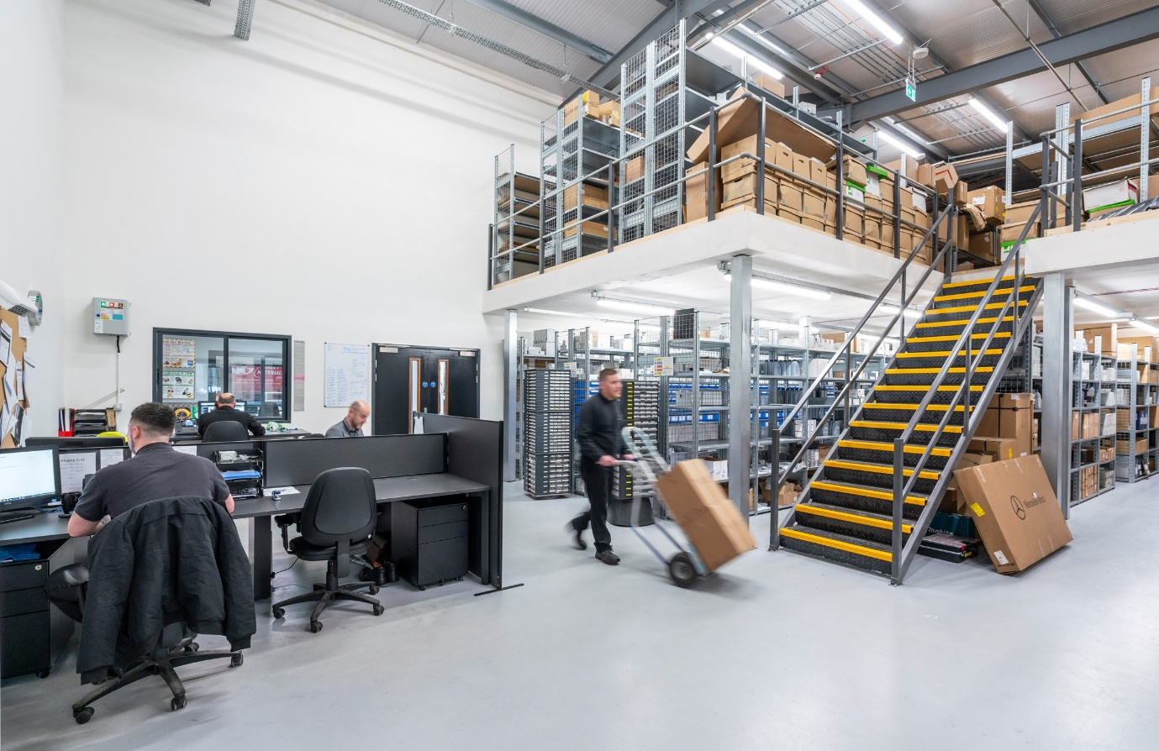

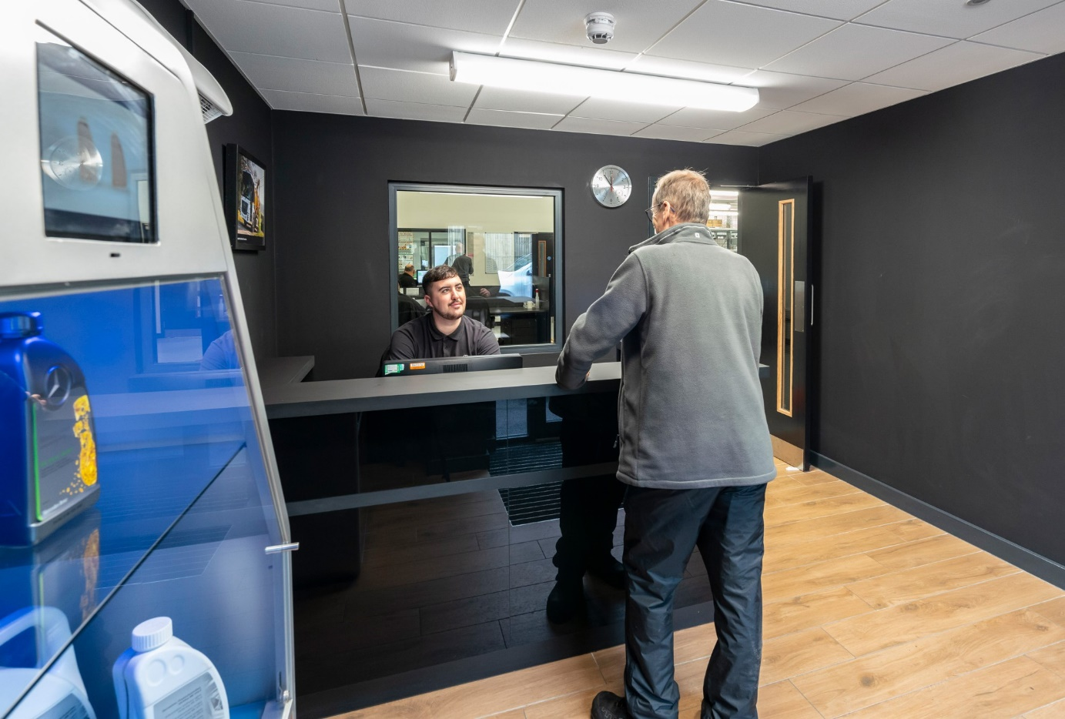

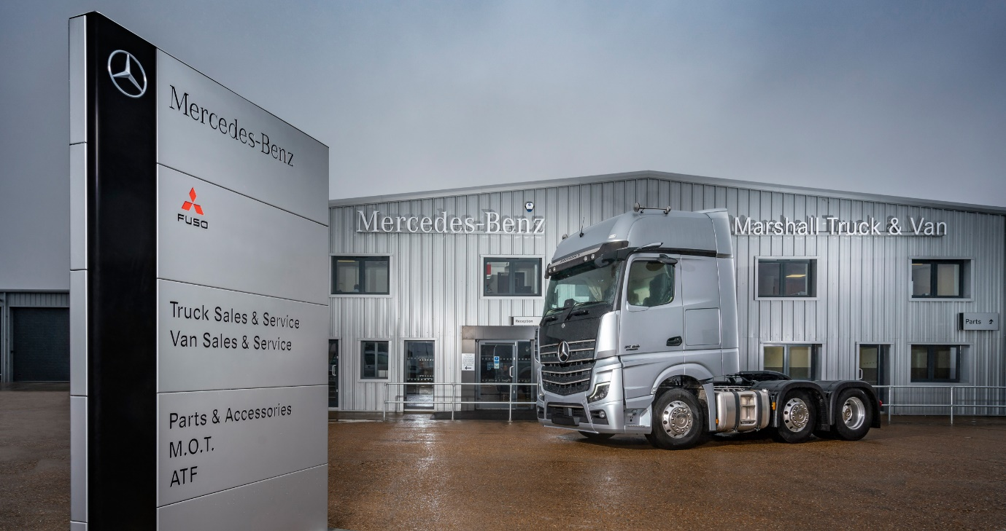

ends

For more information, or to request bigger/higher-res image files, please contact:
Steve Warren or John Ripley
Impact Communications, 01926 842126
Steve: 07770 470251, steve@impactcom.co.uk
John: 07771 484595, john@impactcom.co.uk

