

Date: 26 November, 2021

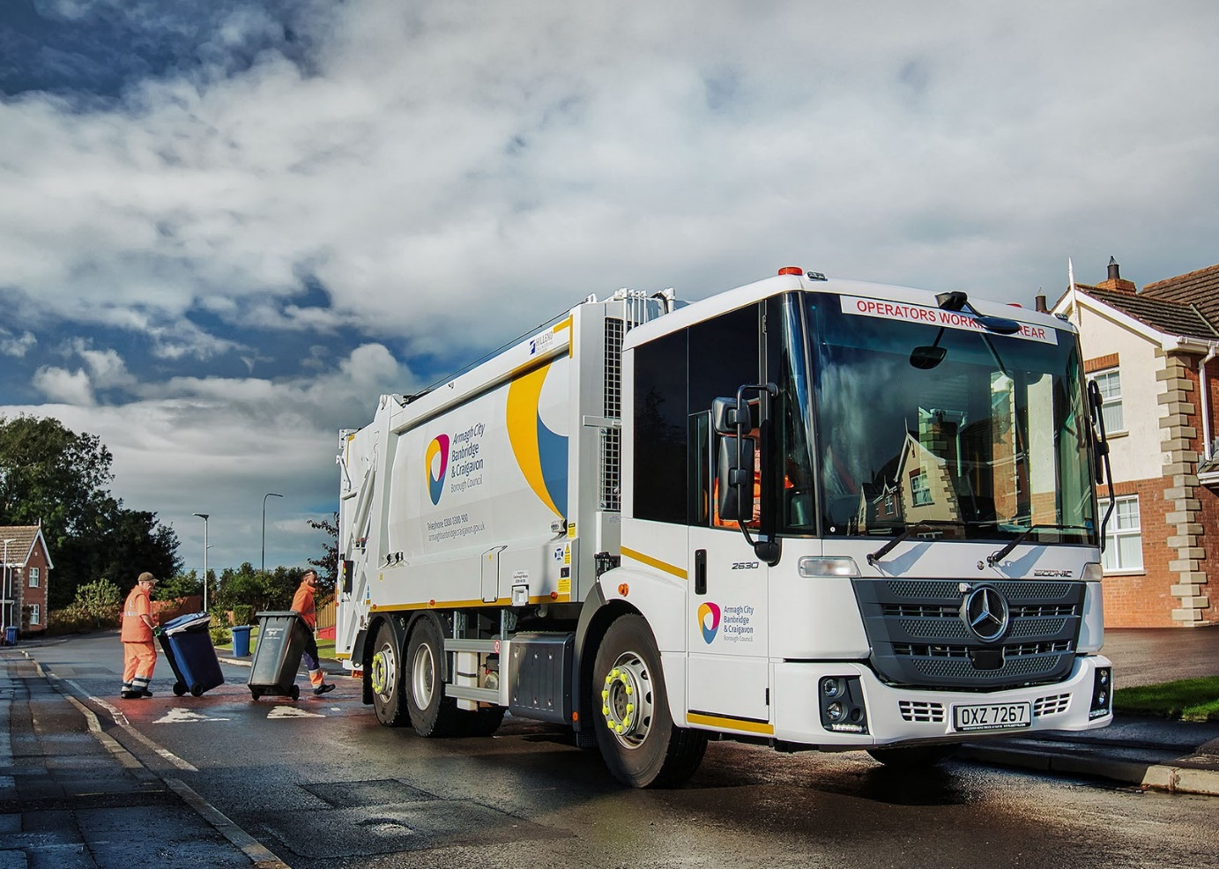

Refuse collections are ‘as easy as ABC’ with Farid Hillend Engineering-bodied Mercedes-Benz Econics

Impressive reliability combined with positive feedback from crews and customer-focused parts back-up all help to explain why waste and recycling managers at Armagh City, Banbridge and Craigavon Borough Council are delighted to be running another six
Mercedes-Benz refuse collection vehicles.

The 26-tonne Econics were supplied by MBNI Truck & Van, of Newtownabbey. It worked closely on the successful tender with primary contractor Castlereagh Motors, which represents specialist bodybuilder Farid Hillend Engineering in Northern Ireland.

Armagh City, Banbridge and Craigavon Borough Council – or ABC Council as it is commonly known – was established in 2015, and is Northern Ireland’s second largest local authority by population and economic activity.

Its latest 6x2 Econics have rear steer axles for enhanced manoeuvrability on residential streets. As 2630 L variants they are powered by 7.7-litre in-line six-cylinder engines that produce 220 kW (299 hp) and are paired with six-speed automatic Allison gearboxes. Their Powertrak compaction bodies, meanwhile, have 21m³ capacities and are fitted with Zoeller Delta high level bin lifts.

The trucks’ introduction coincided with the launch of a new service for the residents of Armagh. Collections of recyclables in kerbside boxes and food caddies were previously outsourced to an external supplier. This arrangement had been in place for nearly 20 years, but came to an end this month (November) following a public consultation that saw 85% of respondents opt for the wheeled bins already used in other areas.

Waste Development Manager Lisa Doherty explained: “We’ve effectively harmonised the system by bringing the Armagh collections in-house. The result is a single, standardised, council-managed service, with the efficiencies this implies, for all residents across the borough.”

To deliver this extended service Armagh City, Banbridge and Craigavon Borough Council has been growing its refuse and recycling fleet, which now extends to more than 70 trucks of various sizes and marques. All are inspected and maintained at its purpose-built workshop on the Carn Industrial Estate, Portadown.

These vehicles make fortnightly collections of dry recyclables in green bins and organic waste in brown bins, and, on alternate weeks, the residue in black bins. Of all the waste it collects, 54% is currently recycled but the authority is focused on improving this rate by reducing contaminations – a recent campaign urged households not to put items such as foil, aerosols, and shampoo and bleach bottles into the general rubbish.

The authority’s fleet already included a number of Mercedes-Benz Econics that were supplied by MBNI Truck & Van five years ago. Workshop Manager Simon Smyth confirmed: “In terms of uptime those vehicles have been excellent. They’ve given us very few problems, while the parts delivery service we receive from the team at the Dealer’s Dungannon branch is first class.”

He added: “The Mercedes-Benz is also liked by a lot of our crews. It’s exceptionally well built, easy to access and comfortable, thanks to its spacious, air-conditioned cab and full air suspension.”

The Econic affords drivers an unrivalled view. The truck attracts the maximum five stars from Transport for London’s Direct Vision scheme, thanks to its deep, panoramic windscreen, and the full-height, glazed folding side door specified by Armagh City, Banbridge and Craigavon Borough Council. This, coupled with the low seating position, allows drivers to make direct eye contact with cyclists and pedestrians at junctions or in traffic queues.

The Active Brake Assist 5 emergency braking aid is also standard equipment. Active Brake Assist 5 can detect vehicles ahead and stationary objects in its own lane, at speeds of up to 56 mph (90 km/h). Detection of a dangerous situation triggers a three-stage reaction: first, the system warns the driver with visual and audible alerts; then, if the driver fails to react, it applies partial (approximately 50%) braking; finally, if the driver has still not intervened, it initiates maximum braking to bring the truck to a halt, activating the hazard warning lights to alert drivers behind.

The new sensor fusion has dramatically improved response to moving pedestrians at speeds of up to 31 mph (50 km/h). Active Brake Assist 5 is now capable of applying full braking when encountering pedestrians crossing its path, approaching from the front or walking ahead. Not only does this remarkable technology increase safety for vulnerable road users and vehicle crews, but it also helps to relieve stress for drivers.

Meanwhile, the electronic architecture required for operation of Active Brake Assist 5 means Armagh City, Banbridge and Craigavon Borough Council’s new Econics benefit from Electronic Parking Brakes too. The EPB is applied automatically when the engine is switched off. When the truck is at a standstill after emergency braking, the automatic HOLD function also prevents it from rolling away.

Farid Hillend Engineering added to the vehicles’ comprehensive safety armouries by fitting Backeye®360 camera systems.

www.armaghbanbridgecraigavon.gov.uk

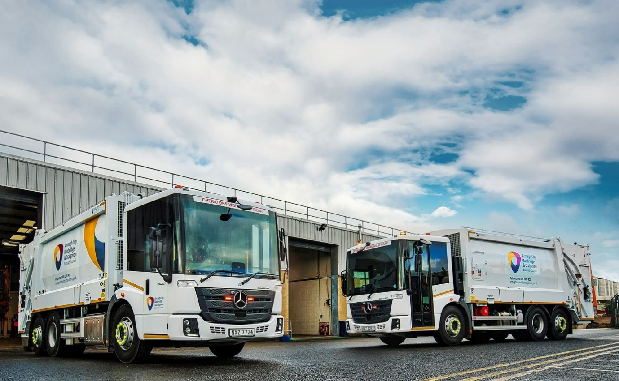
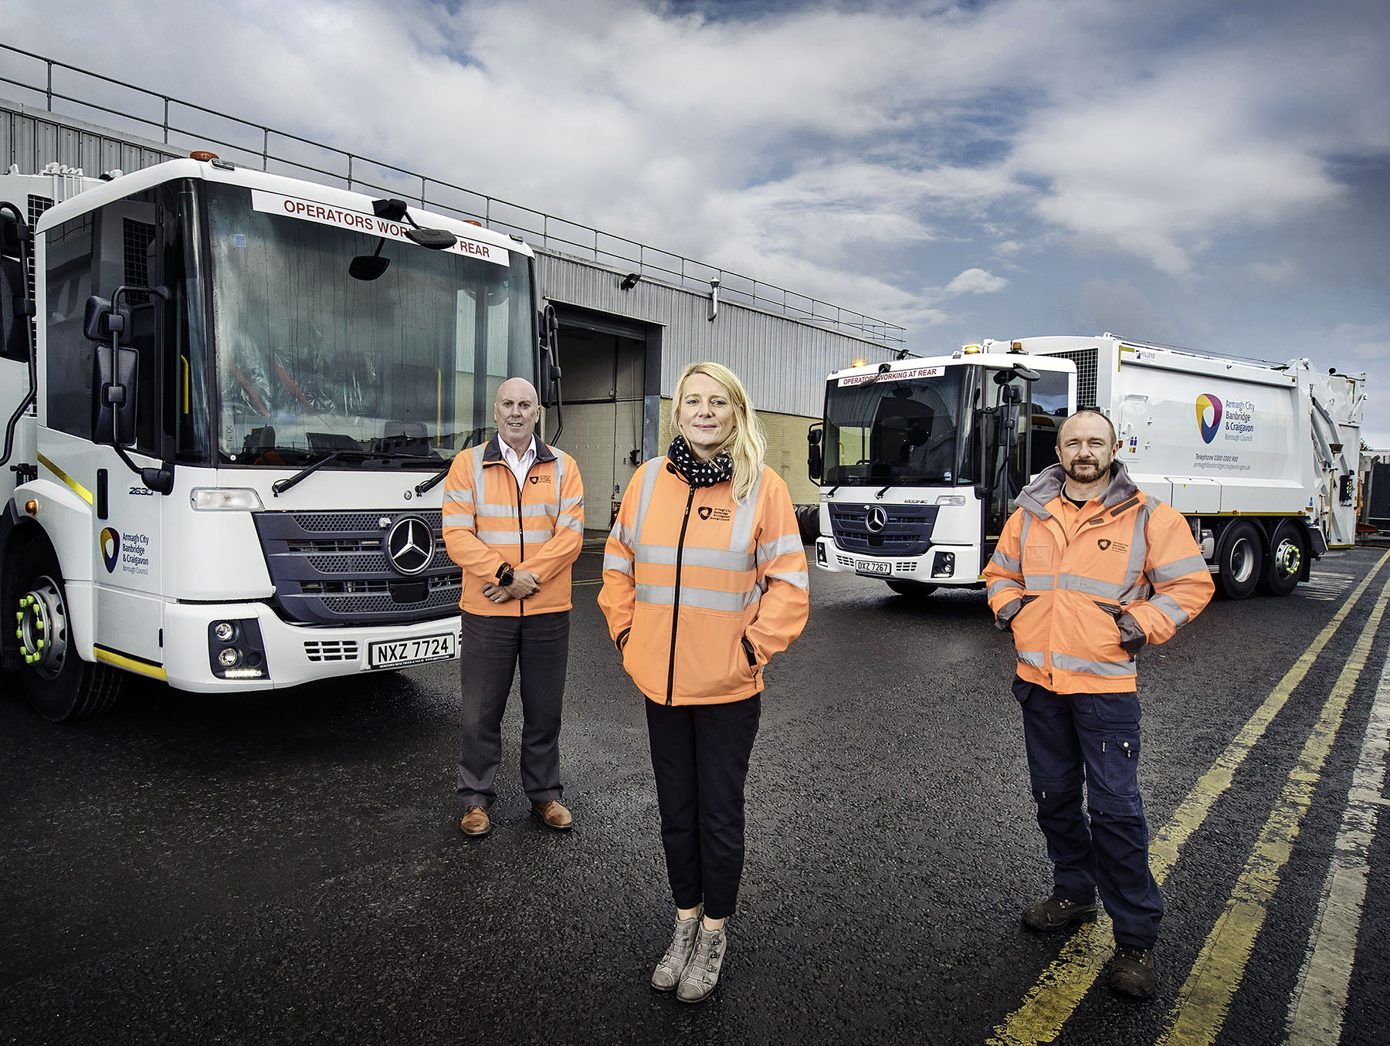

Delivering efficiencies: Pictured with two of their new Mercedes-Benz Econics, Armagh City, Banbridge and Craigavon Borough Council’s Waste Development Manager Lisa Doherty, Operations Manager John Farrell, left, and Workshop Manager Simon Smyth are all playing their parts as the authority strives to further improve its recycling rates

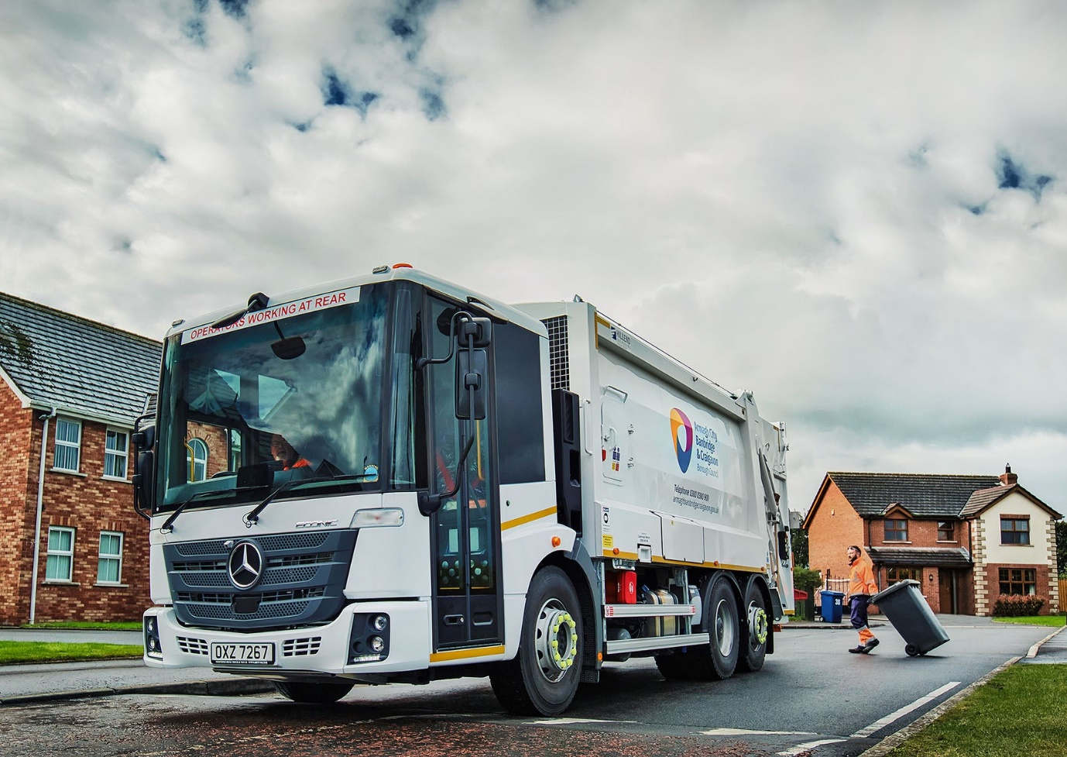

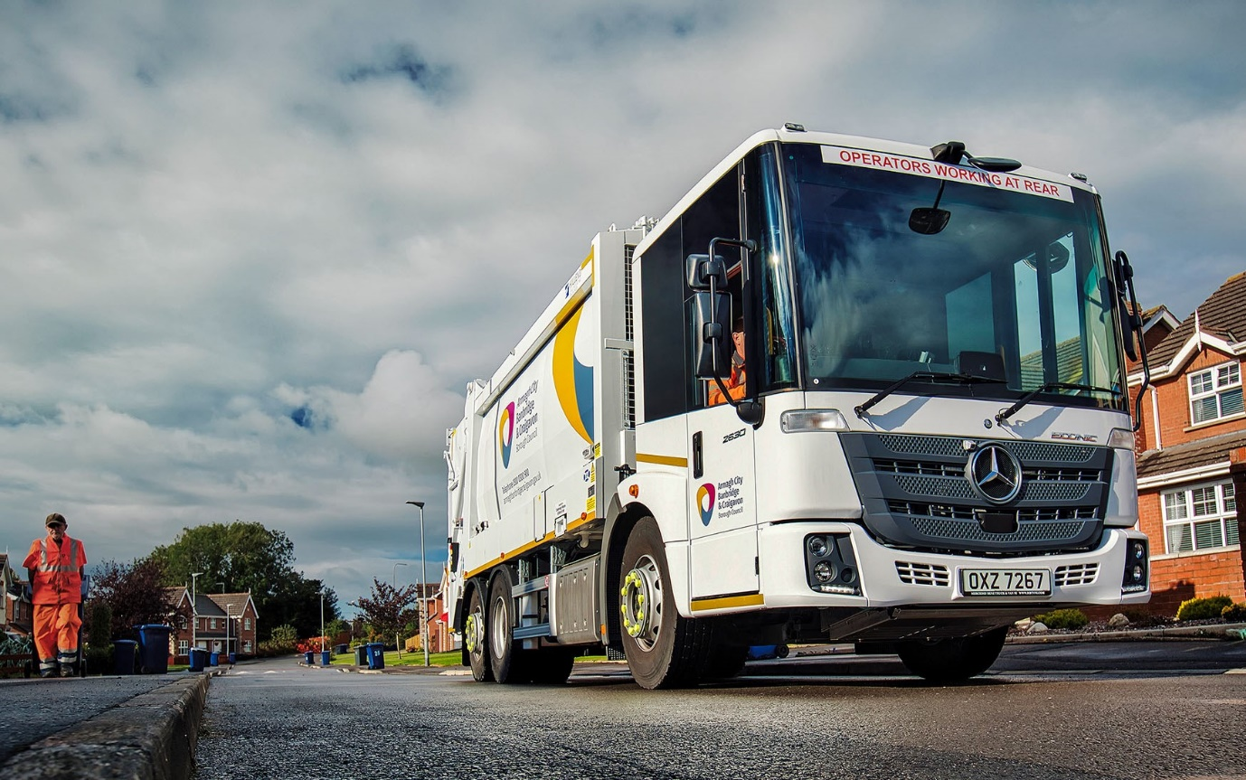

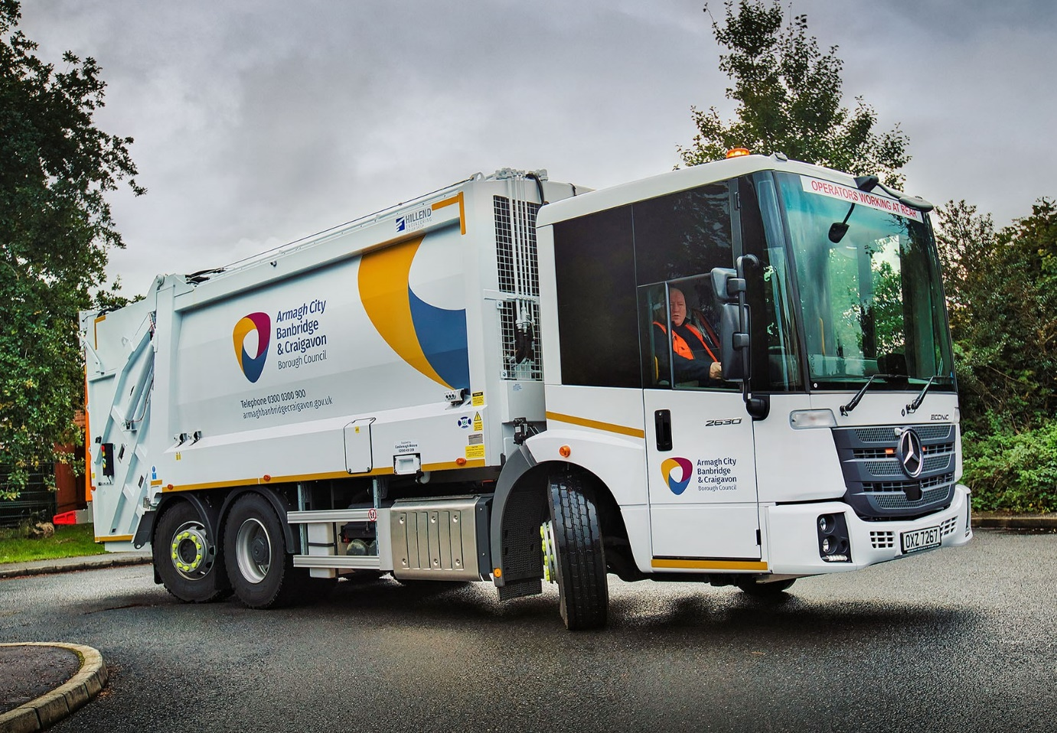

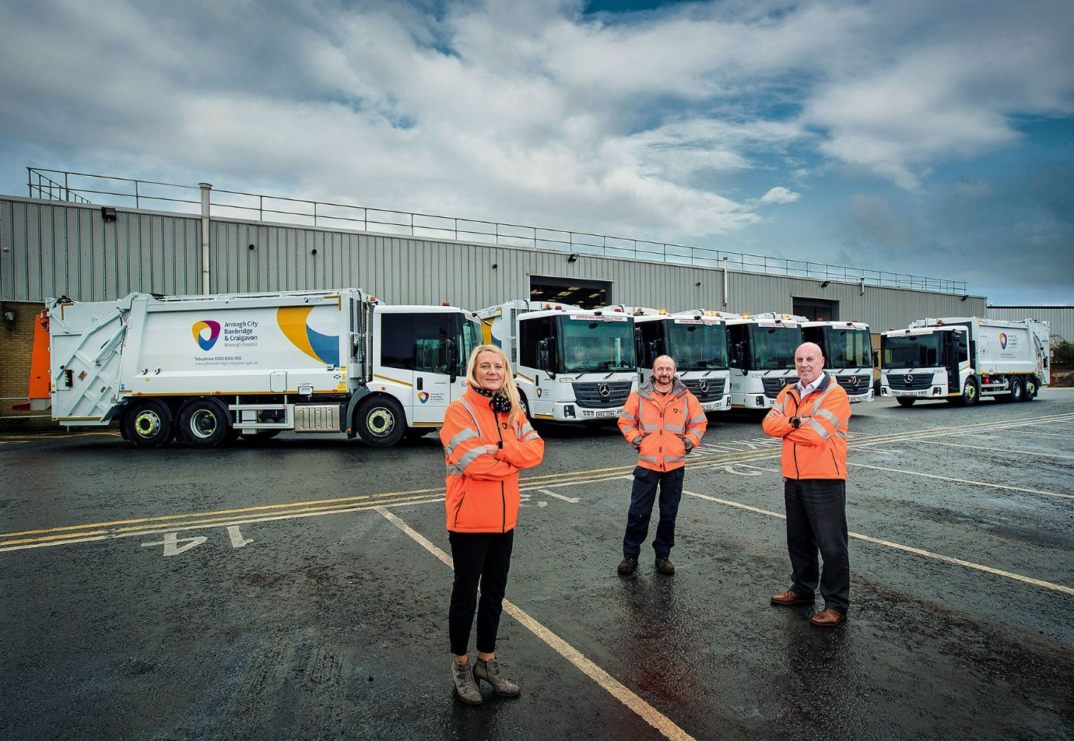

ends

For more information, or to request bigger/higher-res image files, please contact:
Steve Warren or John Ripley
Impact Communications
Steve: 07770 470251, steve@impactcom.co.uk
John: 07771 484595, john@impactcom.co.uk



