

Date: 21 May 2021

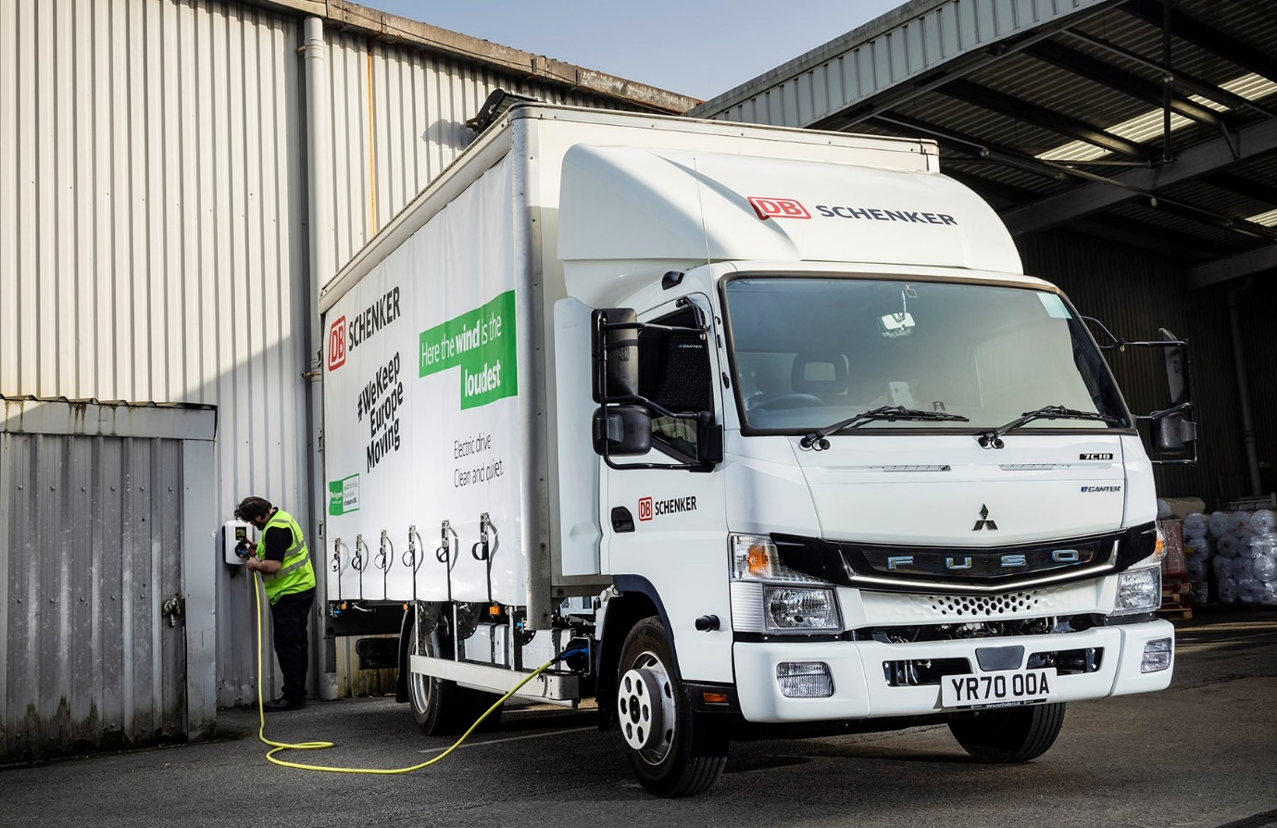

DB Schenker charges ahead with zero-emission FUSO eCanter light truck

Logistics leader DB Schenker has taken another step forward in its Europe-wide drive towards zero-emission urban deliveries by commissioning its first UK-based, all-electric FUSO eCanter.

The new 7.5-tonner is operating from Bradford and works in and around the city centre. Its curtainside body is by En-Veco, the specialist electric vehicle arm of West Midlands-based bodybuilder Bevan Group, which also fitted its 1,000kg Dhollandia tail-lift.

The truck leaves DB Schenker’s depot each morning with its batteries fully charged, and will typically cover up to 90km while making as many as ten deliveries and a similar number of collections during each round. The eCanter returns to base at the end of the day, its laden weight only rarely having dropped below 6.0 tonnes, and is then recharged overnight.

DB Schenker Fleet Manager Dave Shepherd observed: “With its compact footprint and impressive manoeuvrability, the eCanter is clearly well suited to inner-city deliveries.

“Not only does this vehicle offer the reliability and competitive running costs we need, but as legislation moves on, and ultra-low emission zones become more widespread, as well as stricter, it can help us to future-proof our delivery operation.”

The eCanter is the world’s first fully electric light-duty truck to enter series production and represents a major advance in the battle to improve air quality in towns and cities. Its electric drivetrain features six 13.8 kWh lithium-ion batteries, giving a total power output of 82.8 kWh (66 kWh usable). The permanent-magnet motor delivers 129 kW (180 hp) via a single-gear transmission in the rear axle.

Mr Shepherd reported: “The eCanter is certainly easy to use and our drivers like it. They’ve benefited from specialist training in the most efficient use of the braking regeneration function, which is helping us to get the maximum available range from the driveline.”

That training was provided by Senior TRUCKtrainer Alistair Colquhoun, from Mercedes-Benz Trucks’ Wentworth Park complex – the FUSO light truck range is sold and supported by Mercedes-Benz Trucks in Great Britain.

Dealer Northside Truck & Van will maintain the eCanter in its Bradford workshop, under a four-year Mercedes-Benz Finance contract hire agreement. Mercedes-Benz Trucks UK Key Account Manager Brent Manning assisted by arranging for Stratford Energy Solutions, of Stratford upon Avon, to supply and install a 22 kW charging point at DB Schenker’s depot.

“This vehicle is one small but important part of a much bigger picture for our business,” continued Dave Shepherd. “We’re keen to explore any avenue that can help to reduce the impact of our operations on the environment, and the eCanter potentially has a significant role to play.”

The Bradford-based eCanter is one of 36 that are being delivered to DB Schenker distribution centres across Europe, to support the operator’s sustainability strategy and its leadership in the field of emission-free urban logistics. With five eCanters in service in France and Germany, DB Schenker is already FUSO’s largest electric fleet customer.

Mr Shepherd added: “Electric power is a new departure for us, so we’re still working out the most effective way to use the vehicle and will be monitoring its performance very closely. The early signs are certainly promising, though. As well as the obvious environmental benefits, on the evidence of what we’ve seen so far we expect it to prove highly economical to operate.”

A single charge gives the battery-powered FUSO an effective operating range of more than 62 miles (100 km), which is ample for many urban delivery applications. The eCanter is already well proven – the UK’s first 10 examples were delivered to three operators in 2018, with a further six supplied to other customers the following year, and worldwide there are now more than 200 in operation.

DB Schenker’s Bradford operation runs a fleet of 36 vehicles, ranging from 3.5-tonne vans to 44-tonne artic units. The overwhelming majority are by Mercedes-Benz – of the five that are not, four are due to be replaced shortly with new-generation Actros 2545 tractor units supplied by Northside Truck & Van.

www.dbschenker.com

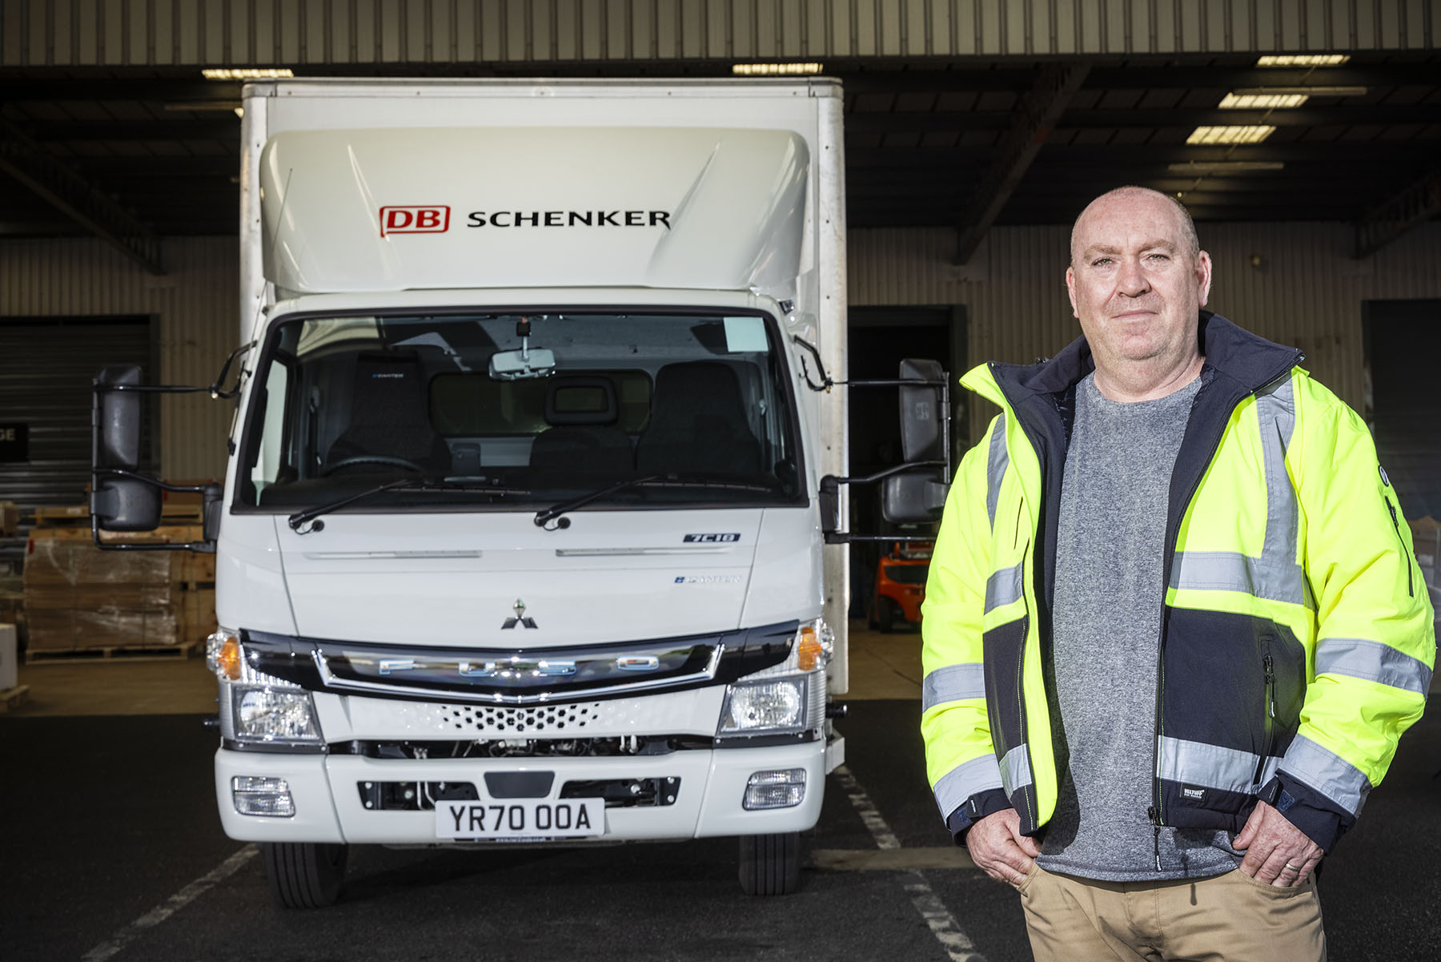

Making the switch: DB Schenker’s Dave Shepherd is a fan of the all-electric FUSO eCanter

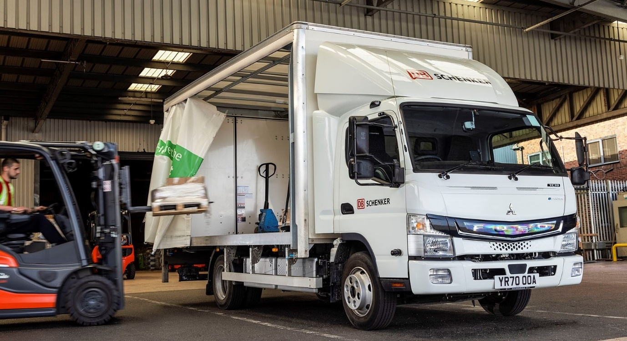

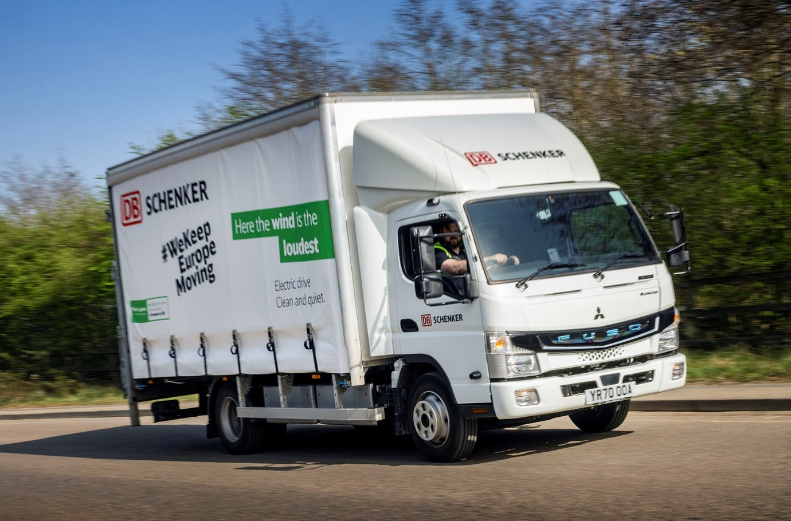

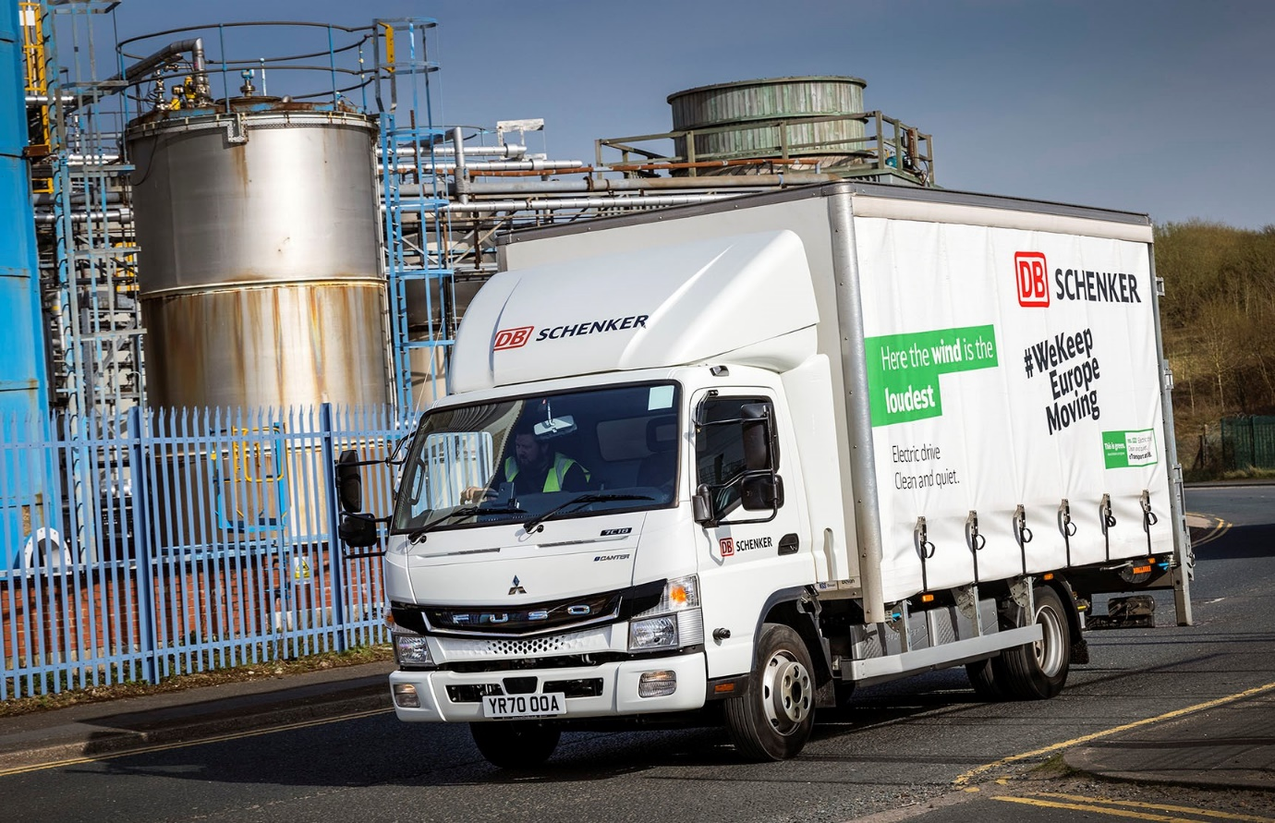

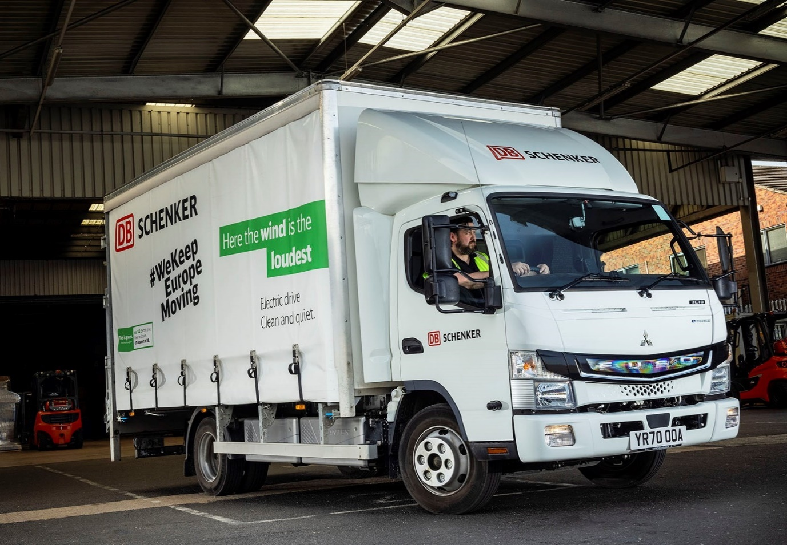

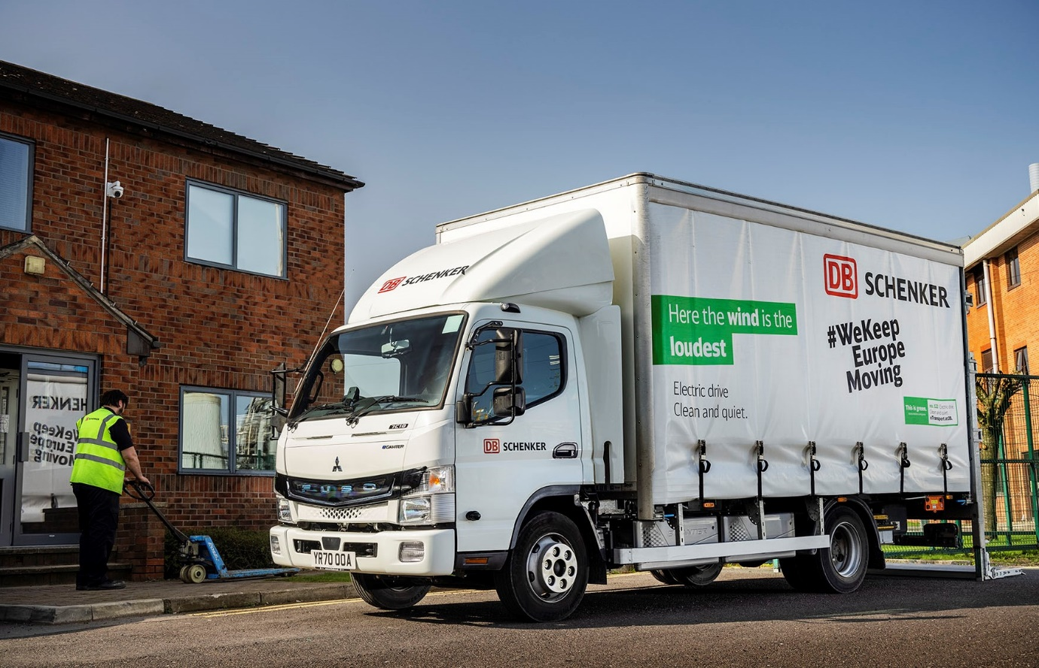

ends

For more information, or to request higher-res image files, please contact:

Jamie Fretwell at Mercedes-Benz Trucks UK Ltd
07712 519230, jamie.fretwell@daimler.com

or

Steve Warren or John Ripley
Impact Communications, 01926 842126
Steve: 07770 470251, steve@impactcom.co.uk
John: 07771 484595, john@impactcom.co.uk

About Mercedes-Benz Trucks UK Ltd
Mercedes-Benz Trucks UK Ltd is the sales and marketing organisation responsible for all Daimler truck products in the UK, including FUSO Canter. In 2019, the company registered 6,963 new trucks. Mercedes-Benz accounted for 6,188 new trucks registered in 2019, making it the third-biggest truck brand in the UK. Meanwhile, FUSO registrations hit 775 – including 580 new trucks over 6.0-tonnes. The flagship new Mercedes-Benz Actros which won the 2020 International Truck of the Year award, features seven core innovations including MirrorCam, Multimedia Cockpit and Active Brake Assist 5. Our premium range of innovative trucks – Actros, Arocs, Atego, Econic and Unimog – draw upon more than 125 years of exceptionally high standards of quality, backed up by our promise of Trucks You Can Trust.
www.mbtrucks.co.uk

About DB Schenker

With around 76,900 employees at more than 2,100 locations in over 130 countries, DB Schenker is one of the world’s leading logistics providers. The company operates land, air, and ocean transportation services, and it also offers comprehensive solutions for logistics and global supply chain management from a single source.
www.dbschenker.com
Blog.dbschenker.com

