

Date: 13 July 2020

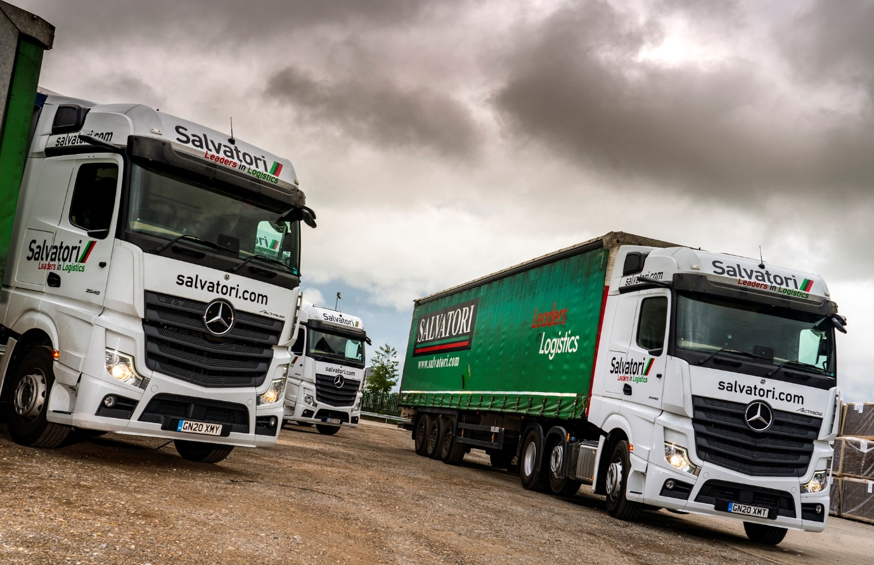

Salvatori enters a new era by welcoming its first eight Mercedes-Benz Actros from Sparshatt Truck & Van

The opening by The Salvatori Group of an additional depot in Sittingbourne, Kent, paved the way for the introduction of its first Mercedes-Benz trucks.

The transport, logistics and warehousing provider is now running eight new-generation Actros 2548 tractor units with flat-floored BigSpace cabs and pioneering safety features, including MirrorCam technology and Active Brake Assist 5 emergency braking systems.

The subject of a Mercedes-Benz Finance contract hire agreement, the latest additions to its fleet were supplied by Sparshatt Truck & Van. Double-shifted, they are now being inspected and maintained by the Service team at the Dealer’s headquarters, which, like Salvatori’s new branch, is on the town’s Eurolink Industrial Estate.

The Salvatori family have been in business in the Canterbury area for more than 80 years. Their company, which is also the UK’s longest-established processing fruit trader, prides itself on its philosophy of always putting the customer first, and on its “old-fashioned” values of meticulous attention to detail, and working with honesty and integrity.

The Salvatori Group’s own head office and main depot, which has storage facilities for up to 11,000 pallets, is in Aylesham, Canterbury. The company runs a fleet of approximately 90 trucks, the majority of them tractor units, in which two other brands hold sway.

It provides international full load and groupage services, and regularly sends trucks to all parts of Europe. The Actros, however, are on domestic work. They undertake local and regional collections and deliveries during the day, then trunk each night to the Palletways hub in Lichfield, Staffordshire, and Greenford, West London – Salvatori is a current holder of the prestigious Palletways Platinum Award.

The operator ordered its new Actros after trialling one of Sparshatt’s demonstration units for a week last year. With a 390 kW (530 hp) output, that vehicle was more powerful than the new trucks it is now running, which employ 350 kW (476 hp) versions of the same 12.8-litre in-line six-cylinder engine. It also had a GigaSpace cab, the biggest of the four available.

Managing Director Daniel Salvatori confirmed: “The demonstrator did well on fuel, while the drivers liked it too. Ultimately, for us, a truck is a tool with which to do a job. I need it to be reliable, I need it to be fuel-efficient and environmentally-friendly, and above all I need it to be safe and comfortable for our drivers. I’m very optimistic, on the evidence of what we’ve seen so far, that the Actros will tick all of these boxes.”

Salvatori specified its new units with Multimedia Cockpit, interactive, the optionally enhanced version of Mercedes-Benz Trucks’ revolutionary new dashboard, which replaces switchgear with twin screens that are both stylish and intuitive to operate. The upgrade brings a bigger, 12in instrument panel and extra functionality, including navigation and Traffic Sign Assist.

The manufacturer’s ground-breaking emergency braking system now employs cameras for the first time, as well as radar. Active Brake Assist 5 delivers dramatically improved responses at speeds of up to 50 kph, and can apply full braking – as opposed to the 50% achieved previously – if it detects a pedestrian crossing the truck’s path.

Meanwhile, the images relayed by MirrorCam’s rear-facing cameras to screens mounted inside the cab, on the A-pillars, provide drivers with significantly better visibility. Just as importantly, the absence of conventional wing mirrors contributes to increased safety for vulnerable road users, by eliminating the large blind spots they cause.

“Our drivers were all very quickly converted to the cameras,” confirmed Mr Salvatori. “As with so much else on this truck, MirrorCam is a very radical concept, one that’s both interesting and exciting.”

Salvatori maintains the trucks it operates from Aylesham in its own workshop. The very high level of aftersales support pledged by Sparshatt was a crucial factor in the company’s decision to run only Mercedes-Benz trucks from its Sittingbourne depot.

Truck Sales Executive Martin Kemsley hosted Daniel Salvatori and a colleague when they made a personal visit to Sparshatt before committing to the Actros. “It’s a big and impressive set-up,” Mr Salvatori recalled. “We were given a tour of the premises and met members of the Dealer’s aftersales management team, as well as some of the guys on the shop floor.

“I was entirely satisfied with all that we saw and heard, as we were given all the promises we’d been seeking. Ultimately, time will tell, but Sparshatt certainly has a great opportunity to impress us – as I told its workshop manager, it’s what he and his team do over the next few years that will sell us the next Mercedes-Benz trucks.”

www.salvatori.com

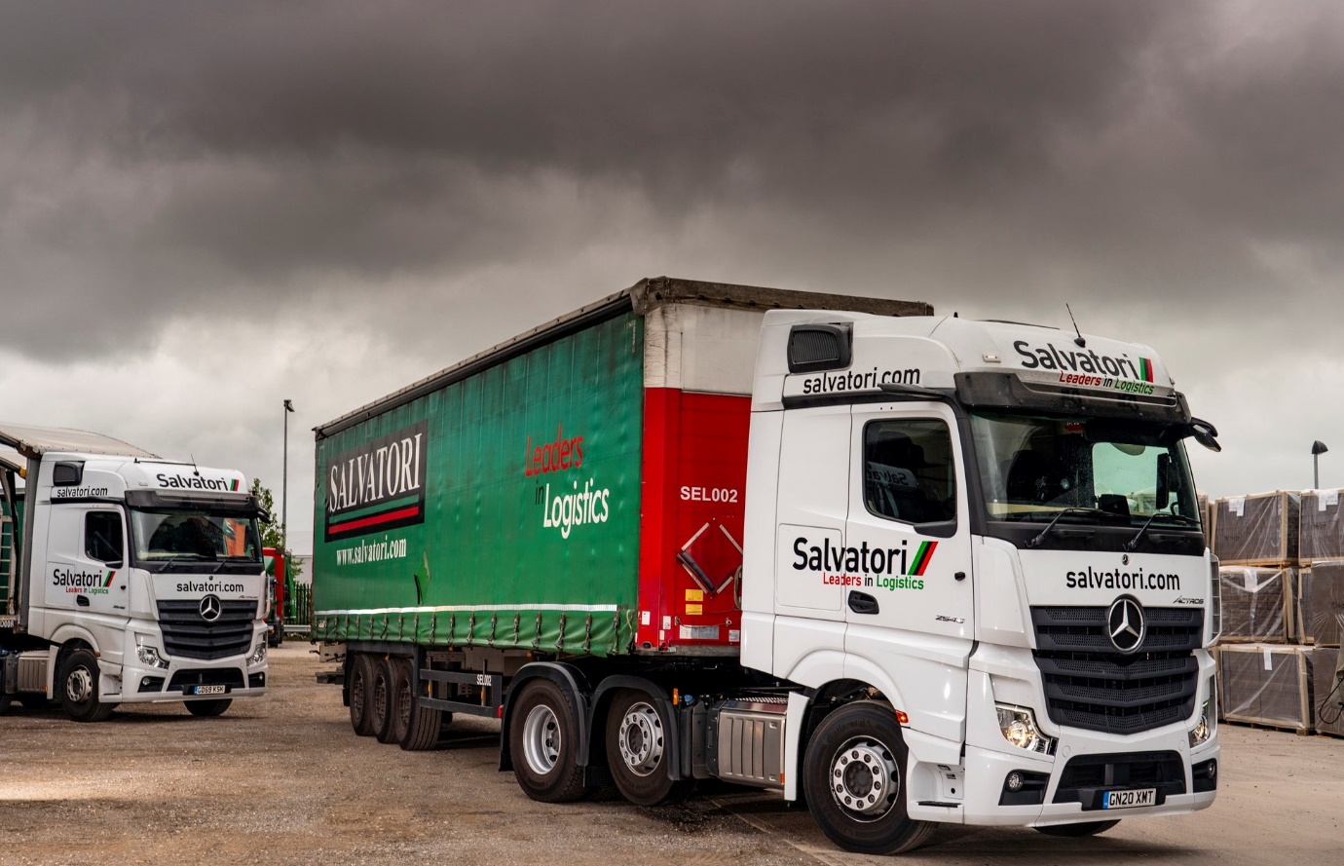

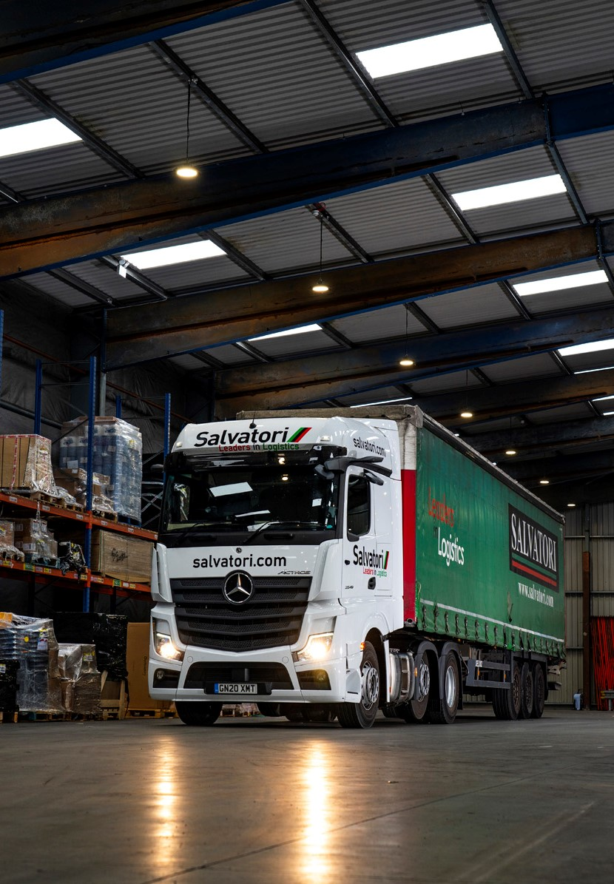

ends

For more information, or to request bigger/higher-res image files, please contact:
Steve Warren or John Ripley
Impact Communications, 01926 842126
Steve: 07770 470251, steve@impactcom.co.uk
John: 07771 484595, john@impactcom.co.uk

