

Date: 30 July 2019

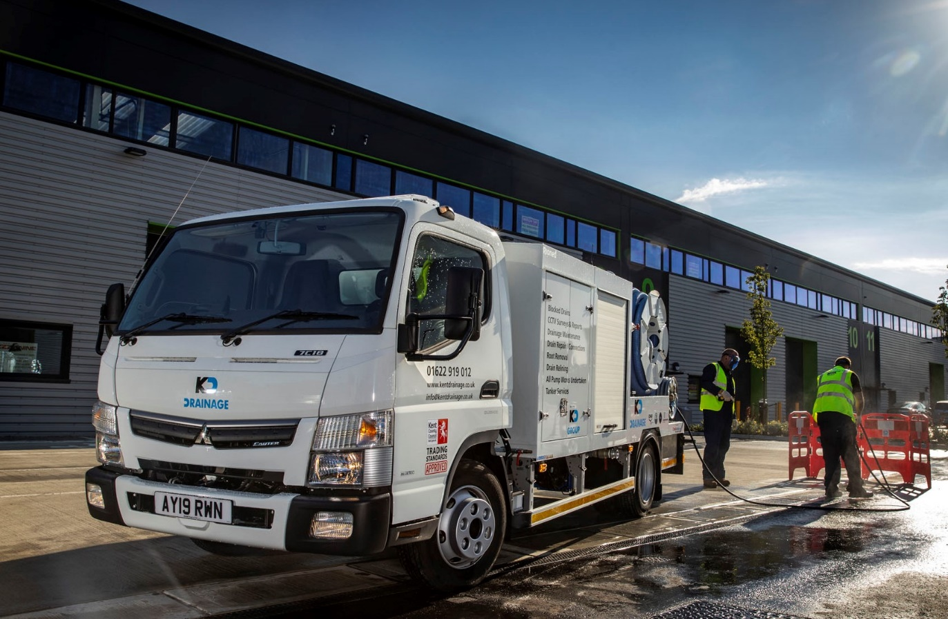

Rioned’s 46 FUSO Canters have the power to ‘go with the flow’

Strong demand from sewer and drain cleaning contractors for its latest jet/vac combination unit prompted specialist equipment manufacturer Rioned to follow-up on an initial order for 21 FUSO Canters with another for a further 25.

Moving forward, the Dutch-owned company’s UK operation, which is based in Thetford, Norfolk, anticipates purchasing some 40 chassis per year from East Anglia Dealer Orwell Truck & Van.

All 7.5-tonne Canter 7C18 models with Comfort day cabs, the trucks are powered by 3.0-litre common-rail turbodiesels producing a range-topping 129 kW (175 hp) and up to 430 Nm of torque across a broad engine speed range. Fully-automated, dual-clutch DUONIC transmissions contribute to their impressive fuel-efficiency, while an engine brake is also fitted as standard.

Rioned chose the Canter for several reasons. Chief among these was the fact that in order to meet the latest emissions standards, the new RioCom 7.5t jet/vac combi relies on the vehicle’s Euro VI engine PTO (Power Take-off) to operate its jetting and vacuum pumps.

“We were previously using a competitor’s chassis and an auxiliary engine for this application,” recalled Rioned UK Sales Manager Mark Cox. “Although the new model is our first production-line PTO drive unit, previous bespoke projects have utilised the Canter’s PTO with great success.

“We’ve always listened to our customers and, as a result, the 7.5-tonne unit has evolved over time. With the 2019 model, we’ve produced a machine that offers more suction, more storage and a sleeker design, while its more powerful Euro VI engine means the Canter offers a better driving experience.”

He continued: “Payload capacity and reliability are also crucial in this industry. The Canter delivers on both counts. Its compact footprint is another key attribute for contractors that work in busy urban environments, where access can often be restricted.

“Indeed, the fact that our new machine complies with the requirements of the Ultra Low Emission Zone (ULEZ) means we’re receiving a lot of interest from established and prospective customers who operate in London.”

Among these is Rochester-based Kent Drainage, whose vehicles spend most of their time in the capital. It purchased the prototype which Rioned presented at this year’s Commercial Vehicle Show. “We’re certainly impressed with the vehicle,” confirmed Director Tom Coe. “It’s highly manoeuvrable and looks neat and tidy, yet is also very powerful for such a small unit.”
The RioCom unit incorporates a Jurop pump with a suction capacity of 8,200 litres (1,800 gallons) per minute – nearly 50% up on previous combis – and 100 metres of high-pressure hose. Its 3,000-litre tank is partitioned to hold 2,000 litres of waste water and 1,000 litres of clean water for jetting.

Meanwhile, in response to recommended changes to the New Road and Street Works Act, Rioned has also included additional secure, shuttered storage space. “There’s a requirement for contractors to carry more equipment when working on UK highways,” explained Mark Cox. “We’ve met this without adding to the overall weight,”

Non-road mobile machinery (NRMM) Stage V emissions regulations which require that relevant equipment must be registered, currently apply to all ‘Major Development Sites’ in Greater London. From September 2020 they will be extended to cover all sites. As Rioned’s new combi utilises the Canter’s engine PTO, it is automatically compliant.

Rioned UK is pre-building the new units at its production facility in The Netherlands, for sale from stock. Fourteen have been sold to customers since the launch in April and the company has already scheduled 25 units to be built in 2020 to meet demand. Canter-mounted RioCom 7.5t jet/vac combis are also being added to its rental fleet.

Like other FUSO Canter Dealers in Britain, Orwell Truck & Van is also a member of the franchised Mercedes-Benz Trucks network – Rioned UK is taking advantage of competitive funding support from Mercedes-Benz Finance to acquire the Canter chassis.

“We are Europe’s leading manufacturer of sewer and drain cleaning equipment, and already enjoy an excellent relationship with Mercedes-Benz,” added Mr Cox. “I’ve every confidence that our new partnership with Orwell Truck & Van will prove equally successful. The Dealer’s pricing is keen, and its Truck Sales Executive Chris Benefer has been very supportive, answering any questions quickly and efficiently.”

www.rioned.co.uk

www.kent-drainage.co.uk

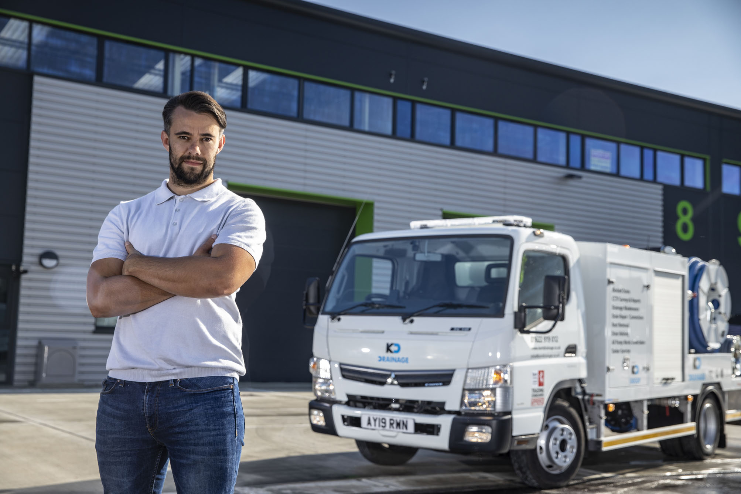

Flushing with success: Kent Drainage Director Tom Coe is delighted with his company’s new FUSO Canter

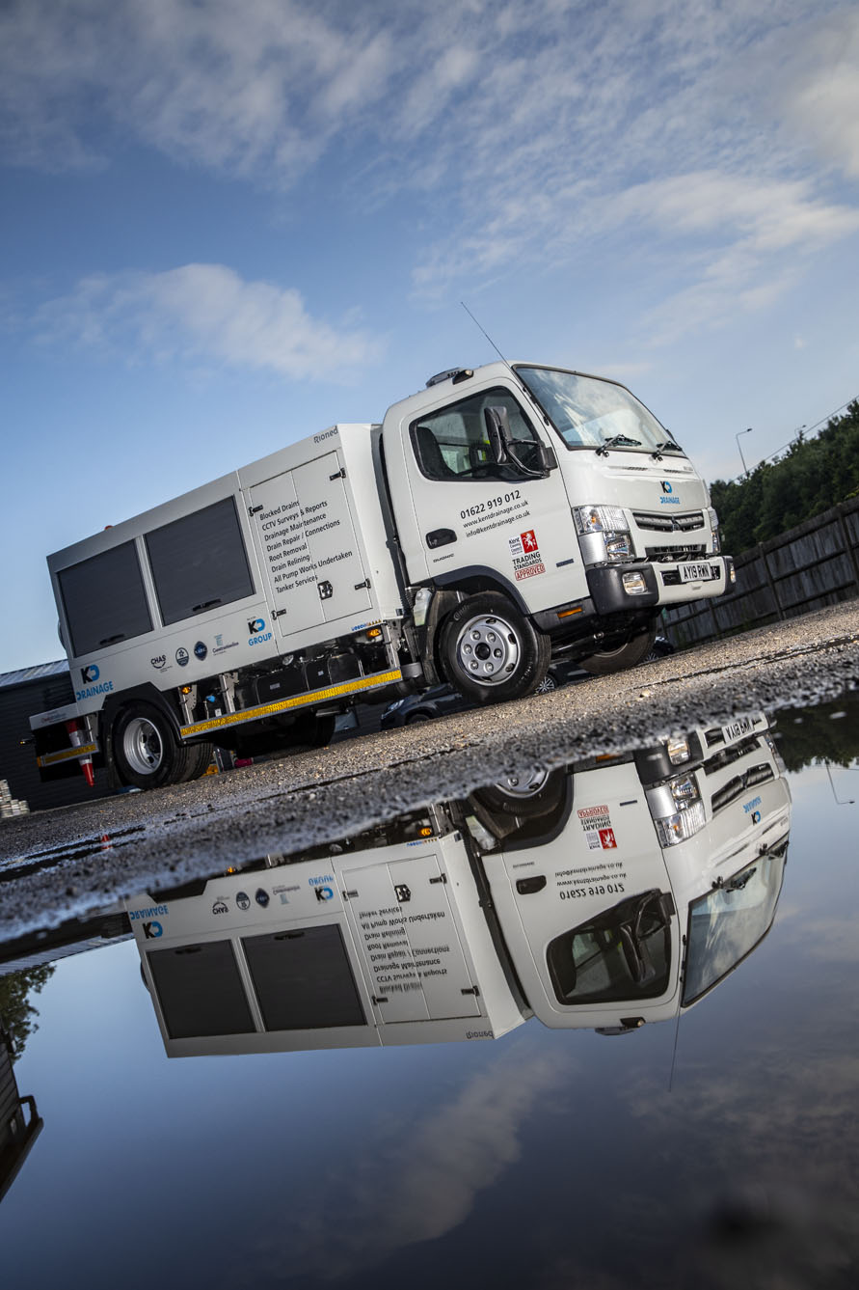

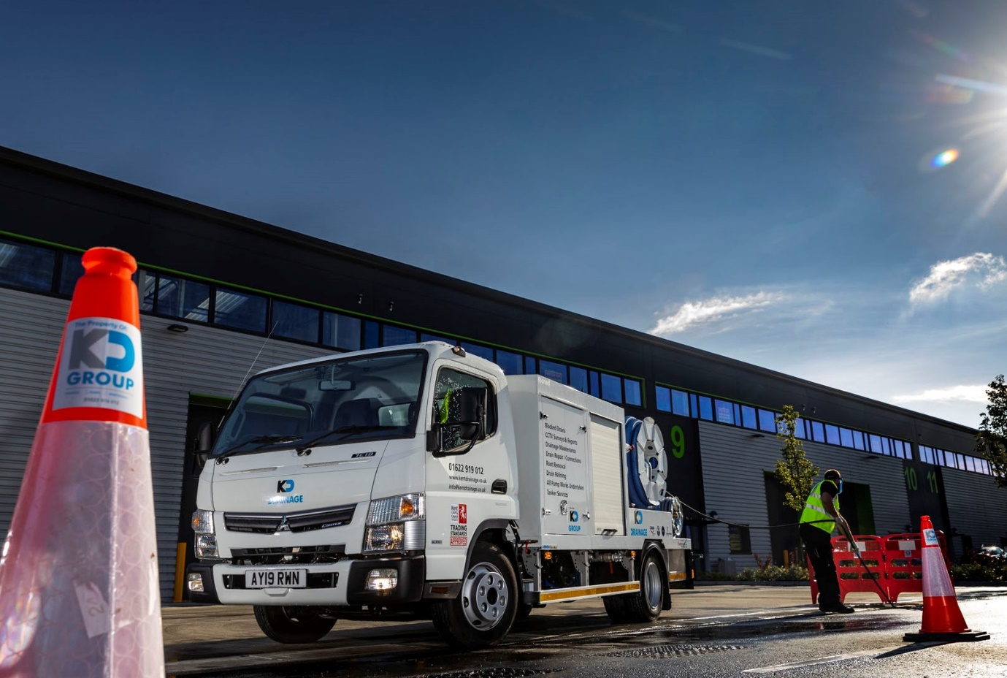

ends

For more information, or to request bigger/higher-res image files, please contact:
Steve Warren or John Ripley
Impact Communications, 01926 842126
Steve: 07770 470251, steve@impactcom.co.uk
John: 07771 484595, john@impactcom.co.uk

