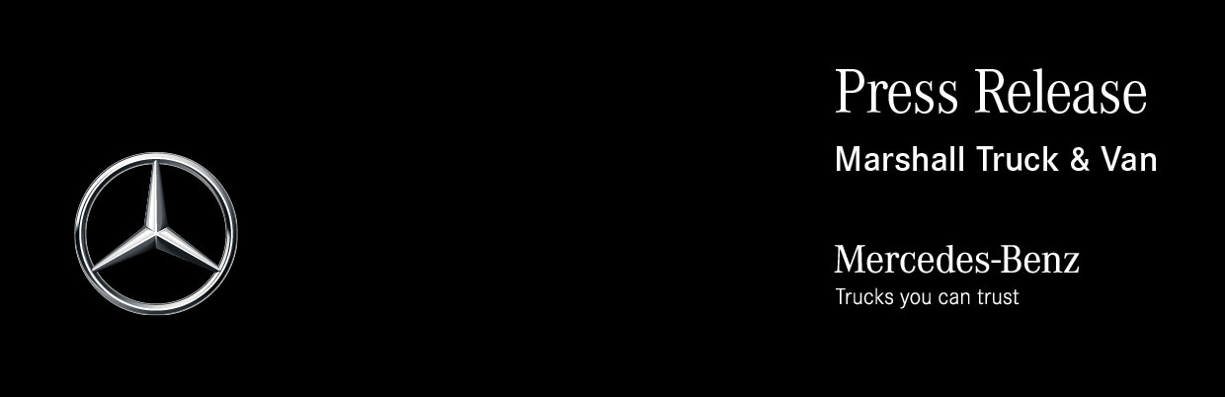

Date: 25 January 2023

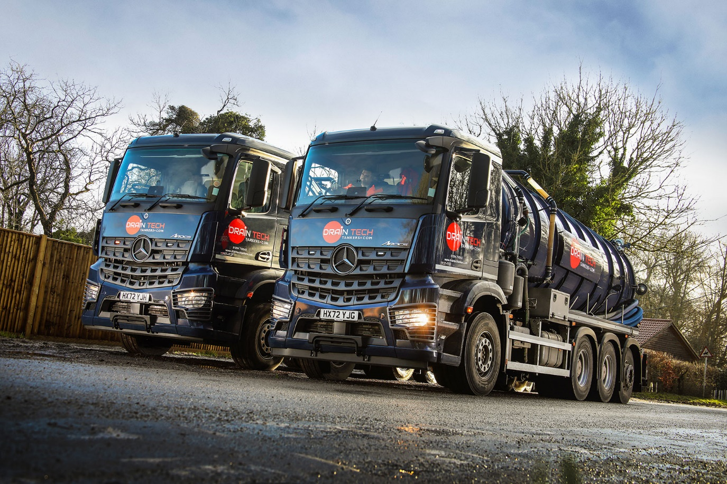

Draintech Tankers pumps up its fleet by switching to Mercedes-Benz Arocs from Marshall Truck & Van

So delighted was Hampshire-based Draintech Tankers with its first two Mercedes-Benz tankers that it returned to Marshall Truck & Van just three months later with a follow-up order for another couple.

The Andover-based operator previously acquired its trucks from two other manufacturers –the nearest agent for one is some 20 miles away, the second 10 miles further on.

In the face of soaring demand from customers, Director Robert Simpson resolved last year to take a fresh look at Draintech Tankers’ vehicle sourcing and maintenance arrangements with a view to reducing the amount of time its trucks were spending off the road.

As Marshall Truck & Van’s Andover branch is practically on the company’s doorstep, the Mercedes-Benz Dealer was an obvious place to start. And having recently undergone a £1-million upgrade that included an extension to the workshop, its facility on the town’s Walworth Industrial Estate made a positive first impression.

Likewise the muscular Mercedes-Benz Arocs. “I could see immediately that it was a quality product and well suited to our work, while Marshall Truck & Van’s proximity to us was also a big attraction,” recalled Mr Simpson. “On this basis, I was very happy to order our first Mercedes-Benz vehicles.”

Draintech Tankers specialises in emptying septic tanks, cesspits and sewage treatment plants, for customers located across the Test Valley area of west Hampshire. It also provides a variety of associated services such as high-pressure jetting and drain unblocking, clearing grease traps and oil interceptors, repairing pumps, and installing drainage.

Acquired with funding support from Daimler Truck Financial Services, the two vehicles that entered service last autumn both have ClassicSpace M-cabs and are fitted with stainless steel vacuum tanks by VJ Engineering, of Rugby. Each is also equipped with a Jurop RV520 hydraulic drain pump, washdown jetting system, full opening rear door, and stainless steel storage trays and lockers.

One is an 8x4 Arocs 3248 with 12.8-litre in-line six-cylinder engine producing 350 kW (476 hp). This truck, which carries a 4,200-gallon tank, is in ENA configuration, with single front steer axle, double-drive bogie and rear steering axle.

The other, a 6x2 Arocs 2542 variant, is powered by a 310 kW (421 hp) version of the same ‘straight-six’ as its larger stablemate. This truck has a 3,200-gallon tank and is also equipped to pull a tri-axled drawbar trailer on which is mounted another tank with 3,000-gallon capacity.

“Since shortly after they arrived both have been on 24-hour hire to our local water supplier,” explained Mr Simpson, “helping to deal with parts of the drainage network that have experienced very high flows with all the heavy rain we’ve seen in this region.”

He continued: “These are still relatively early days but we’re very confident that we’ve made a wise choice. The Arocs are performing strongly while the feedback from our drivers has been extremely positive, with the comfortable, well-equipped cabs coming in for particular praise.

“I spend most of my time in the office now but I started ‘on the tools’ so I know very well that having the best equipment can make working life a lot easier. The axle set-up on the eight-wheeler is especially useful in this regard, because of the enhanced manoeuvrability it offers. Coupled with double drive, it means the truck is very well suited to jobs on local farms where access can be tricky.”

If the Arocs have impressed, so, too, has Marshall Truck & Van, which is inspecting and maintaining both under five-year Mercedes-Benz Complete Service Contracts – and now looking after Draintech’s older vehicles too.

“The Dealer is very attentive and provides first class aftersales support,” reported Mr Simpson. “What’s more, while the difference in distance between our previous suppliers’ premises and Marshall’s is not huge, the time we’re saving by not having to make the longer journeys for every inspection and service soon adds up. Last year was extremely busy and with our vehicles working flat out to meet demand it’s already made a real difference.
“All of which explains why, having commissioned our first Arocs in September, we had no hesitation in returning to Marshall Truck & Van in December to order a pair of identical chassis.”

The new trucks, which will also be funded by DTFS, bodied by VJ Engineering, and maintained under contract, are scheduled for delivery in the autumn. They will be additions to a fleet which, as well as Draintech Tankers’ original Arocs, comprises five other trucks.

“The success of our business has been built on the provision of top-quality equipment and excellent customer service – and that’s exactly what we’ve received from Mercedes-Benz and Marshall Truck & Van,” added Mr Simpson.

www.draintechtankers.com

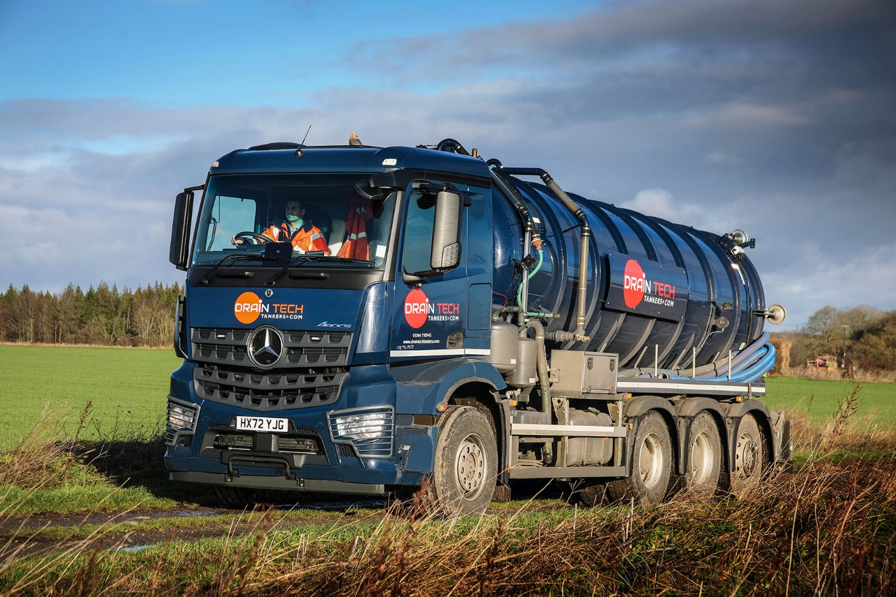

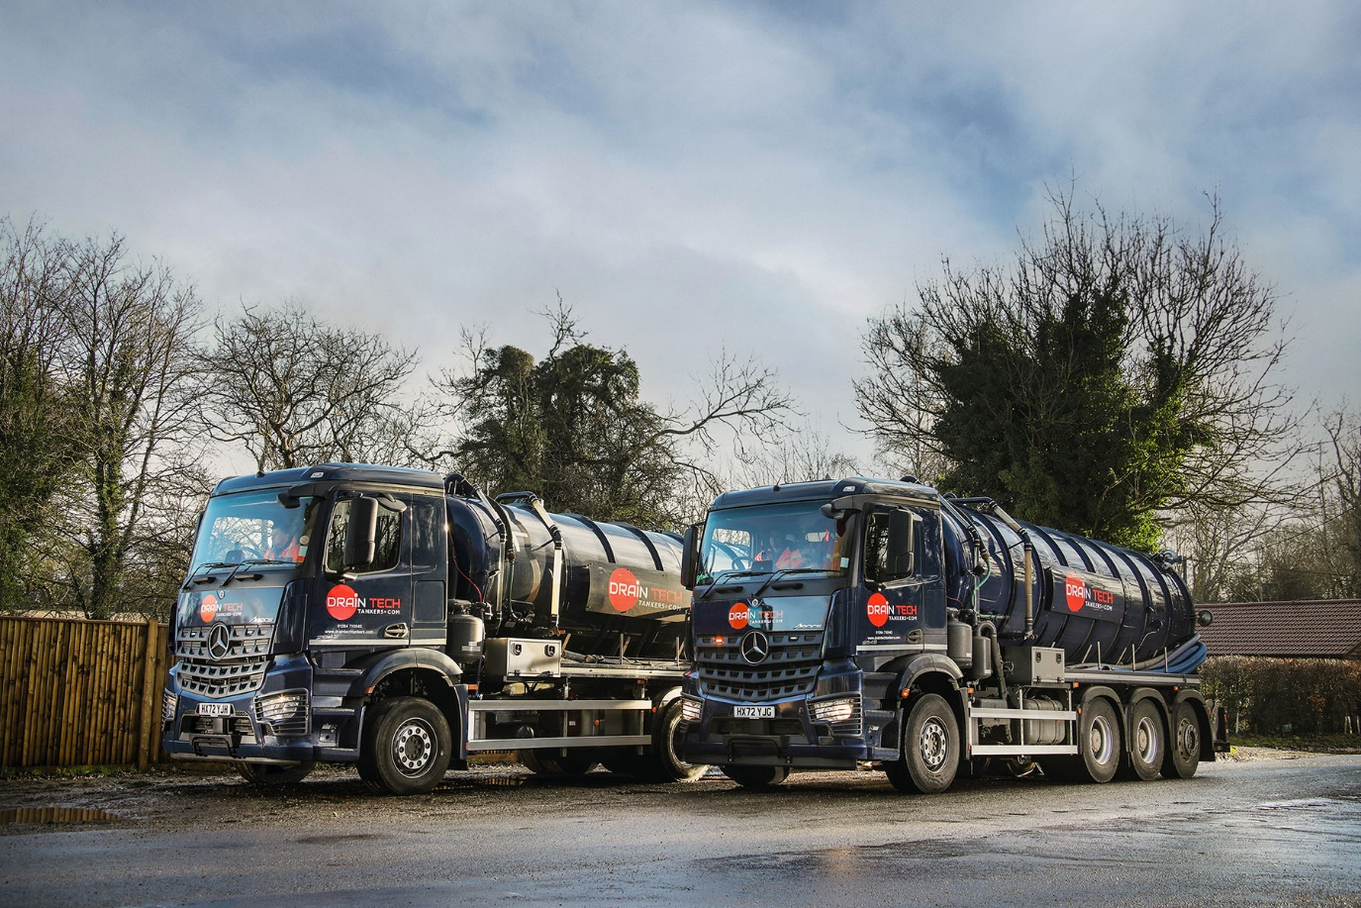

ends

For more information, or to request bigger/higher-res image files, please contact:
John Ripley or Steve Warren
Impact Communications
John: 07771 484595, john@impactcom.co.uk
Steve: 07770 470251, steve@impactcom.co.uk

