

Date: 16 August 2021

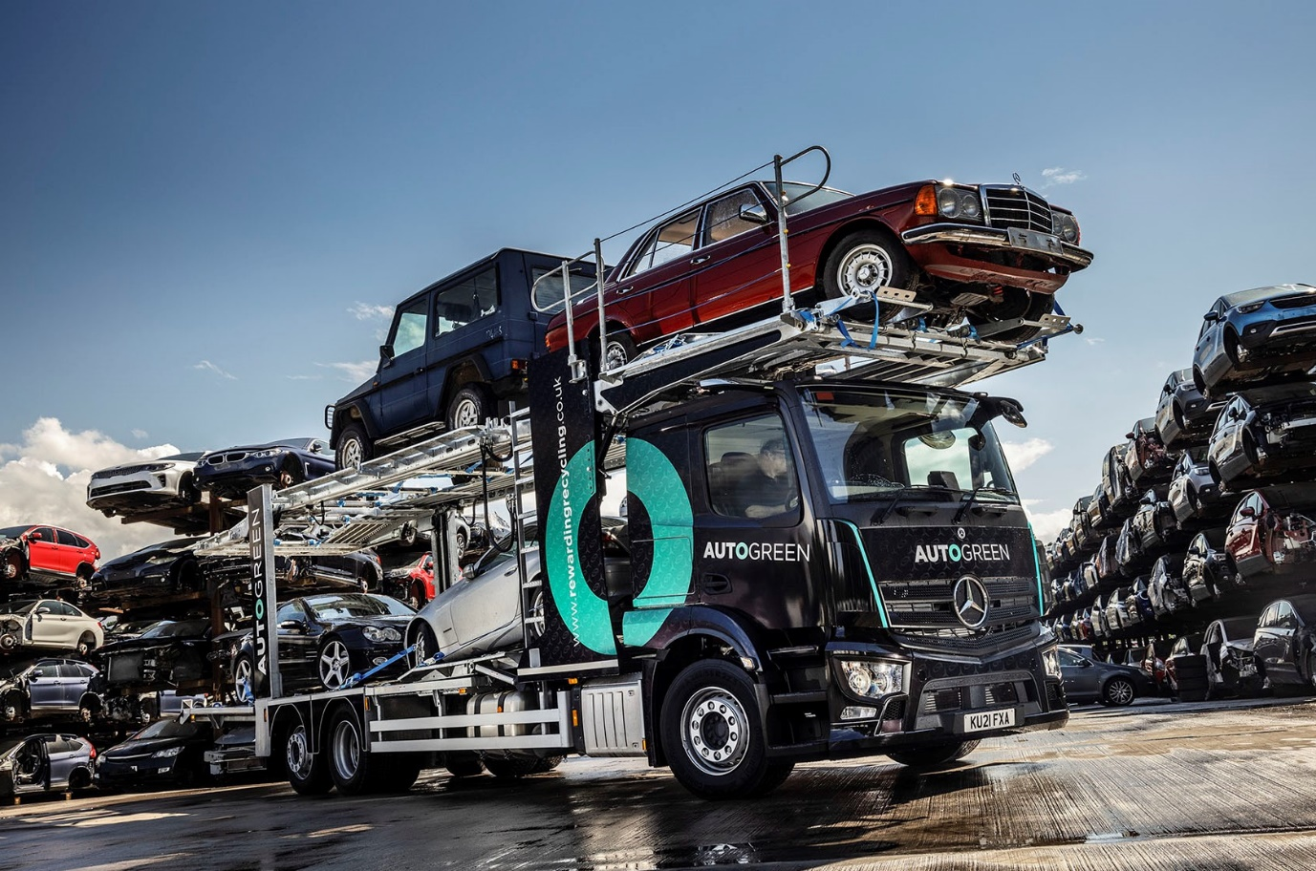

Autogreen aims high with low-roofed Mercedes-Benz Actros from Intercounty Truck & Van

Safety and environmental compatibility were key considerations for end-of-life vehicle collection and disposal specialist Autogreen when choosing the latest, Mercedes-Benz addition to its transporter fleet.

Supplied to the Daventry-based operator by local Dealer Intercounty Truck & Van, the 26-tonne Actros merits an impressive four stars from Transport for London’s Direct Vision Standard scheme.

The truck has a low-roofed CompactSpace L-cab with the 320mm engine tunnel that gives it a relatively low floor height, and a 9.0-tonne front axle, uprated from the standard, 8.0-tonne item. As a 2540L model, it is powered by a 10.7-litre in-line six-cylinder engine producing 290 kW (394 hp).

Standard features include MirrorCam, Mercedes-Benz Trucks’ acclaimed replacement for conventional mirrors, while the vehicle’s comprehensive specification includes a host of extra technical equipment, and comfort and style enhancements bundled within the Actros Safety, Sight, Extra Line and Style Line packages.

The truck’s eight-car transporter body was designed and built in Great Dunmow, Essex, by Belle Car Transporters & Specialised Trailers, while its eye-catching livery is the work of Wrap Cube, of Surbiton, Surrey.

Established in 2004 by a group of industry specialists, Autogreen serves automotive manufacturers – Mercedes-Benz is a highly valued client – as well as dealerships, vehicle import centres and members of the public. It manages the entire process, from nationwide collections and transportations of cars, vans and trucks, through to their compliant disposal in line with the End-of-Life Vehicles (ELV) Directive.

Autogreen and its logistics partners operate a fleet of more than 200 vehicles that includes heavy truck recovery units in addition to transporters of various sizes, the biggest of which carry 12 cars. Mercedes-Benz trucks and vans have featured prominently for years, but the new six-wheeler is Autogreen’s first vehicle from the fifth-generation Actros range.
Director Paul Hillier confirmed: “The latest Actros stands out from the crowd thanks to its array of new technology. Safety and environmental compatibility were important factors in our decision to acquire this new Mercedes-Benz, and we’re particularly pleased that its four-star DVS rating means the truck will be allowed access to London for the next 10 years.

“The new transporter is a fantastic addition to the line-up and has already integrated seamlessly with the exacting standards of our operation. Our collection volumes continue to increase, so it was important that the Actros be equipped to cater for all types of end-of-life vehicle.”

MirrorCam’s roof-mounted cameras relay images to screens mounted inside the cab, on the A-pillars. The system provides enhanced rear vision and eliminates the forward-facing blind spots caused by mirror housings. It contributes to fuel economy, as well as safety and driver comfort – Mercedes-Benz estimates an improvement of up to 1.5% – because the compact and streamlined camera housings offer significantly less wind resistance than mirrors.

Also standard equipment on new Actros is the Active Brake Assist 5 emergency braking system, which employs a camera in addition to radar and, at speeds of up to 50 kph, can apply full braking automatically when encountering pedestrians crossing its path.

The Actros Safety Package includes Proximity Control Assist and a driver’s airbag, plus the upgraded interactive version of the manufacturer’s radical, twin-screen Multimedia Cockpit, which provides a larger, 12in instrument panel and offers extra functionality, including satellite navigation.

The Sight Package also contributes to safety by helping the driver to see, and the truck to be seen. Features include a rain sensor, bi-xenon headlamps and a headlamp cleaning system, automatic main/dipped beam function and cornering light.

“We have a small team based here in Daventry who manage vehicle collections on a 24 hours a day, seven days a week basis,” said Paul Hillier. “Early feedback from our drivers has been entirely positive, especially with regards to the new, in-cab technology, which they’ve embraced very quickly.”

The new truck will be inspected and maintained under a Mercedes-Benz Complete Service Contract by the workshop team at Intercounty Truck & Van’s Milton Keynes branch. Mr Hillier added: “The planning and attention to detail demonstrated by Truck Sales Executive Amit Verma and his colleagues was excellent. We’ll have no hesitation in engaging again with Intercounty when we come to make future additions to our fleet.”

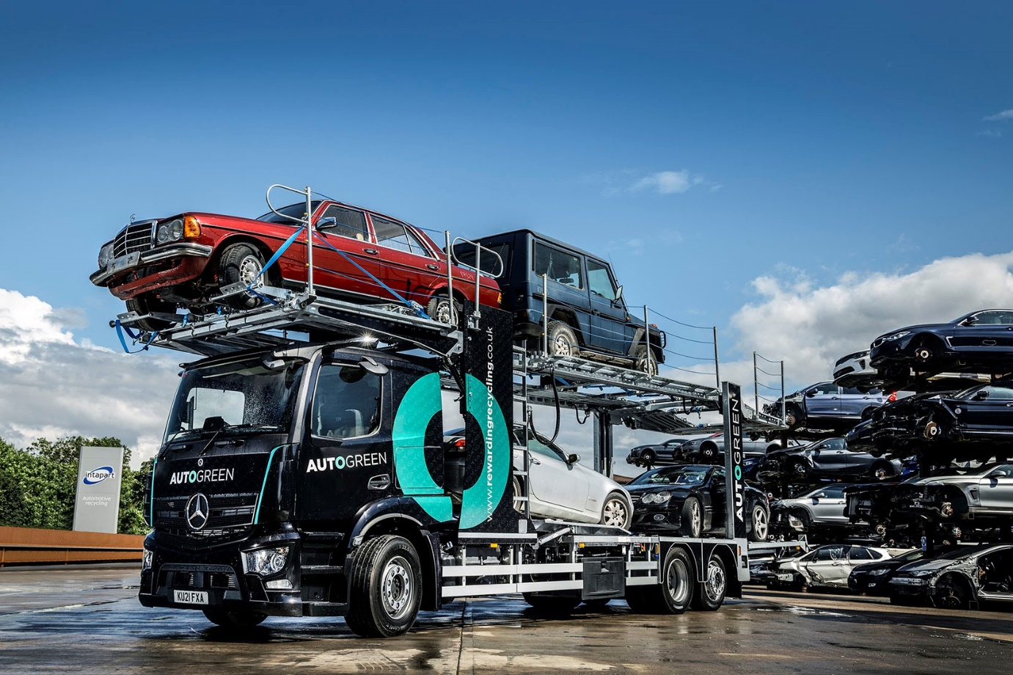

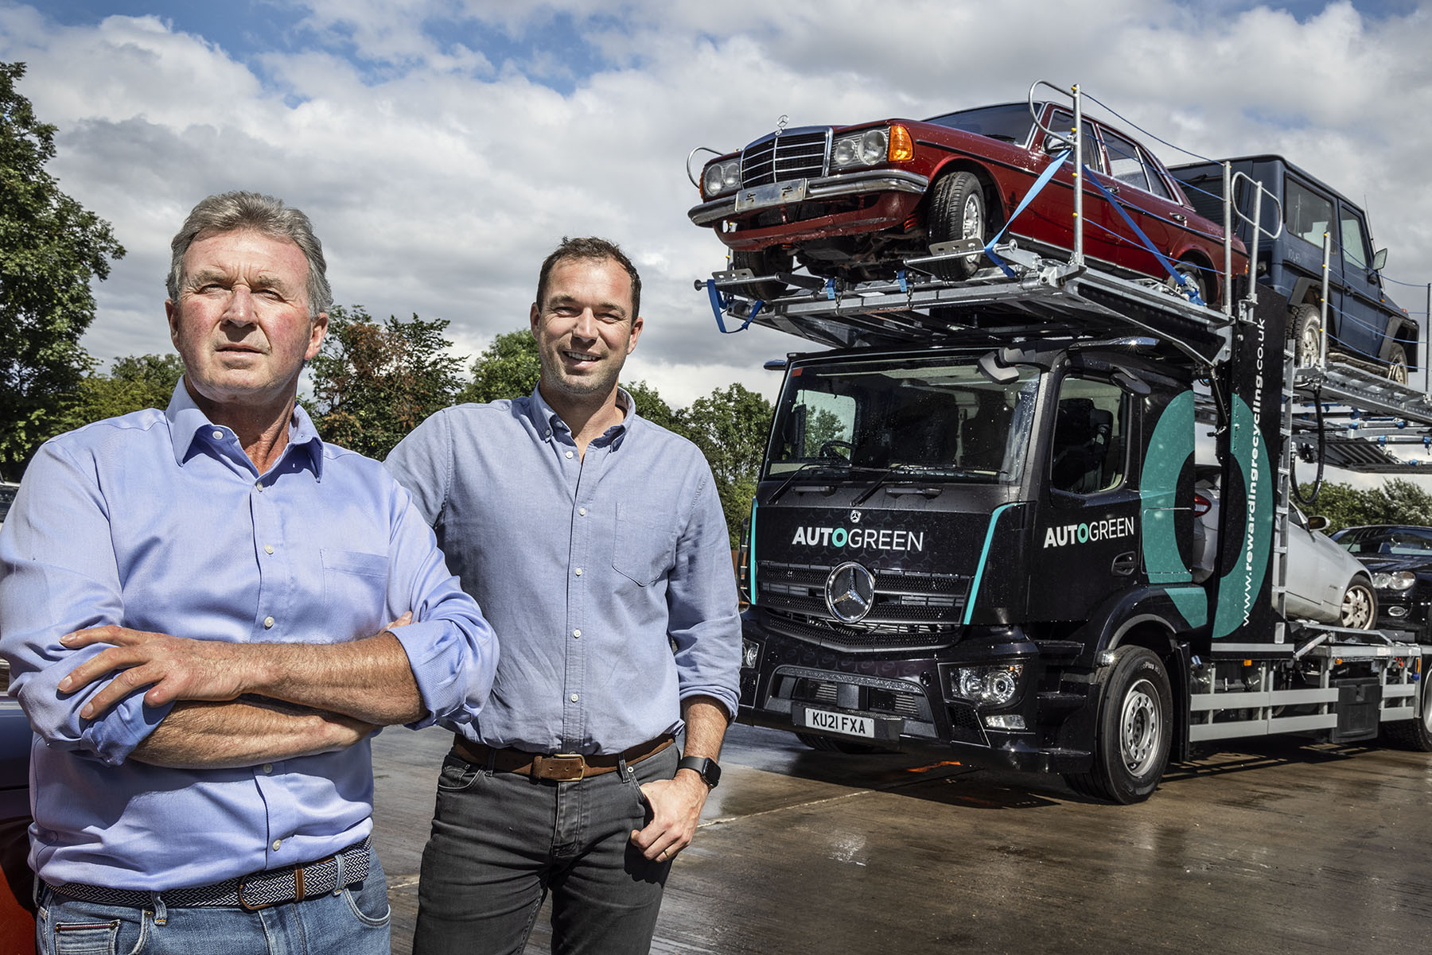

Driving force: Autogreen Directors Paul Hillier and his son Edward are delighted with their new Mercedes-Benz Actros

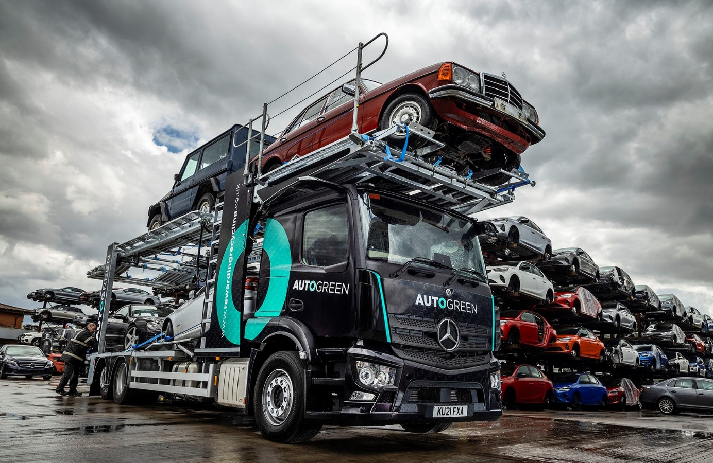

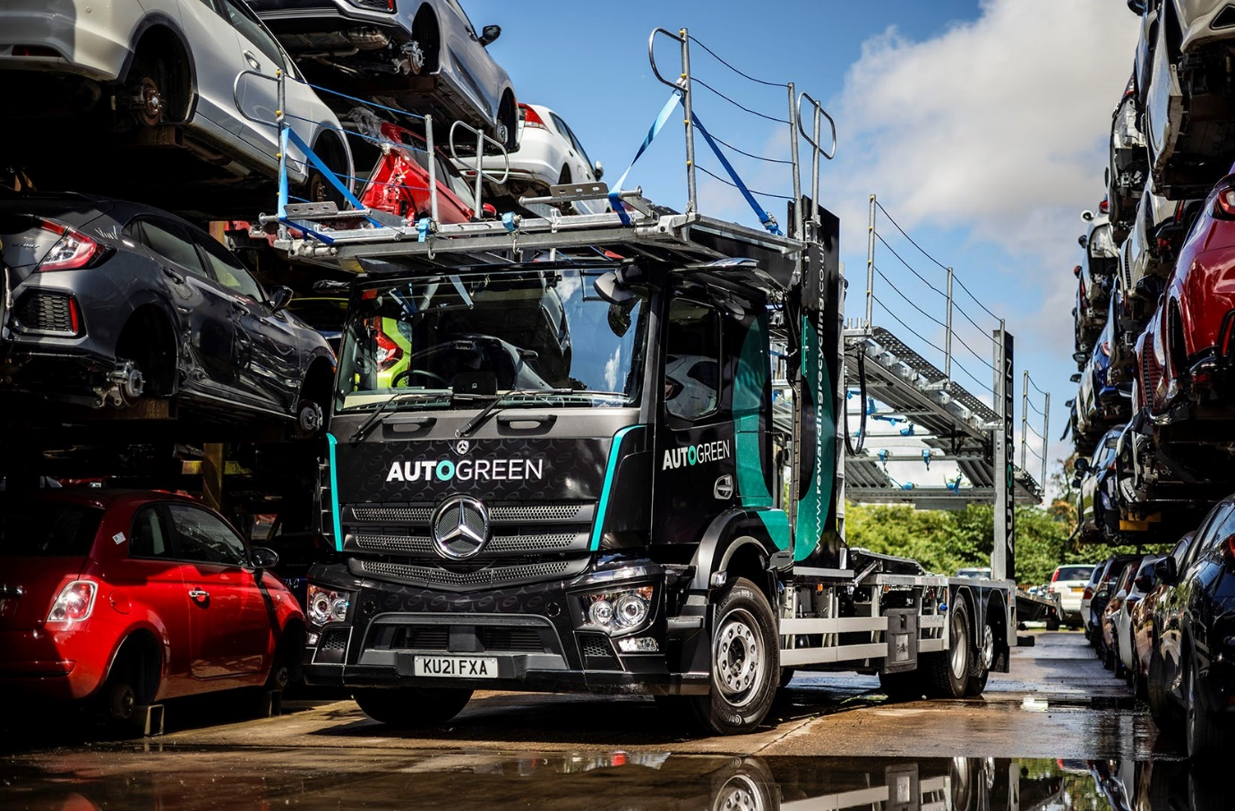

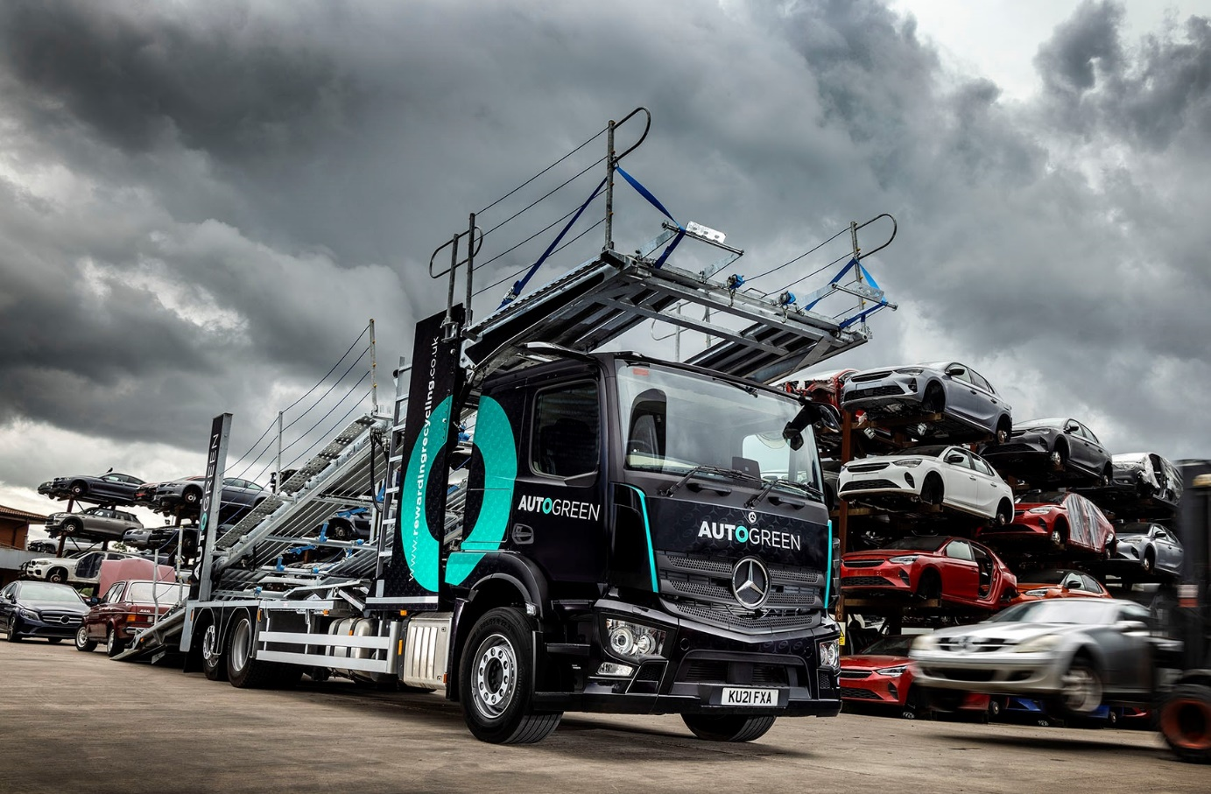


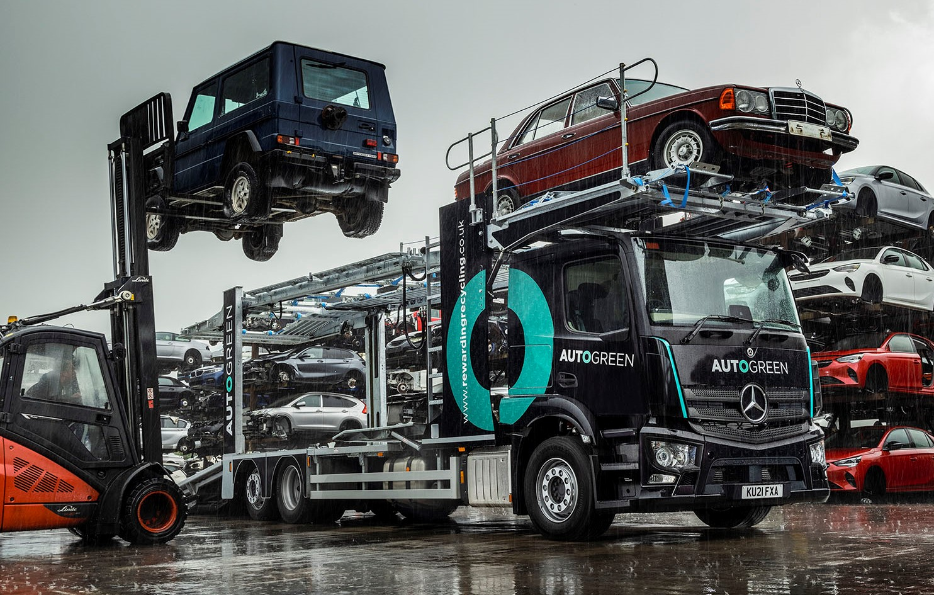

ends

For more information, or to request bigger/higher-res image files, please contact:
Steve Warren or John Ripley
Impact Communications, 01926 842126
Steve: 07770 470251, steve@impactcom.co.uk
John: 07771 484595, john@impactcom.co.uk

