

Date: 7 June 2024

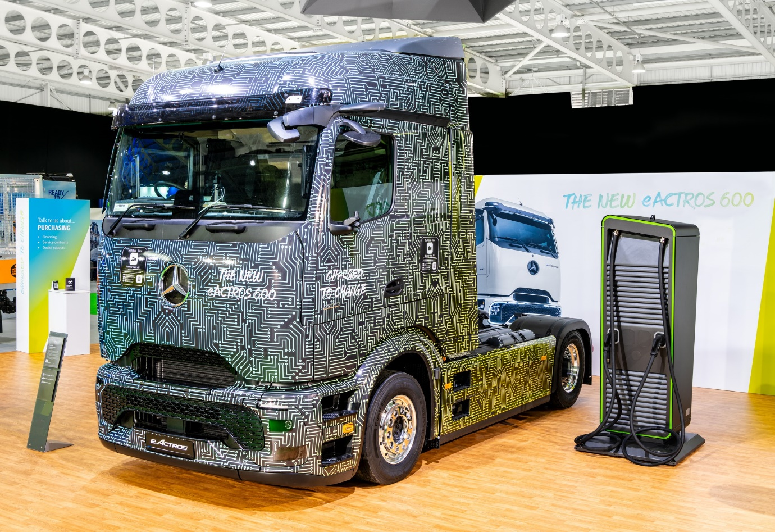

Mercedes-Benz eActros 600 makes UK debut at Road Transport Expo

Mercedes-Benz Trucks is taking centre stage at the opening of this year’s Road Transport Expo event, with the UK unveiling of its first long-haul electric truck.

The eActros 600 tractor unit is specifically designed for long-distance distribution, with enough battery capacity to offer a range of 500 km¹ on a single charge. With the ability to top up during statutory driver breaks, this means the truck could potentially cover up to 1,000 km in a day. Meanwhile, Megawatt Charging System capability means the batteries can recharge from 20% to 80% in around 30 minutes².

The new vehicle’s impressive range comes courtesy of its high battery capacity of more than 600 kilowatt hours – hence the ‘600’ model designation – but is also helped by an extremely efficient driveline, with the pioneering eAxle housing the truck’s two electric motors and four-speed transmission.

The truck on display is a fully operational right-hand drive prototype, making its first public appearance in the UK, and previews the new, aerodynamically optimised ProCabin. Order books for the eActros 600, which will enter series production this year, opened in November 2023.

Of equal importance to operators starting the transition to electrified transport is the comprehensive package of support services offered by the dedicated Mercedes-Benz Trucks eConsultancy team. The comprehensive package of services includes expert advice on choosing the right truck for any application, as well as consulting on everything from planning, constructing and configuring depot charging infrastructure, to TCO (Total Cost of Ownership) optimisation, identifying public subsidies, model-specific driver training and a range of financial services. Mercedes-Benz Trucks also offers trained eConsultancy services through its national Dealer Network.

Those looking beyond the sleek, aerodynamic new ProCabin of the eActros 600 can learn much more about the truck itself. It is powered by three battery packs, each with a capacity of 207 kWh³, based on lithium iron phosphate cell technology without nickel or cobalt. Like any Mercedes-Benz truck it is designed for a tough working life of up to 1.2 million km over 10 years – after which the battery ‘state of health’ should still be over 80%.

Far more than just an Actros with electric motors instead of a diesel engine, though, it also boasts Predictive Powertrain Control cruise and transmission systems specifically tailored to the battery-powered driveline. Cutting edge safety systems including Active Drive Assist 3 and Active Brake Assist 6 are fitted as standard.

Speaking at the opening of Road Transport Expo, held once again at Stoneleigh in Warwickshire, Head of Future Sustainability James Venables said: “Long-distance distribution is the lifeblood of our nation’s economy, and the move towards electric transport is gathering pace all the time – which is why we believe the eActros 600 is arriving at the perfect moment for our industry. We’re looking forward to explaining the benefits it can offer, and the long-term back-up we can provide, to operators across this show’s three days and beyond.”

Notes:

¹ The range was determined internally under specific test conditions, after preconditioning with a 4x2 tractor unit with 40t total towing weight at 20°C outside temperature in long-haul operation and may deviate from the values determined in accordance with Regulation (EU) 2017/2400.

² Based on internal simulations since a binding and uniform Megawatt Charging System (MCS) standard is currently under development.

³ Nominal capacity of new battery, based on internally defined boundary conditions, may vary depending on use case and ambient conditions.

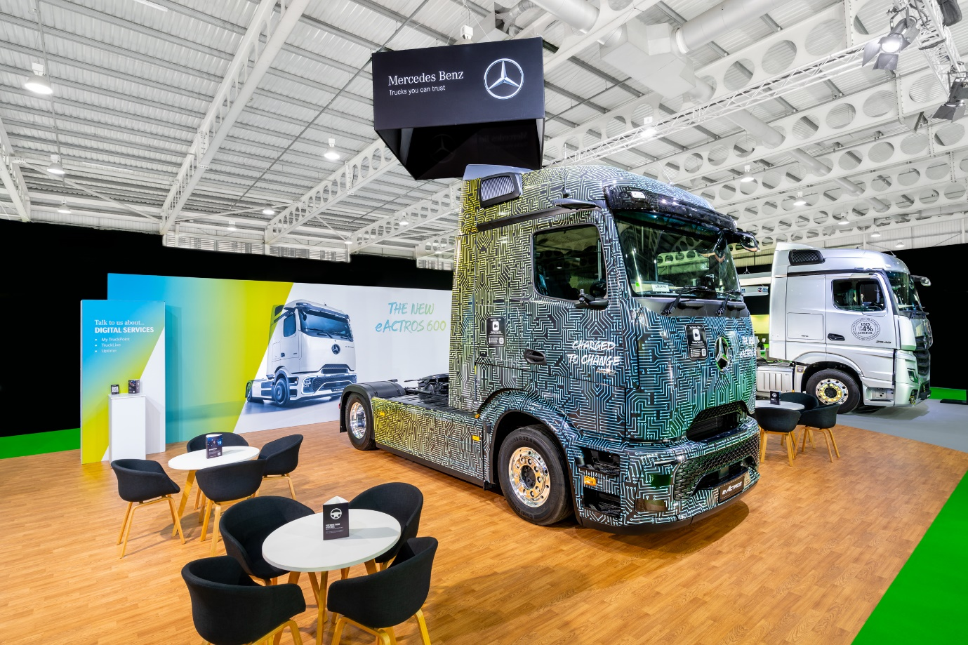

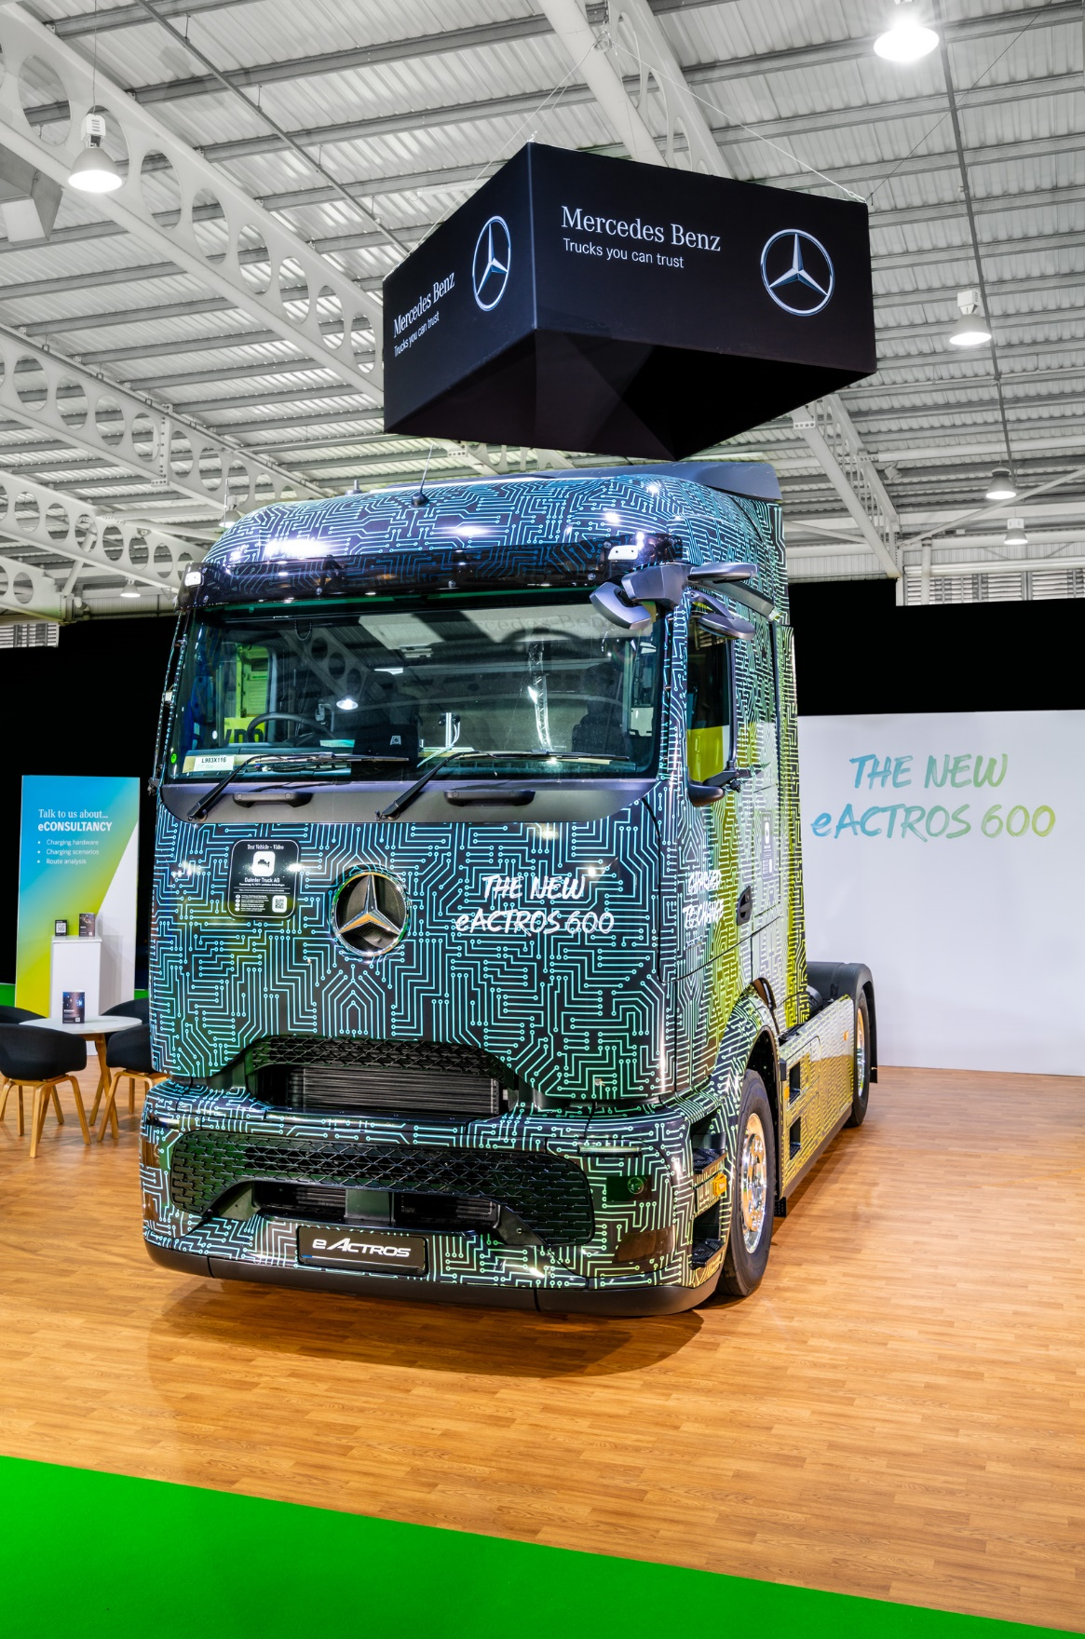

ends

For more information, or to request higher-res image files, please contact:

Dominic Dawes at Daimler Truck UK
07864 600148, dominic.dawes@daimlertruck.com

or

John Ripley: 07771 484595, john.ripley@loopagency.co.uk

