

Date: 31 July 2020

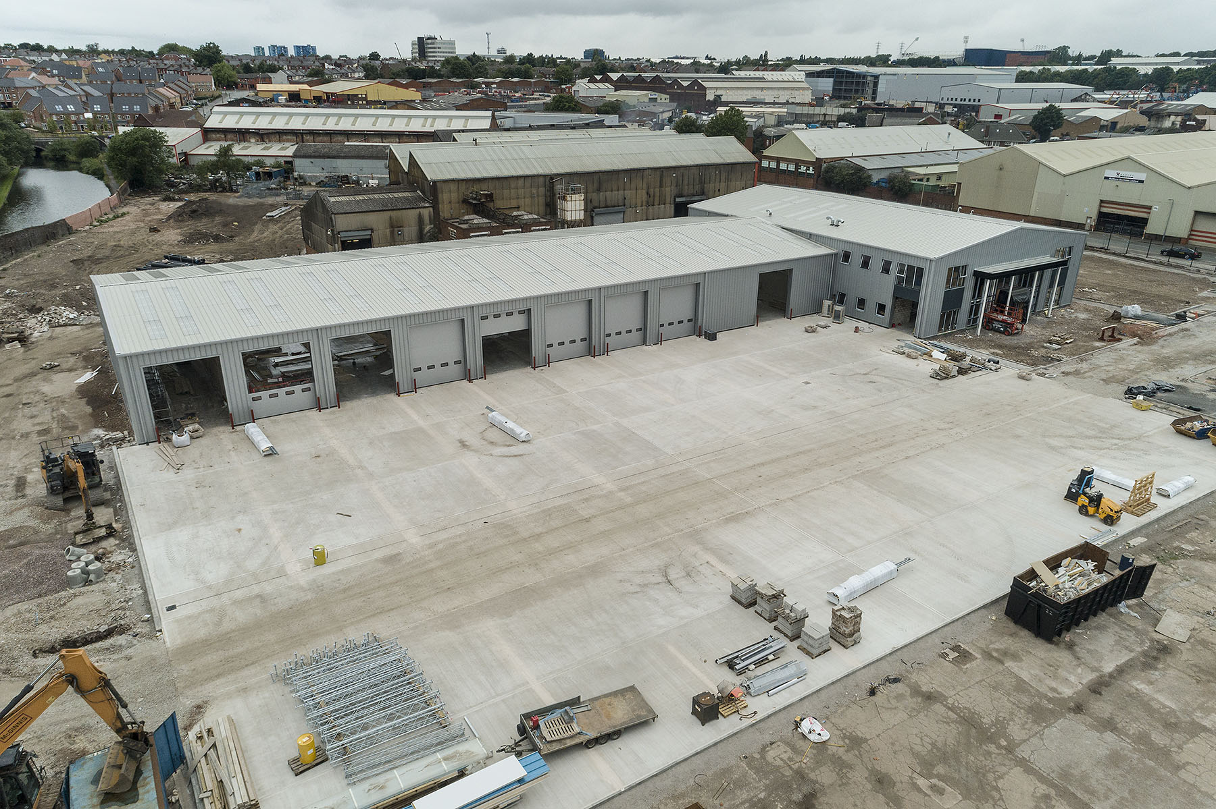

Taking shape: Midlands Truck & Van’s new Birmingham base is due to open in October

Midlands Truck & Van invests £7 million to deliver first-class Mercedes-Benz service for the ‘second city’

Operators of Mercedes-Benz and FUSO commercial vehicles in and around Birmingham can look forward to an even higher level of service when Midlands Truck & Van opens for business at a new, state-of-the-art dealership in the city.

Work on the £7-million project began late last year, and the Dealer is on schedule to welcome the first customers to its new home in Smethwick in October.

The Service department at its current base in Saltley opens at 6am each Monday and then remains so, round-the-clock, until 1pm on Saturdays. Once the new workshop is fully operational and nearing maximum throughput capacity, the business will review its shift patterns to establish the viability of a seven-day working week.

This potential extension to opening times, coupled with the fact that the new facility will be considerably bigger and better equipped than Saltley’s, means that Midlands Truck & Van is aiming to double the number of labour hours it sells each month.

As well as oversight of the final phase of construction and fitting out, the recruitment of additional technicians and parts specialists is therefore high on the agenda for Managing Director Steve Hunt and his Service Director Michael Carolan.

The dealership is taking shape on the Cornwall Road Industrial Estate. Previously the site of a steelworks, and then a plastics factory, the seven-acre plot offers plenty of room for displaying new and pre-owned vehicles available for purchase, and for customers to manoeuvre and park their own trucks and vans.

Midlands Truck & Van will also be the first member of the manufacturer’s commercial vehicle network to introduce a new customer experience concept which is already in operation at a number of Mercedes-Benz car outlets.

A far cry from the traditional truck and van dealership, the building’s open plan reception area has been designed and will be furnished in line with the latest Mercedes-Benz corporate standards. All visitors to the site will be greeted by dedicated hosts, then introduced to other members of the Midlands Truck & Van team with whom they will be able to discuss anything from a sales enquiry to a service booking in stylish, relaxed and comfortable surroundings.

The new building will also incorporate a Parts department which, at 650 square metres, represents a 25% increase on the shelf space currently available to the Dealer. As a result, Midlands Truck & Van will carry correspondingly wider and deeper stocks of the factory-approved spares it needs to keep vehicles on the road and earning for their owners.

The ‘beating heart’ of the development, though, will be the 1,580 square metre, drive-through workshop. Highlights for truck operators include an Authorised Testing Facility (ATF) at which inspectors from the Driver and Vehicle Standards Agency (DVSA) will undertake annual MoT tests, an ADR bay allocated to work on fuel tankers and related specialist equipment for transporting hazardous loads, and another bay fitted with rollers for the installation and calibration of tachographs.

Meanwhile, Midlands Truck & Van’s own technicians will carry out MoT tests on light commercial vehicles in the Class 4, 5 and 7 categories, at times – night or day – best suited to customers.

In addition to these dedicated workspaces, routine maintenance and repairs will be carried out in a further 11 truck bays – each, at 24 metres, comfortably long enough to accommodate an articulated tractor unit and semi-trailer combination – and eight van bays.

“This fantastic facility is going to have a phenomenal impact on our business,” declared Steve Hunt. “It took a long time to find the right location for this project and I’d like to take this opportunity to thank colleagues who’ve continued to deliver exemplary levels of customer service despite having to work in conditions that were less than ideal.

“I can guarantee their patience will be rewarded come October, as our new dealership will be right up there with the very best in the industry. Customers have also welcomed the substantial investment we’re making because it underscores this company’s commitment and determination to keep their businesses moving.”

Steve added: “Our Smethwick facility will provide a perfect platform from which we’ll be able to meet the ever-increasing demand for our aftersales support, and provide the class-leading levels of service that Mercedes-Benz truck and van customers are entitled to expect.”

The opening of its new dealership will mark the completion of a major programme of investment in its branch network by Midlands Truck & Van, one of two Mercedes-Benz commercial vehicle franchisees owned by Northern Ireland’s Ballyvesey Holdings Group.

Midlands Truck & Van recently spent £3 million on the acquisition and refurbishment of the former Mercedes-Benz car outlet in Whitley, Coventry. Its repurposing as one of the country’s biggest Mercedes-Benz van showrooms allowed the Dealer’s former commercial vehicle centre next door to become a truck-dedicated facility.

Midlands Truck & Van’s purpose-built branch, in Willenhall, Wolverhampton, is also still relatively new, having opened at the end of 2015 at a cost of £4 million.

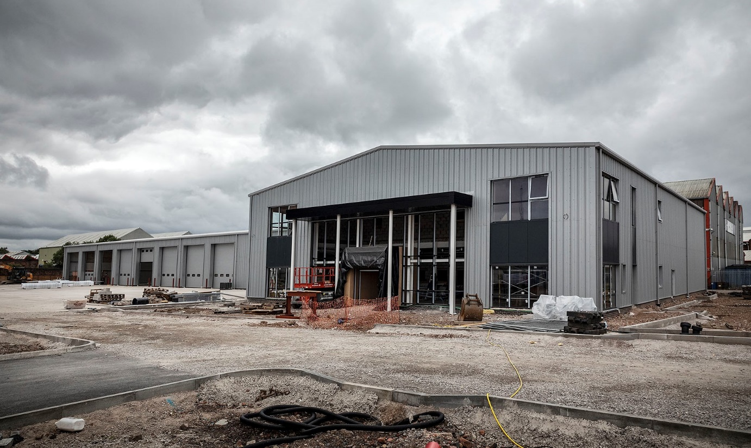
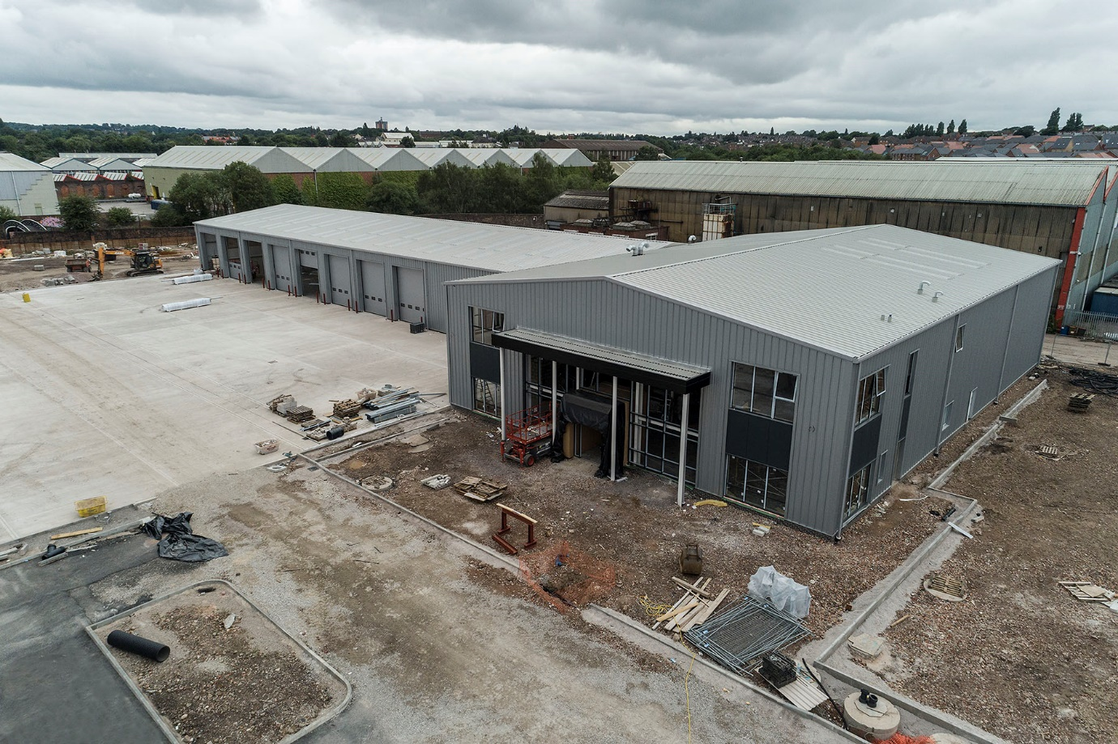

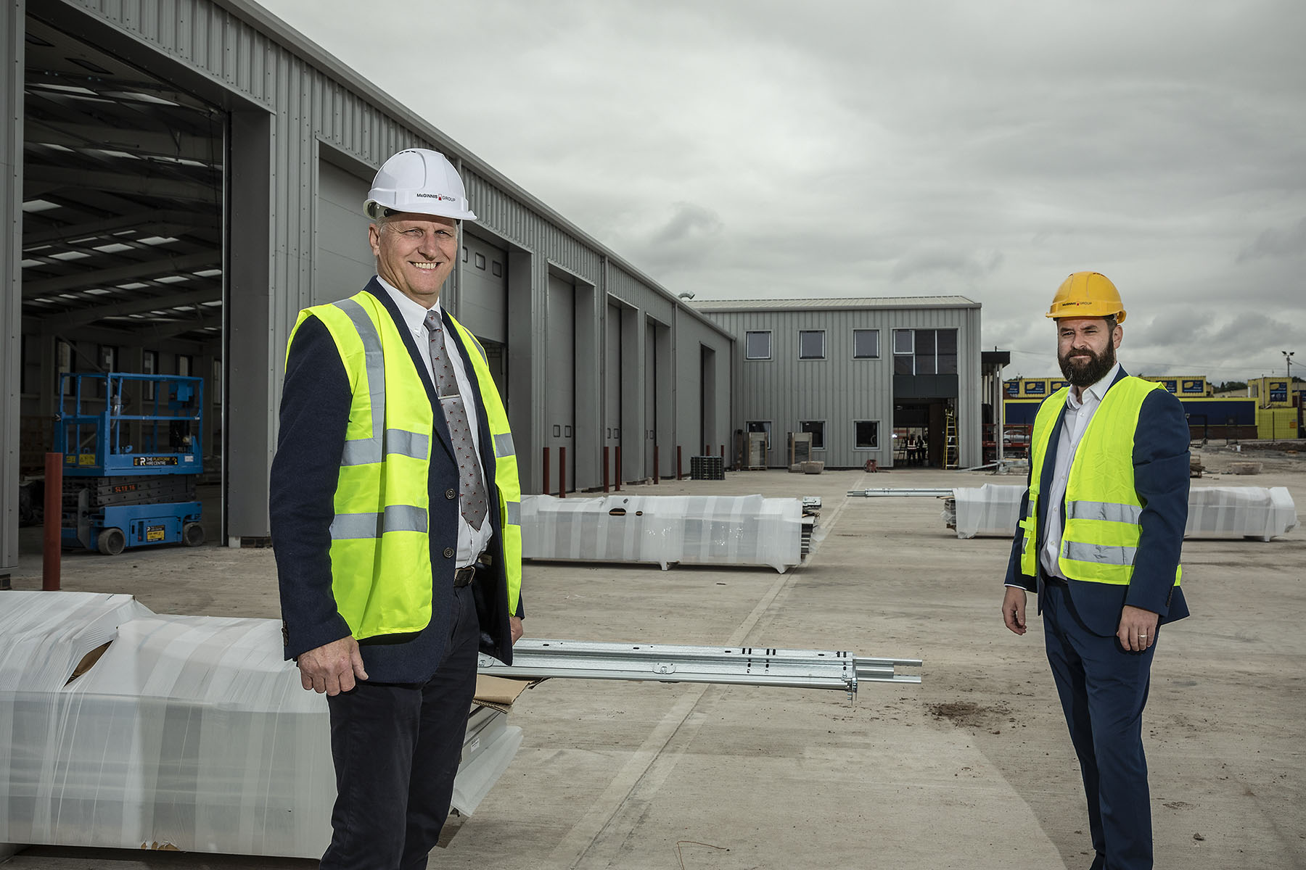

Site visit: Midlands Truck & Van Managing Director Steve Hunt, left, and Service Director Michael Carolan are overseeing the company’s latest infrastructure project

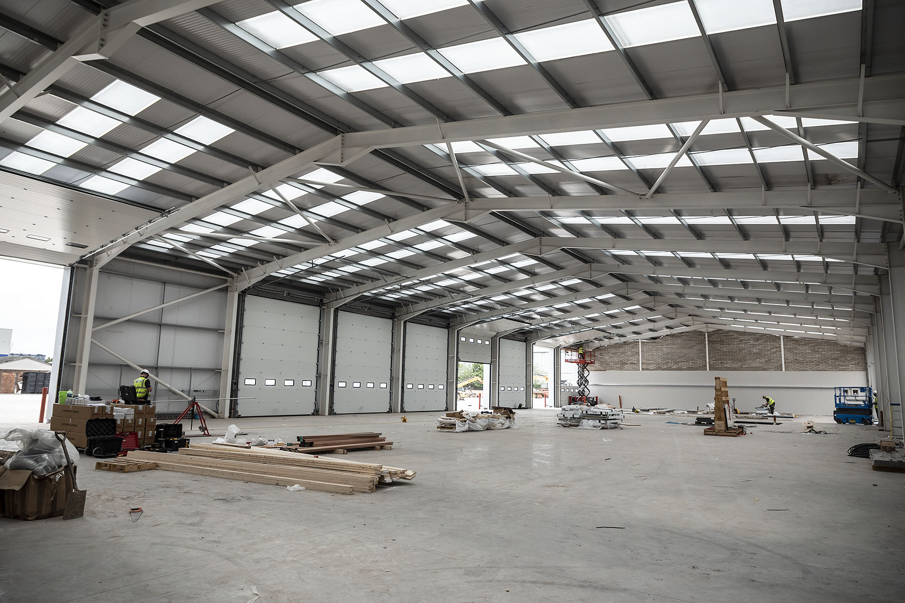

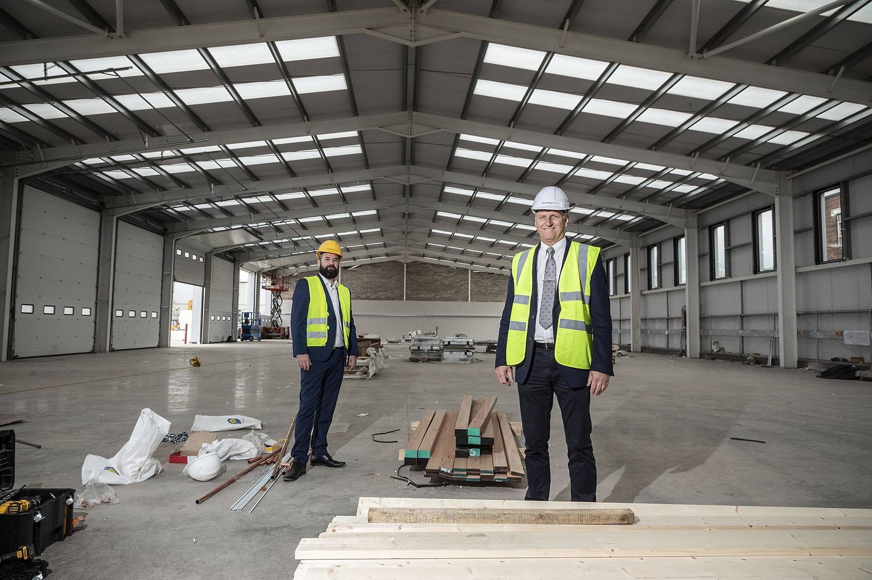

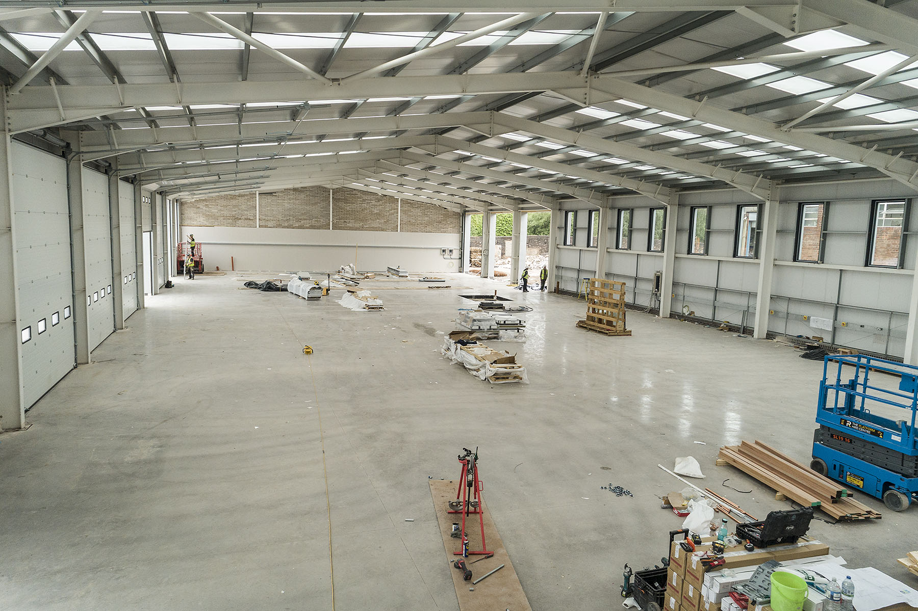

ends

For more information, or to request bigger/higher-res image files, please contact:
Steve Warren or John Ripley
Impact Communications, 01926 842126
Steve: 07770 470251, steve@impactcom.co.uk
John: 07771 484595, john@impactcom.co.uk

