

Date: 14 June 2021

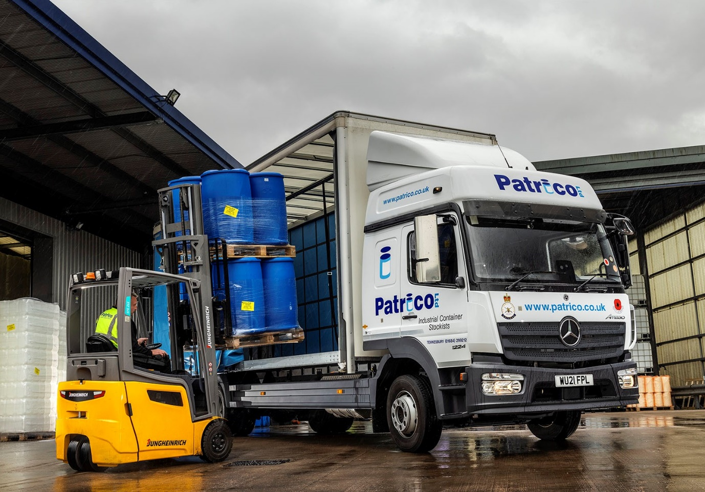

Another robust yet refined Mercedes-Benz Atego adds up to the perfect package for Patrico

Proven product reliability and consistently strong residual values led packaging solutions specialist Patrico back to trusted supplier Rygor Commercials for its latest Mercedes-Benz truck.

The 12-tonne Atego has a BigSpace sleeper cab and is now working alongside the Tewkesbury-based operator’s four other trucks, each of which also wears a three-pointed star. Two are from the same range of light- and medium-duty rigid trucks as the new arrival, while the other two are Actros tractor units.

Patrico stocks and distributes everything from small cartons, bottles and buckets to steel drums and large intermediate bulk containers (IBCs). Its trucks deliver these to customers from the chemical, food production, pharmaceutical and other sectors, located throughout England and Wales,

As a 1224 variant, the new Atego is powered by a 7.7-litre six-cylinder engine that produces 175 kW (238 hp) and drives through a six-speed Mercedes PowerShift 3 automated manual transmission. Its high-volume curtainside body is by Fred Smith & Sons, of West Bromwich.

Patrico Director John Herbert said: “We’ve been buying Mercedes-Benz trucks for many years now and for most of that time we’ve been served by Jeremy Price, Rygor’s Fleet Sales Manager. He is very professional and has come to know our business really well, which means he also understands exactly what we need.

“This level of trust is important in business but it’s not the whole story, because the vehicles Jeremy supplies have provided exceptional service too. We’ve tried other brands occasionally but invariably found that no matter how well they started out, they just couldn’t last the pace like a Mercedes-Benz.”

The latest Atego has replaced one that was seven years old and had covered more than 300,000 km. “I knew we’d have no trouble selling that truck on, and so it proved,” said Mr Herbert. “The resale value of Mercedes-Benz trucks is consistently high; we always get a decent return.”

He continued: “Our drivers are a great bunch and very loyal – some have been with us 25 years or more. They’re often out overnight and we like to look after them, so the fact that as well as being tough and dependable the Atego can be specified with the roomy and comfortable BigSpace cab is another important plus. As far as possible we assign each truck to one person, and they tend to treat them as their own. If you give a driver a smart truck, they make sure it stays that way.”

Patrico was founded in 1983 as a quick response, service-based company, supplying containers to the paint, adhesive, and chemical industries. Following expansion, the company moved a decade later to the larger site in Northway Lane that remains its home to this day. Patrico’s modern warehouse was purpose-built in 2007, following a devastating flood.

As well as enjoying an unrivalled reputation for rugged reliability, the Mercedes-Benz Atego range from 7.5-16 tonnes GVW offers outstanding dynamics, comfort and manoeuvrability. “The Atego is a proven performer,” affirmed Mr Herbert. “It’s exceptionally durable and cost-effective, and is also well-liked by our drivers. For us, it’s just the best truck out there.”

Jeremy Price added: “Patrico prides itself on providing an excellent service to its customers, and my aim has always been to ensure that we at Rygor offer an equally high level of care to John Herbert and his team. Allied to Rygor’s commitment to Setting Standards, the robust yet refined Mercedes-Benz Atego has all the answers.”

www.patrico.co.uk
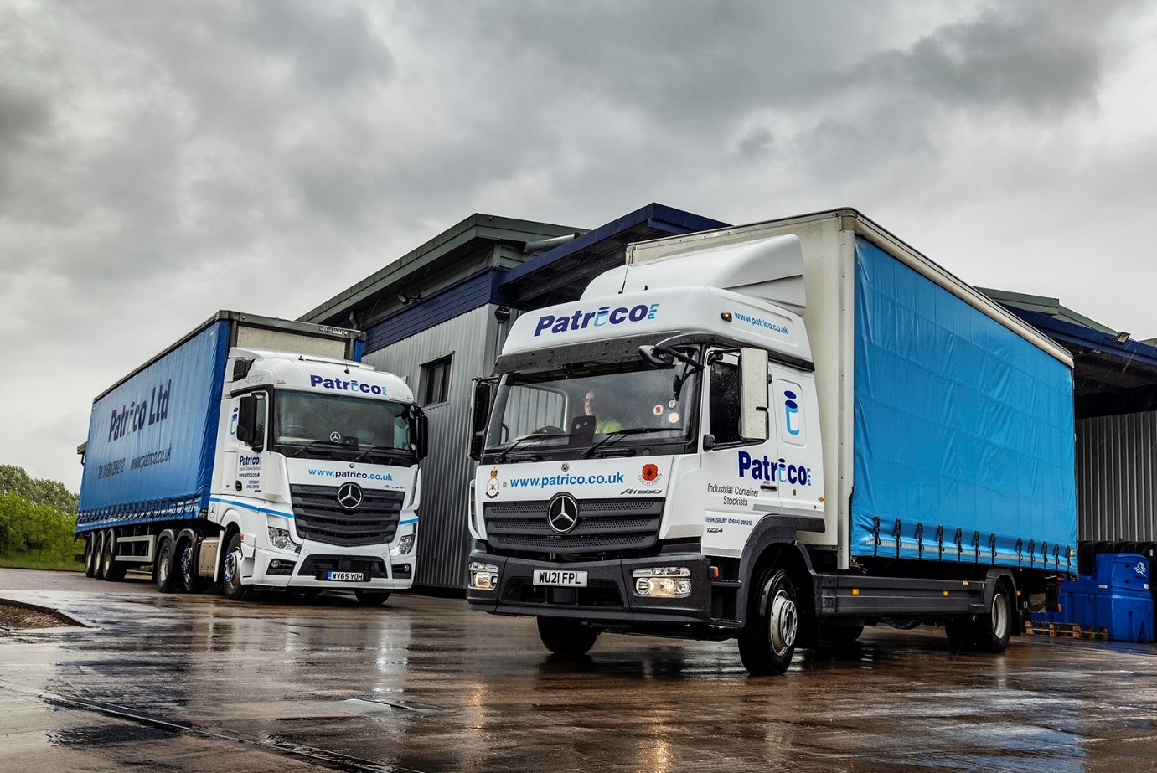

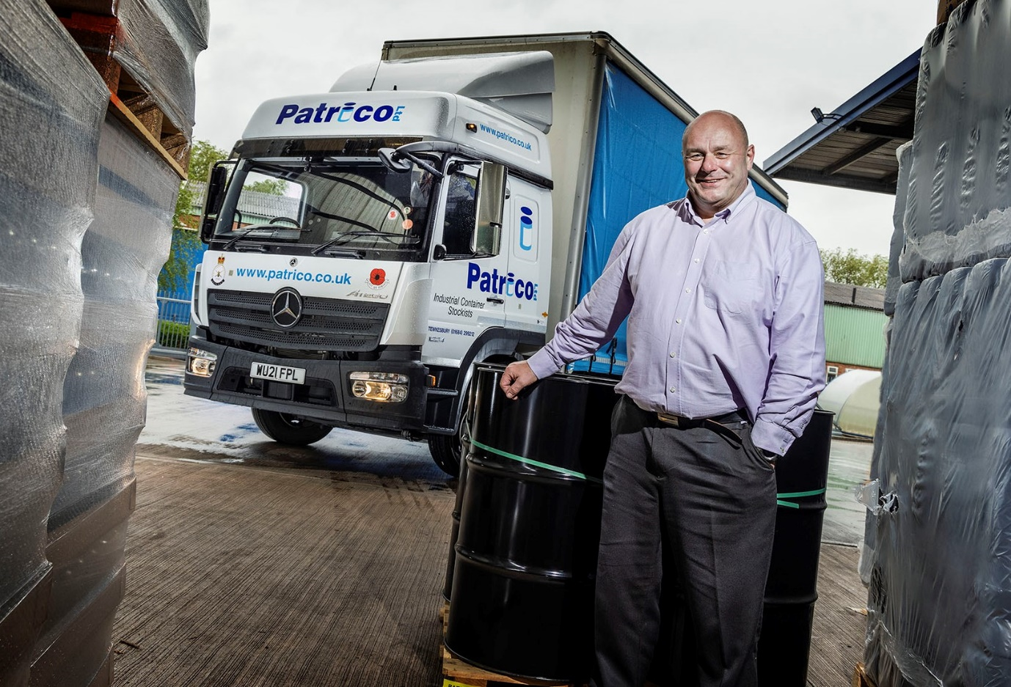

Loyal customer: Patrico’s John Herbert has been buying Mercedes-Benz trucks for nearly two decades
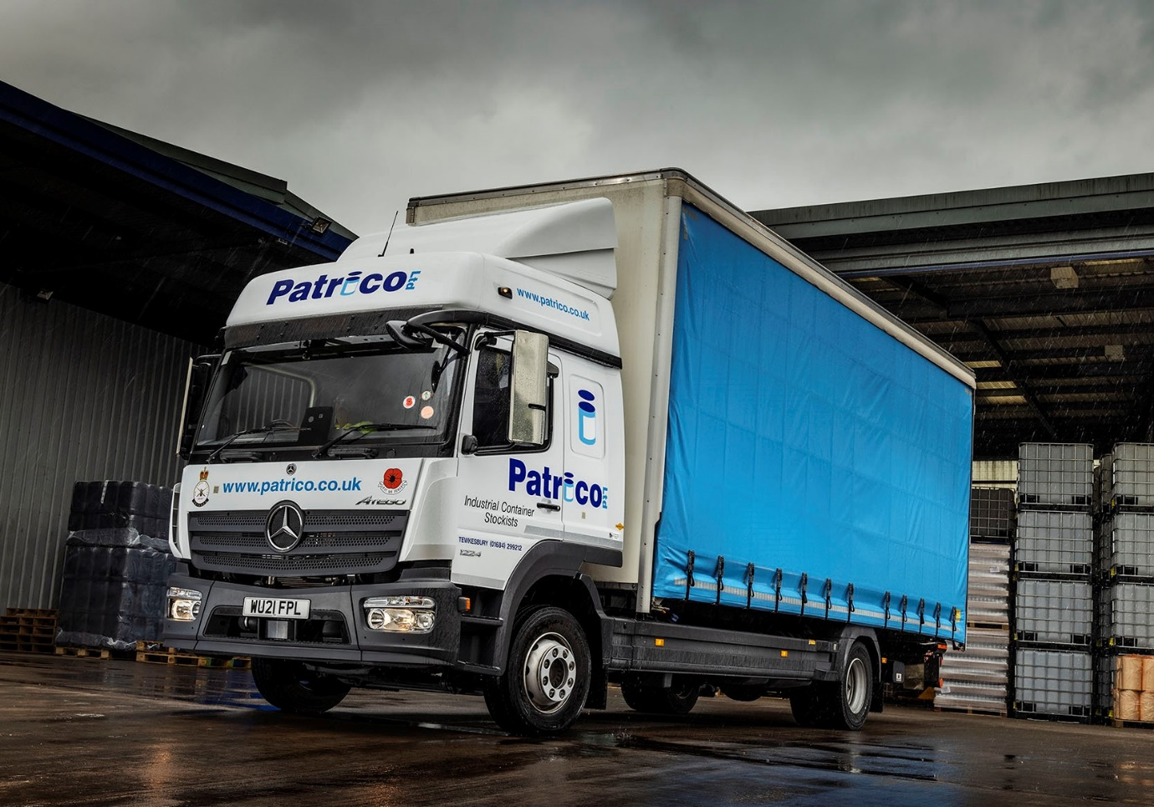

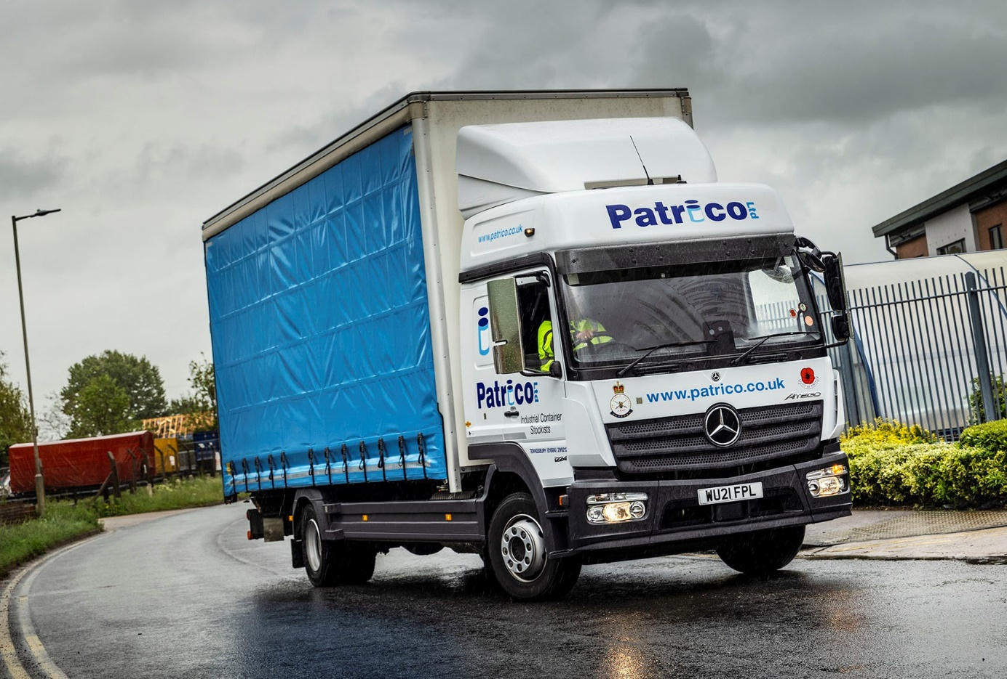

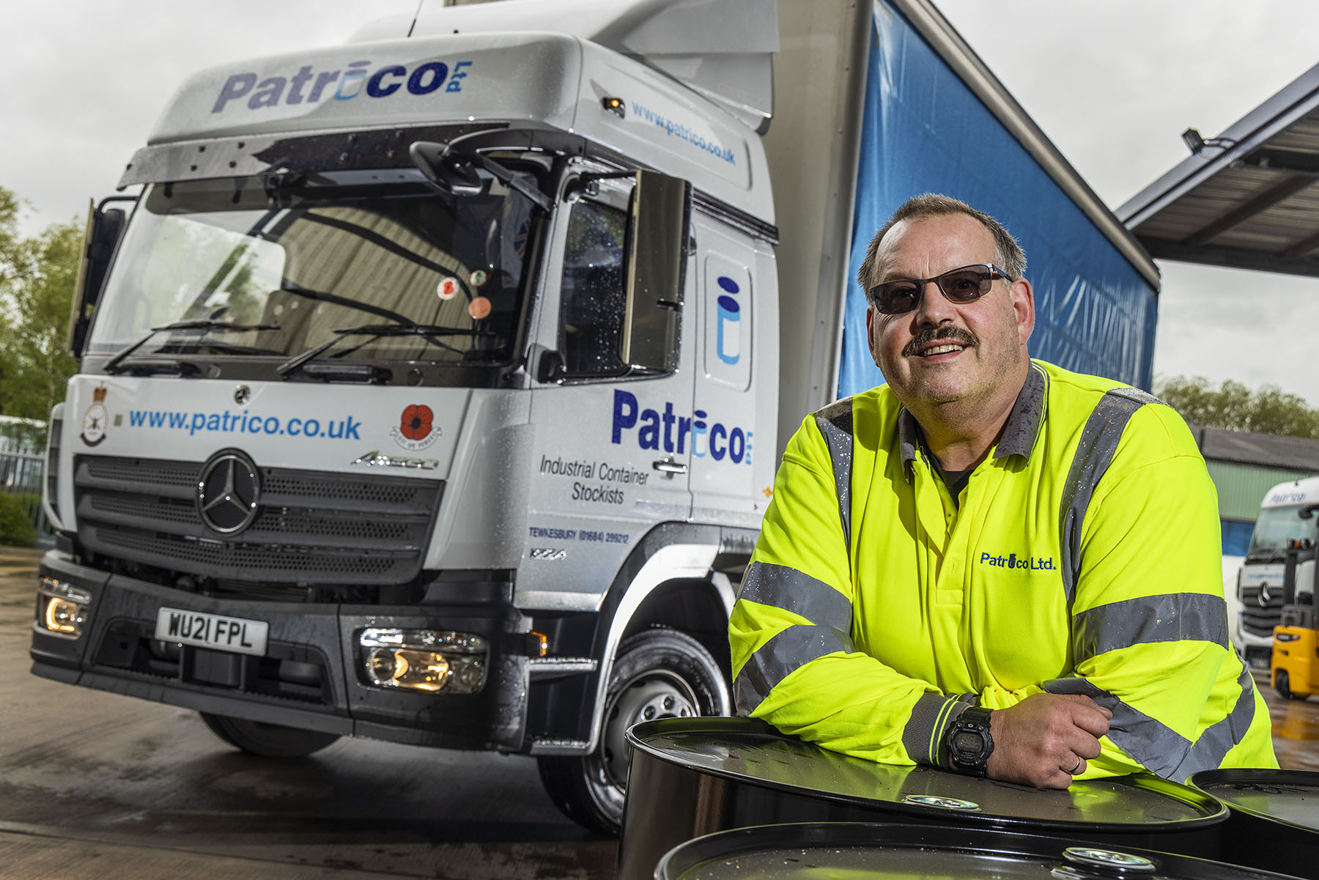

Miles more smiles: Patrico’s latest Mercedes-Benz Atego has been assigned to driver Phil Edge

ends

For more information, or to request bigger/higher-res image files, please contact:
Steve Warren or John Ripley
Impact Communications, 01926 842126
John: 07771 484595, john@impactcom.co.uk
Steve: 07770 470251, steve@impactcom.co.uk

Notes to Editors: Rygor Commercials

Award-winning Mercedes-Benz Commercial Vehicle Dealer group, Rygor Commercials, has branches in Berkshire, Gloucestershire, Oxfordshire, Somerset, West London, Warwickshire, Wiltshire, and Worcestershire, offering extensive coverage for customers throughout the M5, M4 and M42 corridors.

The Rygor business has developed and gone from strength to strength in recent years, investing in extensive renovations of its sites across the country as well as a brand-new, dedicated Heathrow Truck Centre which opened in 2020. With six industry and network awards under its belt in the past 24 months, Rygor continues to be dedicated to providing exceptional customer service, which Sets Standards. The Dealer was delighted to be announced as winner in the ‘Franchised Dealer of the Year’ category at the 2019 Commercial Motor Awards and ‘Van Dealer of The Year 2021’ at the What Van? Awards, accolades which not only demonstrate the company’s focus on customer satisfaction, but also its commitment to the development, training, and wellbeing of its team members.

With a proven track record, Rygor is proud to be selling, maintaining and supporting the most prestigious name in commercial vehicles.

For more information, in the first instance please contact Kate Ruberry-Shoemack, Head of People and Communications at Rygor – kateruberry-shoemack@rygor.co.uk, or in her absence, Communications Assistant, Talitha Scott – talithascott@rygor.co.uk.

