

Date: 18 November 2019

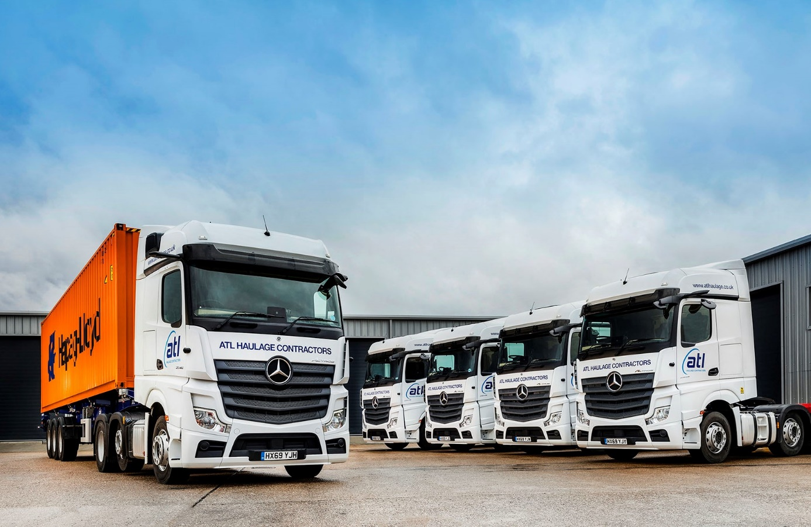

ATL’s 20 new Mercedes-Benz Actros hit the ground running

Container specialist ATL Haulage Contractors is thrilled with the fuel-efficient performance of the 20 new-generation Actros delivered in September by its ‘favourite’ Dealer, Marshall Truck & Van.

Most of the new tractor units are between half-a-mile, and a mile-and-a-half per gallon ahead of its established trucks, a performance which holds out the promise of substantial annual savings in diesel costs.

What’s more, the Actros have been flying since day one. Director Jamie Woodward, who runs ATL Haulage Contractors with his business partners Amit and Ash Karia, observed: “We’d normally expect to have to wait a little while for a truck to loosen up, and dust off the cobwebs, before it started to produce its best fuel figures.

“These Mercedes-Benz units have really hit the ground running, though, and immediately established themselves as front-runners in terms of economy. Our other tractors return anything from 9.5 to 10.5 mpg. By contrast, 15 of the new Actros are already averaging 11 mpg – some may be a little shy of that figure, but others are doing even better!

“On the evidence of the last two months, therefore, our substantial investment in this new equipment has been more than justified. We’ve quickly become big advocates for the new product, and if the new trucks continue to perform as well as they’ve done so far it will strongly influence where we place our next round of orders.”

ATL Haulage Contractors operates more than 120 tractor units. Those that work from its headquarters at the London Gateway deep-water port are by Swedish manufacturers. However, most of the trucks based at its depot in Southampton wear three-pointed stars and are maintained by Marshall Truck & Van. Supplementing this core fleet, the company also works closely with a number of trusted sub-contractors.

The latest units are all Actros 2545 models with flat-floored BigSpace cabs. Their second-generation, 12.8-litre, in-line six-cylinder engines produce 330 kW (450 hp) and drive through Mercedes PowerShift automated manual transmissions.

Between them, the new Mercedes-Benz Actros and Arocs ranges incorporate more than 60 innovations. They include an enhanced version of the well-proven Predictive Powertrain Control system, which scans the road ahead then manages the vehicle’s driveline to restrict diesel consumption and cut emissions. A standard feature across the entire new Actros range, PPC now offers much extended functionality, covering virtually all A roads and many B roads, while also taking account not only of topography, but also of corners, roundabouts, junctions and road signs.

Boosting economy still further is the much-publicised MirrorCam system. As well as increasing safety and reducing the chances of costly accident damage by providing much improved visibility, this ground-breaking technology reduces fuel consumption by up to 1.3% in long-haul operations, thanks to the smaller, more streamlined profile of the rear-facing camera housings compared to conventional door mirrors.

In addition to these and other advanced aids, Mercedes-Benz has provided drivers with a state-of-the-art Multimedia Cockpit, which brings connectivity and intuitive operation to the fore. Stylishly designed and beautifully finished, the new dash is particularly noteworthy for its two interactive screens.

“I love new technology, and the benefits it delivers,” continued Mr Woodward. “But given that so much has changed we thought there might be a bit of initial resistance to these Actros, particularly from some of the more experienced drivers. In fact, things couldn’t have gone much more smoothly. Pretty well all of our drivers have quickly grasped the technology and really like the cab.”

This positive feedback is crucial to an operator that recognises the key role played by drivers in delivering the tailor-made haulage solutions it creates to meet clients’ precise needs. The company prioritises the recruitment, development and retention of the best drivers, and stages a black-tie dinner each year, at which the top performers are recognised and rewarded.

ATL Haulage Contractors purchased its first Mercedes-Benz trucks in 2010. While some of the new Actros replace units that have been stood down, the others represent extensions to the fleet. “We like the product, of course, but the support we receive from Marshall Truck & Van also goes a long way towards explaining why Mercedes-Benz accounts for the bulk of our Southampton fleet,” added Jamie Woodward.

“They’re definitely the best Dealer we work with. Manager Simon Jeffery and his workshop team do everything well. If an issue crops up – as it always will from time to time, with even the best trucks – we know they’ll jump on it quickly and efficiently.

“Communication levels are also very good, and the paperwork is clean and thorough. We’ve had problems with other suppliers that just don’t arise with Marshall, and it makes my life a lot easier knowing they’re watching my back.”

www.atlhaulage.co.uk

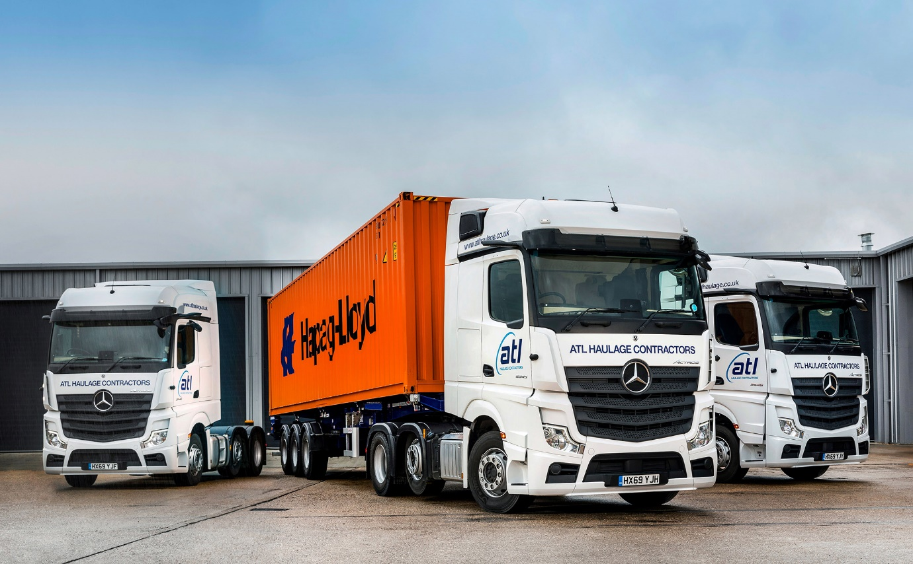

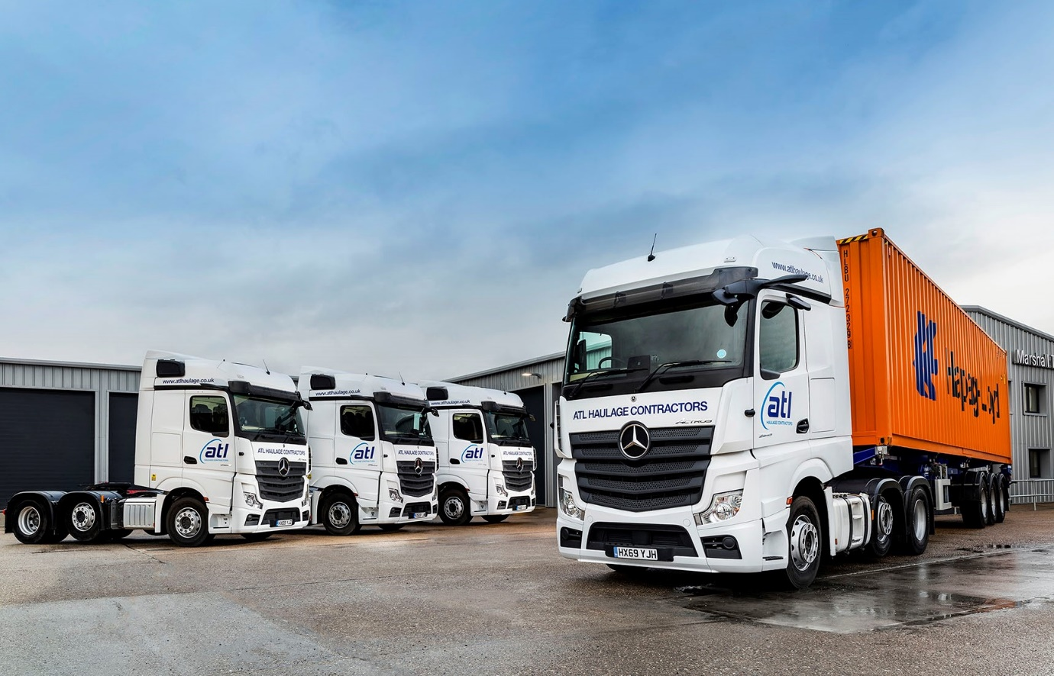

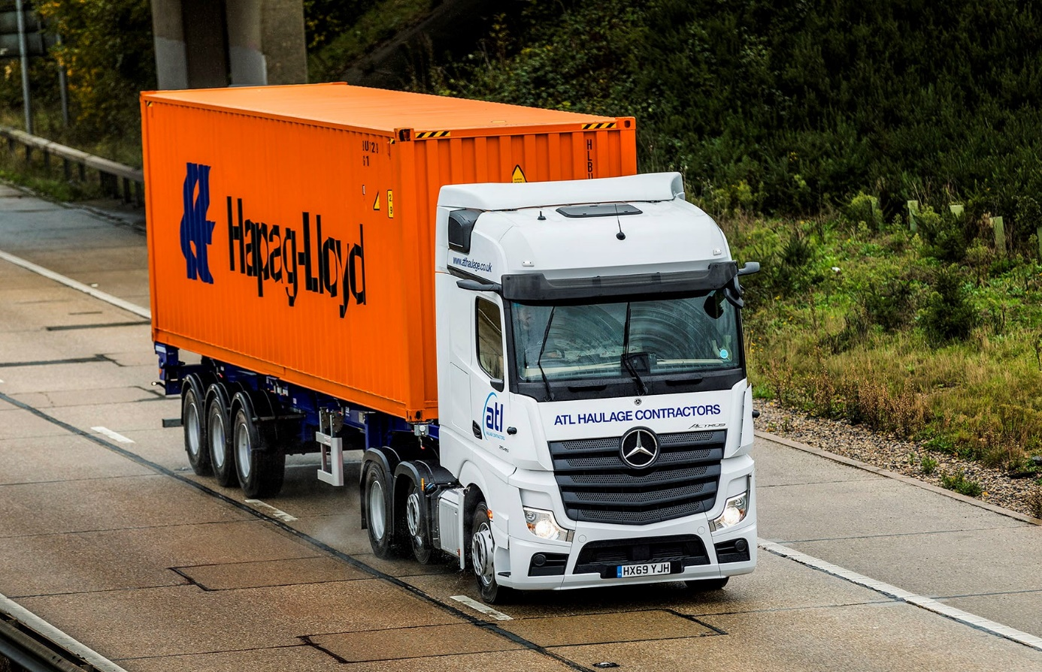

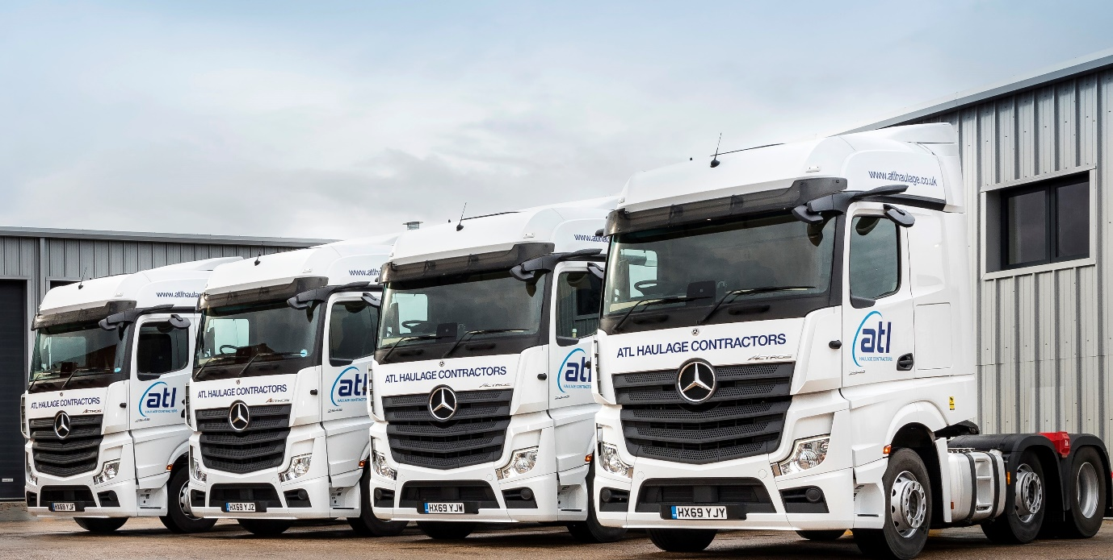

ends

For more information, or to request bigger/higher-res image files, please contact:
Steve Warren or John Ripley
Impact Communications, 01926 842126
Steve: 07770 470251, steve@impactcom.co.uk
John: 07771 484595, john@impactcom.co.uk

