

Date: 28 July 2021

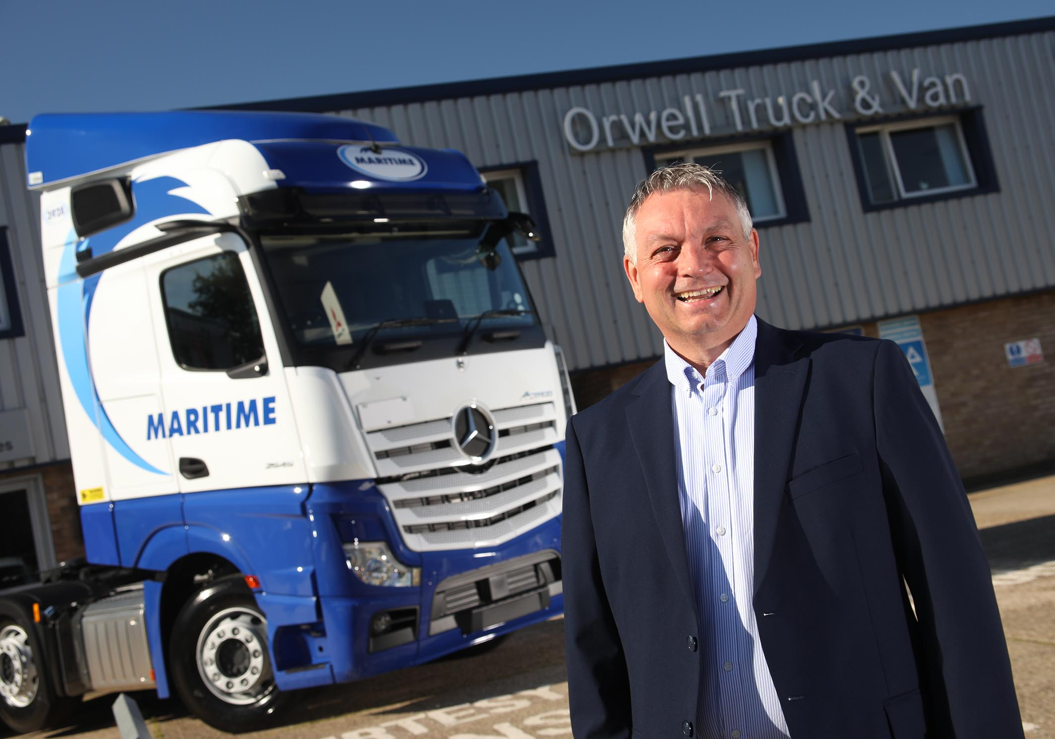

Ton up! Maritime Transport’s Paul Heyhoe is adding 100 new-generation Actros tractor units to his fleet

Maritime charts a course for future success with 100 new-generation Mercedes-Benz Actros from Orwell

Intermodal logistics leader Maritime Transport is looking forward to the final deliveries from a consignment of 100 new-generation Actros tractor units, its first from Mercedes-Benz trucks since 2017.

The Felixstowe-based operator placed its order following successful trials of a demonstration unit supplied by East Anglia Dealer Orwell Truck & Van, which proved impressively fuel-efficient and popular with drivers.

That demonstrator was already undergoing evaluation by Wincanton Container Logistics when the container transport business of Wincanton plc was acquired by Maritime last autumn.

Maritime Fleet Director Paul Heyhoe is responsible for more than 1,200 trucks, all but a handful of them tractor units. The fleet is split between three core brands, of which Mercedes-Benz is one.

He recalled: “We’d found that with our 16- and 17-registered Actros the mpg returns started to improve after they’d been on the road for between a year and 18 months, and continued doing so for a while.

“The demonstrator’s fuel performance, by contrast, was really good from the outset. We took the vehicle off day-time work and gave it to one of our long distance trampers, then compared the figures with the 18-plate truck he’d been in previously. The demonstrator was a full mile per gallon better, and right up there with the very best on the fleet in terms of economy.”

Maritime’s new Actros are all 2545 models with flat-floored BigSpace cabs – in which the operator has specified additional Kuda lockers – and 12.8-litre, in-line six-cylinder engines producing 330 kW (450 hp).

They are easily distinguishable from their predecessors, thanks to the absence of mirrors. Instead, the new tractor units came with Mercedes-Benz Trucks’ MirrorCam system. This ground-breaking technology contributes to safety by providing improved rear vision and eliminating forward-facing blind spots, while also improving economy – Mercedes-Benz estimates by up to 1.5% – through reduced wind resistance from the compact and streamlined camera housings.

Other standard features include upgraded interactive versions of the stylish and intuitive Multimedia Cockpit, which replaces traditional switchgear; Active Brake Assist 5, the latest emergency braking aid, which now employs a camera as well as radar, and is even more responsive to pedestrians crossing the truck’s path; and enhanced Predictive Powertrain Control, which manages gear changes for optimum efficiency.

“The drivers have taken quickly to MirrorCam and particularly like the new dashboard,” confirmed Paul Heyhoe. Multimedia Cockpit, interactive features a larger 12in instrument panel and offers extra functionality, including satellite navigation.

Also winning praise from Mr Heyhoe was the Electronic Parking Brake (EPB), which was introduced last year and is now also a standard feature on new Actros and Arocs models. The EPB is applied automatically whenever the driver opens their door and the vehicle is not moving.

“It’s a nice step forward,” he said. “Safety is our number one priority at Maritime, so we’re keen to embrace any new development that can alert our drivers to risk and help to prevent accidents. The EPB gets a big tick from us.”

Also key to Maritime Transport’s continued reliance on Mercedes-Benz trucks is the support it receives from Orwell Truck & Van, and its fellow members of the manufacturer’s franchised network.

“Main Dealers undertake all of our inspections and maintenance,” he confirmed. “Fleet Sales Manager Rob Dale and his colleagues at Orwell provide a brilliant service. When we do have an issue, as you always will with even the best trucks, they’ll work with us to achieve a speedy resolution.”

Established in 2001, Maritime Transport has diversified over the years to provide complete supply chain coverage through a wide range of services, including curtainsided distribution, intermodal transport, container storage and repair, freight management, and cargo handling and warehousing.

www.maritimetransport.com

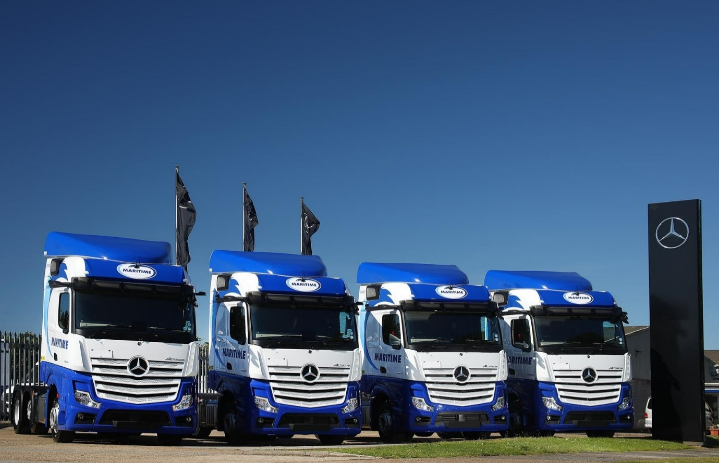

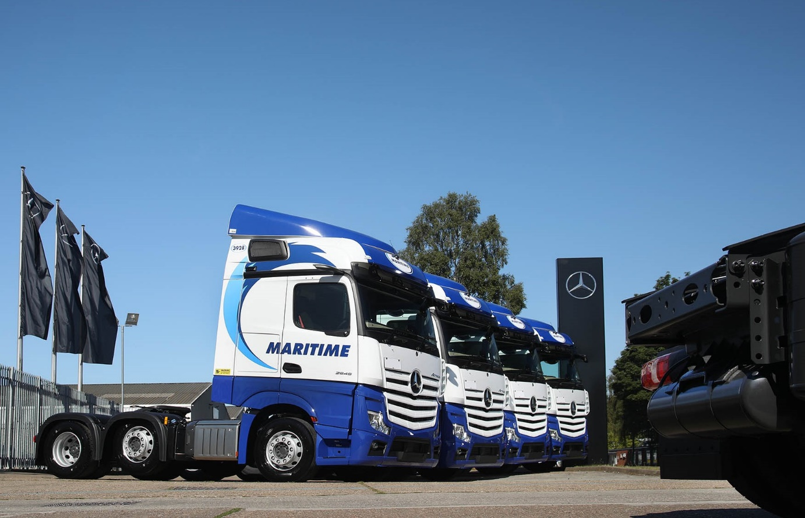

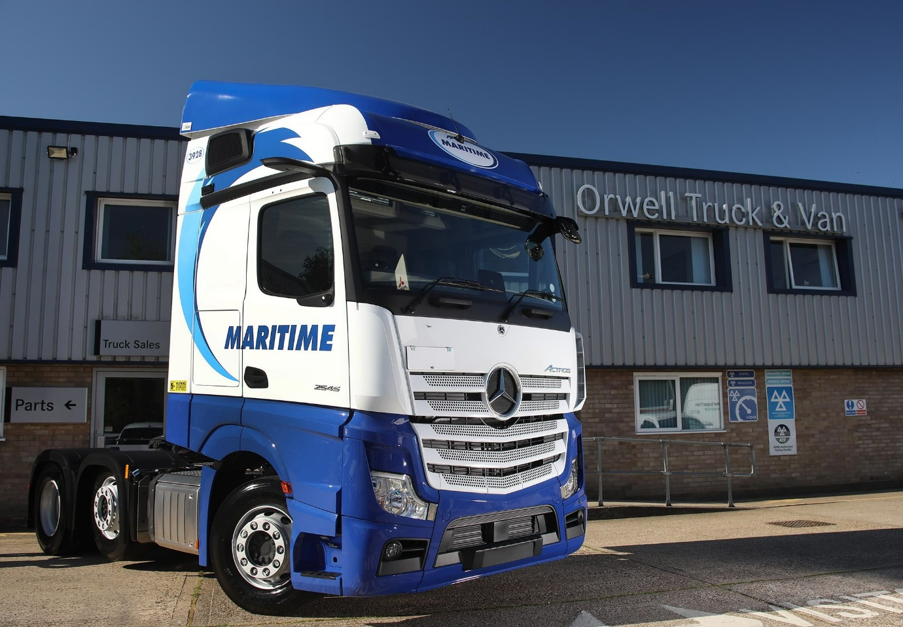

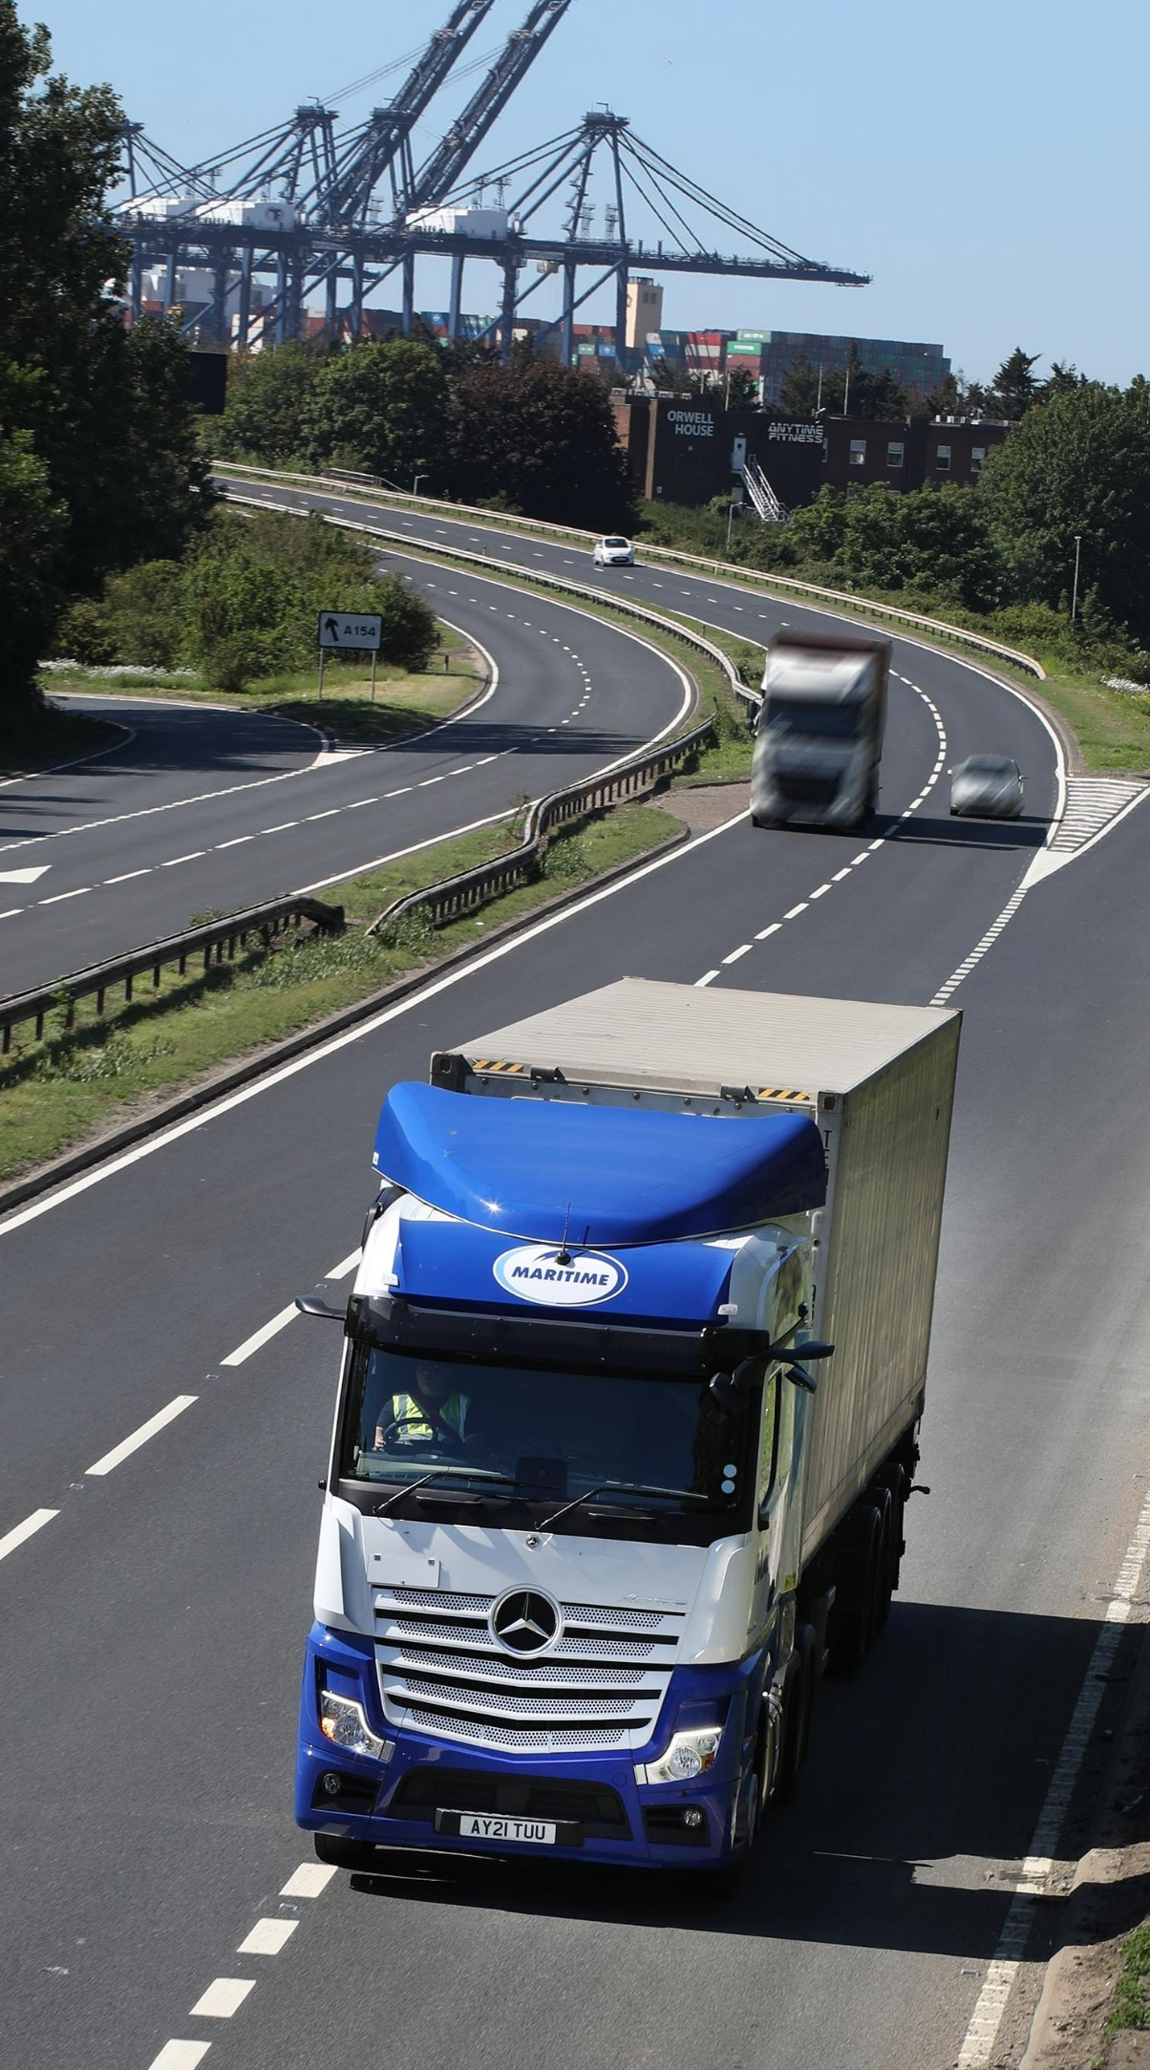
ends

For more information, or to request bigger/higher-res image files, please contact:
Steve Warren or John Ripley
Impact Communications, 01926 842126
John: 07771 484595, john@impactcom.co.uk
Steve: 07770 470251, steve@impactcom.co.uk

