

Date: 18 March 2019

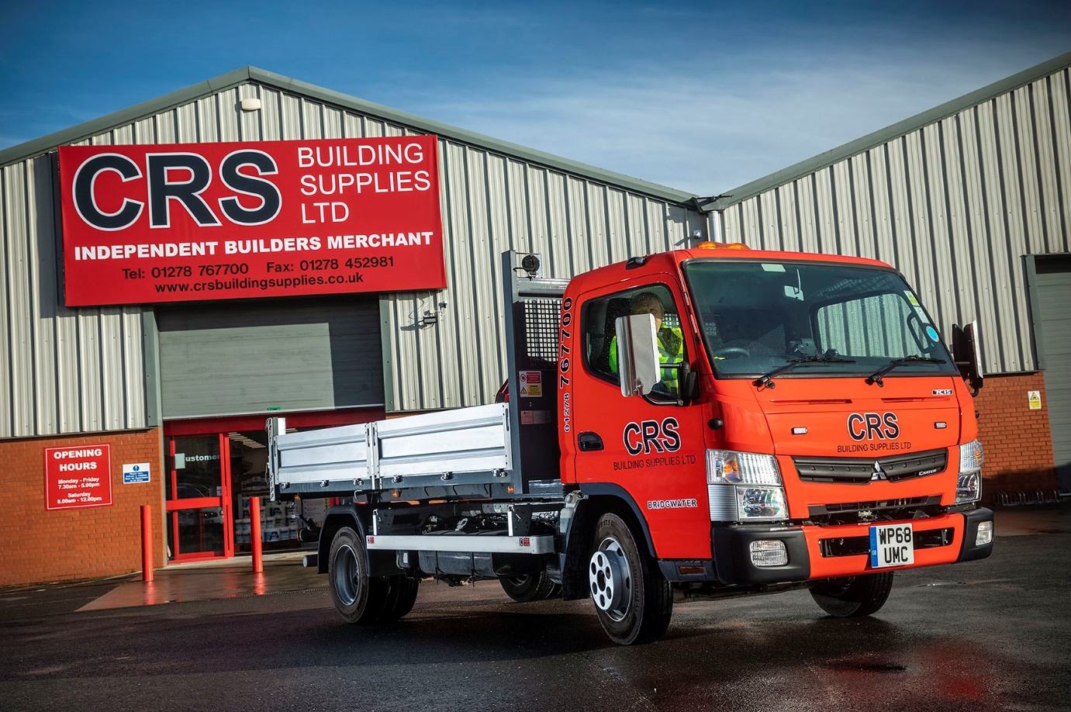

FUSO Canter is loads better for CRS Building Supplies

Payload and productivity gains were among the top priorities when CRS Building Supplies needed four new trucks to offer improved delivery services to its customers – which is why it opted for 7.5-tonne FUSO Canters.

The company operates a chain of 10 builders’ merchant branches in and around Somerset. It acquired its new Canter 7C15 models from Mercedes-Benz Dealer City West Commercials, which celebrates its 10th anniversary in business this year. Like other members of the manufacturer’s franchised network in Great Britain, the Dealer is also responsible for sales and support of the popular FUSO light truck range.

The Canters are a valuable addition to the CRS fleet and work from the operator’s outlets across Somerset – including a new site in Bridgwater, the 10th branch in its county-wide network.

CRS employs a growing line-up of trucks, from 3.5-tonne tippers to 12-26-tonne GVW crane vehicles, which provide free local deliveries of products, including power tools, a wide range of insulation products, timber, bricks and blocks, and loose or bagged sand and aggregates.

The Canters have Comfort day cabs and economical 3.0-litre common-rail diesel engines which offer impressive torque – 370 Nm is available over a broad engine speed range – and generate 110 kW (150 hp). Their robust steel tipping bodies, meanwhile, are by Brit-Tipp, of Warrington.

CRS Building Supplies Transport Manager Paul Gibbard said: “Our smallest vehicles are 3.5-tonne tippers which offer payloads of 900 kg. The Canters are barely any bigger in terms of their external dimensions, but can carry an impressive 3.8 tonnes.

“Their compact footprint and excellent turning circle mean they’re also every bit as manoeuvrable, so they can easily get on and off domestic driveways, and small building sites where access can be tight.

“We can therefore deliver significantly more product on a single journey. The resulting reduction in total vehicle miles is helping to cut our fuel bill while also reducing the impact of our operations on local air quality and traffic levels.”

Safety was another high priority for CRS. The Canter’s low seating position, and deep windscreen and side windows, allow drivers to make eye contact with pedestrians, cyclists and other road users easily, while the Lane Departure Warning System helps keep the vehicle on the straight and narrow. The operator has added all-round recording cameras supplied by Leeds-based SM UK, strobe-light beacons and side repeating marker lights to boost safety still further.

Paul Gibbard continued: “Of course, as 7.5-tonners the Canters fall into operator regulations so we have trained more staff to meet these requirements. The cost of so doing is more than outweighed, though, by the significant gains they’re delivering in overall efficiency and productivity.”

CRS acquired the first two Canters with funding support from Mercedes-Benz Finance, but purchased the second pair outright. All four are the subject of fixed-cost Complete Service Contracts and will be maintained at City West Commercials’ Highbridge workshop.

FUSO Canter models from 3.5-8.55 tonnes GVW are built around a robust, ladder frame chassis, which ensures they are well able to withstand the rigours of harsh operating conditions.

“They certainly look like sturdy little trucks,” added Mr Gibbard. “We’ve also been impressed with what we’ve seen so far of City West Commercials. It’s a new supplier to CRS, although I’ve come across the Dealer while working in previous roles.

“Sales Executive Paul Vickers has been exceptional: he’s never more than a phone call away to answer any queries, and went the extra mile in handling all liaison with the bodybuilder, ancillary suppliers and signwriters, to ensure that our high standards were being met.

“The acquisition and servicing packages Paul put together also combine highly competitive rates with predictable monthly budgeting, which will allow us to plan for the continued growth of our business. He has certainly laid the foundations for what we hope will develop into a long-standing and mutually beneficial working relationship.”

www.crsbuildingsupplies.co.uk

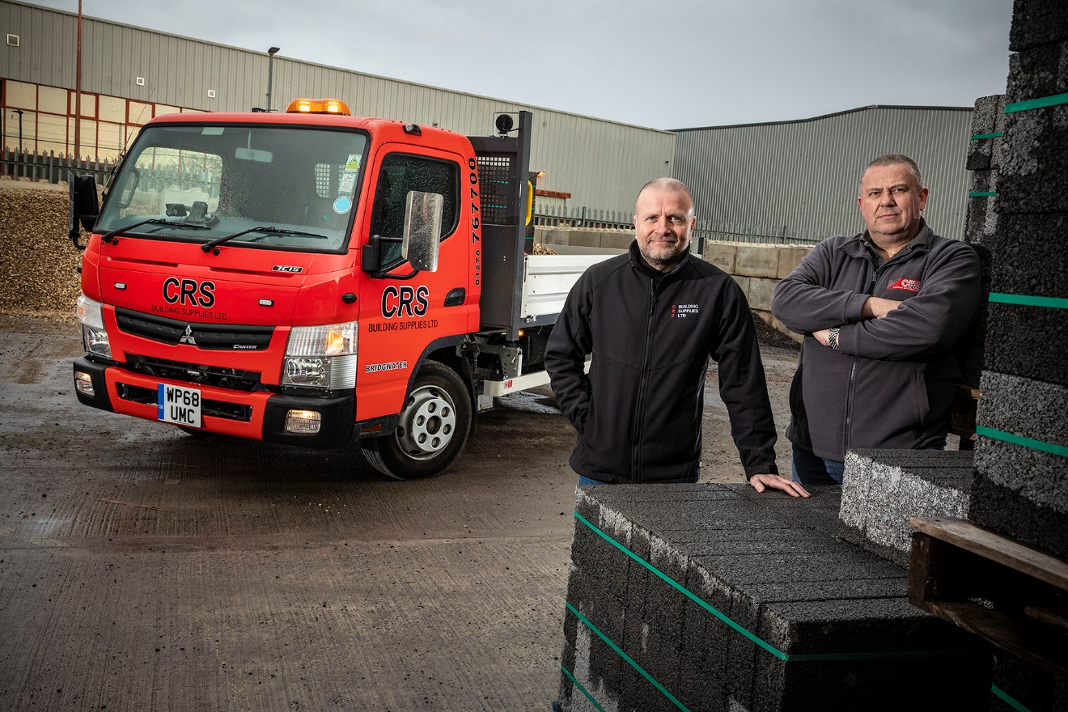

Canter converts: CRS Bridgwater Branch Manager Jon Sanders, left, and CRS Transport Manager Paul Gibbard

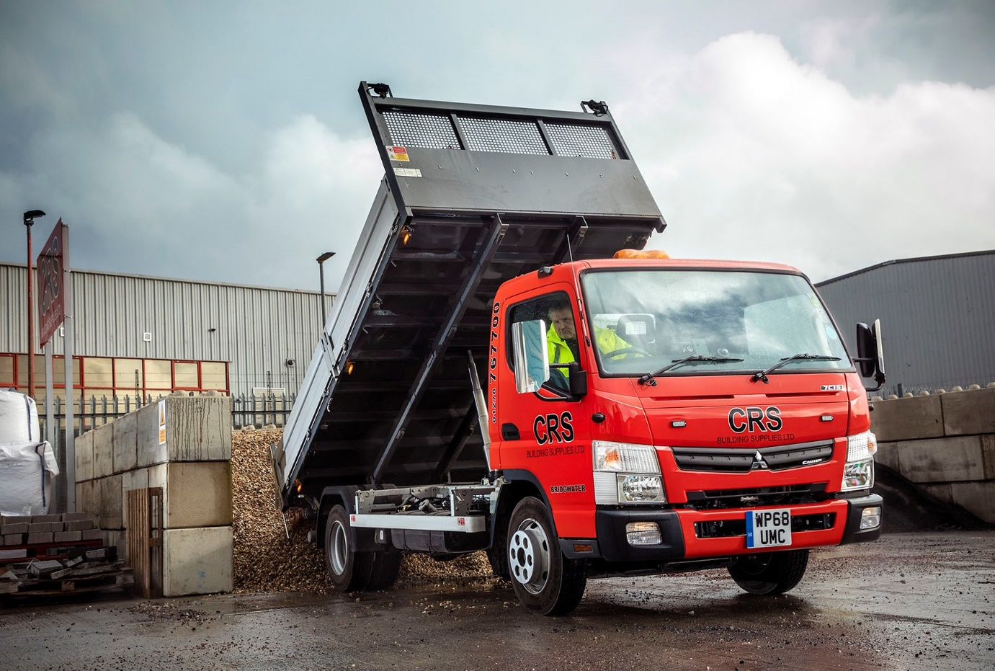

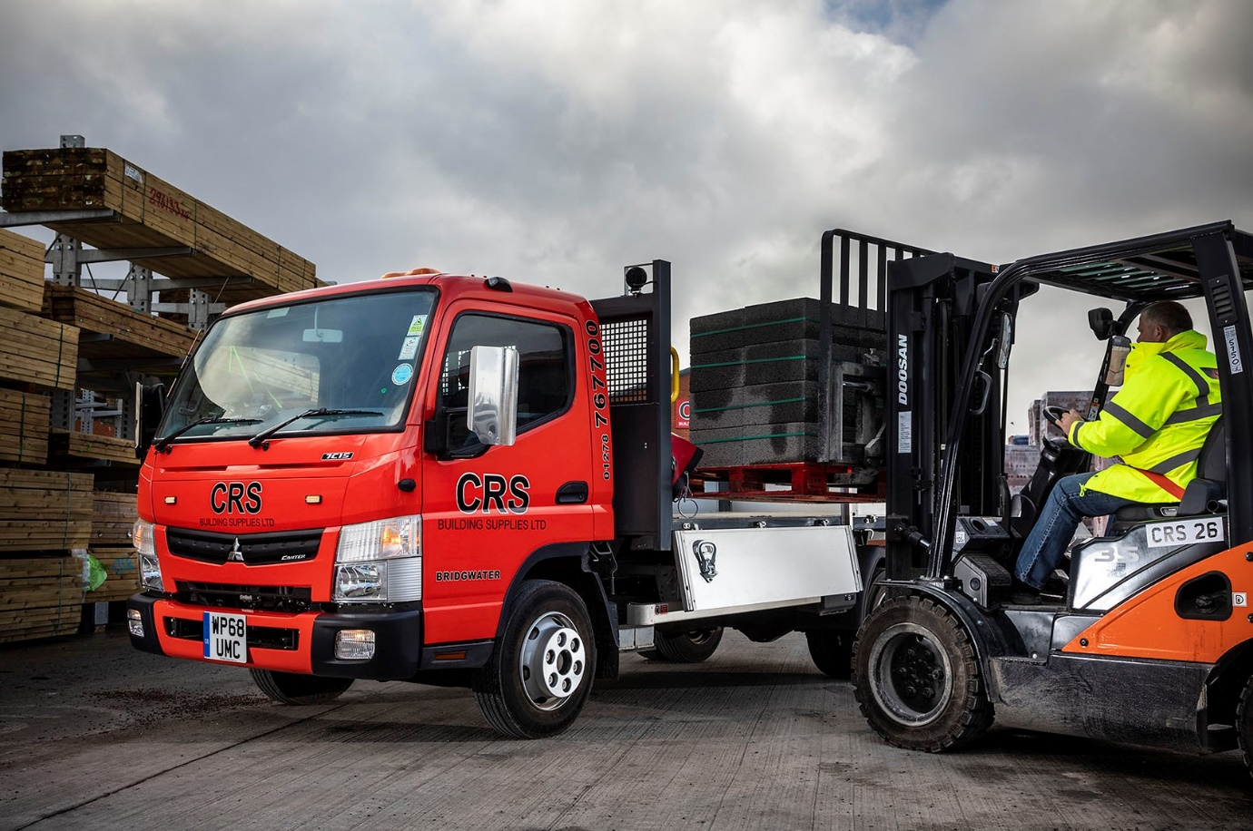

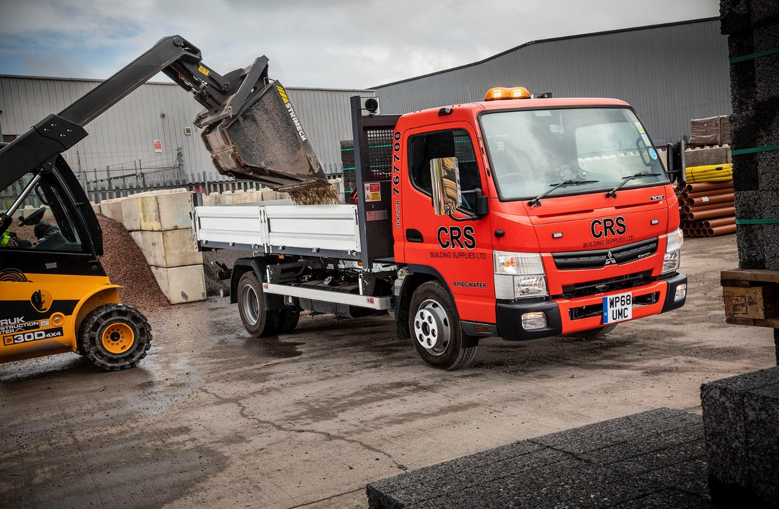

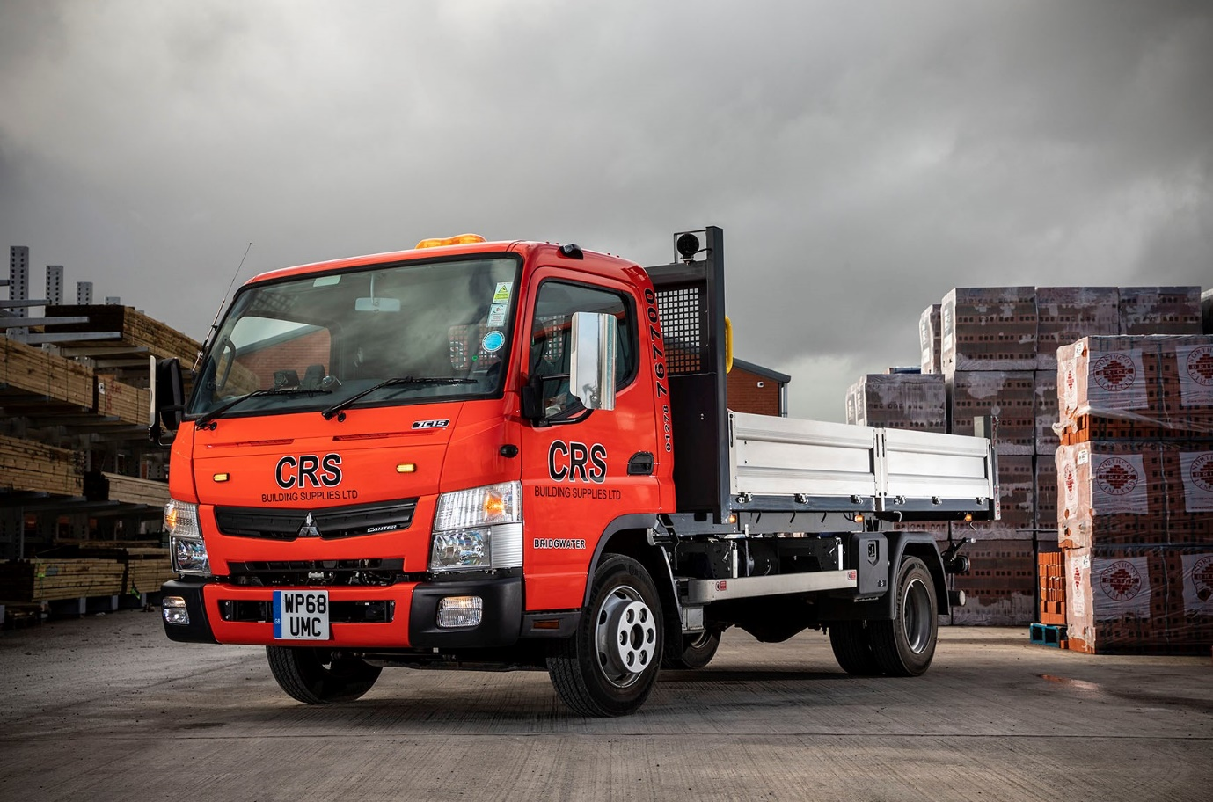

For more information, or to request bigger/higher-res image files, please contact:
John Ripley or Steve Warren
Impact Communications, 01926 842126
John: 07771 484595, john@impactcom.co.uk
Steve: 07770 470251, steve@impactcom.co.uk

