

Date: 22 September 2021

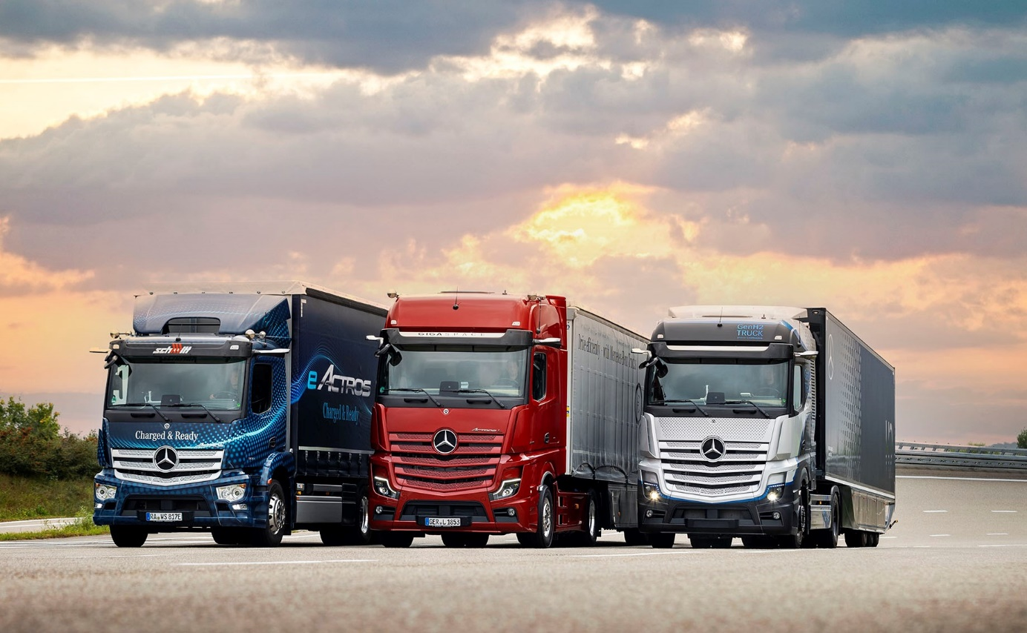

A new era dawns: The battery-electric eActros, left, and hydrogen-powered GenH2 tractor unit flank the luxurious Actros L

Efficiently and sustainably into the future

At “Shaping the Now and Next”, Mercedes-Benz Trucks is presenting solutions for road haulage that are both economically efficient and CO₂-neutral

- With its products, technologies and services, Mercedes-Benz Trucks is underlining its commitment to providing haulage industry companies with the trucks that best meet their needs, either with conventional or electric drive systems.

- The luxurious Actros L sets new benchmarks in the premium long-distance truck segment.

- The full-scale production in Wörth of the eActros for heavy-duty distribution transport from October 2021 is set to be followed by the eEconic for municipal use in the second half of 2022.

- The eActros LongHaul with its range of around 500 kilometres is scheduled for series production in 2024, while the GenH2 Truck with hydrogen-based fuel-cell drive system is due in 2027 and will offer a range of 1,000 kilometres or more. Both are intended to make locally CO₂-neutral road haulage possible even for long-haul transport operations.

- Mercedes-Benz is committed to the Paris Climate Agreement and aims to switch its portfolio completely to electrically powered trucks by 2039.

- Comprehensive advice and strategic partnerships on subjects such as integration into the fleet, charging infrastructure and network connections ensure even greater efficiency in the deployment of electric trucks.

- Customer-focused services and digital solutions for economic fleet operation contribute to the optimisation of total operating costs.

- With the latest driver assistance systems such as the emergency braking assistant with pedestrian detection and Active Drive Assist for partially automated driving, Mercedes-Benz Trucks is consistently closing in on its vision of achieving accident-free driving.

Stuttgart/Wörth am Rhein – The energy revolution in the road haulage industry is focusing the minds of transport operators more than ever on the question of the best drive technology to serve their needs. Another traditional diesel? Or a fully electric truck? The decision is one that needs to be weighed up carefully and calculated over the whole period the truck will be in use. Ultimately, any investment in a new truck must pay for itself. This makes it all the more important to be able to work alongside a manufacturing partner like Mercedes-Benz Trucks, which is actively involved in the evolution of drive technologies and can provide highly efficient vehicles for all types of use.

But that’s not all. Changes to aspects of drivetrain technology are associated with numerous challenges relating to integrating vehicles into the fleet, charging infrastructure and network connectivity, for example. Here, too, Mercedes-Benz Trucks sees itself as a partner able to give active support extending beyond the vehicles themselves to include services and solutions for maximising the benefit to customers using their trucks every day on the road. To this end, Mercedes-Benz Trucks is in close dialogue with customers, in order to ascertain the precise requirements in this area. The current and future vehicle concepts, as well as the services and solutions with which Mercedes-Benz Trucks generates high added value for its customers are showcased in the company’s “Shaping the Now and Next 2021” press event.

Extensive vehicle portfolio covering all customer uses

As far as the vehicles are concerned, Mercedes-Benz Trucks recently launched a new model in the traditional diesel segment in the form of the Actros L, a truck that offers high quality and the best possible driver comfort. The fully electric and locally CO₂-neutral eActros for heavy distribution haulage was presented as recently as June 2021 and is scheduled to go into full-scale production in Wörth from October 2021; it will be followed in the second half of 2022 by the eEconic for municipal use. From 2024, the eActros LongHaul will be ready for series production and 2027 will see the first GenH2 Trucks with hydrogen-based fuel-cell drive system roll off the production line on their way to customers. Both of these vehicles will enable locally CO₂-neutral haulage on long-distance routes. Depending on the customer’s individual requirements, there will be a choice between battery-powered and hydrogen-based fuel cell systems in the trucks: the lighter the load and the shorter the distance, the more battery-electric operations will be favoured. The heavier the load and the longer the distance, the more likely the fuel cell will be the means of choice.

New flagship at Mercedes-Benz Trucks for traditional long-distance haulage: the Actros L

Available to order throughout Europe since July 2021 and set for full-scale production in November 2021, the Actros L is the biggest and highest quality vehicle of the successful Actros model range. The driver’s cab available in the StreamSpace, BigSpace and GigaSpace variants is 2.5 metres wide and makes for an exceptionally spacious interior. The absence of an engine tunnel means the cab has a flat floor, creating a really comfortable ambience. The improved cab insulation reduces unwanted and annoying noise, making the experience more relaxing for drivers, particularly at break times. The seating position has also been improved. The optionally available, newly designed LED headlamps have a higher light intensity than xenon headlamps and provide excellent illumination of the road – a huge plus when it comes to safety, especially in the dark or when visibility is poor. A particularly important contribution towards enhanced safety is made by assistance systems such as the fifth-generation Active Brake Assist (ABA 5) emergency braking assistant with pedestrian detection, as well as by Lane Keeping Assist and MirrorCam, which replaces the main and wide-angle mirrors. Equally important here are equipment options such as the second-generation Active Drive Assist (ADA 2) system which enables level 2 partially automated driving. The activities and functions of the assistance systems are displayed for the driver in the user-friendly Multimedia Cockpit, with its two colour displays forming the centrepiece of the Human Machine Interface (HMI).

A new truck for a new era: the eActros

Even where the most sophisticated classic diesel trucks are concerned, developments in the commercial vehicle sector are heading increasingly in the direction of electric drive systems. In this regard, Mercedes-Benz Trucks is fully committed to the target of achieving locally CO₂-neutral road freight transportation using battery and hydrogen-based fuel cell technology. The company is committed to the Paris Agreement’s aim of decarbonising the sector and aims to complete the switch of its European product portfolio to electrically powered trucks by 2039.

The first step was made by the eActros. Designed for heavy distribution haulage, the eActros celebrated its world première at the end of June 2021, having been extensively trialled for two years by customers in Germany and other European countries as part of the “eActros innovation fleet”. At the technological heart of the eActros is the drive unit with two integrated electric motors along with a two-speed transmission. Both motors provide for impressive ride comfort and great vehicle dynamics, while the quiet and emission-free electric drive means the truck can also be used for night deliveries and entry into inner cities with driving bans for diesel vehicles. Depending on the version, the eActros draws its power from three or four battery packs – each with a capacity of around 105 kWh¹. The maximum capacity of 420 kWh² enables ranges of up to 400 kilometres to be achieved³. The eActros can be charged with up to 160 kW: the three battery packs need a little over an hour to charge from 20 to 80% at a normal DC rapid charging point with a charging current of 400 A⁴. A display in the standard Multimedia Cockpit, Interactive of the eActros keeps the driver up-to-date on the charge level of the batteries and the remaining range, as well as the current and average energy consumption in kWh per 100 kilometres. The standard safety equipment includes the external Acoustic Vehicle Alerting System for improved acoustic detection for example by pedestrians and cyclists, not to mention the Sideguard Assist S1R system for enhanced safety when turning off to the nearside, and the fifth-generation Active Brake Assist with pedestrian detection.

Fully electric municipal vehicle: the eEconic

The next milestone in the portfolio of electric vehicles from Mercedes-Benz Trucks will be the eEconic series, which is scheduled for the second half of 2022. Intensive testing is still underway, after which the vehicle will move on to practical trials with customers. One customer has already opted for the eEconic – Urbaser A/S (Denmark), a company active in the waste management sector in Denmark, has placed an order for eleven vehicles. The key technical specifications of the eEconic are largely identical to those of the eActros. The eEconic as a waste collection vehicle is designed to cover the vast majority of typical waste collection routes operated by an Econic in a single shift without intermediary charging. The electric drivetrain allows for a level cab floor – this facilitates easy cross-cab movement and is particularly beneficial for drivers wishes to use the folding door on the co-driver’s side, well out of the way of the traffic. A significant upgrade over the conventional Econic comes in the form of the modern and intuitive Multimedia Cockpit. A further equipment highlight is the panoramic glazing; the coated and heated Thermocontrol windscreen also prevents misting of the screen, thus improving the view of the road around the vehicle, and heating up of the cab in direct sunlight. A major safety benefit in urban traffic, the eEconic features as standard Sideguard Assist S1R and the 5th generation Active Brake Assist emergency braking assistant. The eEconic celebrates its exhibition premiere at the IFAT 2022 in Munich.

Electric models for long-distance haulage: the eActros LongHaul and the GenH2 Truck

In addition to distribution haulage and municipal operations, Mercedes-Benz Trucks is also committed to the use of alternative drive concepts for longer distances. For example, the battery-electric eActros LongHaul, scheduled to go into production in 2024, is designed to cover regular journeys on plannable routes with a range of around 500 kilometres on just one charge in an energy-efficient manner. A completely new generation of trucks with a drive system based on fuel cells and hydrogen is on its way in the form of the GenH2 Truck. Hauliers should be able to use the vehicle for flexible and demanding trips of up to 1,000 kilometres and more without the need to stop and refill. Performance is comparable to that of a conventional diesel truck thanks to the use of liquid hydrogen, which has a far greater energy density than hydrogen in gaseous form. Following intensive testing of the latest prototype, which began in April 2021, the first trials on the open road are due to start before the end of the year. Customer trials are scheduled for 2023 and from 2027 the first series-produced GenH2 Trucks will be handed over to customers.

Hydrogen offensive with Volvo Group and Shell

In addition to battery-electric trucks, Mercedes-Benz Trucks sees electric trucks with hydrogen-based fuel cell drive systems as a key technology for the CO₂-neutral transportation of the future. To further the development of this technology, in March 2021 Daimler Truck AG set up the “cellcentric” fuel cell joint venture with the Volvo Group. It is the ambition of cellcentric to become one of the world’s leading manufacturers of fuel cell systems. The company is therefore planning to establish one of the biggest operations for mass producing fuel cell systems in Europe. Production is scheduled to start in 2025. On the subject of fuel cell trucks, the collaboration agreement reached by Daimler Truck AG with Shell New Energies NL B.V. (Shell) in May 2021 also deserves a mention here. The two partners are planning to set up a hydrogen tank infrastructure and launch fuel cell trucks in Europe.

Business eco-system with advice

In order to assist customers along every step of their move to e-mobility, Mercedes-Benz Trucks is embedding the eActros and the eEconic in an eco-system which also provides advice and services, as well as a range of digital solutions to increase capacity utilisation of the vehicle and to optimise the total cost of ownership. For example, using a customer’s existing route plans it should be possible to establish a highly realistic and meaningful usage profile for electric trucks. This e-consulting service doesn’t only include electrification of the depot. If the customer desires, it also covers questions concerning planning, applying for and implementing everything to do with the charging infrastructure, and connection to the electricity network. Specifically for this purpose, Mercedes-Benz Trucks has entered into a strategic partnership with Siemens Smart Infrastructure, ENGIE and EVBox Group. Plus, if required, Mercedes-Benz Trucks can additionally provide help with identifying any available public grants for infrastructure and vehicles.

Digital solutions and customer-focused services

To help customers get the very best from their vehicle, Mercedes-Benz Trucks provides customers with a number of applications designed to increase efficiency and convenience, that can be accessed via the Truck App Portal. For example, the telematics services from Fleetboard allow intelligent networking of drivers, truck, fleet and assignments. All help to optimise consumption, reduce wear and increase vehicle utilisation.

The Truck Data Centre is the centrepiece of Fleetboard and serves as the basis for other vehicle connectivity solutions. The connectivity module receives the data from the sensors, cameras and steering devices in the truck and analyses these for a range of applications. The Truck Data Center not only forms the basis for Fleetboard’s numerous services, but also for Mercedes-Benz Uptime, the service for consistent increases in vehicle availability. The intelligent system comprises all relevant vehicle data – from tyre pressure to the engine, and now to the battery status too. In this context, Mercedes-Benz Uptime has been extended by more than 100 e-specific rules that constantly monitor charging processes for example, or voltage history associated with the high-voltage battery. In addition, the information is available via the new cloud-based customer portal. Thanks to the networking between Mercedes-Benz Service and the transport companies, trips to the workshop can be planned and unexpected downtime caused by breakdowns can be reduced.

Individually configurable service packages as well as tailor-made leasing, financing and insurance solutions complete the range of services and ensure greater planning security in these areas. That Mercedes-Benz Trucks is continually looking to innovative solutions in this regard is demonstrated perfectly by the Mercedes-Benz CompleteMile service contract. Like Mercedes-Benz Complete, the flexible service contract encompasses all workshop work including wear parts, but its concept is different: the monthly rate depends on the number of kilometres actually driven. “My TruckPoint by Mercedes-Benz” adds plenty of value where all existing service contracts and the current vehicle status are concerned. This new platform offers a full overview of contracts, quotes, orders for parts, inspections and maintenance, proving to be a useful fleet management tool.

High level of safety for the driver and other road users

With its traditional diesel trucks and battery-electric vehicles Mercedes-Benz Trucks is systematically pursuing its goal of helping to make road traffic as safe as possible by utilising active safety assistance systems, and in doing so is taking another step closer to realising its vision of accident-free driving. This is evidenced not only by Lane Keeping Assist, Proximity Control Assist and MirrorCam, which replaces the main and wide-angle mirrors, but by a host of other safety features.

One example, also available as an option for the Actros L, is the second-generation Active Drive Assist (ADA 2). Under certain preconditions the system actively assists the driver with longitudinal and lateral guidance of the truck and can automatically maintain the distance to the vehicle ahead, accelerate and also steer if the necessary system conditions such as sufficient curve radius or clearly visible road markings are met. In addition, ADA 2 includes the Emergency Stop Assist sub-function which is able to initiate an emergency stop if the driver is no longer controlling the steering wheel despite visual and audible warnings.

If an emergency braking assistant is required by law, all Actros models are also equipped as standard with fifth-generation Active Brake Assist (ABA) with pedestrian detection function. This system can help to avoid accidents where, due to the driver being distracted, the following distance being too short, or an inappropriate speed, the truck is at risk of colliding with a vehicle ahead or a stationary vehicle, or there is a risk of a frontal collision with a pedestrian. ABA 5 works using a combined radar and camera system. Upon detecting the danger of an accident with a vehicle ahead, a stationary obstacle or a person – be that crossing in front of the vehicle, walking towards the vehicle or in the vehicle’s lane – the system first warns the driver visually and acoustically. If the driver fails to respond appropriately, the system can then initiate partial braking in a second stage. If the threat of a collision continues, ABA 5 can perform automated maximum full-stop braking – at vehicle speeds of up to 50 km/h when responding to moving persons. Finally, on coming to a stop the vehicle applies the new electronic parking brake.

One feature designed specifically for the eActros and the eEconic is the external Acoustic Vehicle Alerting System (AVAS). The low noise levels of these vehicles may in some cases lead to dangerous situations, for example if pedestrians or cyclists notice the electric truck too late. The acoustic warning system should prevent such hazardous situations from occurring. AVAS comprises two speakers – one at the front and one at the rear of the vehicle. They are connected with one another and with the vehicle. Depending on the driving conditions, sounds for driving forwards and reversing are played. The forwards noise simulates a quiet fan noise, while in reverse, an intermittent two-tone sound is emitted.

Mercedes-Benz Trucks aims to support the driver as much as possible within the respective limits of each system. However, as the law prescribes, the driver remains fully responsible for driving the vehicle safely at all times.

Statements from management and selected customers/drivers

Karin Rådström, Member of the Board of Management at Daimler Truck AG and responsible for Mercedes-Benz Trucks: “At Mercedes-Benz Trucks we are fully committed to locally CO₂-neutral transport. In 2030, we want more than half of our new vehicles sold in Europe to be locally emission-free. To make that happen, there is no one-size-fits-all, no silver bullet. In line with the different use cases of our customers, we follow a dual electrification strategy based on battery- and fuel cell-electric trucks. But there is more action needed – in terms of infrastructure as well as a reliable regulatory framework.”

Andreas von Wallfeld, Head of Marketing, Sales & Services at Mercedes-Benz Trucks: “Working with and for our customers to find the perfect solution has always been something special to me because every customer has their own individual requirements and challenges that need to be met. Here at Mercedes-Benz Trucks, partnership is a lived experience all round the clock. To be real partners, we do two main things: Firstly, we listen really carefully to what our customers are saying. Secondly, we develop our trucks – be that traditional diesel or electric vehicles – and services such that serve a unique aim: contributing to the success of our customers.”

Cyrille Bonjean, Head of Land Transport Europe at DB Schenker: “DB Schenker is speeding up the electrification of its fleet as well as helping its hauliers move over to electric vehicles. During our trials, drivers were very happy with the prototype of the eActros. In terms of reliability it was on absolutely the same level as a series-production vehicle with a diesel engine.”

Stefan Olin, Managing Director of Urbaser A/S (Denmark): “I like the all-embracing approach taken by Mercedes-Benz Trucks, which includes e-consulting and digital services. As for the eEconic, I’m looking forward to testing it as soon as possible. I think it is helpful for both parties that we as customers are involved at an early stage so we can provide some feedback.”

Bettina Koob, HGV driver, Wilhelm Schüssler Spedition GmbH: “The Actros L is a fantastic drive and with all its features makes driving both relaxing and safe. I’d like a truck like this for long-distance haulage.”

¹ This is approximately equivalent to the energy content of a new battery pack, including safety and performance limitations to maintain system operation.

2 This is approximately equivalent to the energy content of installed new battery packs, including safety and performance limitations to maintain system operation.

3 Range was determined internally in optimum conditions, for example with 4 high-voltage battery modules, after preconditioning, partially laden in distribution haulage without a trailer and at an outside temperature of 20 °C.
4 Based on figures determined in accordance with company-internal experience, under optimum conditions, including an ambient temperature of 20 °C.

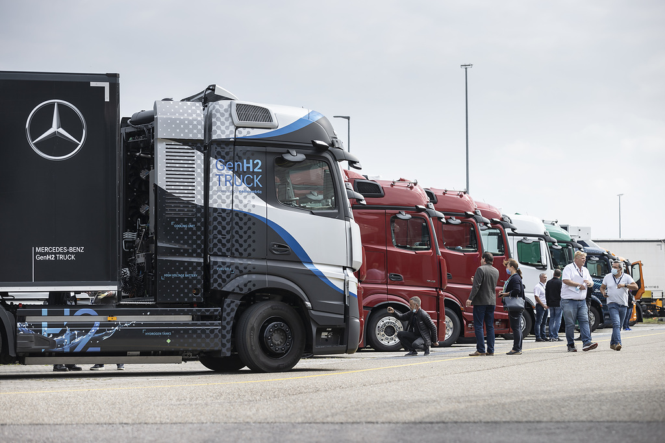

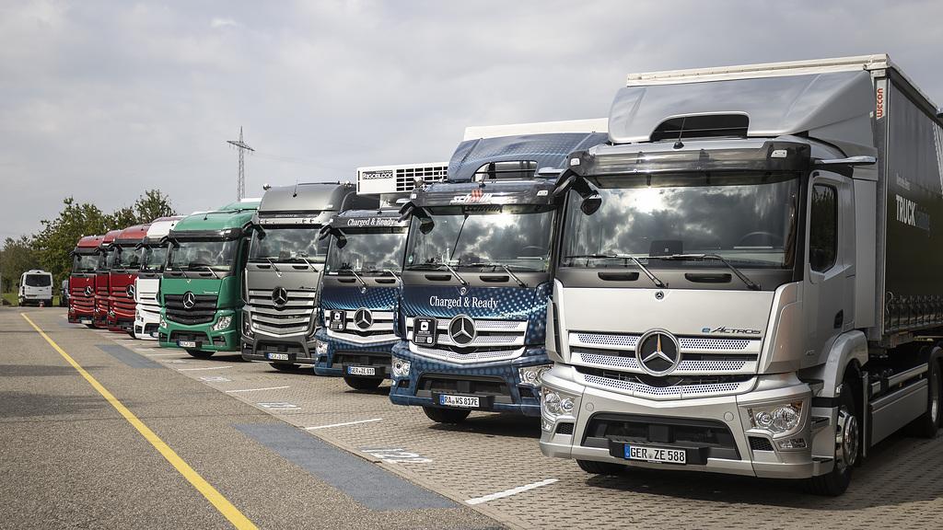

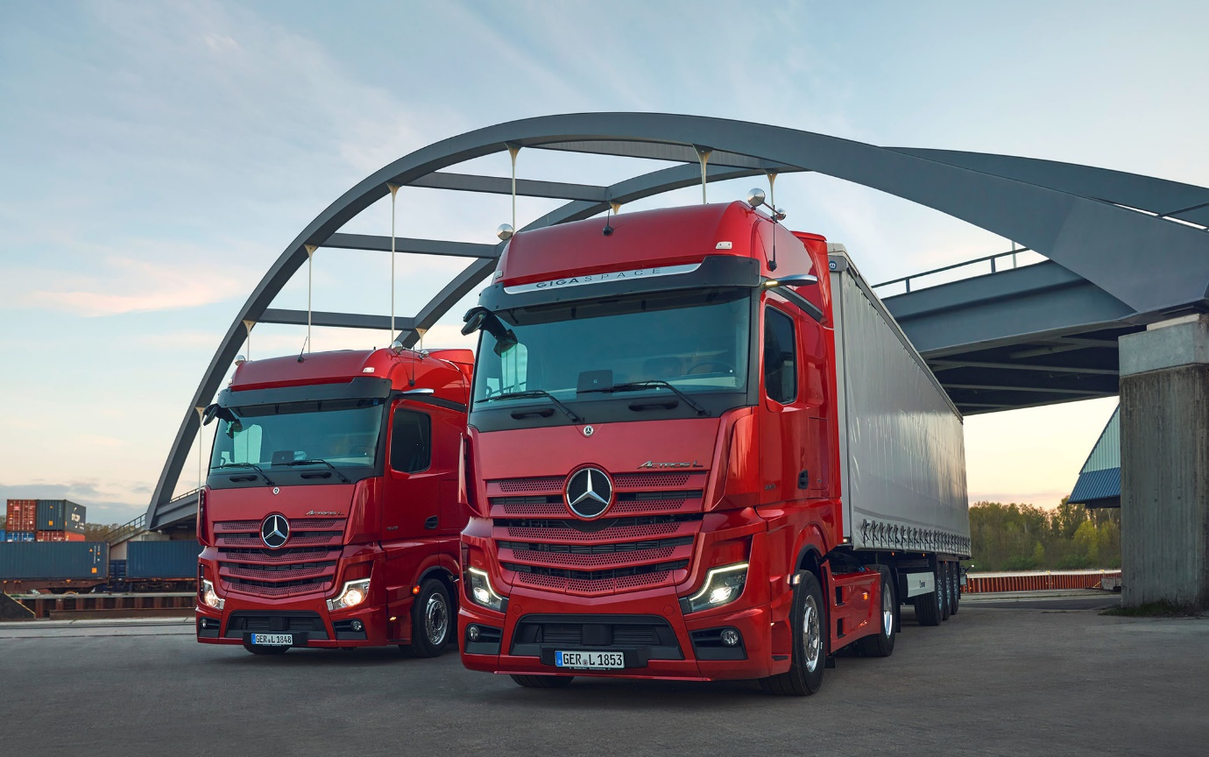

Actros L: Raising the benchmark for driver comfort

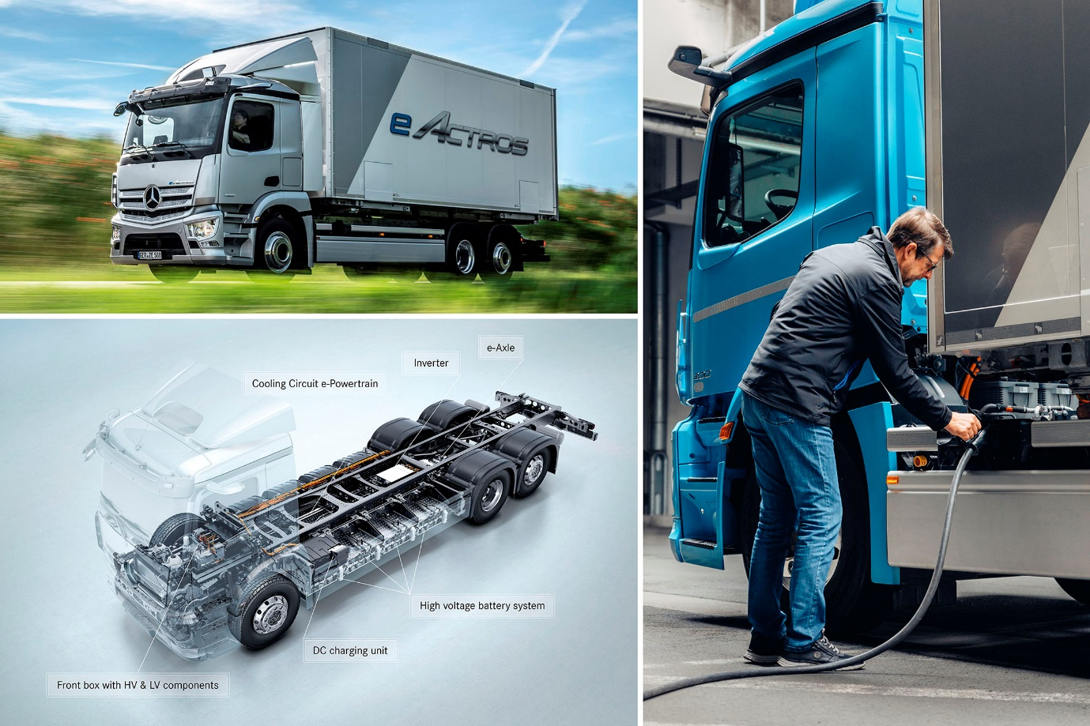

eActros: Full-scale production begins next month (October)

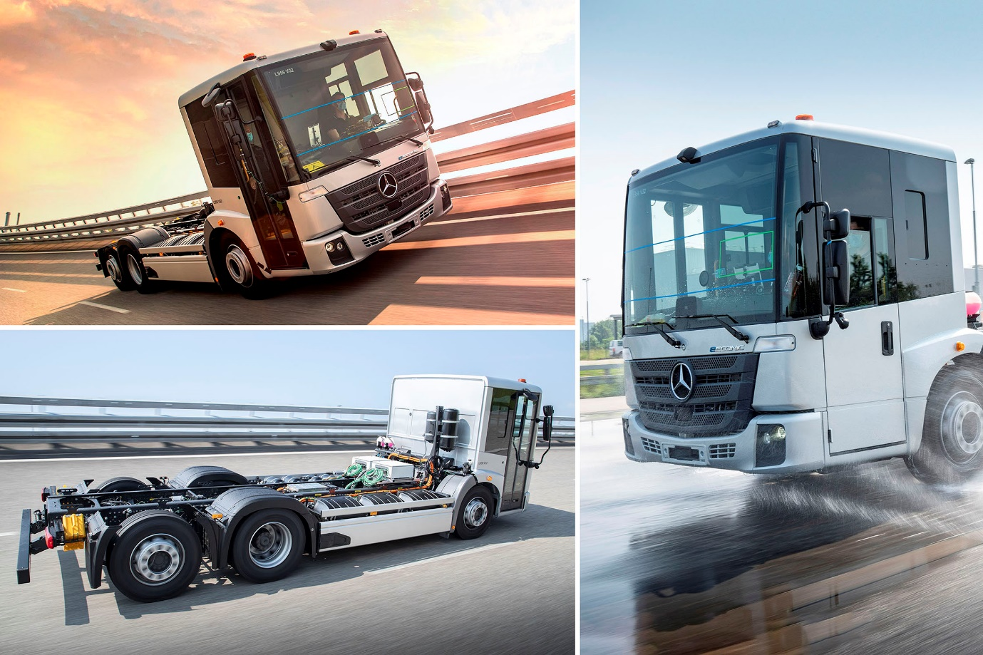

eEconic: Intensive testing of the low-entry truck is now underway

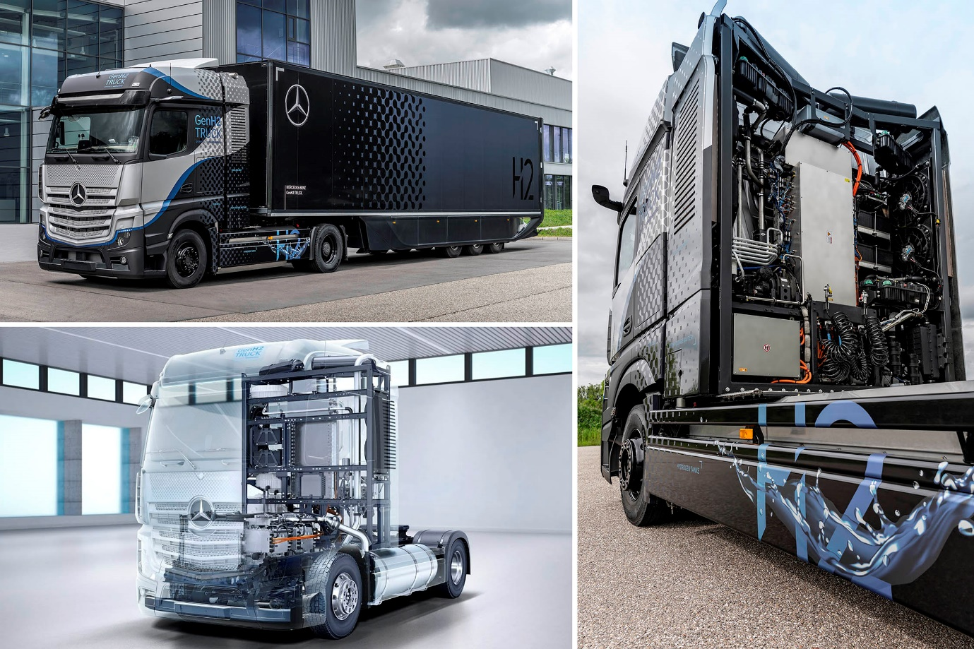

GenH2 – Road trials of the hydrogen-powered truck are due to begin before the end of 2021

For more information, or to request higher-res image files, please contact:

Jamie Fretwell at Mercedes-Benz Trucks UK Ltd
07712 519230, jamie.fretwell@daimler.com

or

Carola Pfeifle, +49 (0)160 8612423, carola.pfeifle@daimler.com

Ulrike Burkhart, +49 (0)160 8613757, ulrike.burkhart@daimler.com

Akim Enomoto, +49 (0)176 30995099, akim.enomoto@daimler.com

Further information from Mercedes-Benz is available online:
www.media.daimler.com, www.mercedes-benz.com and www.daimler-truck.com

Forward-looking statements:
This document contains forward-looking statements that reflect our current views about future events. The words “anticipate,” “assume,” “believe,” “estimate,” “expect,” “intend,” “may,” ”can,” “could,” “plan,” “project,” “should” and similar expressions are used to identify forward-looking statements. These statements are subject to many risks and uncertainties, including an adverse development of global economic conditions, in particular a decline of demand in our most important markets; a deterioration of our refinancing possibilities on the credit and financial markets; events of force majeure including natural disasters, pandemics, acts of terrorism, political unrest, armed conflicts, industrial accidents and their effects on our sales, purchasing, production or financial services activities; changes in currency exchange rates, customs and foreign trade provisions; a shift in consumer preferences towards smaller, lower-margin vehicles; a possible lack of acceptance of our products or services which limits our ability to achieve prices and adequately utilize our production capacities; price increases for fuel or raw materials; disruption of production due to shortages of materials, labor strikes or supplier insolvencies; a decline in resale prices of used vehicles; the effective implementation of cost-reduction and efficiency-optimization measures; the business outlook for companies in which we hold a significant equity interest; the successful implementation of strategic cooperations and joint ventures; changes in laws, regulations and government policies, particularly those relating to vehicle emissions, fuel economy and safety; the resolution of pending government investigations or of investigations requested by governments and the conclusion of pending or threatened future legal proceedings; and other risks and uncertainties, some of which are described under the heading “Risk and Opportunity Report” in this Annual Report. If any of these risks and uncertainties materializes or if the assumptions underlying any of our forward-looking statements prove to be incorrect, the actual results may be materially different from those we express or imply by such statements. We do not intend or assume any obligation to update these forward-looking statements since they are based solely on the circumstances at the date of publication.

Daimler Truck at a Glance
The Daimler Truck AG is one of the worldʼs largest commercial vehicle manufacturers, with more than 35 primary locations around the world and approximately 100,000 employees. The company brings together seven vehicle brands under one roof: Mercedes-Benz (light, medium and heavy trucks as well as city, intercity and touring coaches) and Setra (intercity, long-distance and premium coaches) are our traditional European brands; our U.S. brands Freightliner Trucks (trucks in weight classes 5 to 8 for a wide range of commercial vehicle applications), Western Star (heavy trucks for specialized and long-haul transports) and Thomas Built Buses (light to medium-duty buses); and our Asian brands Bharat Benz, based in Chennai, India (trucks in the weight classes 10 to 55 t and medium and heavy-duty buses) and FUSO with its headquarters in Japan (trucks and buses for Asia, the Middle East, Africa, Europe and Latin America). This allows the Daimler Truck AG to offer its customers around the globe a broad spectrum of commercial vehicles, ranging from minibuses to heavy-duty trucks for special-purpose transport applications – in short: products and solutions for everyone who keeps the world moving. Gottlieb Daimler and Carl Benz laid the foundation for the modern transport industry 125 years ago. Over the past decades, Daimlerʼs truck and bus divisions have consistently set standards for the entire transportation industry – in terms of safety, fuel efficiency and driver and passenger comfort. It is now time for the next evolutionary step: emission-free, automated and connected driving.
Daimler Trucks & Buses is working to bring these important technologies to high-volume series production, across brands, divisions and regions. In this way the company intends to take a major step closer to realizing its vision of CO₂-neutral transport and accident-free driving whilst also contributing to the sustainability of global goods and passenger transport. In 2020, a total of 378,500 trucks and buses were delivered. In 2020 the revenue of the individual areas of business amounted to € 35 billion for the Daimler Truck AG. The adjusted EBIT was € 678 million for the Daimler Truck AG.

