

Date: 13 November 2019

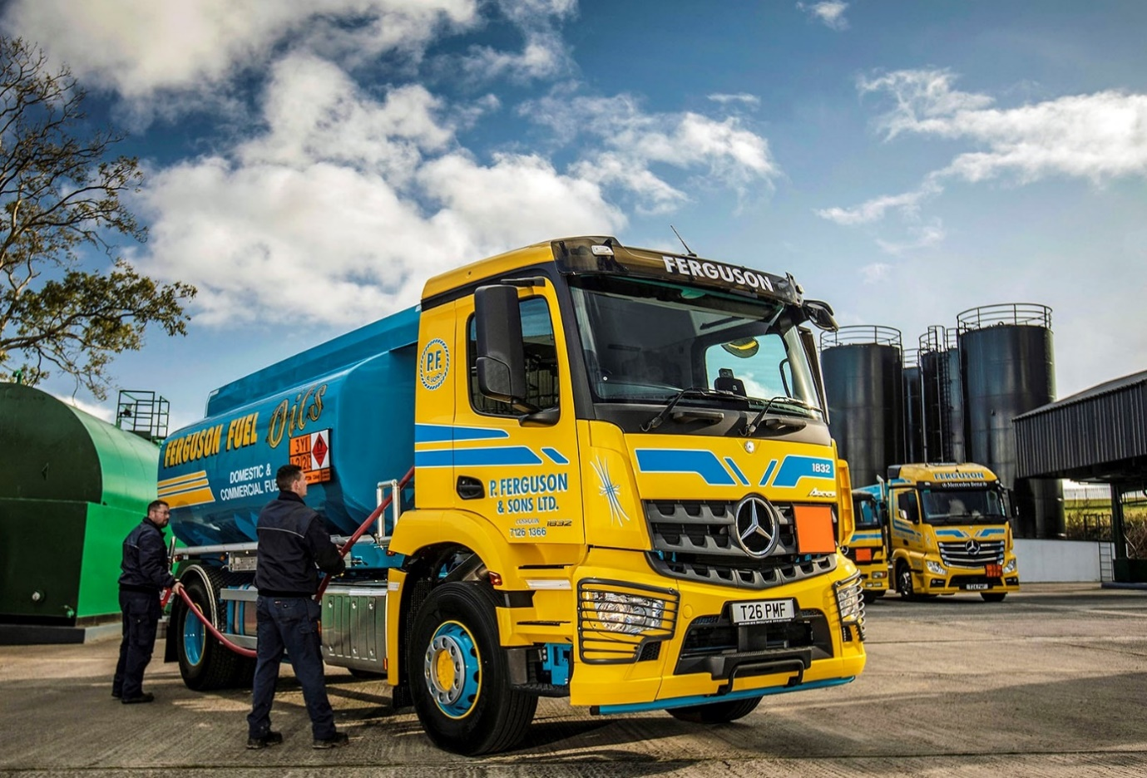

Mercedes-Benz trucks oil the wheels of success for fuel haulier Ferguson

When Patsy Ferguson set up a fuel haulage business back in 1968, he decided from day one to invest in the best trucks on the market. Fast forward more than 40 years and the company, which is now run by his three sons, is still the proud operator of a 100% Mercedes-Benz fleet.

Latest to arrive are a pair of 18-tonne rigids. Supplied by Dealer MBNI Truck & Van, both are 4x2 Arocs 1832 models with ClassicSpace M-cabs and 10.7-litre in-line six-cylinder engines generating 240 kW (326 hp). Their 13,000-litre oil tank bodies are by Road Tankers Armagh.

The new trucks have lined up alongside eight other rigid tankers and a pair of tractor units, one an Actros 2558 model with StreamSpace cab and 425 kW (580 hp) 15.6-litre ‘straight six’, which entered service earlier this year.

These vehicles all deliver heating and fuel oil to domestic and commercial clients. Ferguson’s remaining trucks, two Atego 7.5-tonners, carry coal.

The rigids operate from the company’s headquarters in Derry/Londonderry, and from a second depot in Inishowen, which serves County Donegal. The tractors, meanwhile, pull tank trailers and make bulk collections from the oil terminal at Belfast Harbour.

Patsy Ferguson Jnr, who runs P Ferguson & Sons with his brothers Edward and Seamus, recalled: “Our father was convinced that Mercedes-Benz trucks were the best he could buy, and the company’s experience over the past four decades has proved him right. Our vehicles have always performed superbly – they’ve been consistently reliable, cost-effective to run, and are well-liked by our drivers.
“The Arocs is a great truck. Performance is excellent and the cab interior is very well thought-out. The rugged chassis is also well suited for deliveries to farms and other rural locations, which we sometimes have to access via rough tracks.”

Purpose-designed for construction and related applications, the Mercedes-Benz Arocs offers high ground clearance, and excels in the toughest of working conditions. The comprehensive model range includes rigids from 18-32 tonnes GVW – or even higher, for off-road applications – as well as tractor units in various drive configurations and mighty SLT heavy haulers capable of working at up to 250 tonnes.
“When it comes to tractor units, we’ve always specified big engines,” continued Mr Ferguson. “We had the UK’s first V8-powered 1850 Powerliner from the old SK range – that was a magnificent ‘beast’, and at the time we thought it represented the ultimate in power and performance.

“Things have moved on, though, and our latest, 580 hp Actros is even better. It makes light work of the hilly terrain we have to cover. With its spacious, comfortable cab, superb driver’s seat, and all that power under the right foot it’s a real ‘driver’s lorry’, but like all our Mercedes-Benz trucks it’s also economical to operate.

“Fuel efficiency across the fleet is always where we want it to be. We maintain the trucks in-house but buy our parts from MBNI Truck & Van, whose service is well managed and pricing is competitive. The Dealer is always on hand, too, with advice or technical support should we need it.”

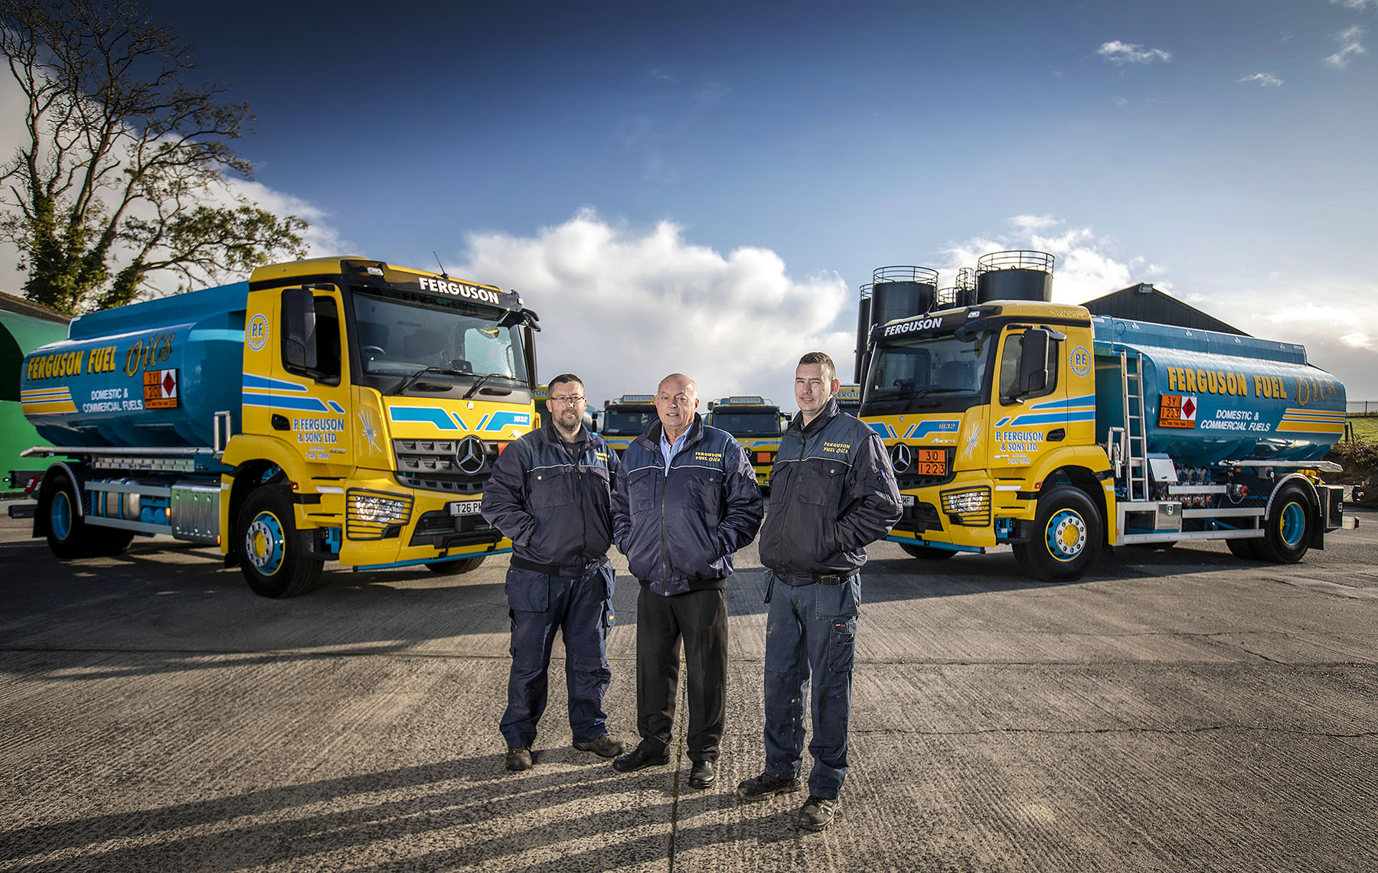

Tried and tested: Edward Ferguson, centre, with drivers Clark Hamilton and Conor Wilson, relies on well-proven Mercedes-Benz trucks

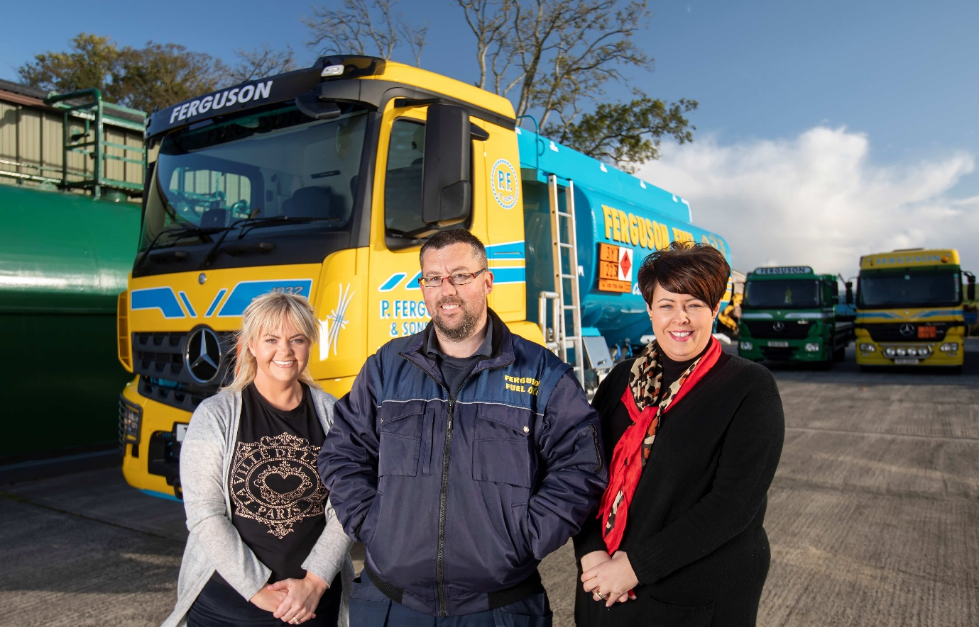

The next generation: Zara, left, and Arlene Ferguson, with their cousin Clark Hamilton

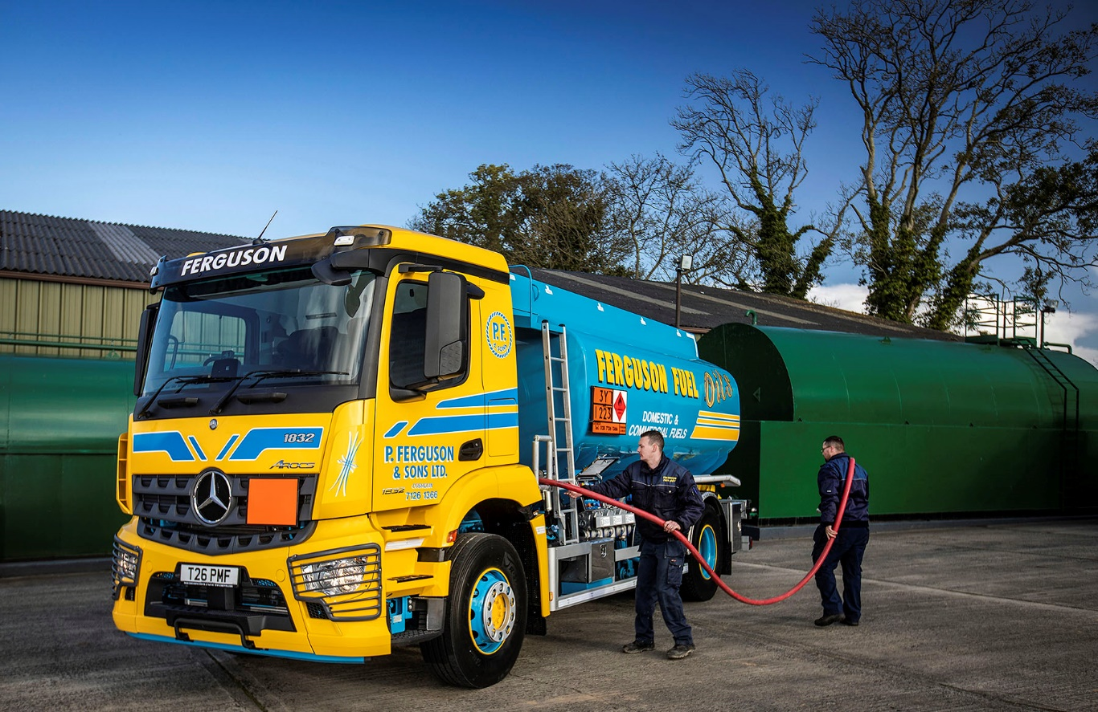

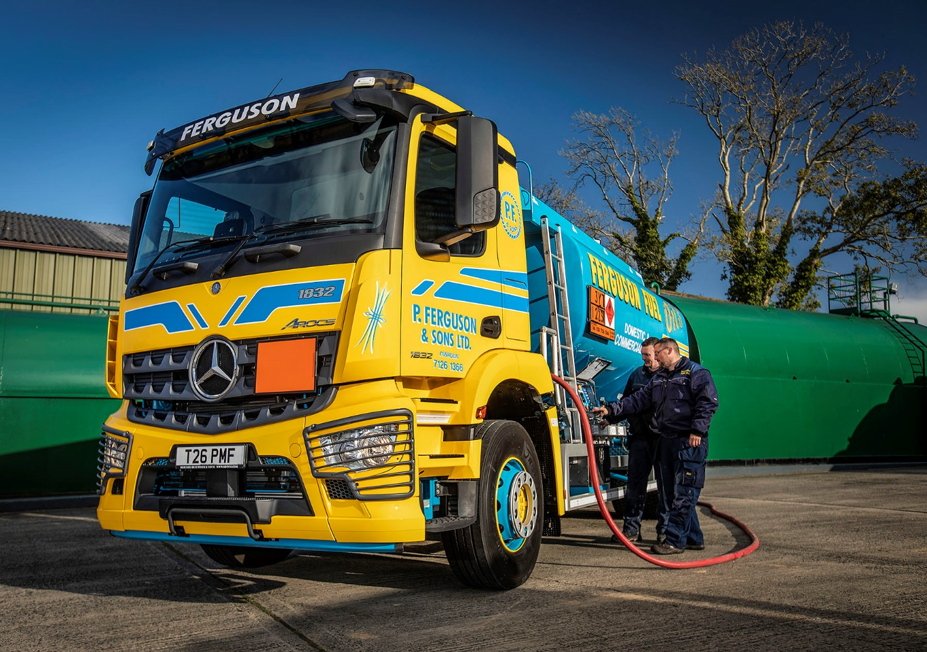

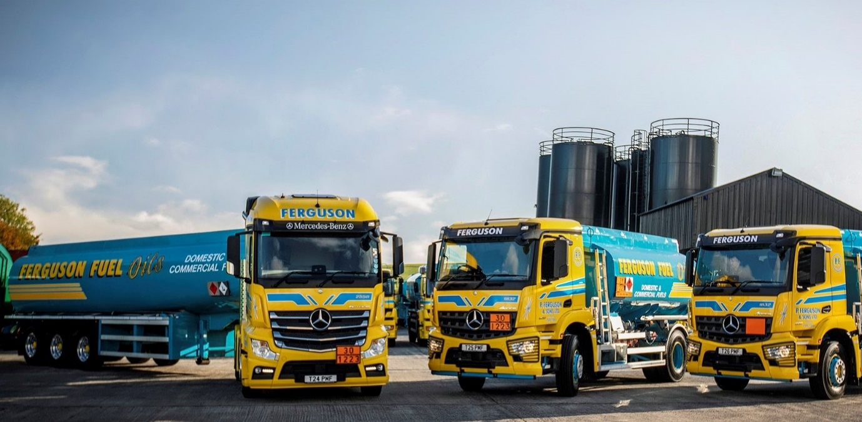

ends

For more information, or to request bigger/higher-res image files, please contact:
John Ripley or Steve Warren
Impact Communications, 01926 842126
John: 07771 484595, john@impactcom.co.uk
Steve: 07770 470251, steve@impactcom.co.uk



