

Date: 18 October 2021

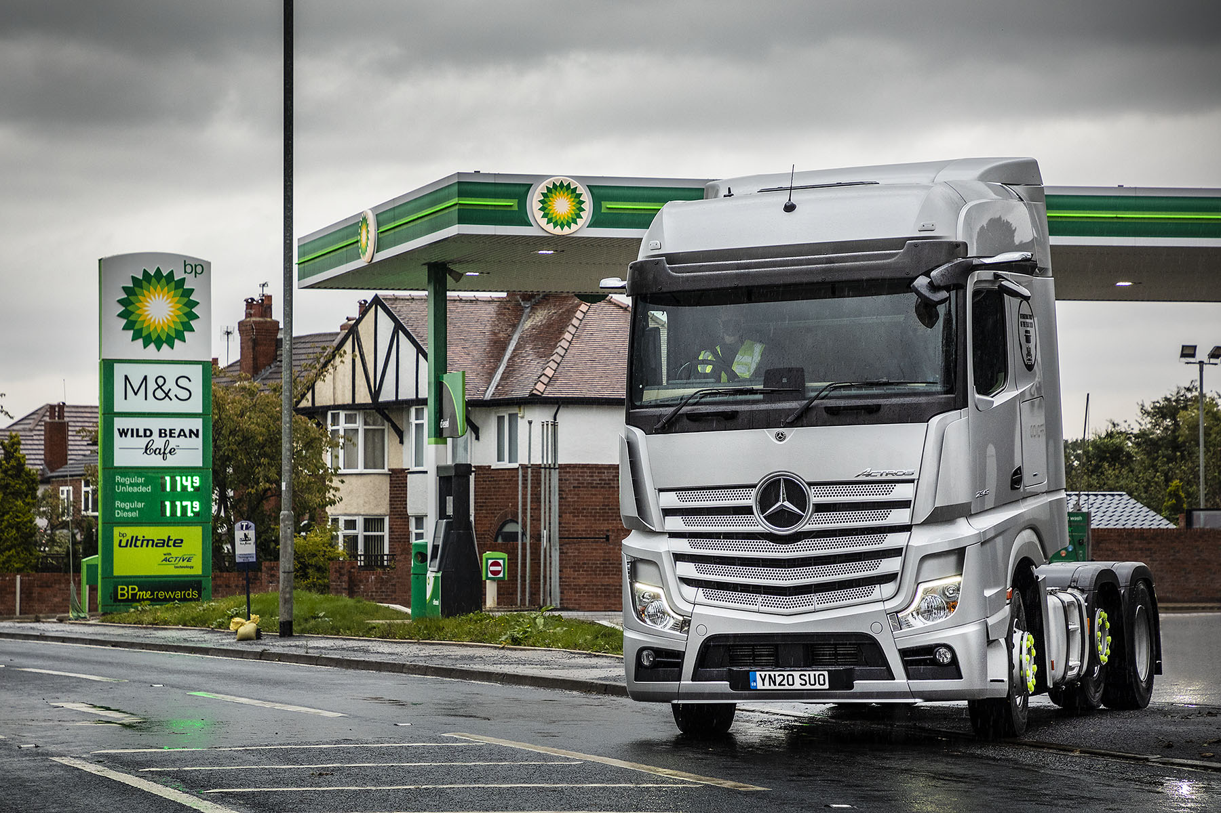

bp and Mercedes-Benz trial pioneering digital in-truck fuel payments in UK

bp and Mercedes-Benz Trucks UK have successfully tested the first digital in-truck fuel payment system in the UK, running a successful pilot trial with Wren Kitchens.

The ground-breaking new app-based system, bp In-Truck Pay, makes fuel purchasing and management faster, more efficient and more secure for both truck drivers and fleet managers. The app has been developed for the latest-generation Mercedes-Benz Actros, which can be specified with Multimedia Cockpit, Interactive. This incorporates the Truck App Portal, an open platform that can be used by fleet managers to easily assign apps to their vehicles via their Multi-Touch Display.

Automatically relaying purchases, mileage and other data back to base, In-Truck Pay eliminates errors, provides accurate information to managers and removes the need for drivers to enter mileage themselves.

bp In-Truck Pay is designed specifically for fleet operators to help get drivers back on the road faster. It requires just three simple steps – drivers confirm the site, unlock the pump and refuel.

The truck directly logs the fuel transaction – paying for the fuel itself. Drivers don’t need to pay in the shop or to enter data. And there is no need for fuel cards, removing complications from managing lost or damaged cards and the risk of fraudulent card use.

When Mercedes-Benz Trucks UK launched its new Actros range in 2019, it polled customers to ask them what type of app they would like developers to offer that could help their businesses. Top of the list was ‘solutions that address refuelling issues.’ This is exactly what bp In-Truck Pay does.

In the pilot trial, Mercedes-Benz truck customer Wren Kitchens – the winner of no fewer than five trophies at this month’s prestigious Motor Transport Awards – used bp In-Truck Pay with 11 vehicles from its fleet.

Lee Thompson-Halls, National Fleet Manager for Wren Kitchens, said: “We strive to always be ahead of the game, and trialling innovative initiatives like this means we can potentially drive progress within our business, and, ultimately, the logistics sector as a whole.

“The trials have shown an increase in efficiency, with savings of approximately five minutes per transaction. When you add that up over time, it will have a hugely positive impact on our business, which delivers over 100,000 kitchens per year across the UK. Not only that, but it will also be beneficial for our drivers, by creating a safer and quicker way to pay for fuel.”

Richard Skidmore, Head of Customer Service Delivery, Mercedes-Benz Trucks UK, commented: “Connectivity is integral to the strategy of Mercedes-Benz Trucks. bp In-Truck Pay demonstrates perfectly how the Truck App Portal can amplify the benefit of running Mercedes-Benz trucks by helping customers to save money, increase efficiency and retain drivers. We are proud of the part our Connectivity team has played in the development of this app that has the potential to transform the way in which operators may purchase their fuel.”

Alexandru Eftimiu, bp’s VP fleet Europe, said: “We aim to provide innovative digital solutions to make customers’ lives easier. bp In-Truck Pay shifts how we connect with our customers through digital and online platforms. It makes life easier and more convenient for both managers and drivers of commercial fleets. We’ve already received fantastic feedback from Wren Kitchens and look forward to bringing bp In-Truck Pay to other customers and countries in due course.”

The pilot – case study

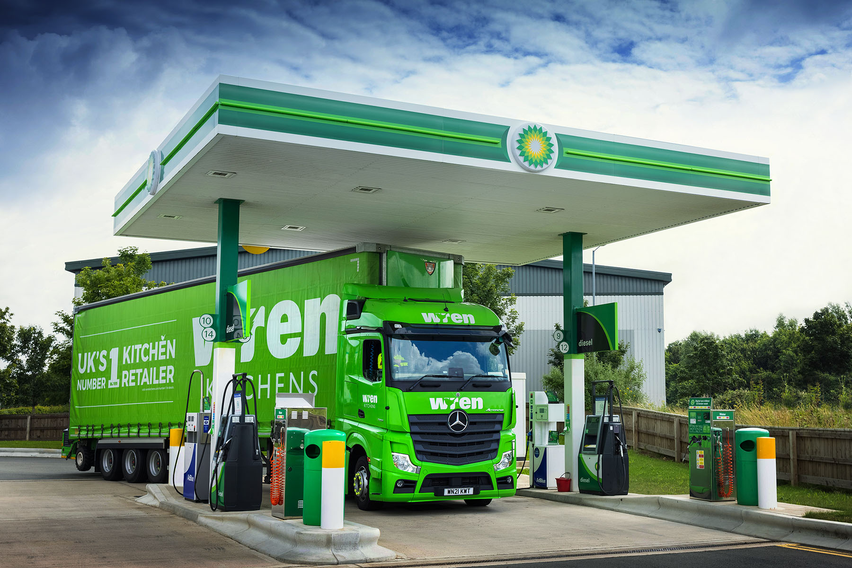

Following ‘proof of concept’ testing by bp and Mercedes-Benz Trucks in autumn 2020, Wren Kitchens embraced the opportunity to pilot the new app.

The UK’s number one kitchen retailer is committed to innovation, and to promoting efficiency, safety and environmental compatibility within its transport operation.

For the pilot, which began in May, bp In-Truck Pay was installed on 11 of Wren Kitchens’ Actros trucks – six tractor units used to distribute quartz worktops from its headquarters in Barton-upon-Humber, and five 18-tonners based at a depot in Tipton in the West Midlands, that deliver kitchens to customers’ homes.

Wren Kitchens buys from bp all but a tiny percentage of the fuel needed to run its fleet of 300 trucks, which operate from a network of seven locations nationwide. Approximately 100 of these vehicles are Mercedes-Benz trucks.

The operator worked closely with development teams from bp and Mercedes-Benz Trucks UK on the implementation of the new system, and provided feedback on its operation, with particular focus on data availability and quality, and driver opinion.

The feedback received was resoundingly positive. Wren Kitchens’ National Fleet Manager Lee Thompson-Halls commented: “Going card-less has saved us so much time and trouble, not only at the fuel station but also on the admin side. It has ensured that we’re working with clear, accurate data, and is also where we need to be from a security perspective.

“Our team of drivers do a challenging job, so anything we can do to make their lives easier and less stressful has to be a good thing, not least because it will help to make them that bit safer at the wheel.”

One driver particularly appreciated being able to remain close to his truck throughout the process of refuelling late at night and in the early hours of the morning, rather than having to walk across to the kiosk to pay, then check round the tractor unit and its trailer on his return.

“Our drivers have found the app very straightforward and easy to use, and they like the idea of being at the forefront of new technology,” reported Mr Thompson-Halls. “A lot of them are looking at the bigger picture and see this as a development that will help drivers of the future, as well as themselves.”

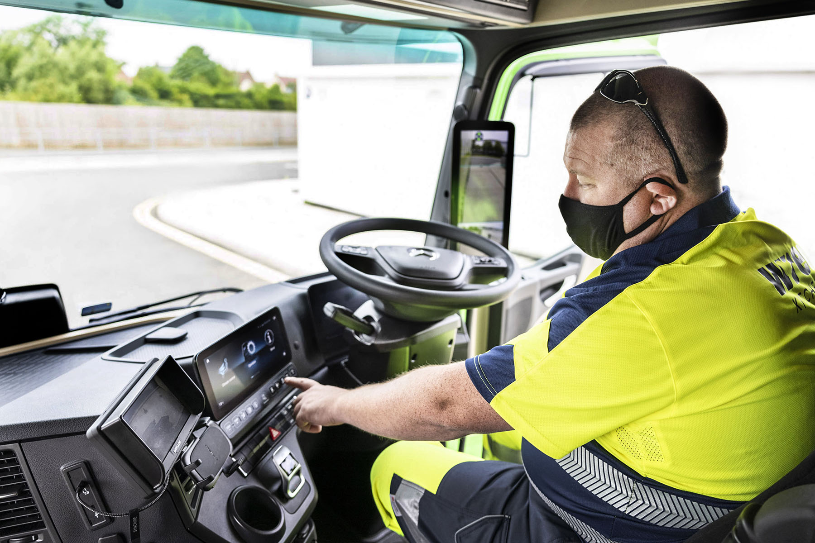

ends

For more information on Mercedes-Benz Trucks, or to request higher-res image files, please contact:

Jamie Fretwell, Mercedes-Benz Trucks UK Ltd
07712 519230, jamie.fretwell@daimler.com

or

Steve Warren or John Ripley
Impact Communications, 01926 842126
Steve: 07770 470251, steve@impactcom.co.uk
John: 07771 484595, john@impactcom.co.uk

For more information on BP, please contact:

Launch – bptrade@hellolaunch.co.uk

About Mercedes-Benz Trucks UK Ltd
Mercedes-Benz Trucks UK Ltd is the sales and marketing organisation responsible for all Daimler truck products in the UK, including FUSO Canter.

The flagship new Mercedes-Benz Actros which won the 2020 International Truck of the Year award, features seven core innovations including MirrorCam, Multimedia Cockpit and Active Brake Assist 5. Our premium range of innovative trucks – Actros, Arocs, Atego, Econic and Unimog – draw upon more than 125 years of exceptionally high standards of quality, backed up by our promise of Trucks You Can Trust.

www.mbtrucks.co.uk

About BP

bp’s purpose is to reimagine energy for people and our planet. It has set out an ambition to ‎be a net ‎zero company by 2050, or sooner, and help the world get to net zero, and recently ‎announced its ‎strategy for delivering on that ambition. For more information visit bp.com

About Wren Kitchens

Wren Kitchens is the UK’s largest manufacturer and retailer of kitchens and stone worktops. Launched in 2009, Wren Kitchens is a family business which employs over 7,200 people across its sites and is one of the largest employers in the Humber Region. For the last two years Wren Kitchens has been recognised as the best place to work in the UK by indeed. Wren provides the best value in the market to its customers. It makes bespoke kitchens at flat pack prices and offers a price match on all appliances, together with market-leading, interest-free finance options. In 2020 Wren Kitchens opened its first U.S. showroom in Milford, Connecticut. Wren makes every one of its kitchens for the US market at its state-of-the-art 252,000 sq. ft. manufacturing facility in Wilkes-Barre, Pennsylvania.

www.wrenkitchens.com

