

Date: 4 November 2022

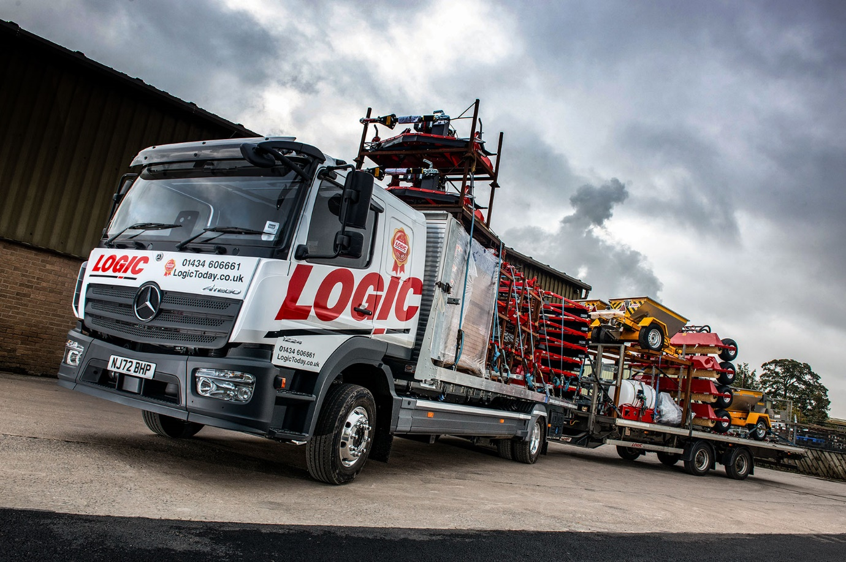

Logic dictates that the best replacement for a
Mercedes-Benz Atego is… another Atego!

As a leading manufacturer of high-quality trailers and associated equipment designed and built for use with all-terrain and utility vehicles, tractors and 4x4s, Northumberland-based Logic is well-placed to recognise and appreciate top-notch engineering.

No surprise, then, that when the time came to stand down its four-year-old Mercedes-Benz Atego, Logic returned without hesitation to North-East Dealer Bell Truck and Van for a second vehicle from the same light- and medium-duty distribution range.

Like its predecessor, the new truck has a 12-tonne gross weight and a ClassicSpace L-cab sleeper. This time, though, rather than opting for another 1221 model with 155 kW (210 hp) 5.1-litre engine, Logic has chosen a more powerful 1224 variant.

Its 7.7-litre in-line six-cylinder engine produces 175 kW (238 hp) and drives through a six-speed Mercedes PowerShift 3 automated manual transmission. Meanwhile, the optional 180-litre fuel tank – the standard item has a 120-litre capacity – extends the vehicle’s range.

Based at Logic’s headquarters and main manufacturing facility in Hexham, the Atego has a platform body with front bulkhead by Wheelbase Engineering, of Darwen, Lancashire, which also fitted a VBG coupling. Load volume, rather than weight, is the critical factor for Logic, so the truck pulls a twin-axled drawbar trailer.

The combination delivers Logic’s products to members of its national dealer network located north of the M62, and transports raw materials and components to and from suppliers, the majority of which are located in the North-East – one weekly round trip, for example, is to a galvanising specialist in Newcastle.

The Atego also trunks, typically a couple of times each month, to Logic’s second distribution centre in Cheltenham, which serves dealers in England and Wales, south of the trans-Pennine motorway. For optimum efficiency, some items are carried in ‘knocked-down’ form and assembled on arrival.

Logic Managing Director Simon Beniams explained: “The drawbar trailer was also built for us by Wheelbase Engineering four years ago, to work with our first Mercedes-Benz Atego. Like the truck, the trailer has a 7.0m bed so is a lot bigger than the version we were using previously. It’s proved very successful.”

He continued: “Although strong and durable, our own trailers, implements and accessories are relatively light, which means we rarely get close to the 22-tonne gross train weight limit. We do make full use of the available space, though, and have even built a frame for the truck body, which takes us close to the maximum permissible 16½ft (5.03m) height.”

Based on its experience with the previous Atego, Logic specified additional load lashing points for the side raves of the new truck’s body, and has also developed an innovative system – “a very unique design” – to secure its products to the floors of the truck and trailer.

Mr Beniams was approached by Bell Truck and Van in 2018. “I assumed a Mercedes-Benz would be out of our price range but was pleasantly surprised when I received the Dealer’s quote – the vehicle specification and package were good, and the price wasn’t anything like as scary as I’d expected,” he recalled.

“Our first Atego proved fit for purpose and did a good job, while we’ve also developed an excellent relationship with Truck Sales Executive Alex Wordsworth and his colleagues at Bell Truck and Van, who know us and understand what we need.

“People do business with people, and we’re not a company that changes suppliers for the sake of it. When the time came to replace our first Mercedes-Benz, we were very happy, therefore, to return to Bell for another.”

The Atego range from 7.5 to 16 tonnes GVW offers precise handling and exceptional ride comfort, while also enjoying an unrivalled reputation for reliability and durability. Logic’s new truck is now being inspected and maintained under a Mercedes-Benz Complete Service Contract at Bell Truck and Van’s Longbenton workshop.

Smartly finished in an eye-catching livery, and fitted with alloy wheels and a sun visor, the Atego is allocated to Les Fowler, who joined Logic in 2020. On the longest runs, which take him to Wick, in the far north of Scotland, he will spend a couple of nights out in his cab.

“Les is one of the best drivers we’ve ever had,” said Simon Beniams. “He’s also worked as a technician and trucks are ‘in his blood’. I value Les’s opinion highly, so involved him in the vehicle specification process.

“It was at his suggestion that we agreed to go with the bigger engine, which is giving him a bit more power on the inclines, as well as the longer-range fuel tank. Les is delighted with the comfort and performance of his new truck, which is great from the company’s perspective, as we’re keen to keep him. All told, it really is quite a machine.”
logictoday.co.uk

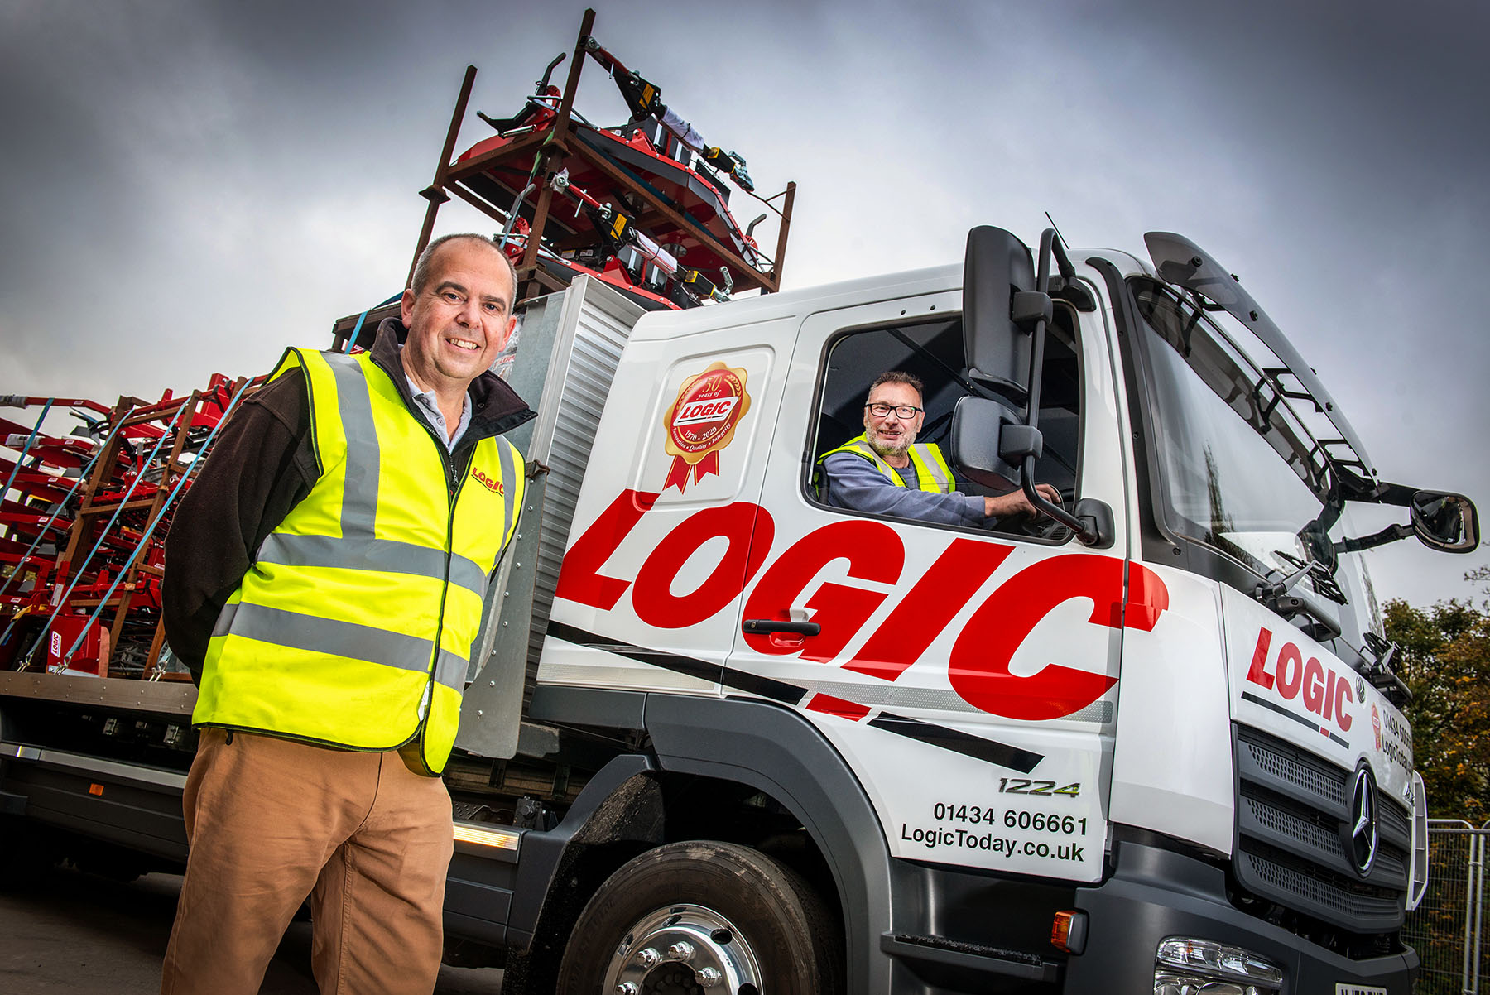

Second’s out! Managing Director Simon Beniams and driver Les Fowler are both delighted after Logic replaced its first Mercedes-Benz Atego with another, more powerful truck from the same range

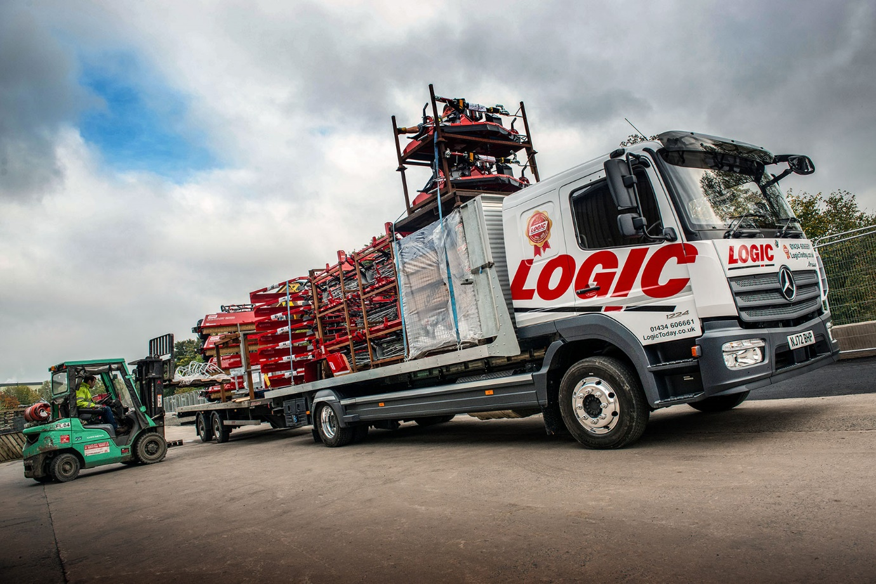

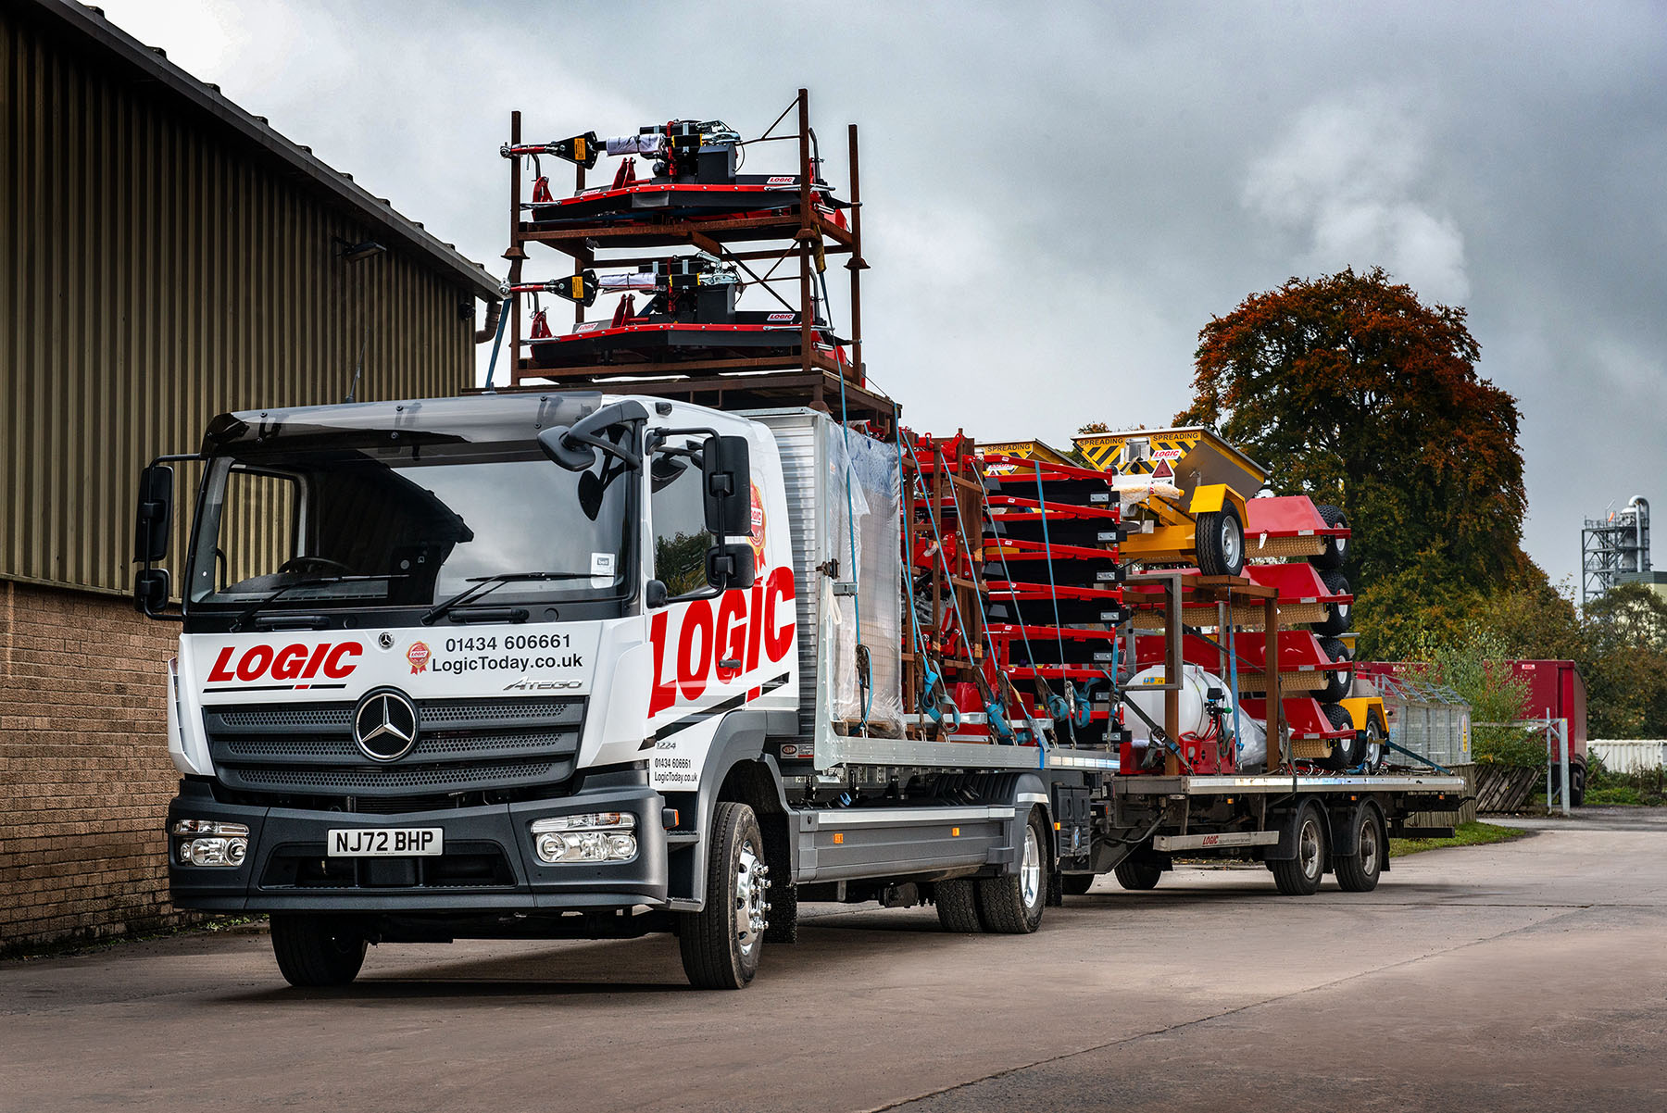

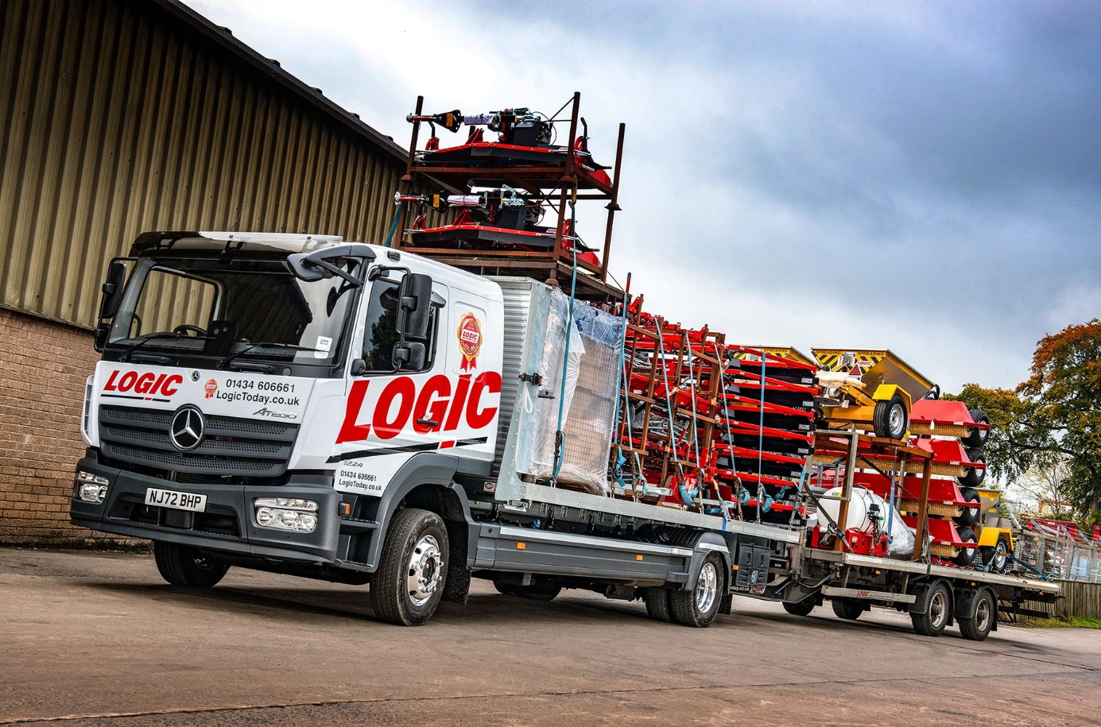

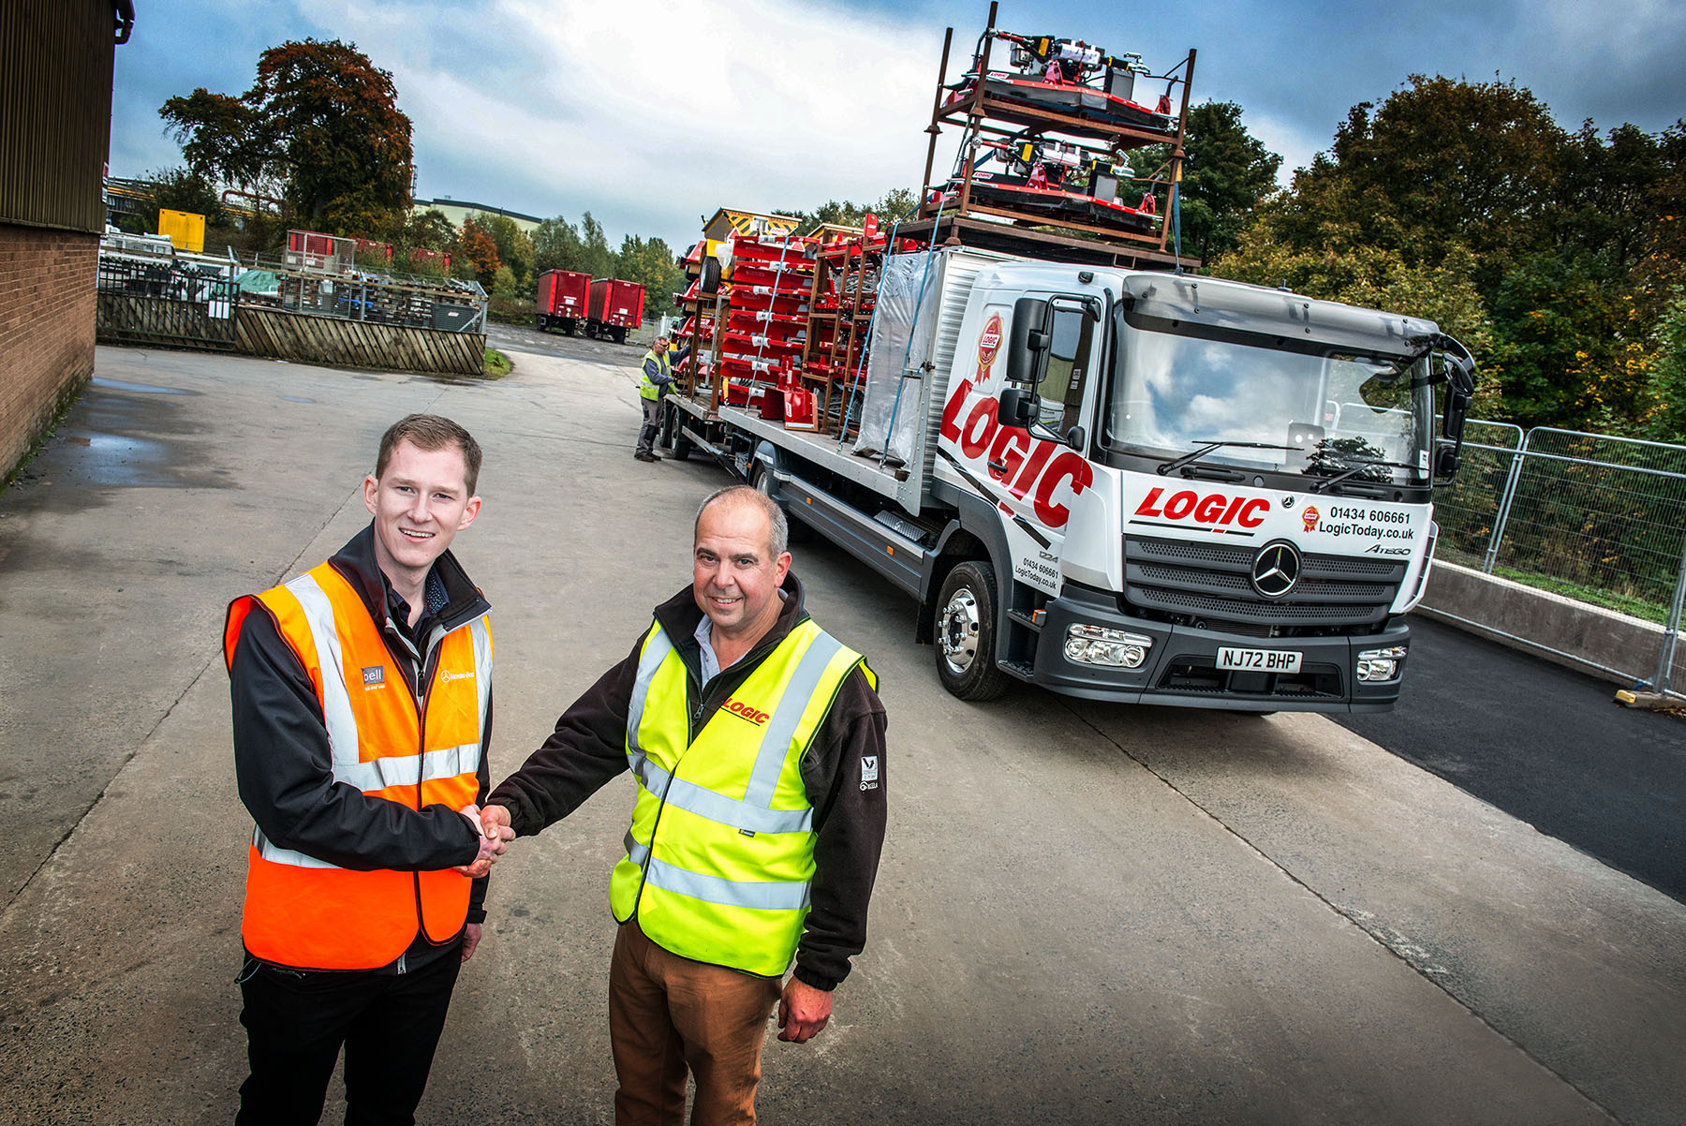

“People do business with people”: So says Logic Managing Director Simon Beniams, right, who is pictured with Alex Wordsworth, Truck Sales Executive at Bell Truck and Van

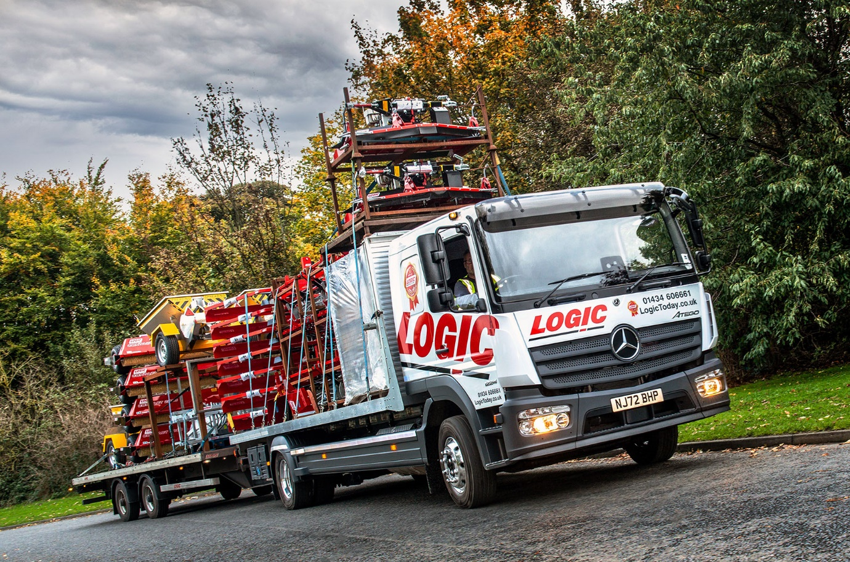

ends

For more information, or to request higher-res image files, please contact:
Steve Warren or John Ripley
Impact Communications
Steve: 07770 470251, steve@impactcom.co.uk
John: 07771 484595, john@impactcom.co.uk

