

Date: 3 March 2020

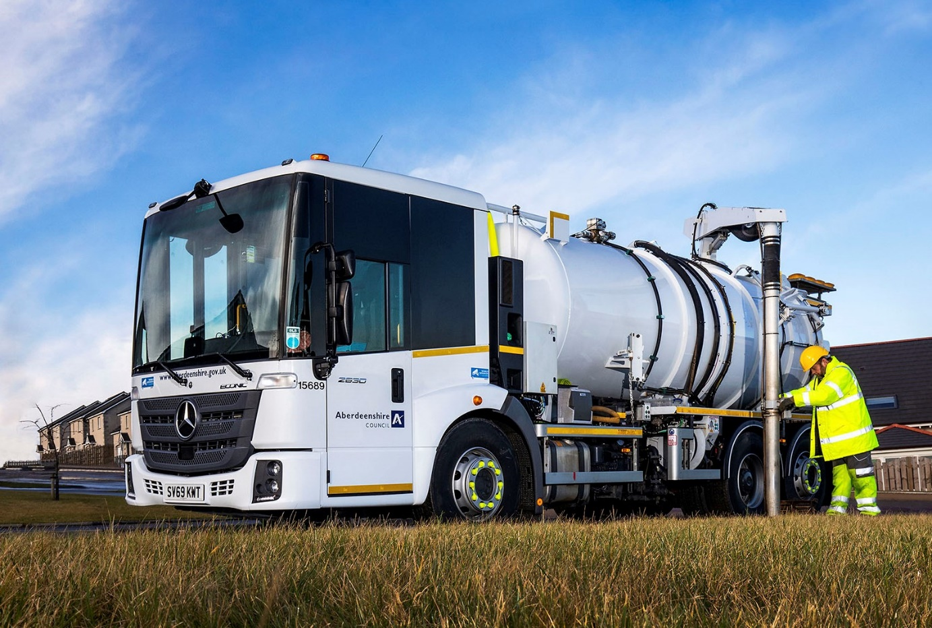

Efficiency gains: Aberdeenshire Council’s new Mercedes-Benz Econic vacuum tanker is able to work for longer than its smaller predecessor, before returning to the depot

Aberdeenshire Council sizes up another nine
Mercedes-Benz Econics from BLS Truck & Van

Bigger was better for Aberdeenshire Council when it replaced nine Mercedes-Benz Econic trucks with new vehicles based on the same low-entry chassis.

The eight refuse collection vehicles and a specialised vacuum tanker arrived via Aberdeen Dealer BLS Truck & Van. All are 6x2 variants with rear-steer axles for optimum manoeuvrability. As Econic 2630L models they are powered by 7.7-litre ‘straight-six’ engines which produce 220 kW (299 hp) – these are paired with six-speed Allison automatic transmissions.

The refuse vehicles are fitted with compactor bodies by Farid Hillend Engineering. Their 4,500mm wheelbases mean the new trucks are 300mm longer those they have replaced. The extra length has allowed the council to fit a larger pod, located in front of the main compactor body, to carry recyclable food waste.

Whale Tankers manufactured and installed the vacuum tanker’s water tanks and high-performance jetting/vacuum system. This vehicle is now being used by the authority’s highways team to clean and empty roadside drainage gullies across the county.

Specified with left-hand drive to give the driver a better view of the edge of the carriageway, it has replaced an 18-tonner – the new truck’s 26-tonne gross weight and longer chassis meant larger tanks with a combined capacity of 11,800 litres of clean and dirty water could be fitted.
Fleet Manager Paul Gray explained: “Our communities are really embracing the recycling of food waste and, as a result of the increased volumes, we needed larger pods on the RCVs. Meanwhile, we’ve made efficiency gains by increasing the size of the gulley emptier because it can stay out for longer on each journey and make fewer trips back to base.”
Aberdeenshire Council has relied on an all-Econic refuse fleet for the last seven years, and Mr Gray praised the reliability of its Mercedes-Benz trucks.
Awarded a five-star Direct Vision rating by Transport for London, the Econic has a deep panoramic windscreen. Its low-seating position, and the full-height, glazed folding side door specified by so many operators – including Aberdeenshire Council for its refuse collection vehicles – allow drivers to make direct eye contact with cyclists and pedestrians at junctions and in traffic queues. This is a major safety advantage in enabling each to understand the other’s intentions.
“The Econic provides good visibility for our drivers, enhancing safety not only for our crews but also for the general public, and particularly vulnerable road users,” continued Mr Gray. “The low entry step to the air-conditioned cab contributes to health and safety as well, by making life much easier for operatives who are in and out of the vehicle many times in a working day.”
Greater Safety is one of the three pillars of Mercedes-Benz Trucks’ all-encompassing RoadEfficiency strategy, and the Econic is equipped as standard with Active Brake Assist 4 emergency braking technology. Programmed to recognise other vehicles at higher speeds, as well as pedestrians when moving more slowly, this is capable of bringing the truck to a complete stop.

Aberdeenshire Council has raised its safety game still further, by also specifying its latest Econics with the optional Rearguard Assist system. This employs radar-based technology to support the driver when reversing at manoeuvring speed, by displaying the distance from objects being approached via the instrument cluster and providing visual and audible warnings. It can also brake the vehicle to a controlled stop when the distance to an object becomes critical.

Mr Gray added: “BLS Truck & Van worked closely with us, liaising with the bodybuilders and helping to ensure that we’ve ended up with vehicles which are perfectly suited to our requirements.”

As with all new Econics supplied through the Mercedes-Benz UK Dealer network, Aberdeenshire Council’s new trucks are backed by comprehensive three-year/160,000 km manufacturer’s warranties.

www.aberdeenshire.gov.uk

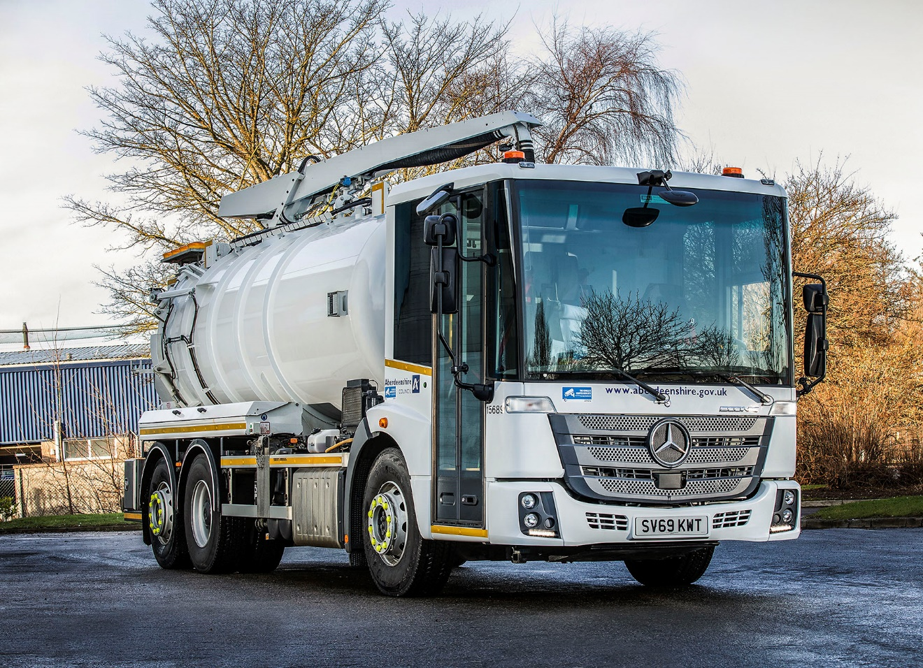

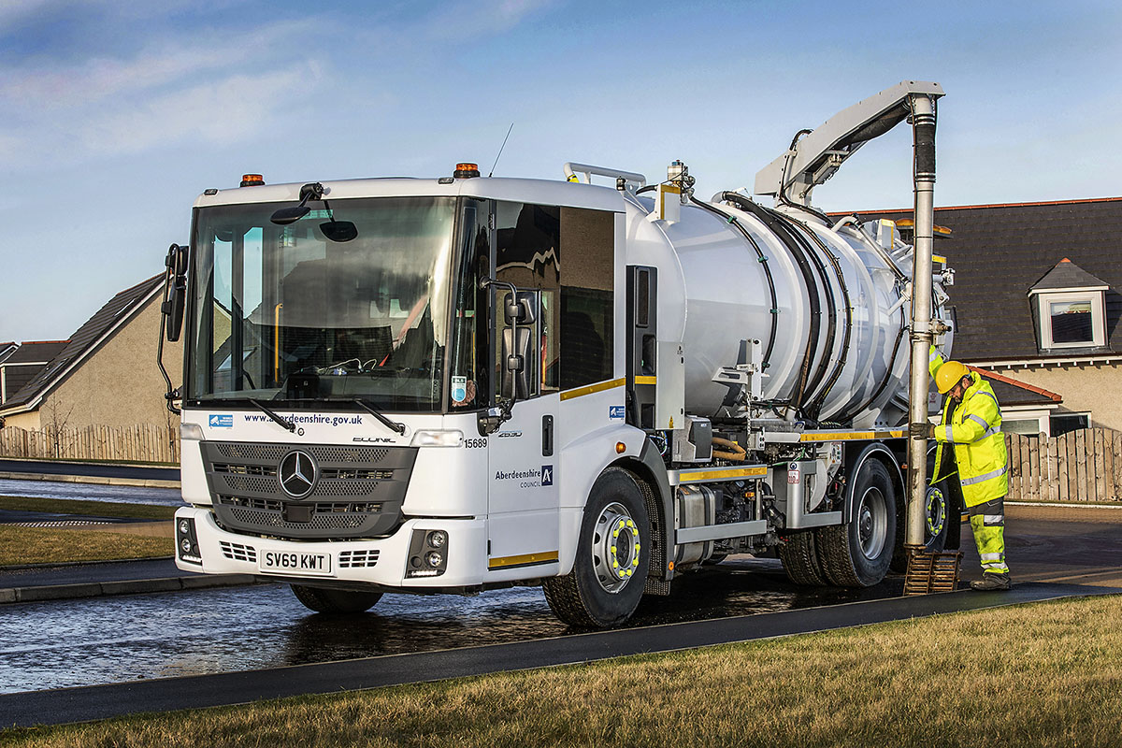

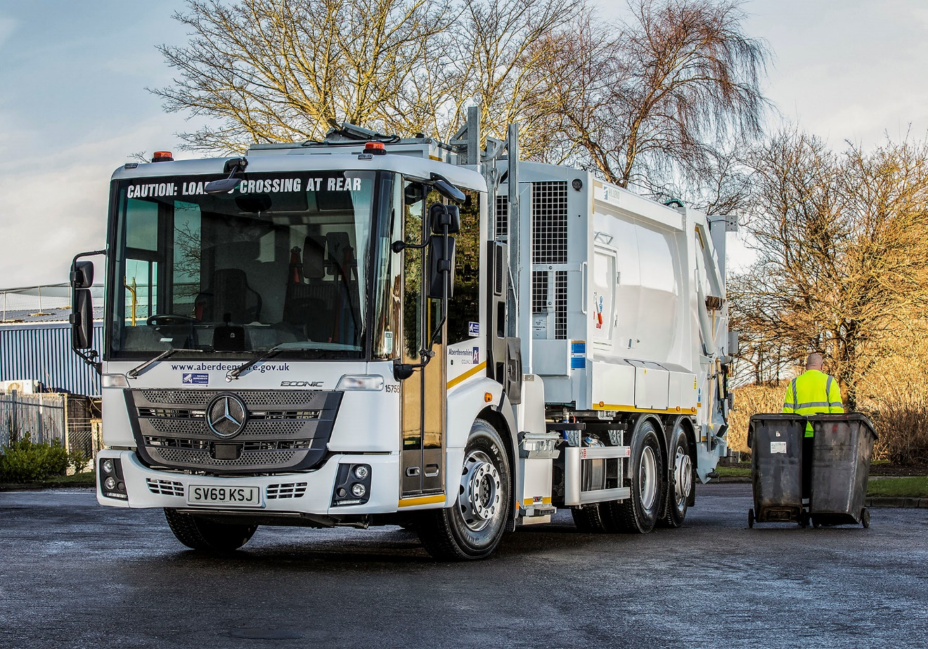

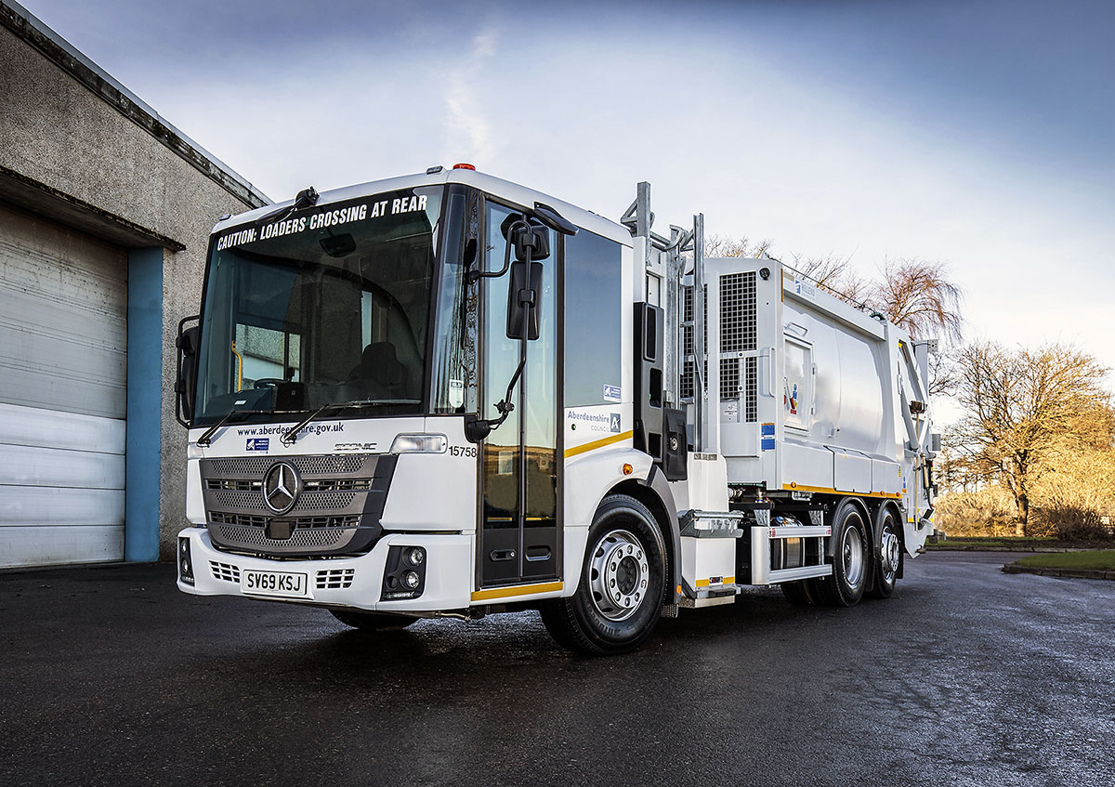

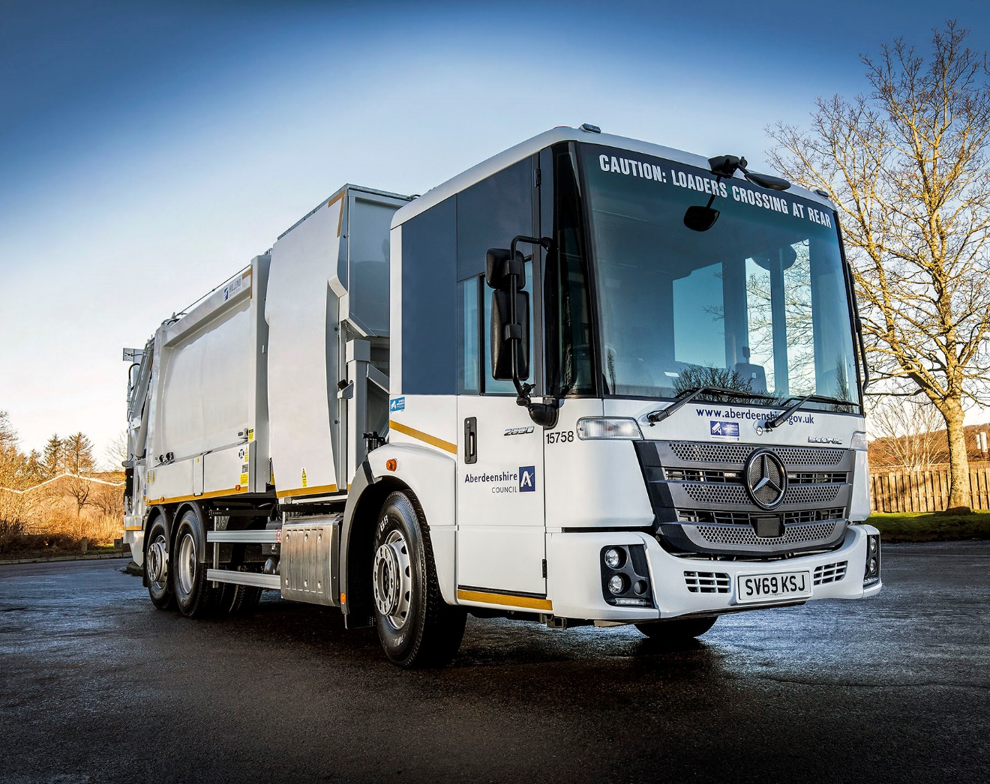

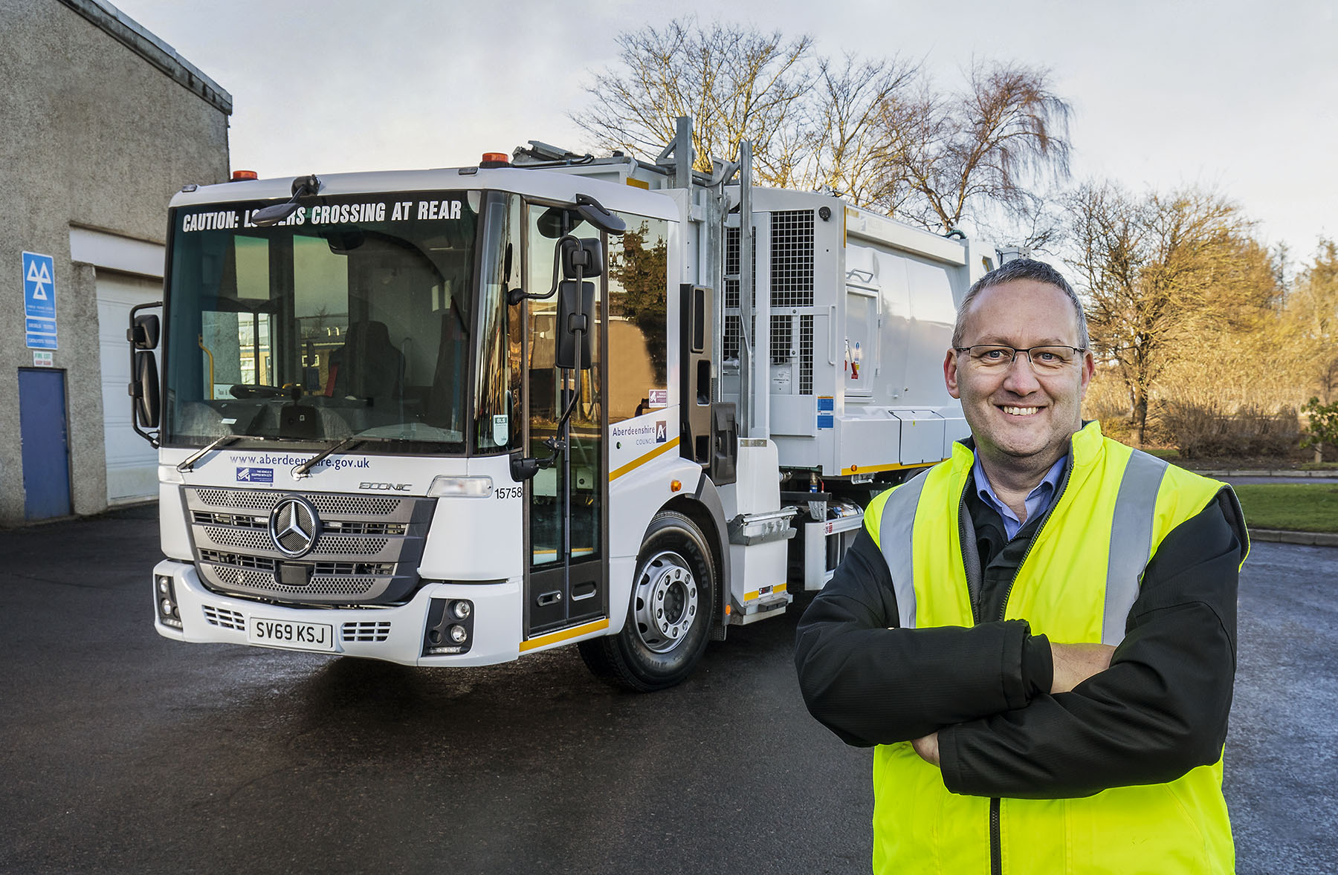

Successful partnership: Aberdeenshire Council Fleet Manager Paul Gray knows he can depend on his Mercedes-Benz Econics

ends

For more information, or to request bigger versions of image files, please contact:
John Ripley or Steve Warren
Impact Communications, 01926 842126
John: 07771 484595, john@impactcom.co.uk
Steve: 07770 470251, steve@impactcom.co.uk



