

Date: 24 May 2019

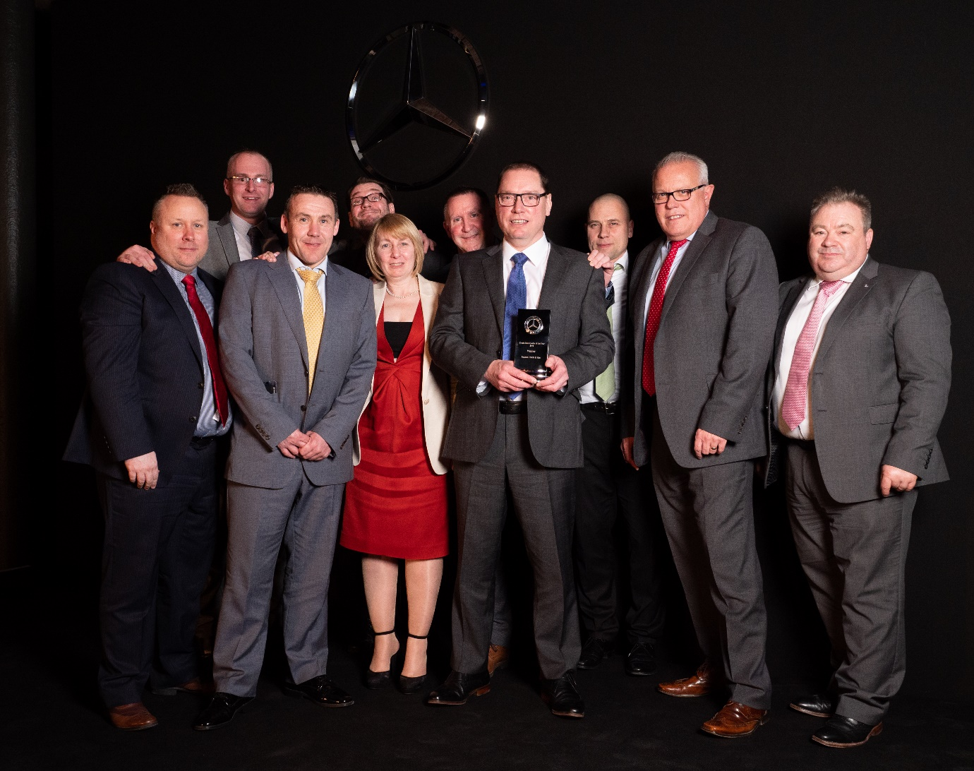

Winners all: Lester Freakley, centre, and the victorious Roanza Truck & Van team, with representatives of Mercedes-Benz Trucks UK

Roanza Truck & Van scoops Mercedes-Benz Trucks sales award

Superlative performance in the supply of commercial vehicles propelled North-West Dealer Roanza Truck & Van to the title of Mercedes-Benz Trucks Sales Dealer of the Year.

The prestigious award was collected by Truck Sales Director Lester Freakley at the manufacturer’s annual celebration of franchisee excellence – which was staged on Roanza’s ‘home turf’, in Liverpool.

“This is a fantastic achievement, especially given the tough competition we faced from the other 16 members of the Mercedes-Benz Trucks Dealer Network,” he declared. “It underlines once again our unwavering commitment to customers, and to the brand we represent.”

Roanza sells and supports the Mercedes-Benz Trucks range, and FUSO Canter light trucks, from a network of eight branches strategically located throughout Greater Manchester, Merseyside, Cheshire and Staffordshire, as well as a site in South Yorkshire. The coveted Sales Award recognised another magnificent set of results across the group during 2018.

Lester revealed: “This success represents the culmination of a long process. Over the last five years we’ve consistently invested in the development of our staff and facilities, with the result that we’ve almost doubled our sales volumes over the same period.

“We’ve added more sales professionals and split our staff into retail and fleet teams, to ‘home in’ more precisely on the differing needs of these two sectors. Our most recent recruit is a dedicated Connectivity Specialist, Tony Jarvis, whose role is to offer expert advice to customers on the latest technology available on our vehicles, including Fleetboard telematics and Uptime vehicle management technology.”

Although he accepted the trophy, Lester was quick to reflect the Dealer’s ethos of teamwork by paying tribute not only to members of his own sales team, but also to colleagues working across all parts of Roanza’ business.

He continued: “This was a sales award, but we could not have won without the hard work of colleagues in other departments. Sales support, administration, TRUCKtrainers, parts and service specialists, all play a vital role in delivering the exemplary customer service that makes acquiring and operating a vehicle from Roanza such an attractive proposition.”

There were other awards for Roanza on the night, too. Ben Clark was named TRUCKTrainer of the Year, while Paul Diamond won the Used Truck Sales Star of the Year trophy. Paul Rowley, meanwhile, narrowly missed out after being nominated for the Sales Star of the Year prize.

Ben said: “Supporting operators and drivers to get the very best performance from their Mercedes-Benz trucks is key to the all-embracing customer experience we offer.”

Paul added: “Providing the finest quality pre-owned vehicles, in all sorts of sizes and specifications, is another way we help our customers to make the most efficient use of their resources.”

Lester concluded: “These awards are testament to Roanza’s collaborative approach to working alongside our customers in every way we can. We’re all hugely honoured to receive this recognition from Mercedes-Benz Trucks but the job is never done. We strive constantly to be better.”

www.roanzatruckandvan.co.uk

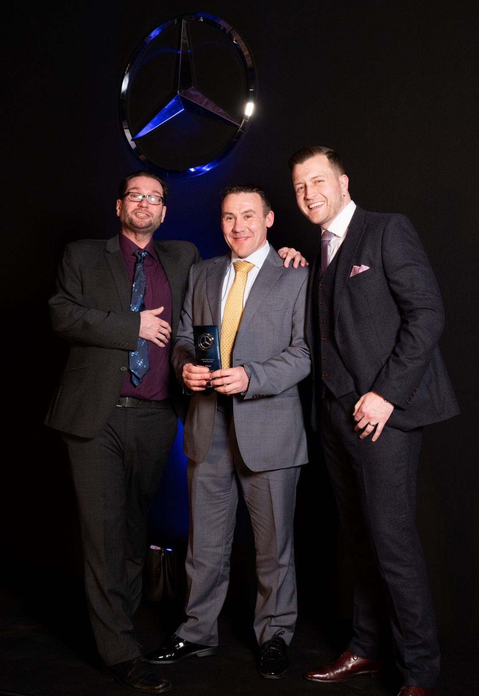

Sales Star: Paul Diamond is flanked by guest presenter Gary Delaney, left, and Tom Morris of Mercedes-Benz Trucks

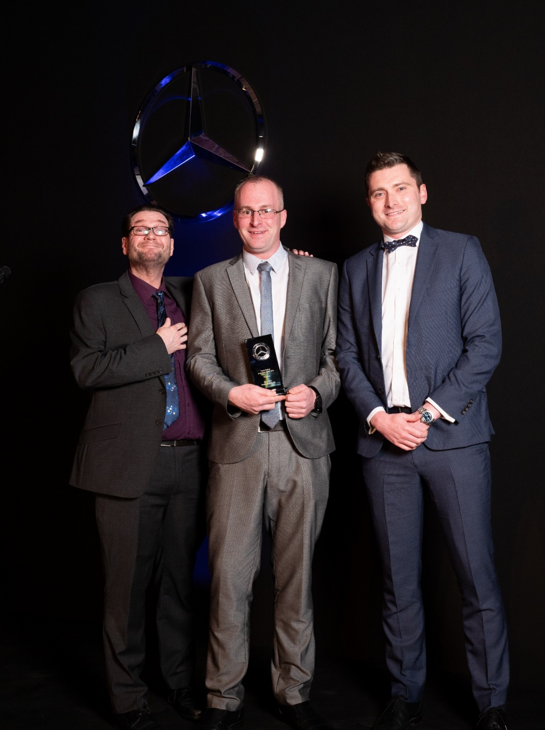

Gaining from training: Ben Clark, centre, with guest presenter Gary Delaney, left, and Richard Skidmore, of Mercedes-Benz Trucks

ends

For more information, or to request bigger/higher-res image files, please contact:
John Ripley or Steve Warren
Impact Communications, 01926 842126
John: 07771 484595, john@impactcom.co.uk
Steve: 07770 470251, steve@impactcom.co.uk

