

Date: 12 October 2021

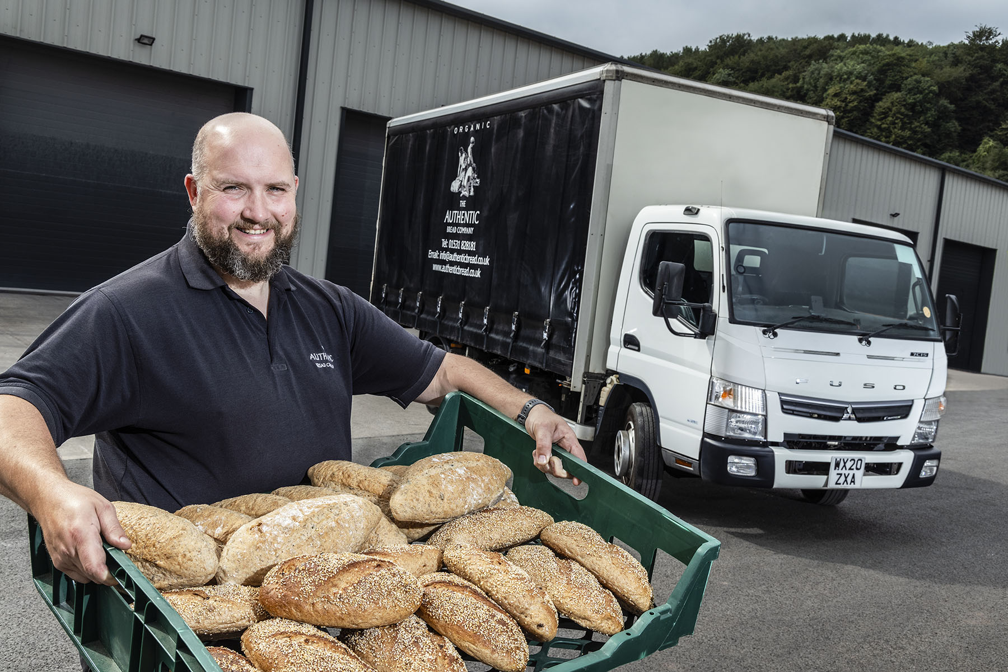

On a roll: The Authentic Bread Company’s Alex Davis ‘used his loaf’ and chose a FUSO Canter from Rygor Commercials

FUSO Canter 7.5-tonner rises to the challenge for The Authentic Bread Company

An award-winning Gloucestershire-based craft baker is emerging strongly from the pandemic thanks in no small measure to the FUSO Canter it sourced from local Dealer Rygor Commercials.

The Authentic Bread Company commissioned its first 7.5-tonne truck to help it meet increased demand from its two biggest wholesale customers, both of which have seen significant growth in their home delivery businesses as a result of successive lockdowns.

The Canter 7C15 model employs a 3.0-litre common-rail turbodiesel that produces 110 kW (150 hp) and an impressive 370 Nm of torque. The chassis was supplied from stock by Rygor Commercials and its curtainside body was built and fitted by JC Payne, in Walsall, West Midlands.

Family-owned The Authentic Bread Company has also just relocated to new premises at Longhope, which are three times the size of its previous home, less than 10 miles away at Strawberry Hill, Newent.

Its Canter is being inspected and maintained under a Mercedes-Benz Finance contract hire agreement by the workshop team at Rygor’s flagship branch on the Railway Triangle development in Gloucester.

Rygor had previously supplied The Authentic Bread Company with two curtainside-bodied 3.5-tonne Mercedes-Benz Sprinter chassis cabs. The latest of these was retired to make way for the Canter.

Like other members of Mercedes-Benz Trucks UK’s franchised Dealer network in Britain, Rygor Commercials is also responsible for sales and support of the popular FUSO Canter light truck range. This comprises variants from 3.5-8.55 tonnes, all of which are built around a strong yet light ladder frame.

In addition to Rygor’s dedicated support, The Authentic Bread Company was attracted to the 7.5-tonne Canter by its excellent reputation for reliability and durability, and its market-leading carrying capacity – as specified by the operator with five-speed manual gearbox and 3,850mm wheelbase, the 7C15 offers a combined body and payload allowance of 5,100 kg, roughly a tonne more than a conventional chassis with the same gross weight.

The Authentic Bread Company was established in 1995 by former BT engineer Alan Davis, a passionate baking enthusiast. He created one of the country’s first organic bakeries in a converted garage alongside the family’s rural home.

More than a quarter of a century later the company remains true to its organic values, producing a comprehensive range of breads, cakes and savouries with home-baked flavours. Alan is still Managing Director and his wife Jane a Director, while their son Alex is Operations Manager and daughters Emily and Sophie are, respectively, Commercial Manager and Technical Manager.

Alex Davis commented: “We’d been expanding steadily and having long since outgrown our previous base had already resolved to move to new, bigger premises. However, the Covid pandemic prompted a further spike in demand.

“At one point last year our sales were 400% up on the corresponding period 12 months earlier. The good news is that our major customers appear to have retained much of the new home delivery business they took on during lockdowns – once people have tasted our delicious, wholesome products, they invariably come back for more.”

He continued: “The Canter’s impressive carrying capacity has been instrumental in enabling us to meet all of this increased demand. We work the vehicle hard – it’s contracted to cover a quarter of a million kilometres over three years, and runs constantly between our bakery and customer locations in Andover and Devon.”

The FUSO Canter is also relatively compact and significantly more manoeuvrable than its 7.5-tonne competitors. “Given that access to one of the depots we serve is quite tight, the Canter’s smaller footprint and excellent turning circle add up to another big ‘plus’,” he reported.

The Authentic Bread Company was also keen to acquire its first truck from an established and trusted supplier. “Rygor’s Fleet Sales Manager Jeremy Price was very helpful in providing information and going through the options with me, before we confirmed our order,” recalled Alex Davis.

“Jeremy also arranged the attractively priced contract hire package, which includes reassuring replacement vehicle cover, and as the chassis was supplied from stock we didn’t have to wait too long for delivery either. The acquisition process could not have been any easier.”
The operator’s vehicles are out on the road from Sunday to Thursday each week. “When workshop visits are due they always go in on a Friday so we don’t suffer any downtime,” said Mr Davis. “Rygor’s collection and delivery service is very handy.

“Meanwhile, on the rare occasions that we’ve had an issue with one of our Sprinters the Dealer has responded quickly and efficiently. I’ve every confidence that we can look forward to the same level of aftercare with our first FUSO Canter.”

Rygor Commercials’ Jeremy Price added: “The Davis family are passionate about bread making. We’re delighted that they’ve now added another key ingredient to their recipe for success, in the shape of a FUSO Canter backed by Rygor’s commitment to Setting Standards.”

www.authenticbread.co.uk

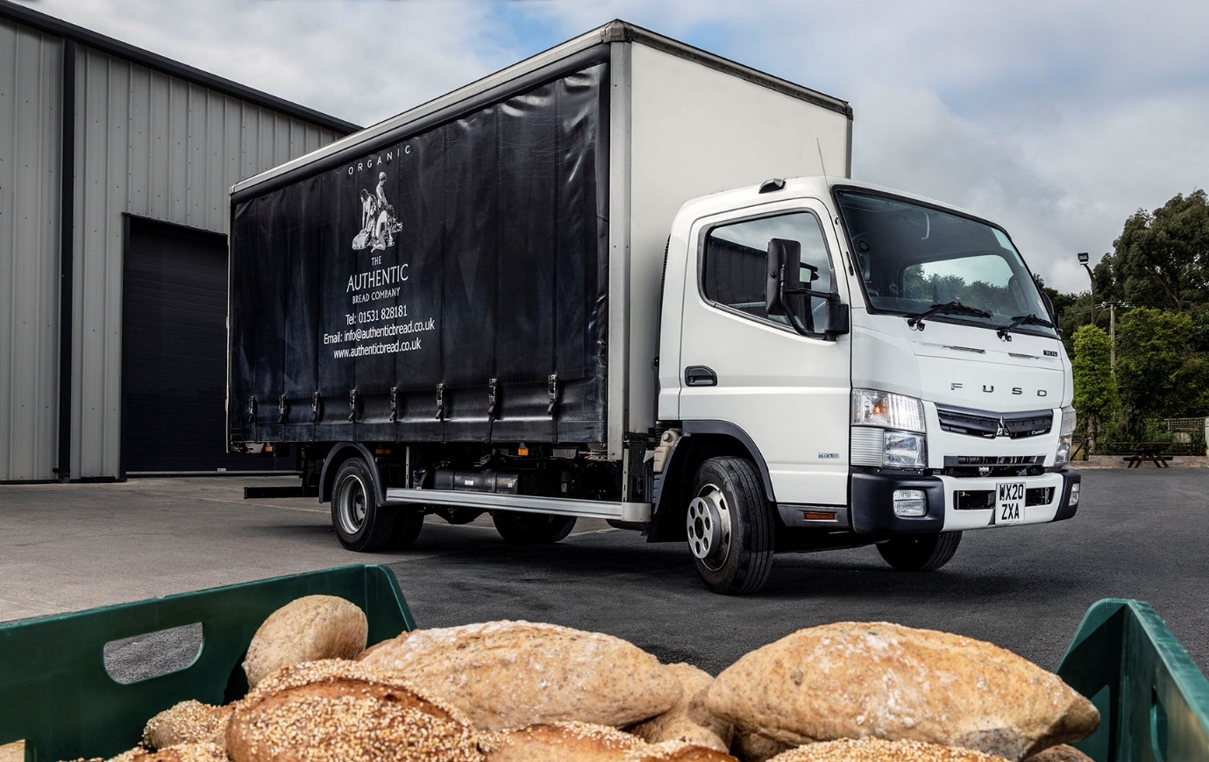

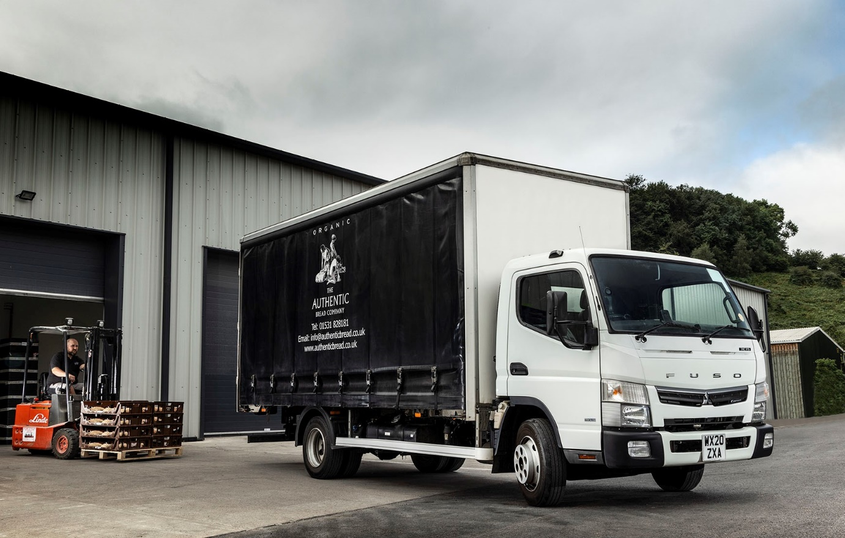

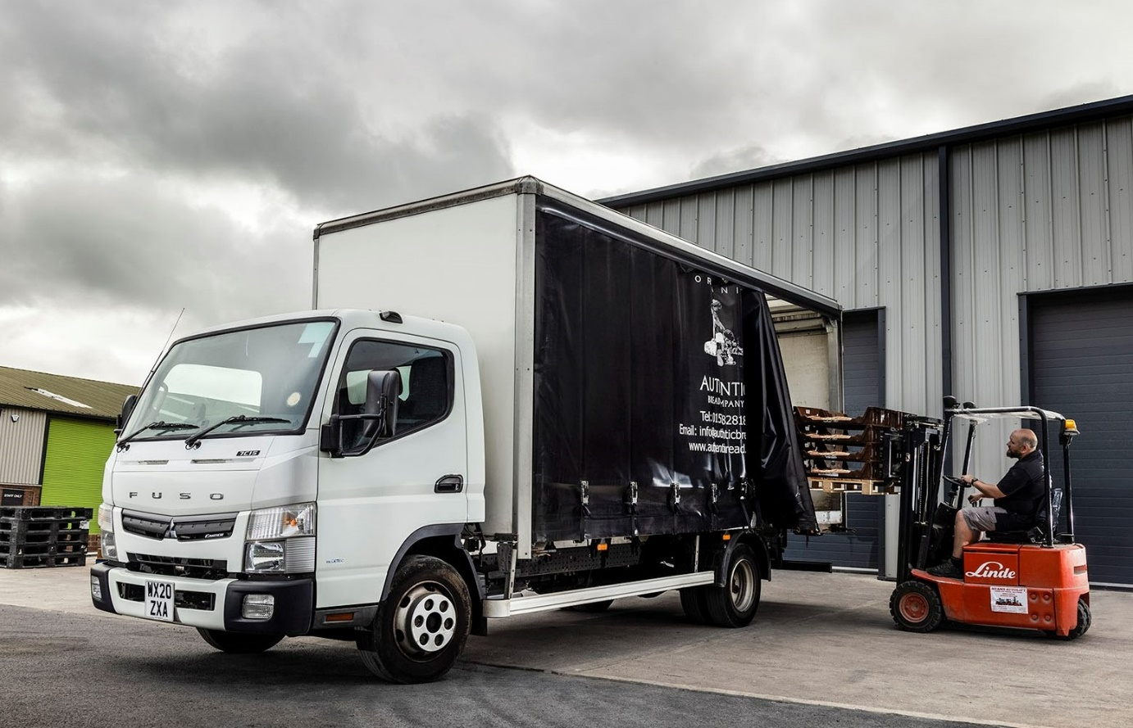

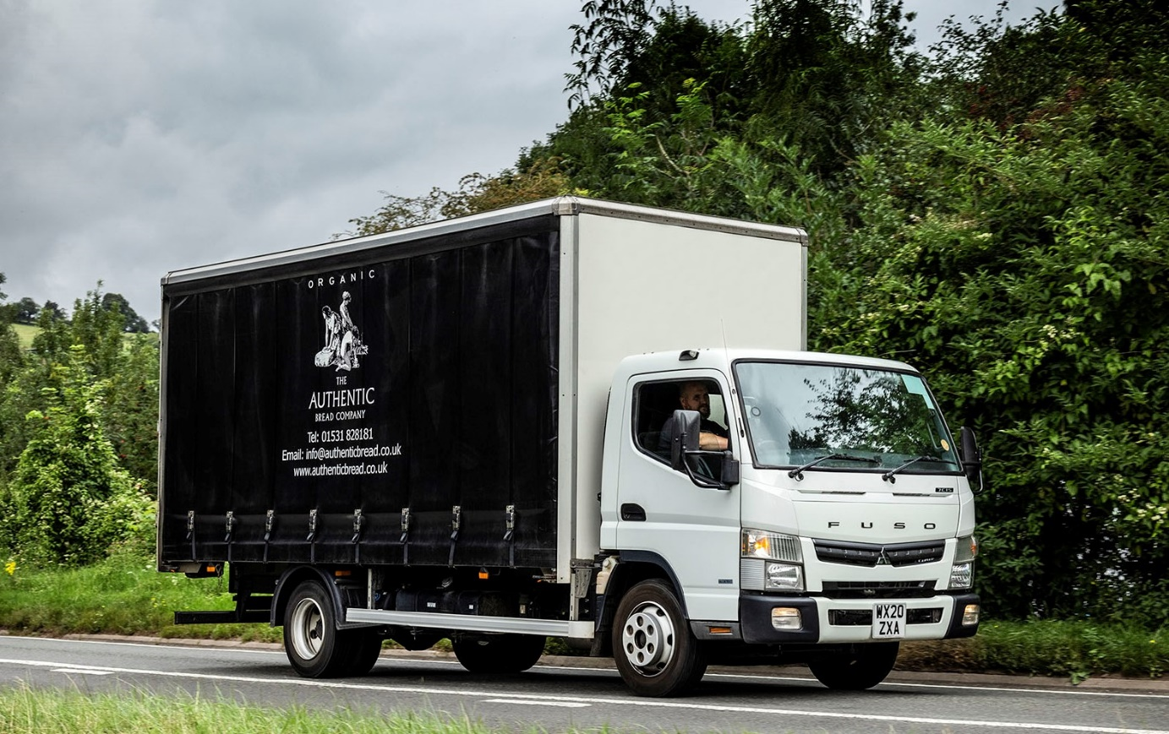

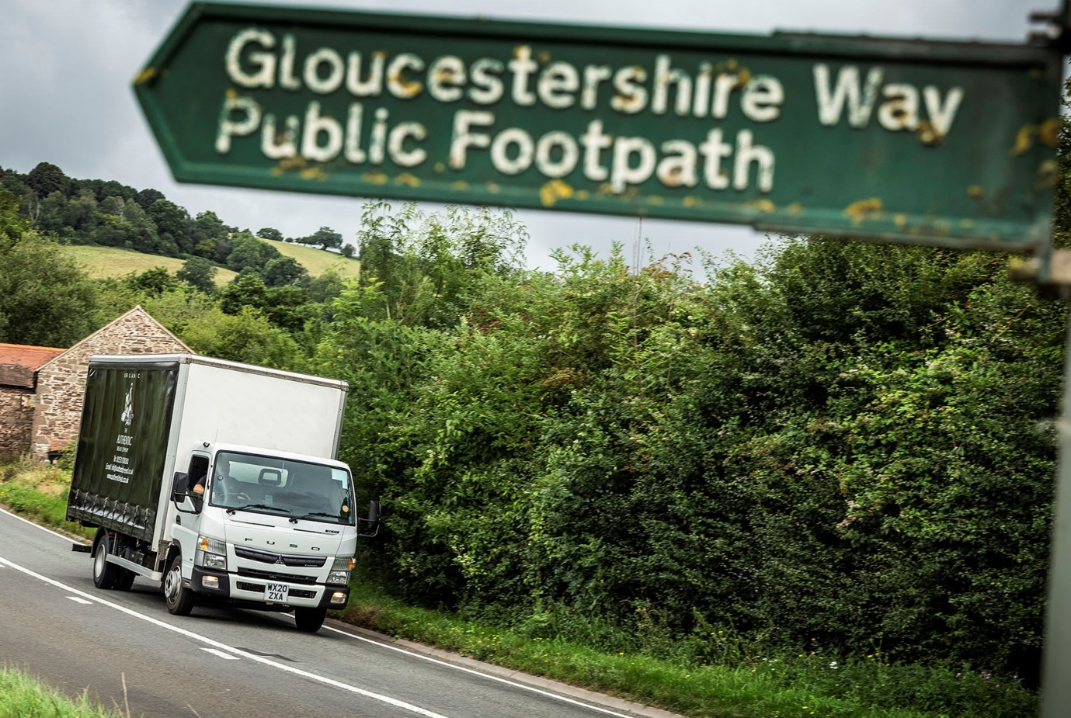

ends

For more information, or to request bigger/higher-res image files, please contact:
Steve Warren or John Ripley
Impact Communications, 01926 842126
Steve: 07770 470251, steve@impactcom.co.uk
John: 07771 484595, john@impactcom.co.uk

Notes to Editors: Rygor Commercials

Award-winning Mercedes-Benz Commercial Vehicle Dealer group, Rygor, has branches throughout Berkshire, Gloucestershire, Oxfordshire, Somerset, West London, Warwickshire, Wiltshire and Worcestershire, offering extensive coverage for customers throughout the M5, M4 and M42 corridors.

The Rygor business has expanded and gone from strength to strength in recent years, launching its flagship Gloucester branch in late 2016 (which won Showroom of the Year at the 2018 Commercial Motor Awards) and undergoing a significant refurbishment of its Oxford branch in 2018. Rygor was delighted to be announced as winner of the ‘Best Sales Team’ award at the 2019 AM Awards, demonstrating our continued commitment to our customers and dedication to providing exceptional customer service.

With a proven track record, Rygor is proud to be selling and supporting the most prestigious name in commercial vehicles.

For more information, in the first instance please contact Kate Ruberry-Shoemack, Head of People and Communications at Rygor – kateruberry-shoemack@rygor.co.uk

