

Date: 11 August 2021

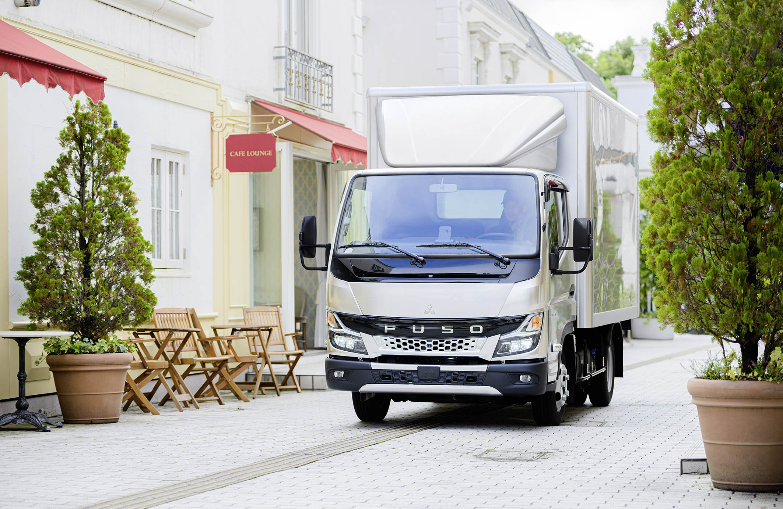

Sales of the all-new FUSO Canter begin in Britain; major updates in design, safety and comfort for Daimler’s light truck

FUSO has today announced the start of sales of the all-new FUSO Canter light-duty truck in Britain. The new model, which incorporates an eye-catching, redesigned cabin, as well as improvements in safety and comfort, is now available to order from Mercedes-Benz Trucks UK dealers across the country.

For decades, the FUSO Canter has been an international hit in the light-duty truck segment due to its class-leading turning circle, high payload and excellent versatility. Since its market launch in 1963, over 4.5 million FUSO Canters have been produced worldwide.

Like its predecessor, the new FUSO Canter is available in four weight classes (3.5-8.55 tonnes), eight wheelbases (2,500 mm to 4,750 mm), and with three engine output variants (130 hp to 175 hp).

For the first time in Britain, the 3.5-tonne FUSO Canter will be available with a narrower, 1.7m-wide S (standard) cabin, in addition to the established 2.0m width of the C (comfort) cab. Crewcab variants will continue to be offered in several weight classes.

FUSO also provides increased flexibility for bodybuilders with a new wheelbase of 3,400mm for the new-to-the-UK 3S models. With the newly developed compact exhaust system, the new FUSO Canter meets the EURO VI – STEP E emission standard.

Advanced Design

The new Canter features a revised face that combines historical brand cues with a modern design language, connecting form to the functionality of a solid light-duty truck. It also reflects FUSO’s Black Belt design identity, which runs through other vehicles of the Japanese brand’s global product range. The sleek lines of the cabin integrate optional LED headlights and represent a technological and conceptual update after ten years.

Advanced Safety

The new Canter can now be ordered with the advanced safety feature Sideguard Assist®. This detects moving vulnerable road users on the passenger side of the truck through radar sensors. The system emits alerts if it detects any risk of collision when the driver is steering towards the passenger side or has applied the left-turn indicator. The previous model featured Advanced Emergency Braking System (AEBS), Electronic Stability Program (ESP®) and Lane Departure Warning System (LDWS); Sideguard Assist now provides further safety support. Other enhancements include optional LED headlights with 30% better visibility, a new Autolight function, and reinforced rear underrun protection that minimises the impact in the event of an accident.

Advanced Comfort

Over the past decades, FUSO has made continuous improvements to its light-duty truck to meet customer needs. Thanks to improved insulation, the new Canter has an impressively low interior noise level. The spacious cab with good all-around visibility allows the driver to manoeuvre easily in the city. The Canter’s low entry height and easy cross-cab access is designed to support truck drivers, especially those engaged in the distribution business.

This new-generation Canter, with its upgraded design, advanced safety features, and improved comfort, will bring another level of quality and efficiency onto European roads. Production at the FUSO plant in Tramagal, Portugal, is set to begin in December 2021.

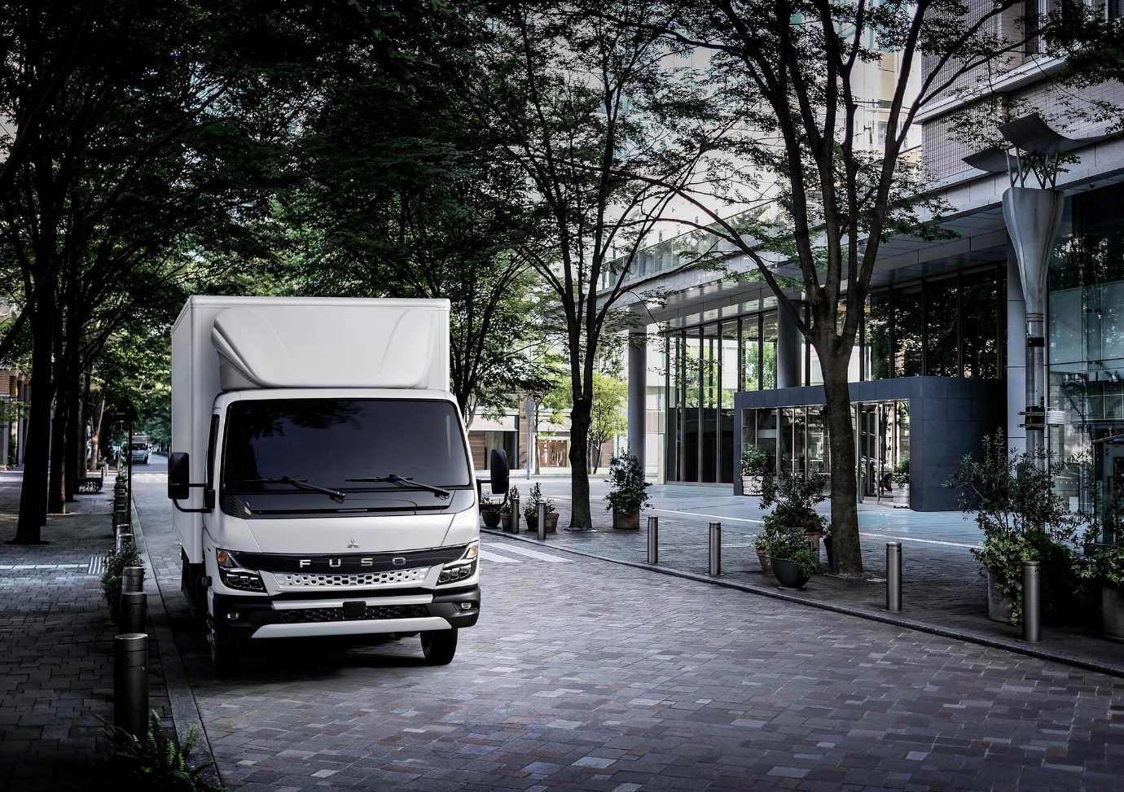

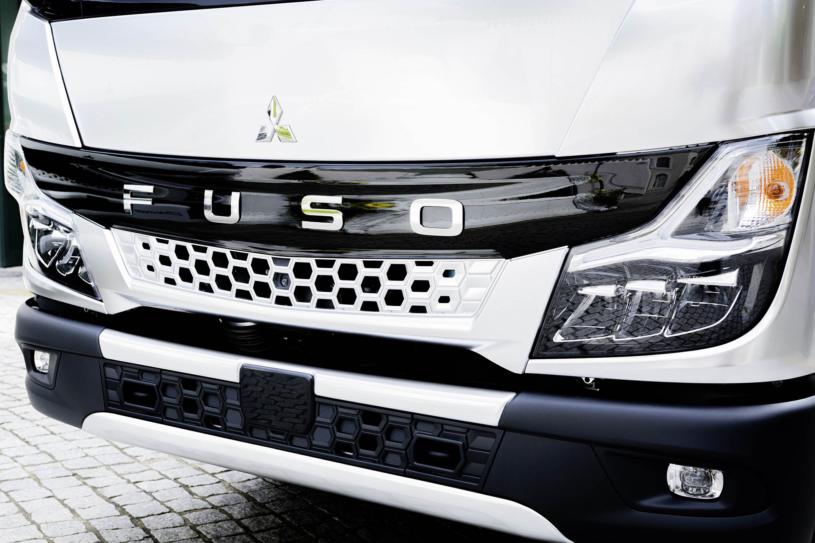

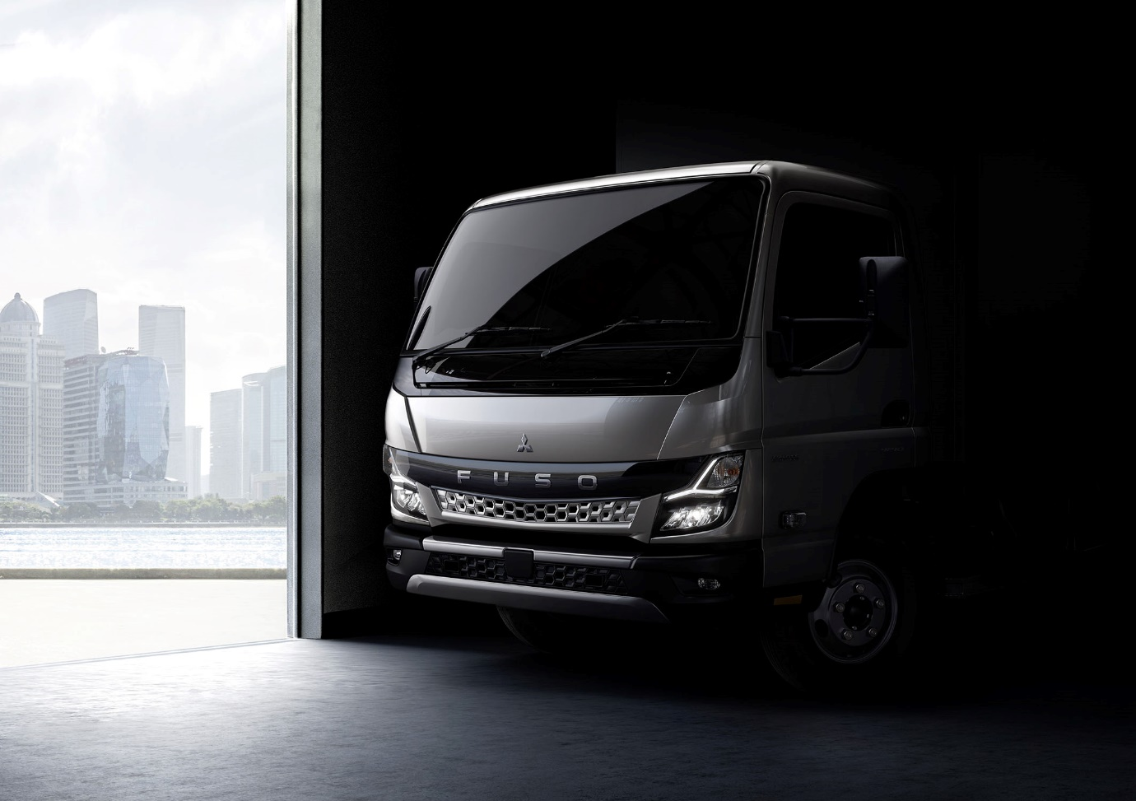

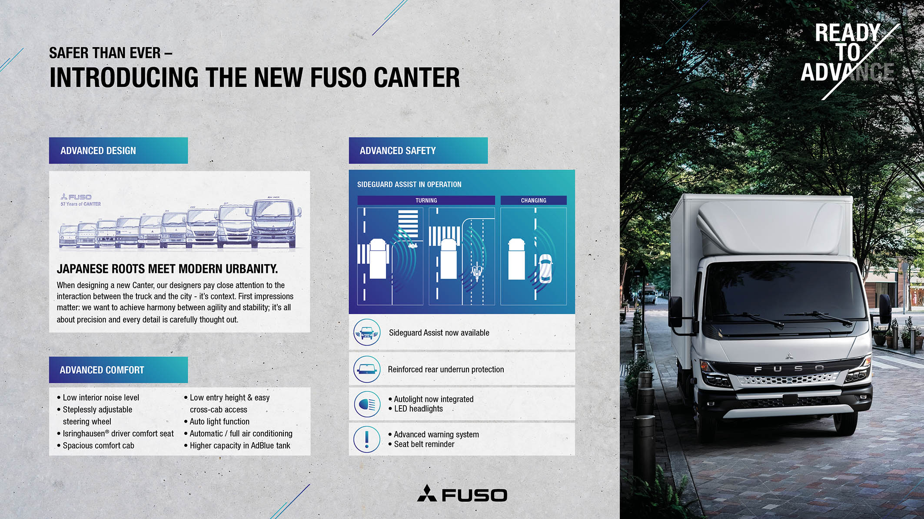

ends

For more information, or to request higher-res image files, please contact:

Jamie Fretwell at Mercedes-Benz Trucks UK Ltd
07712 519230, jamie.fretwell@daimler.com

or

Steve Warren or John Ripley
Impact Communications, 01926 842126
Steve: 07770 470251, steve@impactcom.co.uk
John: 07771 484595, john@impactcom.co.uk

