

Date: 25 October 2021

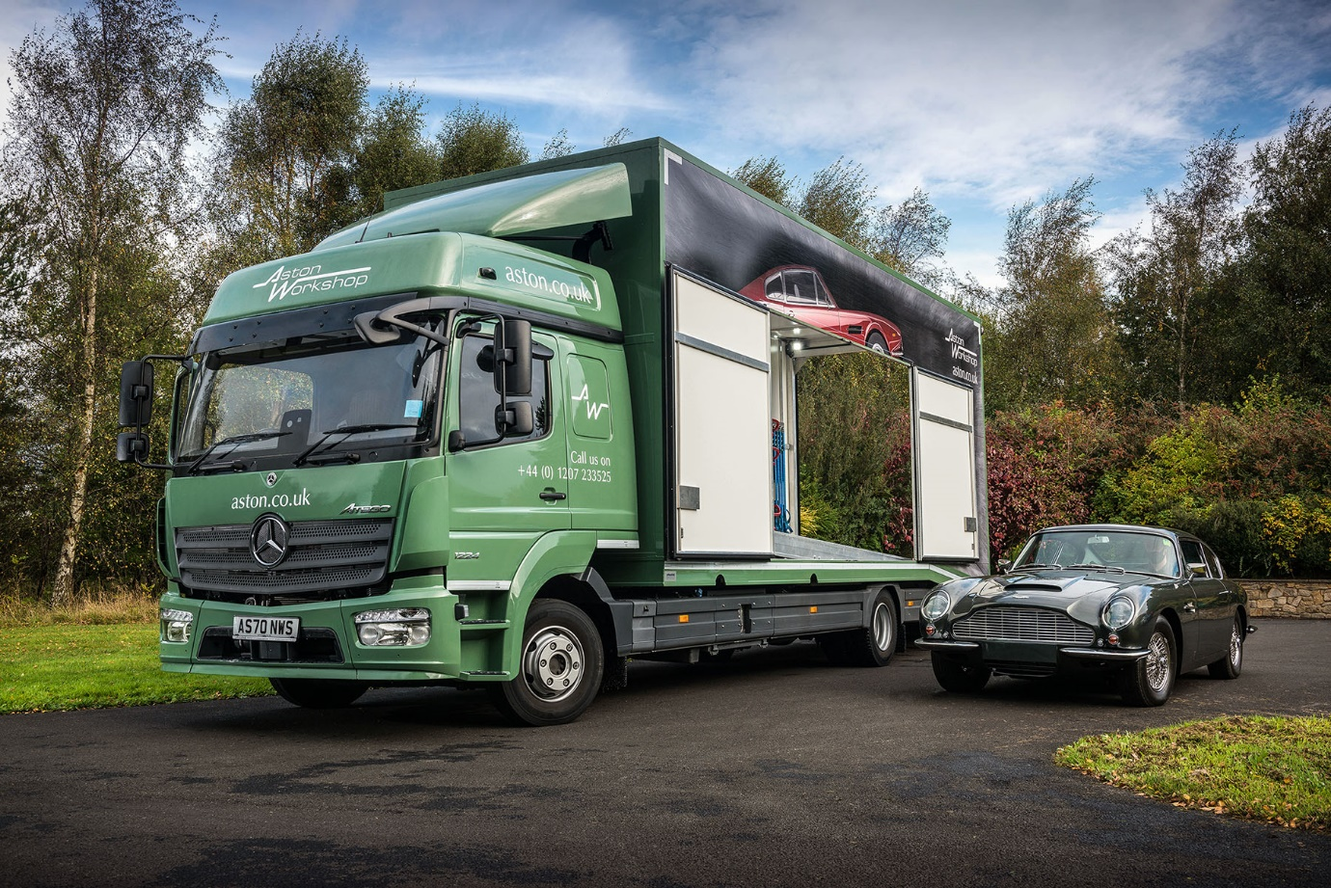

When only the best would do, Aston Workshop chose a smart Mercedes-Benz Atego from Bell Truck and Van

As owners of some of the most exclusive British-built luxury sports cars and grand tourers, Aston Workshop’s customers expect the highest standards of service. This explains why the Durham-based company has now entrusted the crucial job of transporting their cherished heritage vehicles to a new Mercedes-Benz Atego.

Supplied by North-East Dealer Bell Truck and Van, the stylishly finished 12-tonner is used to collect and deliver Aston Martins nationwide. It has a BigSpace sleeper cab – the roomiest available for the Atego range – and is fitted with a fully enclosed twin-deck transporter body by German specialist Moetefindt.

Purpose-designed for light- and medium-duty distribution applications, the Mercedes-Benz Atego covers the 7.5-16 tonnes gross weight spectrum. It offers outstanding dynamics, comfort and manoeuvrability, while also enjoying an unrivalled reputation for reliability and durability.

As a 1224 variant, Aston Workshop’s truck is powered by a 7.7-litre in-line six-cylinder engine that produces 175 kW (238 hp) and drives through a six-speed Mercedes PowerShift 3 automated manual transmission.

The body was ordered via Moetefindt’s UK agent, JAC Technologies, of Dereham, Norfolk. The lockable rigid box provides full weather protection and security, and features three-fold loading ramps that allow an extremely low loading angle for cars with minimal ground clearance. Eye-catching images of classic Aston Martin cars were applied by Top Signs, of Hexham, Northumberland.

Aston Workshop is one of the UK’s leading sales and service providers for classic and modern Aston Martins. As well as maintaining cars, its expert engineers offer a range of restoration and upgrade packages.

The company takes pride in offering customers a door-to-door delivery service encompassing not only cars but also any associated parts or fittings, which is provided by its own staff using the dedicated vehicle.

The Atego has replaced a 7.5-tonne truck by another manufacturer and will be inspected and maintained under a five-year Mercedes-Benz Complete Service Contract by the Service team at Bell Truck and Van’s Billingham branch.

As Workshop Manager Neil Calvert explained, the new vehicle represents a comprehensive upgrade on its predecessor. “Our old transporter had a single deck and could only move one car at a time. The fact that the new truck can carry two cars gives us much more flexibility and will help us to meet the demands of our growing business.

“The Moetefindt bodywork is purpose-designed for sports and racing cars. It is built to an extremely high standard and complements our very smart-looking Atego perfectly. The powerful brand image of the three-pointed star coupled with the eye-catching graphics has made for a vehicle with a really strong visual impact.”

He continued: “The cab has a quality feel and is a big step up in terms of comfort. It’s a lot more spacious than our previous truck, and is also better equipped and put together. Naturally, therefore, the driver is delighted with it.

“The Mercedes-Benz Atego enjoys an excellent reputation as a vehicle that can be trusted to provide years of reliable service, so we’re looking forward to a long and hassle-free operating life from our new transporter.”

There was praise, too, for Bell Truck and Van. “The Dealer’s Sales Executive Alex Wordsworth was very attentive throughout the order process,” recalled Neil Calvert. “He took the time to understand our requirements and as a result we’ve ended up with a truck specification that suits our needs perfectly. Alex also liaised with the bodybuilder to secure Type Approval for the vehicle, and arranged the Mercedes-Benz maintenance plan, which has allowed us to fix our costs at an attractively competitive rate.”

Established more than 30 years ago by owner Bob Fountain, Aston Workshop now employs a team of 40 specialist staff who boast a combined total of more than 400 years’ experience with the marque.

Buyers looking for a truly special Aston Martin can opt for a faithful reconstruction of the fabled DB4 GT Zagato or an entirely new model in the shape of the V8 Superleggera, which marries swooping 1960s-inspired lines with 6.0-litre V8 muscle. Those wanting to bring their classic DB4, 5 or 6 models bang up to date, meanwhile, can choose an EV conversion which offers electric power to the classic Aston Martin marketplace for the first time.

www.aston.co.uk

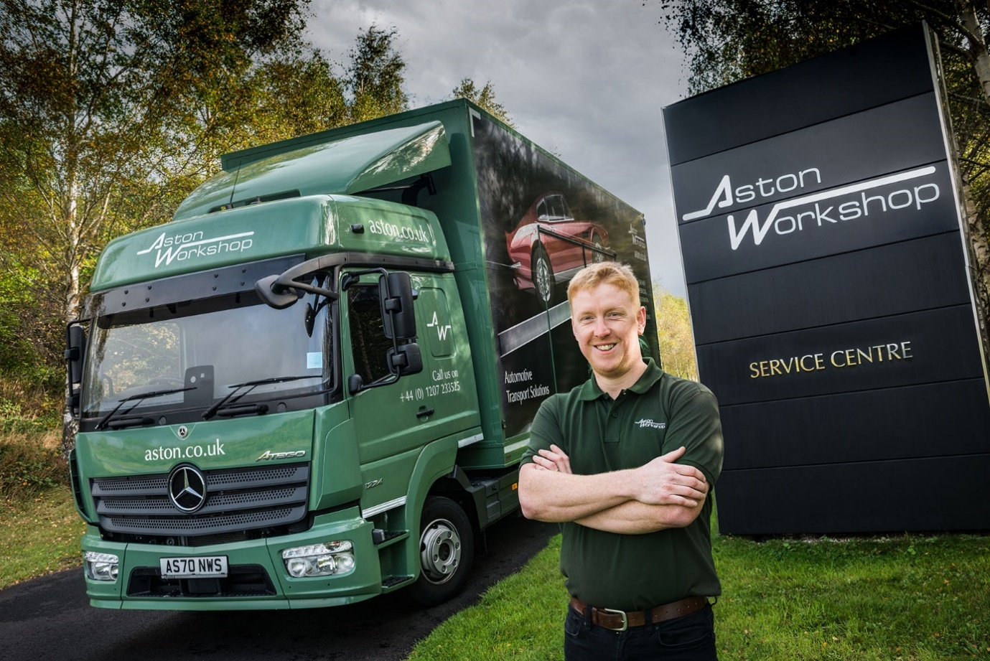

Double tops: Neil Calvert says the twin-deck Mercedes-Benz Atego transporter represents a big step forward for Aston Workshop

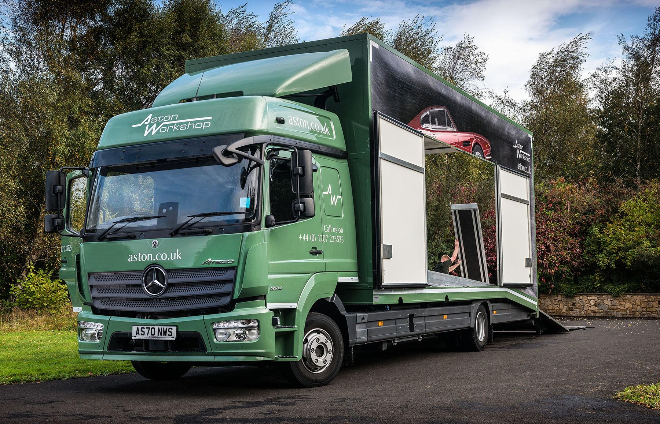

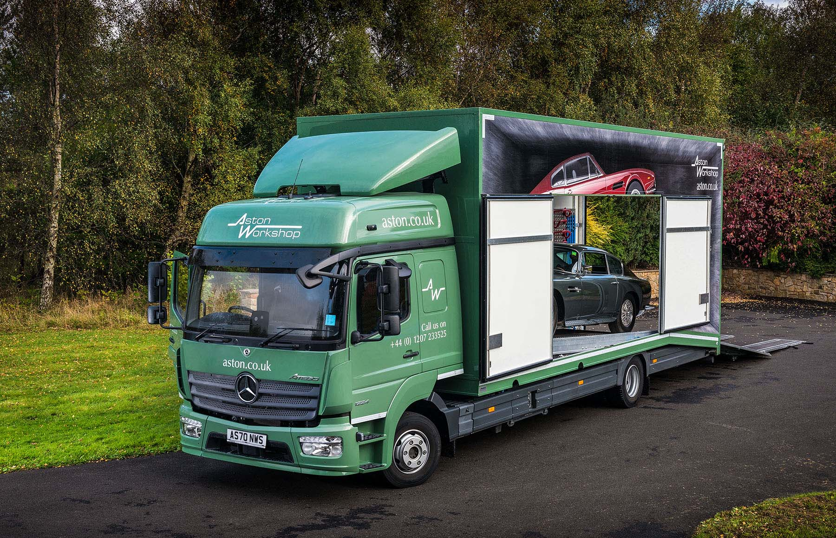

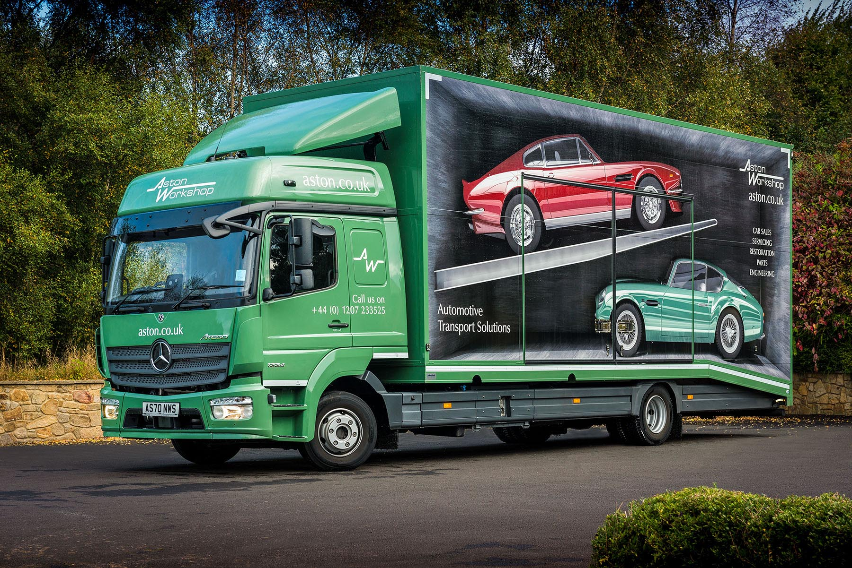

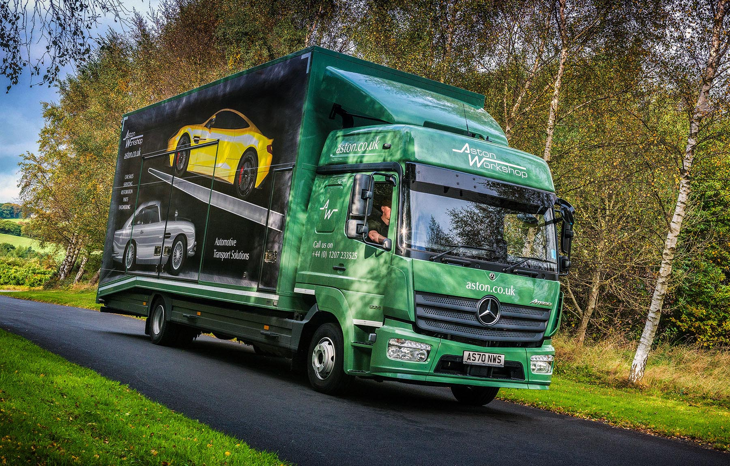

ends

For more information, or to request higher-res image files, please contact:
Steve Warren or John Ripley
Impact Communications, 01926 842126
Steve: 07770 470251, steve@impactcom.co.uk
John: 07771 484595, john@impactcom.co.uk

