

Date: 23 September 2020

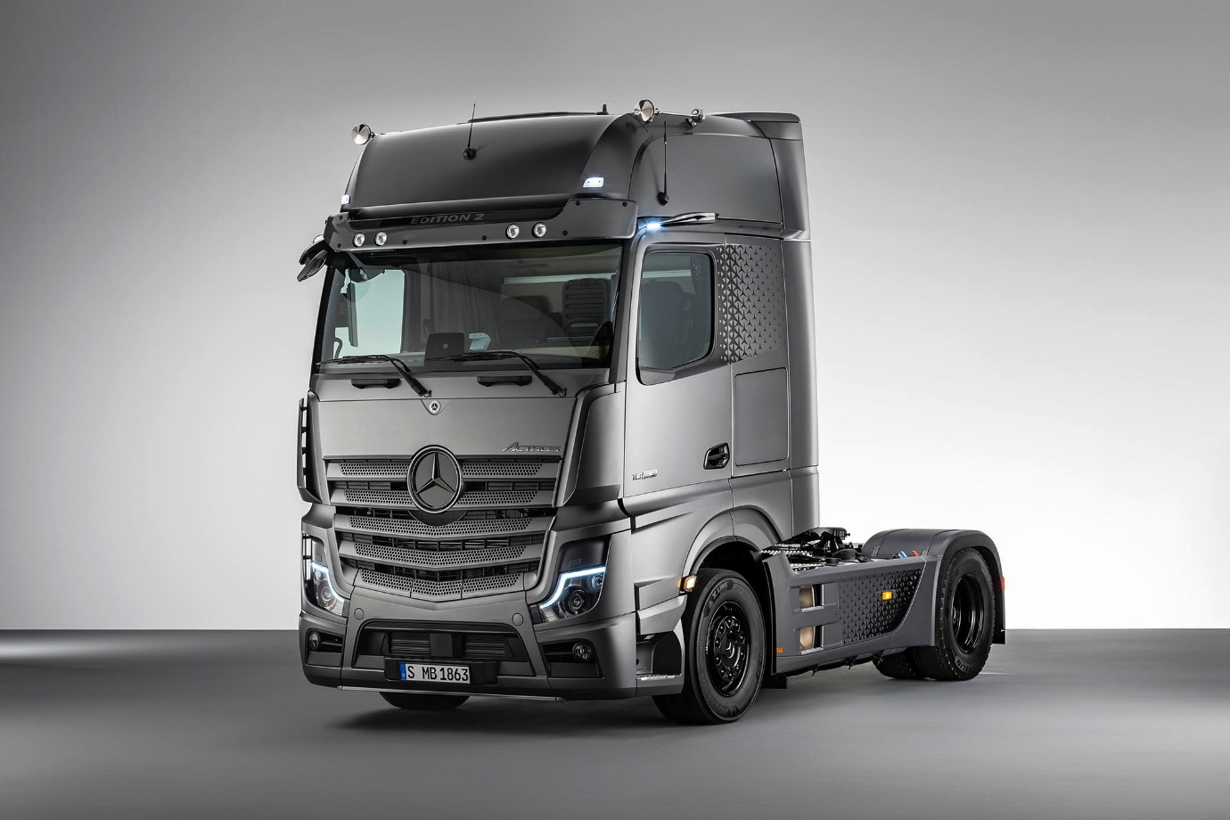

Mercedes-Benz unveils a new long-distance flagship – introducing the exclusive Actros Edition 2

- A new special model from Mercedes-Benz Trucks, the Actros Edition 2 is aimed at innovation-loving professional drivers whose truck is their home

- Production of the new Actros Edition 2 will be limited to just 400 units

Stuttgart – More efficiency for hauliers, increased comfort for drivers, and improved safety for all road users – the ground-breaking innovations introduced with the newest Actros generation from Mercedes-Benz Trucks set the industry’s highest standards. Features such as the Multimedia Cockpit, MirrorCam, enhanced safety systems and partially developed driving functions ensure that the Actros is perfectly placed to meet the ever-increasing demands of operators and drivers engaged in long-haul and heavy-duty distribution transport applications. Numerous awards, including the prestigious ‘International Truck of the Year 2020’ accolade, confirm that with its fifth-generation Actros Mercedes-Benz Trucks has once again raised the bar.

However, with haulage companies and truck manufacturers facing major challenges in a highly competitive environment, there can be no standing in the commercial vehicles sector. For this reason, and in order to ensure that its customers are best placed to meet the challenges of tomorrow, Mercedes-Benz Trucks is adding a new tractor unit model to its premium range: the Actros Edition 2.

Actros Edition 2: A special model with the ‘Wow!’ factor

Available for order from January 2021, and with production limited to just 400 examples, the Actros Edition 2 is aimed at employed and owner-drivers who love innovation. Their truck is also their home, and they value premium comfort and individual style particularly highly. For those lucky enough to drive an Actros Edition 2, it will be so much more than just a tool to do a job. Instead, it will be a vehicle with which they forge a strong emotional bond. Hauliers, meanwhile, can rely on this flagship model to enhance the images of their companies, and attract the best drivers at a time of shortage.

Up to 40 new options for the vehicle’s interior and exterior combine with design elements from its Edition 1 predecessor to give the Edition 2 an unmistakeable character that sets it apart from other models in the internationally successful Actros range. This, then, is a truck with a genuine ‘Wow!’ factor.

Driving, working and living in a luxurious environment

Mercedes-Benz Trucks has brought together a comprehensive range of equipment to create the Edition 2’s intoxicating sense of luxury. The stylish interior boasts a dashboard and door handles covered in nappa leather, while other elements have a carbon-fibre look, and the roof hatch features ambient lighting. The new home screen in the Multimedia Cockpit’s primary display, and the polished and brushed aluminium Edition 2 badge on the passenger side, are also real eye-catchers. The top bunk comes with bedding and is 900 mm wide, while an all-around curtain – almond beige on the inside, black on the outside – ensures stylish privacy. Likewise, the curtain bearing an impression of the Mercedes-Benz three-pointed star, in front of the bed.

Exterior highlights include exclusive side wall decals with a star pattern, Edition 2 lettering in the lacquered sun visor, the Actros emblem in front, Actros lettering on the upper side of the cab’s back wall, as well as four additional LED spotlights in the sun visor and three LED working lights behind the cab. Stainless steel entrance steps and rear axle caps, with protective wheel nut caps, add another dash of style, as do the illuminated Mercedes-Benz three-pointed star with black aperture, decorative grille elements in dark chrome, and the darkened headlamp surround.

All two- and three-axle Actros variants with GigaSpace and BigSpace cabs, whether left- or right-hand drive, can be specified as an Edition 2. Cab paint can be tailored specifically to match an operator’s corporate shade, while the front of the vehicle is always finished in moonstone grey metallic, making the truck instantly recognisable.

The Edition 2’s series equipment comprises the following:
- Safety Package, with a number of active driver assistance systems
- Comfort Package, with LED ambient lighting, shaving mirror, refrigerator and many other amenities for comfortable living
- Driving Package, with leather steering wheel, electric sun blind and more
- Sight Package, which includes bi-xenon headlights, rain sensor and LED rear lamps
- Media Package, with sound system, notebook holder, additional 12/15 V socket
- Extra Line, with LED position lights in the MirrorCam, LED indicators and Welcome Light

Made-to-measure acquisition (leasing and financing) and insurance solutions are also available with the Actros Edition 2, as are individually configurable service packages.

Reassuring security features and tailored connectivity

The current Actros generation represents another step forward by Mercedes-Benz Trucks on the road towards a future with accident-free traffic and fully accident-free driving made possible by active safety assistance systems. The Actros Edition 2 is equipped as standard with the latest Active Brake Assist 5 emergency braking system, and MirrorCam, which replaces conventional main and wide-angle mirrors, while optional Active Drive Assist (ADA) technology makes partially automated driving (SAE level 2) a reality. In conjunction with these assistance systems, enhanced Predictive Powertrain Control (PPC) not only delivers valuable fuel savings, but also relieves stress and makes the job easier for drivers on rural routes.

Two colour displays form the centrepiece of the Human-Machine Interface (HMI) in the user-friendly Multimedia Cockpit. Further HMI innovations such as the display of the next navigation event in the primary display, or the total weight of tractor unit and trailer, are also included. For PPC, the kilometre display is no longer shown as a bar diagram but in absolute values, and the battery status is also displayed.

Customers choosing the Multimedia Cockpit, interactive upgrade to the standard version will also benefit from fast access to the Mercedes-Benz Truck App Portal. This enables haulage companies to harness the new opportunities of connectivity and equip their vehicles with efficiency- and comfort-enhancing apps such as telematics services from Fleetboard or third-party providers. The new HABBL logistics application from Fleetboard Logistics enables operators to integrate their own trucks and those of sub-contractors into the dispatching process, provide assignment data, and facilitate communication with the drivers. Everyone involved in the transport process – driver, dispatcher and end customer – receives the required information, boosting efficiency and transparency.

Mercedes-Benz Uptime provides a digital protective shield for the Mercedes-Benz truck

The Truck Data Center is the centrepiece of Fleetboard and other vehicle connectivity solutions. The connectivity module receives the data from the truck’s sensors, cameras and steering devices, and analyses these for a range of applications. The Truck Data Center not only forms the basis for Fleetboard’s numerous services, but also for Mercedes-Benz Uptime, the innovative service product that maximises vehicle availability.

Mercedes-Benz Uptime combines intelligent vehicle networking with intensive customer service. The goal is to ensure the truck spends as much time as possible on the road, so it can reliably fulfil assignments. Workshop visits are minimised and planned more efficiently. Faults are identified and can be repaired earlier than would otherwise be possible, thereby reducing the risk of breakdowns.

Mercedes-Benz Uptime’s fully automatic telediagnosis monitors the truck’s vehicle systems continuously and in real time. The system recognises over 1,200 different important events and continuously analyses the ‘health status’ of more than 40 systems, alerting customers and service partners to fault events within an average of 240 seconds. Mercedes-Benz Uptime not only helps to avoid foreseeable breakdowns but can also reduce 50% of unplanned workshop visits by bundling repair and maintenance requirements. This technology is already popular with customers: in 2019 more than half of all Mercedes-Benz Trucks with a Truck Data Center installed, were equipped with this system in the markets where it is offered, including the UK.

Further information is available here: d.ai/NOWandNEXT2020-pressmaterial

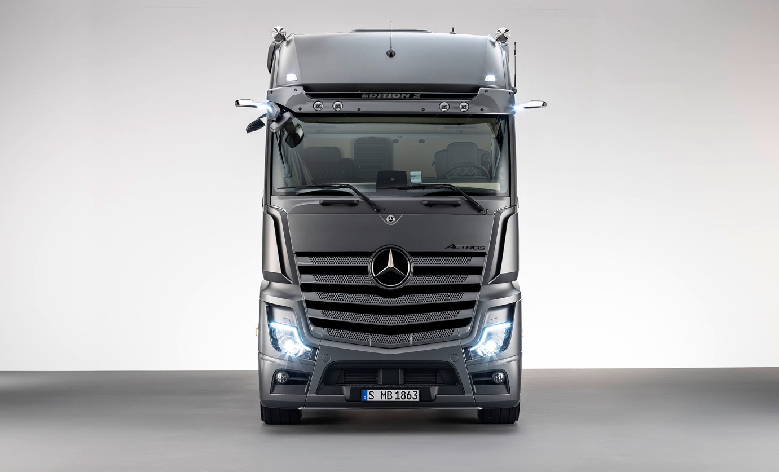
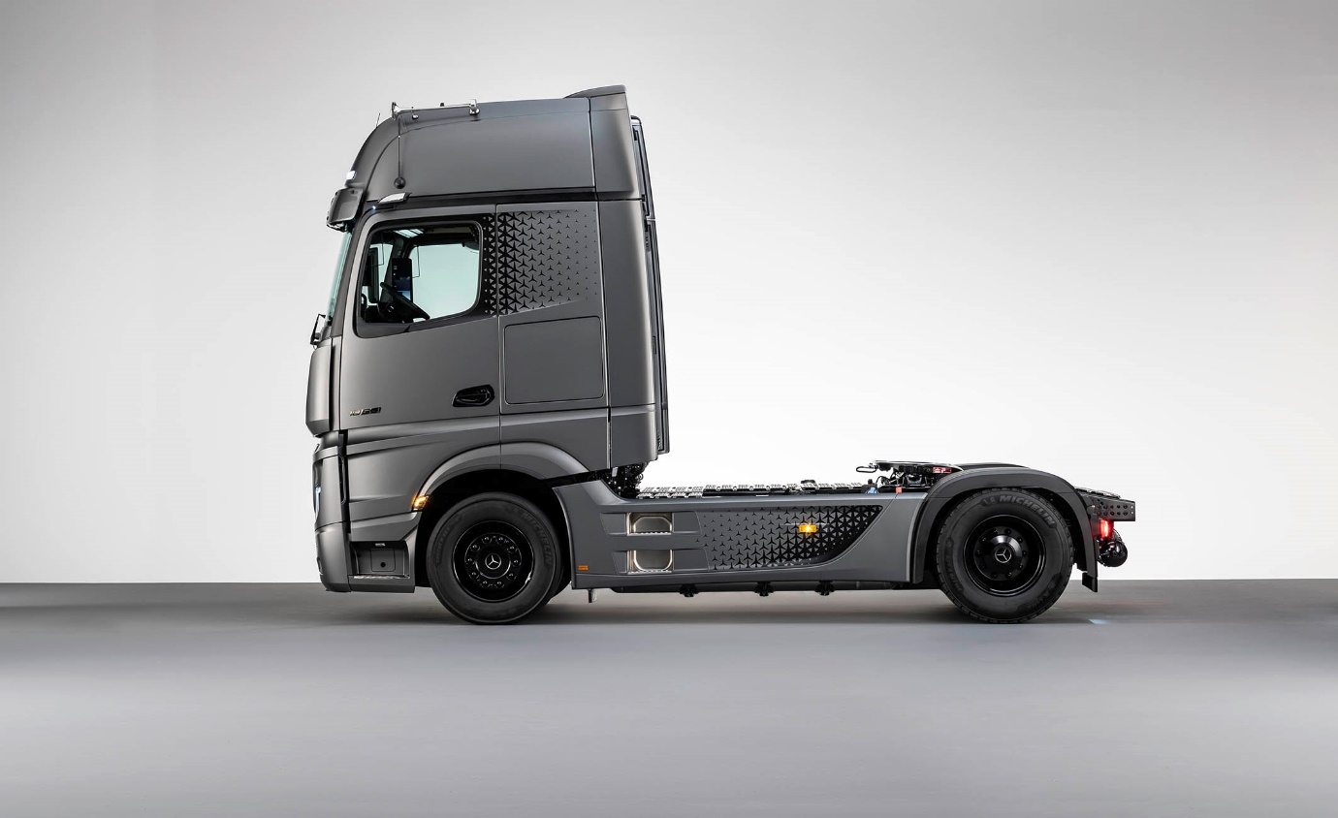
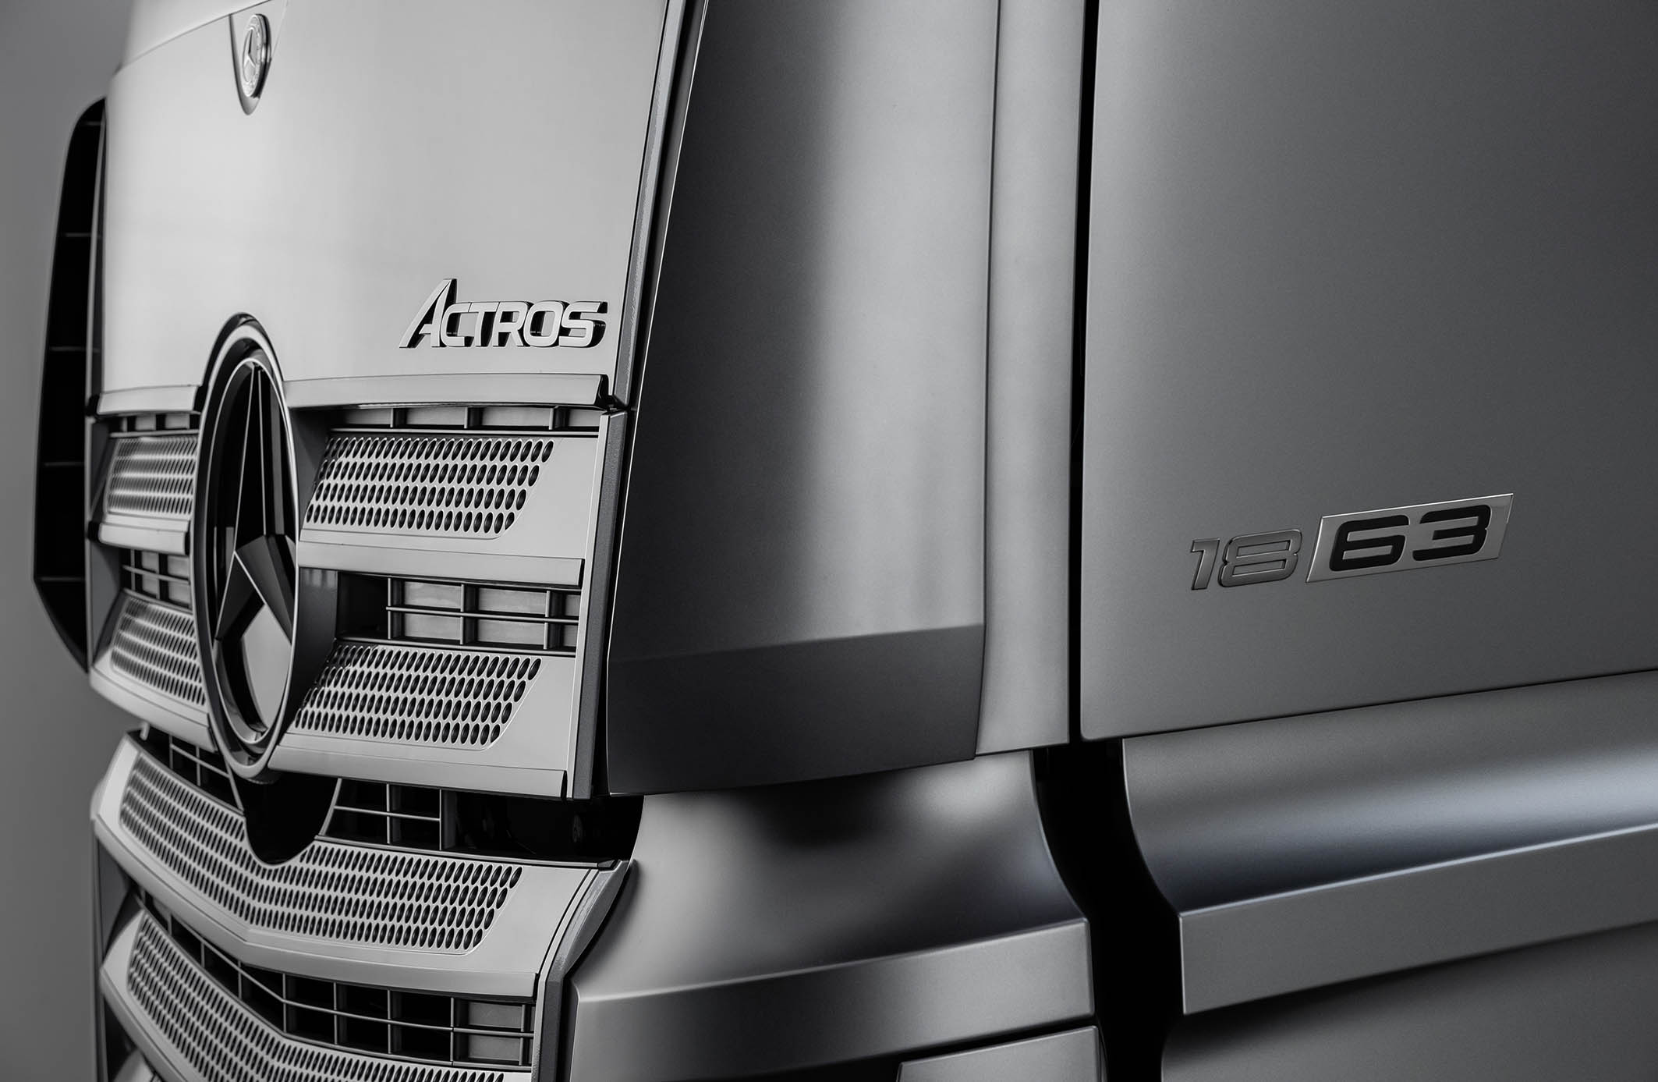

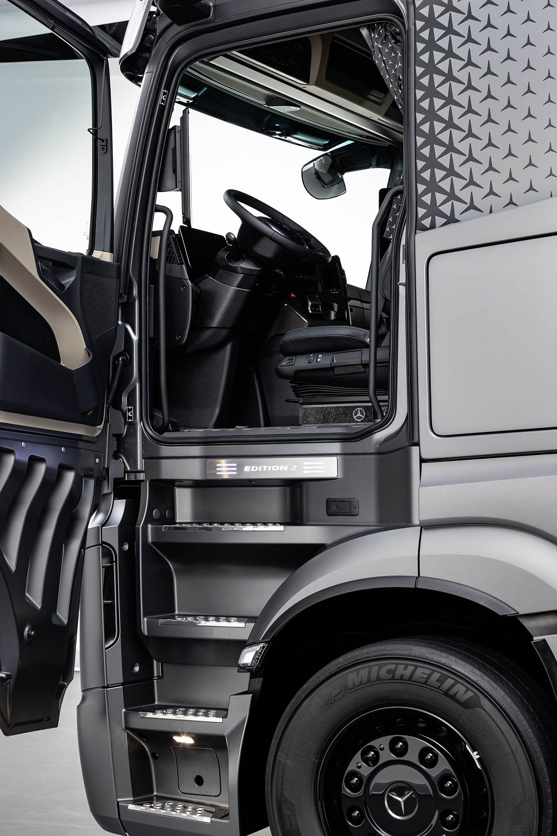

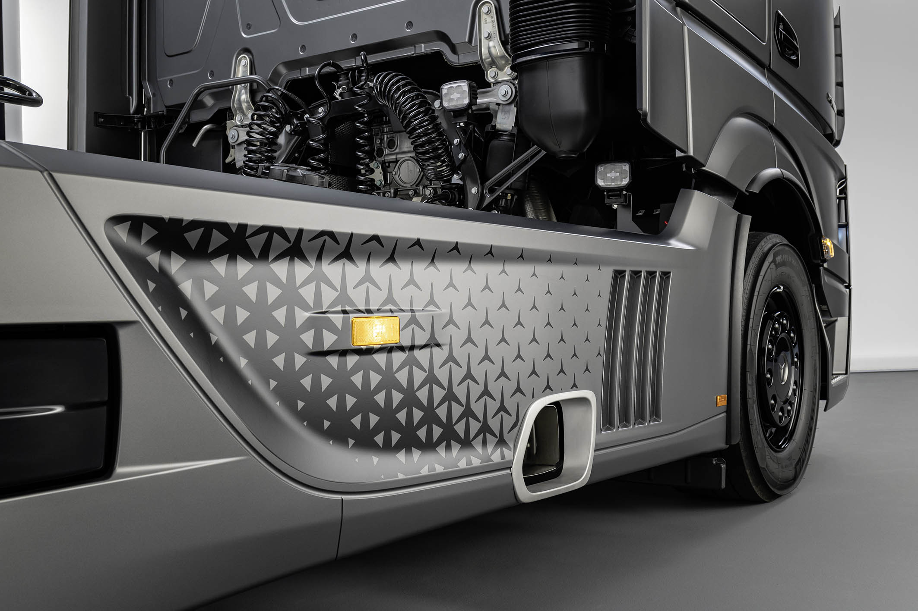

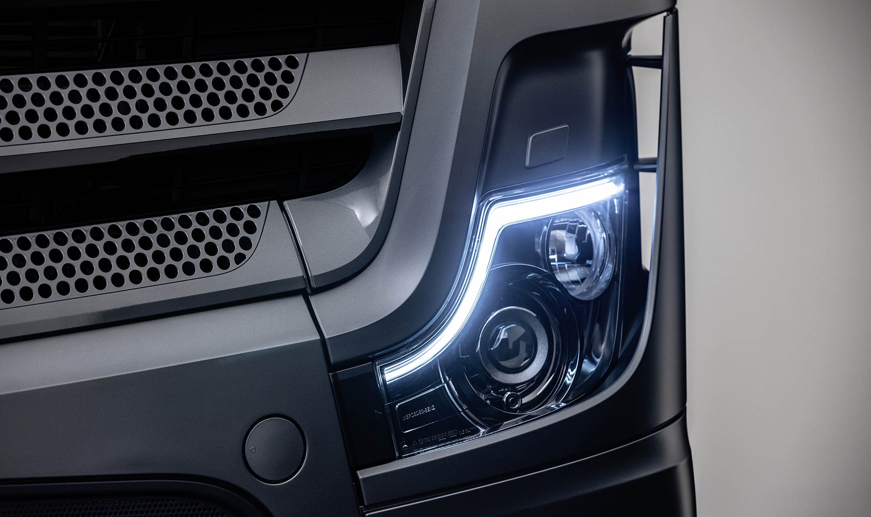

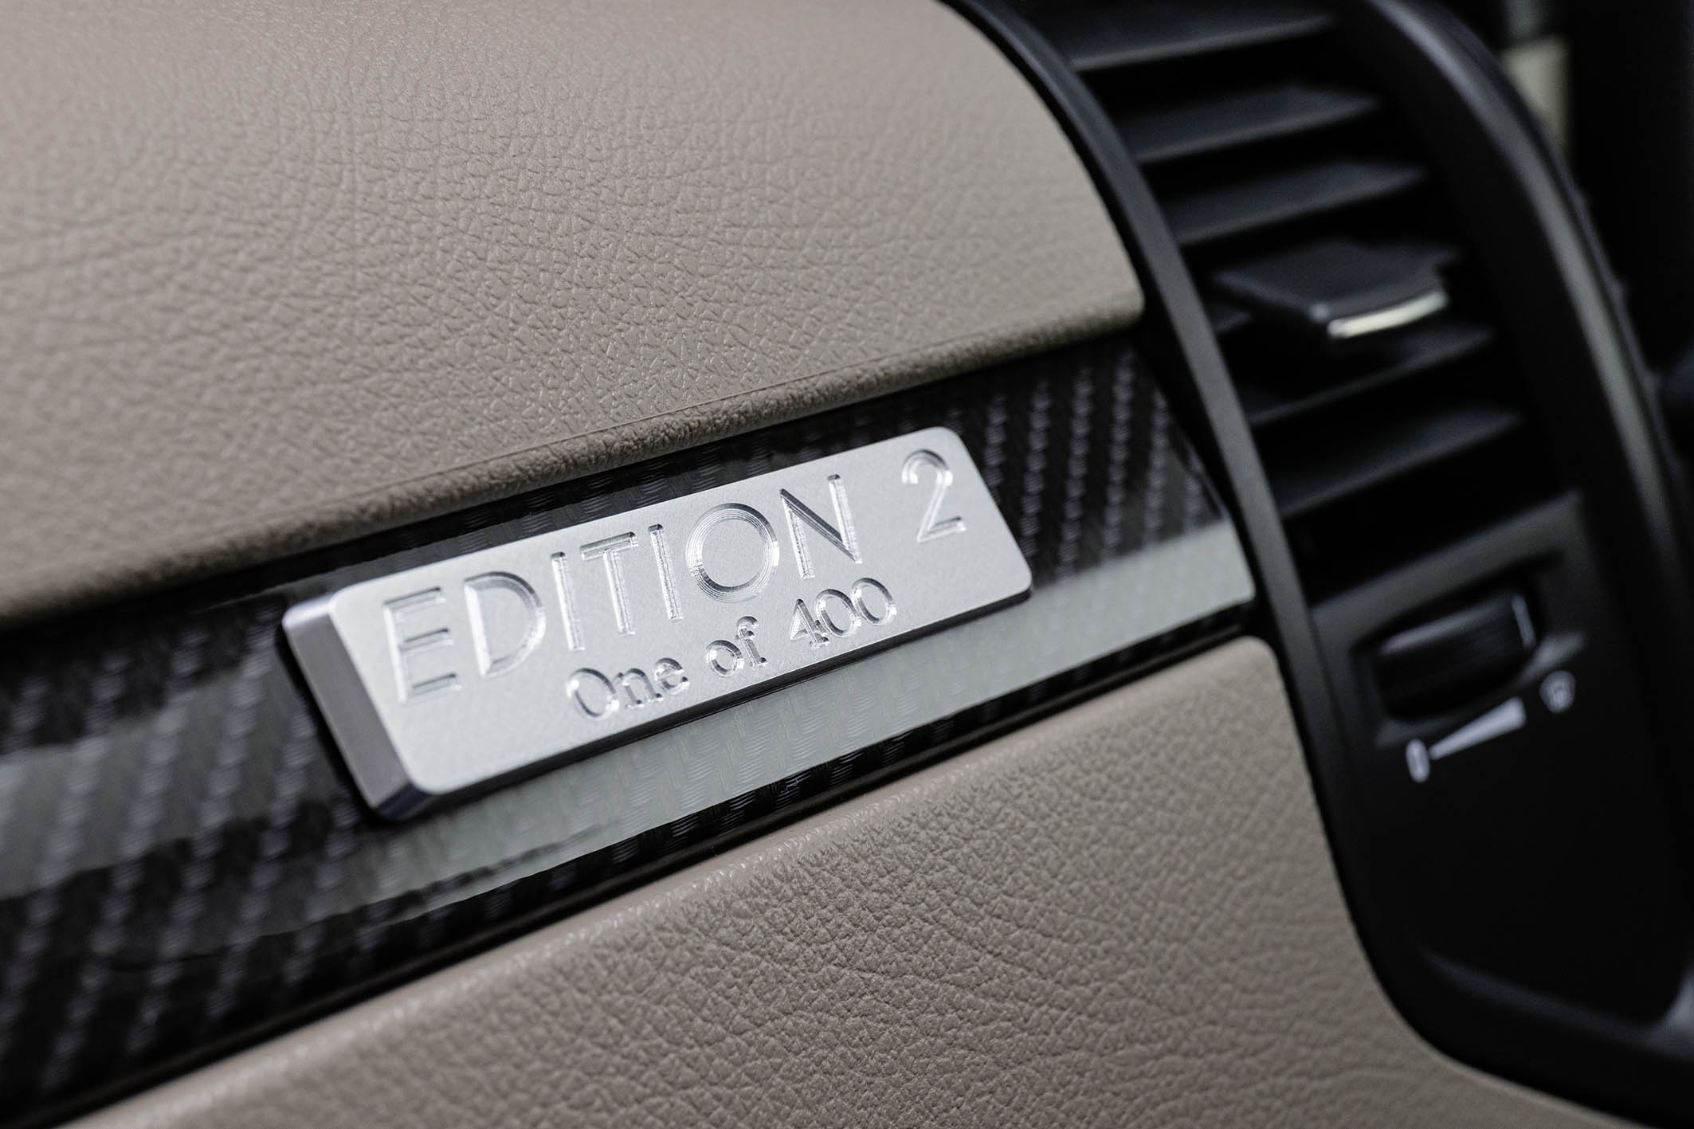

ends

For more information, please contact:

Jamie Fretwell at Mercedes-Benz Trucks UK Ltd
07712 519230, jamie.fretwell@daimler.com

Further information on Daimler Truck AG is available at:
www.media.daimler.com and www.daimler-truck.com

