

Date: 21 September 2022

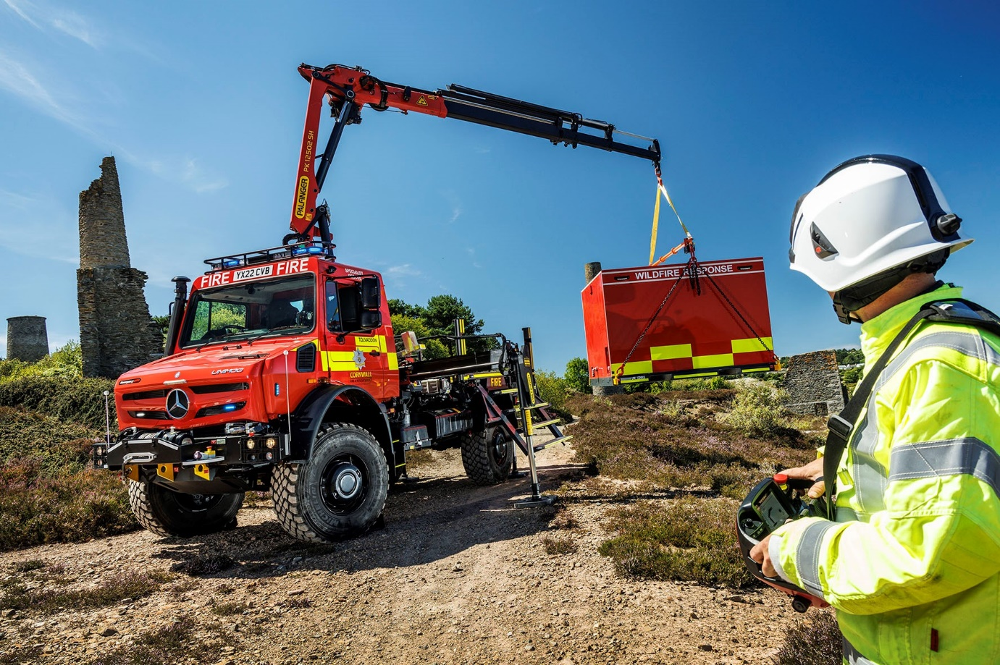

Multi-role Mercedes-Benz Unimog adds flexible, ‘go anywhere’ capability for Cornwall Fire & Rescue Service

Fire officers in Cornwall have responded to the increasing frequency of wildfires and flash floods by commissioning an extreme off-road Mercedes-Benz Unimog that can be kitted out to tackle both types of incident and much more besides.

The ultra-high mobility Unimog UHE will transport mission-specific ‘pods’, each of which is packed with specialist equipment.

These are the work of prime contractor Emergency One (UK), of Cumnock, Ayrshire, a leading manufacturer of appliances and specialist vehicles for fire services. Its conversion design included three sets of access steps that fold up against both sides and the rear of the pods while in situ.

Dealer South Cave Tractors supplied the 4x4 chassis, which has the maximum permissible gross weight of 14.5 tonnes. Technicians at its workshop in Brough, East Yorkshire, also fitted a sub-frame and, immediately behind the cab, the Palfinger PK12502 SH crane used to lift the pods on and off the vehicle, as well as the outriggers and winches front and rear.

As a U5023 variant, the Unimog is powered by a 5.1-litre four-cylinder engine that produces 170 kW (230 hp) and a muscular 900 Nm of torque across a broad rev range, which it transmits via an optional EAS automated manual version of the standard gearbox. To supplement its eight forward and six reverse gears, Cornwall Fire & Rescue Service specified the working and crawler gear range, which provides another eight forward and reverse ratios.

The vehicle offers unrivalled traction thanks to its strong yet torsionally flexible frame and a torque tube suspension system that achieves exceptional levels of axle articulation. The extreme off-road Unimog has a standard water fording capability of 800mm but the Cornwall Fire & Rescue Service vehicle has been optionally specified for operation in depths of up to 1,200mm.

The innovative Central Tyre Inflation system allows the driver to drop the pressures from the cab when the Unimog is off-road. In addition to increasing grip, this brings an environmental benefit by minimising damage to the ground. Tyres can then be reinflated when back on a hard surface for greater safety and fuel efficiency at normal road speeds.

The new Unimog is based at Tolvaddon Community Fire Station, Camborne. It was supplied with four pods – one each for ‘Wildfire Response’, ‘Flood Response’, ‘Line Rescue’ and ‘Disaster Response’ – and also boasts the additional power and communications systems that will allow it to double as a mobile command unit.

This is the authority’s second Mercedes-Benz Unimog. The first, a rescue pump with crew cab, is built on a U500 implement carrying chassis and works from Launceston Fire Station – this unit has provided outstandingly reliable service since it was purchased in 2007.

Firefighters from stations across the county have battled record numbers of fires in gorse and other vegetation throughout this exceptionally hot, dry summer – during one 48-hour period, 422 calls were made to fire control, putting the service under “sustained operational pressure”.

According to Mark Salter, Group Manager – Assets Team at Cornwall Fire & Rescue Service, the latest addition to the fleet will significantly enhance its ability to deal with some of the most challenging incidents.

“The Mercedes-Benz Unimog was the obvious chassis on which to base this new and highly specialised appliance,” he said. “Given some of the rough terrain here in Cornwall, exceptional off-road performance was an absolute ‘must’. No other vehicle with a similar carrying capacity can match the Unimog’s ‘go anywhere’ aptitude.

“As a result of the drought we’ve dealt with numerous fires on difficult-to-access moorland in recent weeks. The Wildfire Response pod carries a 1,000-litre water tank and nebular misting system, as well as bush cutters for creating fire breaks, misting leaf blowers and other gear, so will be an invaluable aid to firefighters in tackling such incidents in the future.

“The Line Rescue pod carries a versatile range of line rescue and recovery systems, including a bipod and Tirfor winches, that will be used to recover members of the public and large animals after falls over cliffs or down old mineshafts, a regular occurrence in this part of the world.

“Meanwhile,” he continued, “the Flood Response pod, coupled with the Unimog’s impressive wading ability, will enable us to recover residents who have become stranded in their homes after torrential downpours, as has happened two or three times in recent years.

“Completing the picture, the Disaster Response pod contains heavy-duty equipment that might be used to rescue casualties in the event of anything from a building collapse to a plane crash or an accident involving a heavy goods vehicle.”

He added: “From the very early stages of specification and issue of the tender documents this has been a complex and demanding project, so to take delivery of the finished vehicle is extremely exciting. Emergency One have been brilliant throughout, facilitating factory inspections and answering all of our questions. Nothing has been too much trouble.

“Once training programmes have been completed for the firefighters who will operate the new Unimog, and our workshop colleagues who will maintain it with parts support from our local Mercedes-Benz Dealer, I’ve every confidence that this impressive vehicle will prove its worth by providing the increased operational capability for which it was designed.”

Mercedes-Benz Trucks will be presenting another Unimog U5023, in this case a crew cab variant, at the Emergency Services Show 2022, which takes place at the NEC, Birmingham, from September 21-22.
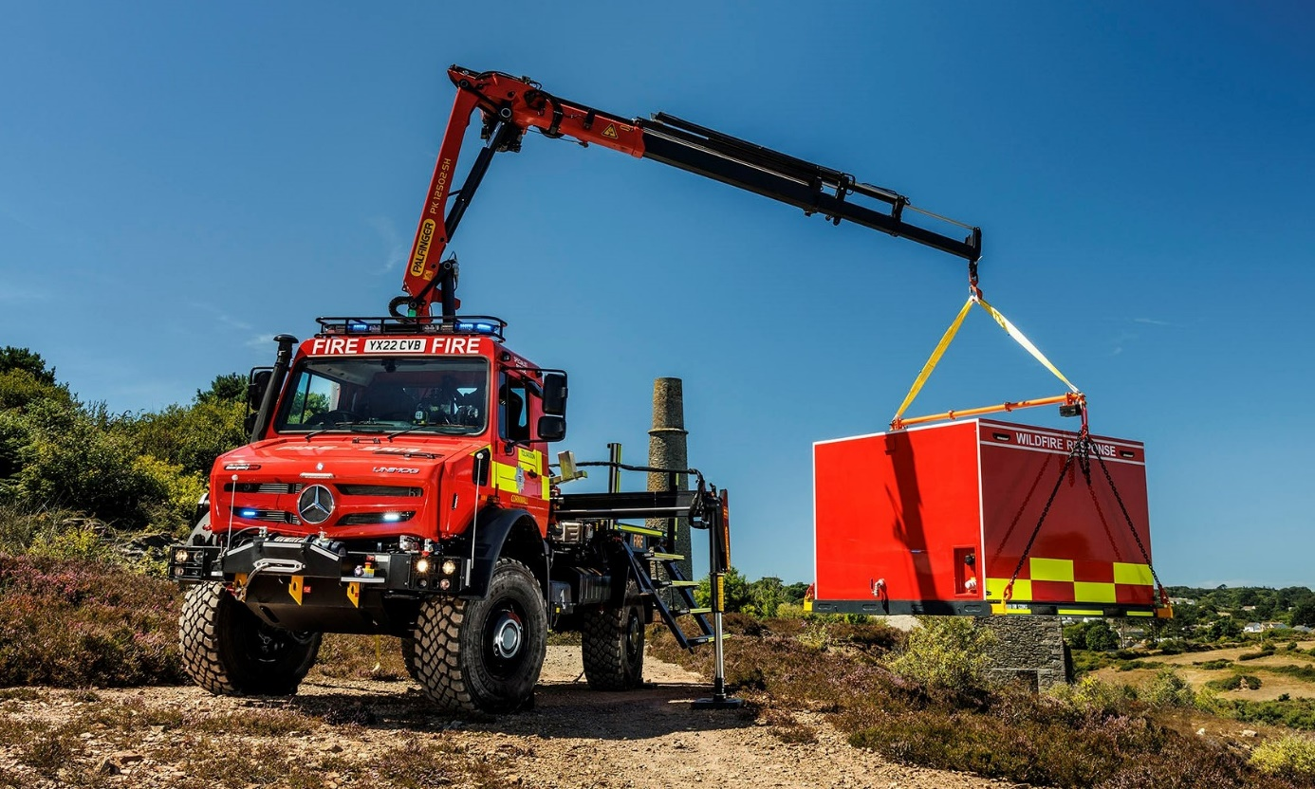

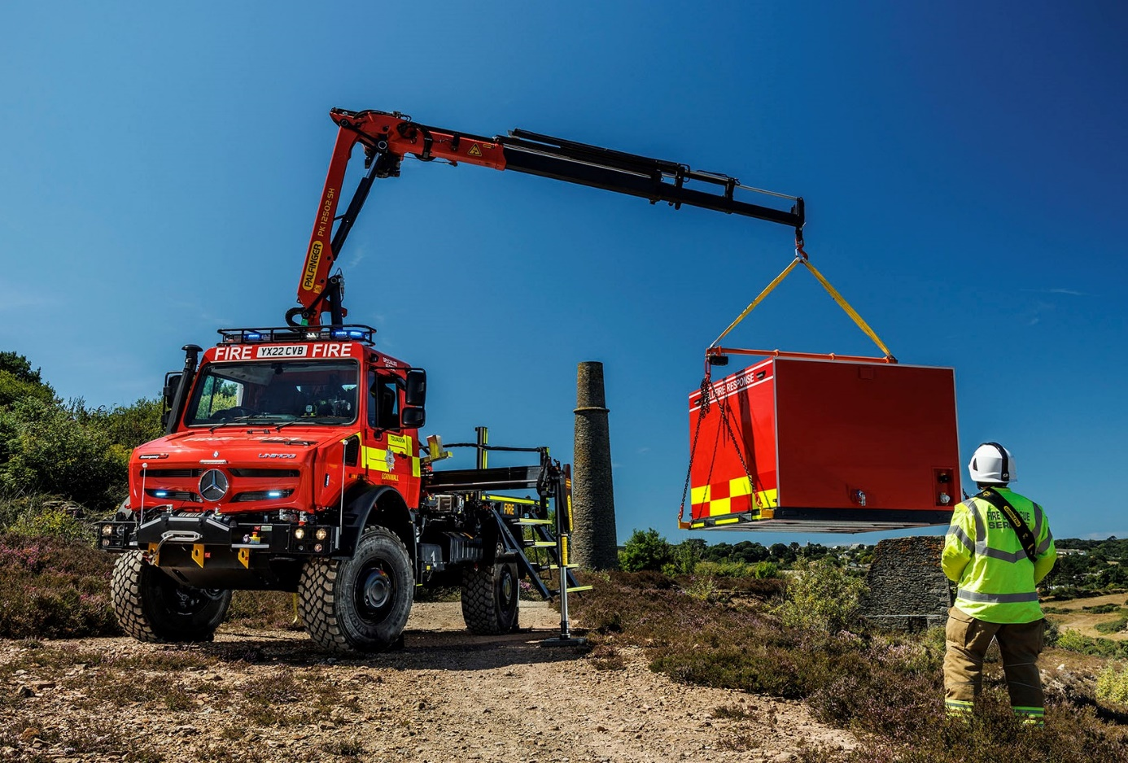

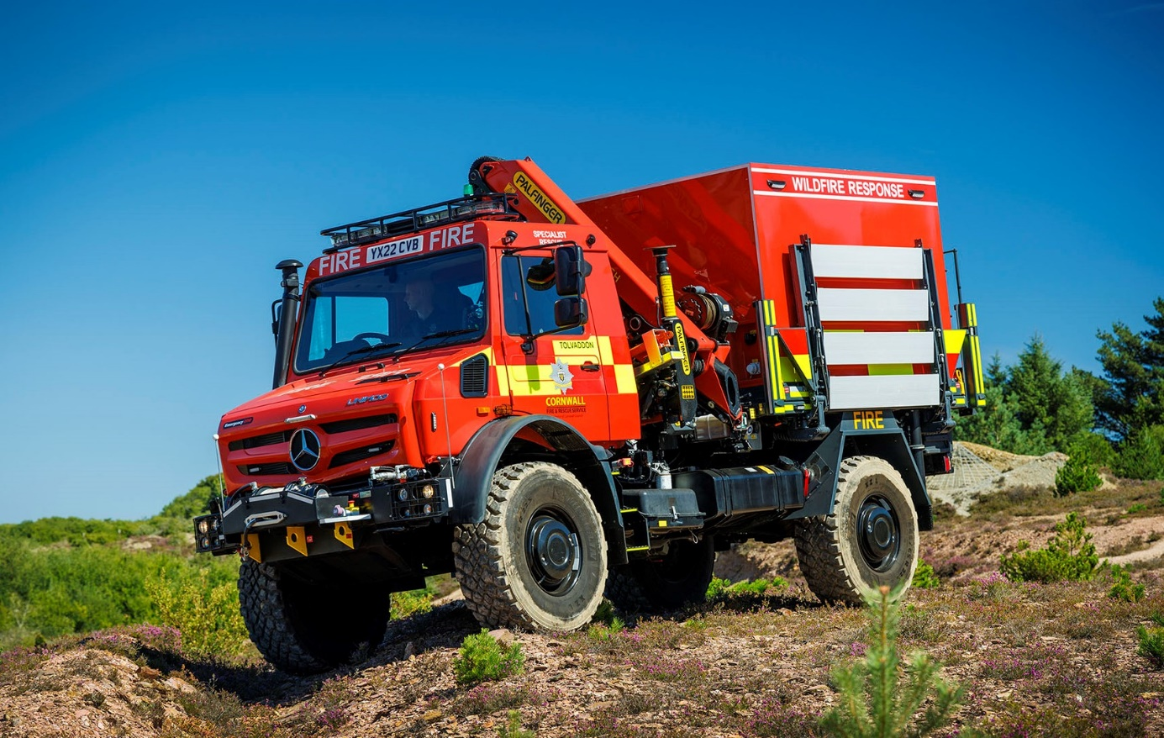

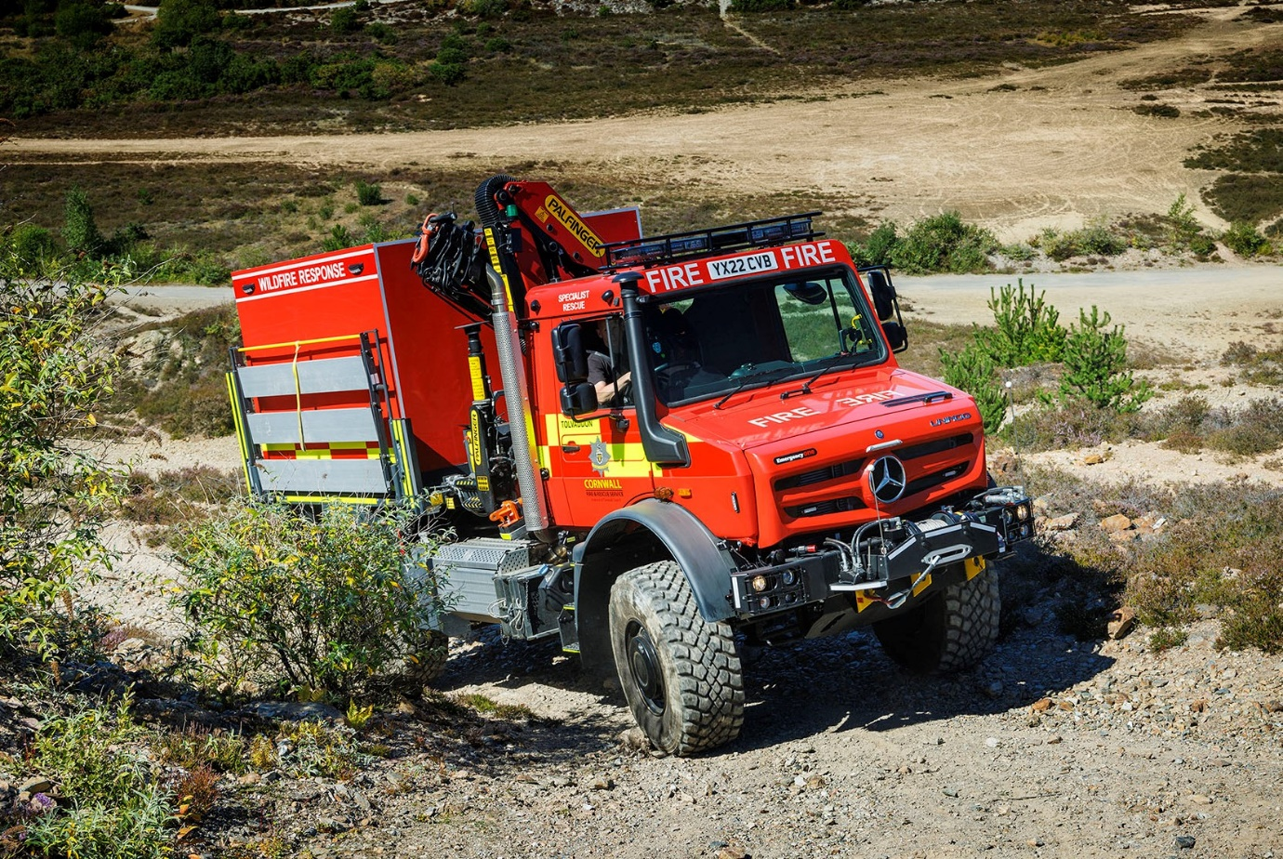

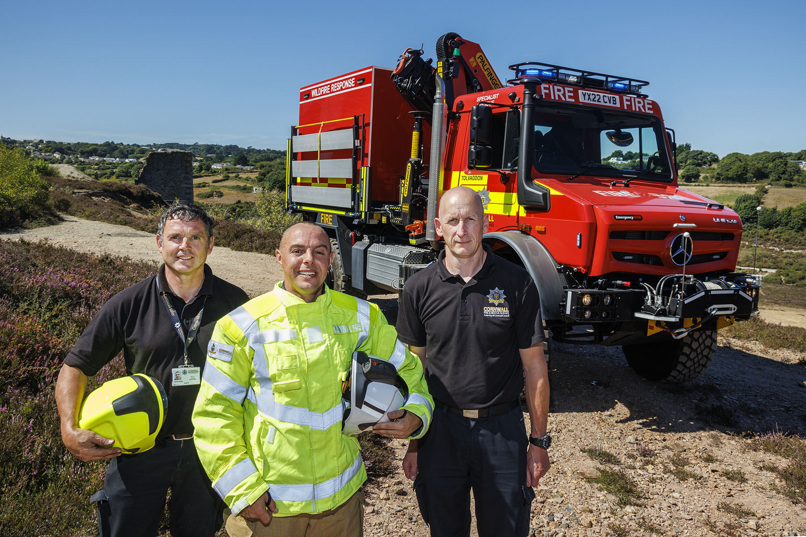

Preparing for action: Cornwall Fire & Rescue Service colleagues, from left, Contracts Manager Adrian Stone, Watch Manager – Assets Ben Goddard, and Driver-trainer Phil James are pictured during training on the new Unimog

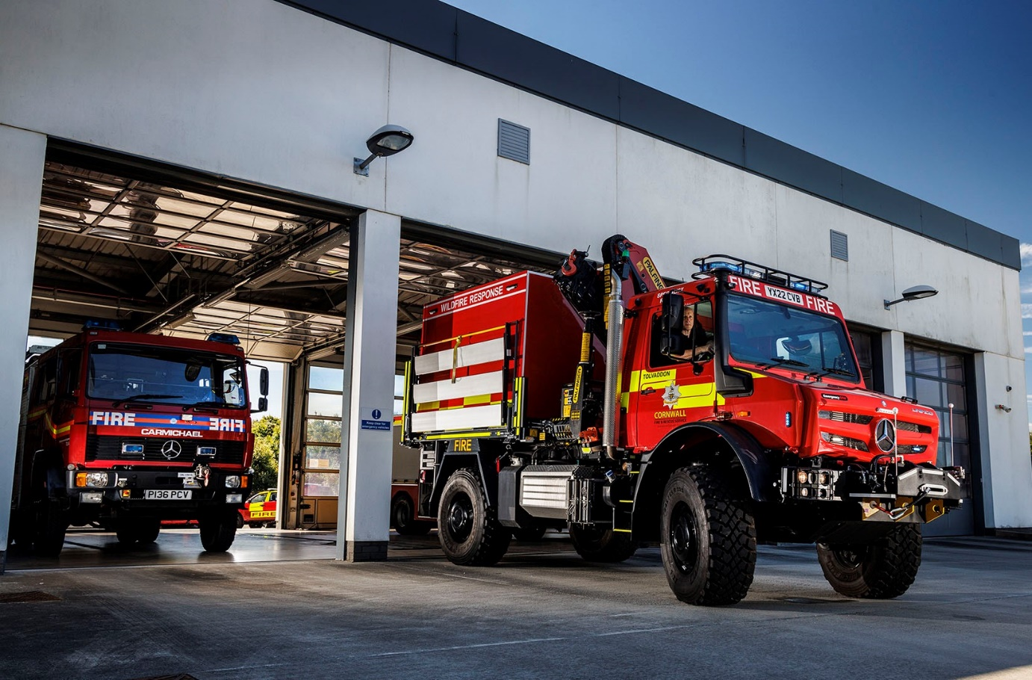

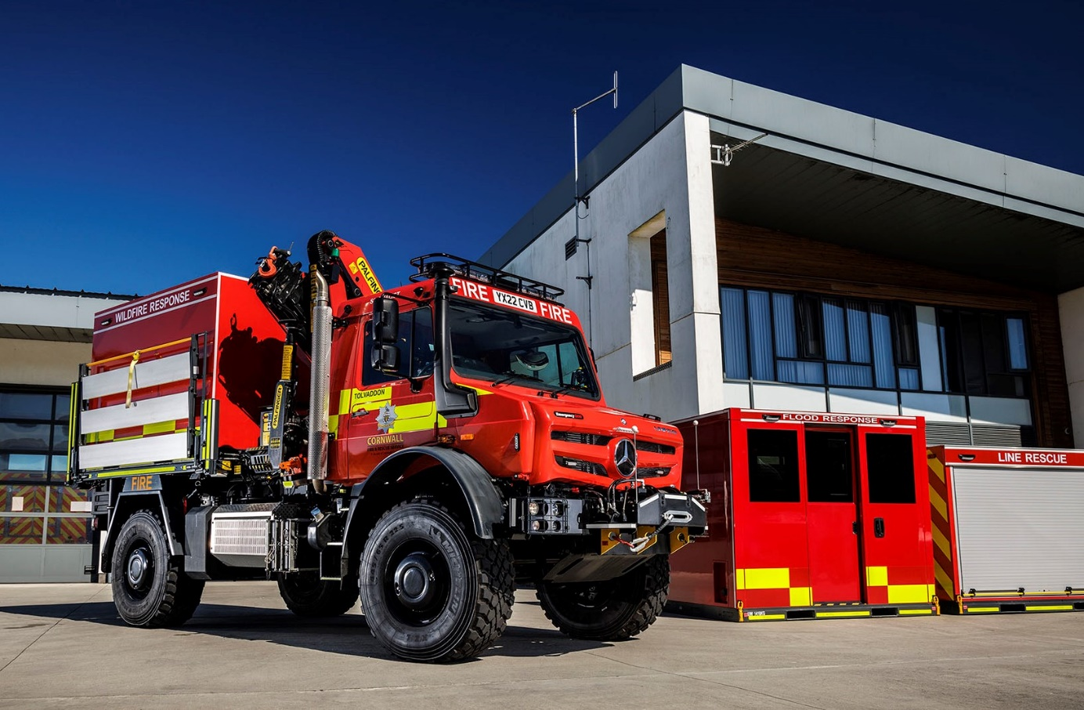

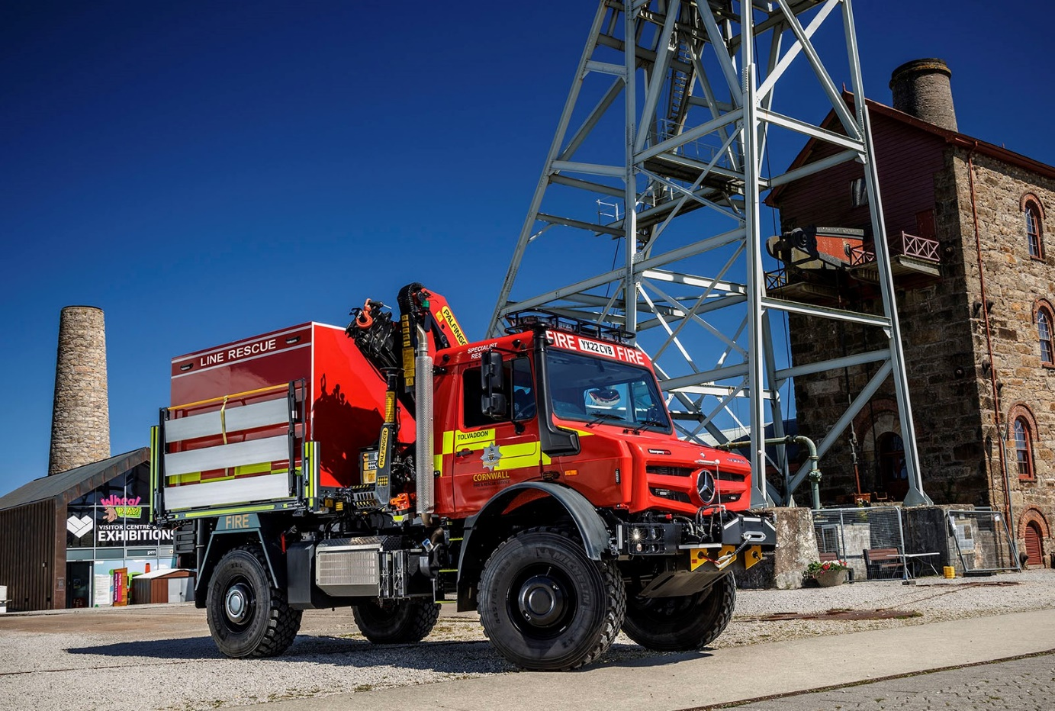

cornwall.gov.uk/fire-and-rescue-service

//e1group.co.uk

mercedes-benz-trucks.com/en_GB/brand/unimog-part-of-a-legend

 @unimogofficialuk

 @UnimogUK

ends

For more information, or to request bigger/higher-res image files, please contact:

Jamie Fretwell at Mercedes-Benz Trucks UK Ltd
07712 519230, jamie.fretwell@daimlertruck.com

or

Steve Warren or John Ripley
Impact Communications
Steve: 07770 470251, steve@impactcom.co.uk
John: 07771 484595, john@impactcom.co.uk



