

Date: 16 September 2020

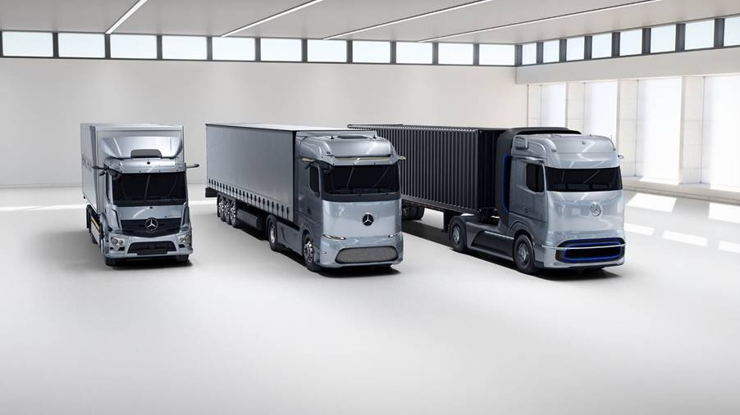

Daimler Trucks presents technology strategy for electrification – world premiere of Mercedes-Benz fuel-cell concept truck

- Mercedes-Benz GenH2 Truck, a fuel-cell truck with a range of up to 1,000 kilometers and more for flexible and demanding long-haul transport – customer trials in 2023, start of series production in second half of this decade.

- Mercedes-Benz eActros LongHaul, a battery-electric truck with a range of about 500 kilometers for energy-efficient transport on plannable long-haul routes – projected to be ready for series production in 2024.

- Mercedes-Benz eActros, a battery-electric truck with a range of well over 200 kilometers for heavy urban distribution to go into series production in 2021.

- ePowertrain global platform architecture offers synergies and economies of scale.

- Martin Daum, Chairman of the Board of Management of Daimler Truck AG and Member of the Board of Management of Daimler AG: “Our customers make rational purchasing decisions and are unwilling to compromise on their trucks’ suitability for everyday use, tonnage and range. With our alternative drive concepts from Mercedes-Benz – the GenH2 Truck, the eActros LongHaul and the eActros – and our electric trucks of the Freightliner and FUSO brands, we have a clear focus on customer requirements and are creating genuine locally CO₂-neutral alternatives for them.”

- Andreas Scheuer, Federal Minister of Transport and Digital Infrastructure: “We need zero-carbon goods vehicles on our roads. These include hydrogen fuel cell trucks. There is huge potential inherent in hydrogen for the protection of our environment and a strong economy. That is why we have been funding hydrogen as a transport fuel for over ten years – one current example is the concept truck presented today. We will continue to provide strong support to the development of climate-friendly drivetrains and innovations in and for Germany. This will include, but not be limited to, significantly expanding the funding of vehicles.”

Stuttgart / Berlin – Truck manufacturer Daimler Trucks today presented its technology strategy for the electrification of its vehicles, ranging from urban distribution to international long-haul transport, thus reaffirming its commitment to the goals of the Paris Climate Protection Convention. The event focused on the technology for hydrogen-based fuel-cell trucks for the long-haul transport segment. The Mercedes-Benz GenH2 Truck, which today had its world premiere as a concept vehicle, marks the beginning of fuel-cell drive. With the GenH2 Truck, Daimler Trucks is demonstrating for the first time which specific technologies the manufacturer is driving forward at full speed so that heavy-duty fuel-cell trucks can perform flexible and demanding long-distance haulage operations with ranges of up to 1,000 kilometers and more on a single tank of hydrogen. Daimler Trucks plans to begin customer trials of the GenH2 Truck in 2023; series production is to start in the second half of the decade. Thanks to the use of liquid instead of gaseous hydrogen with its higher energy density, the vehicle’s performance is planned to equal that of a comparable conventional diesel truck.

Daimler Trucks today also presented for the first time a preview of a purely battery-powered long-haul truck, the Mercedes-Benz eActros LongHaul, which is designed to cover regular journeys on plannable routes in an energy-efficient manner. Daimler Trucks plans to have the eActros LongHaul ready for series production in 2024. Its range on one battery charge will be approximately 500 kilometers. Additionally, with the Mercedes-Benz eActros for distribution transport, which was already presented in 2018 and has been tested intensively since then by customers in everyday transport operations, Daimler Trucks will start series production of a purely battery-powered heavy-duty truck next year. The range of the series-produced eActros on one battery charge will significantly exceed that of the prototype’s approximately 200 kilometers.

Daimler Trucks is pursuing similar vehicle schedules for the North American and Japanese markets as it is for Europe. By the year 2022, Daimler Trucks’ portfolio in its main sales regions – Europe, the USA and Japan – is to include series-produced vehicles with battery-electric drive. The company also has the ambition to offer only new vehicles that are CO₂-neutral in driving operation (“from tank to wheel”) in Europe, North America and Japan by 2039.

As a new worldwide modular platform architecture, the so-called ePowertrain will be the technological basis of all medium- and heavy-duty CO₂-neutral, all-electric series-produced trucks from Daimler Trucks – whether powered purely by batteries or by hydrogen-based fuel cells. It will feature high levels of performance, efficiency and durability. With the ePowertrain, Daimler Trucks plans to achieve synergies and economies of scale for all relevant vehicles and markets.

Martin Daum, Chairman of the Board of Management of Daimler Truck AG and Member of the Board of Management of Daimler AG, and Sven Ennerst, Member of the Board of Management of Daimler Truck AG for Development, Procurement and the China Region, presented the technology strategy at STATION-Berlin. The speakers included Andreas Scheuer, Federal Minister of Transport and Digital Infrastructure.

Genuine locally CO₂-neutral alternatives for truck customers

Martin Daum: “We are consistently pursuing our vision of CO₂-neutral transport with a focus on the genuinely locally CO₂-neutral technologies battery power and hydrogen-based fuel cells, which have the potential to succeed in the market in the long term. This combination enables us to offer our customers the best vehicle options, depending on the application. Battery power will be rather used for lower cargo weights and for shorter distances. Fuel-cell power will tend to be the preferred option for heavier loads and longer distances.”

“Our customers make rational purchasing decisions and are unwilling to compromise on their trucks’ suitability for everyday use, tonnage and range. With our alternative drive concepts from Mercedes-Benz – the GenH2 Truck, the eActros LongHaul and the eActros – and our electric trucks of the Freightliner and FUSO brands, we have a clear focus on customer requirements and are creating genuine locally CO₂-neutral alternatives for them. We have now set out the key technological specifications of our electric trucks so that the requirements are known to everyone involved at an early stage. It is now up to policymakers, other players and society as a whole to provide the right framework conditions. To make CO₂-neutral all-electric vehicles competitive, regulatory and government action is needed, including the necessary infrastructure for charging with green electricity and for the production, storage and transport of green liquid hydrogen,” Daum continued.

Federal Minister Andreas Scheuer: “We need zero-carbon goods vehicles on our roads. These include hydrogen fuel cell trucks. There is huge potential inherent in hydrogen for the protection of our environment and a strong economy. That is why we have been funding hydrogen as a transport fuel for over ten years – one current example is the concept truck presented today. We will continue to provide strong support to the development of climate-friendly drivetrains and innovations in and for Germany. This will include, but not be limited to, significantly expanding the funding of vehicles.”

Key figures of the GenH2 Truck based on conventional long-haul trucks

The development engineers at Daimler Trucks have based the GenH2 Truck on the capabilities of the conventional Mercedes-Benz Actros long-haul truck with regard to tractive power, range, and performance. For example, the series-production version of the GenH2 Truck is to have a gross vehicle weight of 40 tons and a payload of 25 tons. Two special liquid-hydrogen tanks and a particularly powerful fuel-cell system will make this high payload and long range possible, and therefore form the core of the GenH2 Truck concept.

Daimler experts can draw on existing expertise for the development of liquid-hydrogen tanks, and they are also cooperating closely with a partner. With regard to fuel cells, the manufacturer benefits from its experts’ decades of experience, in terms of technology as well as production methods and processes. This represents an enormous advantage. In April this year, Daimler Truck AG concluded a preliminary, non-binding agreement with the Volvo Group to establish a new joint venture for the development to series maturity, production and commercialization of fuel-cell systems for use in heavy-duty commercial vehicles and other applications. Joining forces will decrease development costs for both companies and accelerate the market introduction of fuel cell systems. The joint venture is to benefit from the expertise of Daimler Truck AG and the Volvo Group. To facilitate the joint venture with the Volvo Group, Daimler Truck AG has brought together all Group-wide fuel-cell activities in the newly founded subsidiary Daimler Truck Fuel Cell GmbH & Co. KG.

Liquid hydrogen enables applications with high energy throughput

Daimler Trucks prefers to use liquid hydrogen (LH2), because in this state, the energy carrier has a far higher energy density in relation to volume than gaseous hydrogen. As a result, the tanks of a fuel-cell truck using liquid hydrogen are much smaller and, due to the lower pressure, significantly lighter. This gives the trucks a larger cargo space and higher payload weight. At the same time, more hydrogen can be carried, which significantly increases the trucks’ range. This makes the series GenH2 Truck, like conventional diesel trucks, suitable for multi-day, difficult to plan long-haul transport and where the daily energy throughput is high.

Daimler Trucks is currently pressing ahead with the development of the necessary tank-system technologies to make liquid hydrogen usable also in mobile applications as an energy source for series-produced fuel-cell trucks. The storage of cryogenic liquid hydrogen at -253 degrees Celsius is already common practice in stationary applications, for example in industry or at hydrogen filling stations. This also applies to the transport of liquid hydrogen as cargo.

Interaction between battery and fuel-cell systems

The two stainless-steel liquid-hydrogen tanks intended for the series version of the GenH2 Truck will have a particularly high storage capacity of 80 kilograms (40 kg each) for covering long distances. The stainless-steel tank system consists of two tubes, one within the other, that are connected to each other and vacuum-insulated. In the series version of the GenH2 Truck, the fuel-cell system is to supply 2 x150 kilowatts and the battery is to provide an additional 400 kW temporarily. At 70 kWh, the storage capacity of the battery is relatively low, as it is not intended to meet energy needs, but mainly to be switched on to provide situational power support for the fuel cell, for example during peak loads while accelerating or while driving uphill fully loaded. At the same time, the relatively light battery allows a higher payload. It is to be recharged in series-production vehicles with braking energy and excess fuel-cell energy. A core element of the sophisticated operating strategy of the fuel-cell and battery system is a cooling and heating system that keeps all components at the ideal operating temperature, thus ensuring maximum durability. In a pre-series version, the two electric motors are designed for a total of 2 x 230 kW continuous power and 2 x 330 kW maximum power. Torque is 2 x 1577 Nm and 2 x 2071 Nm respectively.

Mercedes-Benz eActros LongHaul offers advantages depending on use case

The Mercedes-Benz eActros LongHaul battery-powered long-haul truck will be in the same vehicle class as the GenH2 truck. Its features will be largely identical to those of the series-produced GenH2 Truck or a conventional diesel truck. The comparatively short range of the eActros LongHaul on one battery charge is offset by its high energy efficiency, as battery electric drive has the highest efficiency among alternative drive systems. This offers transport companies significant advantages in the application scenarios envisaged for the eActros LongHaul due to its low energy costs. Many of the long-haul applications in the practical operations of transport companies do not require a range greater than the approximately 500 kilometers that the eActros LongHaul will be able to cover on one charge. In addition, legal requirements regarding truck drivers’ driving times limit the need for longer ranges, depending on the case. In the EU, for example, truck drivers have to take a break of at least 45 minutes at the latest after 4.5 hours of driving. During this time, thanks to the latest charging technology, the battery can be charged with a large proportion of the energy needed for the ongoing journey. The eActros LongHaul will therefore be the right choice for transport companies for regular use on plannable routes and with the appropriate distances and charging possibilities.

Charging infrastructure for eActros LongHaul can be available relatively soon

With its market launch in the middle of the decade, the eActros LongHaul will be available some time before the GenH2 Truck. The required infrastructure can also be set up sooner – and at comparatively low cost – by the transport companies themselves for charging at their depots. This so-called depot charging is the most important step for the use of the eActros LongHaul, and means that the first areas of application can already be covered. Another key component is opportunity charging for range extension, for example, while unloading or loading when the electric truck is anyway stationary. In the future, public charging at publicly accessible stations along main transport routes will also become increasingly important – a nationwide charging infrastructure will maximize the operating range of battery-electric trucks. New, more durable batteries will also contribute to the competitiveness of battery-electric trucks, reducing total cost of ownership over a vehicle’s lifecycle.

Mercedes-Benz eActros to be integrated into comprehensive consulting service

At the International Commercial Vehicles Show in 2016, Daimler Trucks was the first manufacturer worldwide to present a heavy-duty electric truck. In early 2018, Daimler Trucks celebrated the world premiere of the further developed Mercedes-Benz eActros, and intensive practical tests have been taking place with customers since the fall of 2018. Since then, findings from customer testing have flowed directly into the further development of the prototype into a series-production vehicle. So far, they have shown that the purely battery-electric eActros is outstandingly suited for sustainable heavy-duty distribution transport. It is in no way inferior to a conventional diesel truck in terms of availability and performance. However, the series-production eActros will be significantly superior to the current prototype in some aspects, such as range, drive power and safely. The series-production eActros will be on a par with a conventional Actros also in terms of payload. The eActros will be launched as a two-axle and three-axle truck. Daimler Trucks will embed the vehicle in a holistic ecosystem that includes consulting services for electric mobility, such as analyzing routes, checking possible subsidies, supporting operational fleet integration and developing suitable charging-infrastructure solutions.

Daimler Trucks & Buses: extensive practical expertise in electric drive

The first practical operation of the Mercedes-Benz eEconic low-floor truck, which is based on the eActros and was announced by Daimler Trucks this year, is planned for 2021 and series production is scheduled to start in 2022. The eEconic will mainly be used as a waste-collection vehicle in urban waste-management applications. This is a very good choice for battery-powered trucks due to the comparatively short and firmly planned routes of up to about 100 kilometers and a very high proportion of stop-and-go operation. In the United States, the medium-duty Freightliner eM2 and the heavy-duty Freightliner eCascadia are also currently undergoing practical tests with customers. The vehicles have a target range for series production of up to 370 km (eM2) and up to 400 km (eCascadia). Series production of the eCascadia is scheduled to start in mid-2022 and of the Freightliner eM2 in late 2022. A small series of more than 170 FUSO eCanter light-duty trucks are in use in with numerous customers in Japan, the United States and Europe; the first of them were handed over to customers already in 2017. The eCanter offers a range of 100 km. At Daimler Buses, the Mercedes-Benz eCitaro has been in series production since the fall of 2018. It will be followed in 2022 by the version with fuel cells as a range extender. With nearly 400 vehicles in use with customers, Daimler Trucks & Buses has gained comprehensive, practice-oriented expertise with electric vehicles, and has recorded a total of well over seven million kilometers driven by battery-electric test and series-produced trucks and buses with customers worldwide.

Modular ePowertrain for various markets and segments

Within the context of its global platform strategy, Daimler Trucks is also using a globally uniform basic architecture for all-electric trucks: the ePowertrain. The technological heart of the ePowertrain is, as a first step, the integrated electric drive, the so-called eDrive. This is used in the form of an e-carrier concept, i.e., an e-axle with one or two integrated e-motors including transmission. The eDrive is an in-house development by Daimler experts and offers numerous advantages over concepts with one central motor. For example, the more compact design allows a larger space to install a larger battery with a higher capacity, which has a positive effect on range. The high battery capacity also ensures high power transmission to the e-axle, thus allowing continuous power delivery. The recuperation potential also increases due to the combination of a large battery with very powerful e-motors. The eDrive is to be applied in various vehicles at Daimler Trucks in the medium- and heavy-duty segment worldwide – whether with purely battery-electric or hydrogen-based fuel-cell drive. The eDrive is designed as a drive family consisting of different variants, the first of which will have its premiere in the series-produced version of the Mercedes-Benz eActros. Within a modular system, the eDrive can be tailored to suit the market, segment and vehicle type.

The global concept of the modular ePowertrain thus creates synergies with regard to technology developments for different markets and segments, as well as economies of scale through larger numbers of uniform components. This in turn results in competitive costs that can be passed on to customers. In addition, a high proportion of components taken over from conventional powertrains is planned to contribute to competitive development and production costs.

Daimler Trucks’ consulting approach reflects new drive-system complexity

In the coming years, truck customers will face the challenge of choosing the drive technology that is best for them – depending on the industry, segment and specific application. The goal of Daimler Trucks’ consultants is to meet this gradually increasing complexity with tailored offers at the right time. They will accompany customers every step of the way and work together to develop suitable solutions for entry into electric mobility. The core of Daimler Trucks’ consulting approach to the electrification of truck fleets is that the aspects of vehicle range and charging infrastructure are treated as a single entity. The experts at Daimler Trucks therefore also look in detail at how the charging infrastructure and charging processes themselves can be optimized.

With its approach to the electric-mobility ecosystem, Daimler Trucks is pursuing a holistic and global method that focuses on individual customer needs. The manufacturer is cooperating with specialized partners in all relevant sectors to offer customers access to the required components. At the beginning of the year, Daimler Trucks took an additional step by launching a worldwide initiative to establish a charging infrastructure for battery-electric trucks. Within the framework of the eTruck Charging Initiative, Daimler Trucks is bringing together the main players – electric-truck customers, power-grid operators and energy suppliers, as well as charging-hardware manufacturers and charging-software providers – and is thus driving forward joint infrastructure solutions for electric-truck customers within the network.

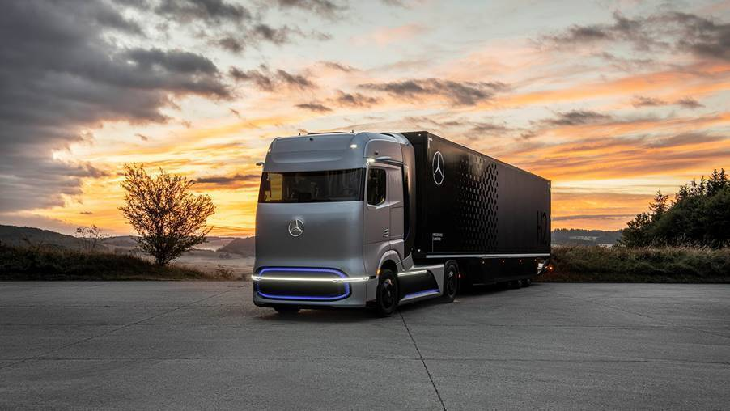

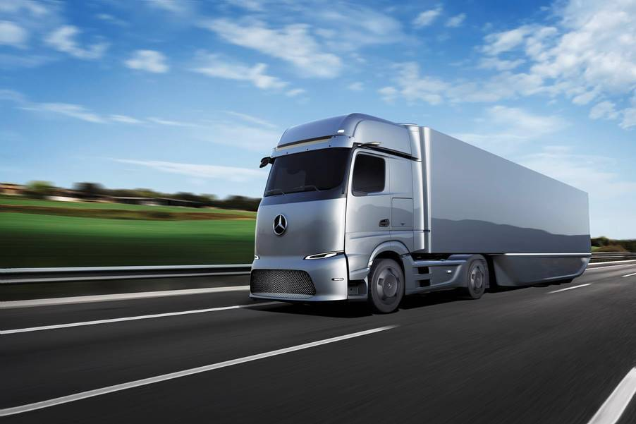

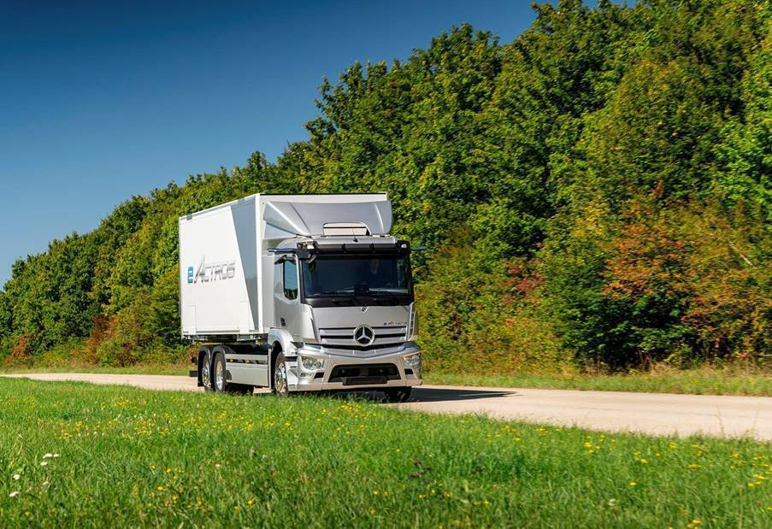

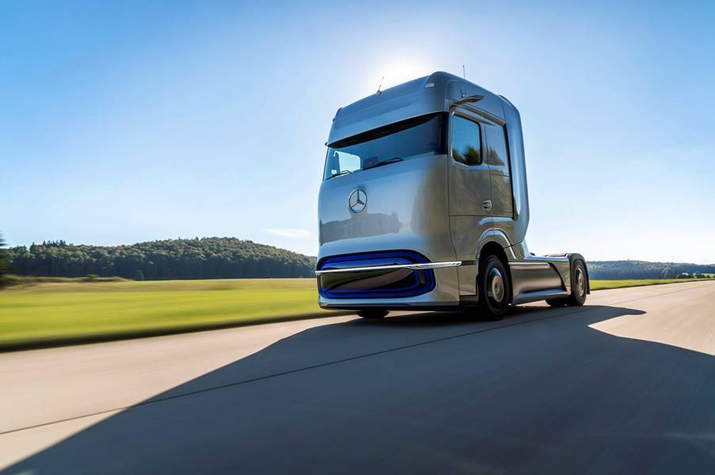

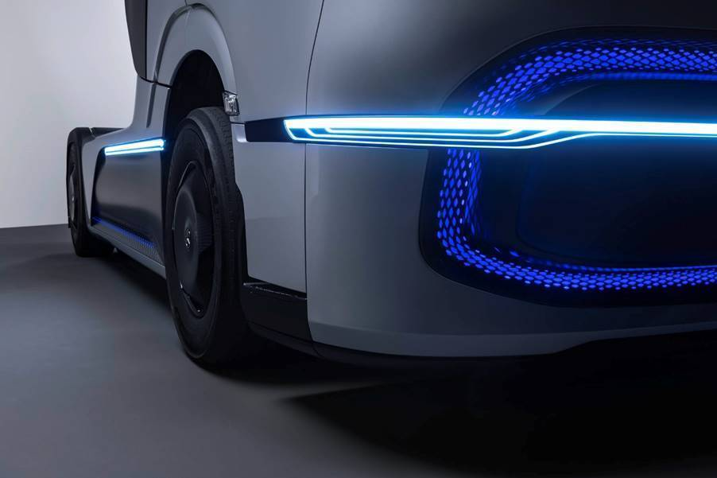

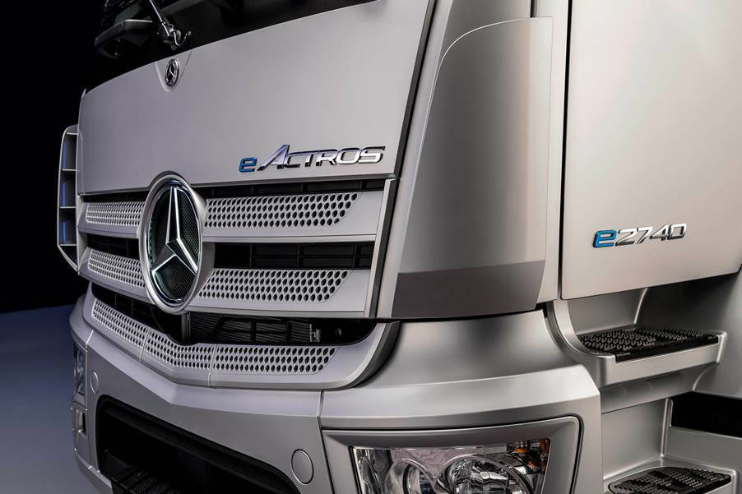

ends

Pictures:
Pictures of the vehicles are available on our media site at d.ai/hydrogenfuture-pressmaterial. Photos of the event will follow a little later.

Contacts:

Peter Smodej, +49 (0) 711 17 5 32 30, peter.smodej@daimler.com
Uta Leitner, +49 (0) 711 17 5 30 58, uta.leitner@daimler.com
Florian Laudan, +49 (0) 711 17 4 15 26, florian.laudan@daimler.com

or

Jamie Fretwell at Mercedes-Benz Trucks UK Ltd
07712 519230, jamie.fretwell@daimler.com

Further information on Daimler Truck AG is available at:
www.media.daimler.com and www.daimler-truck.com

