

Date: 15 January 2020

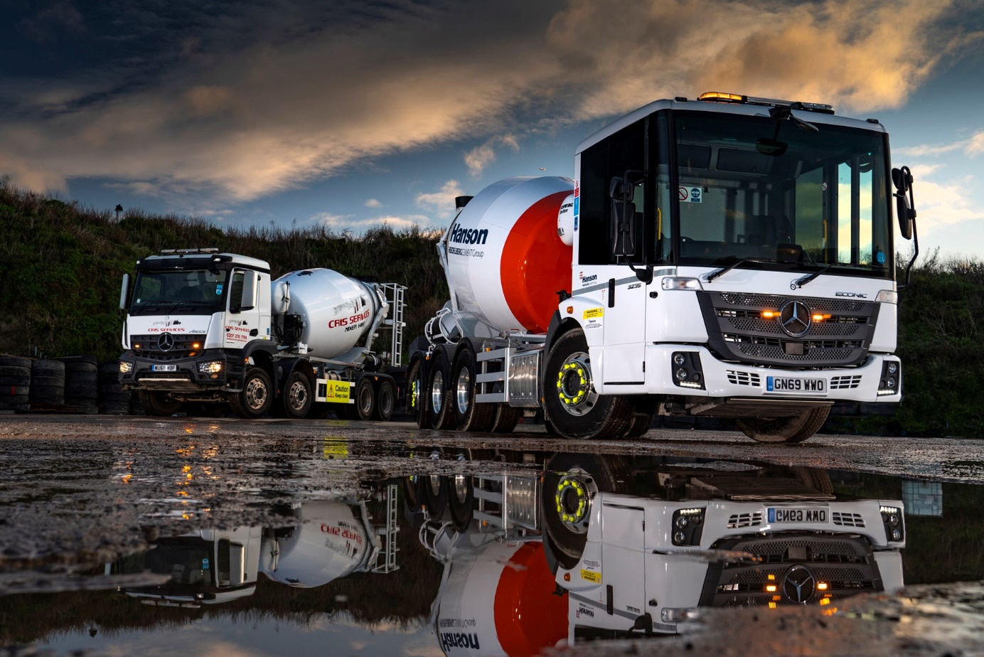

Team players: Cris Services’ latest Econic is pictured, right, with the only one of its 11 Mercedes-Benz trucks which does not operate in Hanson livery, an Arocs from its rental fleet

Cris puts another cross in the Mercedes-Benz Econic box

Hanson contractor Cris Services Group has underscored its commitments to safety and compliance by adding a sixth low-entry Mercedes-Benz Econic mixer truck to its fast-growing fleet.

Like its predecessors, all bar one of which entered service within the last 12 months, the new 8x4/4 chassis was supplied by Dealer Sparshatt Truck & Van, and wears the colours of the operator’s leading customer, Hanson UK.

Former driver Cris Calina founded his business with a single truck in 2002. A Gold standard FORS (Fleet Operator Recognition Scheme) member, Cris Services Group now runs a fleet of 35 eight-wheeled mixers, which also includes five muscular Mercedes-Benz Arocs.

The company works from a main base in Purfleet, Essex. Its trucks transport wet concrete throughout the south-east, but predominantly within the area bounded by the M25. While most are under contract to Hanson, nine vehicles – including one of the Arocs – are available for rental by other customers.

All are fitted with 8m³ Schwing Stetter drums – Cris Services also operates its own workshop business, CS Commercial Repairs, which is an authorised service agent for the German manufacturer of concrete mixers and transport systems.

Rather than maintaining his Mercedes-Benz trucks in-house, however, Mr Calina prefers to take out Complete Service Contracts and entrust his Econic and Arocs mixers to the expert aftersales team at the £2-million dealership in Dartford which Sparshatt Truck & Van opened last summer.

Greater Safety is one of the three pillars of Mercedes-Benz Trucks’ all-embracing RoadEfficiency strategy. The Econic is equipped as standard with Active Brake Assist 4 emergency braking technology, which incorporates a pedestrian-recognition capability, and has been awarded a five-star Direct Vision rating by Transport for London.

The truck’s deep, panoramic windscreen and full-height, glazed folding side door, afford unrivalled visibility. This, allied to a seating position which is much lower than that of a conventional construction vehicle, allows drivers to make direct eye contact with cyclists and pedestrians at junctions or in traffic queues.

Safety-focused Hanson UK, which is part of the Heidelberg Cement Group, runs a substantial fleet of Econics, and encourages its franchisees – particularly those operating in urban areas – to do likewise. Like other approved suppliers throughout Britain, Cris Services benefits from the buying power of its high-profile customer. Hanson negotiates centralised framework agreements for chassis provision with Mercedes-Benz, and these translate into the highly competitive purchase prices enjoyed by its franchisees.

Acquired with funding support from Mercedes-Benz Finance, Cris Services’ latest, fully air-suspended Econic is now operating alongside four of the others at the Hanson depot in Kings Cross. The remaining example works from another Hanson site at Silvertown, in east London.

Mirroring Cris Services’ previous Econics, the new truck is a 3235 L model, and powered by a 7.7-litre six-cylinder engine which produces 260 kW (354 hp). However, while earlier vehicles drive through six-speed Allison automatic gearboxes, the latest employs a 12-speed version of the fuel-efficient Mercedes PowerShift 3 automated manual transmission.

Its ENA configuration – single front steer axle, double-drive bogie and rear-steer axle – gives the truck a surprisingly tight turning circle. The resulting, enhanced manoeuvrability compared to a standard 32-tonne construction eight-wheeler is a major advantage for operation in the capital. As with all new Econics supplied through the manufacturer’s UK Dealer network, the vehicle is covered by a three-year/160,000 km warranty.

Cris Calina commented: “Our first Econic has been on the road for a couple of years now and has been very good – we’ve had no reliability issues with any of our Mercedes-Benz trucks.

“There was a bit of initial resistance to the Econic’s low-entry cab from some drivers, but this was quickly overcome. Within a very short time at the wheel they realised how much better the visibility is, and, as a result, how much less stressful the job could be. The Econic is also air-conditioned and flat-floored, which makes it comfortable and very easy to access or exit safely.”

He added: “Sparshatt’s new facilities in Dartford are very impressive, and the Dealer provides a highly professional service. Our drivers drop off their trucks at the end of the day so they can be inspected and serviced overnight – they go home in a courtesy van then return next morning, by which time their vehicle is ready for work.”

www.cris-services.com



Raising safety standards: Cris Calina with his latest Hanson-liveried Mercedes-Benz Econic

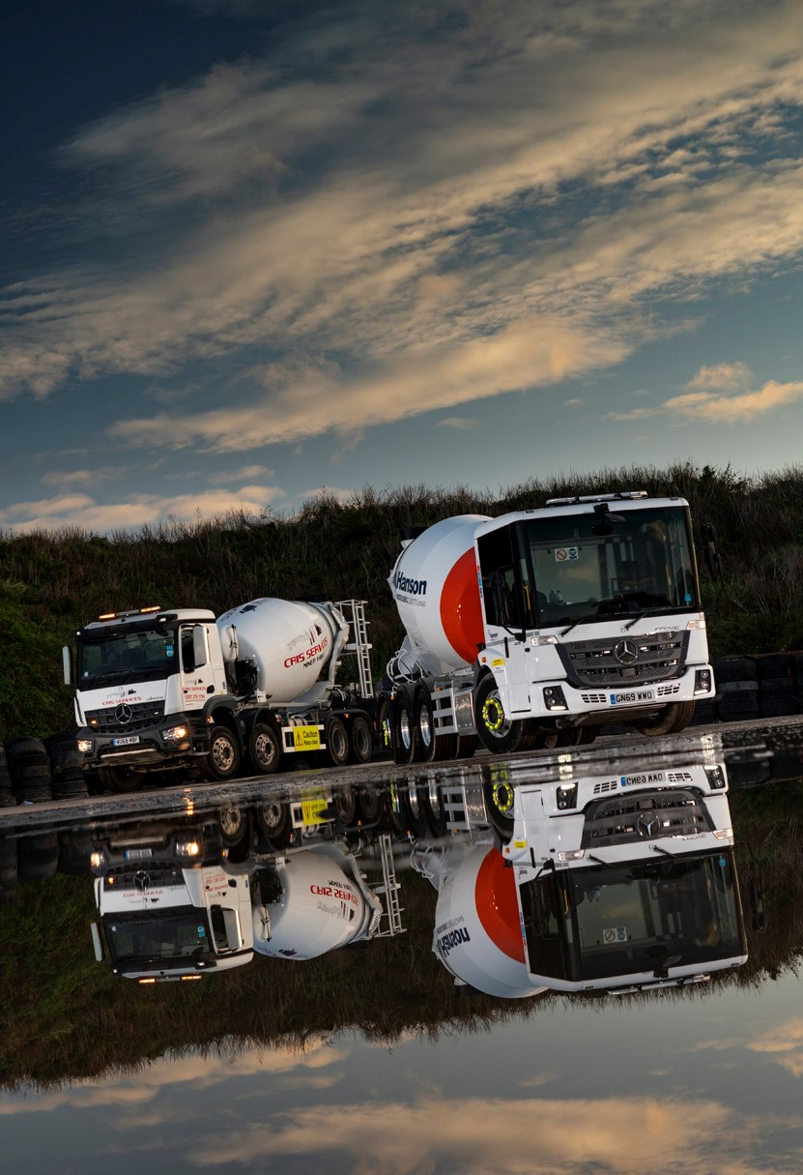

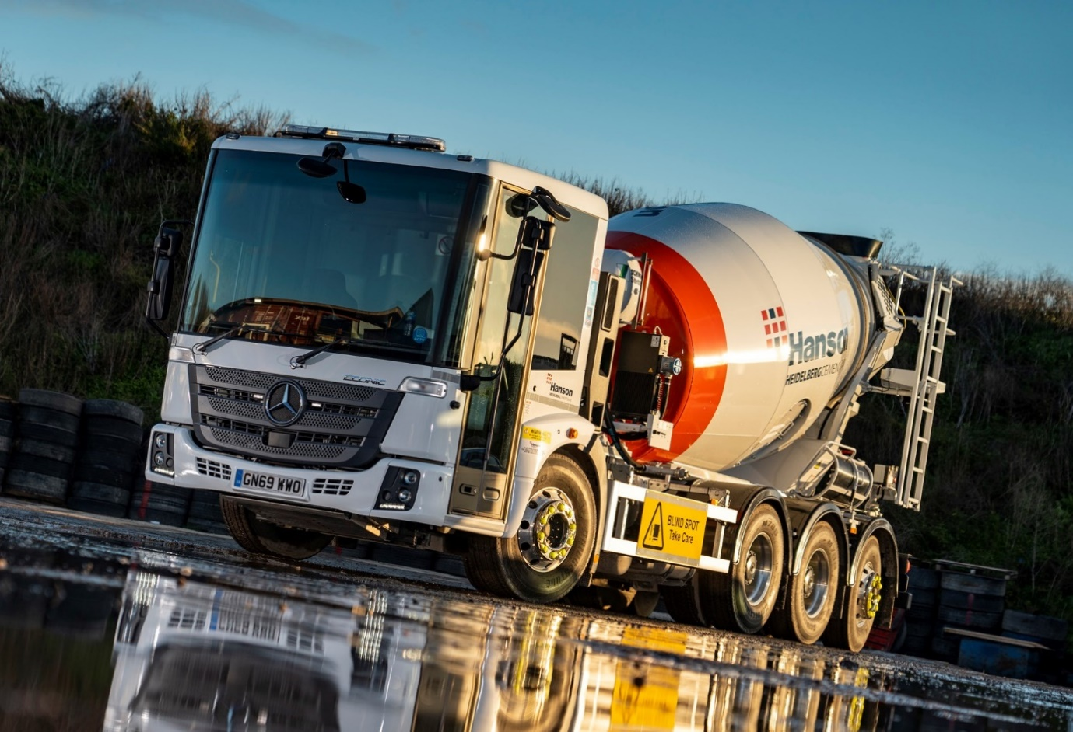

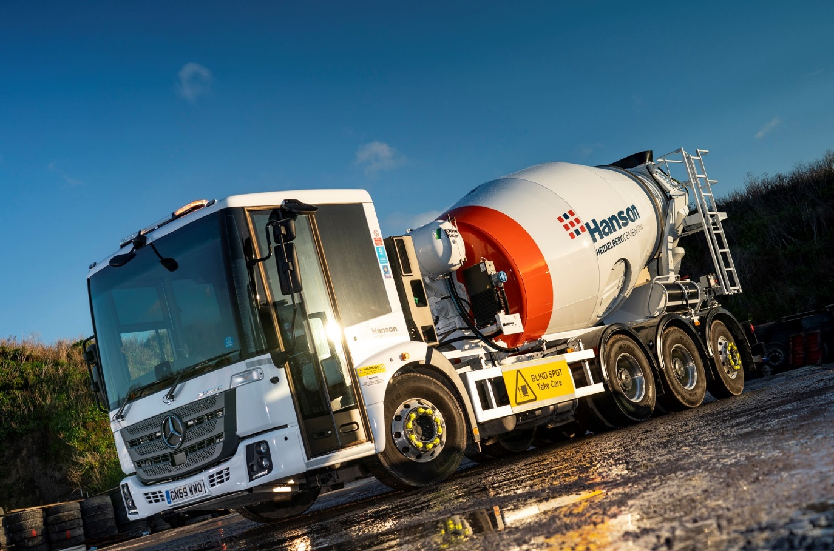

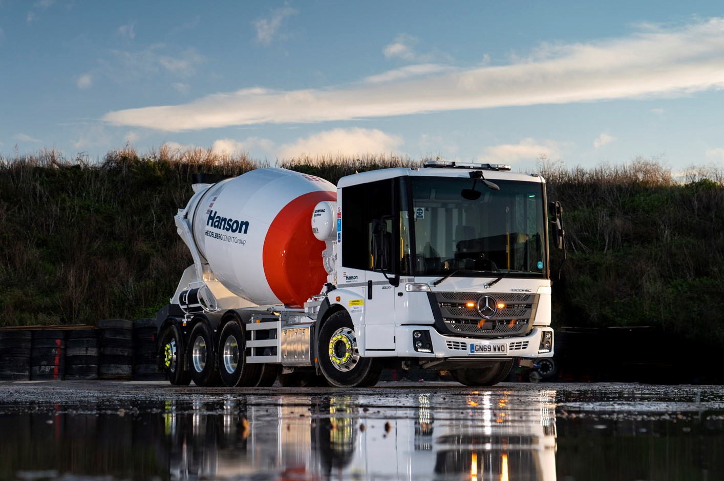

ends

For more information, or to request bigger/higher-res image files, please contact:
Steve Warren or John Ripley
Impact Communications, 01926 842126
Steve: 07770 470251, steve@impactcom.co.uk
John: 07771 484595, john@impactcom.co.uk

