

Date: 19 July 2021

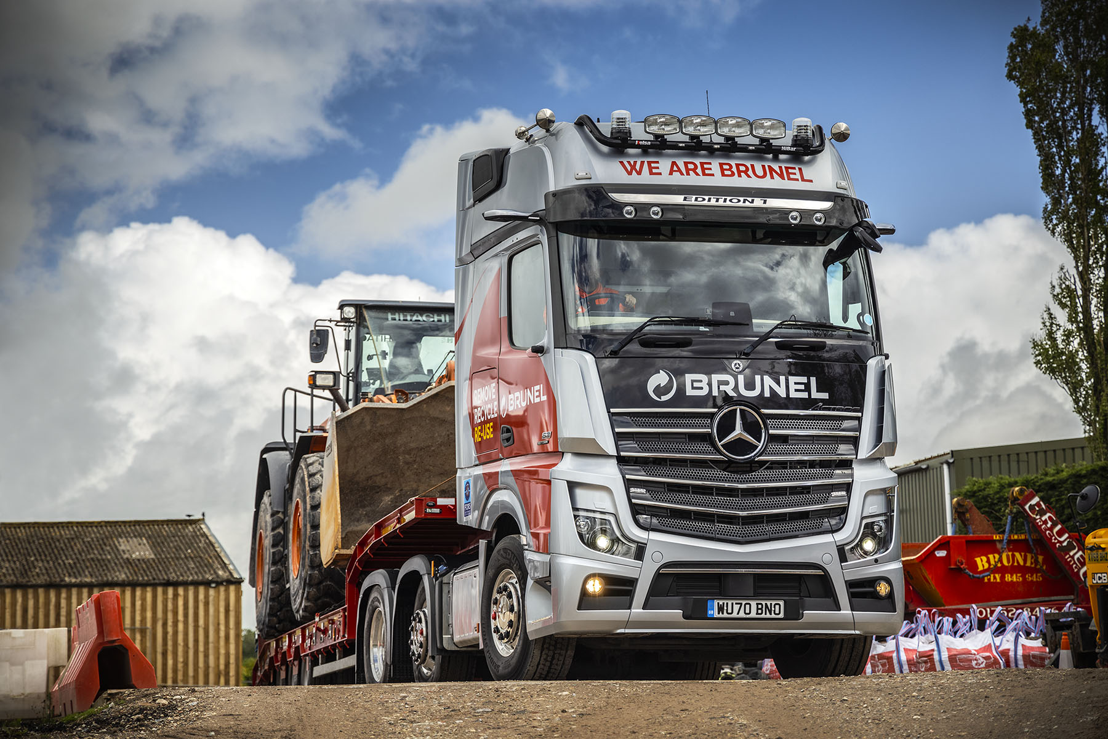

Nothing but the best – Brunel’s first tractor unit is an awesome Mercedes-Benz Actros Edition 1 from Rygor Commercials

Cornish operator Brunel has marked the beginning of a new era by introducing another two Mercedes-Benz trucks, including a limited-edition flagship.

Having traded previously as Brunel Recycling, it has just adopted a fresh new image. “This business has grown to offer so much more than just recycling,” explained Managing Director Brian Venables. “Our rebrand reflects this. We will now be known simply as Brunel.”

Brunel is accredited to Bronze standard by the Fleet Operator Recognition Scheme (FORS) and runs 11 trucks, all but the oldest of which wear three-pointed stars and arrived via Dealer Rygor Commercials. The new vehicles are the first to wear the new, shortened form of the company’s name.

The exclusive new Actros Edition 1 is also its first tractor unit. Just 400 of these stunning models were built, and of these only 35 were made available to UK customers. The other new vehicle is an eight-wheeled Arocs tipper, which had been pre-bodied for the Dealer’s stock and was delivered at short notice.

Family-owned Brunel operates from headquarters in Saltash. Its roots date back to 1989, when David Venables established a landfill business, to which he then added a waste transfer station and skip hire venture.

The founder retired in 2014, at which point his son Brian took over and adopted the ‘Remove-Recycle-Reuse’ motto which is also proudly emblazoned on its Mercedes-Benz trucks. Today, the company provides a comprehensive portfolio of haulage, demolition, recycled aggregates and concrete services to customers throughout Devon and Cornwall.

Based on the imposing GigaSpace cab, the Actros Edition 1 is instantly recognisable thanks to its gloss black grille, darkened headlamp covers and rims, and branded sun visor incorporating four extra LED main-beam headlamps. Transport Manager Steve Allen enthused: “It’s a fantastic truck; there can’t be a better looking one on the road.”

Like most examples, Brunel’s is powered by a range-topping 15.6-litre in-line six-cylinder engine that produces a potent 460 kW (625 hp). In addition to the many innovations that come as standard in the latest Actros – MirrorCam, Active Brake Assist 5, and enhanced Predictive Powertrain Control technology, for example – the limited-edition model is loaded with additional equipment.

Brunel’s graded aggregates are widely used for construction projects in Plymouth and the surrounding area. The firm also supplies interlocking blocks, readymix concrete and recycled aggregates, undertakes site clearances, demolitions and muckaway work, and offers low-loader haulage and heavy plant and machinery hire services.

The Edition 1 works with a pair of new trailers by Kel-Berg, both of which have already seen action on one of the city’s biggest ever civil engineering projects, the Forder Valley Link Road, in which Brunel is heavily engaged. The tri-axled low-loader transports the company’s own plant, while the Hardox steel tipping trailer carries up to 27 tonnes of soil and stone to and from the site.

The new 8x4 Arocs is a 3243K model with ClassicSpace M-cab. It is powered by a 10.7-litre in-line six-cylinder engine that produces 315 kW (428 hp), and has a steel Predator Ultimate tipping body by Abba Commercials.

Like the Edition 1, the Arocs is fitted with MirrorCam, Mercedes-Benz Trucks’ ground-breaking alternative to conventional mirrors. Not only do drivers benefit from greatly improved rear visibility, with reversing guides displayed on the screens inside the cab on the A-pillars, but the absence of mirror backs also eliminates forward-facing blind spots.

Steve Allen is already a confirmed fan of the system, not least because the compact, roof-mounted camera housings hold out the promise of financial savings as well as safety gains. “We have a lot of narrow, hedge-lined lanes in this part of the world, so like every other operator down here we’ve always had to contend with a certain amount of mirror damage.

“Being so much smaller and higher, though, the cameras should be a lot less vulnerable to knock-offs. We’ve also noticed that the cameras don’t get anything like as dirty as mirrors do when the truck is working on sites.”

The Edition 1 is assigned to driver Anthony Ruby, who joined Brunel in 2014, when it expanded into tipper work. “Everywhere I go, people want to talk to me about the Actros, and to photograph it,” he said.

“MirrorCam is very easy to use, and represents a big step forward in my opinion, while the big engine is a joy – I just put it in cruise control and let it do its stuff. I feel genuinely privileged every time I climb up into a vehicle that’s so comfortable it’s like sitting in your front room.”

Both trucks also came with Multimedia Cockpits, which replace traditional switchgear with stylish and intuitively operated twin screens. The Edition 1’s upgraded interactive version incorporates a larger, 12in primary colour display, and offers extra functionality.

Other features of the exclusive truck’s black leather-trimmed cab interior include door handles with contrasting topstitching and a polished and brushed aluminium dashboard badge that confirms it as ‘One of 400’. Driver Anthony can also choose from no fewer than eight colours of ambient ceiling lighting.

The operator purchased its first 8x4 Arocs 3240K tipper from Rygor Commercials in 2015. It now has six of these vehicles, as well as a tipper-grab, a hook-loader, a volumetric mixer and the Actros tractor unit.

Brian Venables worked alongside his brother and co-Director Max until 2018, when Max left to become Managing Director of Plymouth Albion Rugby Club, which the family also owns. Brian, whose wife Nadine is Brunel’s Operations Manager, reported: “Our experience of running Mercedes-Benz Trucks over the last six years has been entirely positive. We’re very proud to be running a fabulous Actros Edition 1 – as our first tractor unit, it’s added an extra dimension to our range of capabilities.

“The Arocs, meanwhile, has proved well able to withstand the rigours of our kind of work. These trucks are tough and reliable, while the ground clearance is excellent too – that’s a big advantage when we’re working on rough sites and helps to explain why they are so popular with our drivers.”

He added: “With a fresh new look, our succinct new name honours the heritage of our business. The wide range of services we provide to the construction industry remains the same, and we’re still committed to providing an excellent service to our customers, among them some of the UK’s leading construction companies.”

As with its previous Mercedes-Benz vehicles, the operator’s latest orders were managed by Rygor Commercials Truck Sales Executive Marcus Cahalin. “Brunel has a very strong brand image and one of the best-looking fleets in the south-west,” he said.

“It’s always a pleasure to work with Brian and his team – they’re commercially astute businesspeople for whom an acquisition must always make sound financial sense, but they’re also enthusiasts with a real passion for their trucks. In other words, the perfect customer for the awesome Actros Edition 1.”

www.brunelrecycling.co.uk

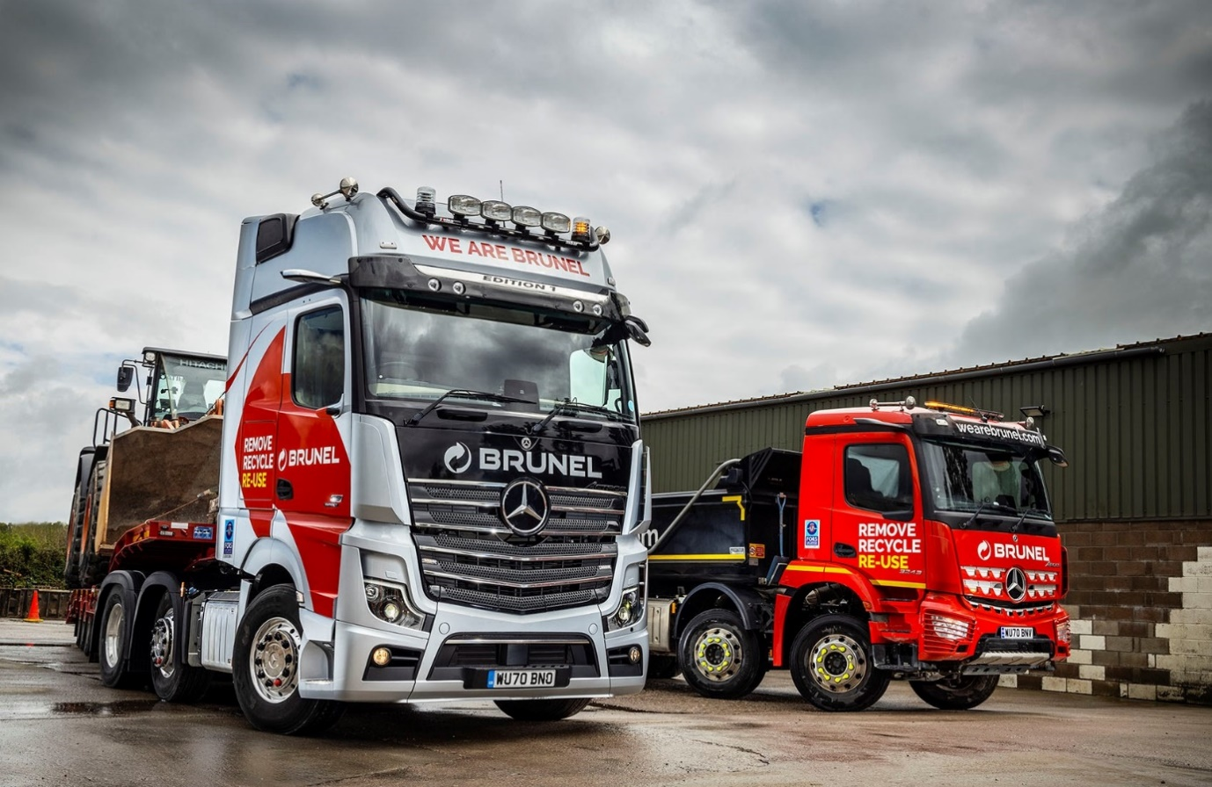

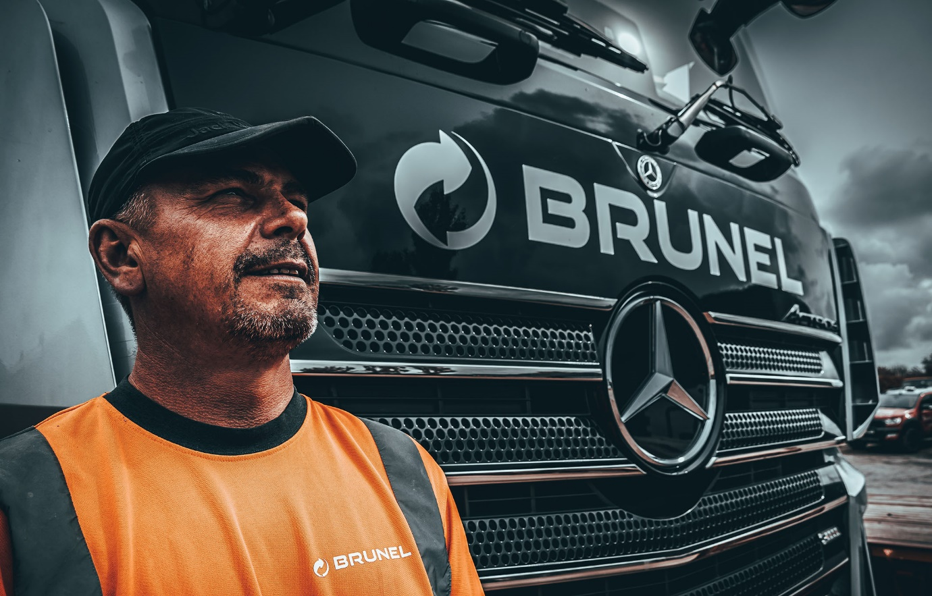

Star-struck: “There can’t be a better looking truck on the road,” said Brunel Transport Manager Steve Allen

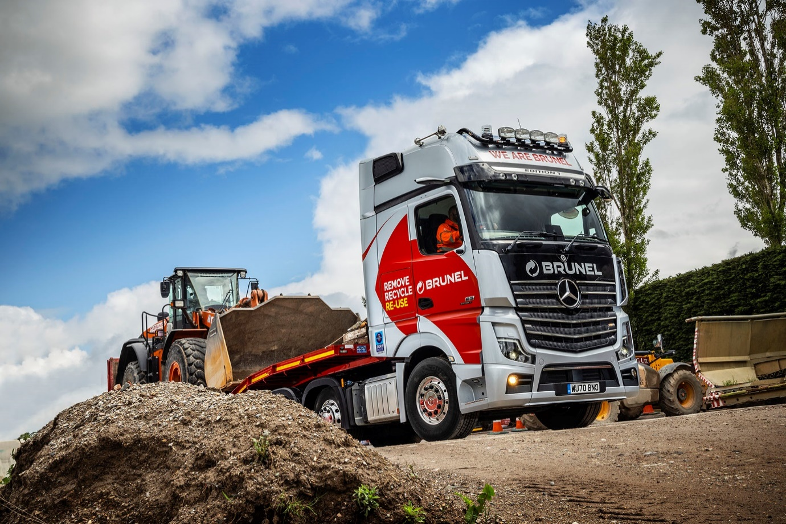
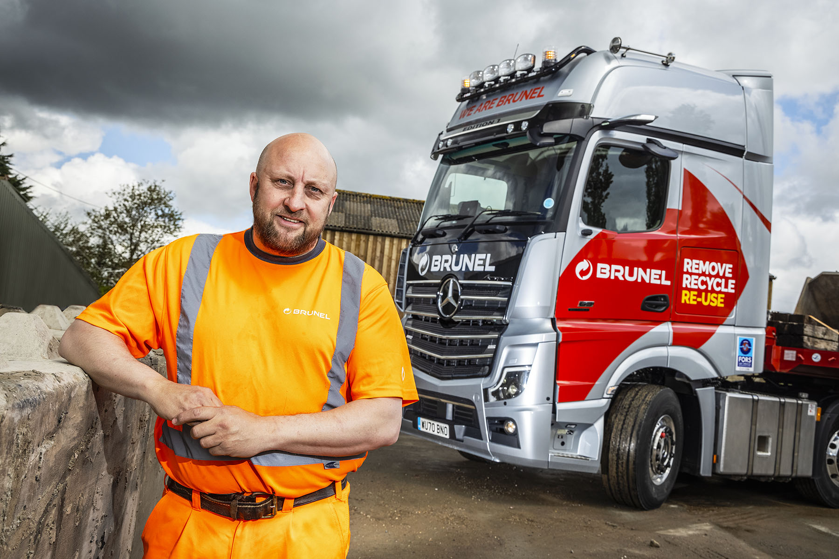

Ruby’s new gem: Brunel driver Anthony Ruby is pictured with his stunning new Actros Edition 1

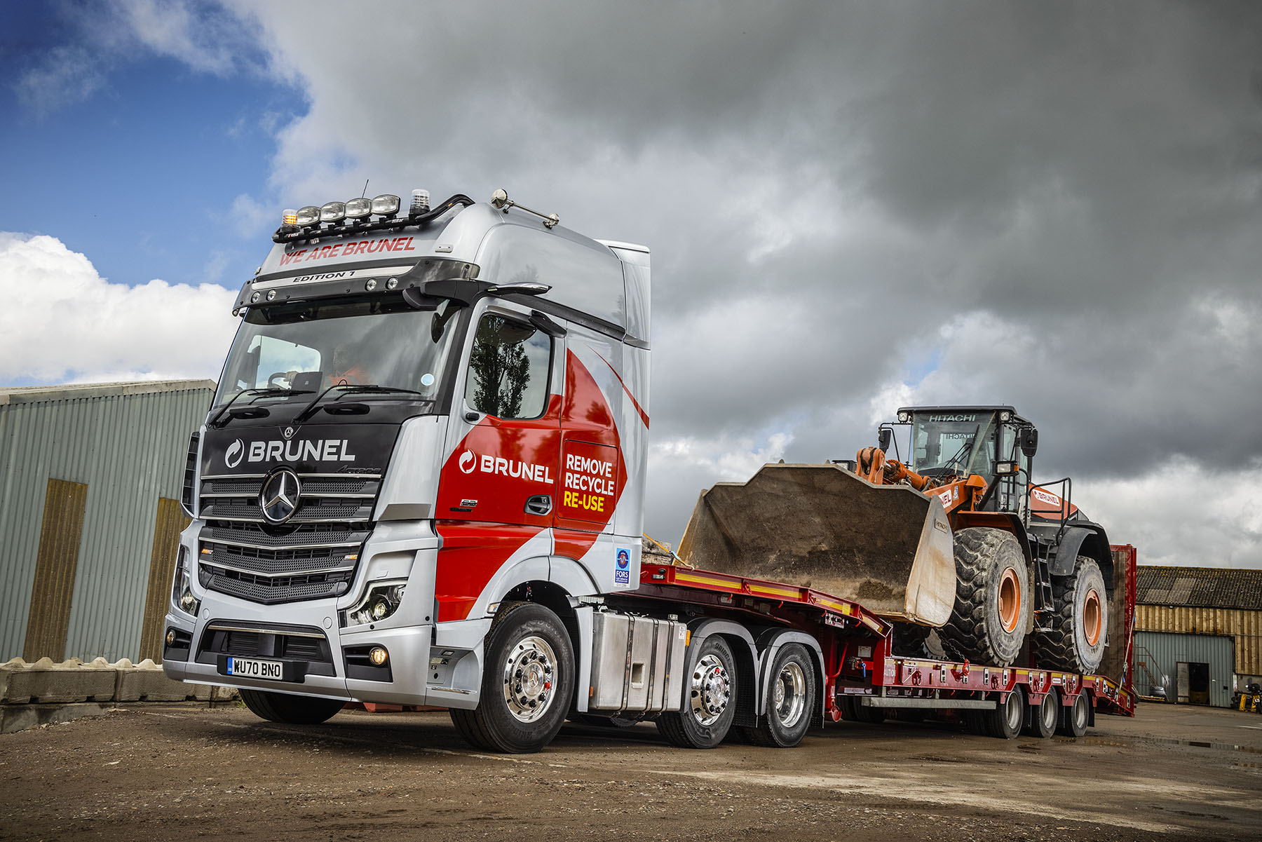

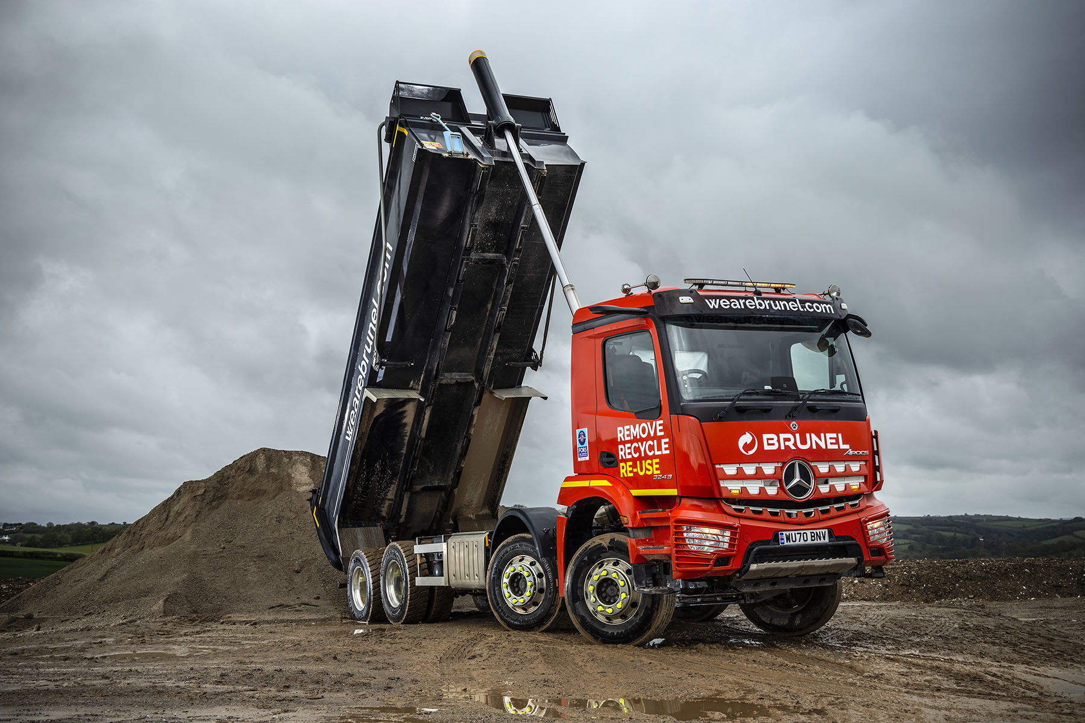

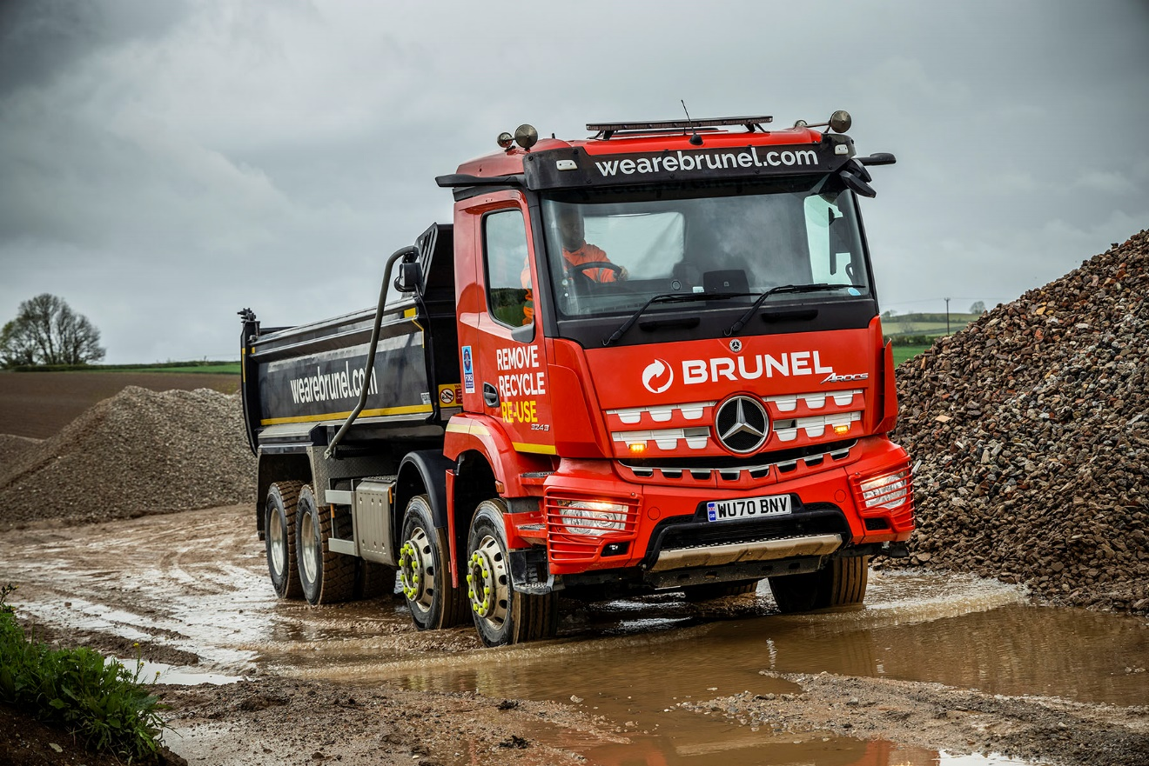

ends

For more information, or to request bigger/higher-res image files, please contact:
Steve Warren or John Ripley
Impact Communications, 01926 842126
Steve: 07770 470251, steve@impactcom.co.uk
John: 07771 484595, john@impactcom.co.uk

Notes to Editors: Rygor Commercials

Award-winning Mercedes-Benz Commercial Vehicle Dealer group, Rygor Commercials, has branches in Berkshire, Gloucestershire, Oxfordshire, Somerset, West London, Warwickshire, Wiltshire, and Worcestershire, offering extensive coverage for customers throughout the M5, M4 and M42 corridors.

The Rygor business has developed and gone from strength to strength in recent years, investing in extensive renovations of its sites across the country as well as a brand-new, dedicated Heathrow Truck Centre which opened in 2020. With six industry and network awards under its belt in the past 24 months, Rygor continues to be dedicated to providing exceptional customer service, which Sets Standards. The Dealer was delighted to be announced as winner in the ‘Franchised Dealer of the Year’ category at the 2019 Commercial Motor Awards and ‘Van Dealer of The Year 2021’ at the What Van? Awards, accolades which not only demonstrate the company’s focus on customer satisfaction, but also its commitment to the development, training, and wellbeing of its team members.

With a proven track record, Rygor is proud to be selling, maintaining and supporting the most prestigious name in commercial vehicles.

For more information, in the first instance please contact Kate Ruberry-Shoemack, Head of People and Communications at Rygor – kateruberry-shoemack@rygor.co.uk, or in her absence, Communications Assistant, Talitha Scott – talithascott@rygor.co.uk.

