

Date: 31 October 2022

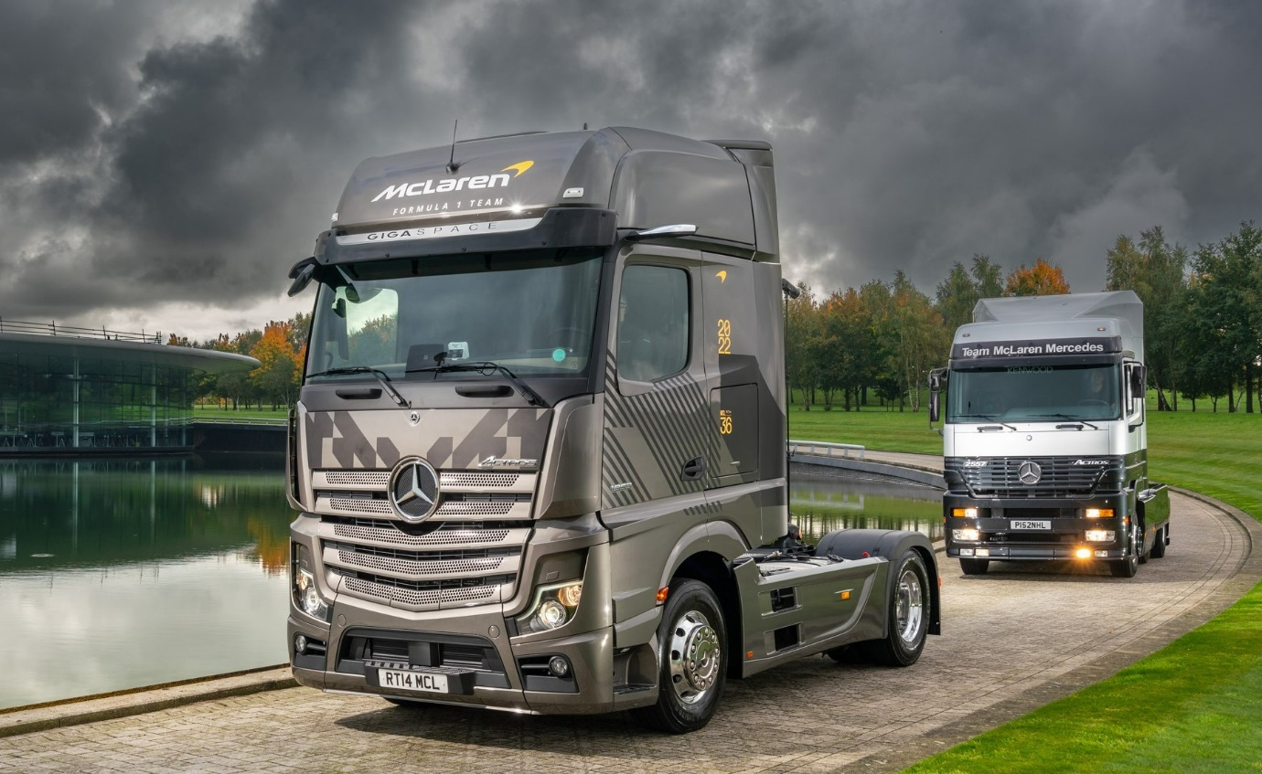

Past meets present: One of McLaren’s new, fifth-generation Actros is pictured with its immaculately-restored, first-generation predecessor

Tracking a quarter-of-a-century of progress in truck technology, F1 team McLaren takes a trip down Mercedes-Benz ‘memory lane’

McLaren truck driver Ian Hodges has been reunited with the 25-year-old Mercedes-Benz Actros tractor unit he once piloted to race circuits throughout Europe, thanks to the stunning efforts of ace restorer Dominic Newby.

Ian joined the Formula One outfit in 1997, the year in which the very first examples of the truck range that set previously unseen standards for efficiency and innovation hit UK roads.

Mercedes-Benz High Performance Engines was McLaren’s works partner at the time, and Dominic’s 6x2 Actros 2557 MegaSpace was one of three identical trucks used to support the illustrious team’s pursuit of more Grand Prix victories.

They pulled the race team transporter that carried the MP4/12 cars of Mika Häkkinen – winner of the Drivers’ World Championship for Mercedes-McLaren in each of the following two years – and David Coulthard, as well as the race engineer & communications trailer, and a hospitality unit.

Fast forward a quarter of a century and after a brief interlude in which McLaren ran Swedish-built trucks, Ian is once again driving a Mercedes-Benz. This time, though, it’s a strikingly-finished 4x2 unit from the fifth-generation Actros range, one of a dozen supplied by Sparshatt Truck & Van.

When Newhaven-based Dominic made a VIP visit in his restored Actros to the impressive McLaren Technology Centre in Woking, Surrey, Ian and his colleagues jumped at the opportunity to compare and contrast the two trucks, and remind themselves how much the technology has moved on.

An enthusiastic contributor to Mercedes-Benz Trucks’ Roadstars platform for drivers, Dominic had already won awards for his restoration of a Mercedes-Benz 1622 tractor unit from 1976, and was keen to take on another project.

He explained: “I’d been looking for a suitable Actros for a long time, because I used to drive one back in the day. So when I learned this particular vehicle was available, my wife and I went to see it. We were pleasantly surprised to discover that not only was it a top-of-the-range model, with features like electric seats, but it also had all the books and, considering its age, was in great condition.”

That was back in the summer of 2020. Dominic bought the Actros and, thanks in part to the truck’s highly distinctive aerodynamic features, quickly divined its McLaren provenance. “There are hardly any first-generation Actros left and as this one is so unique I couldn’t pass up the opportunity to give it a new lease of life,” he said.

The comprehensive, restoration on which he then embarked entailed stripping the truck completely, and entailed the replacement of some electrical wiring harnesses and repairs to a cab suspension airbag. Dominic laboured for nine months in his spare time to return the unit to its former glory.

The first-generation truck’s 425 kW (570 hp) V8 engine and visually arresting, multi-coloured upholstery are very much ‘of their time’. By contrast, the interior of Ian’s new Actros, with its aluminium-effect and chrome StyleLine trim and leather upholstery, is a masterclass in understated comfort and quality.

Powered by a 390 kW (530 hp), 12.8-litre in-line ‘straight-six’, his 1853 GigaSpace boasts an exhaustive list of advanced Mercedes-Benz technology, including MirrorCam, the ground-breaking, camera-based replacement for conventional mirrors, and the upgraded, interactive version of the radical, twin-screen Multimedia Cockpit dashboard.

On safety, meanwhile, as well as the standard-fit Active Brake Assist 5 system, with its market-leading pedestrian-recognition capability, and the Lane Keeping Assist and Proximity Control Assist driver aids, the truck is equipped with an optional, secondary water retarder.

“It’s a lovely truck, with a beautiful interior,” enthused Ian, who still supports the race team, driving to and Continental race venues at which Lando Norris and Daniel Ricciardo are competing in this year’s F1 World Championship with their Mercedes-Benz-engined McLaren MCL36 cars.

After finding himself back behind the wheel of the 1997 Actros, Ian said: “I’ve been working with Mercedes-Benz trucks for most of my career here at McLaren, and have particularly fond memories of the first, which was a real trail-blazer with its Telligent vehicle management systems and all-disc braking system.

“I have to confess, though, that I’d forgotten the lurid colour scheme on the seats! Dominic’s Actros looks every bit as good now as it did the day we took delivery. He’s done a marvellous job and it’s a great testament to his attention to detail and workmanship.”

McLaren’s latest Actros are all left-hand drive 4x2 1853s. Eight are LsnR variants with low-height frames and assigned to freight duties, their Krone Mega Liner trailers carrying everything needed to build and equip the team’s garage at each venue. The remaining four standard units, including Ian’s, pull the specialised engineering trailers that sit in the paddock throughout the Grand Prix weekends.

Responsibility for operation of the McLaren truck fleet rests with long-serving Transport Manager Ian ‘Barney’ Barnard, and his two Transport Specialists Martin Boyes and Giles Matteson. Martin, who joined the team in 2000, commented: “It was a real treat to see such a bespoke truck stood alongside a vehicle from our generic fleet. His Actros is an absolute credit to Dominic, and certainly reflects all of the time, effort and passion he has expended on the restoration.”

Martin continued: “Ours is a technology-led business, while the Actros has always been a platform for truck innovation. We have many friends at Mercedes-Benz and enjoy a long-established relationship with the manufacturer that we value very highly.

“The same is true of our association with Sparshatt Truck and Van. Not only does the Dealer inspect and maintain the fleet at our base in Woking, but if necessary its technicians also provide support at race circuits. The Actros is a premium-quality product and when it comes to aftersales back-up, Sparshatt provides a premium level of service.”

mclaren.com

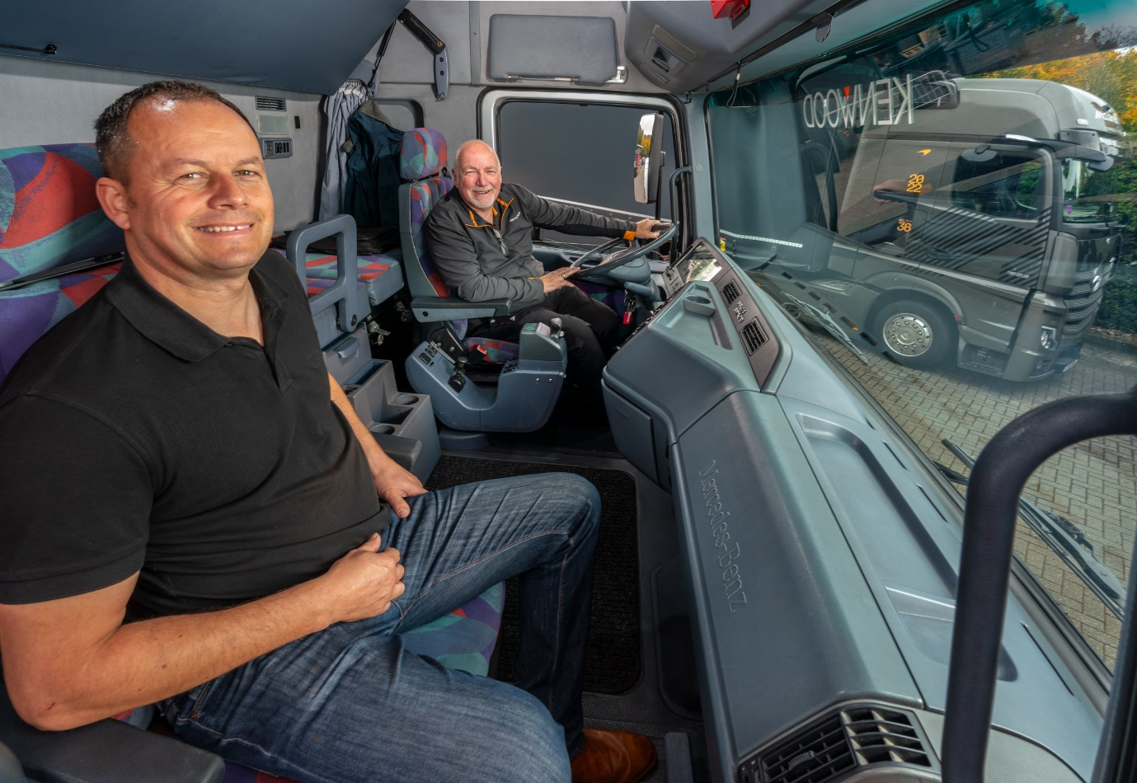

Turning back the clock: Once again behind the wheel of his first Actros, McLaren driver Ian Hodges is pictured with Dominic Newby, the restoration specialist who made it possible

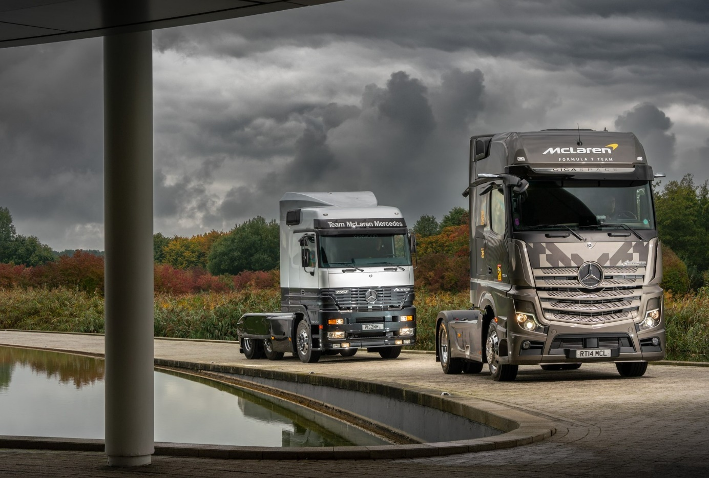
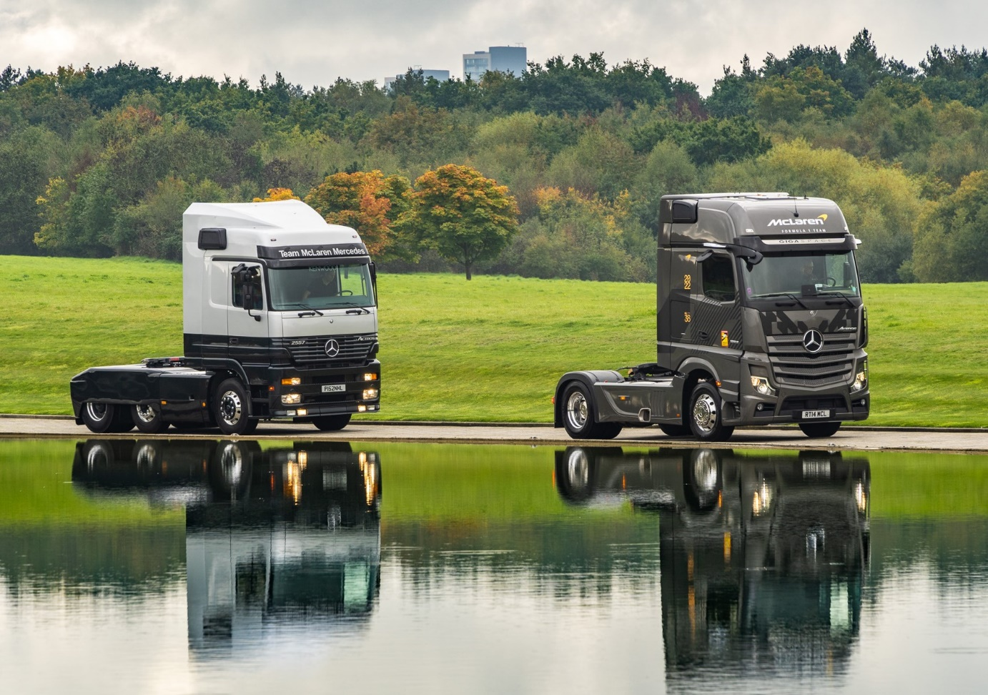

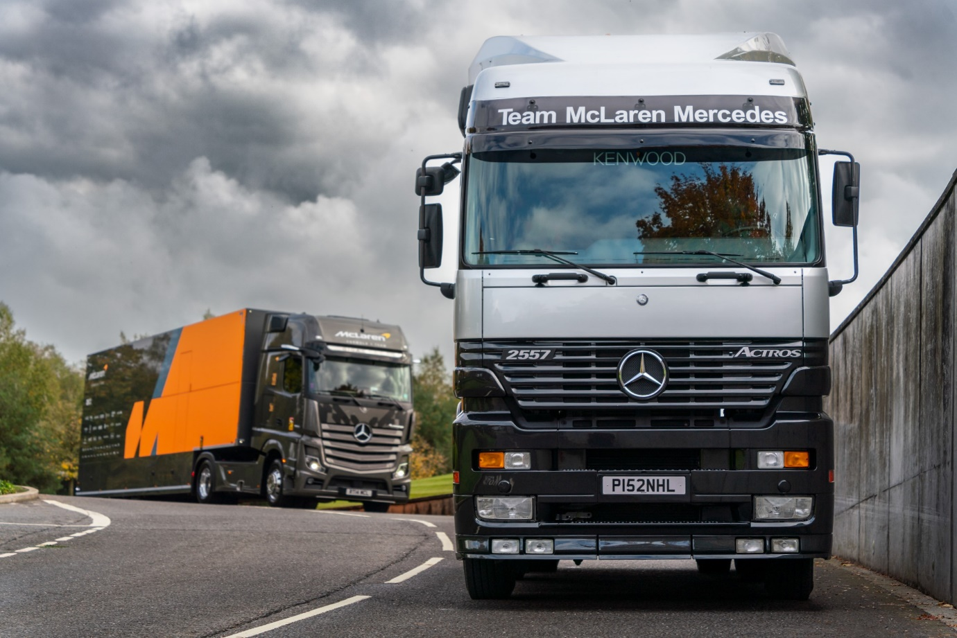

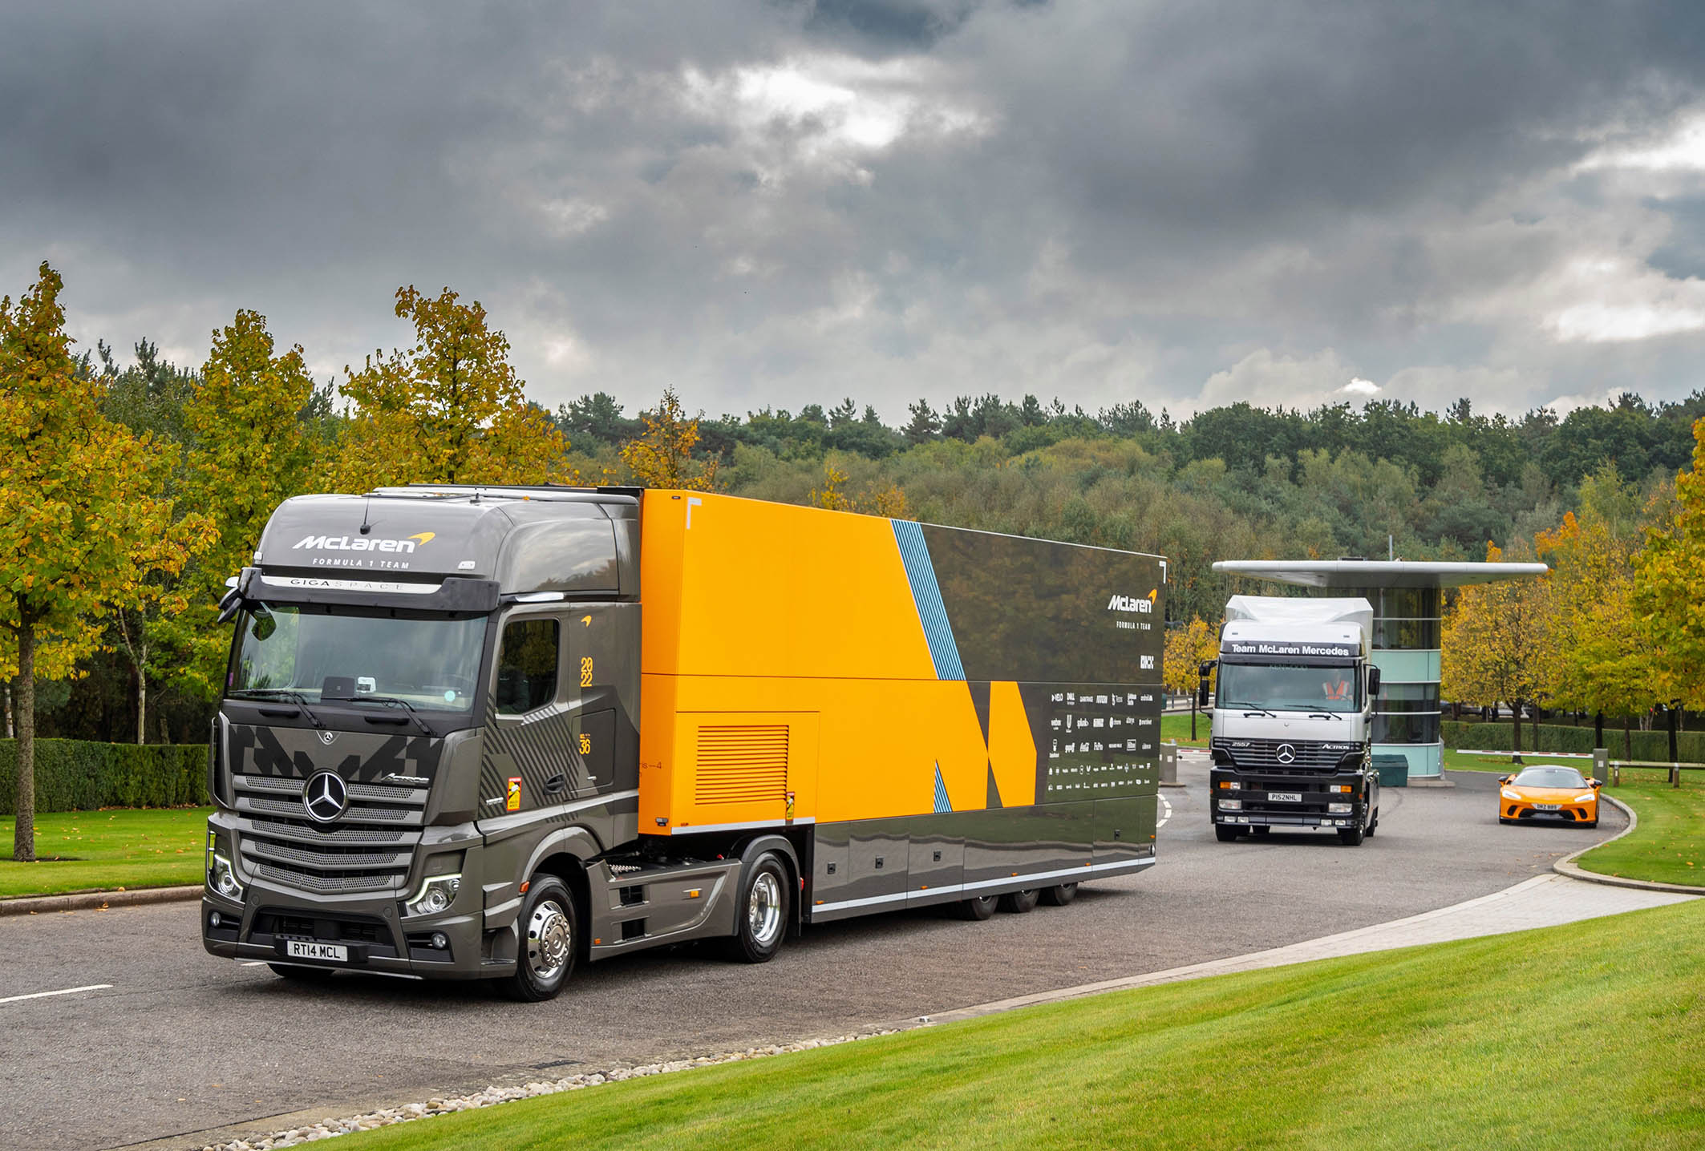

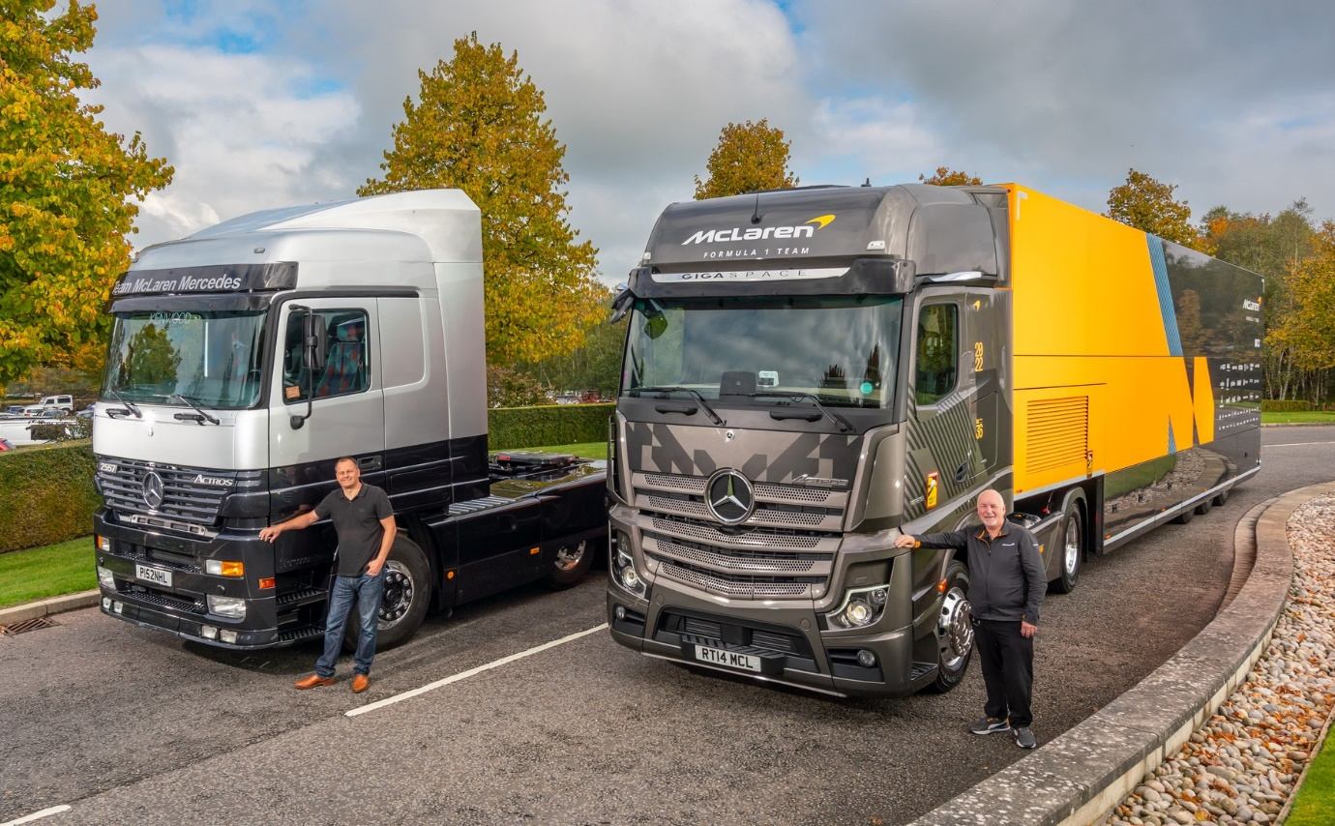

McLaren milestones: Dominic Newby and his restored first-generation Actros, are pictured with Ian Hodges and his truck from the fifth-generation of the same model range

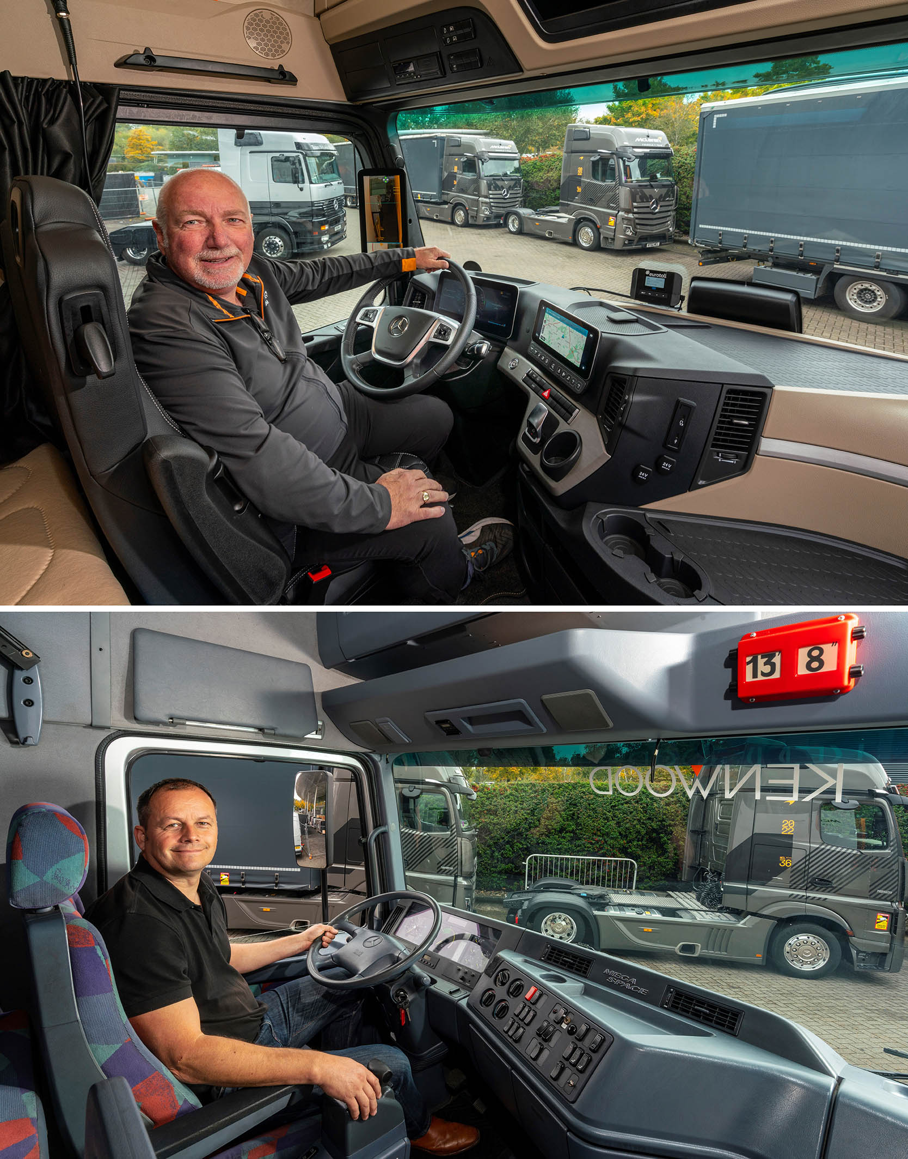

Cutting-edge: Just as Ian Hodges’ Multimedia Cockpit, interactive, dashboard sets the present day standard for style and driver-friendly efficiency, so, too, did Dominic Newby’s a quarter of a century ago

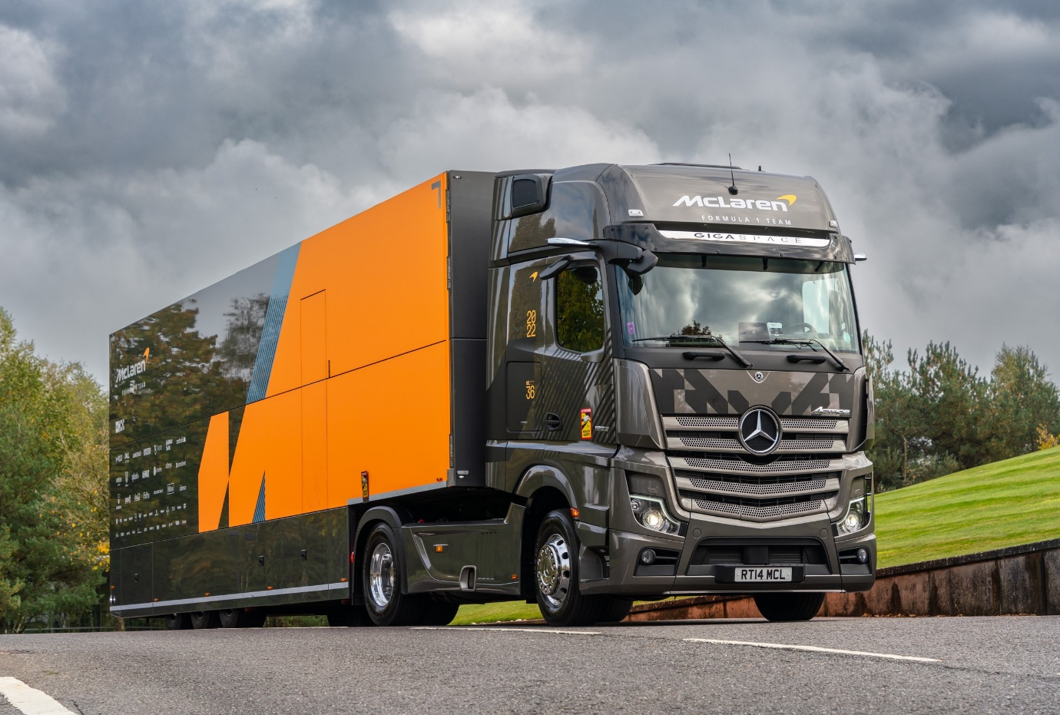

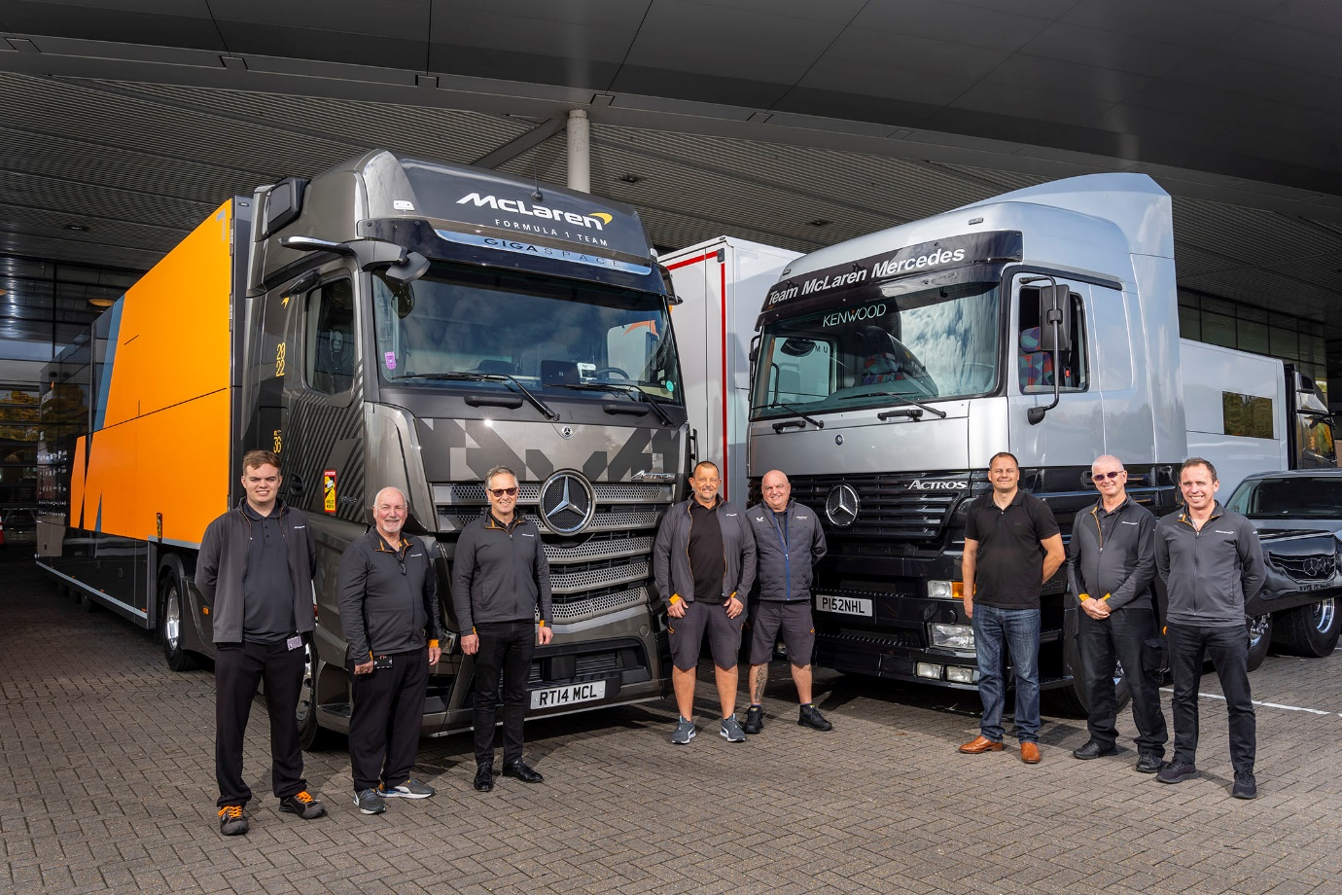

VIP visit: Dominic Newby, third from right, and his restored Mercedes-Benz Actros received a warm welcome to McLaren’s Woking headquarters from members of its transport team

ends

For more information, or to request bigger/higher-res image files, please contact:
Steve Warren or John Ripley
Impact Communications
Steve: 07770 470251, steve@impactcom.co.uk
John: 07771 484595, john@impactcom.co.uk

