

Date: 30 July 2020

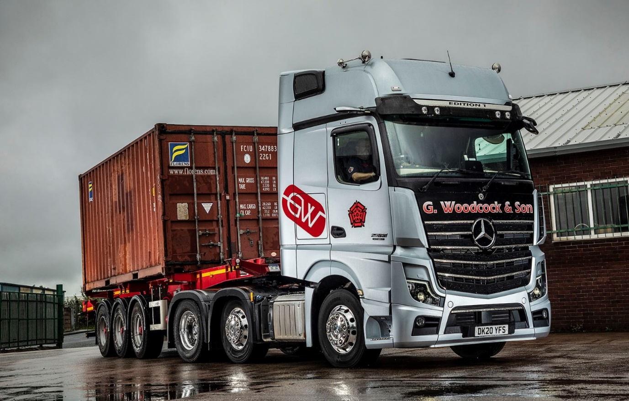

Woodcock flies to a new high with stunning
Mercedes-Benz Actros Edition 1

An exceptional truck that would make a big impact and reward a valued driver – G Woodcock & Son found the vehicle it was looking for in the limited-edition Mercedes-Benz Actros Edition 1.

The family-owned haulier is based in Royton, near Oldham, and runs seven Actros tractor units which transport shipping containers nationwide.

Just 400 Actros Edition 1s have been built, of which only 35 were allocated to the UK market. Supplied by local Dealer Roanza Truck & Van, G Woodcock & Sons’ new flagship is a 2563 model and powered by a potent 460 kW (625 hp), 15.6-litre ‘straight six’.

The truck stands out from the rest thanks to its striking appearance – as well as an eye-catching gloss black grille, its range-topping GigaSpace cab boasts darkened headlamp covers and rims, and an Edition 1-branded sun visor incorporating four extra LED main-beam headlamps.

The black leather-trimmed interior – even the door handles have contrasting topstitching – features a polished and brushed aluminium dashboard badge that confirms it as ‘One of 400’ Edition 1s. Drivers can choose from no fewer than eight colours of ambient ceiling lighting, while the bed measures an industry-leading 900 mm wide.

G Woodcock & Sons can trace its roots back to the 1920s, although the company in its current form was established by proprietor Geoff Woodcock 45 years ago. Now 79, he continues to run the business with his son Nicholas.

The Woodcocks normally choose high-quality pre-owned trucks – other recent additions to the fleet have included low-mileage Mercedes-Benz Approved Used units also acquired from Roanza Truck & Van.

This time, however, Geoff Woodcock decided to push the boat out. “We’re a relatively small company in a crowded marketplace, so I felt we had to do something to really get us noticed,” he explained.

Mr Woodcock saw the Actros Edition 1 for the first time at Roanza’s Trafford Park Dealership. “I knew immediately that it was exactly what I was looking for,” he recalled. “It’s a fantastic-looking vehicle and makes a real statement – you certainly can’t miss it.”

He continued: “Our trucks leave home on Monday mornings, bound for the ports of Felixstowe, Southampton and London Gateway, then they’re off all over the country and we don’t see them again until Friday.

“The drivers are highly valued members of our team and great ambassadors for the company. They all like their Actros tractors but the keys for the Edition 1 have gone to John Kershaw. He’s been with us for seven years, although I’ve known him, and indeed his father, who was also a driver, for much longer.”

The Edition 1 brings together the many ground-breaking innovations –MirrorCam, Active Brake Assist 5, the Multimedia Cockpit, and enhanced Predictive Powertrain Control technology among them– that come as standard on the new-generation Actros range, with a lengthy list of extra equipment.

The optional Sight Package, for instance, provides for ‘best possible’ lighting and visibility by adding a rain sensor, bi-xenon headlamps, fog lamps, LED daytime running lights, cornering lights and LED tail lights. Other additional specification is bundled within the Driving, Comfort, Media and Stowage Packages.

The new truck’s proud custodian has been a professional driver for three decades. “I came out of a ’17-plate Actros with a 480 hp engine,” said John Kershaw. “That was a nice truck, but the Edition 1 is in a different league altogether. The ride is incredibly smooth, and the engine pulls really well – it never has to try too hard on the hills, but just sails along.

“The interior is amazingly luxurious too, with leather everywhere, a huge bed and superbly comfortable mattress, plus an excellent DAB radio and sound system. I’ve had the truck two weeks and it always causes a stir. I’ve seen guys doing double-takes out on the road, and whenever I pull in at a truckstop someone always comes over for a closer look.”

Geoff Woodcock added: “Our Actros tractors have proved over many years to be extremely reliable and cost-effective to operate. They’re also great to drive and provide a comfortable living and working space. The Actros Edition 1 combines all of these qualities with an added layer of exclusivity.”

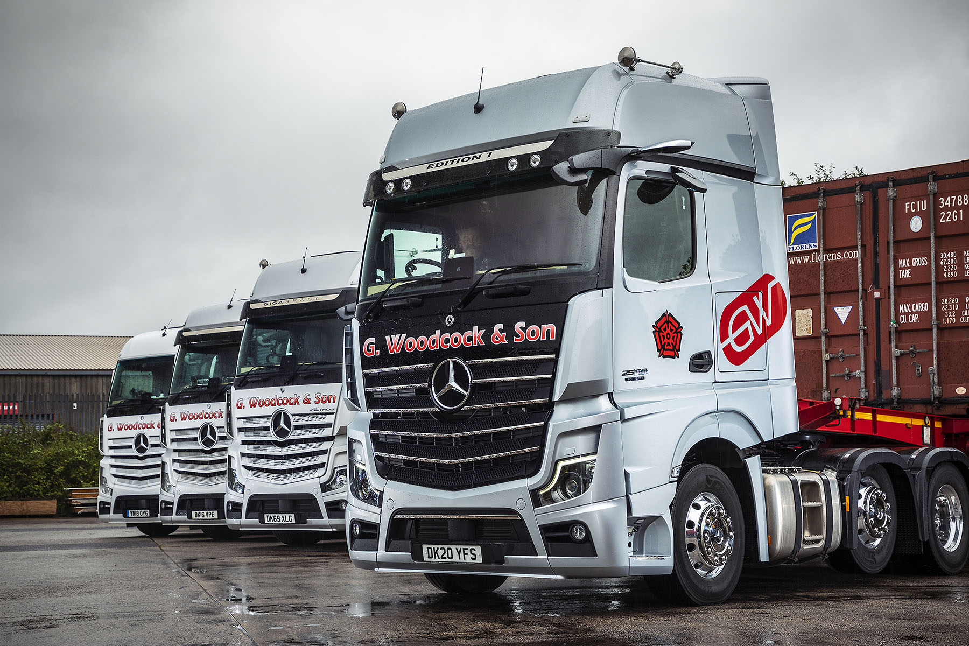

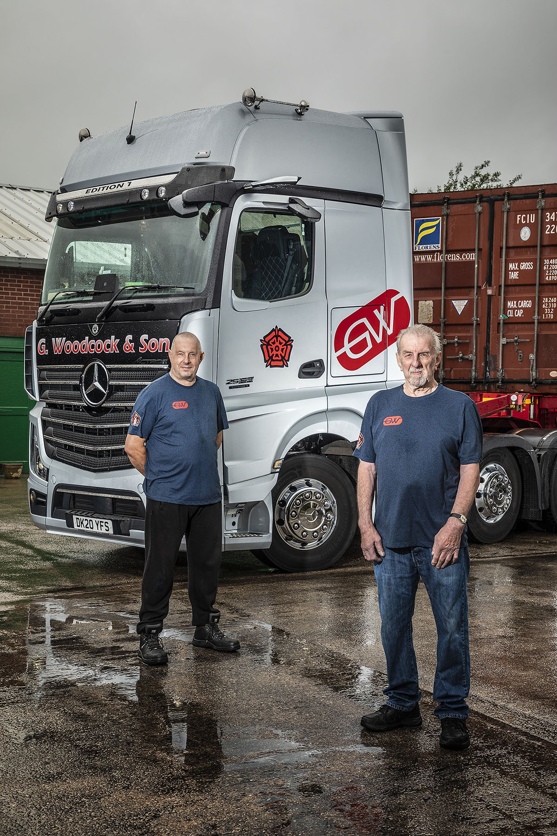

Star attraction: Geoff Woodcock and his son Nicholas with their new Actros Edition 1
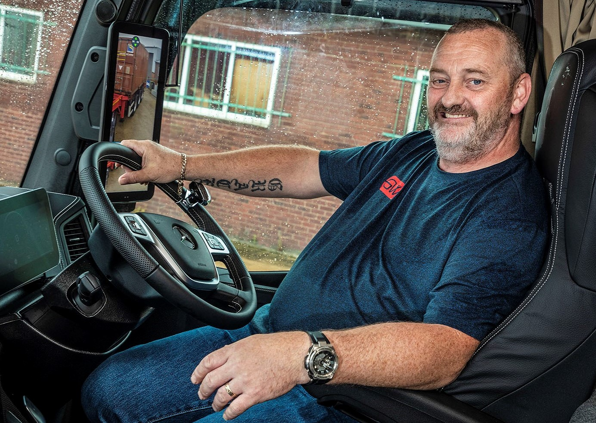

Luxury liner: Driver John Kershaw is a king of the road in his new Actros Edition 1

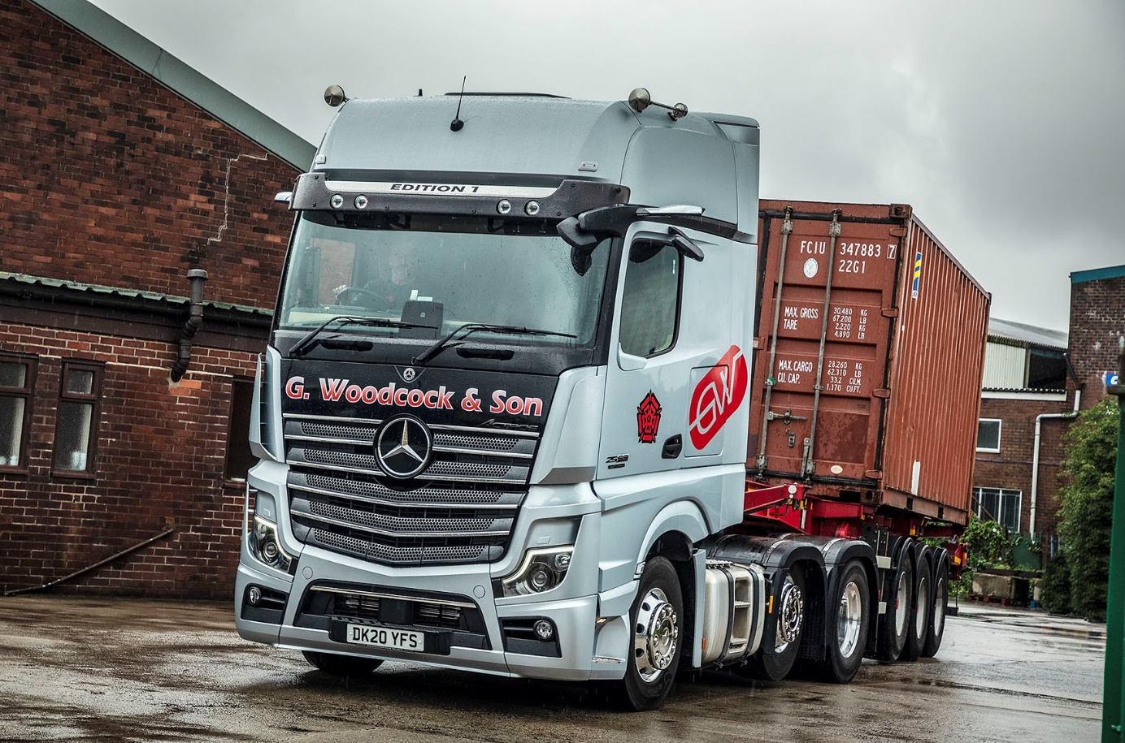

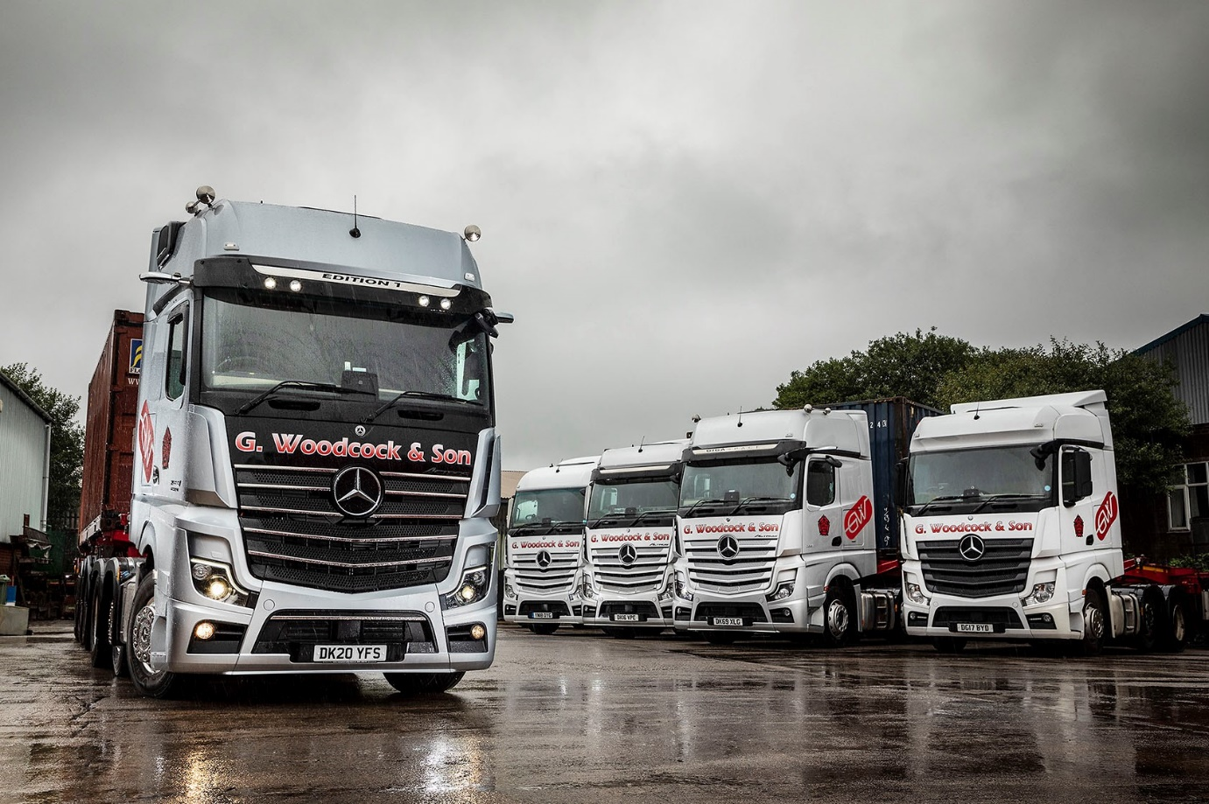

ends

For more information, or to request bigger/higher-res image files, please contact:
Steve Warren or John Ripley
Impact Communications, 01926 842126
Steve: 07770 470251, steve@impactcom.co.uk
John: 07771 484595, john@impactcom.co.uk

