
Press Release


Date: 10 July 2024

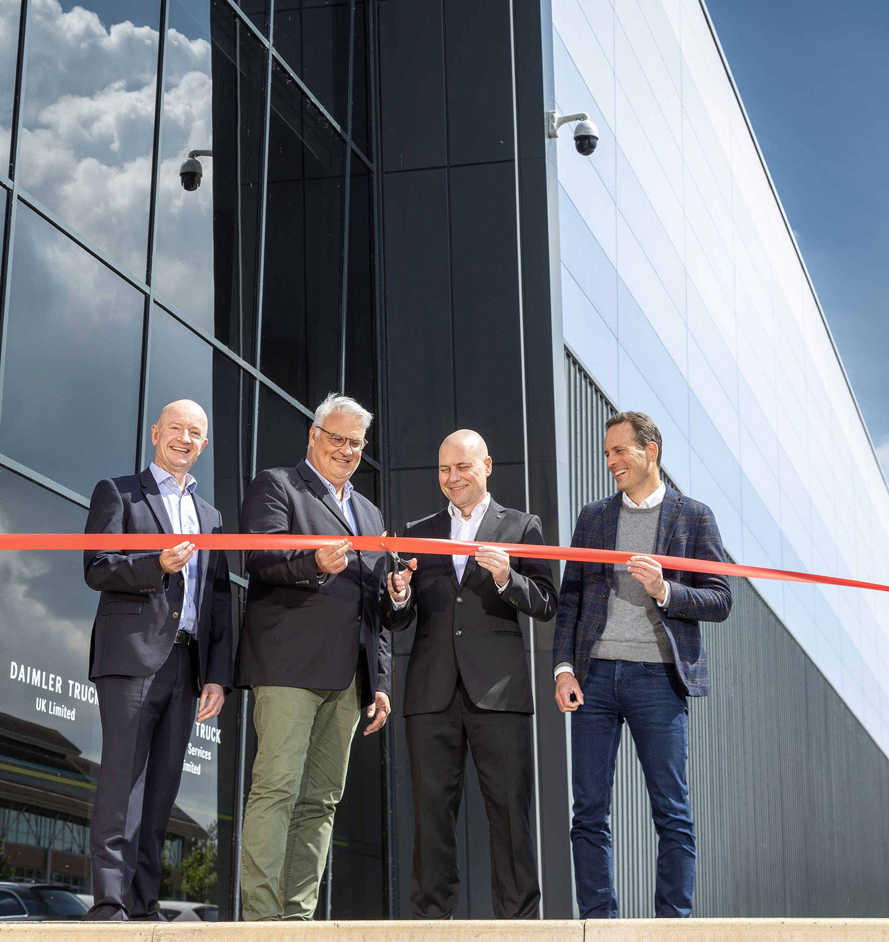
All systems go: Daimler Truck UK Managing Director Heiko Selzam cuts the tape to officially open the company’s new headquarters, with, from left, Daimler Truck Financial Services UK Managing Director Nick Andrews, Daimler Truck Head of Sales & Marketing Jean-Marc Diss, and Florian Schulz, Head of Sales & Customer Service FUSO Europe

Daimler Truck UK unveils new headquarters
Daimler Truck UK Limited and Daimler Truck Financial Services Limited marked the start of the latest chapter in their history, with the official opening of their new head office.

The move follows the formation of Daimler Truck UK Limited, the wholesale distributor for Mercedes-Benz Trucks and FUSO Trucks in Great Britain, and Mercedes-Benz Trucks in Northern Ireland, earlier this year.

The opening of the new site at Willen, Milton Keynes, represents a significant change. Previously the businesses were run from premises at nearby Tongwell, shared with the UK headquarters of Mercedes-Benz Passenger Cars, Vans and Financial Services. Now, for the first time, the two companies are sole occupants of their own home.

The smart new building was already in use, with Daimler Truck UK’s Parts Logistics Centre based in its 140,000 sq ft of warehouse space. Following completion of work to create a state-of-the-art office suite for all Truck colleagues, the entire operation is on one site again.

Sustainability is a top priority. The building has secured the highest possible 85% BREEAM (Building Research Establishment Environmental Assessment Method) rating – features include high ceiling clearance with natural light panels in the warehouse, which reduce energy consumption and optimise working conditions, and a rain water collection system that feeds the washrooms in the office area. The vision includes a plan to provide sustainable electric truck charging via solar panels in the near future.

Heiko Selzam, Managing Director, Daimler Truck UK and Nick Andrews, Managing Director of Daimler Truck Financial Services UK cut the tape to officially declare the new building open. They were joined for the occasion by representatives from Daimler Truck’s global headquarters in Stuttgart - Jean Marc Diss, Head of Sales & Marketing, and Florian Schulz, Head of Sales and Customer Services FUSO Europe.

Heiko commented: “The opening of this site represents the final step in the process of dedicating ourselves entirely to the needs of truck operators, and our Dealer network, in the UK. Separating our business from the car and van divisions was a complex and challenging task but has brought the benefit of allowing us to focus on what we do best – bringing our industry-leading vehicles, and the entire ecosystem of support services that back them up, to more customers than ever before.”

Nick Andrews added: “We can now work even more closely with our Sales and Aftersales colleagues to bring our full suite of products to UK truck operators, to help find the most cost-efficient solutions to the wide range of challenges faced by the transport industry today and into the future.”

ends
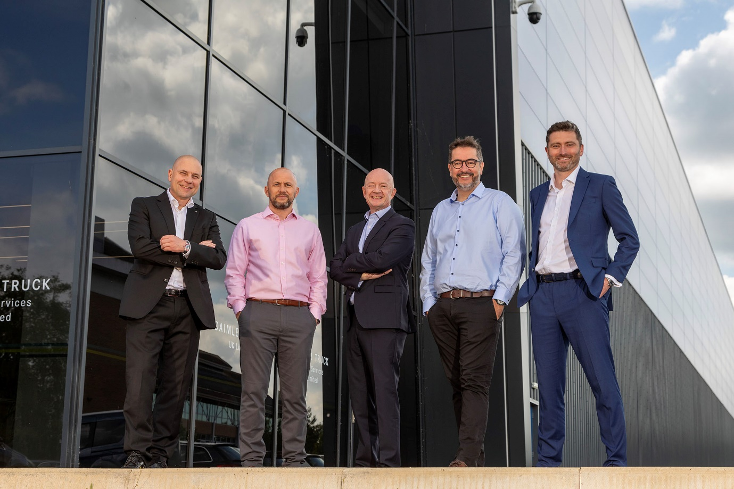
Open for business: From left, Daimler Truck UK Managing Director Heiko Selzam, Sales & Marketing Director Stuart Jeggo, Daimler Truck Financial Services Managing Director Nick Andrews, Daimler Truck UK Chief Financial Officer Hugo Ramalho, and Director, Customer Service & Parts Richard Skidmore

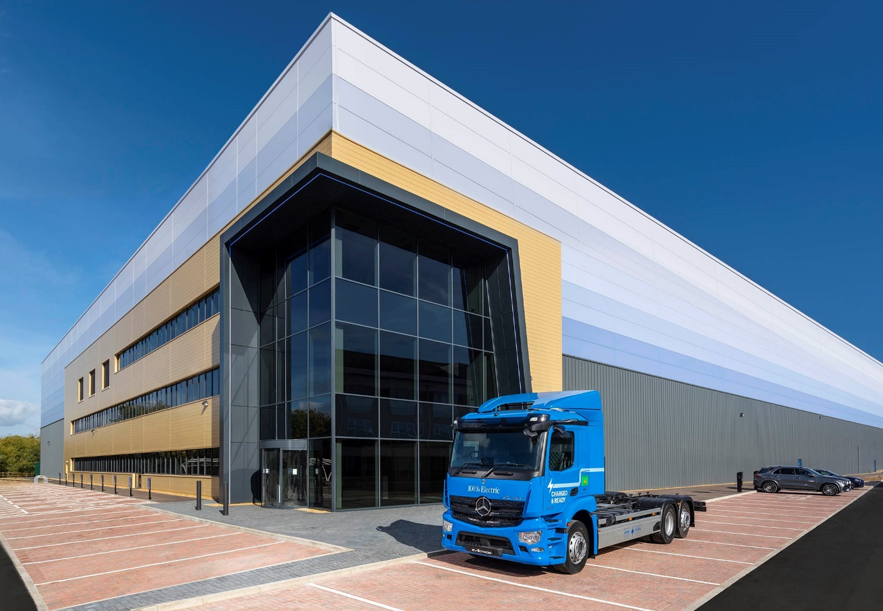
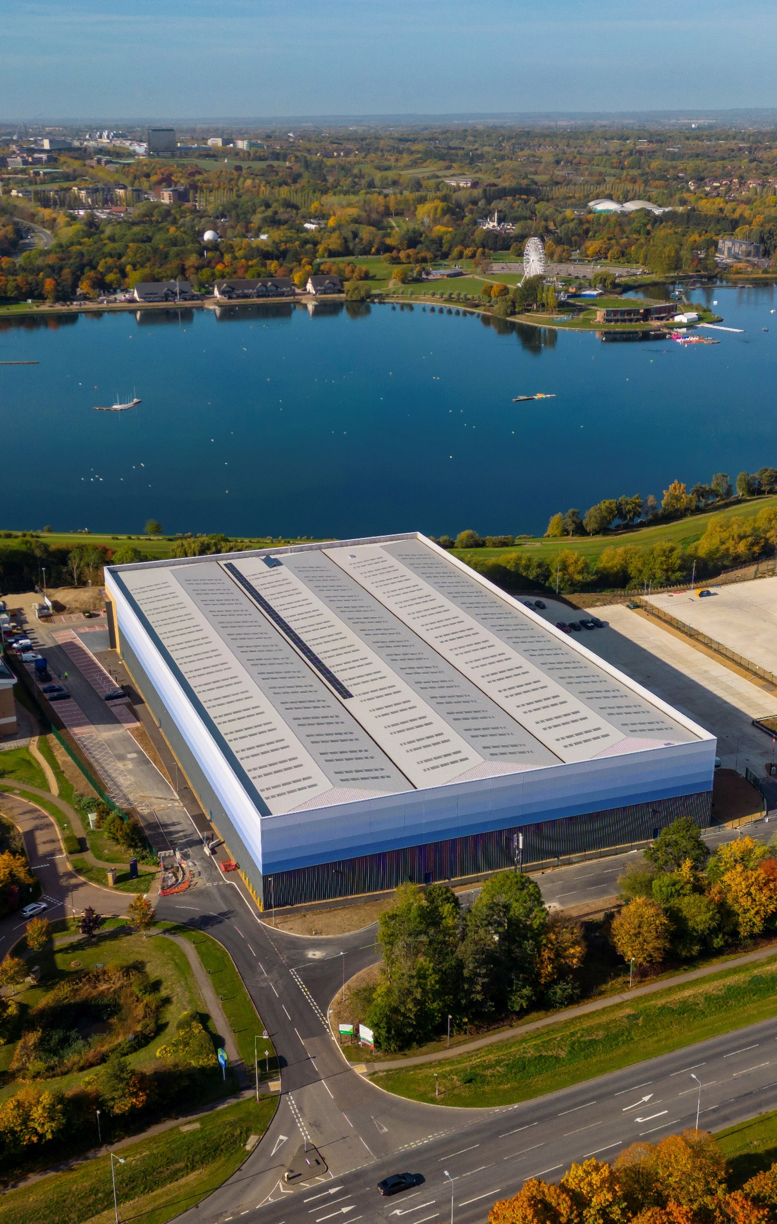
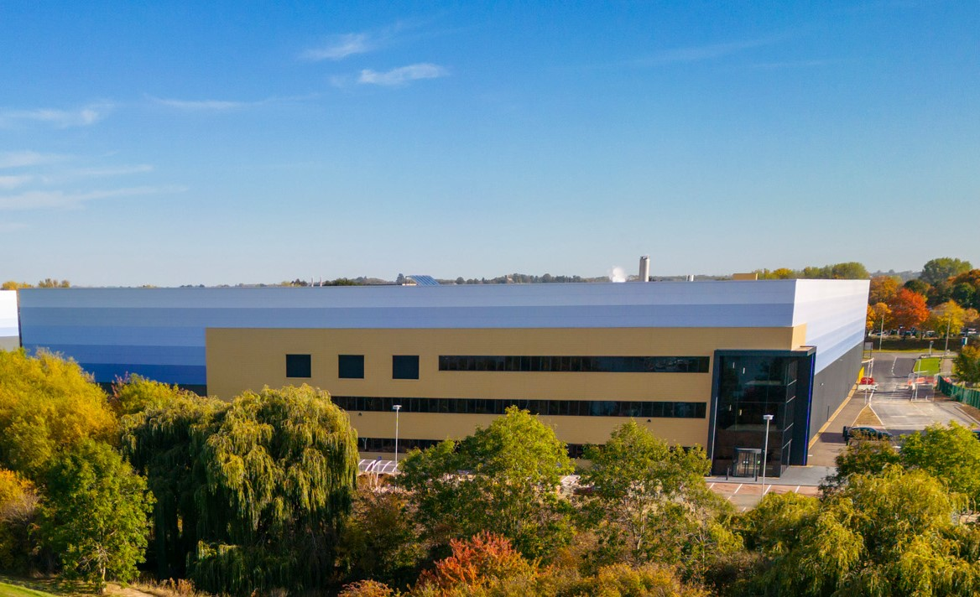

For more information, or to request higher-resolution images, please contact:

Dominic Dawes at Daimler Truck UK
07864 600148, dominic.dawes@daimlertruck.com

or

John Ripley: 07771 484595, john.ripley@loopagency.co.uk

