

Date: 25 May 2023

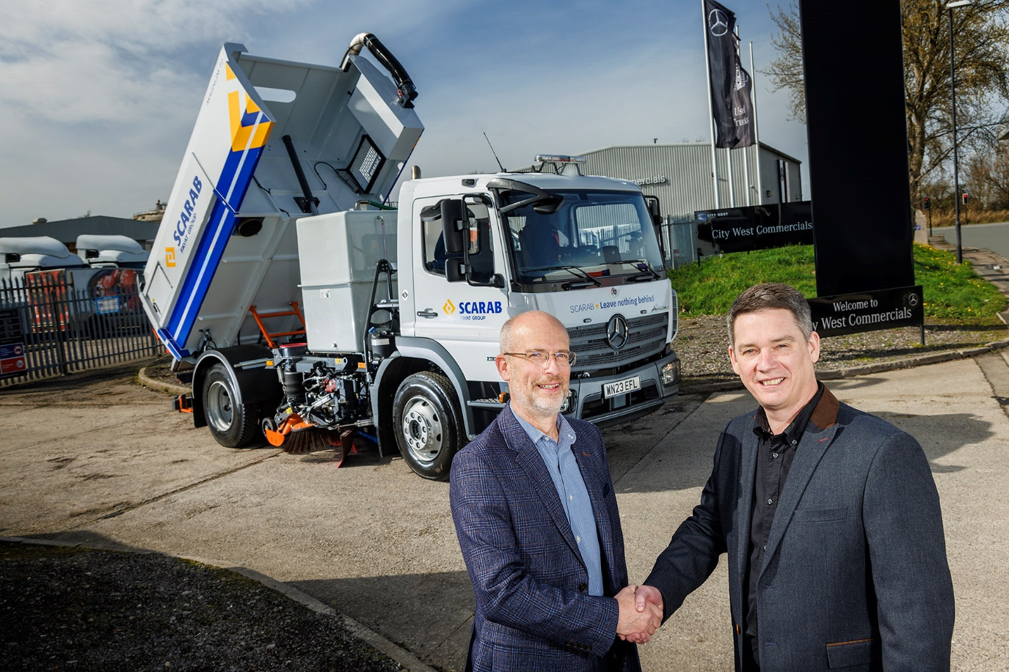

Partners for progress: Scarab’s Andy Farley, left, and Darren Sweet of City West Commercials with their new Mercedes-Benz Atego sweeper truck

City West Commercials teams up with Scarab to create stunning Mercedes-Benz Atego sweeper

Mercedes-Benz Truck Dealer City West Commercials has joined forces with leading sweeper manufacturer Scarab to build a one-of-a-kind demonstrator vehicle.

Based on a 13.5-tonne GVW Mercedes-Benz Atego chassis, and equipped with Scarab’s Magnum 72 Hydrostatic single-engine sweeper body, the truck is thought to be unique.

Initially offered to specialist operators across the country for trials, interest in the vehicle was so high a buyer has already snapped it up. Further demonstrations are planned in the coming months, before it can be released to its new owner, and a replacement demonstrator is already under construction.

“As far as we know it’s the only Scarab-bodied Atego in the country,” said City West Commercials Dealer Principal Darren Sweet. “So we’re eager to show the industry why we believe this is simply the best truck available in its category, with the robust build quality, engineering integrity, driver appeal and top-quality back-up that operators have every right to expect.

The fact that one of the first to try it immediately decided to buy it only goes to show what a fantastic package we’ve created.”

Scarab Business Development Manager Andy Farley added: “The Atego has been unfairly overlooked as a chassis of choice in the sweeper sector – partly because, rightly or wrongly, it’s often been thought of as more expensive than some rivals.

“That’s certainly not the case though. Current pricing means it is very competitive, with a set of attributes that make it a strong option for this application – it’s a premium product, with all the benefits that implies, and the chassis is an excellent ‘fit’ for our equipment.

“The technical support from Mercedes-Benz Trucks for specialist bodybuilders is renowned as possibly the best in the business,” he continued. “That helped our engineers develop a superb demo truck that would take pride of place in any fleet, but will also allow us to tailor the exact specification of any vehicles we sell to the individual needs of any customer. The addition of our highly effective and efficient body equipment can only make it even more attractive.”

The truck is built on an Atego 1323 LKO chassis, which has a raised ride height to allow ample room for implements to be mounted. It is rated at 13.5 tonnes GVW, and powered by a 170 kW (231 hp) 5.1-litre, four-cylinder engine. This drives through a nine-speed manual gearbox and has its steering wheel on the left side of the ClassicSpace cab, for optimum control and visibility when sweeping along the kerbside.

Scarab’s Magnum 72 body, meanwhile, features a 7.2m³ stainless steel hopper with large access doors and automatic ratchet hopper prop, and a 900mm stainless steel high-speed fan with boost facility, inlet cone and screen. Sweeping duties are catered for by 650mm side brushes with variable speed control, a 400mm wide-sweep brush and 740mm wide suction nozzle with auto-blanking. Dust suppression jets are fitted across the vehicle and the 1,800-litre GRP water tank has a large lid to allow for easy cleaning.

The sweeping equipment is all managed by Scarab’s CANbus control system – a panel mounted inside the cab communicates all operational information, data logging and diagnosis.

Custom specification items available to customers include flexible overhead boom configuration and a range of beacons, work lights, cameras and safety options.

The single-engine configuration of Scarab’s Magnum means all the body equipment is driven by the truck’s main powerplant – rather than a second, auxiliary or ‘donkey’ engine. Scarab maintains this set-up offers significant benefits to operators and the environment.

“Removing the second engine reduces the kerb weight of the finished vehicle – which typically translates into a payload increase of more than 25%,” said Andy Farley. “And with only one engine running, there’s an overall reduction in fuel consumption of up to 40%.

“A single-engine vehicle is much cleaner too, because auxiliary motors are not required to meet the same exhaust standards as the truck’s main engine, and therefore produce higher levels of carbon dioxide and nitrous oxide emissions.

“Last but not least are the cost benefits,” he continued. “One reason many operators chose donkey engines in the past was that they could run on low-tax ‘red’ diesel – but rule changes last year mean that is no longer the case. Meanwhile brake wear, clutch wear, parts and labour costs are substantially reduced.

“All these benefits come with no loss of performance, thanks to Scarab’s straight airflow design which means air bends only three times before the exhaust.”

Demand for trials of the new demonstrator has been even stronger than expected. Operators keen to see it in action are urged to contact City West Commercials or Scarab to add their names to the list.

Darren Sweet said: “With robust build, exceptional performance and industry-leading after sales support from both Mercedes-Benz Trucks and Scarab, this partnership has been designed to delivery trusted, high-quality sweeping solutions to customers across the UK.”

www.citywestcommercials.co.uk
www.scarab-sweepers.com
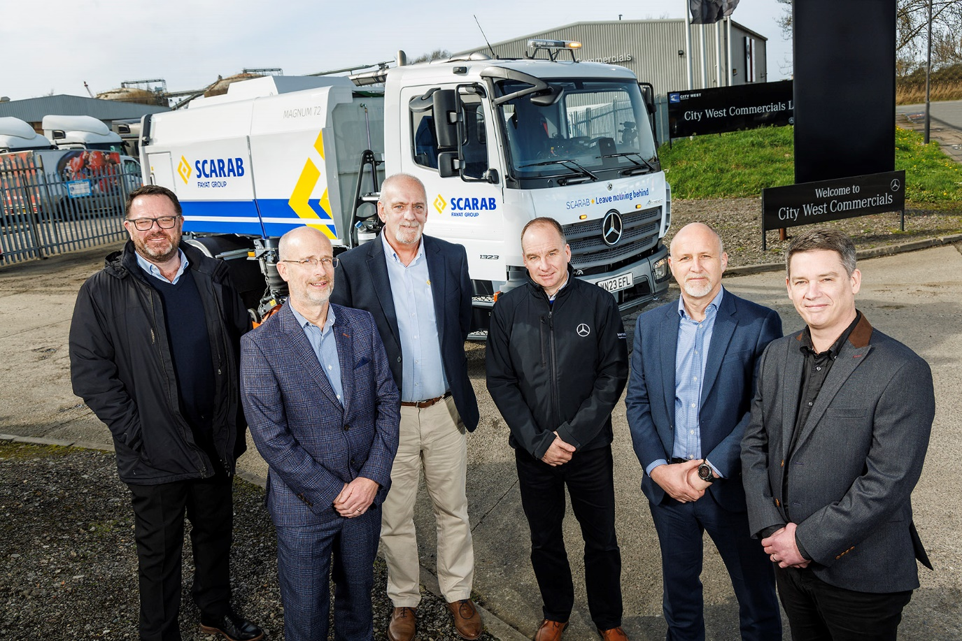

Team players: from left, City West Truck Sales Director Paul Ridout, Scarab’s Andy Farley and Gary Brown, Simon Johnson-Taylor of City West, Scarab UK Sales Manager Simon Stringer, and City West Dealer Principal Darren Sweet

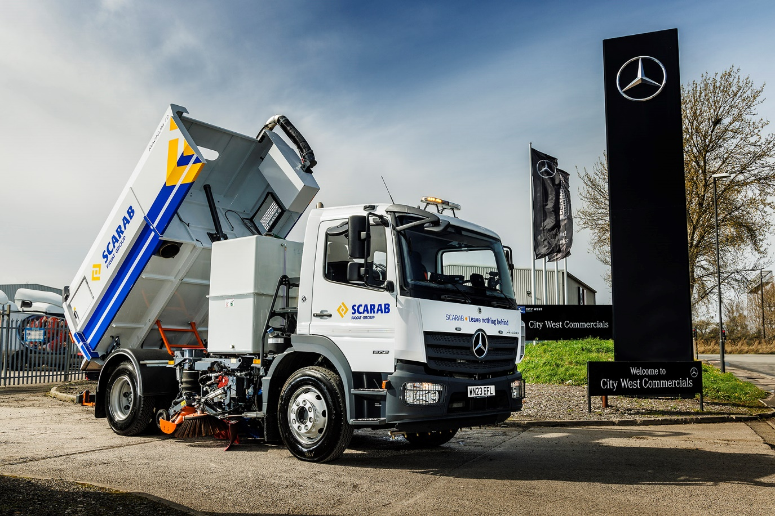

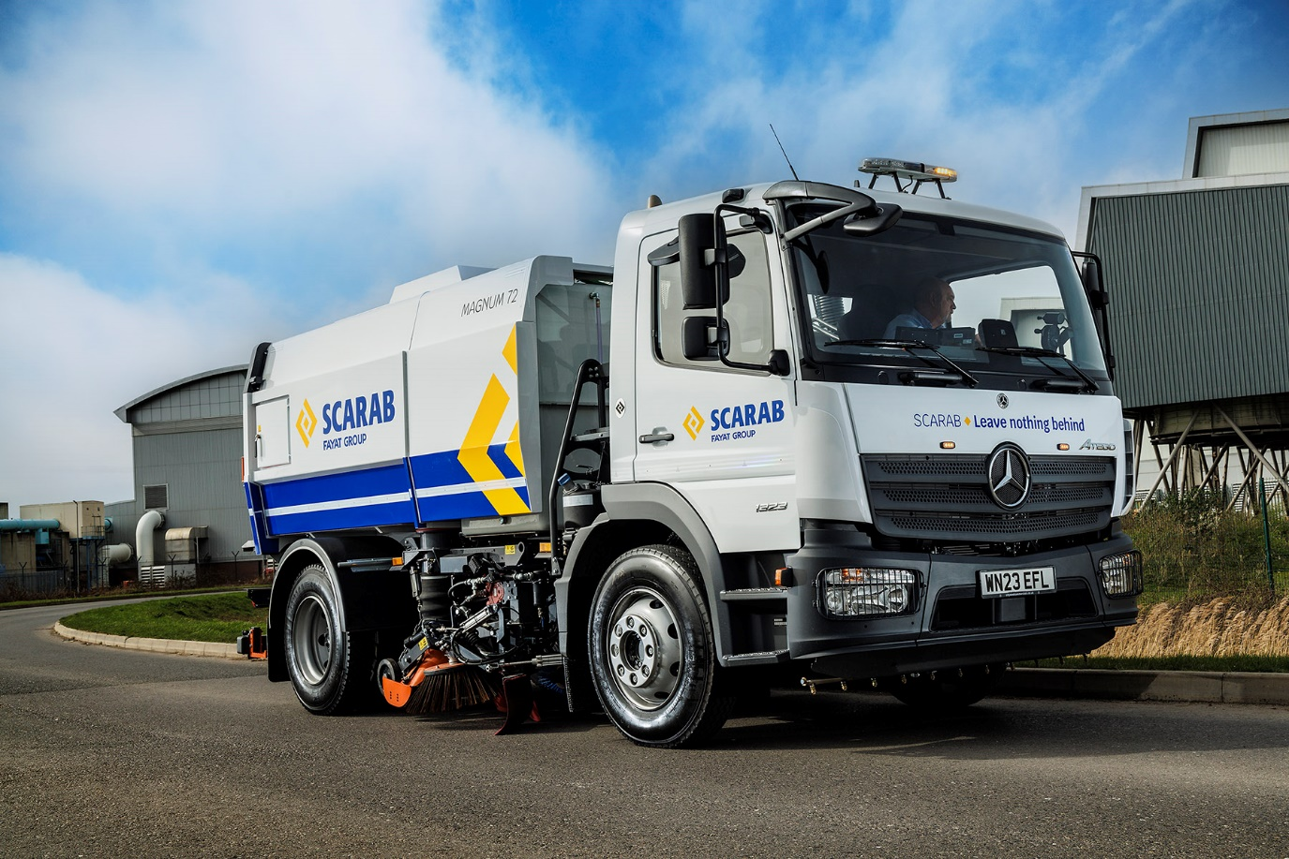

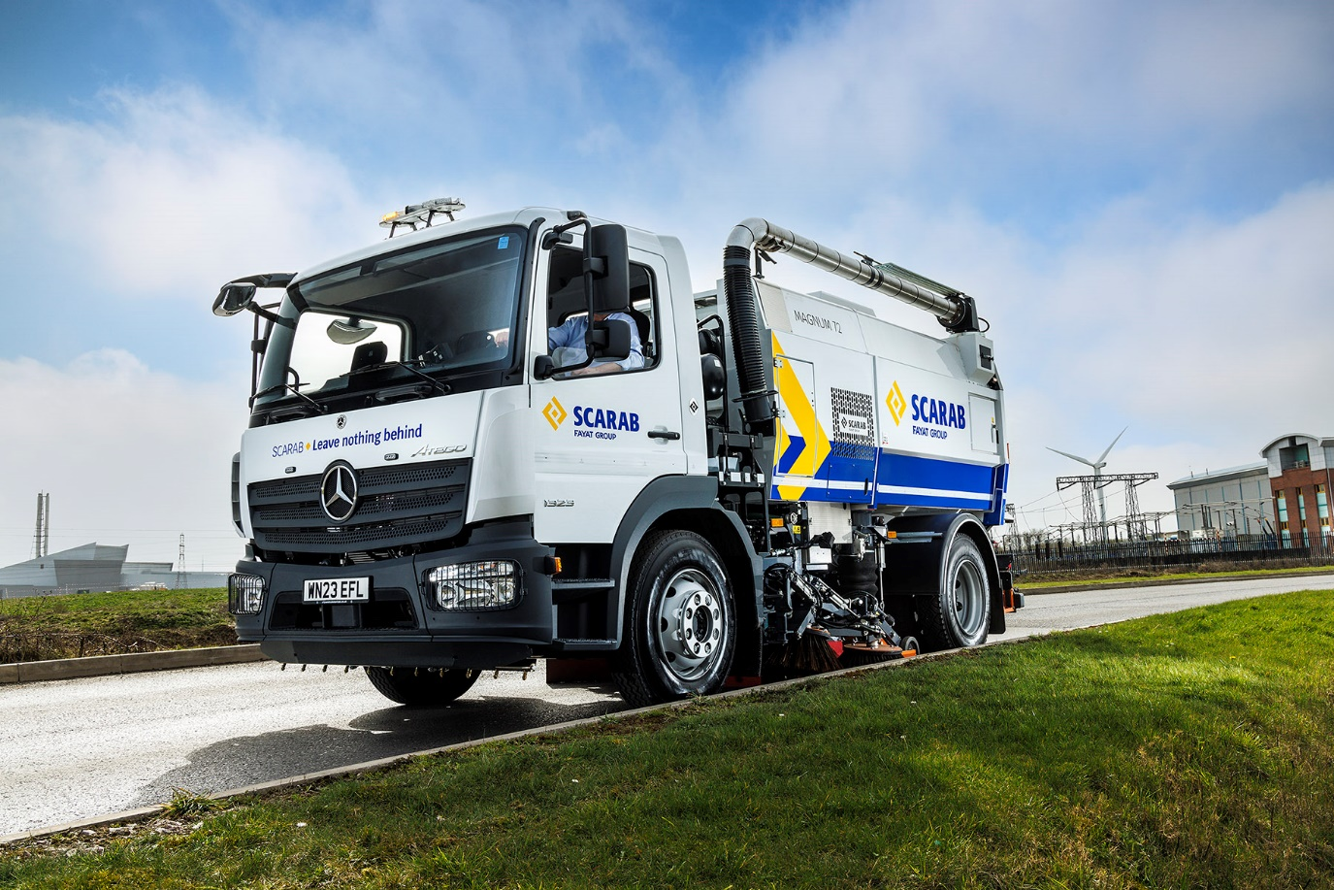

ends

For more information, or to request bigger/higher-res image files, please contact:
John Ripley: 07771 484595, john.ripley@loopagency.co.uk

