

Date: 31 January 2020

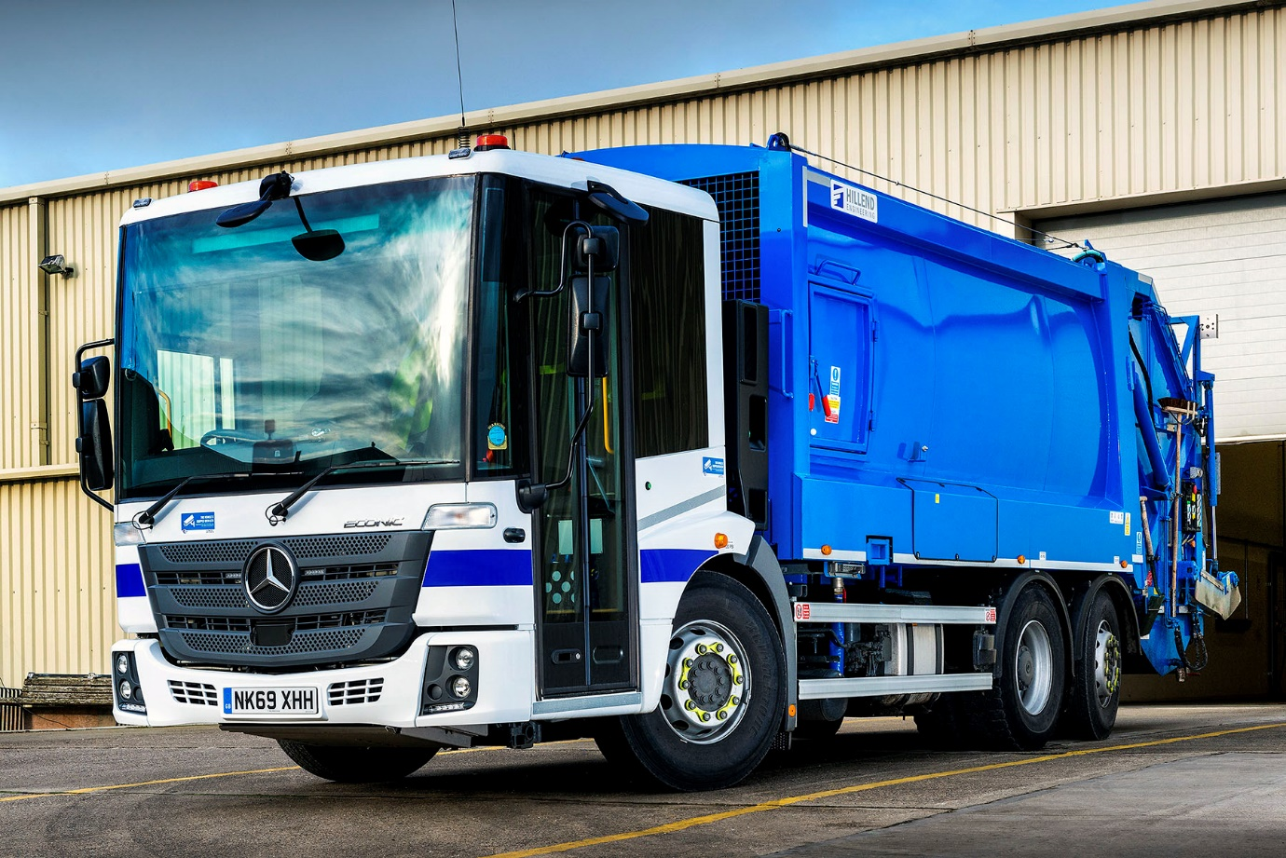

Hartlepool Borough Council plays it safe with tried and trusted Mercedes-Benz Econic

The best just got better for Hartlepool Borough Council, following the arrival of its latest two Mercedes-Benz refuse collection vehicles.

The local authority has relied on low-entry Econic trucks to collect household and commercial waste for more than a decade, and will take delivery of another three in April.

All but a couple of the 18 refuse collection vehicles that currently serve the borough’s 43,000 households were supplied by Bell Truck and Van, which represents the Mercedes-Benz and FUSO brands in the North East. The Econic’s attributes of reliability, user-friendly design, and exemplary safety credentials, are complemented for the council by the Dealer’s customer-focused aftersales support.

Like those which are still to come, the new trucks are 6x2 Econic 2630L models. Their 7.7-litre ‘straight-six’ engines produce 220 kW (299 hp) and are paired with six-speed Allison automatic transmissions. The trucks are also fitted with rear-steer axles for optimum manoeuvrability, and compactor bodies by Farid Hillend Engineering.

The Econic has been awarded awarded a five-star Direct Vision rating by Transport for London. Its deep, panoramic windscreen offers unrivalled direct vision, while the full-height, glazed folding side doors specified by Hartlepool Council, and low seating position allow drivers to make direct eye contact with vulnerable cyclists and pedestrians at junctions or in traffic queues, a major safety advantage in enabling each to understand the other’s intentions.

Greater Safety is one of the three pillars of Mercedes-Benz Trucks’ all-encompassing RoadEfficiency strategy, and the Econic is also equipped as standard with Active Brake Assist 4 emergency braking. Programmed to recognise other vehicles at higher speeds, as well as pedestrians when moving more slowly, it is capable of bringing the truck to a complete stop.

The Council has raised its safety game still further on this occasion, though, by also ordering its new Econics with optional Sideguard Assist and Rearguard Assist systems.

Sideguard Assist employs two short-range radar sensors mounted on the passenger side of the vehicle, which support the driver when making left turns or changing lines in congested areas, by triggering optical and acoustic warnings to alert them to the presence of vulnerable road users alongside.

Rearguard Assist employs radar-based technology to support the driver when reversing at manoeuvring speed, by displaying the distance from objects being approached via the instrument cluster and providing visual and audible warnings. The system can also brake the vehicle to a controlled stop when the distance to an object becomes critical.

Hartlepool Borough Council’s Waste & Environmental Services Team Leader Helen Beaman said: “Our Econics have proved over the years to be extremely reliable and cost-effective to operate. Build quality is first class, and the trucks are well-liked by the operatives who use them.

“The low-entry flat-floored cab contributes to health and safety in being easy to access and exit, and to move across, while the visibility provided by the extensive glazing is certainly appreciated by our drivers. With the additional enhancements we’ve specified this time, these new trucks will allow us to work as safely as possible, for the benefit of crews and local residents alike.”

Ms Beaman continued: “Bell Truck and Van’s support is crucial in enabling us to deliver a highly efficient waste collection service for residents and businesses. We maintain the vehicles in our own workshops, but the Dealer keeps us supplied with a comprehensive stock of parts, and its expert technical advice is only ever a phone call away.”

As with all new Econics supplied through the Mercedes-Benz UK Dealer network, the vehicles are backed by a comprehensive three-year/160,000 km manufacturer’s warranty.

www.hartlepool.gov.uk

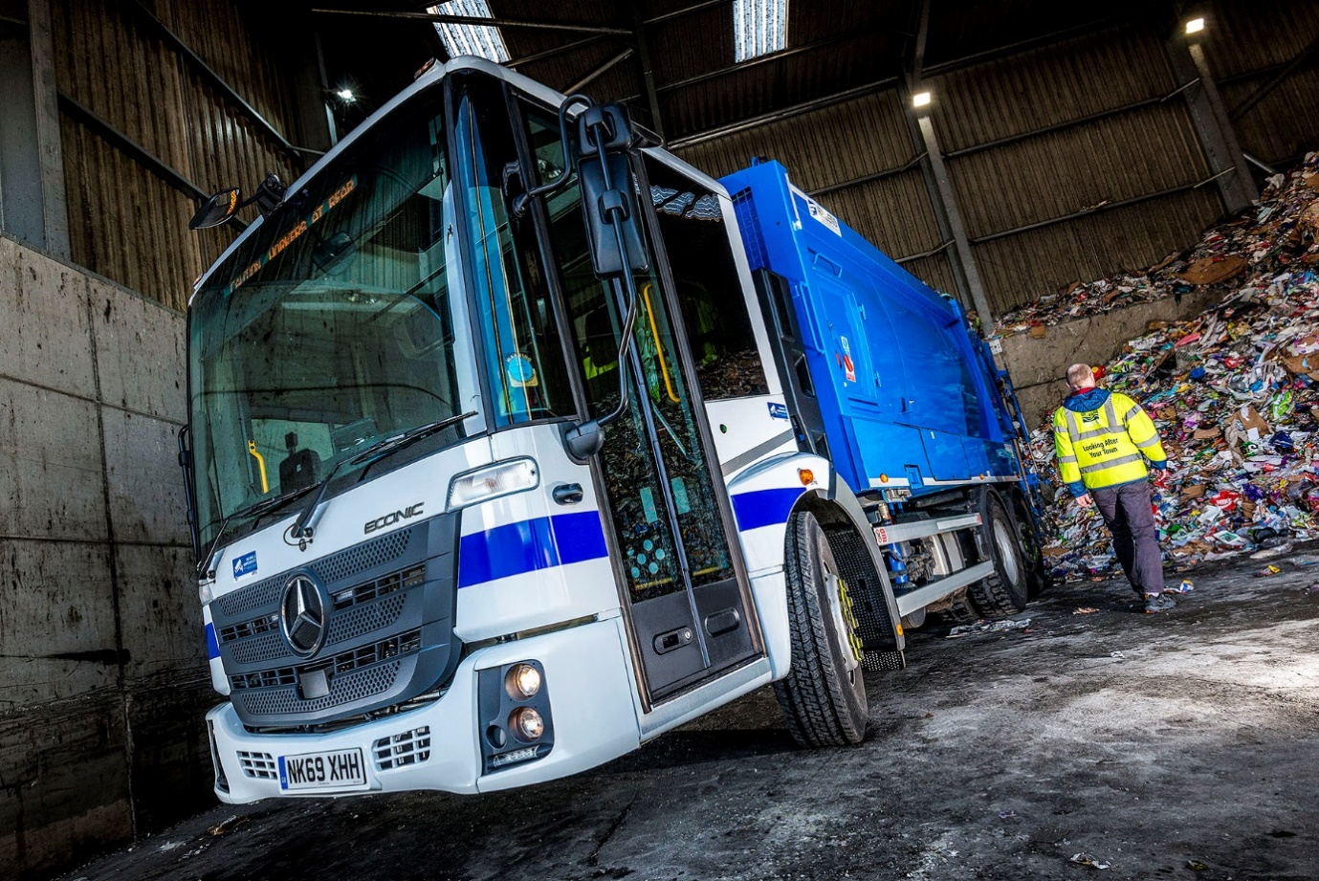

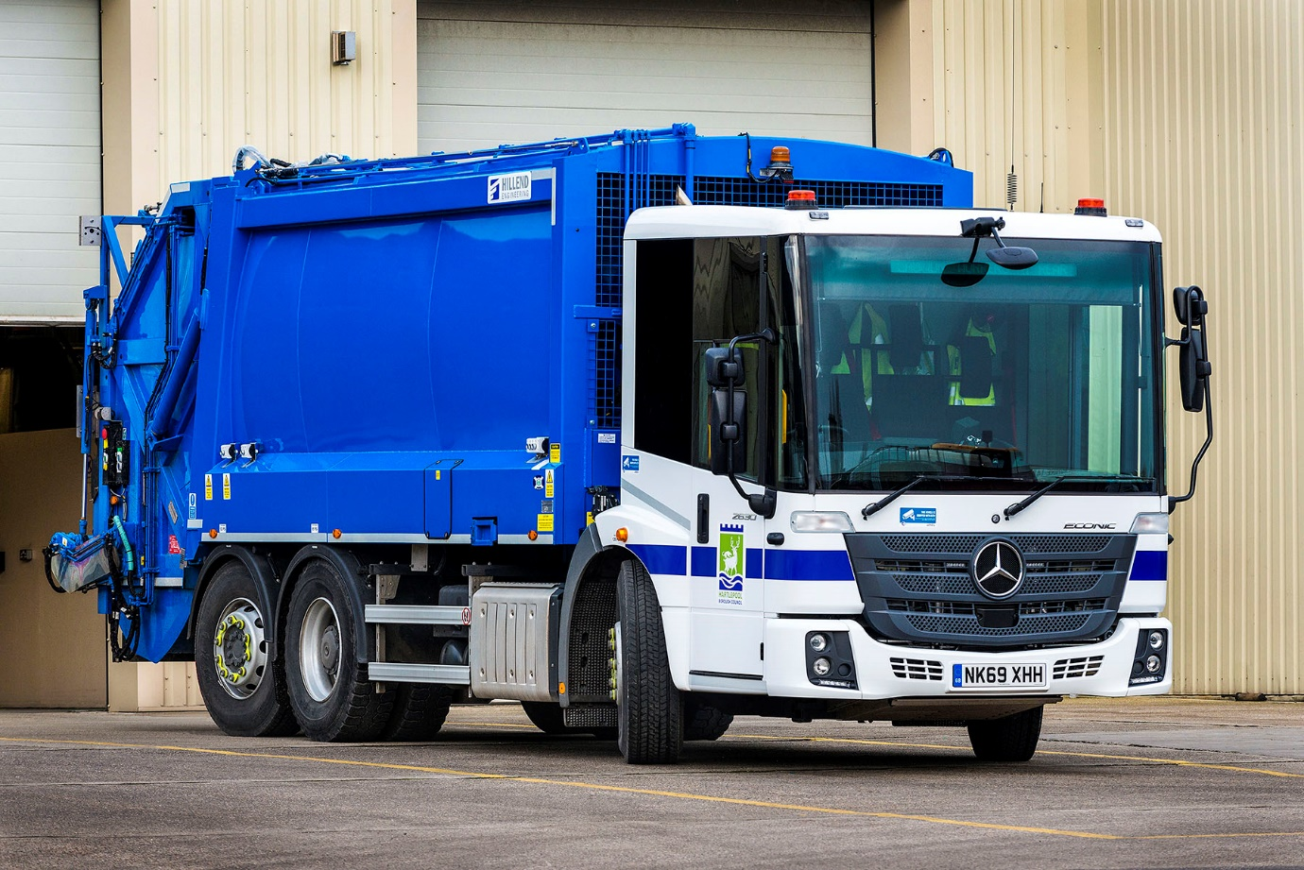
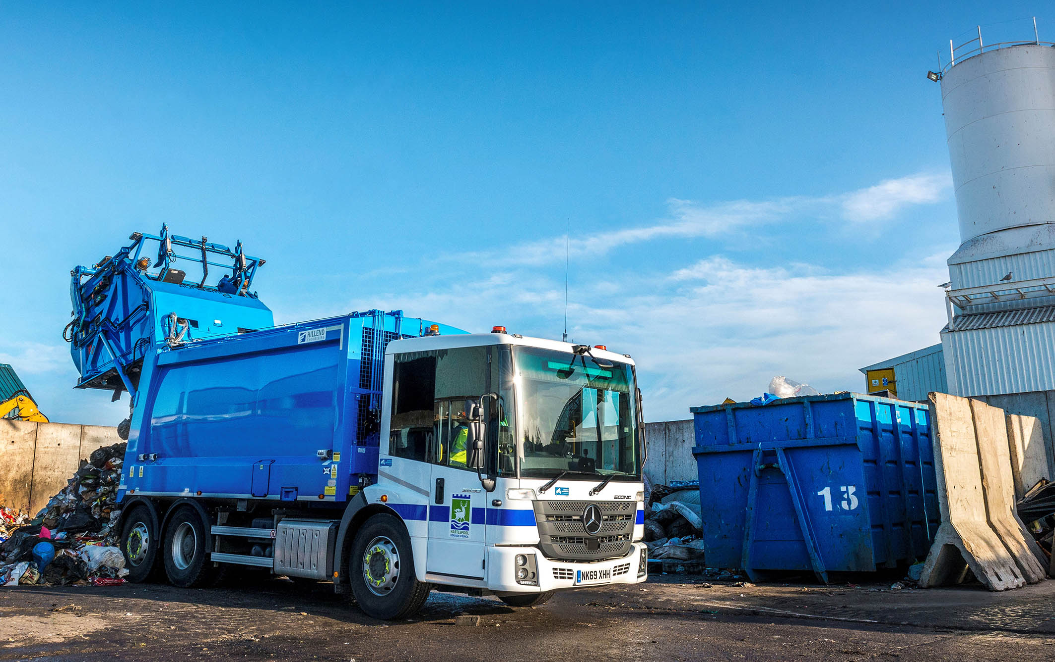

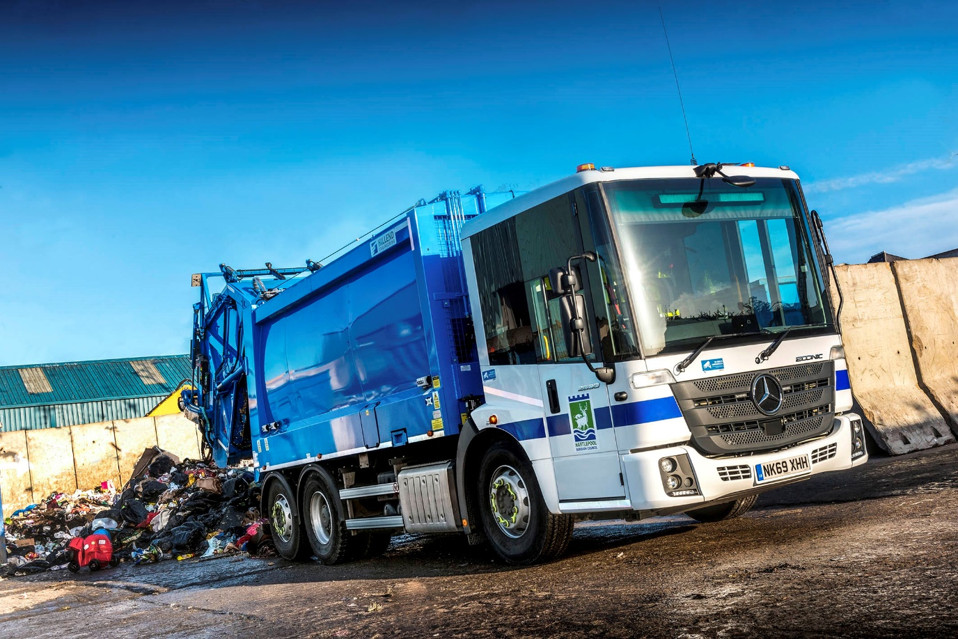

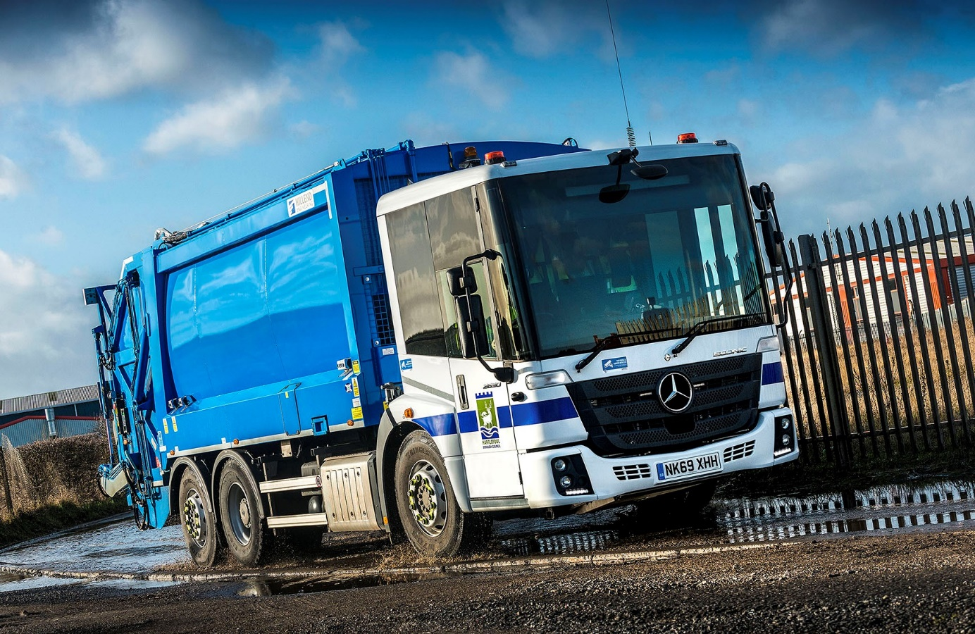

ends

For more information, or to request bigger versions of image files, please contact:
John Ripley or Steve Warren
Impact Communications, 01926 842126
John: 07771 484595, john@impactcom.co.uk
Steve: 07770 470251, steve@impactcom.co.uk

