

Date: 11 November 2019

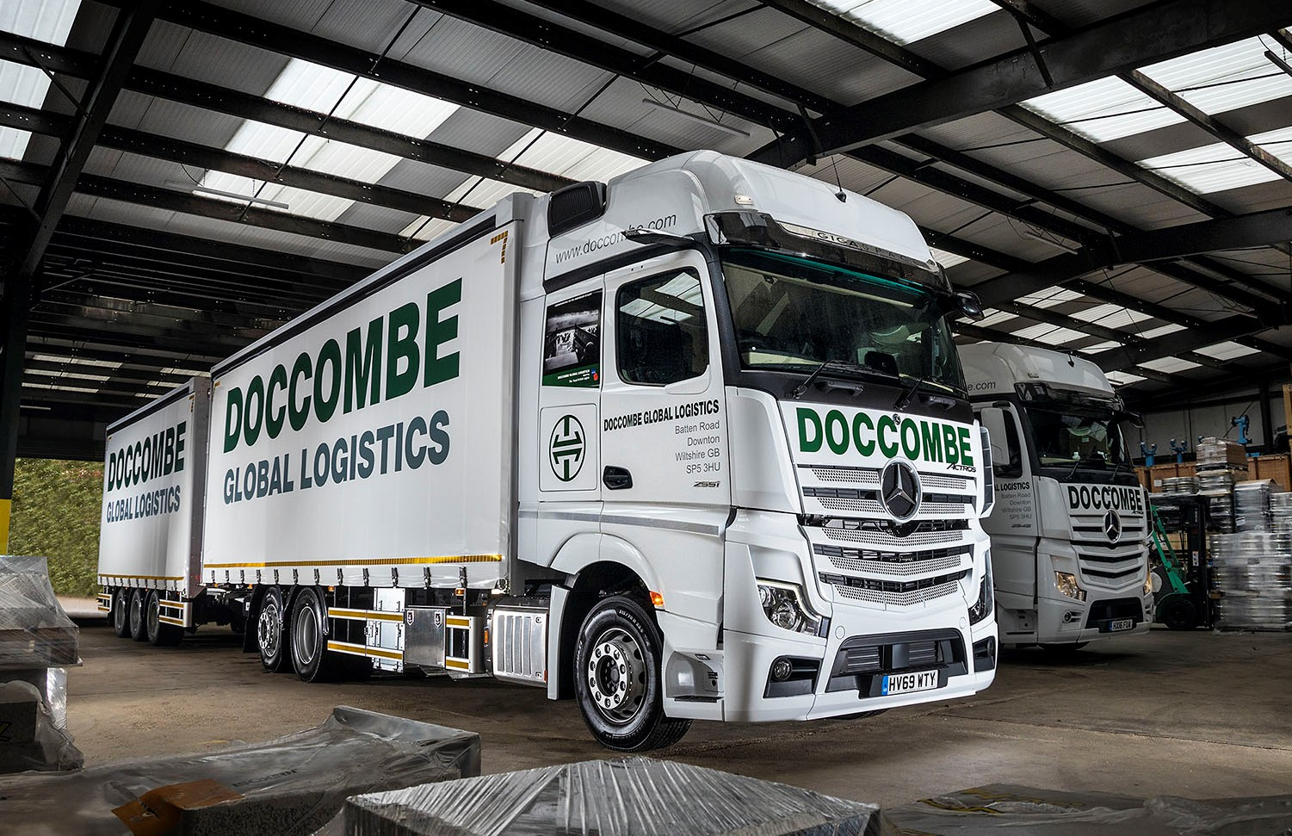

Doccombe Global Logistics’ new Mercedes-Benz Actros delivers a tribute to the D-Day fallen

Long-standing Mercedes-Benz operator Doccombe Global Logistics has commissioned one of the UK’s first new-generation Actros rigids, a smartly finished 26-tonner which was supplied by Dealer Marshall Truck & Van.

The Downton, Wiltshire-based company is a committed supporter of ex-service personnel charity the Royal British Legion. The Actros entered service shortly before Remembrance Day, and appropriately the side panels of its range-topping GigaSpace cab feature scenes which commemorate the 75th anniversary of the D-Day landings.

A 6x2 2551 variant with rear-steer axle, it is powered by a 12.8-litre in-line six-cylinder engine which produces 375 kW (510 hp), and will be maintained under a Mercedes-Benz Complete Service Contract. Its curtainside body is by Wessex Vehicle Services, of Salisbury, as is the tri-axle drawbar trailer with which it works at a Gross Train Weight of 44 tonnes.

Already a hit, the Actros will be joined by a second, identical model early next year. Marshall Truck & Van also supplied Doccombe Global Logistics in September with a pair of six-wheeled drawbar rigids from the previous Actros model generation and a 12-tonne Atego.

The company has run an all-Mercedes-Benz fleet for more than 20 years, and today’s fleet comprises trucks from 12 tonnes GVW to 44-tonne tractor units and drawbar rigs, as well as Sprinter panel vans and curtainsiders.

Managing Director John Underhill explained: “Together, Mercedes-Benz Trucks and our local Dealer Marshall Truck & Van provide a vehicle and service package which is designed and implemented for the benefit of the operator. It’s one that meets and even exceeds the expectations of those who, like us, demand the highest possible standards.

“We take nothing for granted, so we invited quotes from other manufacturers before committing to our latest order. However, on the basis of previous performance and the promise of even better fuel economy and safety standards from the new Actros, we were happy once again to place the business with Mercedes-Benz.”

The fifth-generation Actros incorporates more than 60 innovations. These include MirrorCam technology, which replaces conventional mirrors. Compact, rear-facing cameras display images of the view down each side of the vehicle on screens inside the cab. As well as enhancing safety by offering a wider and clearer field of rearward vision, MirrorCam removes previous blind spots, while its smaller, more aerodynamic profile improves fuel economy by reducing wind resistance.

The Multimedia Cockpit makes the driving experience as comfortable, engaging and easy as possible. Stylish in appearance, it features two interactive screens, and brings connectivity and intuitive operation to the fore via a new Truck Data Centre which permanently connects the truck with the Cloud.

Developments beneath the skin are no less significant. The Active Brake Assist 5 emergency braking system boasts improved pedestrian recognition capability, while the latest iteration of Predictive Powertrain Control – which uses 3D GPS mapping to ‘read’ the road ahead, then responds by managing speed, braking and the transmission to maximise fuel efficiency – offers much increased functionality. The system now covers virtually all A roads, and many B roads, and takes account not only of topography but also of corners, roundabouts, junctions and traffic signs.

“First impressions suggest that the truck’s combination of new features will benefit our drivers by providing the best working conditions,” said Mr Underhill. “Driver Adam Davenport is certainly impressed with the cab comfort, and any reservations he may have had about the extent of the new technology were quickly dispelled thanks to a comprehensive handover by Marshall’s sales executive Bill Kingsmill, who explained everything clearly.

“We’ll be monitoring the new truck’s performance closely, but confidently expect it to make a positive contribution to our ‘bottom line’ through reduced operating costs and maximum vehicle usage.”

Like the rest of Doccombe’s top-weight fleet, the Actros is assigned to long-haul runs across Europe. Meanwhile, the latest Atego is on UK-wide distribution and local pallet delivery duties. “We tend to run our Atego rigids on a four-year replacement cycle,” said Mr Underhill. “They are worked pretty hard, but have proved consistently to be extremely reliable, solid trucks, which have given us a high level of operational efficiency.”

Doccombe Global Logistics grew out of the work of the Underhill family, particularly John’s son Daniel, in running aid missions to former Eastern Bloc countries. Daniel was just 15 when, in 1990, he organised his first convoy to Romania – it was to be the first of 26 missions over the next five years. The distribution business was established in 1993, initially to support the family’s charity efforts. Gradually it became the main focus of the operation as the communities the charity was helping became self-sufficient. As Operations Director, Daniel continues to work alongside his father and co-Directors Tiggy Underhill and Matthew Shervington, all veterans of the aid convoys.

www.doccombe.com

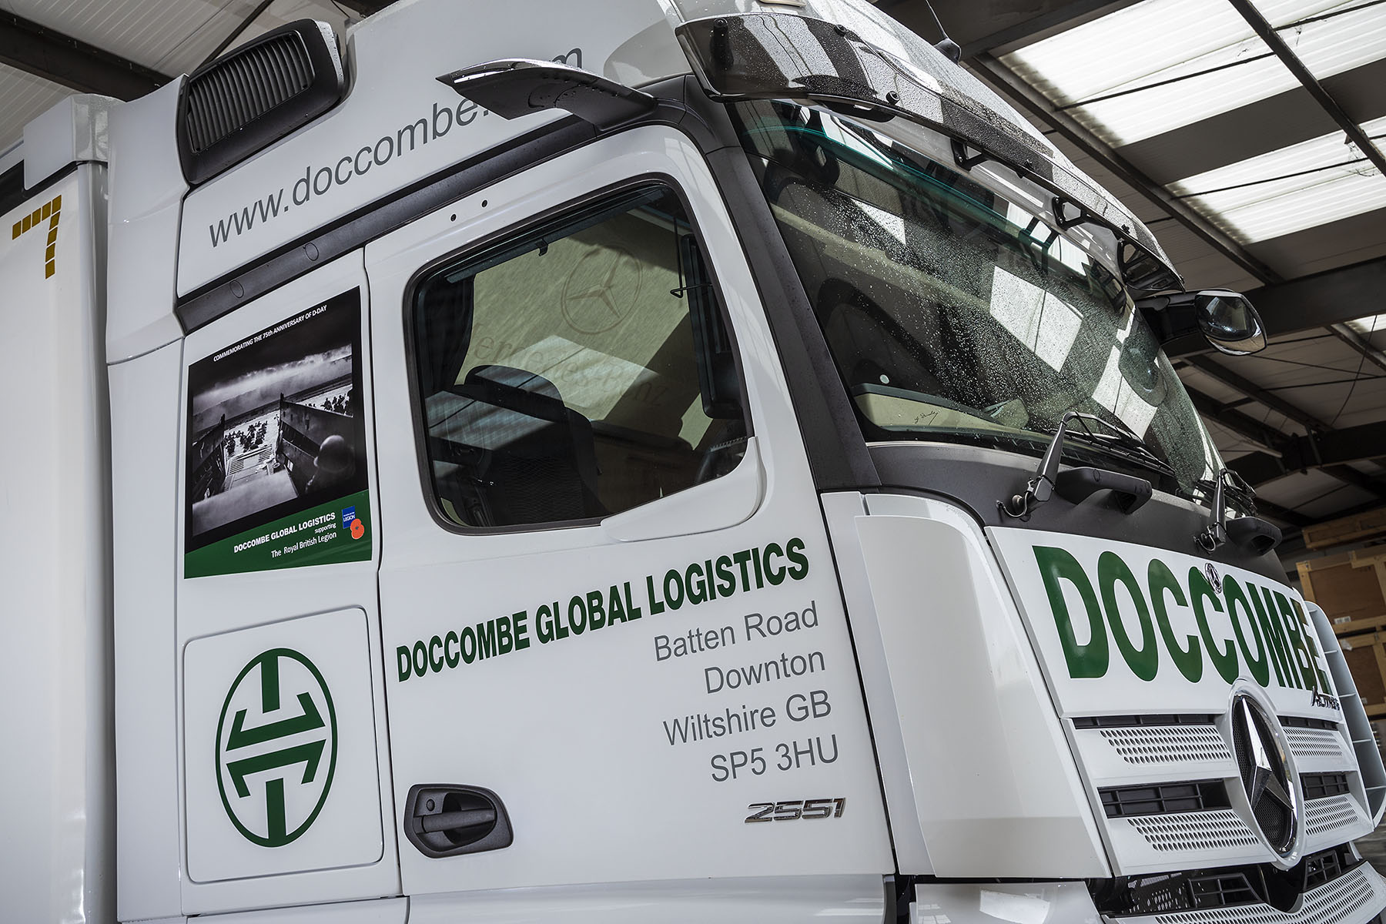

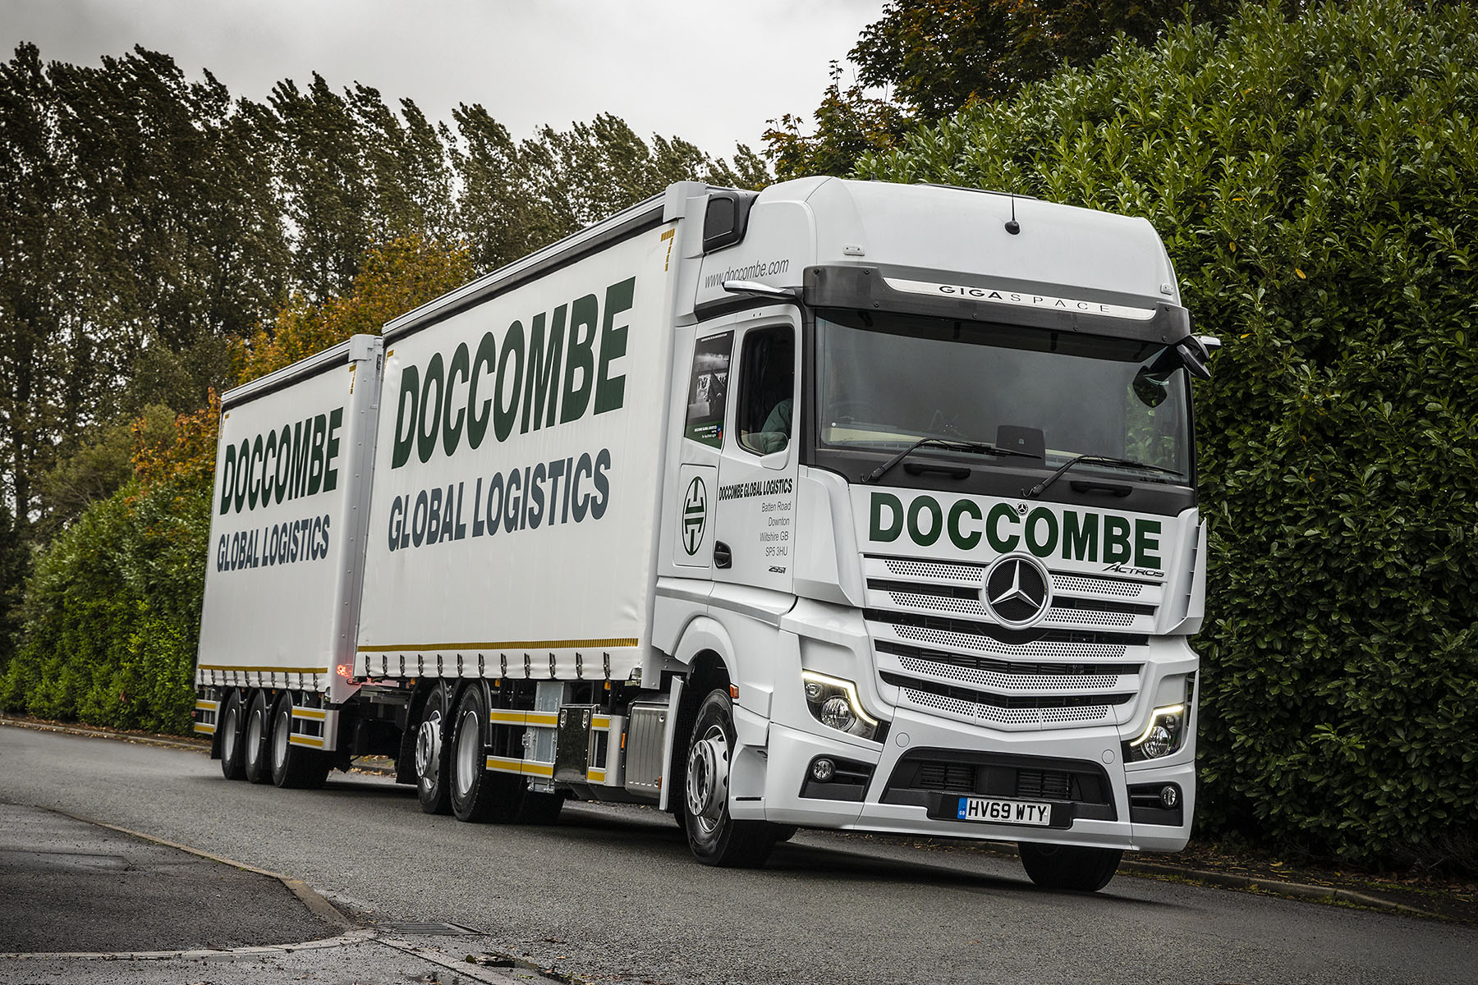

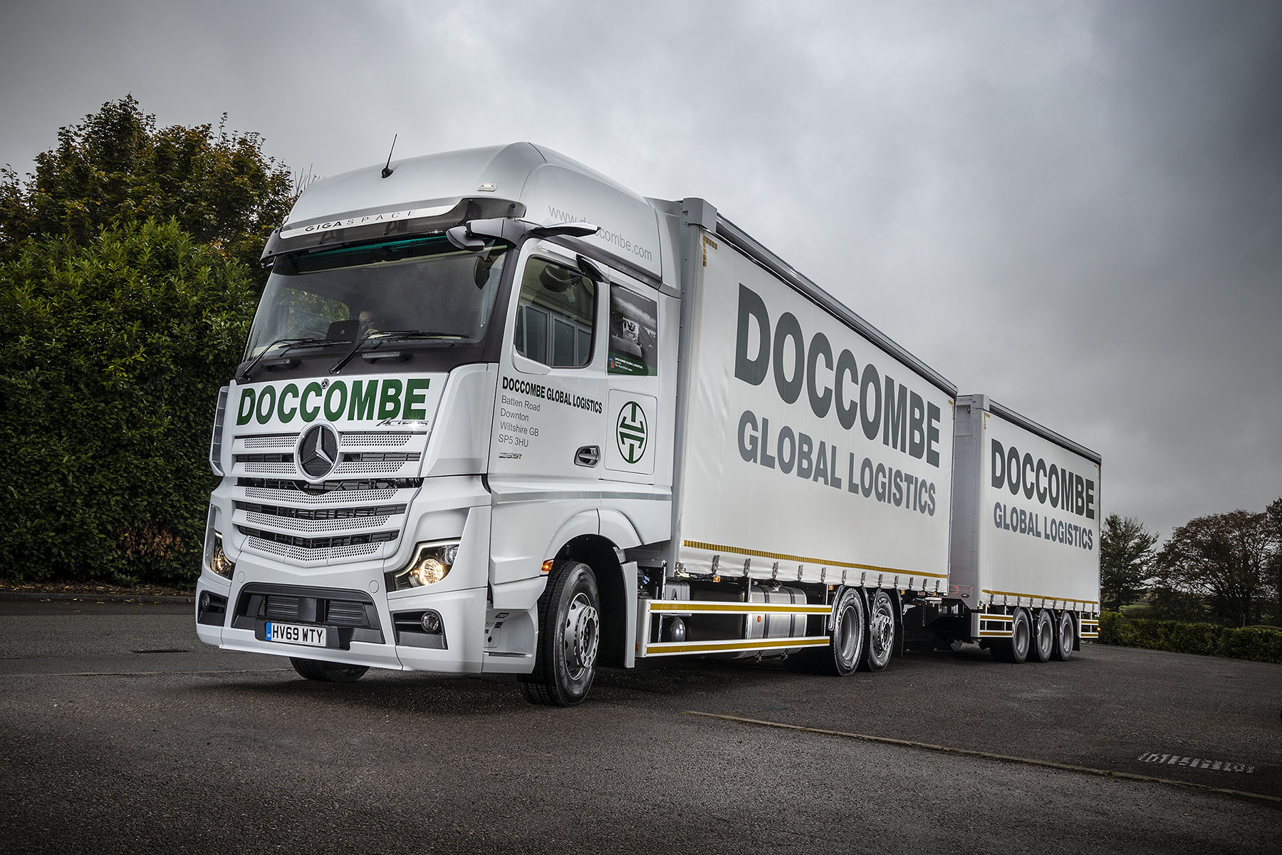

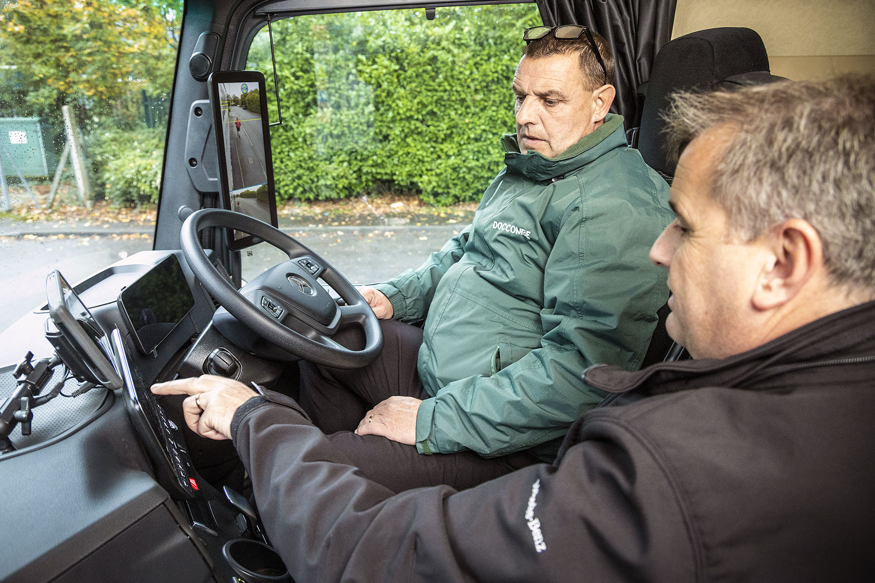

Screen time: Doccombe Global Logistics driver Adam Davenport is given a guided tour of his new truck’s Multimedia Cockpit by Marshall Truck & Van’s Bill Kingsmill

ends

For more information, or to request bigger/higher-res image files, please contact:
Steve Warren or John Ripley
Impact Communications, 01926 842126
Steve: 07770 470251, steve@impactcom.co.uk
John: 07771 484595, john@impactcom.co.uk

