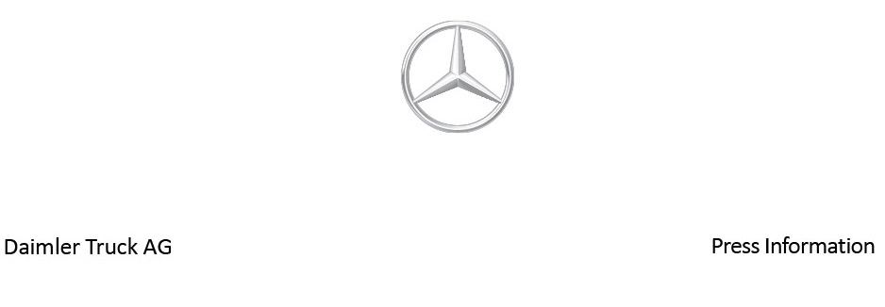

Date: 9 May 2022

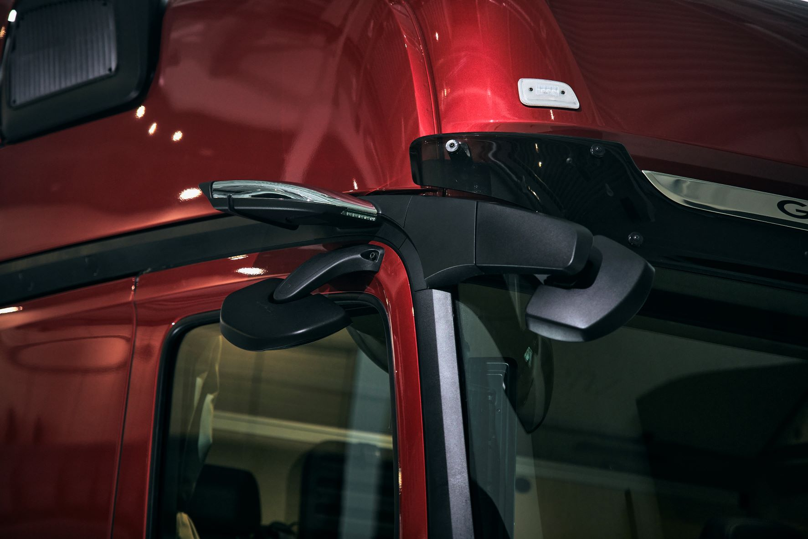

Second generation of MirrorCam:
Mercedes-Benz Trucks is evolving some important details of the mirror camera system

- Mercedes-Benz Trucks is already launching the second generation of MirrorCam

- Camera arms ten centimetres shorter on each side and new image parameters provide even better support for drivers in many road traffic situations

- Enhanced housing design further reduces camera lens debris

- An even more realistic illustration of the environment and even more image information

- Prof. Uwe Baake, Head of Product Development at Mercedes-Benz Trucks: “The intensive discussions with our customers and their experiences from day-to-day operations formed the foundations for us to make further adjustments to individual technical parameters, thereby generating even greater added value, especially in terms of display and safety.”

Stuttgart – Mercedes-Benz Trucks presented a truck with cameras instead of exterior outside mirrors back in 2014 with its study entitled “Mercedes-Benz Future Truck 2025”. In 2018, it was the first in the industry to introduce series production of MirrorCam – the first mirror camera system for trucks. A series-produced truck equipped with MirrorCam no longer had traditional main and wide-angle mirrors. Instead, it had a system consisting of two cameras attached to both sides of the roof frame as well as two portrait-format monitors attached to the A-pillars in the cab, together with the corresponding controls in the driver’s cab. A conscious decision was made to use two equally sized, 15-inch monitors on the driver’s and front passenger's sides. This is because the larger the image of a moving object, the easier it is to judge its speed. For the driver to identify the image information relevant to the situation as quickly as possible, a complex, multi-quadrant view was also replaced by a single image.

Mercedes-Benz Trucks has now updated MirrorCam for the first time. With the second generation, available for the Actros and Arocs as well as eActros series since April 2022, Mercedes-Benz Trucks has evolved important details of the system, winning several Innovation Awards. Prof. Uwe Baake, Head of Product Development at Mercedes-Benz Trucks, explains: “The intensive discussions with our customers and their experiences from day-to-day operations formed the foundations for us to make further adjustments to individual technical parameters, thereby generating even greater added value, especially in terms of display and safety.”

In addition to improved aerodynamics and correspondingly lower fuel consumption and energy requirements, MirrorCam has brought about increased road safety, given that where the glass mirrors previously concealed large areas (‘blind spots’) to the sides of the A-pillar, MirrorCam does not obstruct the field of vision. This is particularly beneficial at junctions, when manoeuvring, and in tight bends. Furthermore, the electronic system uses functions such as semi-trailer tracking or special views for challenging manoeuvring tasks to make everyday operations easier for professional drivers.

Less is more: Shorter camera arms are beneficial

The exterior of the second MirrorCam generation stands out because the camera arms on both sides have been shortened by ten centimetres. This applies to both the narrower and wider cab and, among other advantages, allows drivers to reverse in a straight line more easily than with the first MirrorCam generation. This comes as a result of MirrorCam’s perspective now being even more akin to that of conventional glass mirrors. Shorter dimensions bring about another benefit because with the 2.5 metre-wide cab, the camera arm now protrudes no further than the kerb mirror which is within the driver’s sight. Collisions with objects at the edge of the road are now virtually impossible. As chassis widths are identical, this also applies to the 2.3 metre-wide cab variant.

Further optimised image parameters on MirrorCam

As part of the revision of the camera-based system, Mercedes-Benz Trucks has also evolved further features. For example, the revised MirrorCam arms now incorporate an enhanced housing design which further reduces the risk of debris obscuring the camera lens and causing undesirable visual effects. In addition, engineers at Mercedes-Benz Trucks have further optimised the tone mapping – tone mapping is a process in which an image is adapted so that a large range of tones are displayed correctly on a medium – reflected primarily as an improved contrast display. The camera system’s evolution in colour and brightness adaptation, which is already very bright in itself, means that the displays show the area relevant to the driving situation even more accurately when the vehicle is reversing into a dark or poorly lit facility, for example.

Committed to safety and driver convenience

These revisions result in an even higher added value for MirrorCam overall. Thanks to its supporting effect, the enhanced system can help to manage situations such as overtaking, manoeuvring, driving in poor visibility and darkness, cornering and passing narrow spaces even more safely and without causing stress. The existing advantages are still available, such as wide-angle mode when reversing, distance lines on the display for better assessing the distance from objects behind the vehicle being driven, camera image panning when cornering, and monitoring of the vehicle’s surroundings during rest periods.

The interaction between MirrorCam and the cornering assistant from Mercedes-Benz Trucks has already proved helpful, especially in complex traffic situations and at confusing junctions. If, contrary to expectations, there is a risk that a truck driver fails to spot a cyclist or pedestrian when turning left, Sideguard Assist can – within its system limits – warn the driver as part of a multi-stage process, using the MirrorCam display to provide visual warnings.

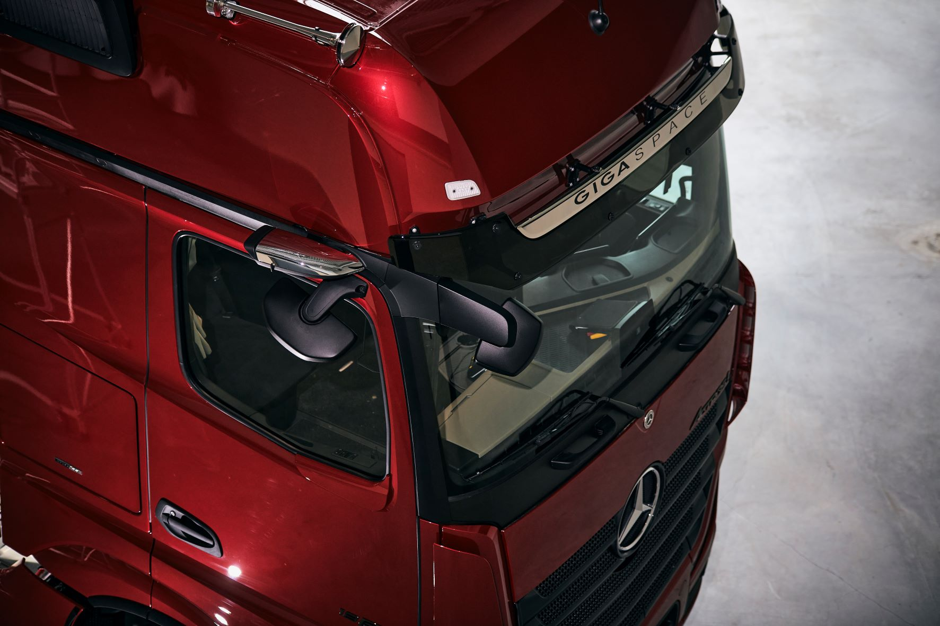
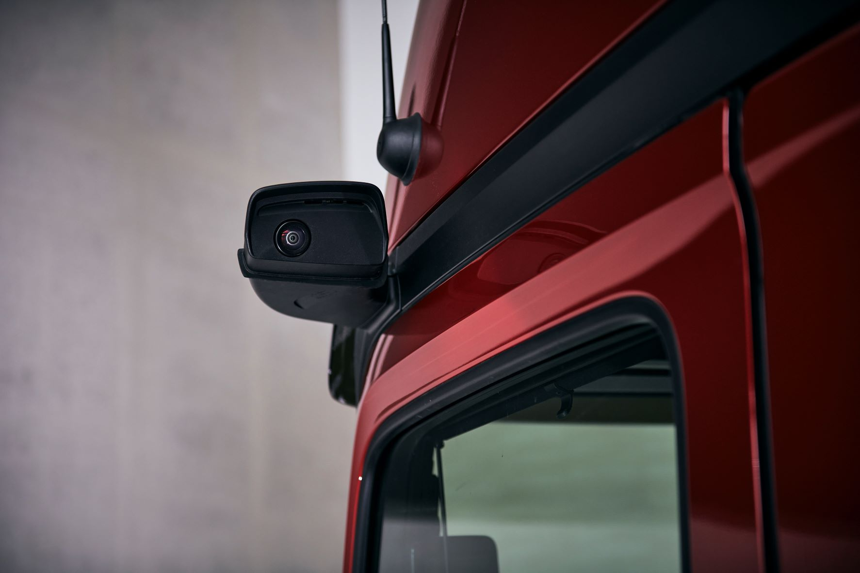

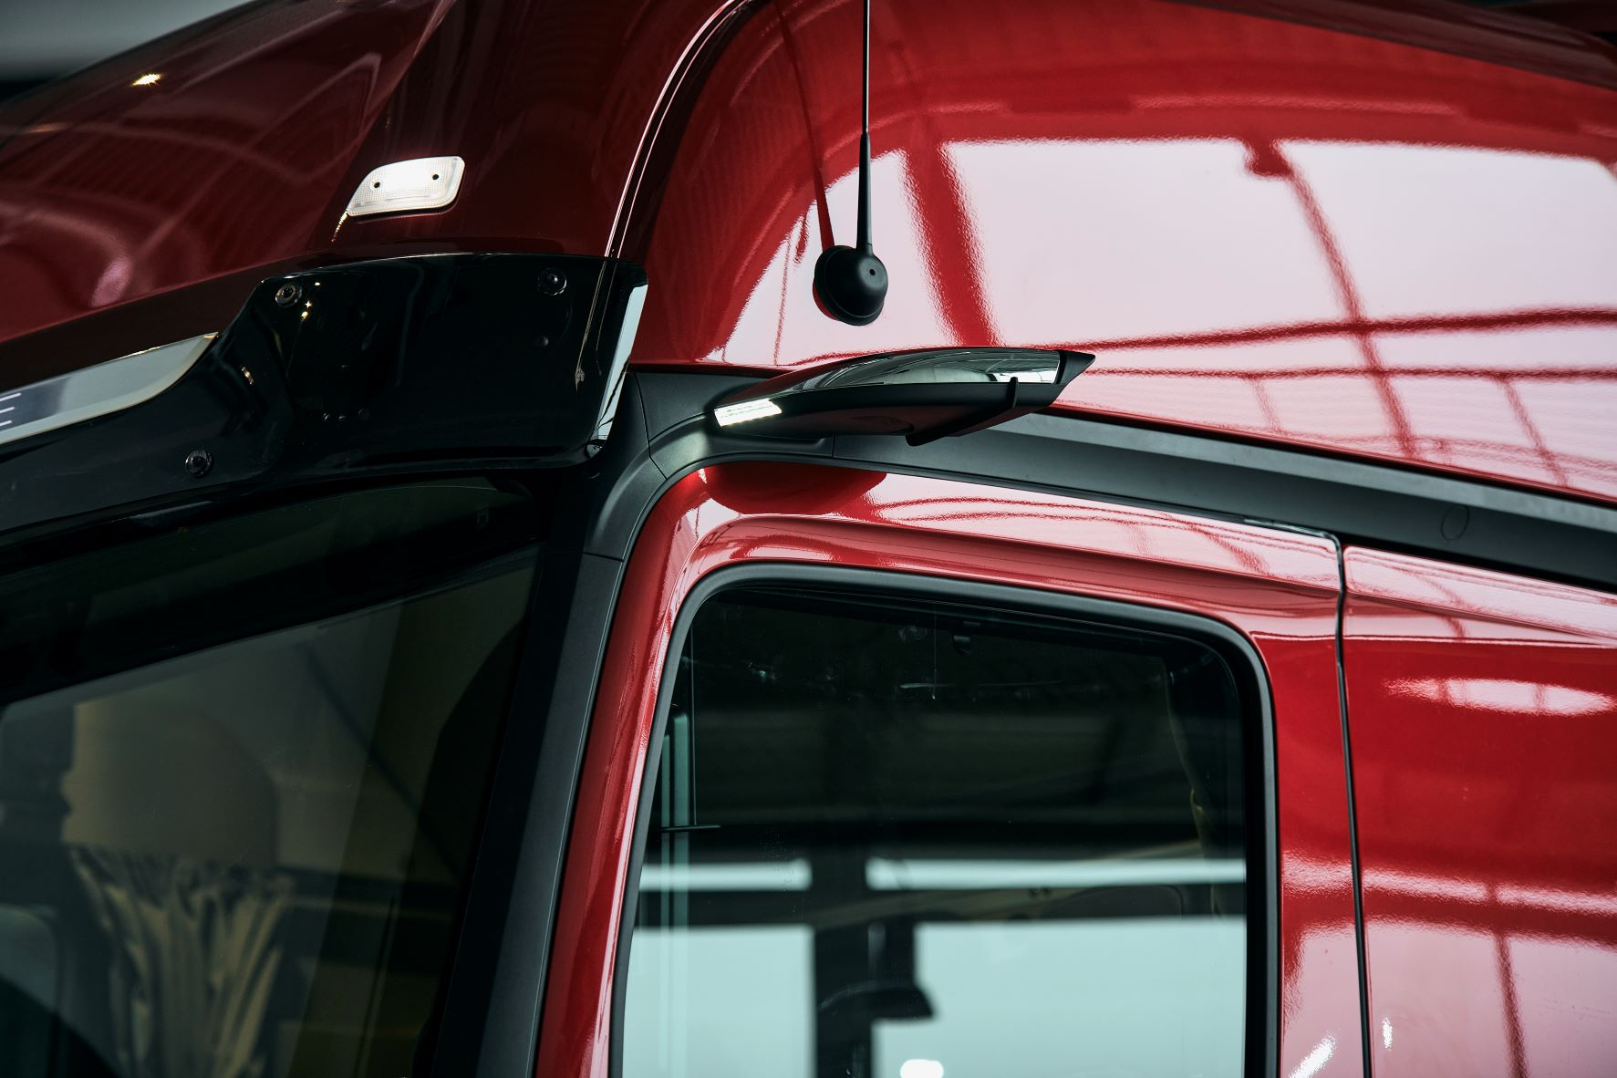

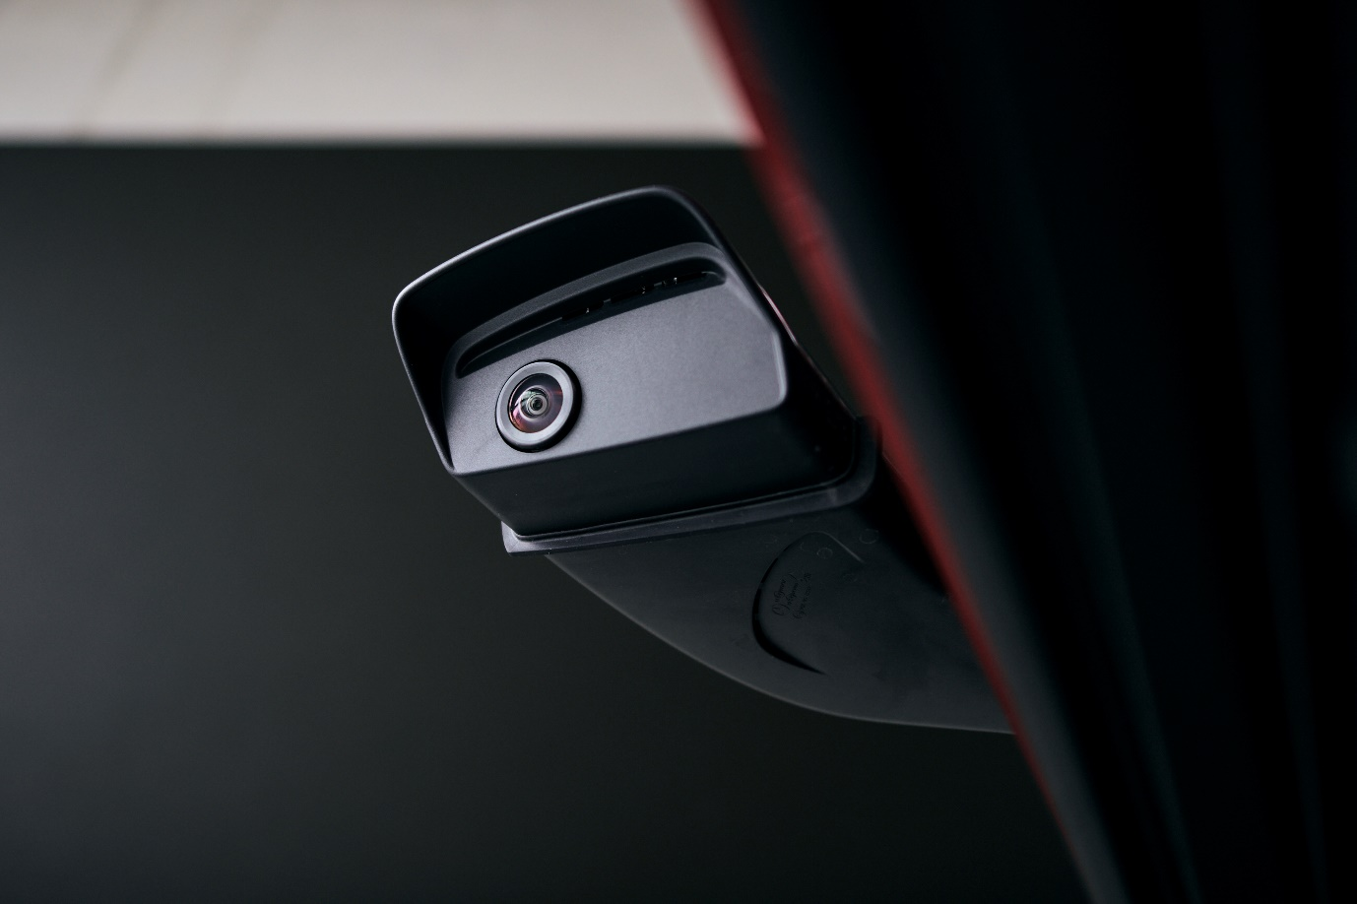

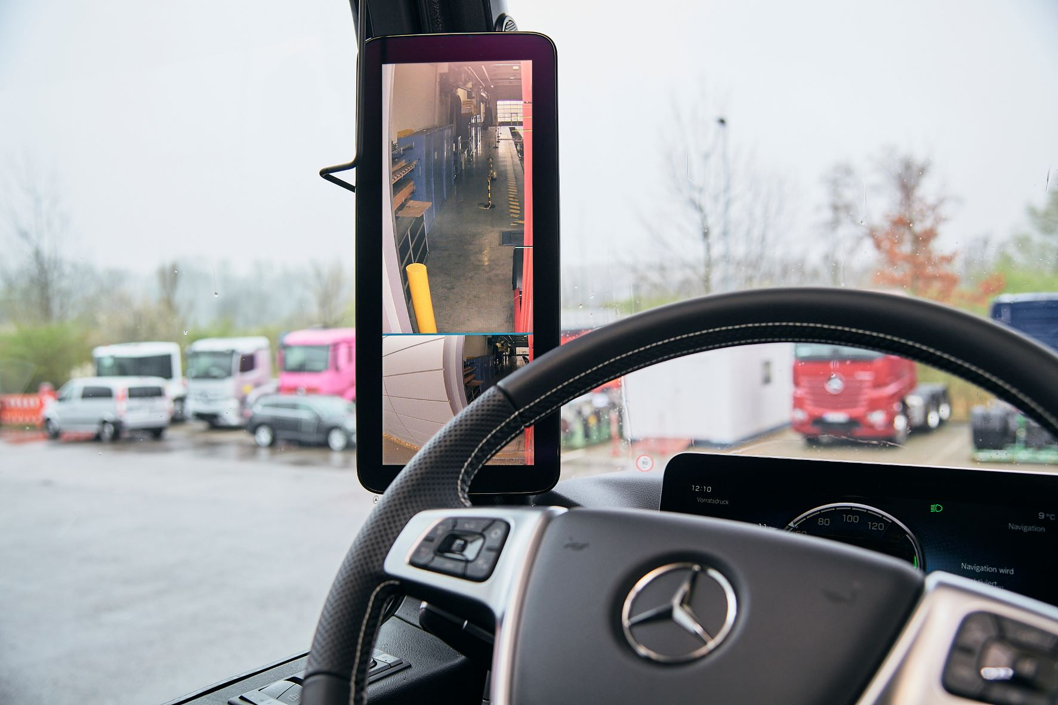

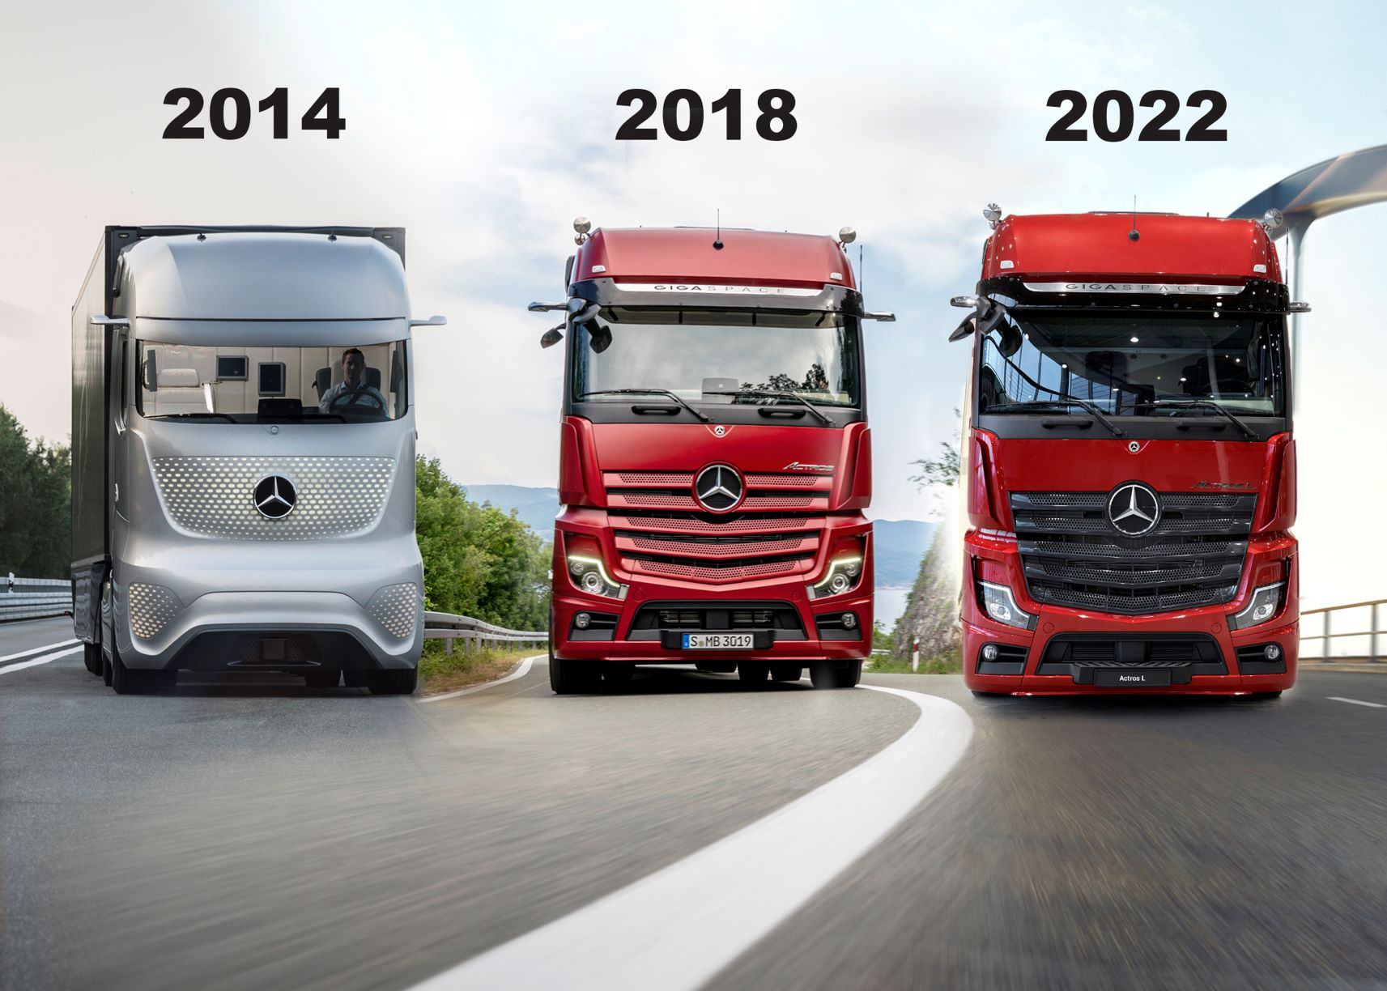

ends

For more information, please contact:

Jamie Fretwell at Mercedes-Benz Trucks UK Ltd
07712 519230, jamie.fretwell@daimler.com

or

Steve Warren or John Ripley
Impact Communications
Steve: 07770 470251, steve@impactcom.co.uk
John: 07771 484595, john@impactcom.co.uk

or

Carola Pfeifle, +49 160 8612423, carola.pfeifle@daimlertruck.com
Ulrike Burkhart, +49 160 861 3757, ulrike.burkhart@daimlertruck.com

Further information about Daimler Truck is available at:
www.media.daimlertruck.com and www.daimlertruck.com

Forward-looking statements:
This document contains forward-looking statements that reflect our current views about future events. The words “anticipate,” “assume,” “believe,” “estimate,” “expect,” “intend,” “may,” ”can,” “could,” “plan,” “project,” “should” and similar expressions are used to identify forward-looking statements. These statements are subject to many risks and uncertainties, including an adverse development of global economic conditions, in particular a decline of demand in our most important markets; a deterioration of our refinancing possibilities on the credit and financial markets; events of force majeure including natural disasters, pandemics, acts of terrorism, political unrest, armed conflicts, industrial accidents and their effects on our sales, purchasing, production or financial services activities; changes in currency exchange rates, customs and foreign trade provisions; a shift in consumer preferences towards smaller, lower-margin vehicles; a possible lack of acceptance of our products or services which limits our ability to achieve prices and adequately utilize our production capacities; price increases for fuel or raw materials; disruption of production due to shortages of materials, labor strikes or supplier insolvencies; a decline in resale prices of used vehicles; the effective implementation of cost-reduction and efficiency-optimization measures; the business outlook for companies in which we hold a significant equity interest; the successful implementation of strategic cooperations and joint ventures; changes in laws, regulations and government policies, particularly those relating to vehicle emissions, fuel economy and safety; the resolution of pending government investigations or of investigations requested by governments and the conclusion of pending or threatened future legal proceedings; and other risks and uncertainties, some of which are described under the heading “Risk and Opportunity Report” in this Annual Report. If any of these risks and uncertainties materializes or if the assumptions underlying any of our forward-looking statements prove to be incorrect, the actual results may be materially different from those we express or imply by such statements. We do not intend or assume any obligation to update these forward-looking statements since they are based solely on the circumstances at the date of publication.

Daimler Truck at a glance
Daimler Truck Holding AG ("Daimler Truck") is one of the world's largest commercial vehicle manufacturers, with over 40 main locations and more than 100,000 employees around the globe. The founders of Daimler Truck have invented the modern transportation industry with their trucks and buses a good 125 years ago. Unchanged to this day, the company's aspirations are dedicated to one purpose: Daimler Truck works for all who keep the world moving. Its customers enable people to be mobile and get goods to their destinations reliably, on time, and safely. Daimler Truck provides the technologies, products, and services for them to do so. This also applies to the transformation to CO2-neutral driving. The company is striving to make sustainable transport a success, with profound technological knowledge and a clear view of its customers' needs. Daimler Truck's business activities are structured in five reporting segments: Trucks North America (TN) with the truck brands Freightliner and Western Star and the school bus brand Thomas Built Buses. Trucks Asia (TA) with the FUSO and BharatBenz commercial vehicle brands. Mercedes-Benz (MB) with the truck brand of the same name. Daimler Buses (DB) with the Mercedes-Benz and Setra bus brands. Daimler Truck's new Financial Services business (DTFS) constitutes the fifth segment, the product range in the truck segments includes light, medium and heavy trucks for long-distance, distribution and construction traffic and special-purpose vehicles used mainly in the municipal and vocational sector. The product range of the bus segment includes city buses, school buses and intercity buses, coaches and bus chassis. In addition to the sale of new and used commercial vehicles, the company also offers aftersales services and connectivity solutions.

