

Date: 17 June 2019

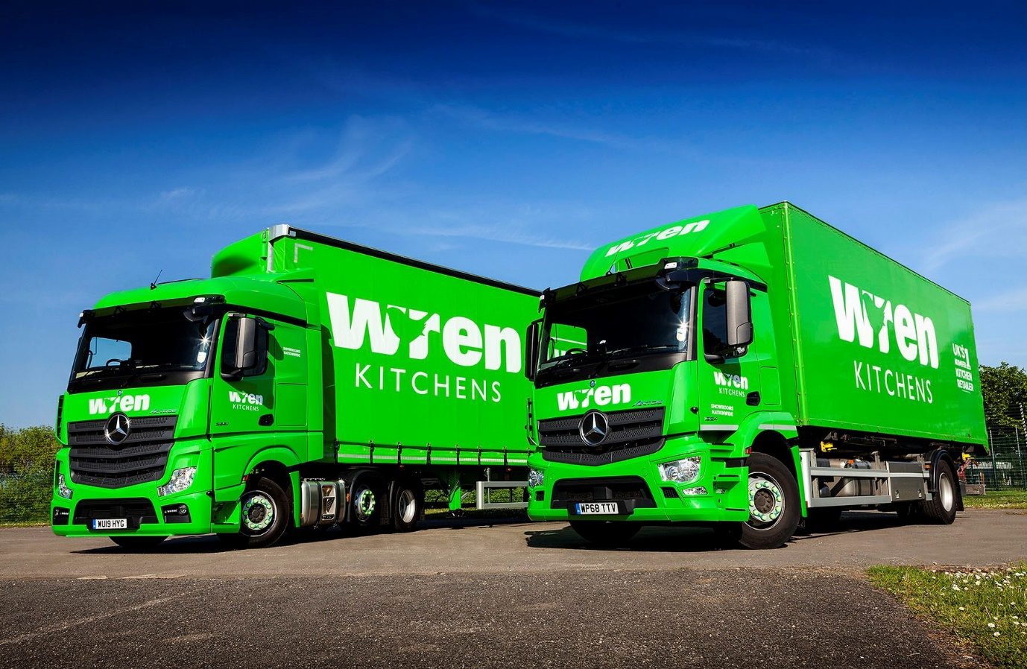

Mercedes-Benz Dealer Rygor Commercials serves up a new fleet of 43 trucks for Wren Kitchens

Wren Kitchens has marked its 10th anniversary by commissioning its first 12 Mercedes-Benz trucks, with Dealer Rygor Commercials set to deliver another 31 vehicles over the course of the summer.

The order reflects the privately-owned designer, manufacturer, and retailer’s absolute commitment to safety, as well as the reliability and fuel-efficiency for which Mercedes-Benz and FUSO trucks are renowned.

Other important factors behind Wren Kitchens’ decision were the premium brand values associated with the three-pointed star, and the promise of timely, customer-focused back-up from members of the Mercedes-Benz Trucks UK Dealer network – its new trucks will be maintained under Mercedes-Benz Complete Service Contracts.

Finished in Wren Kitchens’ vibrant lime green livery, a pair of Actros tractor units and 10 fully air-suspended Antos 18-tonners with demountable box bodies are already in service. The remaining trucks will all be rigids and will also work with swap bodies – next come 10 7.5-tonne FUSO Canters, then another 21 18-tonne Antos, most of which will pull drawbar trailers.

Customers visiting Wren Kitchens’ 78 state-of-the-art showrooms nationwide benefit from bespoke design at affordable prices. Established in 2009, the company operates from headquarters in Barton-Upon-Humber, North Lincolnshire, employs more than 4,000 people, and takes pride from the fact that all of its kitchens are manufactured in the UK.

Wren Kitchens’ new tractor units are Actros 2551 models with 12.8-litre straight-six engines producing 375 kW (510 hp), and aerodynamic StreamSpace cabs. Both are assigned to the operator’s new quartz work surface manufacturing venture – as LnR variants they have low frame heights, which enables them to work with its four new ‘swan-neck’ double-deck trailers by Cartwright.

While the tractors came as standard with Mercedes-Benz Safety Packs, Wren Kitchens ticked the options box to specify these on its 18-tonne rigids as well. The Safety Pack comprises Active Brake Assist 4 emergency braking technology with pioneering pedestrian recognition capability, as well as the Proximity Control Assist system and a driver’s airbag.

The Antos have extended M- ClassicSpace day cabs and, as 1824 versions, employ 7.7-litre six-cylinder engines that deliver 175 kW (238 hp). Their box bodies are by Abel Demountable Systems. Sixteen of the Antos which have yet to arrive are being equipped for drawbar trunking operations to outbases – the majority will tow trailers carrying second bodies of the same size, but six will be ‘road trains’ that pull two smaller boxes on the trailer.

These smaller bodies will be transferred from the Antos to the 7.5-tonne vehicles – including the new FUSO Canters – which Wren Kitchens employs to make ‘final mile’ deliveries to customer locations where access is restricted, or where the size of the consignment does not warrant a bigger vehicle.

A payload advantage of some 200 kg compared to its established 7.5-tonne chassis was key to Wren Kitchens’ decision to order its first FUSO trucks. All will be Canter 7C18 models with high-torque 3.0-litre engines producing 129 kW (175 hp) and driving through smooth-shifting dual clutch DUONIC automated manual transmissions.

As Wren Kitchens’ Vice-President of Transport, Lee Holmes is responsible for a fleet of 152 trucks which is currently dominated by a French manufacturer and, at 7.5 tonnes GVW, by another Japanese marque. “We’ve been growing fast, and opening new outbases, so decided the time was right to review our existing arrangements,” he explained.

“We undertook an evaluation process, trialled various demonstrators and met everyone we wanted to speak to. The candidates for our business were gradually whittled down and we ended up with Mercedes-Benz and Rygor Commercials.

“Ultimately, it was Mercedes-Benz Trucks’ leadership in the field of safety that really swung it for us. Nothing is more important to Wren Kitchens than the protection of our employees and, indeed, of other vulnerable road users. We were particularly impressed, therefore, with the Active Brake Assist 4 system’s ability to intervene and prevent an accident in the event that a pedestrian steps in front of the truck.”

Active Brake Assist 4 employs multi-mode radar to monitor moving and stationary objects in front of the vehicle from a speed of 15 km/h, and sounds an audible warning when it senses potential for a collision. If the driver takes no action, it will apply staged braking followed by full braking power to prevent a crash, or dramatically reduce the effects of an impact. The system is looking for moving pedestrians from a standstill, even one stepping into the truck’s path from behind a parked car, and can apply partial braking, simultaneously activating acoustic and visual warnings, up to a speed of 50km/h.

Proximity Control Assist, meanwhile, works in conjunction with the truck’s cruise control to restrict speed and maintain a pre-set distance from a vehicle in front. This system reduces the risk of rear-end shunts and promotes more comfortable, stress-free driving in nose-to-tail traffic.

Mr Holmes continued: “We’re a high-end manufacturer so Mercedes-Benz complements our image profile perfectly, while the first trucks on the road have made an excellent start – the fuel figures are promising and the driver feedback has been excellent.

“The avoidance of unplanned downtime will also be crucial,” he added. “The fact that our distribution model is based on the operation of vehicles with demountable bodies means that if a vehicle is off the road we can’t just go out and hire a replacement. I’m confident that with the support of the Mercedes-Benz network, our new trucks will live up to their reputation for reliability.”

Mr Holmes also praised the service he and his team had received from Rygor Commercials’ Fleet Sales Specialist Chris Carter. “Chris has always been available to answer any queries, and has done everything we could have asked,” he reported.

Chris Carter commented: “Rygor Commercials is committed to Setting Standards and proud to be doing business with Wren Kitchens, a high-profile leader in its field. This prestigious order underscores our ability to provide national fleet operators with truck acquisition packages which are perfectly tailored to meet the most exacting of requirements.”

www.wrenkitchens.com

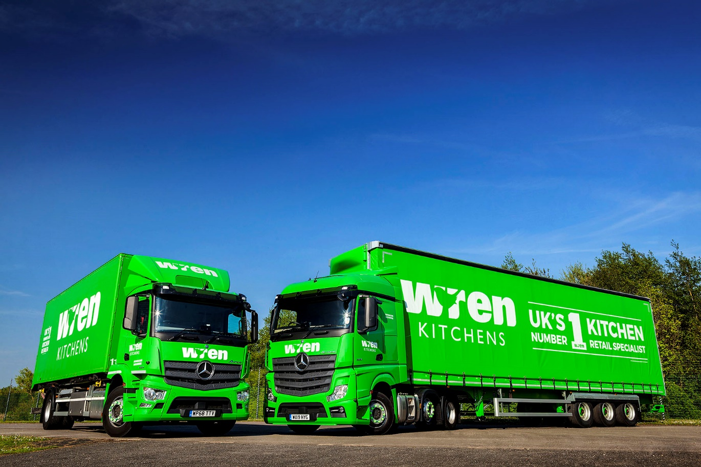

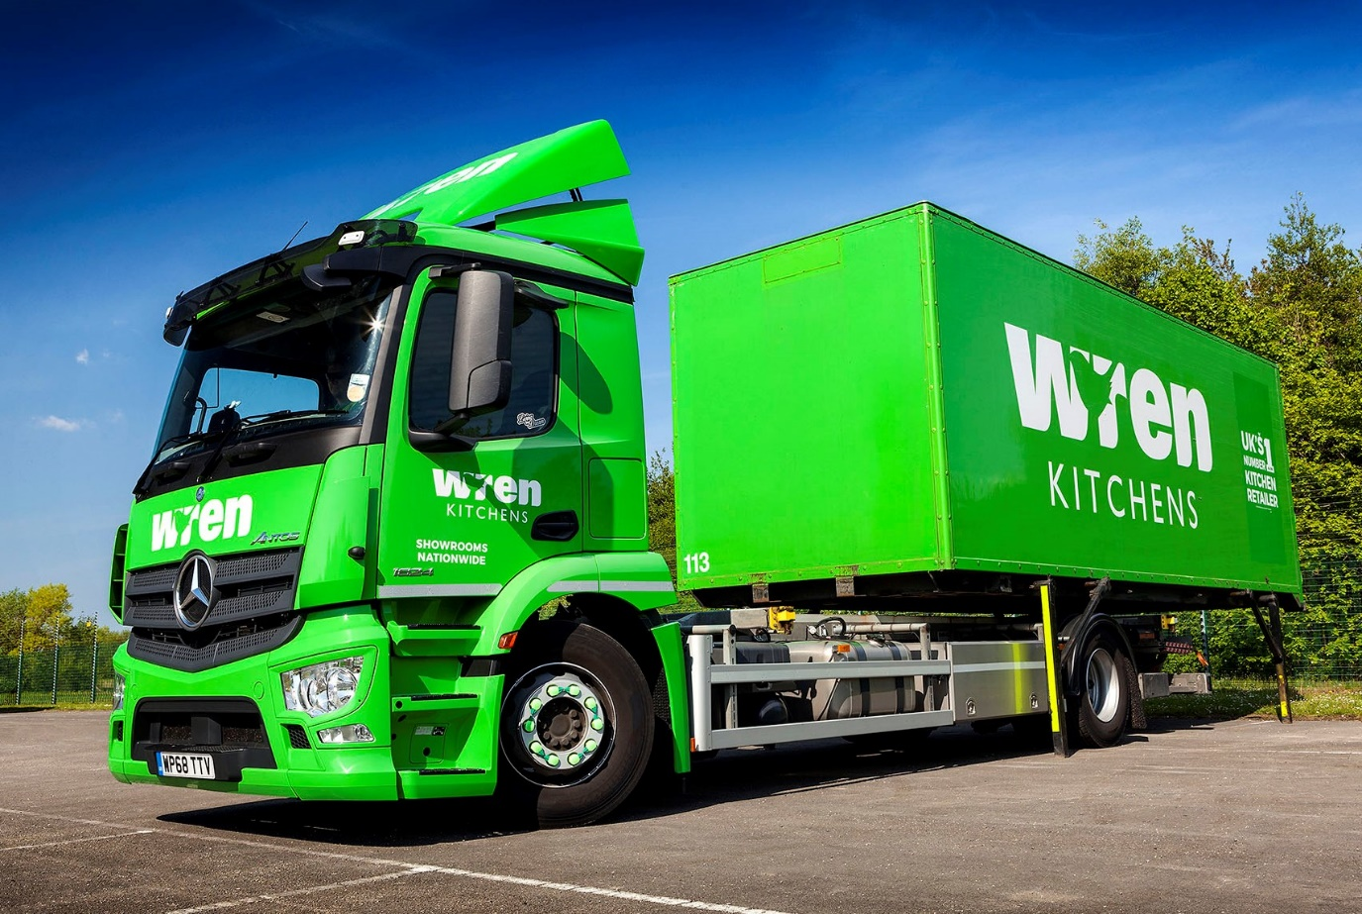

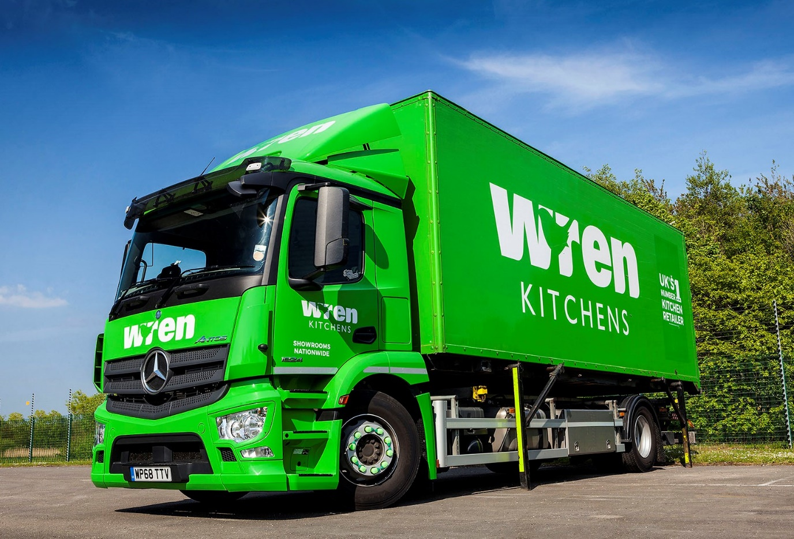

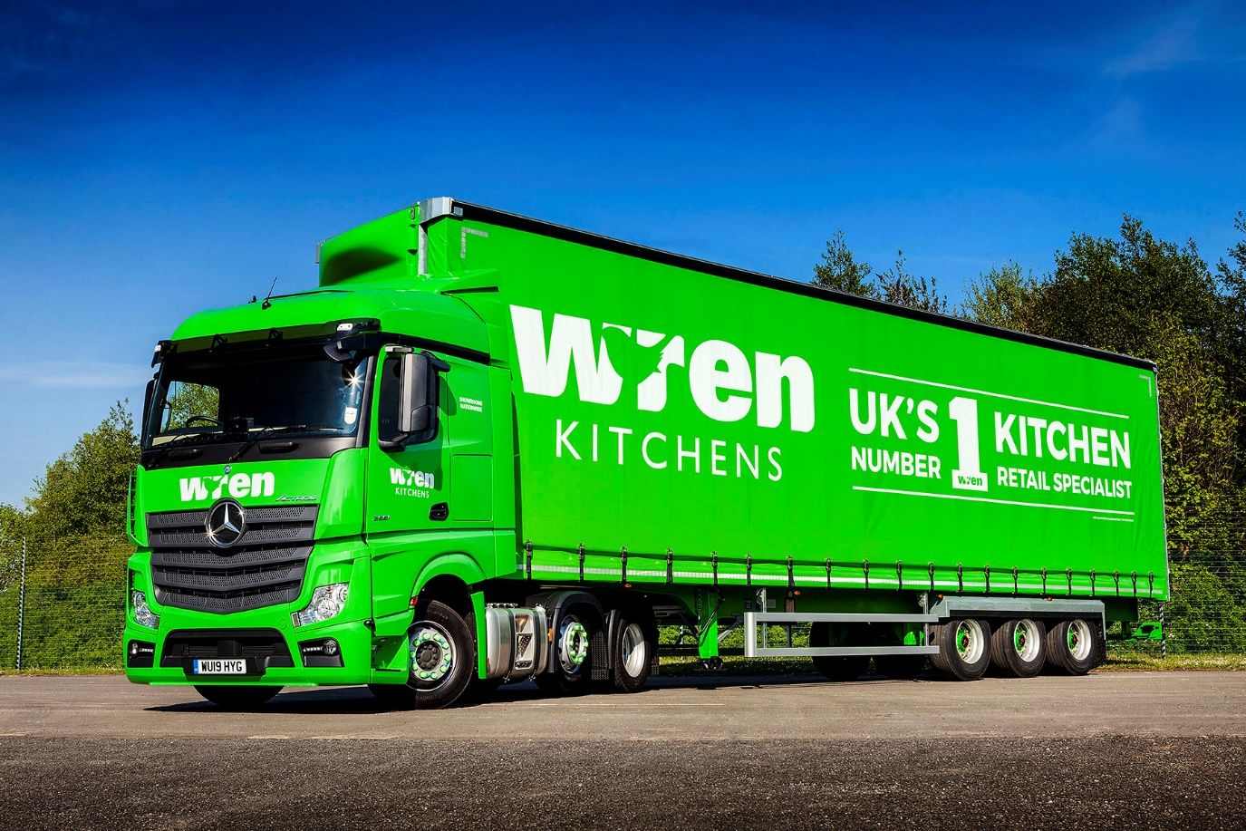

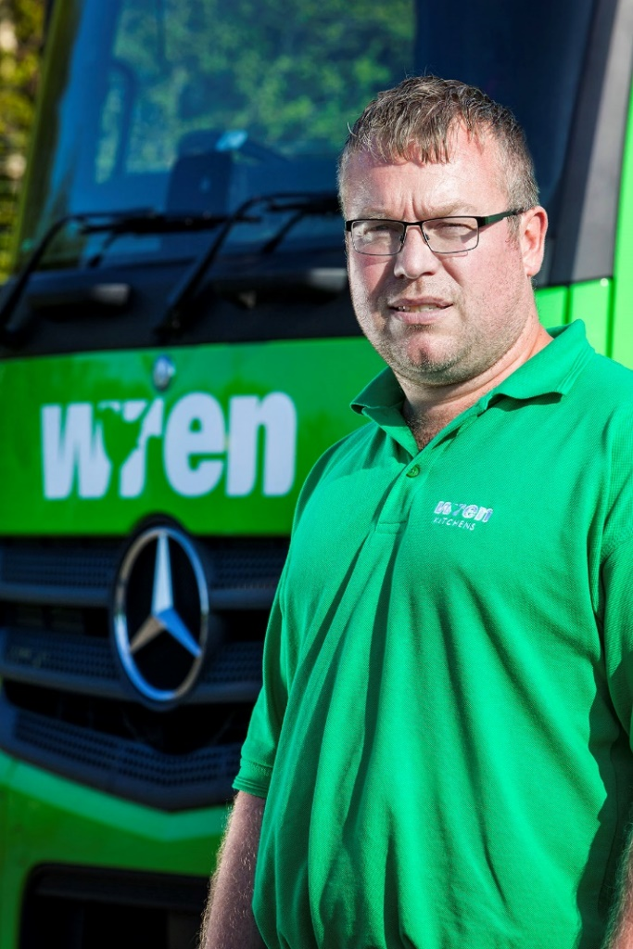

Putting safety first: Wren Kitchens’ Vice-President of Transport Lee Holmes
ends

For more information, or to request bigger/higher-res image files, please contact:
Steve Warren or John Ripley
Impact Communications, 01926 842126
Steve: 07770 470251, steve@impactcom.co.uk
John: 07771 484595, john@impactcom.co.uk

Notes to Editors: Rygor Commercials

Mercedes-Benz Commercial Vehicle Dealer group, Rygor Commercials, has 10 branches throughout Berkshire, Gloucestershire, Oxfordshire, Somerset, West London, Warwickshire, Wiltshire and Worcestershire, offering extensive coverage for customers through the M5, M4 and M42 corridors.

The business has expanded and gone from strength to strength in recent years, launching its flagship Gloucester branch in late 2016 and undergoing a significant refurbishment of its Oxford branch in 2018. With a proven track record, the award-winning Rygor Commercials is proud to be selling and supporting the most prestigious name in commercial vehicles.

For more information, in the first instance please contact Kate Ruberry-Shoemack, Communications Manager at Rygor – kateruberry-shoemack@rygor.co.uk

