

Date: 21 December 2020

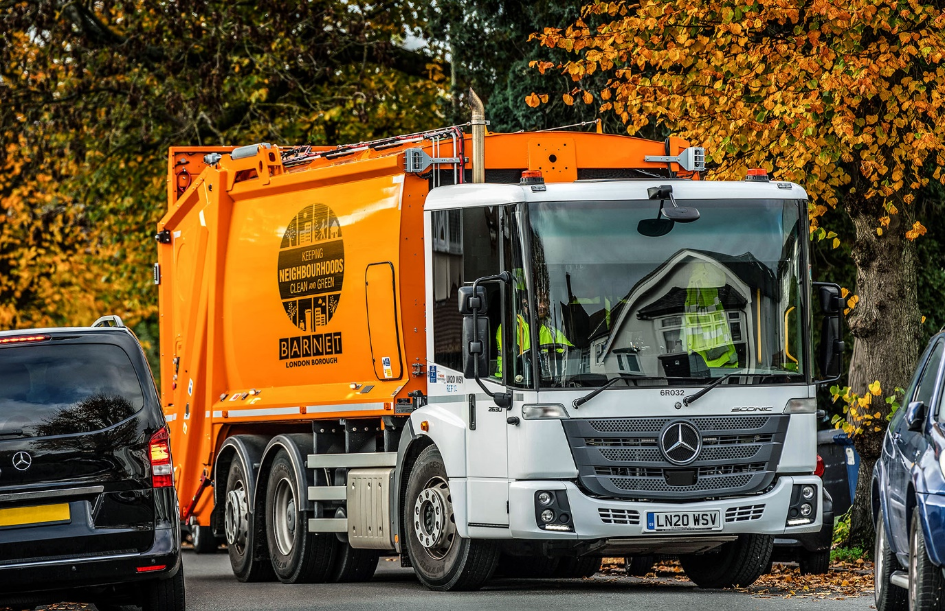

Latest order gives Mercedes-Benz the lion’s share of Barnet Council’s refuse collection vehicle fleet

Less than two years after it commissioned four low-entry Econic refuse collection vehicles from Mercedes-Benz Dealer S & B Commercials, Barnet Council is running 12 more and has just taken the first deliveries from a further consignment of 18.

Those trucks already on the road have proved reliable and attracted positive feedback from crews, while the north-west London authority is also benefiting from the Dealer’s customer-focused back-up.
The latest Econics are all due to be handed over by the end of the month. Like their predecessors, they are 2630 L variants with 7.7-litre in-line six-cylinder engines. Their 220 kW (299 hp) outputs are transmitted via six-speed automatic gearboxes purpose-designed by Allison for stop-start applications, while rear-steer axles assist drivers by significantly reducing turning circles.

Based at Barnet Council Street Scene Services’ Oakleigh depot, near Brunswick Park, the Econics are assigned to collections of domestic waste and recyclables, as well as ‘green’ and trade waste. They are being inspected and maintained under Mercedes-Benz Complete service contracts by the workshop team at S & B Commercials’ Welham Green headquarters, 11 miles away.

Its aftersales support – notably the provision of a collection and delivery service that relieves the authority’s fleet management team of the hassle of arranging vehicle movements – has been instrumental in helping the Dealer to win Barnet Council’s competitive tenders.

The authority has operated a handful of Econics in the past, but prior to this year its fleet of more than 50 refuse collection vehicles was dominated by another brand. Bob Smith, who joined Barnet Council as Fleet Manager in 2016, said: “Unplanned vehicle downtime has been an issue in the past, but on the basis of previous experience I’ve gained with other London councils that run Econics I’m optimistic that we’re now putting those problems behind us.

“Mercedes-Benz has put a lot of thought into the truck’s design. It’s very robust and offers the reliability that’s all-important for an intensive seven-days-a-week operation like our own.
The drivers have really taken to it, too. Some were reluctant to change from their previous vehicles but having tried the rear-steer Econic they wouldn’t want to go back now. Everything invariably works as it should, so as soon as they’ve done their checks they’re straight out on their rounds.”

He continued: “We’re more than happy with S & B’s performance too. Our sales contact Vick Croker (Truck Sales Key Account Manager) is always quick to respond to any questions or requests for information, while the Dealer collects our vehicles at the end of the day, maintains them overnight, and then returns them to us so they’re ready for work the next morning. It’s an excellent service.”

The Econic has a deep, panoramic windscreen, and, as specified by Barnet Council with full-height, glazed folding side door, has been awarded a five-star Direct Vision rating by Transport for London. The vehicle’s low seating position allows drivers to make direct eye contact with cyclists and pedestrians at junctions or in traffic queues, a key advantage in enabling each to understand the other’s intentions.

The Econics are equipped with a 360-degree Sentinel camera system, while Mercedes-Benz safety aids include Active Brake Assist 4 emergency braking technology and Sideguard Assist.

Programmed to recognise other vehicles at higher speeds, as well as pedestrians when moving more slowly, Active Brake Assist 4 is capable of bringing the truck to a complete stop.

Sideguard Assist supports the driver when making left turns and changing lanes in busy environments where visibility may be restricted. Two short-range radar sensors mounted on the passenger side of the vehicle monitor up to a lane’s width, and deliver optical and acoustic warnings which alert the driver to the presence of cyclists, pedestrians or other vehicles.

www.barnet.gov.uk

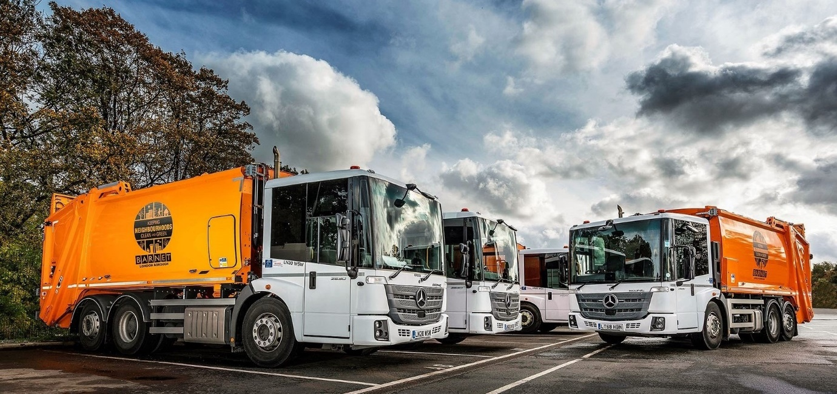

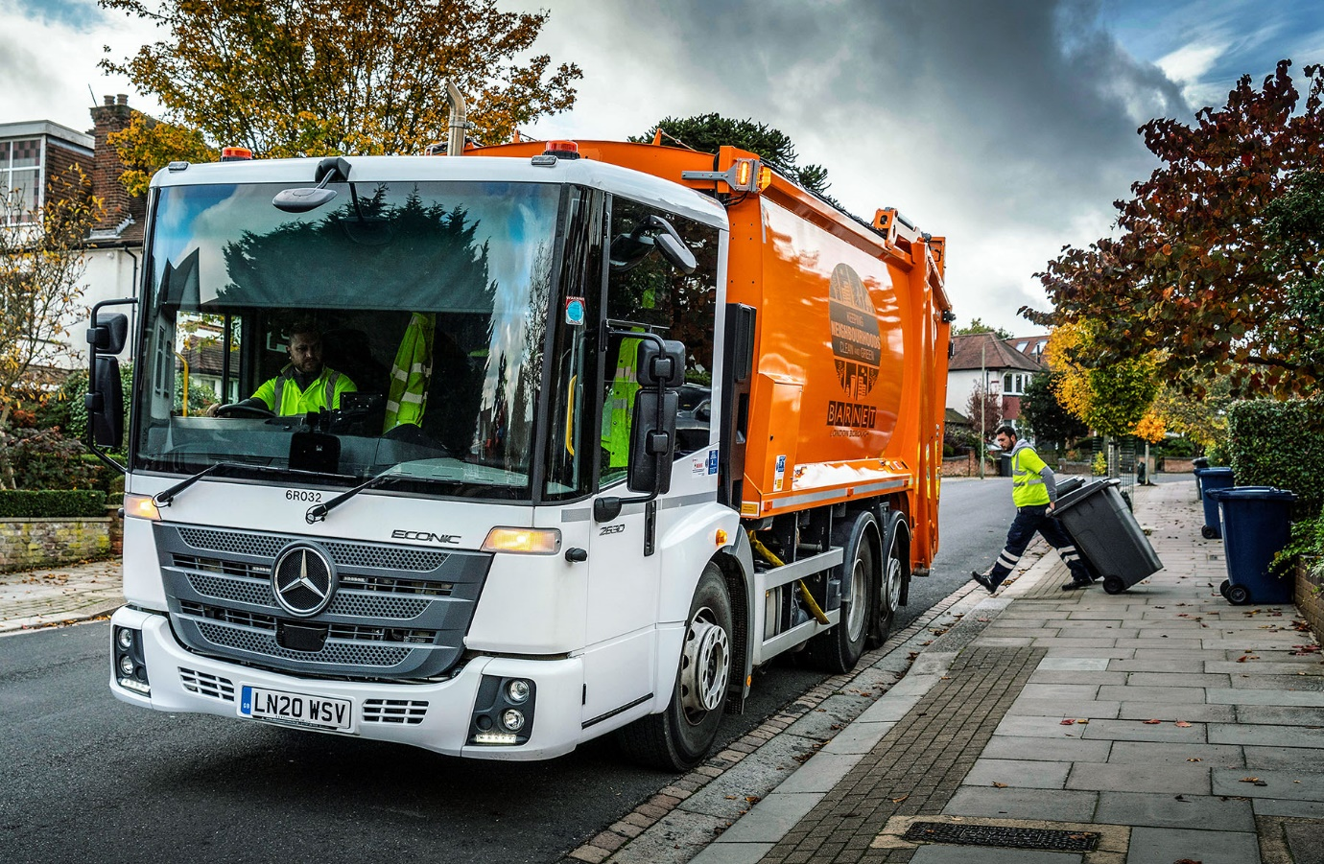

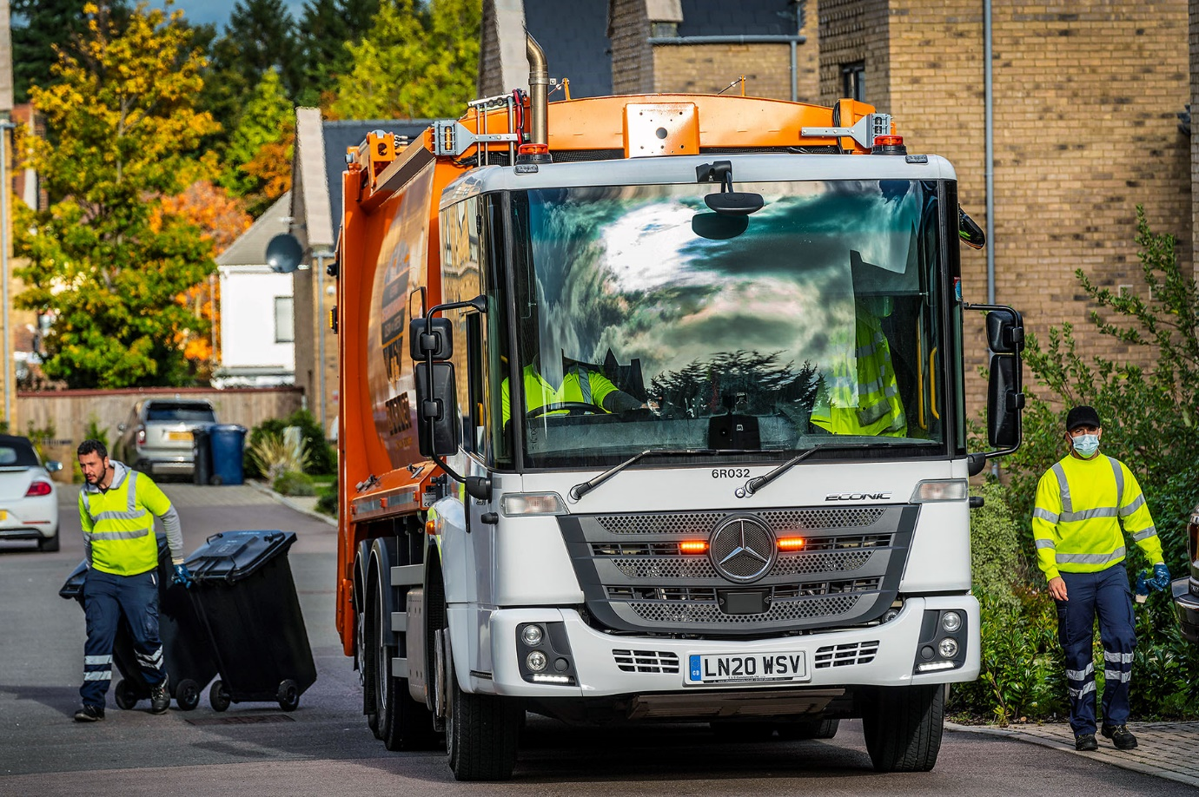

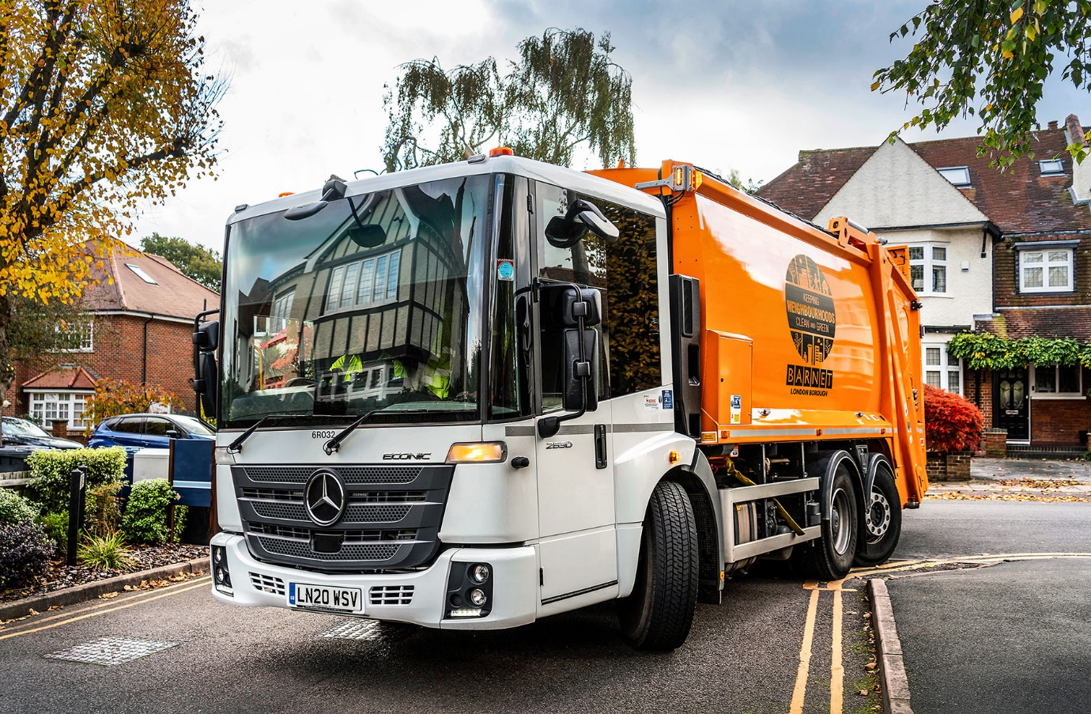

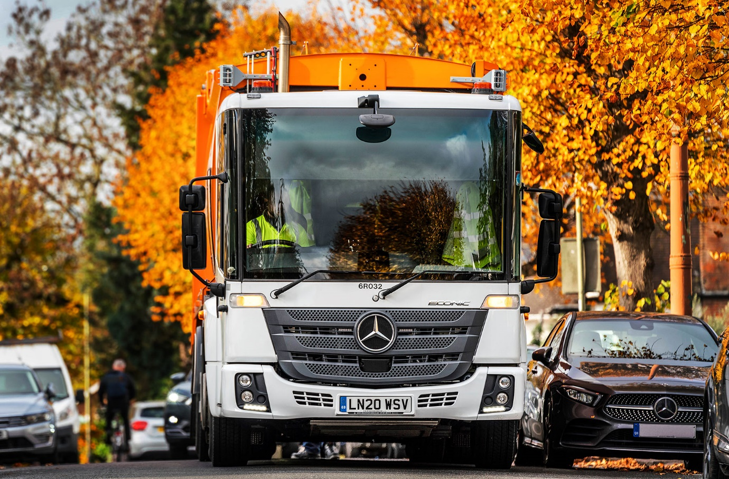

ends

For more information, or to request bigger/higher-res image files, please contact:
Steve Warren or John Ripley
Impact Communications, 01926 842126
Steve: 07770 470251, steve@impactcom.co.uk
John: 07771 484595, john@impactcom.co.uk

