

Date: 24 November 2022

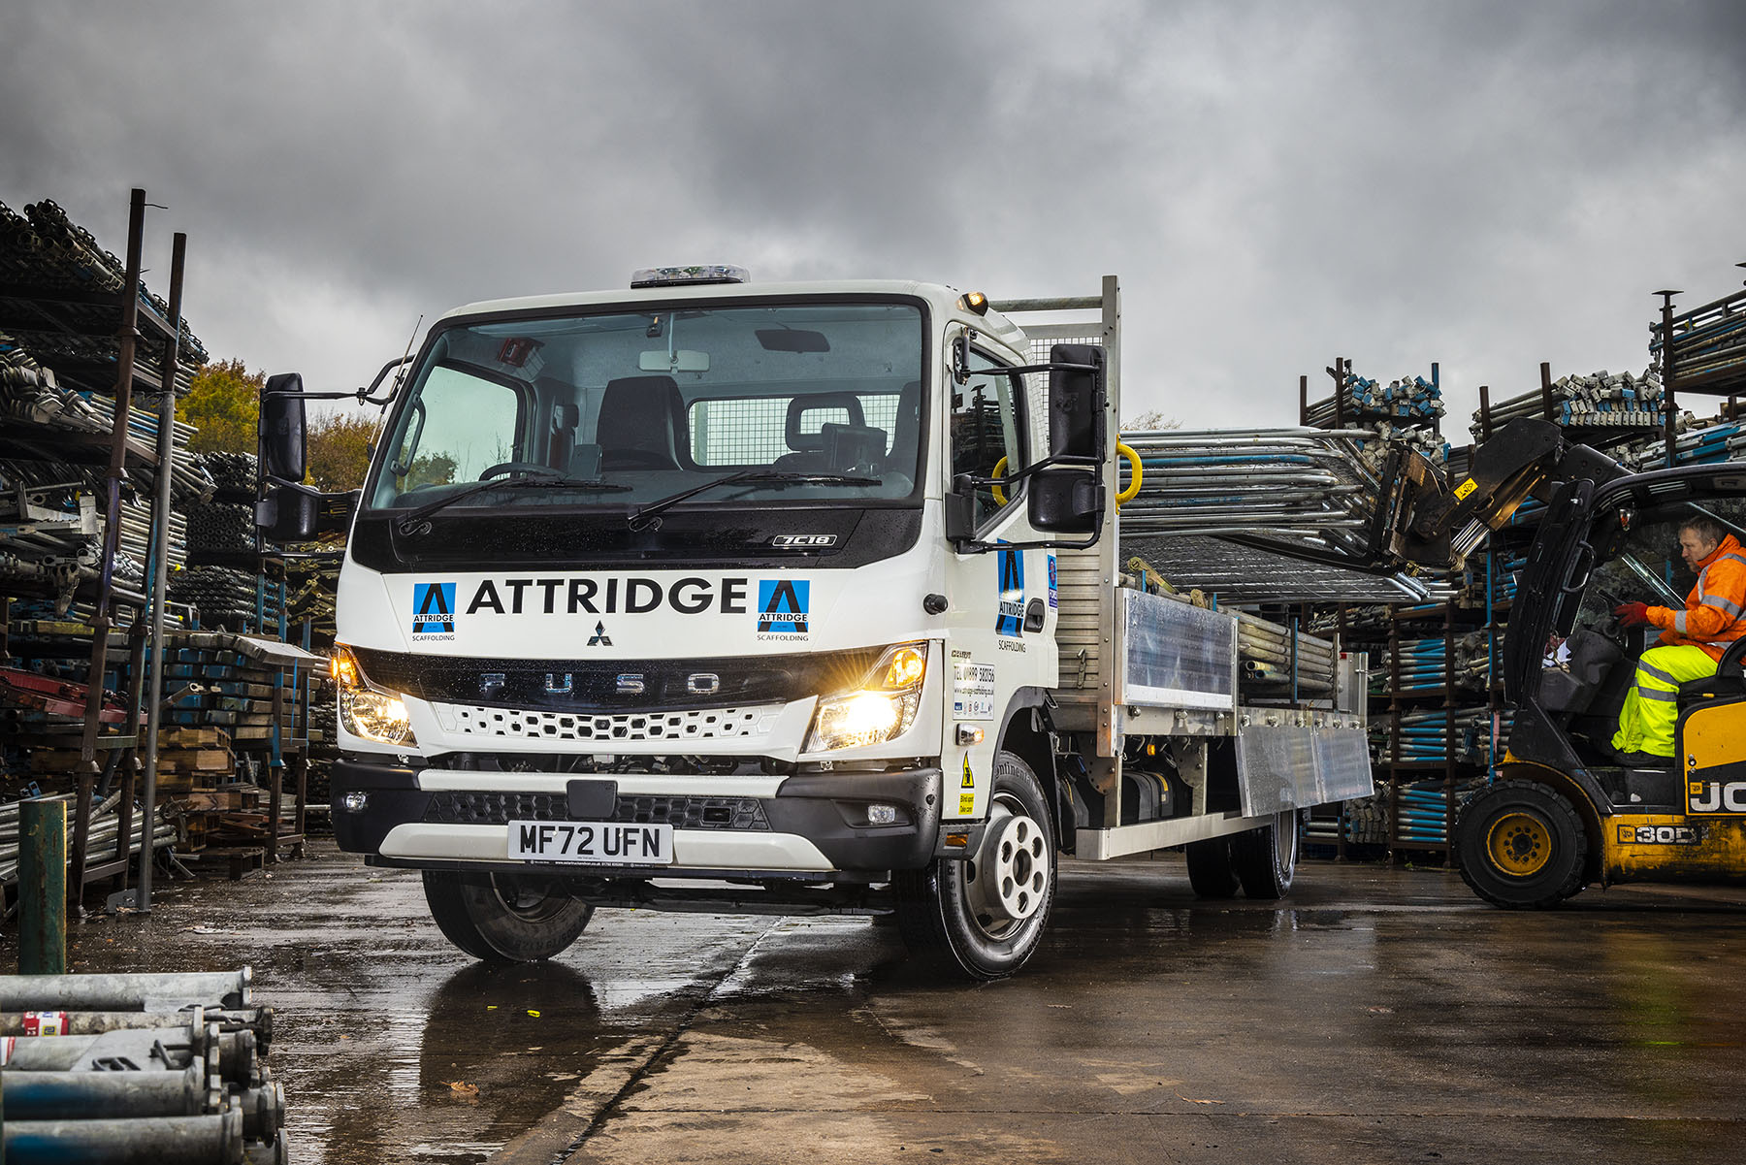

All-new FUSO Canter is on the up for Attridge Scaffolding

When Attridge Scaffolding needed a new 7.5-tonner, the FUSO Canter was always going to be in pole position.

The vehicle’s industry-leading payload, combined with proven reliability and driver-friendly external proportions, make it ideally suited to the Staffordshire-based company’s needs.

Attridge Scafffolding’s latest Canter, its first from the all-new range introduced earlier this year, arrived via the Stoke-on-Trent branch of Dealer eStar Truck & Van, which also sells and supports Mercedes-Benz trucks – both brands are part of the Daimler Truck ‘family’.

Six of the eight 7.5-tonners that work from the operator’s depot in Brereton, near Rugeley, wear the FUSO ‘three diamonds’ badge. The new truck has replaced a five-year-old example from the previous Canter model generation.

Director James Attridge explained: “Ours is a very payload-sensitive application, so the fact that we can easily get 300 kg more on a Canter than any other 7.5-tonner we’ve tried – and a lot more than that, compared to some competitors – is highly significant.

“This attribute alone would incline us towards the Canter, but the vehicle has other benefits too. Our experience has also proved it to be very reliable, well-engineered and cost-effective to operate.

“The Canter’s compact footprint and exceptionally tight turning circle make it very nimble and easy to manoeuvre around city streets, where much of our work takes place. It’s also much less daunting a prospect for drivers stepping up from a 3.5-tonne vehicle, who might be put off by something that looks a lot bigger. We’re particularly pleased with the improved cab of this latest vehicle and eStar’s Sales Executive, Andrew McCarrick, has looked after us very well.”

Attridge Scaffolding’s new Canter is easily distinguished from predecessors by its redesigned cab, which features a more modern ‘face’. The vehicle is also more comfortable, thanks in part to the improved insulation that reduces in-cab noise, while reinforced rear underrun protection minimises the effects of an impact in the event of an accident.

As a 7C18 variant Attridge Scaffolding’s truck employs a 3.0-litre common-rail powerplant that generates a range-topping 129 kW (175 hp) and up to 430 Nm of torque, and is paired with a smooth-shifting DUONIC dual-clutch automated manual transmission with Eco Mode, Parking and Creep functions. A newly developed, compact exhaust system means the new model also meets the EURO VI – STEP E emission standard. Its 22ft aluminium platform with dropsides is by Commercial Body Specialists, also of Stoke-on-Trent.

All new Canters come with a three-year, unlimited mileage warranty but the family-owned operator has taken out additional ExtendPlus cover that provides a further two years’ peace of mind.

Attridge Scaffolding was founded by JFE Attridge in 1972; his son James took over the reins in 1985. As well as running his successful business, Mr Attridge is Chairman of the National Access & Scaffolding Confederation’s Technical Committee.

The company provides scaffolding and related services to customers across the UK, with most of its work undertaken on large-scale construction and civil engineering projects. Deliveries are assigned to a fleet that also comprises five larger trucks – an 18-tonner and four 26-tonners – a couple of which are based on Mercedes-Benz Arocs chassis.

“Our expertise and experience in handling assignments that involve particularly difficult technical challenges or tight possession times has made Attridge Scaffolding the ‘go to’ supplier for many of the country’s biggest contractors,” said Mr Attridge.

“Reliable vehicles are an important component in the toolbox we employ to deliver the results that help us to maintain that reputation.”

www.attridge-scaffolding.co.uk

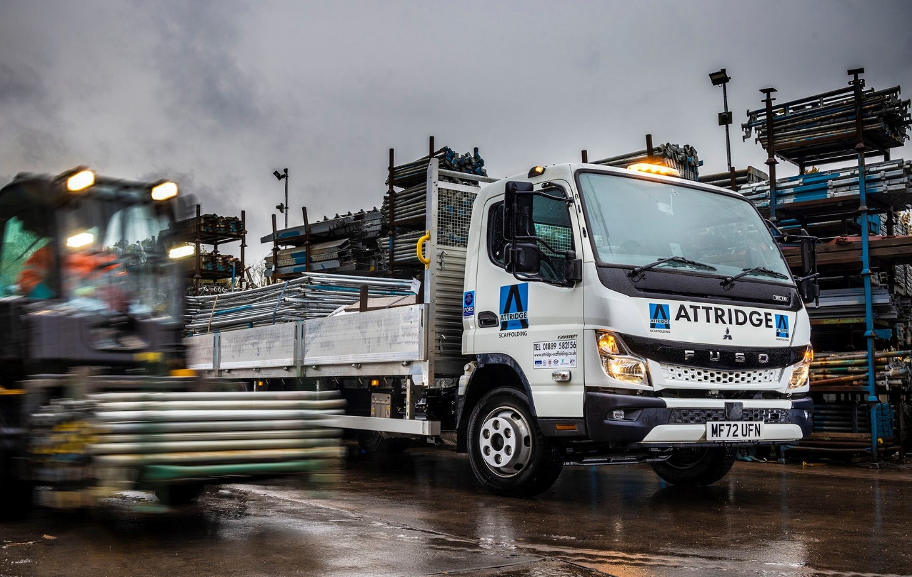

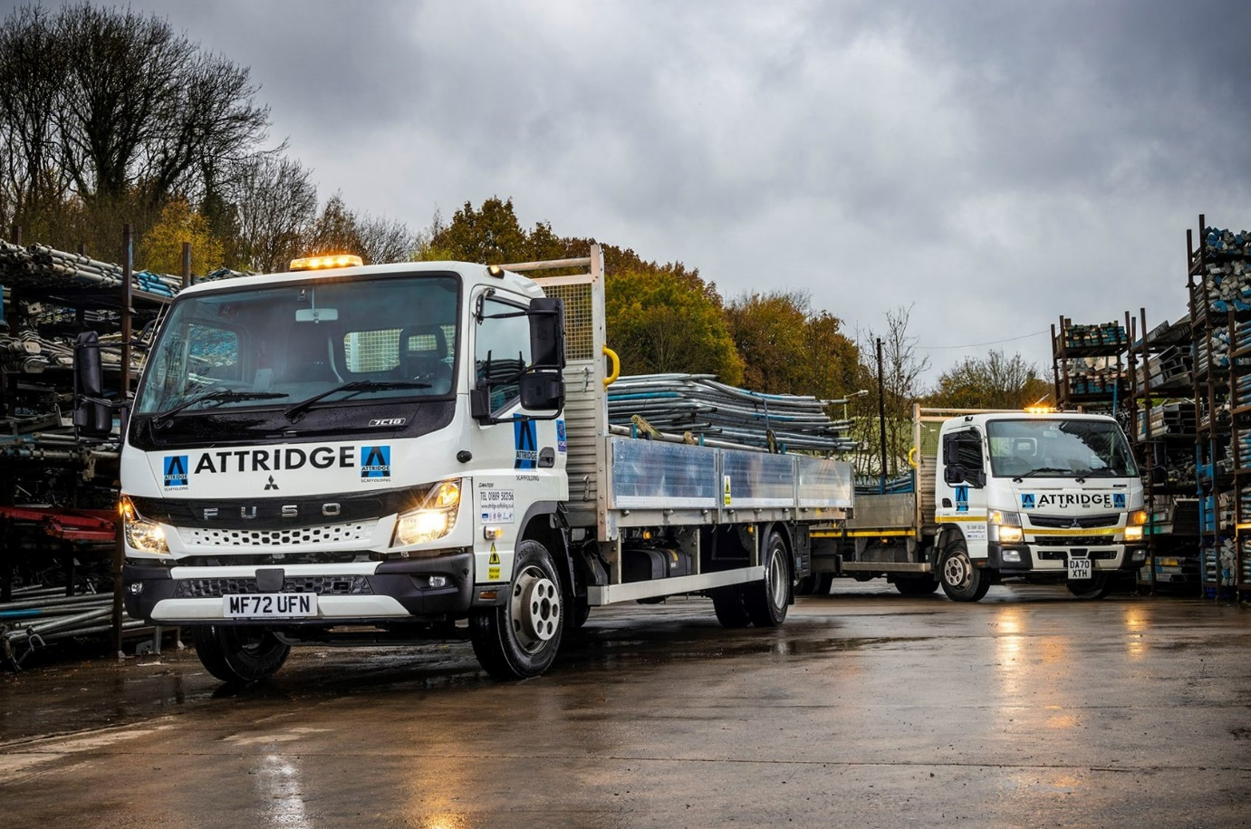

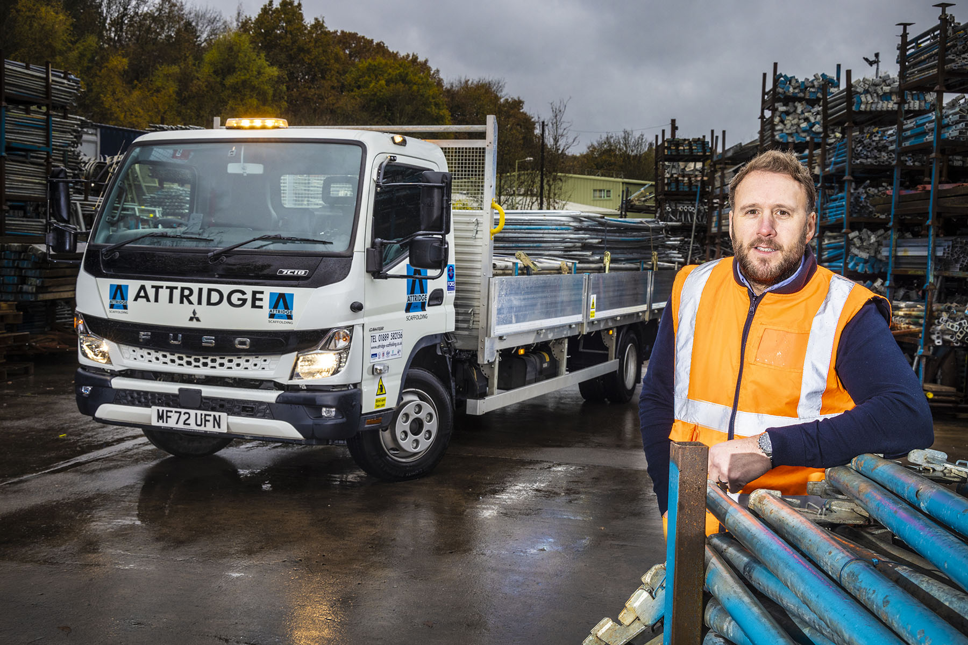

Loads better: Attridge Scaffolding Contracts Manager Justin Cutbush is impressed with the payload of the company’s latest FUSO Canter

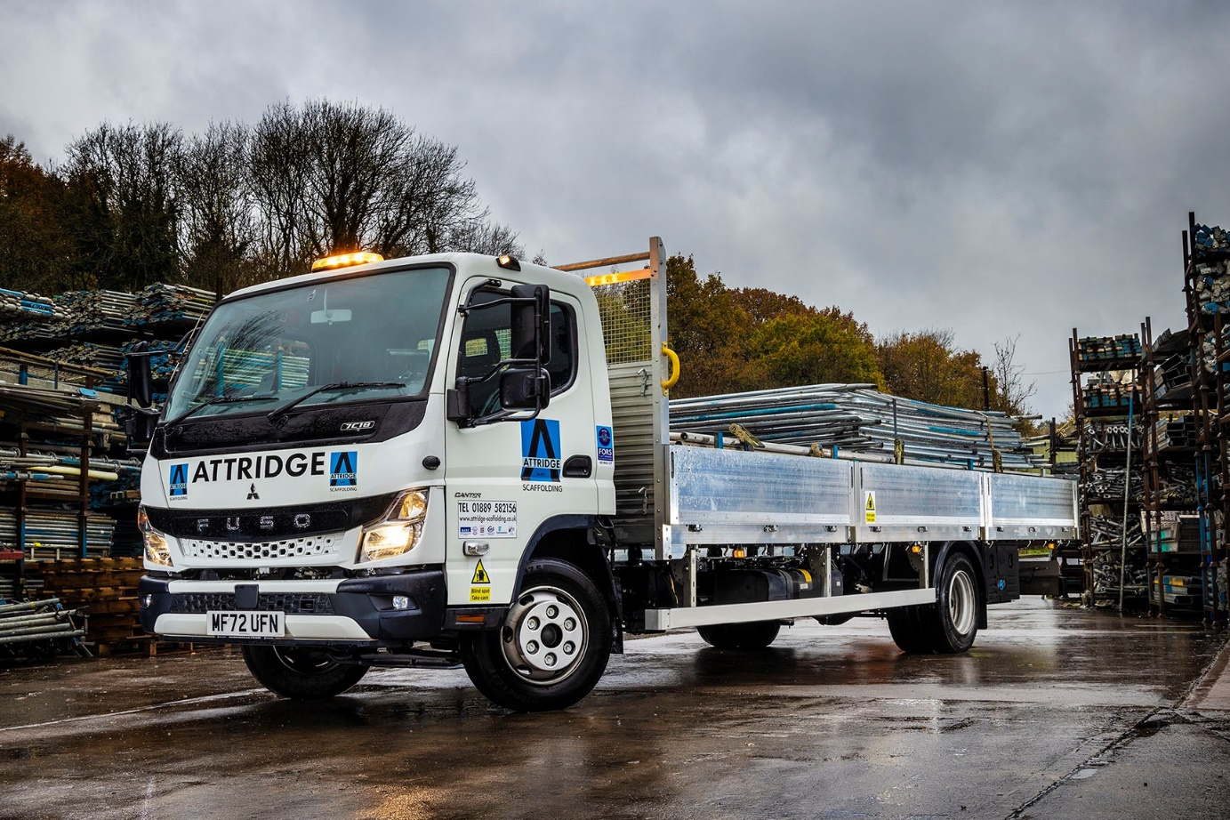

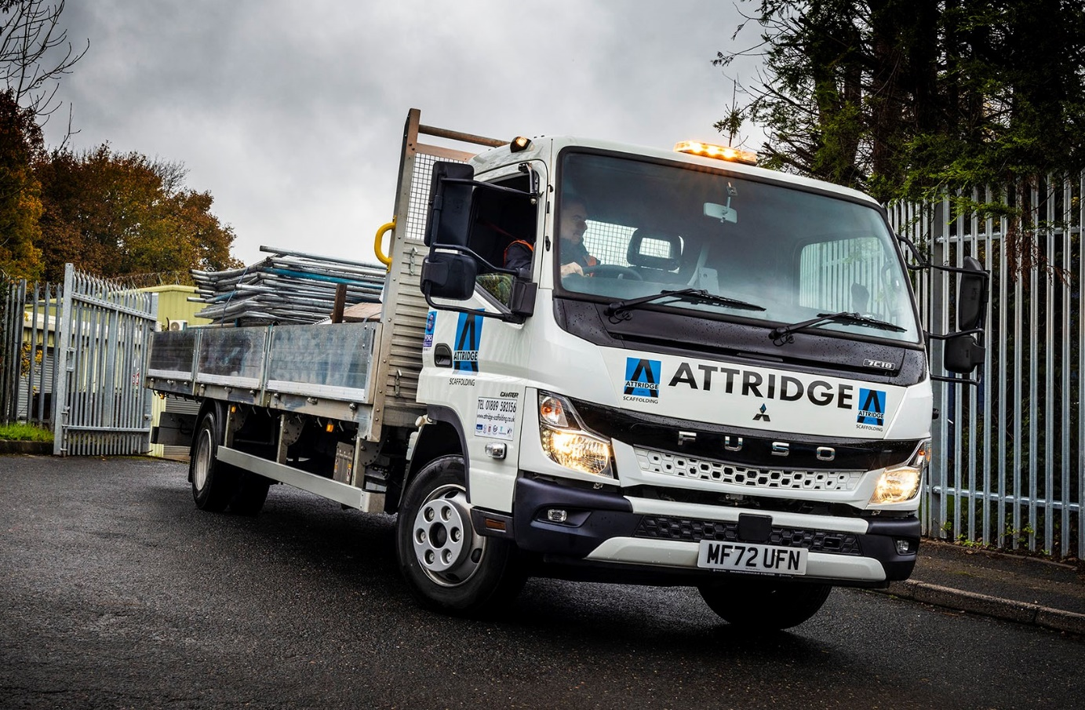

ends

For more information, or to request higher-resolution image files, please contact:
John Ripley or Steve Warren
Impact Communications
John: 07771 484595, john@impactcom.co.uk
Steve: 07770 470251, steve@impactcom.co.uk

