

Date: 21 September 2020

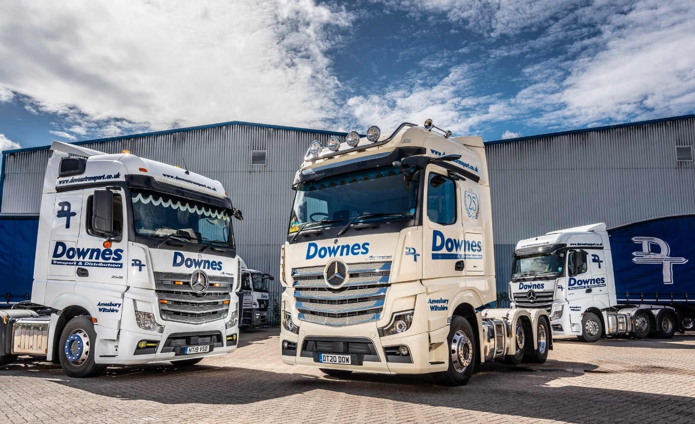

Mercedes-Benz operator Downes Transport reaps an mpg dividend from its eye-catching anniversary Actros

Family-owned haulier Downes Transport ticked a host of option boxes when specifying the latest addition to its Mercedes-Benz-dominated fleet, a stunning Actros tractor unit which is already proving impressively fuel-efficient.

A real head-turner in its pearl white paintwork with colour-coded front bumper and blue chassis, the Actros 2545 BigSpace tractor unit wears a laurel leaf motif highlighting the operator’s 25th anniversary, and boasts a lengthy list of technical and comfort-related enhancements.

Downes Transport is based in Amesbury, Wiltshire. A proud member of the Road Haulage Association, the company also offers warehouse storage and distribution services, and in June joined United Pallet Network (UPN), for which it covers SP and several RG postcodes. Its trucks remained busy throughout the lockdown period, during which it made regular deliveries to hospitals.

Downes Transport’s first new-generation Actros arrived via Marshall Truck & Van. The Dealer also supplied at short notice an Approved Used 2548 variant from the previous Actros model range. A former demonstration unit, this vehicle has been assigned to an extended white goods distribution contract.

Proprietor Douglas Downes established his business in 1995. It became a limited company in 2007, when his son Craig was appointed a Director. All but two of the operator’s seven tractor units wear three-pointed stars, as do six of its eight rigids, most of them 26-tonners.

“I’ve been running Mercedes-Benz trucks since I started out, and have stuck with them ever since for their reliability, competitive running costs, and comfort,” said Douglas Downes. “They’re always popular with our drivers, and that’s certainly true of our 25th anniversary unit.”

Powered by a 12.8-litre, in-line six-cylinder engine that produces 330 kW (450 hp), the company’s new flagship has been allocated to experienced driver Simon Styles, in whose hands it is already returning some highly encouraging fuel figures. “Simon’s getting just over 12 mpg from his new truck, which puts it about a mile-and-a-half ahead of our previous-generation Actros,” confirmed Mr Downes. “I’ll be a happy man indeed if it continues to perform this well.”

New Actros is instantly recognisable thanks to its ground-breaking MirrorCam technology. As well as enhancing safety by providing much-enhanced all-round visibility, not least through the elimination of forward-facing blind spots caused by conventional mirrors, the system cuts diesel costs by an estimated 1.5% because the cameras’ compact, streamlined housings create far less wind resistance.

The latest version of Mercedes-Benz Trucks’ well proven Predictive Powertrain Control (PPC) system also contributes to the reigning International Truck of the Year’s impressive economy. PPC employs digital 3D mapping and GPS data to scan the topography of the road ahead, then manages gear changes and ensures that full use is made of the Mercedes PowerShift 3 transmission’s Eco Roll function to maximise fuel-efficiency and reduce emissions. The system now factors in the curvature of the road as well, making it ideal for use on rural routes.

Contributing to the truck’s striking external appearance are a roof-mounted light bar and air horns, self-cleaning Bi-xenon headlamps, LED daytime running lamps and LED tail lamps, a chrome grille and Alcoa alloy wheels. The ExtraLine pack, meanwhile, includes a chrome-trimmed sun visor, and a welcome light, which projects the Mercedes star onto the ground when the door is opened.
Inside, driver Simon benefits from the upgraded Multimedia Cockpit, interactive, version of Mercedes-Benz Trucks’ radical new dashboard, which comes with a larger 12in instrument panel and additional functionality, and a contemporary StyleLine interior with aluminium-effect trim. The smart leather-upholstery and leather-trimmed steering wheel add to the ‘feel good’ effect, as do the optional LED ambient driving and living lighting, DAB radio, and fridge.

New Actros is also equipped as standard with a potential life saver in the form of Active Brake Assist 5. Whereas the previous version of Mercedes-Benz Trucks’ emergency braking system relied solely on radar, its successor employs a combination of radar and cameras. The result, at speeds of up to 50 kph, is a dramatically improved response to moving pedestrians. Active Brake Assist 5 can now employ full braking – as opposed to the 50% achieved previously – when encountering pedestrians crossing its path.

“We’re delighted with our anniversary truck,” Mr Downes continued. “It looks fantastic, while Simon has really embraced all of the new technology and, if the fuel returns are anything to go by, is clearly using it to good effect.”

Although Downes Transport undertakes some maintenance work in-house, it also signs-up to Mercedes-Benz Complete Service Contracts and relies on the support of Marshall Truck & Van’s Andover branch.

“The Dealer’s back-up is excellent,” he said. “Its workshop team are very flexible and will always attend to our trucks in the evenings or on Saturdays. On the rare occasions we’ve had a problem, Mercedes-Benz Trucks’ 24-hour breakdown service has also performed every bit as well as we could have hoped.”

www.downestransport.co.uk

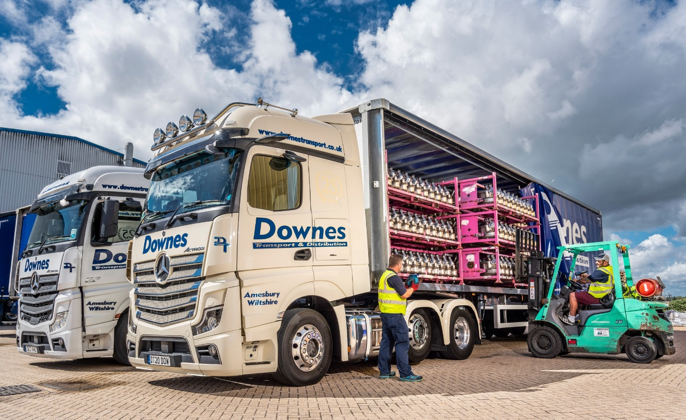
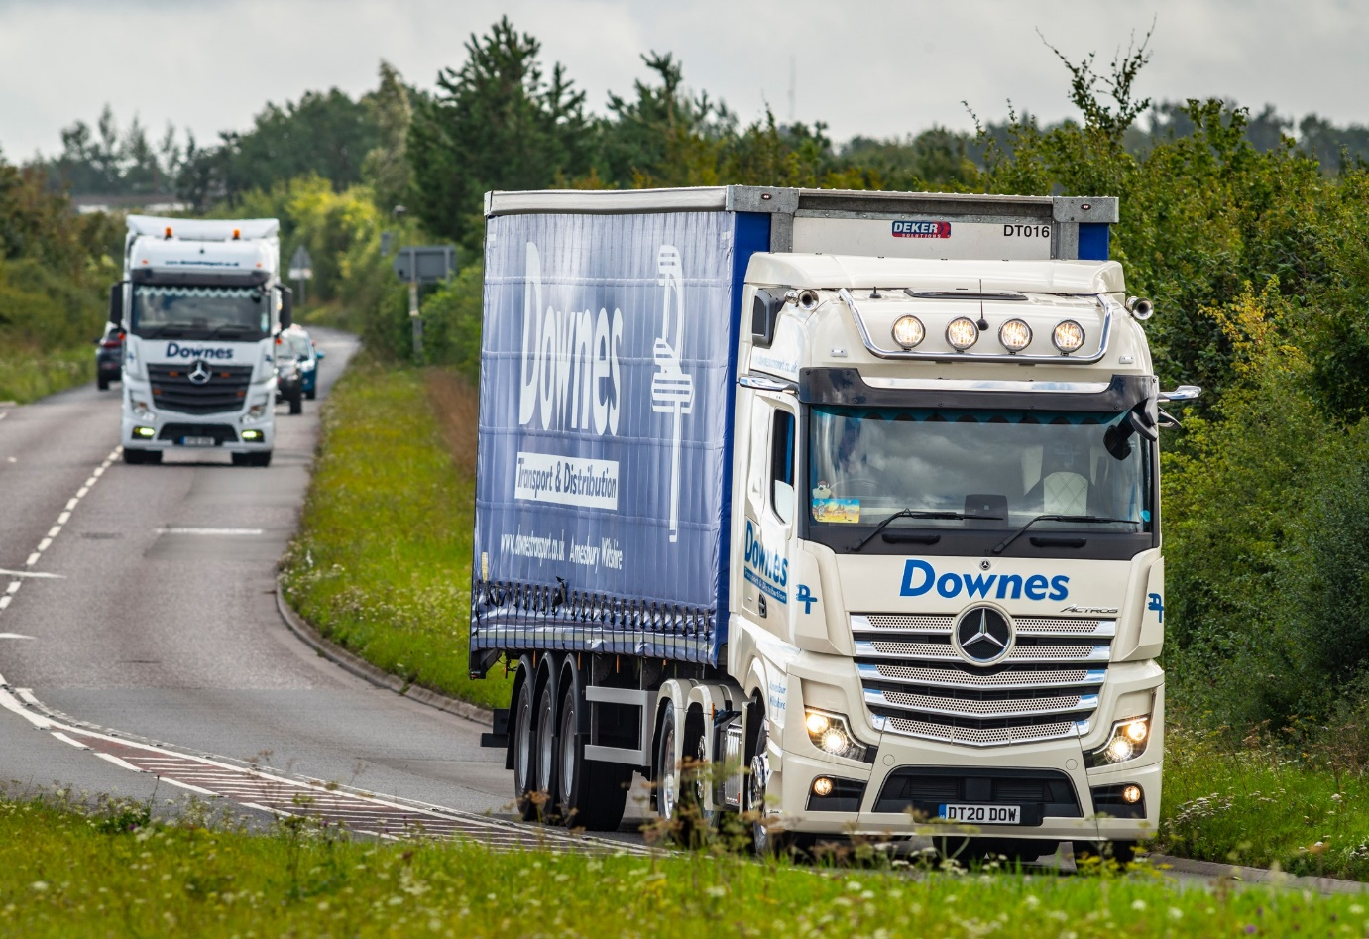

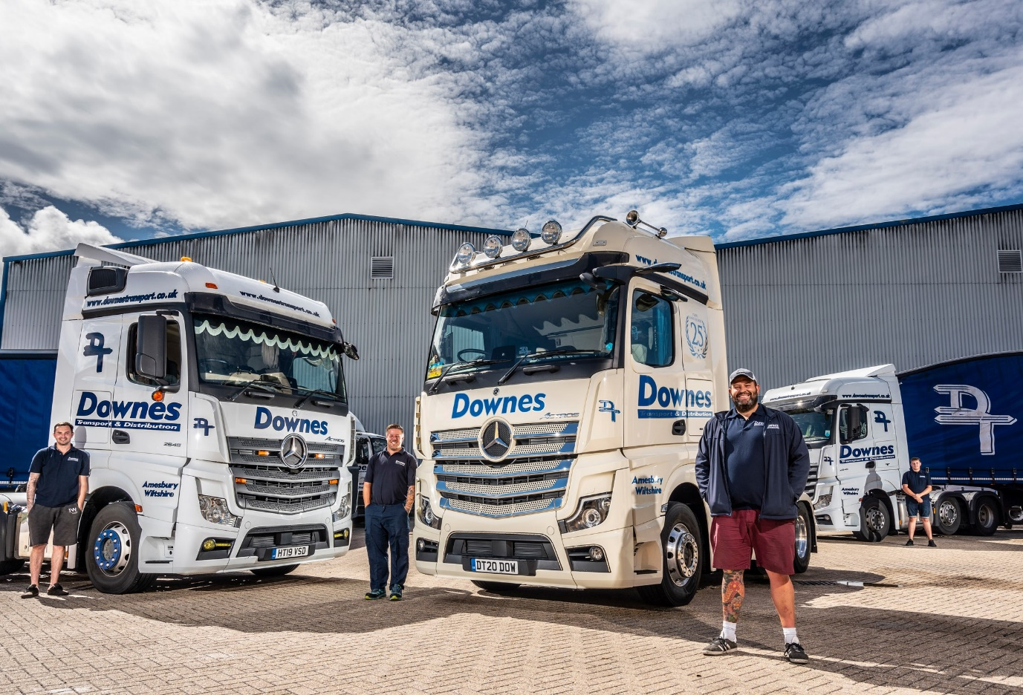

Milestone: Director Craig Downes, foreground, is pictured with Simon Styles, the driver of Downes Transport’s new flagship, and his colleagues Tommy Arkle, left, and Reece Boyson

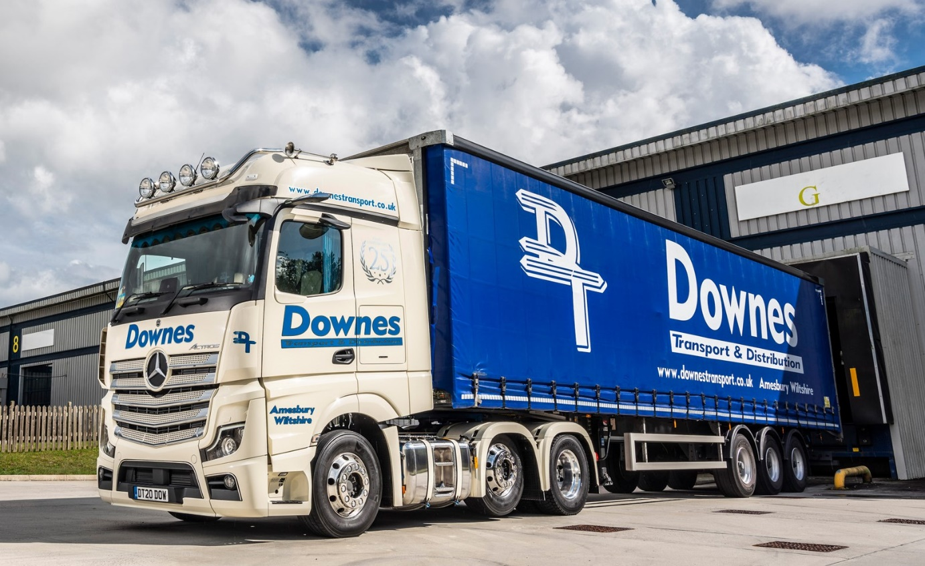

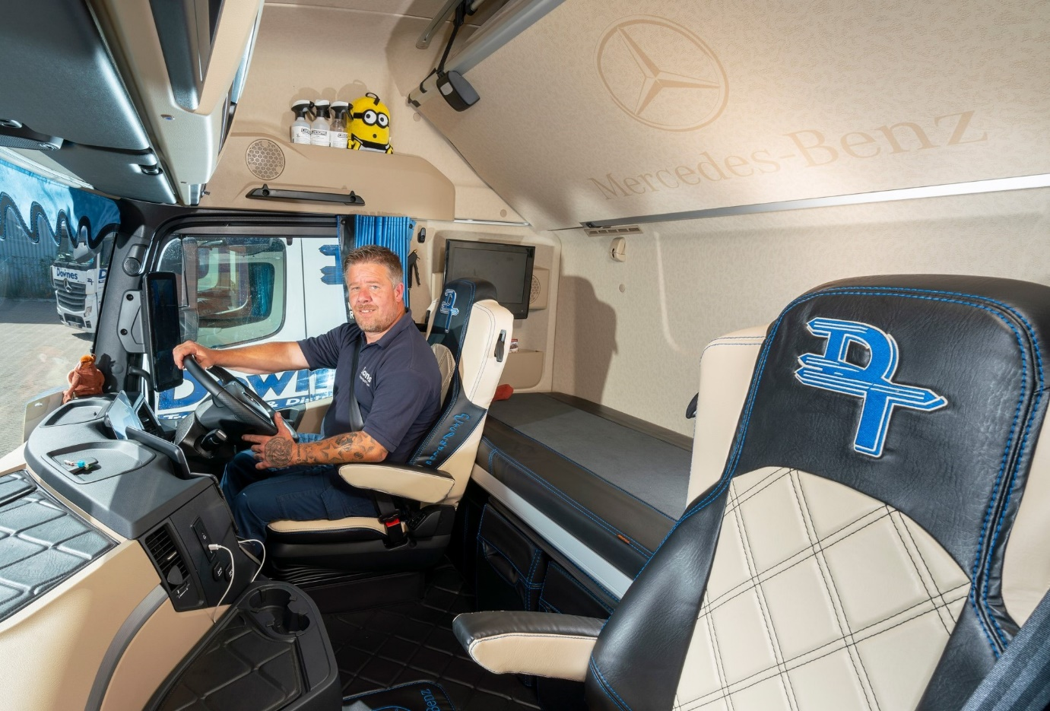

Miles more smiles for Styles: Driver Simon is delighted with his new Mercedes-Benz

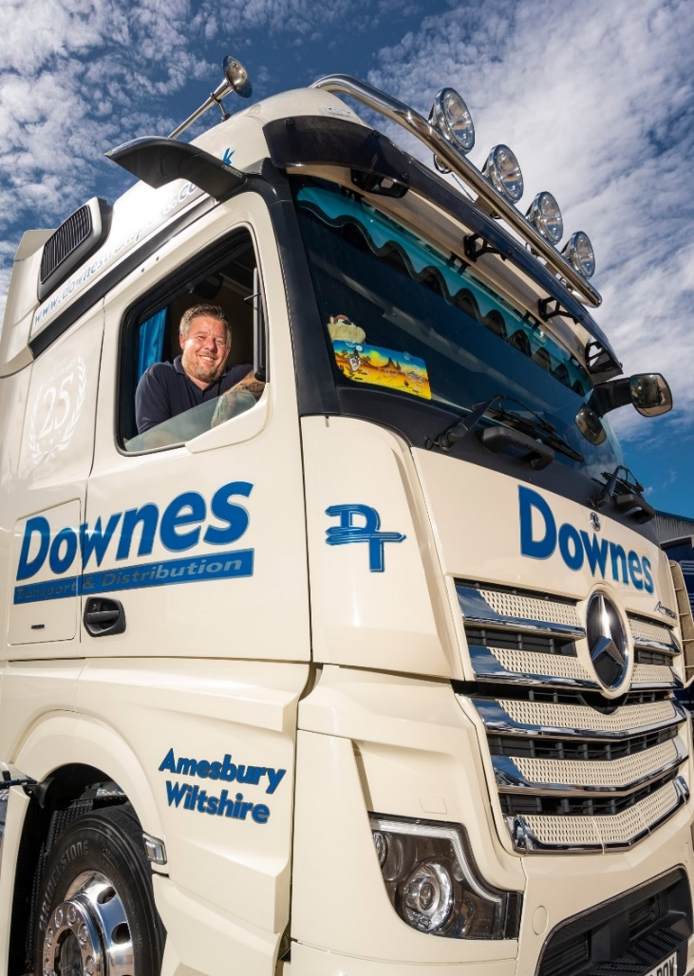

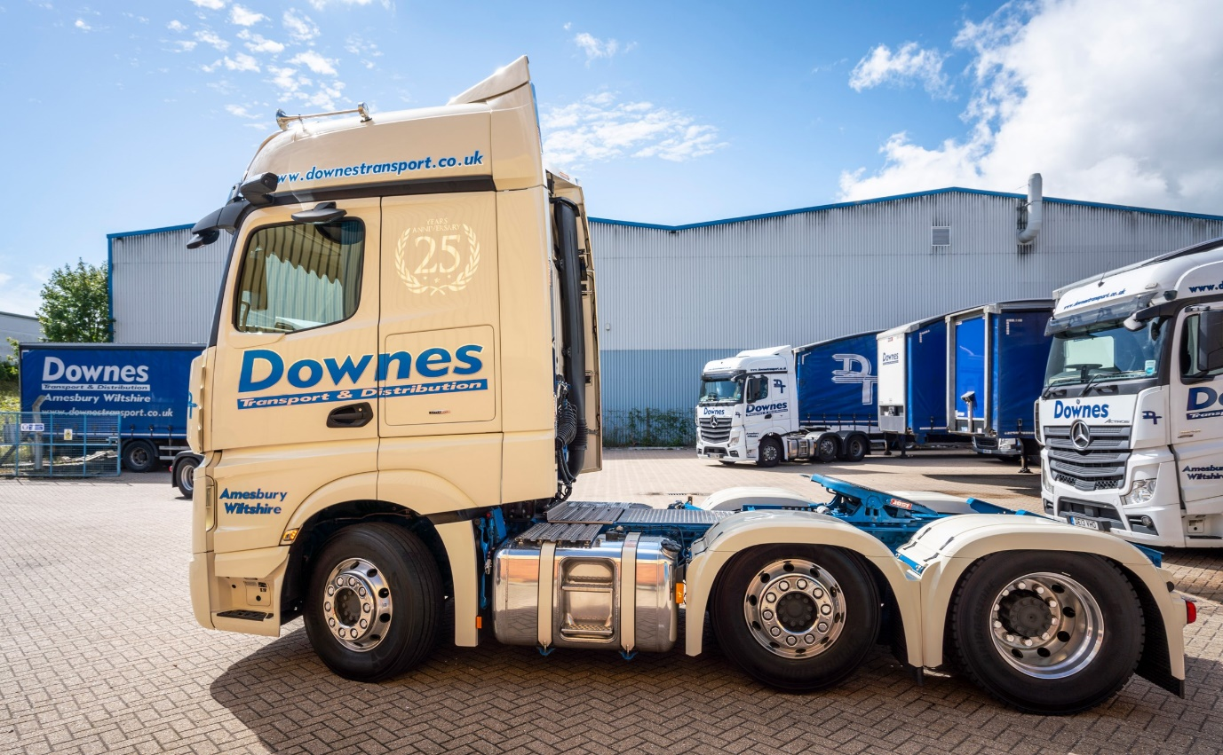

ends

For more information, or to request bigger/higher-res image files, please contact:
Steve Warren or John Ripley
Impact Communications, 01926 842126
Steve: 07770 470251, steve@impactcom.co.uk
John: 07771 484595, john@impactcom.co.uk

